Shane Stacy

CIS 162 Business Card

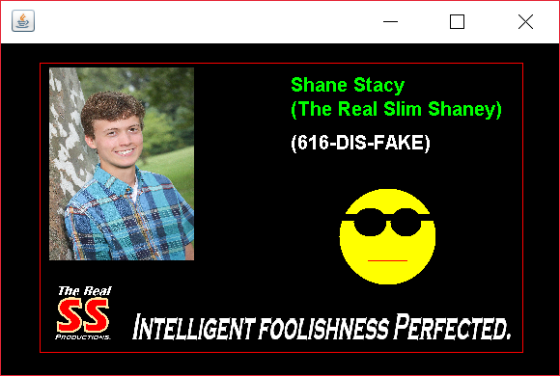

I pledge that this work is entirely mine, and mine alone (except for any code provided by my instructor).

____________________________________

I spent approximately 5 hours on this project from 9/13/17 to 9/20/17 working from and reverse engineering provided sample code in the Project 1 Business Card.pdf and putting together this cover page.