Shane Stacy

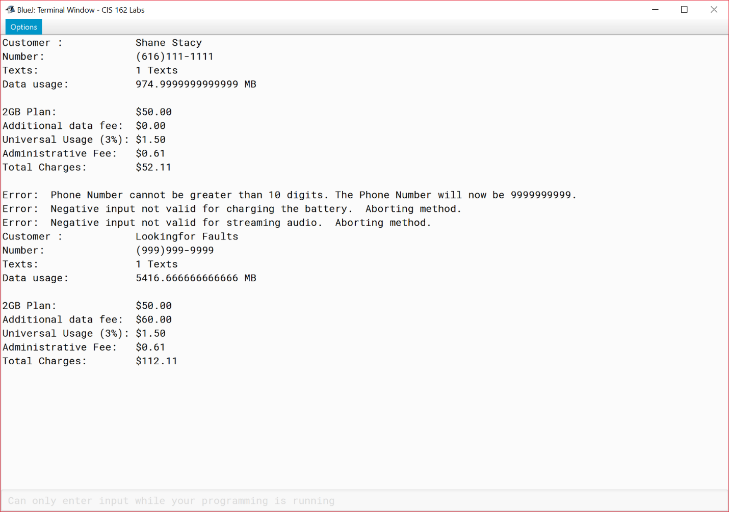CIS 162 MyPhone

I pledge that this work is entirely mine, and mine alone (except for any code provided by my instructor).

____________________________________

I spent approximately 14 hours on this project from 9/26/17 to 10/8/17 working from and reverse engineering provided sample code in the MyPhone.docx and putting together this cover page.