Shane Stacy

CIS 162 PigGame

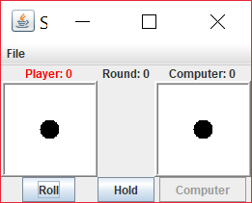

I pledge that this work is entirely mine, and mine alone (except for any code provided by my instructor).

____________________________________

I spent approximately 8 hours on this project from 10/15/17 to 10/26/17 working from and reverse engineering provided sample code in the Project 3 Pig.pdf and putting together this cover page.