Note: When writing your Python code, please remember to use meaningful variable names that clearly describe their purpose. Additionally, include proper comments throughout your code to explain complex logic or describe the functionality of specific sections. Furthermore, for each function, write a docstring at the beginning.

Q1: (5 points)
Write a function that asks the user to enter a distance in kilometers, then convert that distance to miles. The conversion can be done by using the formula:
Miles = Kilometers * 0.6214

Expected Output:

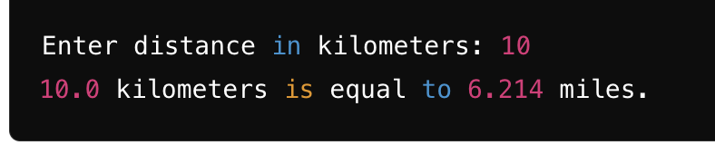

Q2: (7 points)
Write a program (with functions) that gives simple math quizzes. The program should display two random numbers that are to be added, such as:
279
+ 190
The program should allow the student to enter the answer. If the answer is correct, a message of congratulations should be displayed. If the answer is incorrect, a message showing the correct answer should be displayed.

Expected Output:

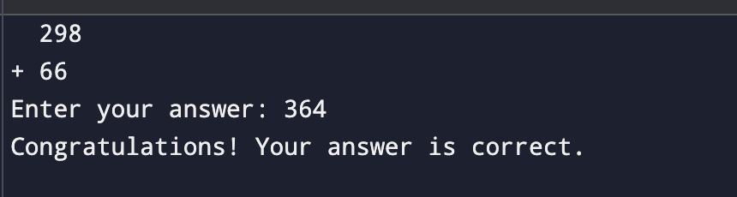

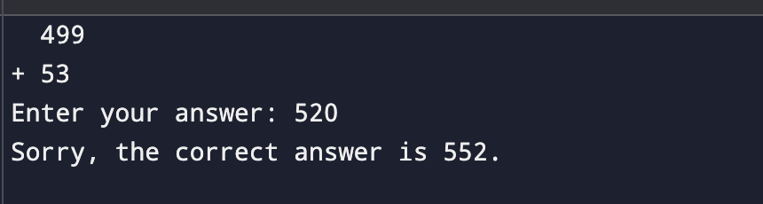

Q3: (6 points)
Write a function called who_am_i that asks the user 3 yes/no questions to guess their personality type. Based on the answers, print a personality trait.
Questions:
- Do you like being around a lot of people? (yes/no)
- Do you enjoy trying new things? (yes/no)
- Do you prefer to plan things out? (yes/no)
Based on the answers:
- If they answer "yes" to all, print "You are adventurous and outgoing!"
- If they answer "no" to all, print "You are thoughtful and reserved."
- If they have a mix of answers, print "You have a balanced personality."
Expected Output:
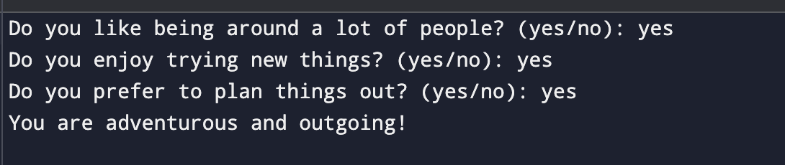
Q4: (5 points)
Write a function called fizz_buzz that prints numbers from 1 to 20. For multiples of 3, print "Fizz" instead of the number, and for multiples of 5, print "Buzz." For numbers that are multiples of both 3 and 5, print "FizzBuzz.”
Expected output:
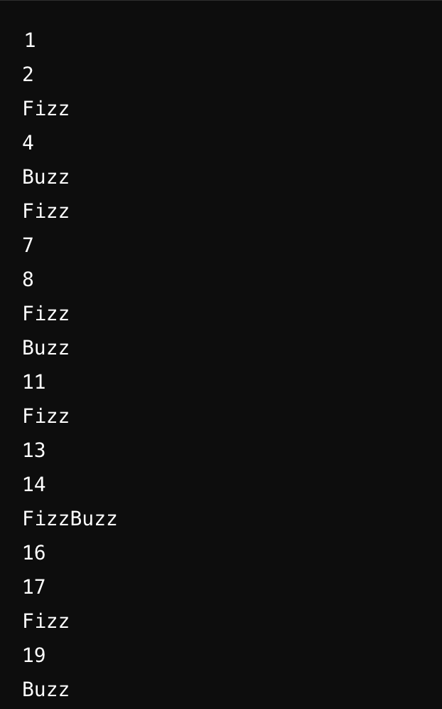
Q5: (7 points)
Write a function called find_min_max. This function should ask the user to enter numbers one by one. When the user enters 0, the input will stop. The function should find and show the smallest and largest numbers entered but ignore the 0.
Expected Output:
