Large Scale Question

Answering at Tourism Data

Wireframe Documentation

Domain: NLP

Author : Debasish Mohanty

Date: 15.02.2024

**PAGES:**

The deployment application contains a single page that takes input and gives formatted textual response..

**States of Pages:**

There are two state for the webpage, those are the *default state,* *generation* *state.* The webpage has two theme i.e. Light and Dark.

**Default State:**

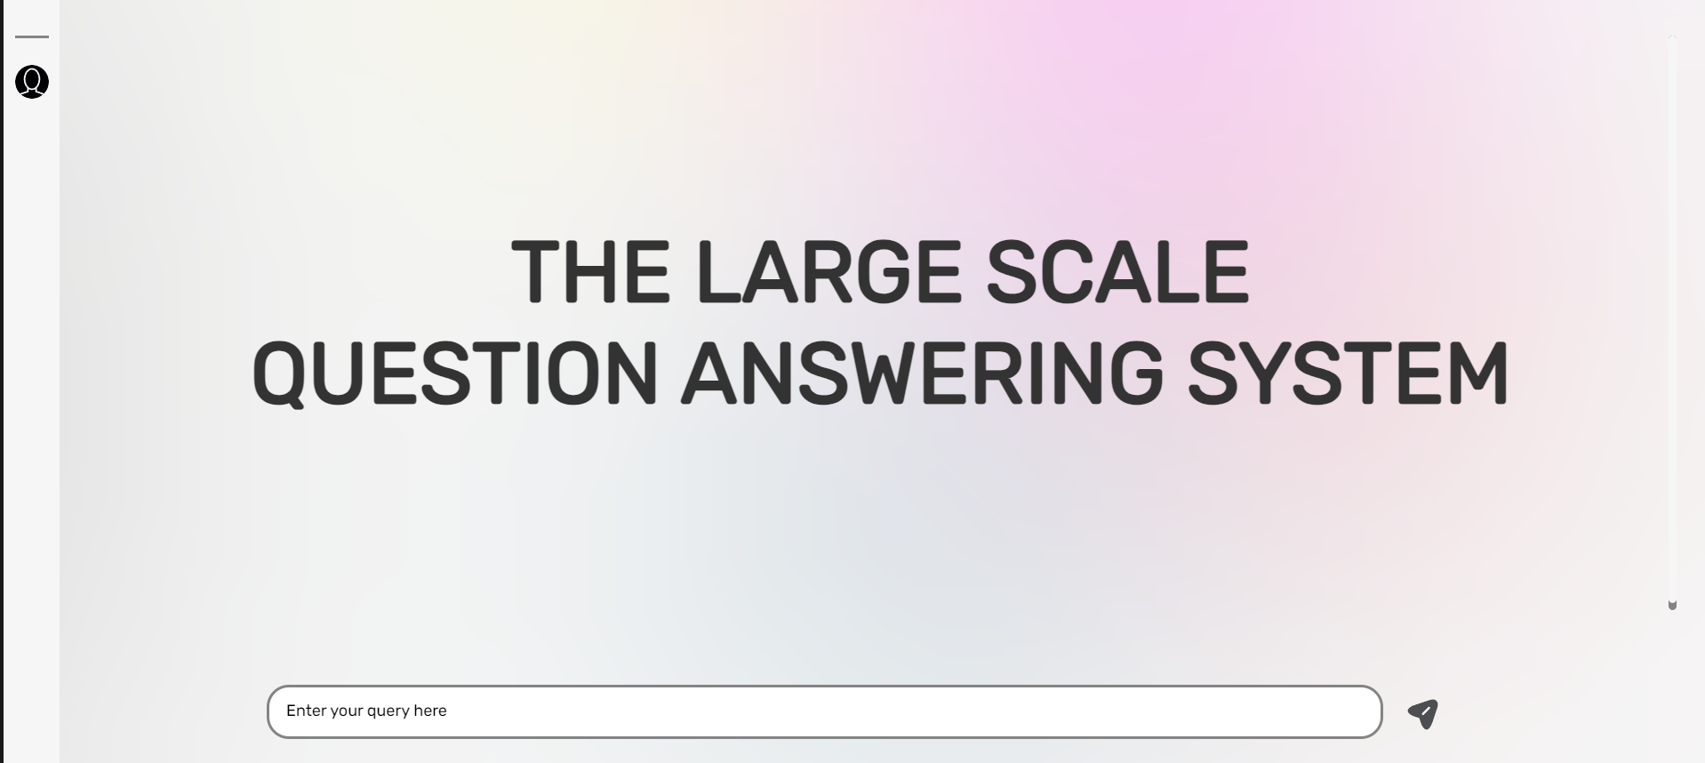

**Generation State :**

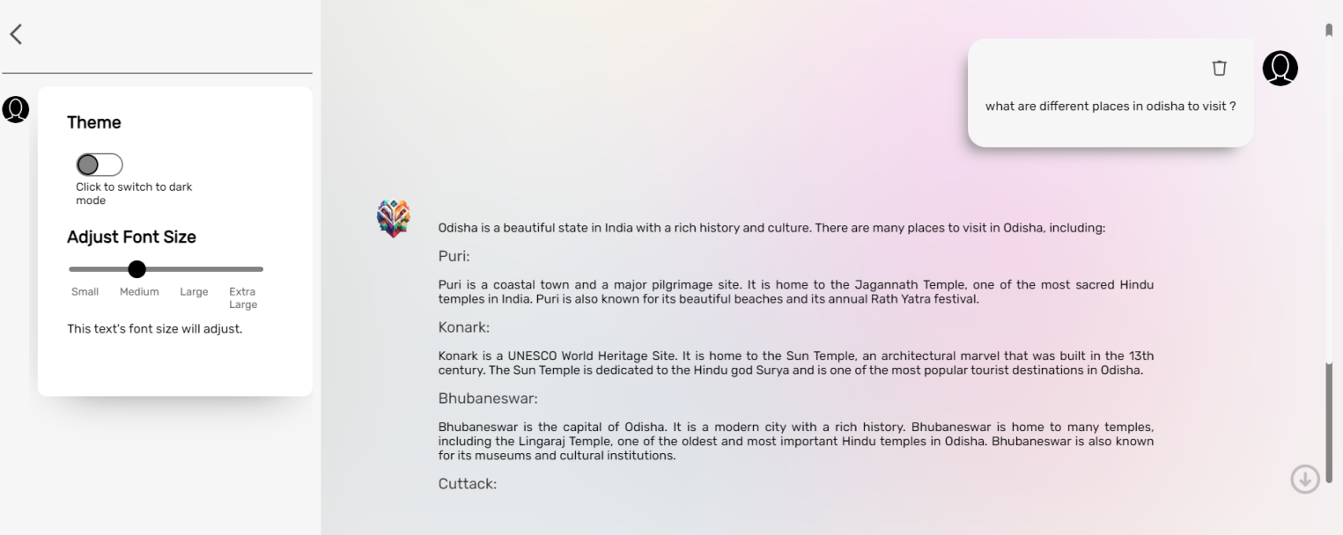

**Sample Dark - Theme:**

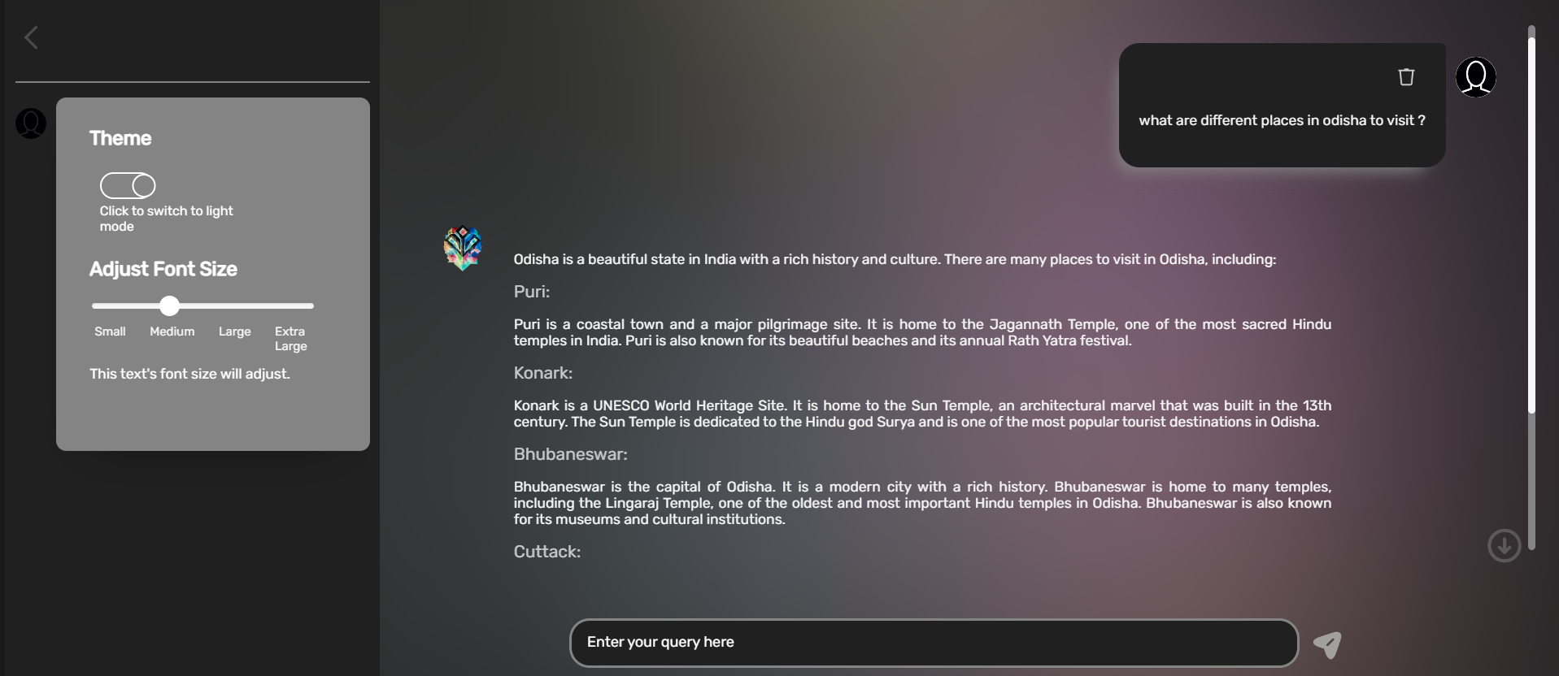

**Responsive View:**

