ML PAPER MAIN DRAFT

INTRODUCTION:

Perovskite Solar Cells are one of the major futuristic alternative of the traditional Si based solar cell. Yet considering the sensitivity and over all stability of the Perovskite materials, we are a little far than the traditional 1st generation solar cells. Following last few years of research in this domain, we can practically notice the scientific progress both in efficiency and stability of PSCs. The development can be more persistent if the results of the collective research could be more organized, accessible and be used in a more efficient manner. There comes the advantage of the machine learning that enables us to develop and optimize our scientific insights by utilizing the exiting data. Using different ML algorithms the development of predictive models has been tested and modified into deployment for research purposes. This can give us advantage to minimize the experimentation redundancy and to examine the effect of compositional materials and their amount on the resulting overall efficiency of PSC. The process doesn’t only develops the ML models for research purposes but also demonstrates the application of synthetic data generation algorithms to avoid the imbalance from of data by over sampling of the minority data classes. We have taken more than 100 parameters involved in the process of the both synthesizing and assembling of the PSCs and processed into ML algorithms after data cleaning and feature engineering. Considering over-fitting and hyper-parameter optimization, the training process is done for numerous iteration to achieve the average accuracy of 85%. (The accuracy can be achieved as high as 90% with proper and delayed hyper-parameter optimization.)

PROCESS SEGMENTATION:

Section 1: Imp : DISCUSSION

Section 2: EXPERIMENTATION AND APPLICATION

1. EXPERIMENT FUNCTIONS
2. UNDERSTANDING THE PROCESS OF PSC DEVELOPEMENT
3. EXAMINING THE FACTORES FROM THE DEVELOPMENT PROCESS
4. EXTRACTING MEANINGFUL SET OF DATA
5. PREPARING DATA ACCORDING TO NUMERICAL OR CATEGORICAL SEGREGATION.
6. ML FUNCTIONS
7. DATA COLLECTION
8. DATA CLEANING
9. SYNTHETIC DATA GENERATION
10. LABEL ENCODING
11. SCALING
12. DEPLOYING INPUT DATA PIPE LINE
13. DISTRIBUTED TRAINING OF K-FOLD CROSS-VALIDATION
14. DEVELOPING DEPLOYING PIPE LINE
15. CREATING USER INTERFACE FOR THE DEPLOYMENT USING GRADIO

Section 3: ADVANTAGES AND POSSIBLITIES

**UNDERSTANDING THE PROCESS OF PSC DEVELOPEMENT:**

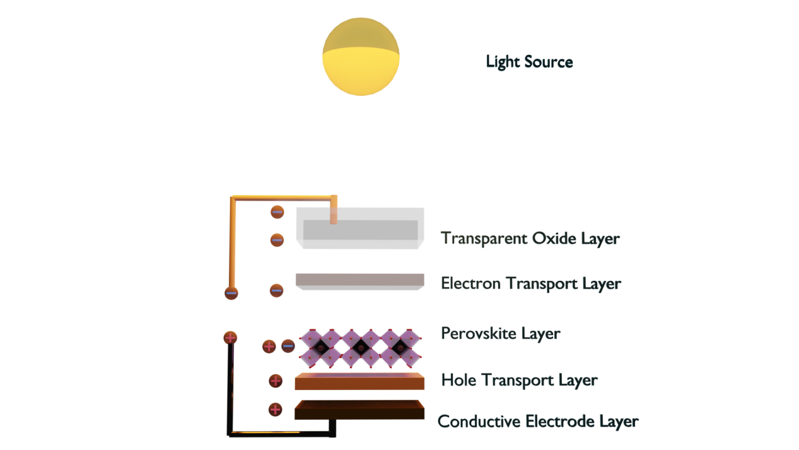

**( Fig 1 : Basic Structure and Components of Perovskite Solar Cell)**

The photovoltaic mechanism is the fundamental process that causes the development of potential difference across the device in most of the solar cells. The mechanism involves exertion of electron hole pairs or exciton simulated by solar spectrum. Solar spectrum usually consists of photons that causes separation of electrons and holes in the solar cell. Within a certain range of band-gap the electrons and holes tend to remain separated. Electrons are collected at electron transport layer and holes are collected at hole transport layer. As the charge separation continues with photon supply the potential difference causes continuous current. But the amount of electric power generated compared to the power applied to the solar cell is a considerable parameter, which is represented as “Power Conversion Efficiency” or PCE. PCE is mathematically a function of Fill Factor, Open circuit voltage, short circuit current and input power given as : -

$$μ=\frac{Fill Factor (FF) × V_{oc} × I_{sc}}{P_{in}}$$

Yet all the above individual factors are mathematically determined. So the experimental composition and geometry of the device plays a crucial role in tuning the theoretical PCE of the PSC device. Perovskite solar cell has a sandwich like structure i.e. the main perovskite layer is placed between electron transport layer and hole transport layer and again these two layers are placed between two conductive layer of glass and metal respectively. (Dependant to the direction of light as shown in the fig-1)

**PSC BASIC STRUCTURE:**

**SUBSTRATE STACK SEQUENCE**

**ETL STACK SEQUENCE**

ETL DEPOSITION PROCEDURE

**PEROVSKITE STACK**

PEROVSKITE COMPOSITION (A,B AND X) (STRUCTURAL COMPONENTS)

PEROVSKITE DEPOSITION PROCEDURE

PEROVSKITE DEPOSITION SOLVENTS

PEROVSKITE DEPOSITION SOLVENTS MIXING RATIOS

PEROVSKITE DEPOSITION AGGREGATION STATE OF REACTANT

PEROVSKITE DEPOSITION THERMAL ANNEALING TEMPERATURE

PEROVSKITE DEPOSITION THERMAL ANNEALING TIME

PEROVKSITE COMPOSITION INORGANIC

PEROVSKITE COMPOSITION LEAD FREE

PEROVSKITE BANDGAP GRADED

QUENCHING INDUCED CRYSTALLIZATION (BOOLEAN)

**HTL STACK SEQUENCE**

HTL DEPOSITION PROCEDURE

HTL ADDITIVE COMPOUNDS

**BACK CONTACT STACK**

BACK CONTACT DEPOSTION PROCEDURE

BACK CONTACT STACK SEQUENCE

BACK CONTACT THICKNESS

**MISCELANEOUS FEATURES**

DEPOSITION SYNTHESIS ATMOSPHERE

CELL AREA MEASURED

NUMBER OF DEPOSITION STEPS

ENCAPSULATION (BOOLEAN)

**NUMERICAL OR ANALYTICAL FEATURES**

JV-AVERAGE OVER N-NUMBER OF CELLS

JV-DEFAULT PCE