Prediction of LC50 value using

Quantitative structure activity relationship models (QSAR models)

Wireframe Documentation

Domain: Machine Learning

Author : Debasish Mohanty

Date: 01.06.2023

**PAGES:**

The deployment application contains a single page that takes input and predicts using the backend.

**States of Pages:**

There are three state for the webpage, those are the *default state,* *prediction state* and *output state*.

**Default State:**

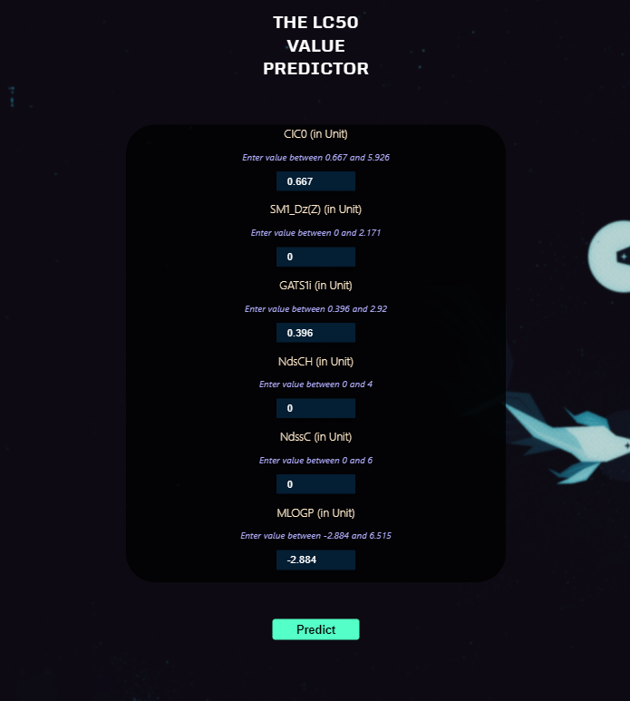

The default state encompasses default parameter values derived from the utilized dataset. Given the anomalous response of the model when confronted with unrealistic data, an input constraint is imposed to confine the values within a range consistent with scientific realism.

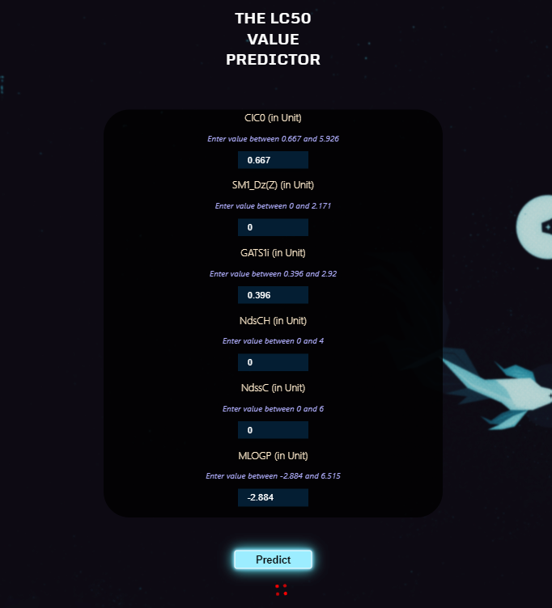**Prediction State :**

The prediction state refers to the stage in which the data input is transmitted to the backend for processing using a set of 15 models trained with cross-validation. The backend performs the prediction and returns the normalized prediction. During this process, a loader animation is displayed to indicate ongoing computation.

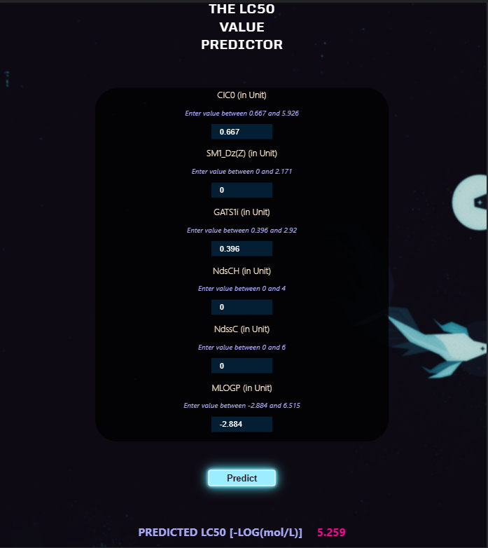**Output State:**

The output state retrieves resulted data from the backend and shows in the frontend. The loader animation is stopped and the predicted value is shown.