SUNN-CICTE Inventory Management System using Selection Sort and Trie Search
Mark.Maru/Dennis Deluna/John.Aro
123CICTE, State University of Northern Negros, Negros Occidental
mark.maru@sunn.edu.ph1, mark.maru@sunn.edu.ph1, mark.maru@sunn.edu.ph1

A B S T R A C T

The SUNN-CICTE Food Ordering System integrates Bubble Sort and Linear Search algorithms within a graphical user interface (GUI) to manage and organize food items efficiently. The system allows users to sort food items either by name or price and enables quick searching of specific items. By implementing these algorithms, the system improves the user's ability to view, search, and select items seamlessly, enhancing the overall functionality and usability of the food ordering process. |  | K E Y W O R D S  Food Ordering System, Bubble Sort, Linear Search, Sorting Algorithms, GUI

Introduction
SUNN CICTE RESTAURANT ORDERING SYSTEM

The HTML and CSS provided create a simple yet functional restaurant ordering system. It features menu items that users can browse, search, and sort. Users can select quantities of items to add to their cart and checkout to view a receipt. The system is responsive and provides a smooth user experience for mobile and desktop devices alike.

Objectives of the Study
The general objective of this study is to develop a food ordering system that allows users to view, sort, and order food items using a GUI. Specific objectives include:

- To implement the sorting of food items by name and price using Linear Search and Bubble Sort.
- To develop a system that allows users to add, update, remove, and view food items.
- To evaluate the efficiency and usability of the sorting algorithms within the food ordering context.

AT LEAST (5) Papers
Acharya, K. (2024):The proposed Online Food Ordering System simplifies food ordering by providing an updated menu for customers to select multiple items and view order details. Orders are placed in a real-time queue, updated in the database, and sent to the staff for efficient processing. This system enhances the food delivery industry by enabling quick and easy ordering, improving customer satisfaction, and increasing restaurant productivity.
Hongzhen, X., Bin, T., & Wenlin, S. (2009):This paper integrates wireless communication and web services to create a food ordering system that works over wired and wireless networks. The system supports desktop PCs and mobile devices for food orders while ensuring secure communication using web service architectures. It improves convenience, accuracy, and operational efficiency for restaurants.
Samsudin, N. A., et al. (2011):The Customizable Wireless Food Ordering System with Real-Time Feedback (CWOS-RTF) combines wireless technology and mobile devices. It allows easy menu updates, real-time customer feedback, and smart device integration for communication between customers and restaurants. CWOS-RTF addresses limitations like cost-effectiveness and lack of customization in earlier systems.
Mittal, U., et al. (2024):This study highlights issues in existing food delivery services, such as inefficiencies and fraud. It proposes a blockchain-based architecture for enhanced security and an auction-based model where delivery riders bid for orders, ensuring fairness. Machine-predicted bids prevent exploitation, improving reliability and transparency for customers, riders, and restaurants.
Anggreainy, M. S., et al. (2021):The paper addresses flaws in traditional food ordering systems, especially during the pandemic. It proposes an online ordering system for onsite food courts to enhance convenience and user experience. The system leverages scrum methodology for development and aims to modernize food ordering processes while addressing emerging challenges.

DISCUSS THE DEVELOPMENT TOOL (), CRUD operation,
searching and sorting algorithm (Show using a diagram/illustration/pseudocode)
1. Searching Algorithm: Linear Search
Linear search is a simple searching algorithm that looks for an element in a list by checking each element one by one.
Function LinearSearch(arr, target):
For i = 0 to len(arr) - 1:
If arr[i] == target:
Return i // Found the item, return the index
Return -1 // Item not found
Linear Search Example:
Consider the list of menu items (sorted alphabetically) where we want to search for the item "Pasta".
Menu Items List: ["Pizza", "Burger", "Pasta", "Soda", "Lasagna"]
Target: "Pasta"
- Start at index 0: Pizza → not a match.
- Move to index 1: Burger → not a match.
- Move to index 2: Pasta → match found, return index 2.
Linear Search Diagram:
Array: ["Pizza", "Burger", "Pasta", "Soda", "Lasagna"]
Target: "Pasta"
Step 1: Compare "Pizza" with "Pasta" (No match)
Step 2: Compare "Burger" with "Pasta" (No match)
Step 3: Compare "Pasta" with "Pasta" (Match found)
Return index 2

2. Sorting Algorithm: Bubble Sort
Bubble Sort is a simple sorting algorithm that repeatedly steps through the list, compares adjacent items, and swaps them if they are in the wrong order. The process continues until the list is sorted.
Function BubbleSort(arr):
n = len(arr)
For i = 0 to n-1:
For j = 0 to n-i-2:
If arr[j] > arr[j+1]:
Swap arr[j] and arr[j+1]
Return arr

Results and Discussion
REFERENCES

- Acharya, K. (2024). Online Food Ordering System Project Report. SSRN Electronic Journal. https://doi.org/10.2139/ssrn.4820973

- Hongzhen, X., Bin, T., & Wenlin, S. (2009). Wireless Food Ordering System Based on Web Services. Journal Name, 475–478. https://doi.org/10.1109/icicta.2009.830

- Samsudin, N. A., Khalid, S. K. A., Kohar, M. F. a. M., Senin, Z., & Ihkasan, M. N. (2011). A customizable wireless food ordering system with realtime customer feedback. Journal Name, 186–191. https://doi.org/10.1109/iswta.2011.6089405

- Mittal, U., Goyal, S., Gummana, E. P., Chamola, V., Agarwal, S., & Mathur, T. (2024). FoodBlock: A secure and cost‐optimal framework for online food ordering using blockchain. Expert Systems. https://doi.org/10.1111/exsy.13601

- Anggreainy, M. S., Setiawan, A. S., Subekti, M., Jingga, K., Noprianto, N., & Hartanto, J. (2021). Implementing Online Food Ordering System for Food Court Using Scrum Approach. Journal Name, 351–356. https://doi.org/10.1109/icsec53205.2021.9684632

Strictly follow the format of referencing by observing the proper APA style 7th Edition

APPENDIX
Appendices, if needed, appear after the references.
Figure 1. Main Dashboard
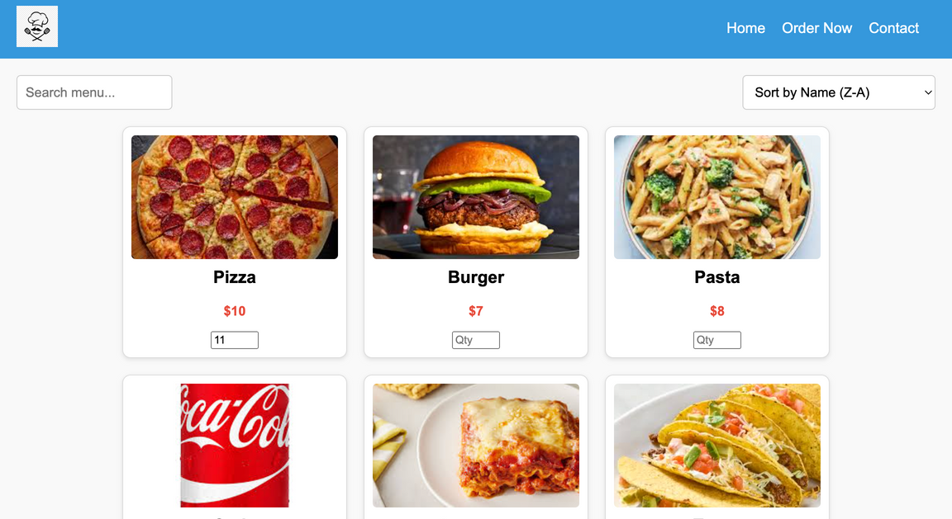

CRUD operation(Screenshot)
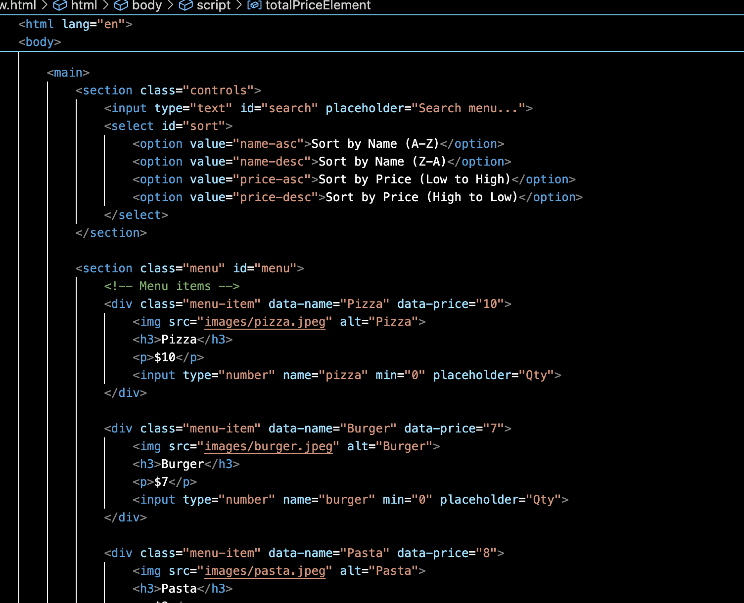

SORTING ALGORITHM( SCREENSHOT)
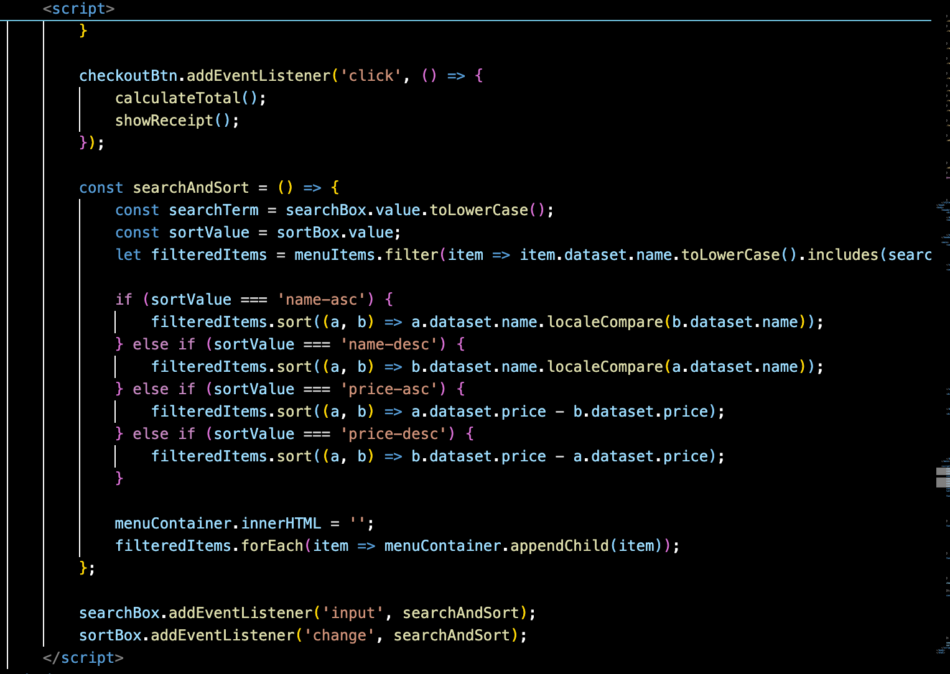

SEARCHING ALGORITHM (SCREENSHOT)

Conclusion and Recommendation
The Restaurant Ordering System aims to streamline the customer’s ordering experience by offering a simple, intuitive interface that allows users to browse a menu, customize orders, and efficiently process transactions. Through the implementation of features like dynamic cart management, search, and sorting functionality, and a detailed receipt generation system, the project enhances user experience, minimizes errors, and provides transparency throughout the ordering process.
By offering mobile responsiveness and ensuring an aesthetically pleasing and user-friendly design, the system is adaptable to various devices, ensuring accessibility for a wide range of customers. The system successfully improves the efficiency of the ordering process and provides an engaging experience that can boost customer satisfaction and loyalty.

