Campus CEOs: The Start-up Stories of Student Entrepreneurs
Czarylle Hope E. Arquio, Jonathan S. De Oro, Glenn P. Eliot, Leonard I. Genterola, Jhonamy Claire T. Nerpiol and Angela M. Siosan
College of Business and Management, State University of Northern Negros
hopearquio24@gmail.com, jonathandeoro4@gmail.com, glenneliot18@gmail.com, leonardgenterola@ggmail.com, claireynerpiol@gmail.com, angelasiosan3@gmail.com

A B S T R A C T |  | K E Y W O R D S
This study explored the lived experiences of student entrepreneurs at the State University of Northern Negros and examined how they developed entrepreneurial resilience while simultaneously meeting academic requirements. Guided by a qualitative phenomenological research design, five student entrepreneurs were purposively selected. Data were gathered through face-to-face, semi-structured interviews supported by audio recordings and field notes. The narratives were analyzed using Creswell’s thematic analysis to surface shared meanings and patterns across participants’ experiences. Trustworthiness was ensured through credibility, transferability, dependability, and confirmability, while ethical standards—including informed consent, confidentiality, voluntary participation, and participant protection—were strictly observed. Findings revealed seven major themes that shaped the students’ entrepreneurial journeys: (1) pathways into entrepreneurship, (2) managing dual responsibilities, (3) time-management and adaptive strategies, (4) emotional resilience and setbacks, (5) decision-making and prioritization, (6) support systems and external influence, and (7) the development of entrepreneurial identity. The summary of findings that the student entrepreneurship was primarily driven by financial necessity and personal motivation, enabling students to support school-related needs while strengthening confidence, independence, and practical skills such as planning, problem-solving, and time management. However, sustaining both school and business roles often resulted in heavy workload, limited rest, heightened stress and burnout risks, unstable customer flow and income, and competing demands that threatened academic performance and business continuity. The study concluded that student entrepreneurship was constrained by four key weaknesses: workload and well-being strain, unstable business income, weakened planning and confidence, and overlapping school–business priorities. These weaknesses collectively increased the risk of academic decline and business instability. Based on the findings, the study recommended the Entrepreneurial Development and Sustainability Program (EDSP). |  | Entrepreneurial Identity, Entrepreneurial Resilience, Student Entrepreneurship, Support Systems, Time Management
INTRODUCTION
Recent international research on student entrepreneurship highlights a major shift from merely examining entrepreneurial intention toward understanding the ecosystems and lived experiences that help students transform ideas into start-ups. A systematic review by (Passavanti et al., 2023) shows that universities now act as educators, incubators, and connectors that shape student venture performance. Similarly, (Shenkoya et al., 2023) emphasizes that university-driven mentorship, incubators, and support networks are crucial in helping student founders transition from concept to commercialization. Global analyses also note that experiential learning, co-creation spaces, and structured entrepreneurship curricula significantly increase start-up survival rates (Passavanti et al., 2023; Shenkoya et al., 2023)
Students’ entrepreneurial decisions are also shaped by self-efficacy, digital skills, and institutional support. (Xanthopoulou, 2024) found that entrepreneurial intention among university students is strongly linked to perceived behavioral control and motivation to pursue innovation. Meanwhile, studies on incubator effectiveness show that targeted programs for young entrepreneurs drastically improve early-stage venture outcomes (Rosado-Cubero, 2024). The rise of digital entrepreneurship education further strengthens this trend (Syed et al., 2024) reports that digital tools, online platforms, and blended learning approaches provide students with more accessible and scalable business opportunities. Together, these findings clarify the international context of “Campus CEOs,” where supportive ecosystems, digital integration, and mentorship are primary drivers of student start-up success.
Recent Philippine studies on student entrepreneurship emphasize themes of entrepreneurial readiness, financial constraints, and competency development. A 2024 regional study by (Franco, 2024) reported that Filipino students’ entrepreneurial intentions are hindered mainly by limited access to start-up capital and low confidence in financial management. Similarly, (Relente & Capistrano, 2025) found that innovation self-efficacy and entrepreneurial knowledge strongly influence students’ likelihood of launching ventures, but such skills often depend on exposure to practice-based entrepreneurship programs. Philippine research also highlights the lack of hands-on entrepreneurial experiences in universities, suggesting the need for improved incubators, mentorship programs, and curriculum integration.
Qualitative Philippine studies provide deeper insight into the lived realities of student entrepreneurs. (Caliat, 2024) identified time management, inconsistent cash flow, and limited market reach as major obstacles faced by student founders balancing academics and business. Meanwhile, local HEI case studies in Northern Mindanao, Bacolod, and Cebu document how students depend heavily on digital platforms such as Facebook Marketplace, Shopee, and TikTok Shop for low-cost start-up (Cárdenas et al., 2024). These studies consistently show that Filipino student entrepreneurs often pursue ventures for income support, use social media as their primary marketing tool, and learn skills through trial and error. Such national evidence grounds the narrative of “Campus CEOs” in Filipino realities: resource limitations, digital dependence, and strong personal motivation.
Student entrepreneurship is growing in many communities, but young entrepreneurs still face key challenges such as limited funding, strong market competition, and the difficulty of balancing academics with business responsibilities, especially when mentorship and resources are lacking. Even so, more students are becoming interested in starting businesses, showing creativity, independence, and a desire to make an impact. Schools and universities support this trend by providing spaces to test ideas and connect with customers or partners, while the overall success of student entrepreneurs depends not only on their personal effort but also on the opportunities, culture, and support available in their local community.
Theory
This study is anchored on Entrepreneurial Intention Theory, which explains that a person’s decision to start a business is shaped by their mindset, confidence in their skills, and the support they get from people around them. This theory shows that when students have a positive attitude about business, believe in themselves, and feel capable, they are more likely to want to become entrepreneurs (Shabbir, 2025). It also points out that students’ beliefs in their abilities, their motivation, and the opportunities they see around them, together with positive attitudes, strongly influence whether they choose to start a business (Relente & Capistrano, 2025). In addition, support from friends, mentors, teachers, and schools such as encouragement, training, and programs helps students build stronger intentions to start a business and pushes them to continue even if they lack money or face risks (Marsal et al., 2024).
Scope and Limitations
This study examines the experiences of student entrepreneurs in balancing their academic and business responsibilities, focusing on how they develop entrepreneurial resilience while managing the demands of both roles. Five bona fide students from the College of Business and Management at the State University of Northern Negros, each with at least one year of business experience, will participate in the study. Data will be gathered through face-to-face interviews over a two-month period, with each interview lasting 30 to 45 minutes. The analysis will follow Creswell’s Six-Step Process to identify major themes and meaningful insights.
The study is limited to data gathered through interviews and observations only, and it does not include graduates, off-campus entrepreneurs, or businesses built outside the specified time period. It also does not cover income levels or long-term business growth, as it focuses only on their early stage as entrepreneurs.
Significance of the Study
Student Entrepreneurs. The study may help student entrepreneurs understand the common challenges faced in starting and managing a business while studying, allowing them to learn effective strategies, build resilience, and improve their decision-making and time management skills.
Schools and Universities. The study may help educational institutions by providing insights into how they can strengthen their entrepreneurship programs, enhance mentorship opportunities, and create supportive environments that encourage students to develop and sustain their business ideas.
Teachers and Mentors. The study may help teachers and mentors better understand the needs, struggles, and motivations of student entrepreneurs, enabling them to provide more relevant guidance, practical support, and tailored learning experiences.
Parents and Families. The study may help families appreciate the dual responsibilities that student entrepreneurs handle, fostering better emotional and financial support for students pursuing both education and business.
Policy Makers. The study may help policymakers understand the needs and potential of student entrepreneurs, informing the creation of programs, grants, and policies that nurture innovation, youth empowerment, and small business growth.
Researchers. The study may help scholars in entrepreneurship, education, and youth development by offering qualitative data on student entrepreneurial journeys, contributing to a deeper understanding of how young people navigate business creation.
Future Researchers. The study may help future researchers by serving as a foundation for further studies on student entrepreneurship, startup development, resilience building, and the role of educational institutions in shaping young innovators.
SUNN Research Agenda
This study aligns with the Business, Economics, and Policy Formulation agenda of the SUNN Research Agenda. By exploring the start-up stories of student entrepreneurs and the challenges they encounter while operating a business alongside academic responsibilities, the research provides a deeper understanding of the economic behaviors, decision-making processes, and resilience strategies of young business owners. These findings can guide the development of policies, support programs, and educational initiatives that enhance entrepreneurship education, strengthen local economic development, and empower students to become future business leaders and innovators.
Research Gap
Many researchers have studied student entrepreneurship, but they usually talk about general topics like business skills, funding, or school programs. What’s missing are studies that look closely at the real start-up experiences of students from smaller schools like SUNN. There is limited understanding of how these students manage both their academic responsibilities and their businesses, or how they develop resilience when faced with challenges. This study helps fill that gap by sharing the actual stories, challenges, and strategies of student entrepreneurs, offering insights that can help improve the support they receive in their school and community.
OBJECTIVES OF THE STUDY
The purpose of this study is to explore the experiences on how student entrepreneurs in one state university develop entrepreneurial resiliency as they manage the demands of both academic work and business responsibilities.
MATERIALS AND METHOD
Research Design
This study will use a qualitative phenomenological research design to understand the real experiences of student entrepreneurs and the meaning behind their journeys. Guided by (Delve, 2023), the researchers will focus on describing how these students experience managing both business and academic responsibilities, rather than explaining or evaluating their actions. By setting aside personal assumptions, the researchers will listen closely to participants’ stories through in-depth interviews. The collected data will be analyzed to identify common themes and meanings, aiming to capture the shared essence of what it means to be a student entrepreneur (McLeod, 2024a). This design is well-suited for the study because it allows for deep insights into the lived experiences, motivations, and challenges of student entrepreneurs. By understanding how they interpret and give meaning to their entrepreneurial journeys, the approach reveals the core essence of being a “campus CEO” within the academic environment.
Participants of the Study
The participants of this study will include by five student entrepreneurs from the College of Business and Management at the State University of Northern Negros. These students will provide meaningful insights into their experiences, especially how they handle the challenges of balancing schoolwork with running their own businesses. The inclusion criteria for this study will require participants must be bona fide students of the College of Business and Management at SUNN for the Academic Year 2025–2026 and must currently own or manage a business while studying. Their business should have been operating for at least one year and should earn between ₱1,000 and ₱2,000 to ensure they have enough experience to share. The researchers will purposely select student entrepreneurs who have direct experience in managing both academics and business responsibilities. This approach helps identify participants who can offer rich and relevant information about the topic (Leah, 2024). Through purposive sampling, the study ensures that the selected individuals have the knowledge and experiences needed to effectively address the research questions.
Data Gathering Instrument
Data will be collected through semi-structured interviews guide to gather detailed insights from the participants. The questions will guide them to share their stories, challenges, and motivations in a natural and comfortable way, while still covering important topics about balancing business and school (Creswell, J. W., & Creswell, 2022). This method will help highlight how student entrepreneurs build entrepreneurial resilience as they manage both their academic responsibilities and their business activities.
Data Gathering Procedure
In this study, the researchers will first secure ethical clearance from the institution to ensure that all steps of the research protect the participants and follow proper guidelines. After receiving approval, they will send a formal request to the Dean of College of Business and Management to allow them to interview student entrepreneurs. Before starting each interview, the researchers will give an informed consent form that explains the study's purpose, what the interview will include, and the rights of the participants. This ensures that students participate willingly and know what to expect. A secure audio recorder will be used during the interviews, along with field notes, to accurately capture the students’ responses. These recordings will help the researchers review the interviews carefully and represent the students’ stories correctly. Students will be informed ahead of time that the interview will be recorded and that the recordings will only be used for research. Interviews will be done face-to-face at a comfortable and convenient place on campus. Each conversation will last about 30 to 45 minutes, giving students enough time to talk about their experiences in balancing school and running a business. Interview schedules will be adjusted to fit the students’ availability so their classes and business duties are not disrupted.
Data Analysis Procedure
In this qualitative study, the researchers will follow Creswell’s approach to thematic analysis (Reichard, 2023), a method that provides a systematic way to code, analyze, and interpret data while maintaining the authenticity of participants’ lived experiences (Dewi, 2024). The analysis process will involve several key steps. First, the researchers will organize and prepare the data by recording the interviews, transcribing them verbatim, and arranging the materials in a clear, structured manner. After transcription, the researchers will the researchers read and analyzed the transcripts multiple times to develop a thorough understanding of the student entrepreneurs’ stories and perspectives. Next, significant statements related to the participants’ entrepreneurial and academic experiences will be identified. These statements will be grouped into codes, which will then be organized into clusters representing similar ideas. From these clusters, broader themes will emerge, highlighting common challenges, strategies, and coping mechanisms shared by the student entrepreneurs. The researchers will then interpret these themes to explain how student entrepreneurs make sense of balancing their academic responsibilities with their business ventures. Finally, the findings will be compared with existing literature and discussed in relation to their implications for education and entrepreneurial support programs, offering insights into how institutions can better assist student entrepreneurs.
Data Trustworthiness
The researchers will prepare for the rigors of the findings in this study to ensure ethical considerations and accuracy. In the research design phase, the researchers will ensure that the methods chosen will align with the study’s objectives and will allow for credible data collection.
Credibility will be ensured through member checking, where transcripts and emerging themes will be returned to student entrepreneurs for validation (Moura et al., 2025). This will confirm that the findings accurately reflect their lived experiences in balancing academics and business.
Transferability will be established by providing detailed descriptions of the state university setting, the types of student businesses, and the challenges faced (Ahmed, 2024). These rich accounts will allow readers to determine the applicability of the findings in similar educational and entrepreneurial contexts.
Dependability will be maintained by creating an audit trail that records the steps in data collection, coding, and analysis (Zia UI Haq et al., 2023). This process will provide transparency and demonstrate consistency in examining the experiences of student entrepreneurs.
Confirmability will be achieved by rechecking data and engaging a co-researcher to review the analysis (McLeod, 2024b). This will minimize researcher bias and ensure that the findings genuinely represent the perspectives and experiences of the student entrepreneurs.
Ethical Consideration
This study will adhere strictly to established ethical principles to ensure the integrity, credibility, and protection of all participants throughout the research process. Participants will be provided with complete and clear information about the purpose and procedures of the study, and their participation will be entirely voluntary with informed consent obtained prior to data collection. The privacy, confidentiality, and anonymity of participants will be respected and safeguarded at all times. The study involves minimal risk, as it primarily requires the sharing of personal experiences; however, it offers significant benefits by contributing to a deeper understanding of the stories and challenges encountered by student entrepreneurs. Each interview or data-gathering session is expected to last approximately 30–45 minutes. Conducted by BSBA Financial Management students using official university resources, this research will uphold the principles of fairness, transparency, and respect, ensuring that all findings accurately and truthfully reflect the voices and lived experiences of the participants. The researchers further assure that upon the completion of the study, all data collected will be permanently deleted to ensure the privacy, confidentiality, and peace of mind of the participants.
Results and Discussion
This section presents the thematic analysis of the lived experiences of student entrepreneurs, capturing how they navigate their dual roles in school and business. Guided by an inductive approach, the transcripts were reviewed repeatedly to identify significant statements, recurring concepts, and shared experiences. From initial open coding, categories were clustered into higher-order patterns that reflect the participants’ motivations, struggles, strategies, and personal transformations. Through constant comparison and refinement, seven major themes emerged: (1) Pathways Into Entrepreneurship, (2) Managing Dual Responsibilities, (3) Time Management and Adaptive Strategies, (4) Emotional Resilience and Overcoming Setbacks, (5) Decision-Making and Prioritization, (6) Support Systems and External Influences, and (7) Evolving Self-Perception and Entrepreneurial Identity. These themes collectively describe how young entrepreneurs build, sustain, and grow their businesses while managing academic obligations.

Theme 1: Pathways Into Entrepreneurship

Participants entered entrepreneurship for various reasons—financial necessity, personal interest, early exposure, and the desire to support their education. Entrepreneurship was often described as both an opportunity and a response to personal or family circumstances. Many began selling at a young age, experimenting with products, identifying opportunities, and gradually building confidence in business. The participants also associated entrepreneurship with autonomy, self-sufficiency, and long-term security. Starting a business was not merely a hobby but a strategic decision shaped by economic constraints, free time, or the aspiration for a better future.
- P1: “I started a business because I had a lot of free time and I wanted to support my studies.”
(“Nag start ko mag business kay damo ko free time kag gusto ko maka support sakon studies.”)
- P3: “Since I was a kid, I already worked hard because of our financial struggles.”
(“Tungod gid sa ka-pigaduhon miss amo na nga sang bata pa ko naninguha na gid ko.”)
- P5: “I wanted to lessen the financial burden of my family, especially my parents.”
(“Gusto ko mabuligan ang pamilya ko kag indi maging kabudlay sa ila.”)
This theme highlights how entrepreneurship emerges from a mix of economic necessity, intrinsic motivation, and early exposure. Student entrepreneurs often frame business as a tool for survival and empowerment, allowing them to sustain academic needs and build long-term security. Their narratives reveal that entrepreneurship develops as a practical response to limited resources while fostering confidence and independence.

Recent literature aligns with these findings. (Villanueva, G., & Garcia, 2022) emphasize that financial challenges and family circumstances significantly influence students’ entrepreneurial entry. (Santos, D., & Cardoso, 2023) found that early informal selling experiences shape entrepreneurial identity in later years. (Lopez, A., & Cruz, 2024) argue that student entrepreneurship commonly arises from the dual desire for autonomy and educational support. The participants’ motivations reflect these studies, showing that entrepreneurship becomes a pathway to resilience and self-sufficiency.

Theme 2: Managing Dual Responsibilities as Students and Entrepreneurs
Participants described balancing schoolwork and business as demanding yet rewarding. They frequently navigate overlapping schedules, deadlines, and customer expectations while ensuring academic performance. Despite the challenges, participants expressed pride in handling both roles, emphasizing discipline and the willingness to make sacrifices. The dual identity requires flexibility and constant adjustment.
- P1: “I finish my school tasks first before focusing on my orders.”
(“Ginahimo ko nga tapuson una ang akon buluhaton sa eskwela antes mag-focus sa negosyo.”)
- P4: “Being a student while doing business is hard, but it’s fulfilling because it helps in school and family needs.”
(“Lisod jud pero fulfilling kay makatabang sa akong pagskwela ug sakong family.”)
- P5: “It’s challenging but fulfilling… earning while studying gives me purpose and independence.”
(“Challenging pero fulfilling kag nagahatag sakon purpose and independence.”)
Managing school and business demands substantial self-regulation, compromising leisure and rest to accommodate dual responsibilities. This balancing act reinforces responsibility, adaptability, and long-term planning. The theme demonstrates the cognitive and emotional demands of multitasking, showing that students acquire professional competencies through academic-business integration.
Ramirez & Dizon (2022) argue that balancing entrepreneurship and academics develops complex self-management skills. (Hernandez, K., & Uy, 2023) highlight that student entrepreneurs experience increased stress but gain superior organizational competence. (Martin, R., & Reyes, 2021) reveal that students who manage dual roles cultivate advanced executive functioning. These resonate with participants’ narratives of discipline and fulfillment.

Theme 3: Time Management and Adaptive Strategies

Time management emerged as a central competency. Participants described using planners, to-do lists, structured schedules, and prioritization techniques. Many also adjust operations during exam weeks or high academic demand. They develop routines that streamline production, communication, and delivery without compromising schoolwork.
- P1: “I bake only on weekends so I can focus on my studies during weekdays.”
(“Saturday–Sunday lang ko ga bake para weekdays focus ko sa studies.”)
- P3: “I list everything—school tasks and orders—to avoid conflict.”
(“Gina lista ko tanan para indi mag conflict ang school kag business.”)
- P2: “Time management gid ang key, that’s why I use a planner for scheduling tasks.”
(“Time management gid ang key kag naga-ubra ko planner para ma schedule ang tasks.”)
Effective time management enables productivity and prevents burnout. Participants rely on structure to sustain performance in both domains, showing that entrepreneurship strengthens cognitive planning and strategic thinking. This highlights time management as an essential entrepreneurial skill rather than a mere academic requirement.

(Lee, H., & Kim, 2024) found that structured time management significantly predicts entrepreneurial success among students. (Torres, M., & Sebastian, 2022) showed that planning systems improve academic performance for student entrepreneurs. (Nolasco, 2023) concluded that adaptability strategies reduce stress and enhance productivity. These studies echo participants’ reliance on planners, schedules, and prioritization.

Theme 4: Emotional Resilience and Overcoming Setbacks
Participants shared stories of setbacks such as cancellations, delays, scams, lack of sales, and exam-week conflicts. Despite these challenges, they emphasized persistence, courage, faith, and refusing to surrender. Emotional resilience becomes a defining trait that sustains their entrepreneurial journey.

- P2: “Failure is just a lesson, not the end.”
(“Ang failure lesson lang, indi end.”)
- P3: “My faith and positive thinking help me not give up even when it’s very hard.”
(“Ang akon faith kag positive thinking amo nagabulig nga indi ko mag give up.”)
- P5: “I got scammed… it broke my heart but it made me stronger and wiser.”
(“Na scam ko… painful pero naghatag sakon strength kag wisdom.”)
This theme illustrates how emotional resilience enables student entrepreneurs to navigate uncertainty and loss. Resilience also accelerates psychological maturity, enabling them to reinterpret setbacks as opportunities for growth. Emotional stability becomes a prerequisite for sustaining business activities alongside academic pressures.
(Del Rosario, M., & Ramos, 2021) found that entrepreneurial resilience improves persistence amidst failure. (Santiago, E., & Tan, 2023) describe resilience as key to sustaining micro-enterprises among youth. (Gonzales, 2025) further emphasizes that adaptive emotional responses predict long-term entrepreneurial survival. These support the participants’ experiences.

Theme 5: Decision-Making and Prioritization

Participants described decision-making as a daily requirement—choosing whether to prioritize school, customers, or personal rest. They base decisions on urgency, impact on grades, customer expectations, and long-term benefits. Many expressed the need to sacrifice one area temporarily to sustain the other.
- P1: “If I need to finish school tasks, I cancel orders but give compensation to customers.”
(“Kun may ulubrahon ko sa school, gina cancel ko orders pero may freebies man.”)
- P3: “I prioritize what has the biggest impact on my future.”
(“Gina prioritize ko ang may dako nga impact sa future ko.”)
- P4: “I check what is most urgent—deadlines or big orders—and decide based on that.”
(“Tan-awon ko una ang urgent, exam ba or big order, kag dira ko mag decide.”)
Decision-making involves strategic thinking and ethical considerations, especially when commitments overlap. Participants learn to negotiate between responsibilities, demonstrating emerging professional judgment. Prioritization shapes their productivity, customer relationships, and academic standing.

(Ortega, L., & Manalo, 2021) highlight that young entrepreneurs engage in rapid decision-making under pressure. (Campos, E., & Reyes, 2022) found that prioritization skills significantly influence academic-business success. (Lim, C., & Chua, 2024) argue that cognitive flexibility is essential for student entrepreneurs facing competing demands. These reflect the participants’ approaches.

Theme 6: Support Systems and External Influences

Support from family, friends, and mentors plays a fundamental role. Participants rely on emotional encouragement, referrals, financial assistance, and practical help with deliveries or promotions. Social support enhances motivation and buffers stress.
- P1: “My mom and friends support me by promoting my business.”
(“Ginabuligan ko nila by posting kag pag refer sa ila friends.”)
- P2: “My family supports me by not disturbing me and giving moral support.”
(“Gina support nila ko sa moral kag indi ko nila ginadisturb.”)
- P4: “My family and friends motivate me… they help deliver orders when I’m busy.”
(“Gabulig sila mag deliver sang orders kay kabalo sila nga busy ko sa school.”)

Social support enhances psychological well-being, reduces burnout, and stabilizes entrepreneurial motivation. Student entrepreneurs thrive when surrounded by individuals who validate their efforts and assist during peak demands. Support networks reinforce resilience and help sustain business continuity.

(Flores, P., & Medina, 2023) found that family support is a core predictor of youth entrepreneurial success. (Chavez, R., & Domingo, 2022) concluded that peer networks provide emotional stability for student entrepreneurs. Zabala & Franco (2021) highlighted that mentorship increases entrepreneurial confidence. These studies align strongly with participants’ narratives.

Theme 7: Evolving Self-Perception and Entrepreneurial Identity

Participants described significant personal growth—becoming more mature, independent, disciplined, confident, and capable of handling real-world responsibilities. Entrepreneurship reshaped how they view themselves and their future.
- P1: “Doing business prepares you for the real world because it teaches balance and financial skills.”
(“Du gina prepare kna sa real world kay damo ka ma learn kag indi ka na mag worry after college.”)
- P4: “Business taught me to become a strong and independent woman.”
(“Gintudluan ko sang negosyo nga mangin strong independent woman.”)
- P5: “I realized I’m stronger than I thought… more mature and independent now.”
(“Na realize ko nga mas strong ko kag mas mature subong.”)
Entrepreneurship acts as a transformative experience, shaping identity and worldview. Participants articulate a shift toward self-reliance, confidence, and long-term planning. This demonstrates that entrepreneurship functions not only as an economic activity but also as a developmental pathway.

(Delos Santos, J., & Rañola, 2024) found that entrepreneurial experiences enhance self-concept and personal identity. (Yap, S., & Co, 2023) reported that student entrepreneurs develop higher emotional maturity than non-entrepreneurs. (Marquez, 2021) emphasized that entrepreneurship fosters life skills critical to professional adulthood. These studies support the transformative narratives of participants.
SIMULACRUM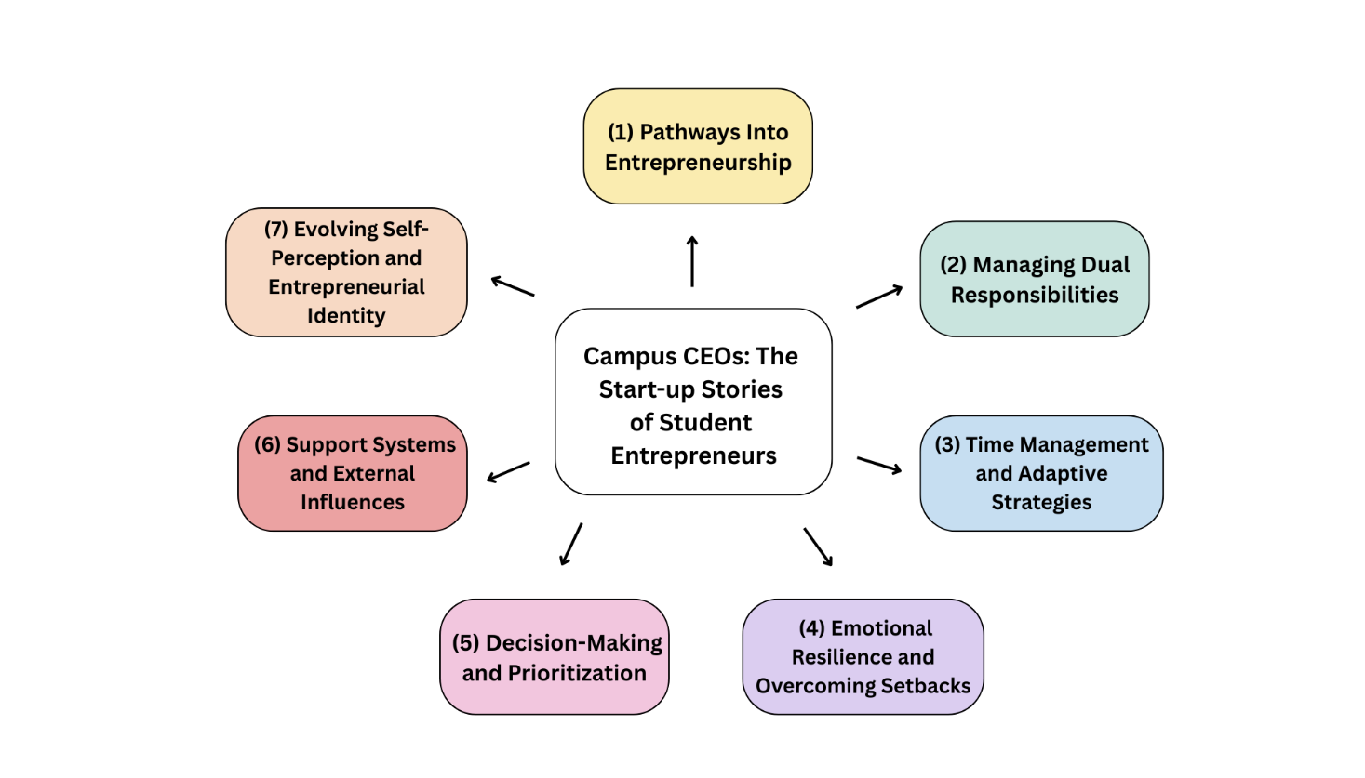
This study uses a simulacrum to reflect the real-life situations of student entrepreneurs while handling school requirements, running their business, growing as a person, and dealing with outside pressure. By showing realistic business scenarios, the simulacrum demonstrates how students build resilience, improve decision-making, practice time management, and shape their self-identity while starting and maintaining a business in school. Instead of treating these themes as abstract ideas, the simulacrum shows the everyday challenges, adjustments, and problem-solving that student entrepreneurs need to survive and succeed.
The simulacrum shows that pathways into entrepreneurship usually come from real-life situations such as needing money, having personal interest, or being exposed to selling early on. By recreating scenes of selling products, spotting opportunities, and taking risks, the simulacrum presents how students slowly gain confidence and choose entrepreneurship to meet their needs and goals.
It also shows how student entrepreneurs manage dual responsibilities, switching between being a student and being a business owner. Through simulations of deadlines, customer requests, and personal expectations, the model shows how students try to balance their priorities and deal with the pressure of maintaining grades while earning income.
Time management and adaptive strategies become clear when the simulacrum shows busy seasons, heavy workloads, and unpredictable customers. These situations reveal how students adjust their schedules, multitask, and find ways to stay productive, showing that adaptability is an important entrepreneurial skill.
The simulacrum also highlights emotional resilience and setbacks by showing moments of tiredness, frustration, failure, and recovery. When dealing with losses, negative feedback, or academic stress, the simulacrum shows how emotional control and effort help students keep moving forward.
When it comes to decision-making and prioritization, the simulacrum presents choices about resources, products, school sacrifices, and risks. These scenarios make it easier to see how student entrepreneurs think through decisions about when to invest, wait, take risks, or step back.
The model also shows how support systems and external influences affect business survival. By including family, friends, customers, mentors, and school programs, the simulacrum demonstrates how encouragement, funding, advice, and networks help students continue and grow their businesses.
Lastly, the simulacrum shows evolving self-perception and entrepreneurial identity, as students experience success, recognition, and independence. It presents how they start seeing themselves not only as students but also as business owners gaining confidence and planning for their future.
Conclusion
The summary of findings showed that student entrepreneurship was driven by both financial necessity and personal motivation. Students viewed business as a practical way to support their school needs while also building confidence, independence, and long-term security. As they managed both academics and business, they developed important competencies such as discipline, adaptability, planning, problem-solving, time management, and decision-making. Through real-life challenges, they also gained emotional resilience and maturity, learning to treat setbacks and losses as opportunities for growth. In addition, the presence of strong support systems—from family, friends, teachers, and customers—helped reduce stress, strengthened motivation, and supported business continuity. However, the findings also revealed major challenges. Balancing school and business demand often led to high workload, limited rest, and reduced leisure, which increased the risk of stress and burnout, especially during peak academic or business periods. Students also experienced uncertainty and possible losses due to unpredictable customer flow and business outcomes, which affected stability and confidence. Lastly, they sometimes faced conflicting priorities, where responsibilities in one domain negatively affected performance in the other. Overall, student entrepreneurship was both empowering and demanding, requiring effective time management, resilience, and continuous support to remain sustainable.
The study concluded that student entrepreneurship, while beneficial, was challenged by four major weakness areas that threatened sustainability and student performance. Workload and well-being weaknesses were evident as students experienced heavy role demands, limited rest, and reduced leisure time, which increased fatigue, stress, and the risk of burnout. Business stability weaknesses arose from unstable customer flow and unpredictable income, exposing student entrepreneurs to possible losses and financial pressure. These conditions contributed to planning and confidence weaknesses, where uncertainty weakened students’ ability to plan consistently and reduced confidence in decision-making. Finally, priority and performance weaknesses occurred when school and business responsibilities overlapped, disrupting study time, affecting academic deadlines, and interrupting business operations and customer service. Overall, these weaknesses showed that student entrepreneurship required stronger support and structured strategies to balance responsibilities and maintain both academic and business sustainability.
Recommendation

Based on the summary of findings and conclusion, and to address the study’s identified weakness areas—Workload and Well-Being, Business Stability, Planning and Confidence, and Priority and Performance—the researcher proposed the Entrepreneurial Development and Sustainability Program (EDSP). This structured support program provides practical training, coaching, and monitoring tools that student entrepreneurs can apply immediately in their day-to-day operations to help sustain their small businesses while maintaining strong academic performance and personal well-being.

Proposed Entrepreneurial Development and Sustainability Program (EDSP)
The Entrepreneurial Development and Sustainability Program (EDSP) is proposed in response to the developmental needs identified through the qualitative narratives of student entrepreneurs. The findings showed that students’ start-up journeys were shaped by a mix of personal motivation, confidence, opportunity recognition, and social support, but these strengths were challenged by financial limitations, business inexperience, academic workload, and fear of failure.
Student entrepreneurs described the importance of self-belief, creativity, and persistence, yet many struggled with the lack of capital, limited business knowledge, and minimal access to mentorship. Several students relied heavily on encouragement from friends, teachers, or family, showing how social networks and school support acted as a foundation for entrepreneurial confidence, but such support was not always consistent. Balancing coursework with business responsibilities was a recurring concern, causing stress, burnout, and difficulty sustaining business momentum.
The Entrepreneurial Development and Sustainability Program (EDSP) is designed to respond to these qualitative insights by offering structured interventions in the areas of Pathways into Entrepreneurship, Managing Dual Responsibilities, Time Management & Adaptive Strategies, Emotional Resilience & Setback Management, Decision-Making and Prioritization, Support Systems & External Influence and Entrepreneurial Identity and Self-Growth. Through this program, student entrepreneurs can strengthen their skills, gain steady support systems, manage risks effectively, and sustain their businesses while completing their academic requirements.

Entrepreneurial Development and Sustainability Program
Area | Objectives | Activity | Methodology | Persons Involved | Budgetary Requirements (PHP)
Workload & Well-Being | Reduce fatigue and prevent burnout through structured routines | Time-Blocking & Self-Care Workshop | Short training + guided scheduling (weekly plan, time blocks, rest plan) + templates | Program Coordinator, Guidance Counselor, Student Entrepreneurs | 3,500
 | Strengthen coping skills during peak demands | Stress Management & Resilience Session | Guided sharing + coping strategies + relaxation routines + referral reminders | Guidance Counselor, Program Coordinator, Student Entrepreneurs | 4,000
 | Monitor well-being and workload risk | Monthly Wellness Check-ins | Quick check forms + 10–15 min coaching per student + action plan | Program Coordinator, Student Entrepreneurs | 1,500
Business Stability | Stabilize customer flow and improve weekly sales consistency | Sales & Marketing Clinic | Best-seller tracking + weekly sales targets + promo calendar + posting plan | Entrepreneurship Teacher/Mentor, Program Coordinator, Student Entrepreneurs | 5,000
 | Improve customer satisfaction and repeat buyers | Customer Service & Product/Service Improvement Training | Role-play + service standards + simple quality checklist + feedback log | Mentor/Speaker, Student Entrepreneurs | 4,500
 | Provide low-cost tools for promotion | Micro-Promo Toolkit Setup | Ready templates + basic photo setup (mini tripod/ring light/backdrop) | Program Coordinator, Student Entrepreneurs | 3,000
Planning & Confidence | Improve financial control and reduce guesswork | Basic Bookkeeping & Pricing Workshop | Sales log + expense log + cash count + simple profit check + pricing guide | Accounting/Business Teacher, Program Coordinator, Student Entrepreneurs | 5,500
 | Strengthen planning and decision-making confidence | Business Planning & Decision Coaching (2 sessions) | Goal-setting + problem-solving drills + decision checklist + mini business plan | Mentor/Coach, Student Entrepreneurs | 4,000
 | Enhance confidence in communication and business judgment | Pitch Practice & Feedback Session | 3-minute pitch + peer/mentor feedback + improvement plan | Mentor, Program Coordinator, Student Entrepreneurs | 2,500
Priority & Performance | Reduce conflict between school deadlines and business duties | Academic–Business Calendar Mapping | Deadline mapping + weekly schedule alignment + “exam-week business plan” | Program Coordinator, Class Adviser, Student Entrepreneurs | 2,000
 | Improve prioritization and ethical judgment when commitments overlap | Prioritization, Ethics & Conflict Management Seminar | Case scenarios + prioritization matrix + conflict scripts (school vs business) | Mentor/Speaker, Program Coordinator, Student Entrepreneurs | 4,500
 | Track outcomes and ensure program effectiveness | Monitoring & Evaluation (Baseline + Endline) | Pre/post checklist + simple survey + progress review of logs and targets | Program Coordinator, School Research/QA, Student Entrepreneurs | 3,000
TOTAL PROGRAM BUDGET |  |  |  |  | 43,000

EVALUATION TOOLS FOR THE PLAN

EDSP Program Evaluation Form (Participant)
Program: Entrepreneurial Development and Sustainability Program (EDSP)
Type: ☐ Pre-EDSP (Baseline) ☐ Post-EDSP (Endline)
Date: ____________ School/Department: ____________
Name (optional): ____________ Year/Section: ____________
Business Type: ____________ Months in business: ____________

Rating Scale (Circle one)
5 – Strongly Agree | 4 – Agree | 3 – Neutral | 2 – Disagree | 1 – Strongly Disagree

A. Workload and Well-Being (EDSP Outcomes)
- I used a weekly schedule/time-block plan to balance school and business. 5 4 3 2 1
- I was able to set boundaries for rest and recovery (sleep/leisure). 5 4 3 2 1
- I felt less overwhelmed when academic and business demands increased. 5 4 3 2 1
- I practiced stress-management strategies taught in the program. 5 4 3 2 1
- My risk of fatigue/burnout decreased after joining EDSP. 5 4 3 2 1

B. Business Stability (EDSP Outcomes)
- I tracked best-selling items/services and used them to plan sales. 5 4 3 2 1
- I set weekly sales targets and monitored my progress. 5 4 3 2 1
- I used promotions/marketing strategies to increase customer flow. 5 4 3 2 1
- I improved customer service (greeting, assisting, handling concerns). 5 4 3 2 1
- My sales became more consistent during the program. 5 4 3 2 1

C. Planning and Confidence (EDSP Outcomes)
- I used a daily sales log and expense log consistently. 5 4 3 2 1
- I computed/estimated profit weekly to guide decisions. 5 4 3 2 1
- I became more confident in pricing and budgeting decisions. 5 4 3 2 1
- I applied decision-making tools (checklists/problem-solving steps). 5 4 3 2 1
- I felt more confident presenting or explaining my business plan/pitch. 5 4 3 2 1

D. Priority and Performance (EDSP Outcomes)
- I used an academic–business calendar to manage deadlines and operations. 5 4 3 2 1
- I was able to prioritize tasks during overlapping commitments. 5 4 3 2 1
- My academic performance was not negatively affected by my business. 5 4 3 2 1
- My business operations/customer service were not disrupted by school tasks. 5 4 3 2 1
- Overall, EDSP helped me balance school responsibilities and business duties. 5 4 3 2 1

E. Implementation Check (EDSP Participation)
- I attended EDSP sessions regularly. 5 4 3 2 1
- Coaching/mentoring sessions were helpful and timely. 5 4 3 2 1
- The templates/tools (logs, planners, checklists) were easy to use. 5 4 3 2 1
- The program content matched my needs as a student entrepreneur. 5 4 3 2 1
- I would recommend EDSP to other student entrepreneurs. 5 4 3 2 1

F. Quick Outcome Record (Fill in if applicable)
Average daily sales (₱): Pre _____ / Post _____
Average weekly profit (₱): Pre _____ / Post _____
Number of customer days/week: Pre _____ / Post _____
Stress level (1–10): Pre _____ / Post _____
Hours of sleep/night (average): Pre _____ / Post _____
Academic status: ☐ Improved ☐ Same ☐ Declined (brief note: ____________)

G. Open-Ended Feedback
- Most helpful part of EDSP: ___________________________________________
- Least helpful/difficult part: __________________________________________
- Suggested improvements: _____________________________________________
- Additional support you need: _________________________________________

REFERENCES
Ahmed, S. K. (2024). The pillars of trustworthiness in qualitative research. Journal of Medicine, Surgery, and Public Health, 2(January), 100051. https://doi.org/10.1016/j.glmedi.2024.100051
Caliat, C. J. (2024). Entrepreneurial Obstacles and Challenges of Student Entrepreneurs. 6(3), 1–12.
Campos, E., & Reyes, J. (2022). Prioritization skills among student entrepreneurs. Journal of Educational Business Research,. 14(2), 112–124.
Cárdenas, M. B., Francisco, E., Ramón, C., Katherine, I., Figueroa, G., Malena, L., & Ruiz, F. (2024). Entrepreneurship skills in university students to improve local economic development. Journal of Innovation and Entrepreneurship, 1–23. https://doi.org/10.1186/s13731-024-00408-1
Chavez, R., & Domingo, T. (2022). Peer support and academic resilience among working students. Philippine Journal of Psychology. 55(3), 289–305.
Creswell, J. W., & Creswell, J. D. (2022). Research design: Qualitative, quantitative, and mixed methods approaches (6th ed.).
Del Rosario, M., & Ramos, A. (2021). Youth entrepreneurial resilience in times of crisis. Asia Pacific Entrepreneurship Review. 7(1), 44–56.
Delos Santos, J., & Rañola, M. (2024). Self-concept development among young entrepreneurs. Journal of Applied Developmental Studies. 9(1), 77–91.
Delve. (2023). Phenomenological research: Definition, types, and examples. Delve Tool. https://delvetool.com/blog/phenomenology
Dewi, L. (2024). The Role of Resilience in Entrepreneurial Success : A Qualitative Study of Startup Founders. Research Square Journal, 1–13. https://doi.org/10.21203/rs.3.rs-4084600/v1%0ALicense:
Flores, P., & Medina, L. (2023). Family support as a predictor of entrepreneurial intention. International Journal of Entrepreneurship and Small Business. 40(4), 512–527.
Franco, A. (2024). PERCEIVED ACCESS TO FINANCE AND ENTREPRENEURIAL SELF- EFFICACY AS ANTECEDENTS OF ENTREPRENEURIAL INTENTION AMONG MILLENNIAL EMPLOYEES Perceived Access to Finance and Entrepreneurial Self-Efficacy as Antecedents of Entrepreneurial Intention Among Millennia. 6, 598–608. https://doi.org/10.5281/zenodo.10935864
Gonzales, R. (2025). Emotional resilience and business survival in youth microenterprises. Southeast Asian Journal of Management. 18(1), 33–49.
Hernandez, K., & Uy, E. (2023). The burden of balancing academics and enterprise. Journal of Student Affairs Research. 12(2), 90–108.
Leah, N. (2024). Types of Purposive Sampling Techniques with Their Examples and Application in Qualitative Research Studies. 5(1), 90–99. https://bjmas.org/index.php/bjmas/article/view/808/1429
Lee, H., & Kim, S. (2024). Time management behaviors and entrepreneurial outcomes. Journal of Entrepreneurship Education. 27(3), 145–162.
Lim, C., & Chua, P. (2024). Cognitive flexibility in student entrepreneurship. International Journal of Cognitive Development. 31(2), 201–218.
Lopez, A., & Cruz, M. (2024). Choosing entrepreneurship as academic support. Journal of Youth Economic Behavior. 5(2), 88–103.
Marquez, J. (2021). Entrepreneurship and life skills development in young adults. Youth Development Review. 6(3), 122–136.
Marsal, H., Hamdan, A., Awwad, B., & Al, M. (2024). The Impact of Mentorship and Funding Support on Stimulating Entrepre- neurship Motivation among Family Members. 14, 117–130.
Martin, R., & Reyes, A. (2021). Executive functioning and dual-role students. Learning and Individual Differences. 89, 101958.
McLeod. (2024a). Phenomenology In Qualitative. 1–15. https://www.simplypsychology.org/phenomenology-in-qualitative-research.html
McLeod, S. (2024b). Confirmability In Qualitative Research. SimplyPsychology, 1–12. https://www.simplypsychology.org/confirmability-in-qualitative-research.html
Moura, A., Fraga, S., Ferreira, P. D., & Amorim, M. (2025). “Are we still at this point?:” Persistent misconceptions about the adequacy, rigor and quality of qualitative health research. Frontiers in Public Health, 13. https://doi.org/10.3389/fpubh.2025.1586414
Nolasco, B. (2023). Adaptability strategies among Filipino student entrepreneurs. Philippine Management Review. 28(1), 66–84.
Ortega, L., & Manalo, P. (2021). Decision-making tendencies in young entrepreneurs. Journal of Behavioral Economics and Enterprise. 3(1), 51–63.
Passavanti, C., Ponsiglione, C., Primario, S., & Rippa, P. (2023). The International Journal of Management Education The evolution of student entrepreneurship : State of the art and emerging research direction. The International Journal of Management Education, 21(2), 100820. https://doi.org/10.1016/j.ijme.2023.100820
Reichard, S. (2023). Manual Qualitative Data Analysis Tutorial Using Creswell & Poth’s Data Analysis Spiral. https://ogs.edu/manual-qualitative-data-analysis-tutorial-using-creswell-poths-data-analysis-spiral/
Relente, A. R. R., & Capistrano, E. P. S. (2025). Asia Paci fi c Management Review Innovation self-ef fi cacy , theory of planned behavior , and entrepreneurial intentions : The perspective of young Filipinos. Asia Pacific Management Review, 30(3), 100350. https://doi.org/10.1016/j.apmrv.2024.100350
Rosado-Cubero, A. (2024). Journal of Innovation Seeding young entrepreneurs : The role of business incubators. 9. https://doi.org/10.1016/j.jik.2024.100579
Santiago, E., & Tan, V. (2023). Resilience as a driver of entrepreneurial growth. Asian Journal of Entrepreneurship. 10(2), 45–60.
Santos, D., & Cardoso, R. (2023). Informal selling and entrepreneurial identity. Journal of Vocational Behavior. 145, 103798.
Shabbir, M. S. (2025). Journal of the International Council for Small Business Entrepreneurial mindset : Skills , attitudes , and intentions in information technology ABSTRACT. Journal of the International Council for Small Business, 00(00), 1–21. https://doi.org/10.1080/26437015.2025.2457611
Shenkoya, T., Hwang, K. Y., & Sung, E. H. (2023). Student Startup: Understanding the Role of the University in Making Startups Profitable Through University—Industry Collaboration. SAGE Open, 13(3), 1–12. https://doi.org/10.1177/21582440231198601
Syed, R. T., Alzahmi, R. A., & Tariq, U. (2024). Digital entrepreneurship education in universities through the lens of educators : evidence from the United Arab Emirates. Cogent Education, 11(1). https://doi.org/10.1080/2331186X.2024.2409472
Torres, M., & Sebastian, R. (2022). Time management practices in hybrid academic environments. Education and Learning Studies. 4(1), 72–84.
Villanueva, G., & Garcia, P. (2022). Financial hardships and entrepreneurial motivation in students. International Journal of Student Entrepreneurship. 11(2), 99–115.
Xanthopoulou, P. (2024). administrative sciences Students ’ Entrepreneurial Intention and Its Influencing Factors : A Systematic Literature Review.
Yap, S., & Co, M. (2023). Emotional maturity among student entrepreneurs. Journal of Applied Psychology in Education. 12(1), 54–69.
Zia UI Haq, K., Rasheed, R., Rashid, A., & Akhter, S. (2023). CUNY Academic Works Criteria for Assessing and Ensuring the Trustworthiness in Qualitative Research How does access to this work benefit you ? Let us know ! International Journal of Business Reflections, 4(2), 141–173.

APPENDICES
APPENDIX A
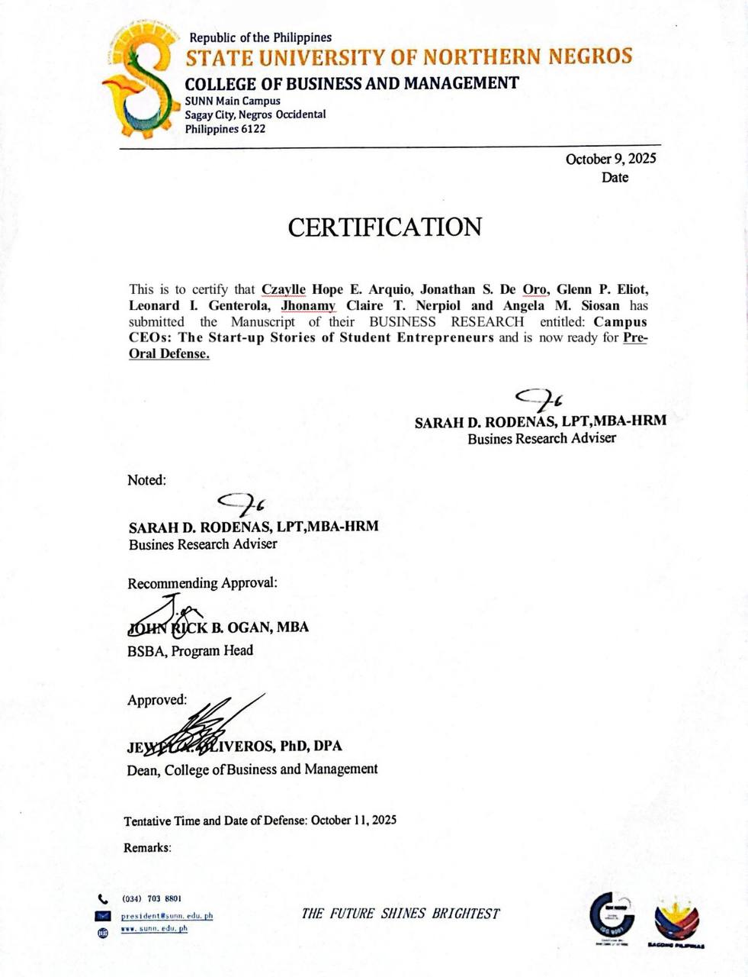

BRANCH HEAD LETTER

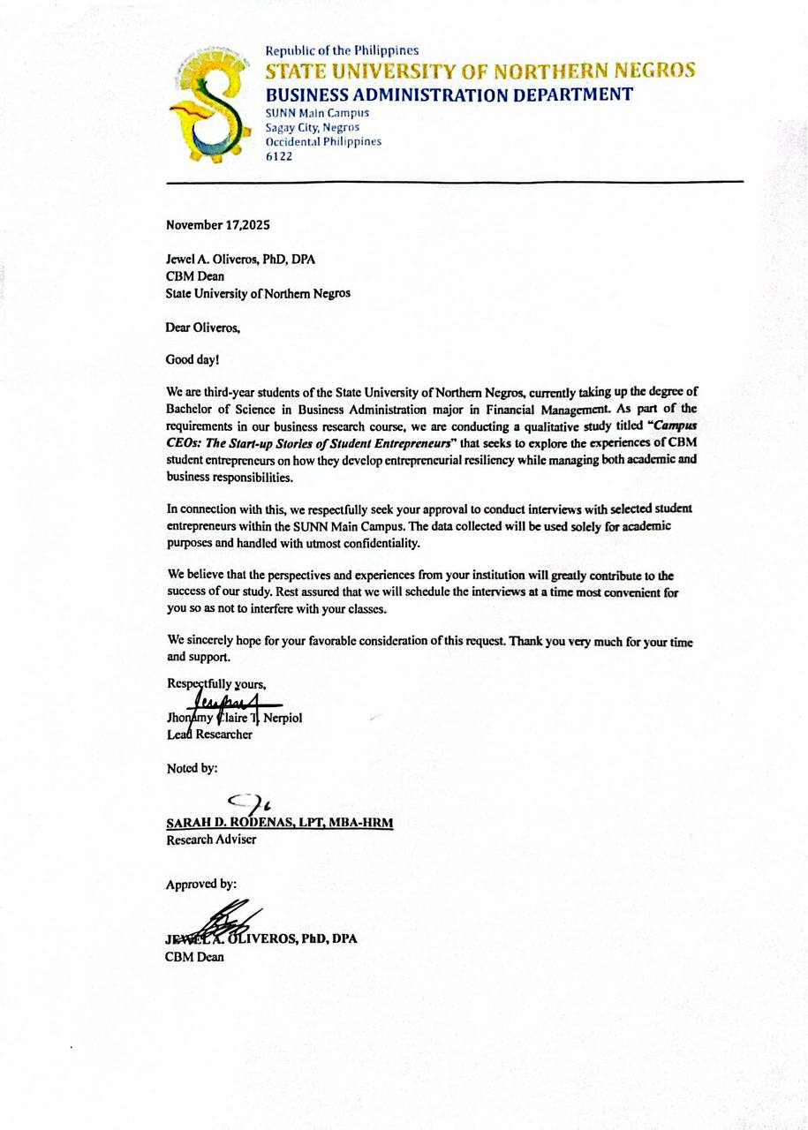
ETHICAL CLEARANCE

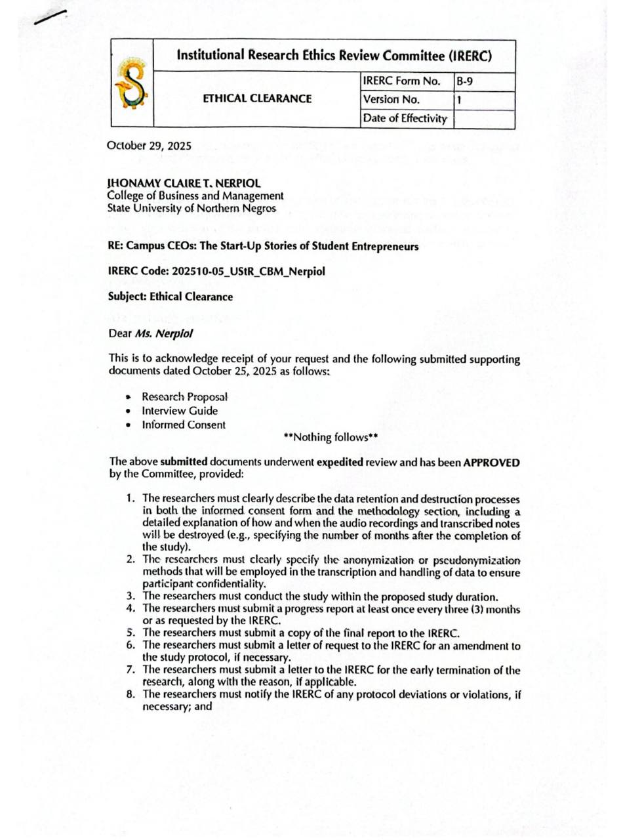
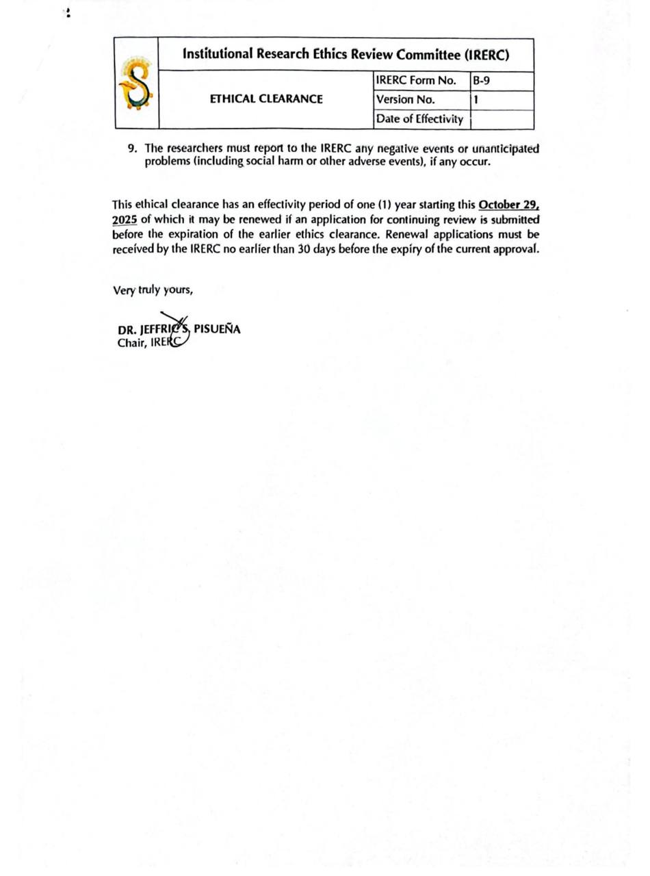

CERTIFICATION OF APPROVAL TO CONDUCT DATA GATHERING
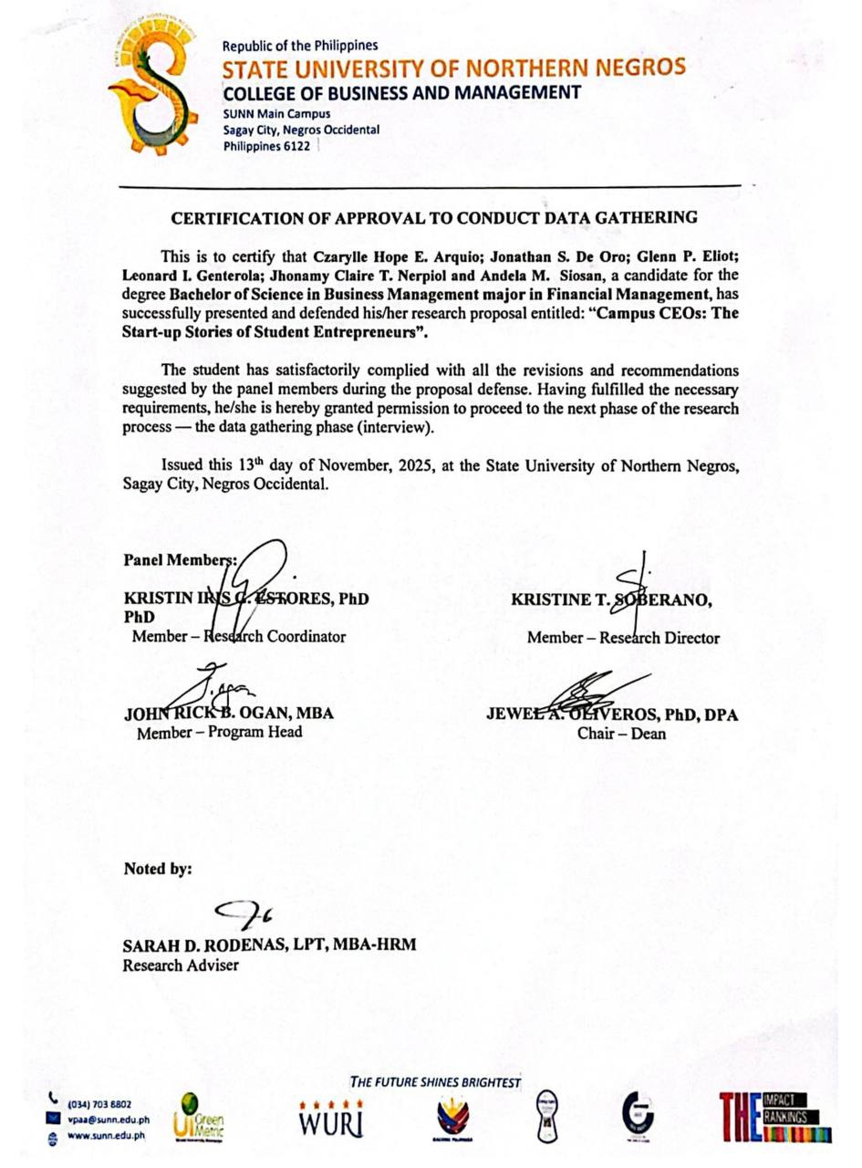

INFORMED CONSENT
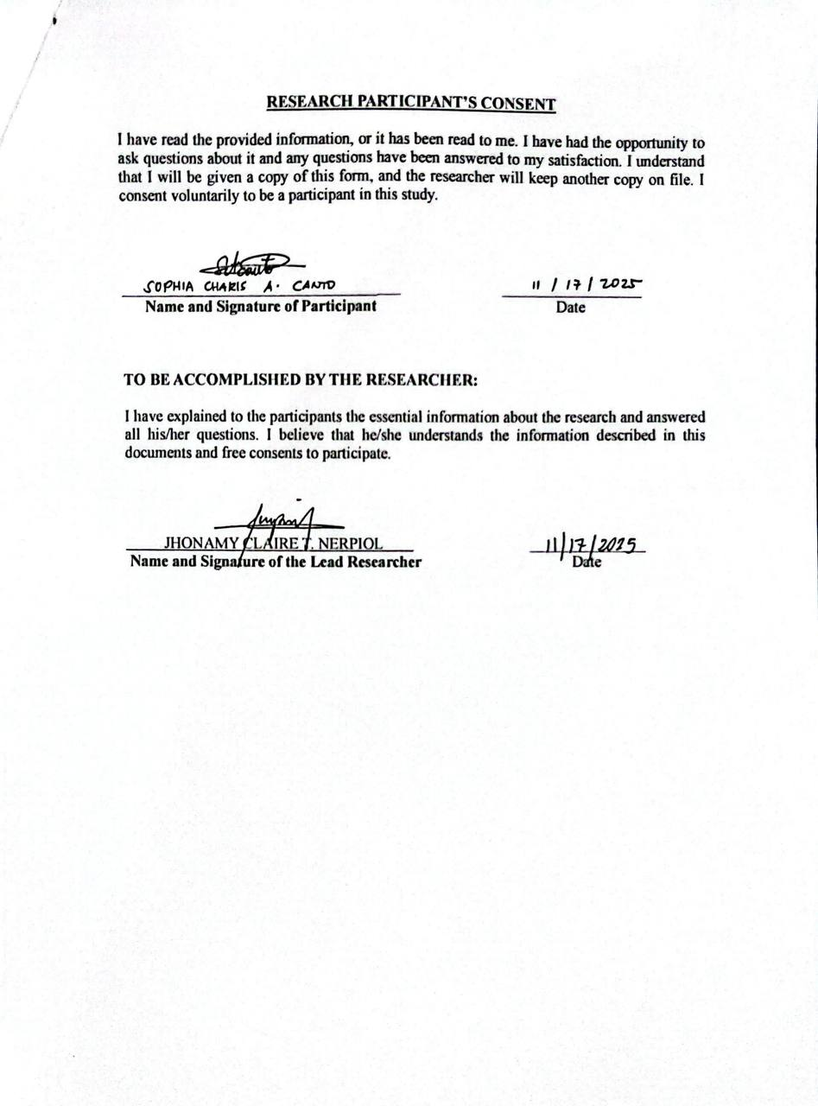
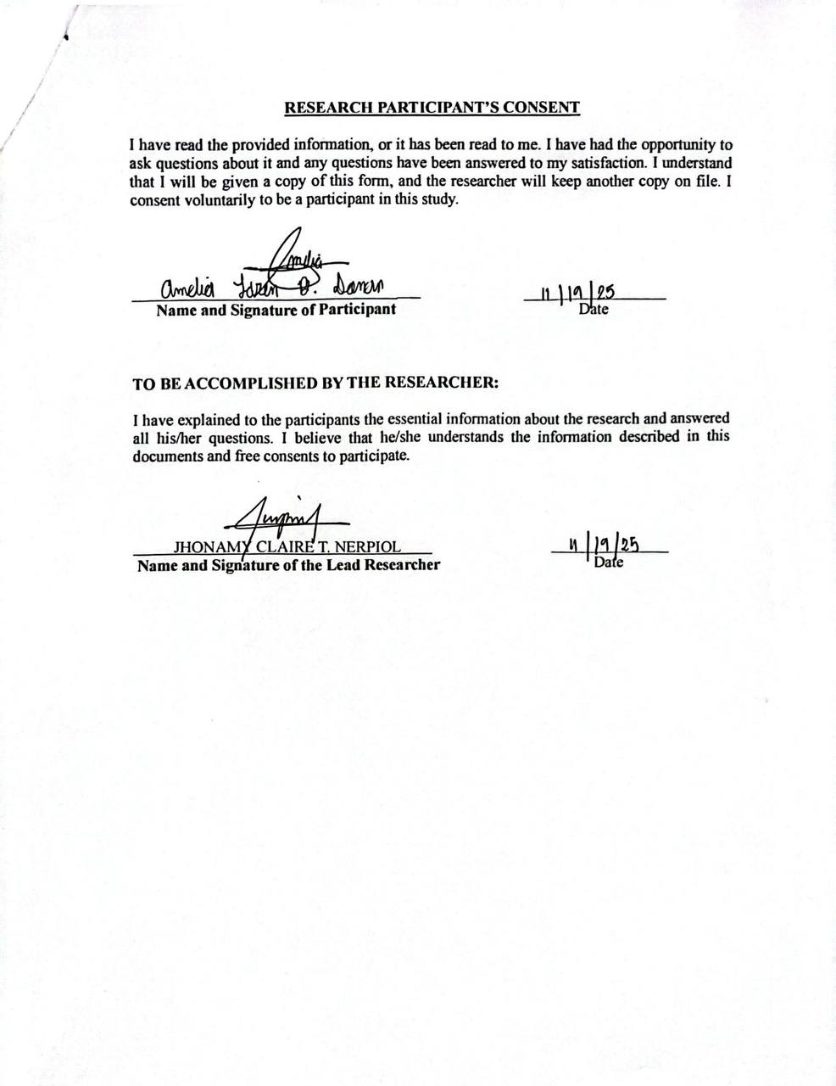

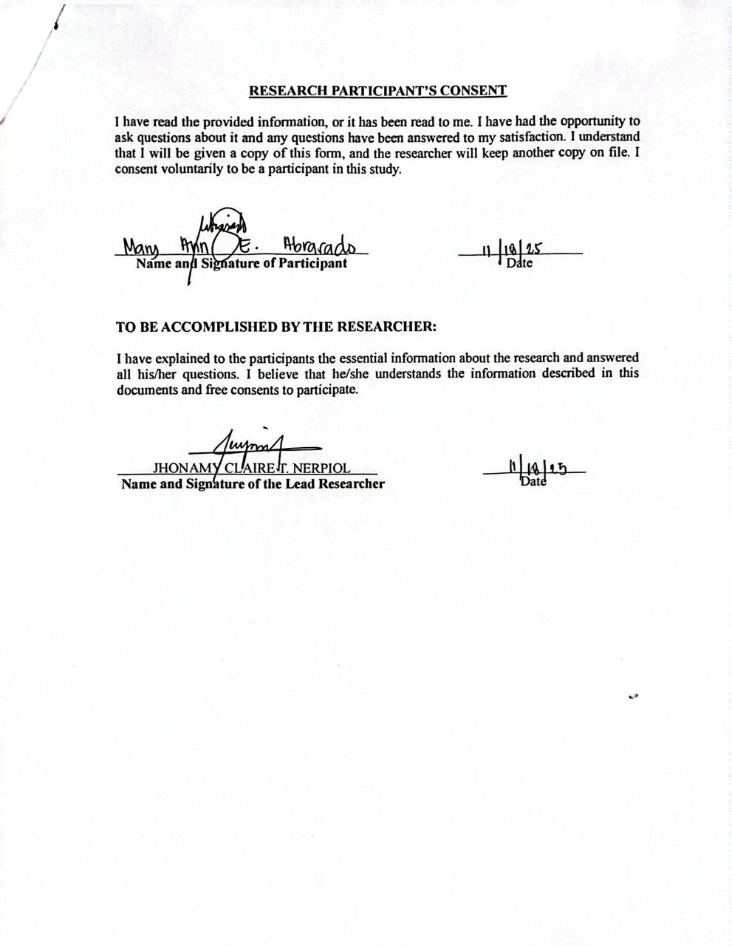
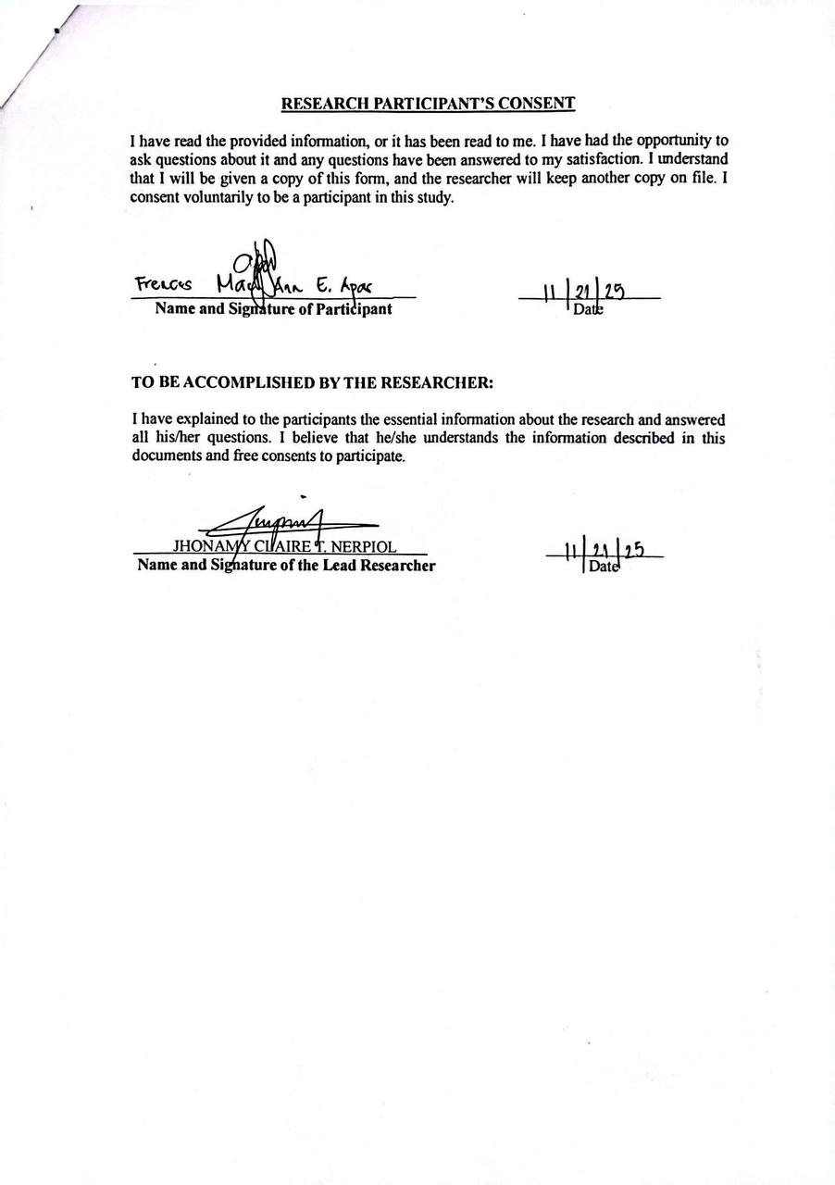
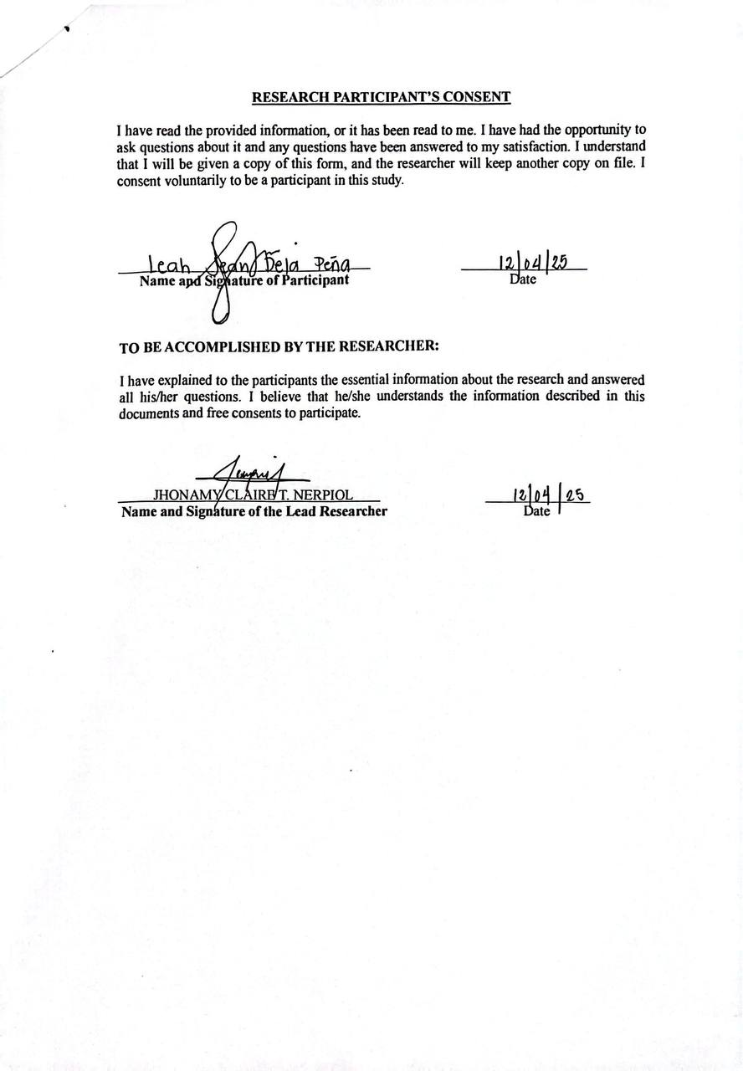

CERTIFICATION FOR AUDIT TRAIL
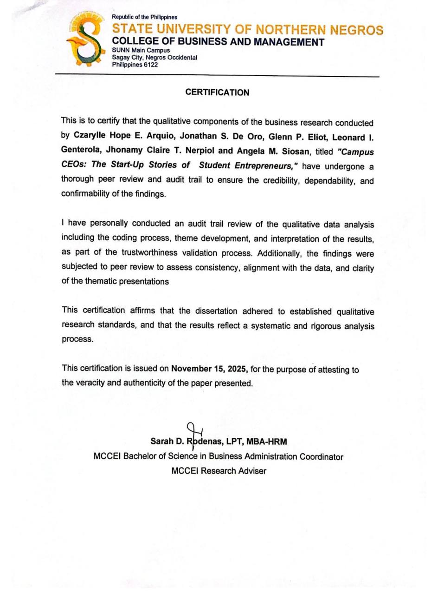

APPENDIX B
Interview Guide:
The primary question is, what characterizes the Campus CEOs: The Start-up Stories of Student Entrepreneurs, and secondary questions are:
Part 1: General Questions
1. | How long have you been managing your business while studying?  Pila na ka dugay nga may negosyo ka samtang naga-eskwela ka pa?
2. | Can you describe your main duties and responsibilities as a student entrepreneur?  Mahimo mo bala i-sugid kung ano ang imo mga ginahimo bilang estudyante nga may negosyo?
3. | What is it like managing your schoolwork and business at the same time every day?  Kamusta ang imo eksperyensya sa pagdumala sang imo negosyo kag eskwela sa pareho nga tion?
4. | How has your experience helped you manage your time and balance school and business better?  Paano ka natun-an sang imo eksperyensya nga mas maayo nga ma-ayos ang imo oras kag mabalanse ang negosyo kag pag-eskwela?
5. | What skills or qualities do you think are most important to perform well both as a student and as an entrepreneur?  Ano nga mga abilidad o kaalam ang kinahanglan para mangin maayo ka nga estudyante kag negosyante?
Part II. Entrepreneurial Resiliency
1. | What keeps you motivated when school or business becomes hard?  Ano ang naga-padayon nga rason o inspirasyon mo kon may kabudlayan sa imo negosyo o eskwela?
2. | What values or attitudes help you bounce back after failure or problems?  Ano nga mga batasan o prinsipyo ang naga-bulig sa imo nga makabawi kon may kapaltahan o problema?
3. | How do you stay focused on your goals even when things get tough in school or business?  Paano ka nagapadayon kag nagapokus sa imo mga handum bisan kon may mga problema?
4. | Can you tell a story about a big challenge you faced and how you were able to overcome it?  Mahimo mo bala i-sugid ang isa ka daku nga problema nga imo naagyan kag paano mo ini nalampuwasan?
5. | What experiences made you more confident and emotionally stronger as a student entrepreneur?  Ano nga mga eksperyensya ang naghatag sa imo sang mas daku nga kumpiyansa kag kabakod bilang estudyante nga negosyante?
Time Management and Adaptability
1. | How do you plan your day to handle both school and business tasks?  Paano mo ginaplano ang imo adlaw para matapos mo ang imo mga buluhaton sa eskwela kag negosyo?
2. | What do you do when unexpected problems happen in your school or business?  Ano ang imo ginahimo kon may indi ginapaabot nga problema sa imo negosyo o eskwela?
3. | How do you make sure you’re doing well in both school and business?  Paano mo ginapaniguro nga maayo ang imo performance sa duha — negosyo kag eskwela?
4. | Can you share a time when you had to change your plans to meet both school and business deadlines?  Mahimo mo bala i-sugid ang isa ka tion nga kinanlan mo bag-uhon ang imo plano para matapos ang imo mga buluhaton sa eskwela kag negosyo?
5. | How do you decide what to do first when both your studies and business need your attention?  Paano ka nagadesisyon kon ano ang una mo nga himuon kon pareho nga importante ang imo negosyo kag eskwela?
Support Systems and Personal Growth
1. | Who or what helps you deal with the challenges of being a student entrepreneur?  Sino o ano ang naga-bulig sa imo kon may kabudlayan ka bilang estudyante nga may negosyo?
2. | How do your family, friends, or mentors help you stay strong and motivated?  Paano ka ginabuligan sang imo pamilya, mga abyan, o mga mentor para magpabilin ka nga mabakod kag determinado?
3. | How has managing both school and business helped you improve as a person and as an entrepreneur?  Paano ka ginbuligan sang imo negosyo kag pag-eskwela nga magtubo bilang isa ka tawo kag negosyante?
4. | How does getting emotional or social support make you more confident in handling both roles?  Paano ka ginabuligan sang emosyonal o sosyal nga suporta nga mangin mas kumpiyansa ka sa imo kaugalingon?
5. | What changes or lessons have you learned about yourself since you started your business?  Ano nga mga leksyon o kabag-uhan ang imo natun-an parte sa imo kaugalingon halin sang nagsugod ka sang imo negosyo?

Themes, Codes, and Sample Participant Quotations
Themes | Codes | Sample Participant Quotations  (English + Original)
Theme 1: Pathways Into Entrepreneurship | Financial need; Early exposure; Desire for independence | P1: “I started a business because I had a lot of free time and I wanted to support my studies.”  (“Nag start ko mag business kay damo ko free time kag gusto ko maka support sakon studies.”)  P3: “Since I was a kid, I already worked hard because of our financial struggles.”  (“Tungod gid sa ka-pigaduhon miss amo na nga sang bata pa ko naninguha na gid ko.”)  P5: “I wanted to lessen the financial burden of my family, especially my parents.”  (“Gusto ko mabuligan ang pamilya ko kag indi maging kabudlay sa ila.”)
Theme 2: Managing Dual Responsibilities | Balancing roles; Academic duties; Sacrifice | P1: “I finish my school tasks first before focusing on my orders.”  (“Ginahimo ko nga tapuson una ang akon buluhaton sa eskwela antes mag-focus sa negosyo.”)  P4: “Being a student while doing business is hard, but it’s fulfilling because it helps in school and family needs.”  (“Lisod jud pero fulfilling kay makatabang sa akong pagskwela ug sakong family.”)  P5: “It’s challenging but fulfilling… earning while studying gives me purpose and independence.”  (“Challenging pero fulfilling kag nagahatag sakon purpose and independence.”)
Theme 3: Time Management & Adaptability | Planning; Scheduling; To-do lists | P1: “I bake only on weekends so I can focus on my studies during weekdays.”  (“Saturday–Sunday lang ko ga bake para weekdays focus ko sa studies.”)  P3: “I list everything—school tasks and orders—to avoid conflict.”  (“Gina lista ko tanan para indi mag conflict ang school kag business.”)  P2: “Time management gid ang key, that’s why I use a planner for scheduling tasks.”  (“Time management gid ang key kag naga-ubra ko planner para ma schedule ang tasks.”)
Theme 4: Emotional Resilience | Persistence; Mindset; Faith | P2: “Failure is just a lesson, not the end.”  (“Ang failure lesson lang, indi end.”)  P3: “My faith and positive thinking help me not give up even when it’s very hard.”  (“Ang akon faith kag positive thinking amo nagabulig nga indi ko mag give up.”)  P5: “I got scammed… it broke my heart but it made me stronger and wiser.”  (“Na scam ko… painful pero naghatag sakon strength kag wisdom.”)
Theme 5: Decision-Making | Prioritization; Urgency; Choosing tasks | P1: “If I need to finish school tasks, I cancel orders but give compensation to customers.”  (“Kun may ulubrahon ko sa school, gina cancel ko orders pero may freebies man.”)  P3: “I prioritize what has the biggest impact on my future.”  (“Gina prioritize ko ang may dako nga impact sa future ko.”)  P4: “I check what is most urgent—deadlines or big orders—and decide based on that.”  (“Tan-awon ko una ang urgent, exam ba or big order, kag dira ko mag decide.”)
Theme 6: Support Systems | Family support; Peer encouragement | P1: “My mom and friends support me by promoting my business.”  (“Ginabuligan ko nila by posting kag pag refer sa ila friends.”)  P2: “My family supports me by not disturbing me and giving moral support.”  (“Gina support nila ko sa moral kag indi ko nila ginadisturb.”)  P4: “My family and friends motivate me… they help deliver orders when I’m busy.”  (“Gabulig sila mag deliver sang orders kay kabalo sila nga busy ko sa school.”)
Theme 7: Entrepreneurial Identity | Growth; Independence; Confidence | P1: “Doing business prepares you for the real world because it teaches balance and financial skills.”  (“Du gina prepare kna sa real world kay damo ka ma learn kag indi ka na mag worry after college.”)  P4: “Business taught me to become a strong and independent woman.”  (“Gintudluan ko sang negosyo nga mangin strong independent woman.”)  P5: “I realized I’m stronger than I thought… more mature and independent now.”  (“Na realize ko nga mas strong ko kag mas mature subong.”)

DENDOGRAM
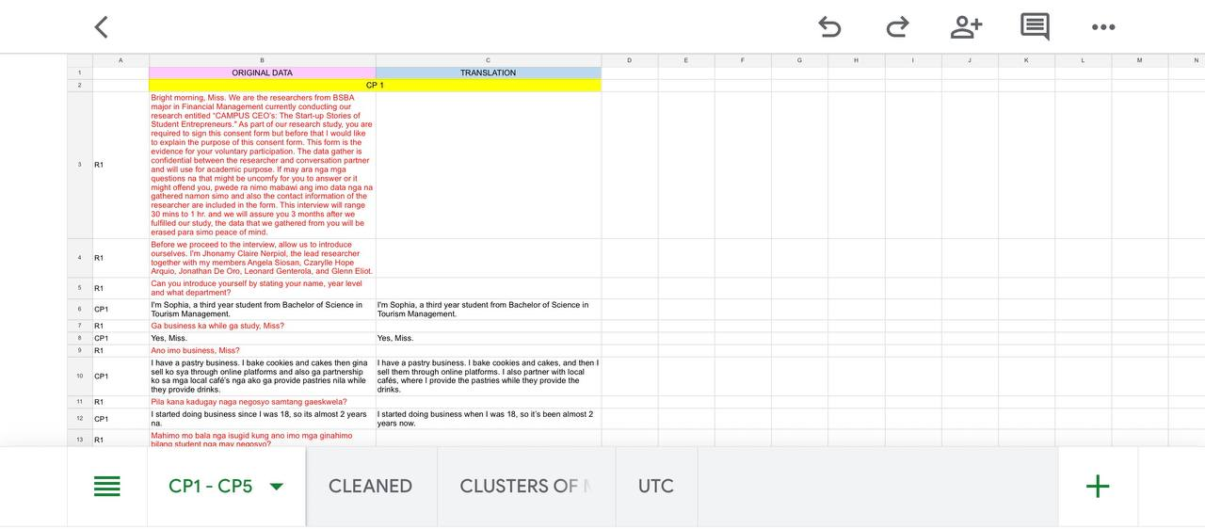
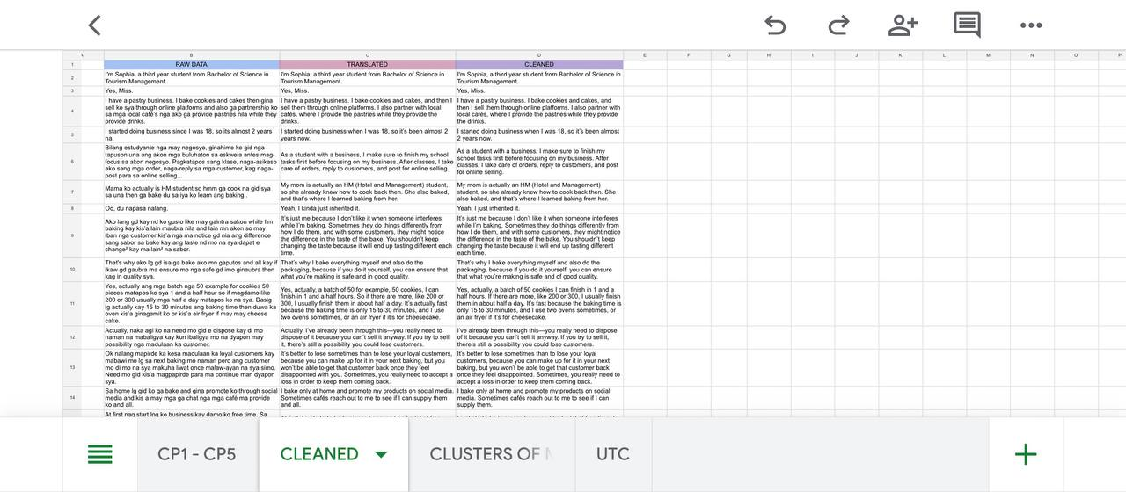
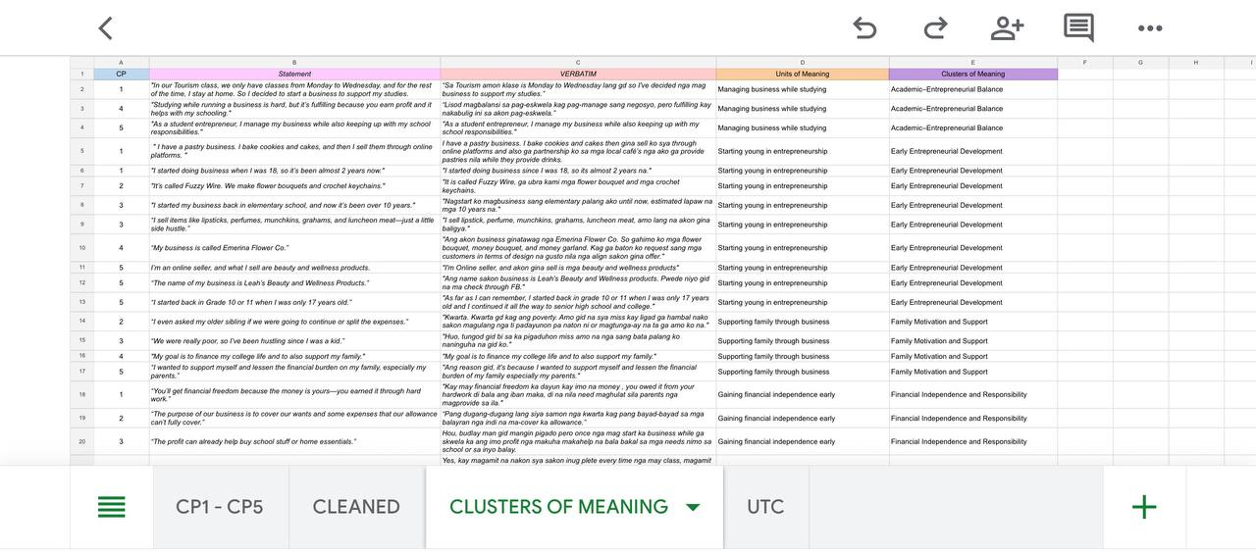


CURRICULUM VITAE
Name: Czarylle Hope E. Arquio
Age: 20 years old
Address: Brgy. Poblacion 1, Sagay City, Negros Occidental
Contact Number: 09462145044
Email Address: hopearquio24@gmail.com


Name: Jonathan De Oro
Age: 21 years old
Address: Brgy. Old Sagay, Sagay City, Negros Occidental
Contact Number: 09771297114
Email Address: jonathandeoro4@gmail.com


Name: Glenn P. Eliot
Age: 21 years old
Address: Brgy. Tiglawigan, Cadiz City, Negros Occidental
Contact Number: 09515770836
Email Address: glenneliot18@gmail.com


Name: Leonard I. Genterola
Age: 20 years old
Address: Brgy. Himoga-an Baybay, Sagay City, Negros Occ
Contact Number: 09632183088
Email Address: leonardgenterola@gmail.com


Name: Jhonamy Claire T. Nerpiol
Age: 22 years old
Address: Brgy. Rafaela Barrera, Sagay City, Negros Occ.
Contact Number: 09458535926
Email Address: claireynerpiol@gmail.com


Name: Angela M. Siosan
Age: 20 years old
Address: Brgy. Himoga-an Baybay, Sagay City, Negros Occ.
Contact Number: 09489932714
Email Address: angelasiosan3@gmail.com

