MME3 – EJER3: Ejecución de programas

**1.- Simula la ejecución de los siguientes programas almacenados en memoria sabiendo que las instrucciones están dadas en formato operación-dirección y que las operaciones posibles son las siguientes:**

1. Cargar AC desde memoria
2. Almacenar AC en memoria
3. Sumar al AC de memoria
4. Restar al AC de memoria

|  |  |
| --- | --- |
| Programa 1 | |
| 100 | 1300 |
| 101 | 3301 |
| 102 | 2301 |
|  |  |
| 300 | 0016 |
| 301 | 0007 |

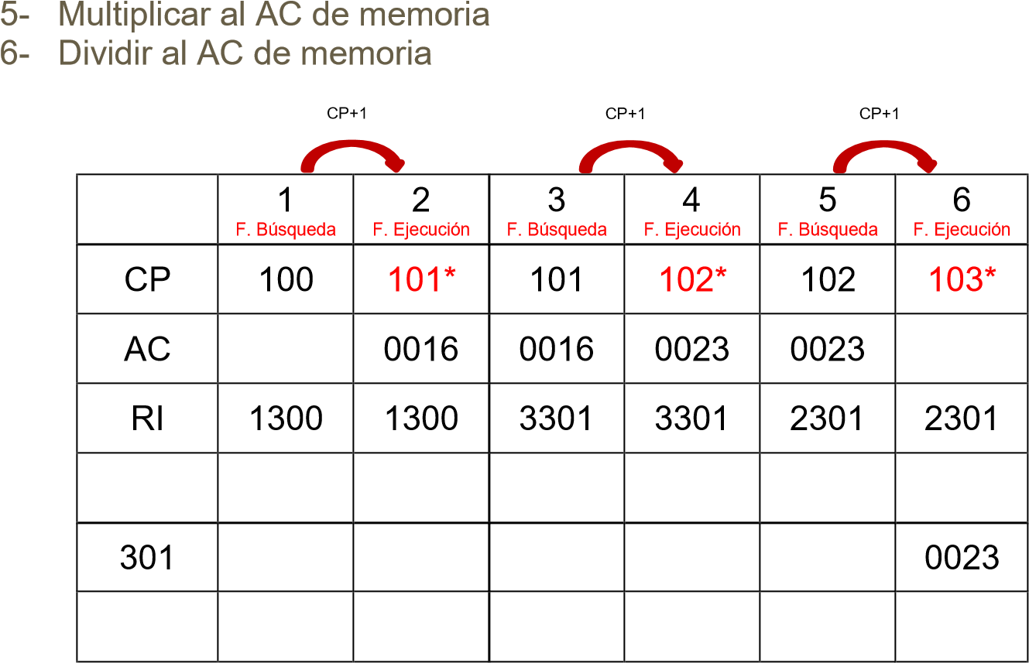Ejemplo resuelto:

|  |  |  |
| --- | --- | --- |
| Completa: | | *F. Búsqueda -> Avance del contador de programa (CP+1) -> F. Ejecución |
| |  |  | | --- | --- | | Programa 2 | | | 110 | 1302 | | 111 | 4303 | | 112 | 2303 | |  |  | | 302 | 0013 | | 303 | 0010 | | |  |  |  |  |  |  |  | | --- | --- | --- | --- | --- | --- | --- | |  | 1 | 2 | 3 | 4 | 5 | 6 | | CP | 110 | 111 | 111 | 112 | 112 | 113 | | AC |  | 0013 | 0013 | 0003 | 0003 | 0003 | | RI | 1302 | 1302 | 4303 | 4303 | 2303 | 2303 | |  |  |  |  |  |  |  | |  |  |  |  |  |  |  | | 303 |  |  |  |  |  | 0003 | | | |

|  |  |  |  |  |  |  |  |  |  |
| --- | --- | --- | --- | --- | --- | --- | --- | --- | --- |
| Programa 3 | |  |  | 1 | 2 | 3 | 4 | 5 | 6 |
| 120 | 1304 | CP | 120 | 121 | 121 | 122 | 122 | 123 |
| 121 | 5305 | AC |  | 0025 | 0075 | 0075 | 0075 | 0075 |
| 122 | 2305 | RI | 1304 | 1304 | 5305 | 5305 | 2305 | 2305 |
|  |  |  |  |  |  |  |  |  |
| 304 | 0025 |  |  |  |  |  |  |  |
| 305 | 0003 | 305 |  |  |  |  |  | 0075 |

|  |  |  |  |  |  |  |  |  |  |
| --- | --- | --- | --- | --- | --- | --- | --- | --- | --- |
| Programa 4 | |  |  | 1 | 2 | 3 | 4 | 5 | 6 |
| 130 | 1309 | CP | 130 | 131 | 131 | 132 | 132 | 133 |
| 131 | 6308 | AC |  | 0008 | 0008 | 0004 | 0004 | 0010 |
| 132 | 3307 | RI | 1309 | 1309 | 6308 | 6308 | 3307 | 3307 |
| 133 | 4306 |  |  |  |  |  |  |  |
| 134 | 2309 |  | 7 | 8 | 9 | 10 | 11 | 12 |
|  |  | CP | 133 | 134 | 134 | 135 |  |  |
| 306 | 0003 | AC | 0010 | 0007 | 0007 | 0007 |  |  |
| 307 | 0006 | RI | 4306 | 2309 | 2309 | 2309 |  |  |
| 308 | 0002 |  |  |  |  |  |  |  |
| 309 | 0008 | 309 |  |  |  | 0007 |  |  |

|  |  |  |  |  |  |  |  |  |  |
| --- | --- | --- | --- | --- | --- | --- | --- | --- | --- |
| Programa 5 | |  |  | 1 | 2 | 3 | 4 | 5 | 6 |
| 140 | 1310 | CP | 140 | 141 | 141 | 141 | 142 | 142 |
| 141 | 3310 | AC |  | 0005 | 0005 | 0010 | 0010 | 0030 |
| 142 | 3313 | RI | 1310 | 1310 | 3310 | 3310 | 3313 | 3313 |  |  |  |
| 143 | 4312 |  |  |  |  |  |  |  |  |  |  |
| 144 | 2312 |  |  |  |  |  |  |  |  |  |  |
|  |  |  | 7 | 8 | 9 | 10 | 11 | 12 |
| 310 | 0005 | CP | 143 | 143 | 144 | 145 |  |  |  |  |
| 311 | 0010 | AC | 0030 | 0015 | 0015 | 0015 |  |  |  |  |
| 312 | 0015 | RI | 4312 | 4312 | 2312 | 0000 |  |  |  |  |
| 313 | 0020 | 312 |  |  |  | 0015 |  |  |  |  |

|  |  |  |  |  |  |  |  |  |  |
| --- | --- | --- | --- | --- | --- | --- | --- | --- | --- |
| Programa 6 | |  |  | 1 | 2 | 3 | 4 | 5 | 6 |
| 150 | 1317 | CP | 150 | 151 | 151 | 152 | 152 | 153 |
| 151 | 5315 | AC |  | 0004 | 0004 | 0008 | 0008 | 0005 |
| 152 | 4316 | RI | 1317 | 1317 | 5315 | 5315 | 4316 | 4316 |
| 153 | 5315 |  |  |  |  |  |  |  |
| 154 | 2314 |  |  |  |  |  |  |  |
|  |  |  | 7 | 8 | 9 | 10 | 11 | 12 |
| 314 | 0001 | CP | 153 | 154 | 154 | 1545 |  |  |
| 315 | 0002 | AC | 0005 | 0010 | 0010 | 0010 |  |  |
| 316 | 0003 | RI | 5315 | 5315 | 2314 | 2314 |  |  |
| 317 | 0004 | 314 |  |  |  | 0010 |  |  |

**2.- Utiliza un esquema de memoria similar al de los ejercicios anteriores para diseñar un programa que realice la operación A + B – (C + D * E)**

|  |  |  |  |  |  |  |  |  |  |
| --- | --- | --- | --- | --- | --- | --- | --- | --- | --- |
| Programa | |  |  | 1 | 2 | 3 | 4 | 5 | 6 |
|  |  | CP |  |  |  |  |  |  |
|  |  | AC |  |  |  |  |  |  |
|  |  | RI |  |  |  |  |  |  |
|  |  |  | 7 | 8 | 9 | 10 | 11 | 12 |
|  |  | CP |  |  |  |  |  |  |
|  |  | AC |  |  |  |  |  |  |
|  |  | RI |  |  |  |  |  |  |
|  |  |  |  |  |  |  |  |  |