4th Wall Cafe – Design Document
last updated: 07-12-2024
Author: Roth Thomas

Overview
The 4th Wall Cafe Project is a multi project solution to create a web application to track and manage products, servers and revenue information as well as an API for online ordering.

Context
The goal is to create an easy to use and secure graphical user interface for employees and a Rest API that exposes clear endpoints for a client to consume.

Solution
The Solution consist of multiple projects:
- Core Layer …………………………………………………………………………………….. 2
- Data Layer …………………………………………………………………………………….. 2
- Application Layer ……………………………………………………………………………… 2
- Testing Layer ………………………………………………………………………………….. 2
- Model View Controller ………………………………………………………………………… 2
- Rest API ……………………………………………………………………………………….. 11
Security ………………………………………………………………………………………………...12
Logging ………………………………………………………………………………………………...12

Core Layer
Contains interfaces, models and entities that are shared across the solution

Data Layer
Connects to the Database for adding, retrieving, updating and deleting data.
I choose Dapper to query the DB over Entity Framework as I expect to encounter complex queries especially for revenue reports so writing SQL might just be easier than configuring EF for that.
Tech:
- SqlServer Database
- Dapper

Application Layer
Contains testable business logic between the Data Layer and MVC / API Layer.

Testing Layer
Contains unit tests for testing logic of the Application Layer
Tech:
- Nunit
- Microsoft Test Sdk

Model View Controller
Here the interface of the web application will be created using MVC workflow and Razor syntax.
For the styling I will leverage bootstrap classes for responsive design.
The following pages will showcase the interface wireframe.

The header and footer are static while the options bar and main section are dynamic.
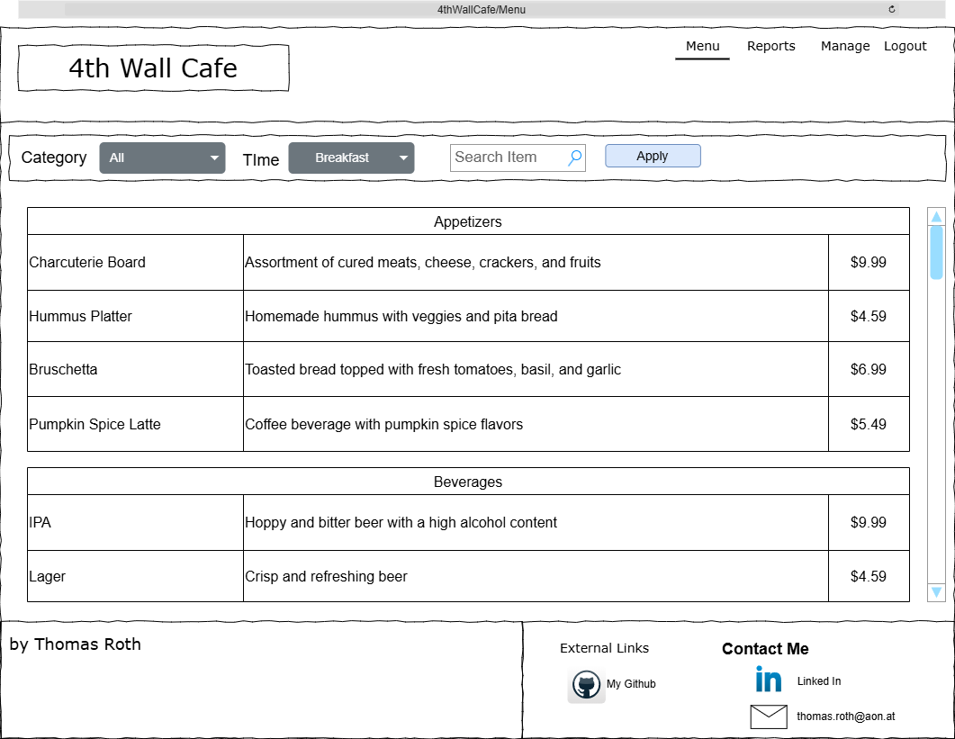
Path: /Menu
The index page shows an overview of all available items for the selected time window with adjusted prices. By default all items are be listed, separated by category, available at breakfast time.
Two Dropdown selections allow to filter items by Category as well as Time Window
Additionally a search input allows to search for a particular item.

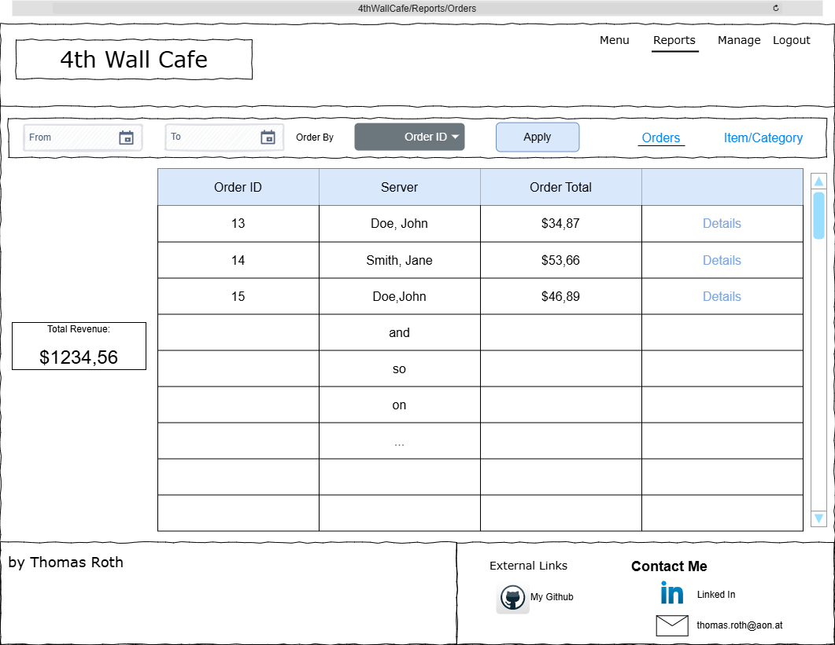
Path: /Reports/Orders
The options bar allows to switch between order reports and item reports.
By default order reports of the current day are presented.
A dropdown in the options bar allows to order the listed orders by Order Id, Server or Order Total.
Two calendar inputs allow to select a time frame.
Below the total revenue for the selected time frame is displayed.
Each order displayed in the list contains a link to a separate page to view order details.

The reports tab is accessible only to users with the accounting role

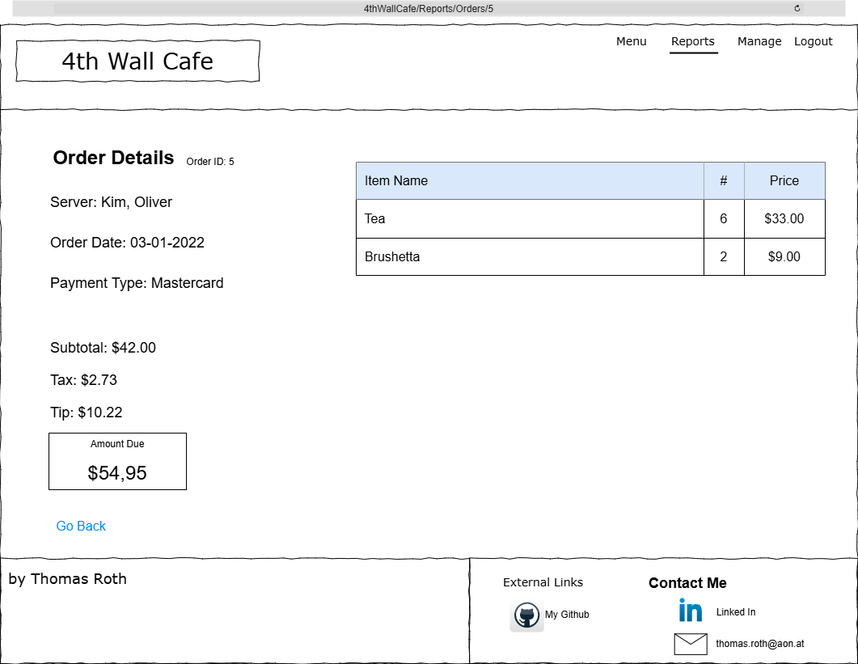
Path: /Reports/Orders/id

Displays the details of an order as shown above.
The reports tab is accessible only to users with the accounting role

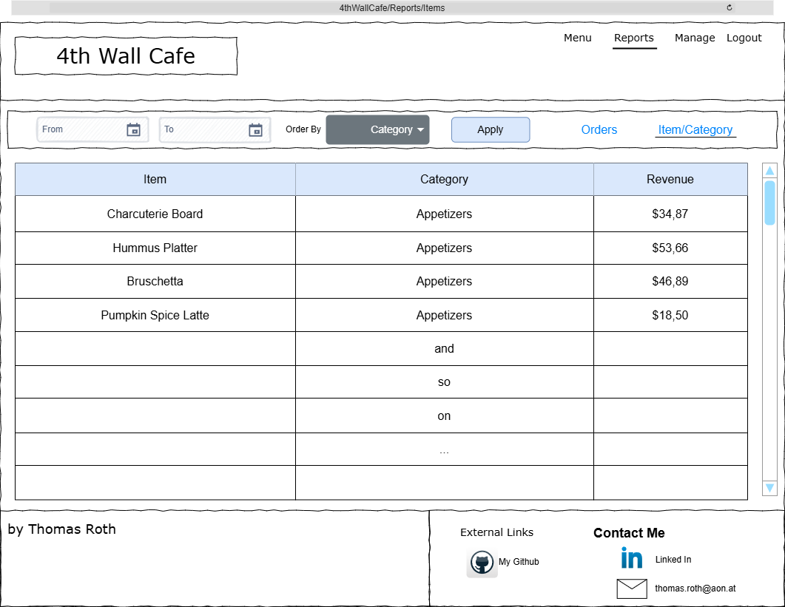
Path: /Reports/Items

Displays an overview of how much revenue each item generated in a given time frame.
By default the current day is selected and items are ordered by category, then item.
A dropdown in the options bar allows to order the list by item, category or revenue.

The reports tab is accessible only to users with the accounting role

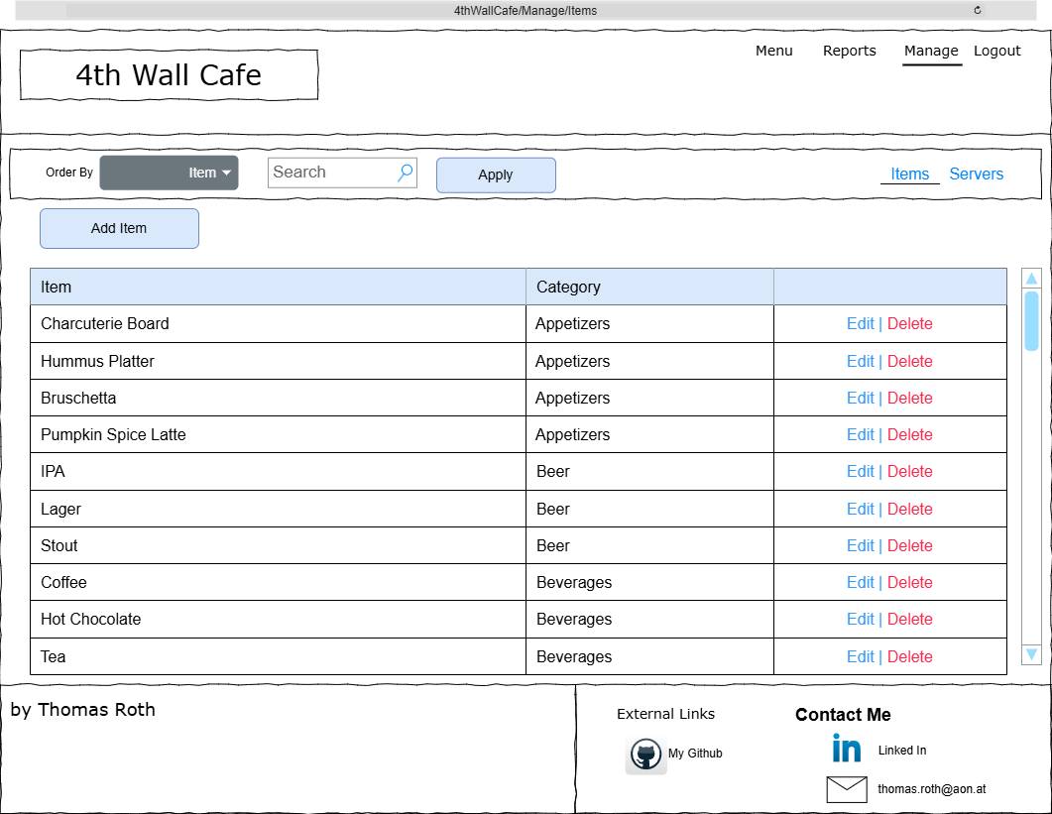
Path: /Manage/Items

By default all items are listed ordered by category.
The options contains a dropdown that allows to order the list by item name or category, two links for item and server management windows and a search bar to search for a particular item by name.

Each list item contains a link to edit or delete an item.
The delete link prompts the user for confirmation.

The Manage tab is only accessible to user with the manager role.

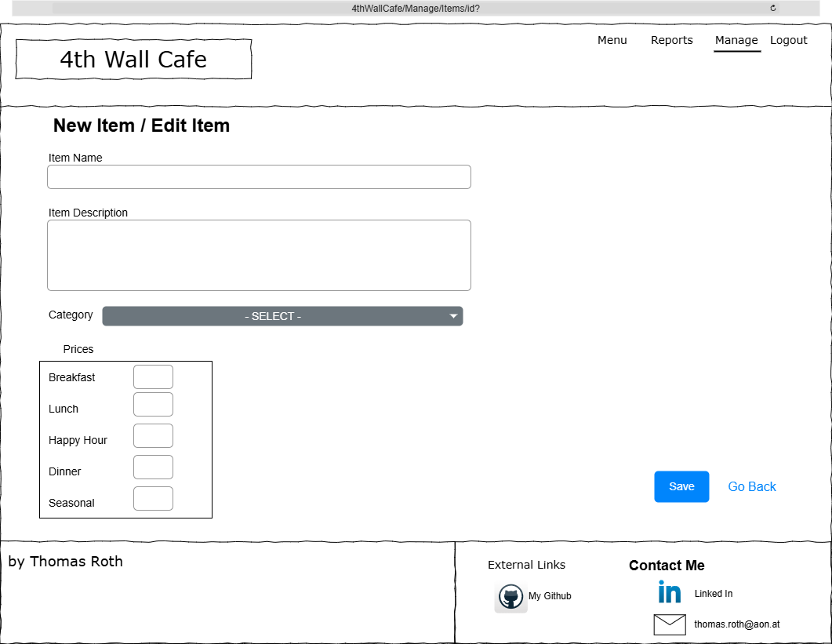
Path: /Manage/Items/ … for adding an item
/Manage/Items/id … for editing an item

The ‘go back’ link will return the user to the item list.
If a prices field is left empty the item will not be available at the given time.

The Manage tab is only accessible to user with the manager role.

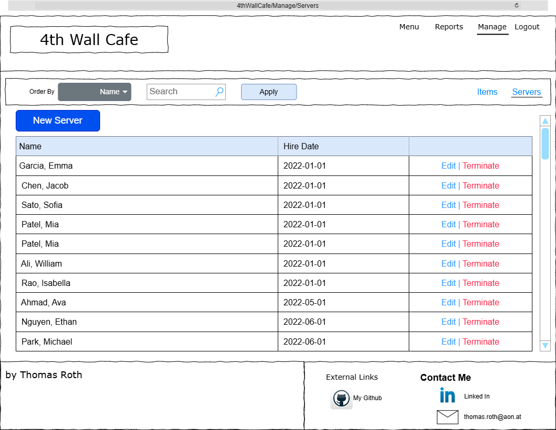
Path: /Manage/Servers

Similar functionality to the Item List.
Allows to add a new server and edit or terminate an existing server.

The terminate link prompts the user for confirmation.

The Manage tab is only accessible to user with the manager role.

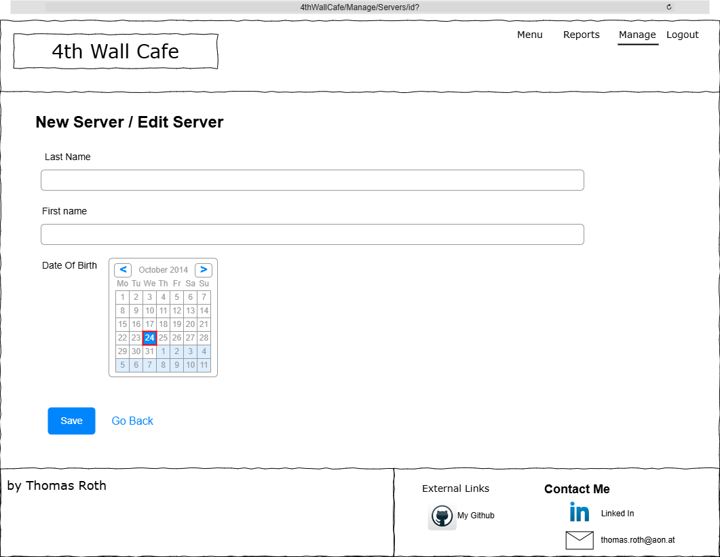
Path: /Manage/Servers/ … for adding a server
/Manage/Servers/id … for editing a server

Upon saving the hire date defaults to Today.
The ‘go back’ redirects to the server list page.

The ServerForm model contains the form validation:
- First Name: Required, Must contain only letters
- Last Name: Required, Must contain only letters
- Date of Birth: Required, Must be at least 18 years old.

The Manage tab is only accessible to user with the manager role.
All parts of the MVC are accessible for users with admin role.

App Feedback and Error handling:

Error messages, as well as success or informational messages are displayed below the header.
Error messages are displayed with red background and white text while success or informational messages are displayed with green background and white text.

Success or informational messages are displayed on successfully adding, or updating items or servers.
Error messages can be displayed for various reasons, like database connection errors, form invalidity, and database creating/updating/deleting errors.

Every success, information and error message is also being logged to the console.
Upon error the user is redirected to either the previous page, home page or form page where an error message, as described above will be displayed.

Rest API

The rest API will allow clients to connect to exposed endpoints to create accounts and order online.
Endpoints:
Usage | Path | Method | Status Code / Returns
Sign Up | /api/signup | Post | 201
Login | /api/authenticate/login | Post | 200 / Json Web Token
Get User Info | /api/users/id | Get | 200 / Json
Edit User Info | /api/users/id | Put | 204
Delete User | /api/users/id | Delete | 204
New Order | /api/orders | Post | 201 / Json
Get Order | /api/orders | Get | 200 / Json
Edit Order | /api/orders/id | Put | 204 / Json
Delete Order | /api/orders/id | Delete | 204

Users signing up or registering will be saved in their own db table “User”.
The table columns and entity would look like this:
LastName : varchar(20)
FirstName : varchar(20)
Email : varchar(100)
Password : varchar(255)
Phone : varchar(20)
Street : varchar(255)
City : varchar(50)
Country : varchar(50)
State : varchar(50)
Zip : varchar(10)
CustomerID : bigint autoincrementing primary key

As the API is used for online ordering we will require new users to register with their address.

Security
The MVC will leverage ASP Identity Entity Framework to manage Accounts and Roles.
For the API I choose a simple JWT approach that verifies a user by reading the bearer token on the request’s Authentication header. Users registering on the API will be saved in a different “User” db table as the Account tables are meant for employees and required different Data.

The Password requirements for both API and MVC are:
- 8 characters minimal length
- at least one upper case character
- at least one lower case character
- at least one digit or other symbol

For the MVC there are two special roles.
- Accountant
- Manager

See MVC Layer section for role restrticted access areas

The API does not assign roles or claims to accounts.

Logging
Again, the MVC and API will, by default, log information level events and above.

- Information Logs on Database changes like creating, updating or deleting data.
- Warning Logs for invalid or unauthorized http requests.
- Error Logs for caught exceptions.

The applications write logs to the console.
Todo: Log to the Database.

