IT Asset Tacking – Design Document
last updated: 18-02-2025
Author: Roth Thomas

Overview
The IT Asset Tracking Project is a multi project solution to manage hardware and software assets, assigning them to employees or departments as well as keeping track of IT support tickets and reading various statistics data like asset values, license usage, ticket resolution times and more.

Context
This project should provide options for managing and tracking assets, support tickets and reading various reports.
The project should provide an Interface that is easy to navigate and easy understand created with ASP.Net MVC. It also provides a complete API that allows for implementation of an external front end.
Both interface and API should have proper Security in Place.

Solution
The Solution consist of multiple projects:
- Core Layer …………………………………………………………………………………….. 2
- Data Layer …………………………………………………………………………………….. 2
- ERD ………………………………………………………………………………………. 3
- Application Layer ……………………………………………………………………………… 4
- Testing Layer ………………………………………………………………………………….. 4
- Model View Controller ………………………………………………………………………… 5
- Rest API ………………………………………………………………………………………..20
Security ………………………………………………………………………………………………...26
Logging ………………………………………………………………………………………………...27

Core Layer
Contains interfaces, models and entities that are shared across the solution

Data Layer
Connects to the Database for adding, retrieving, updating and deleting data.
I choose Entity Framework to query the DB as I expect to write A LOT of queries. A full ORM like EF will speed up creating and updating the repositories for the Data Layer. Also this project represents an application for a possibly large company where other choices like Dapper, as a third party package, could potentially be unreliable.

I made necessary adjustments to the provided ERD to meet the project’s requirements.
Tech:
- SqlServer Database
- Entity Framework
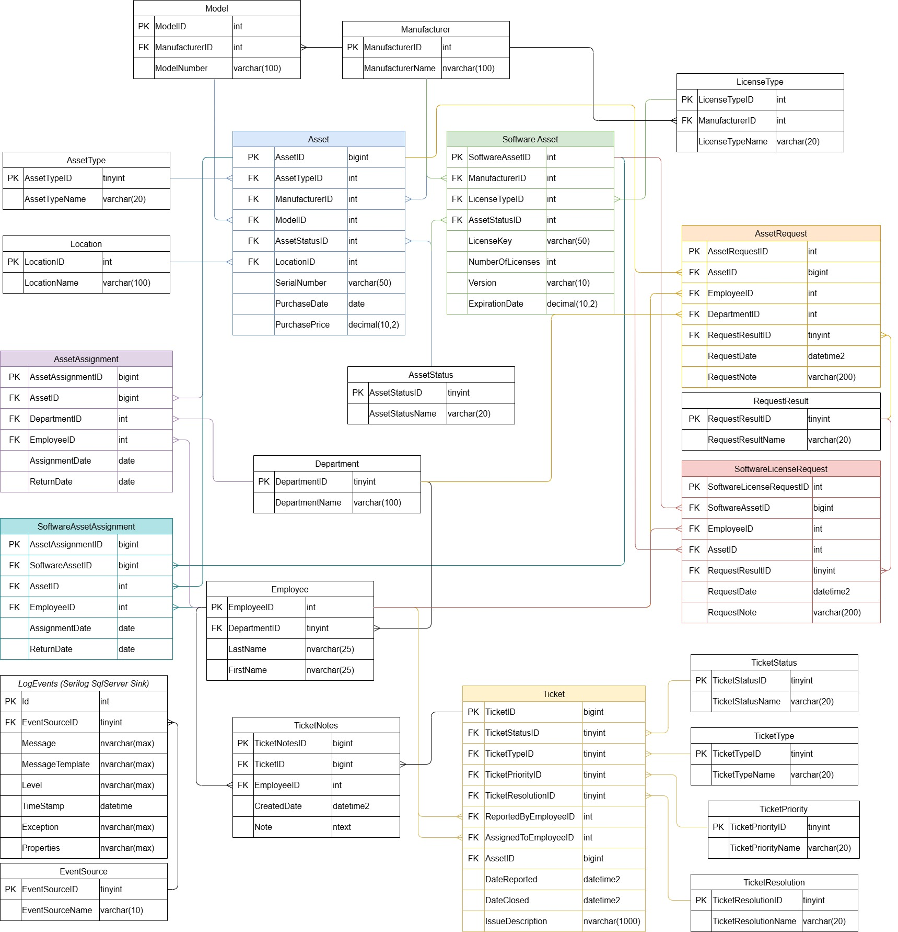
IT Asset Tracking Project - ERD

Application Layer
Contains testable business logic between the Data Layer and MVC / API Layer.
The application class methods return “result” types:
{
Ok: bool,
Data?: <T>,
message: string,
Ex?: Exception
}
which are consumed by the API and MVC Layer.
That way data and errors are being passed to the upper layers where they are handled properly.

Testing Layer
Contains unit tests for any testable logic of the Application Layer
Tech:
- Nunit
- Microsoft Test Sdk

Model View Controller
Here the interface of the web application will be created using MVC workflow and Razor syntax.
Users need to authenticate via Username and Password to view any of the sites content.
Users can have one of the following roles assigned to them:
- Admin: Access to all sites content and functionalities, can add or update users
- Asset Manager: Can add, edit and delete assets, assign assets, generate asset reports.
- Software License Manager: Manages software assets and their assignment, generate software compliance reports
- Help Desk Technician: Manage support tickets. Creating, updating, assigning and adding notes to tickets.
- Department Manager: View assets assigned to their department, request new assets or reassignments, view ticket status for their department’s assets
- Employee: View and create support tickets for their assigned assets.
- Auditor: Read-Only access to all asset and ticket information, generate and view any reports.

For the styling I will leverage bootstrap for responsive design.
The following pages will showcase the interface wireframes.

The header and footer are static while the main section is dynamic.
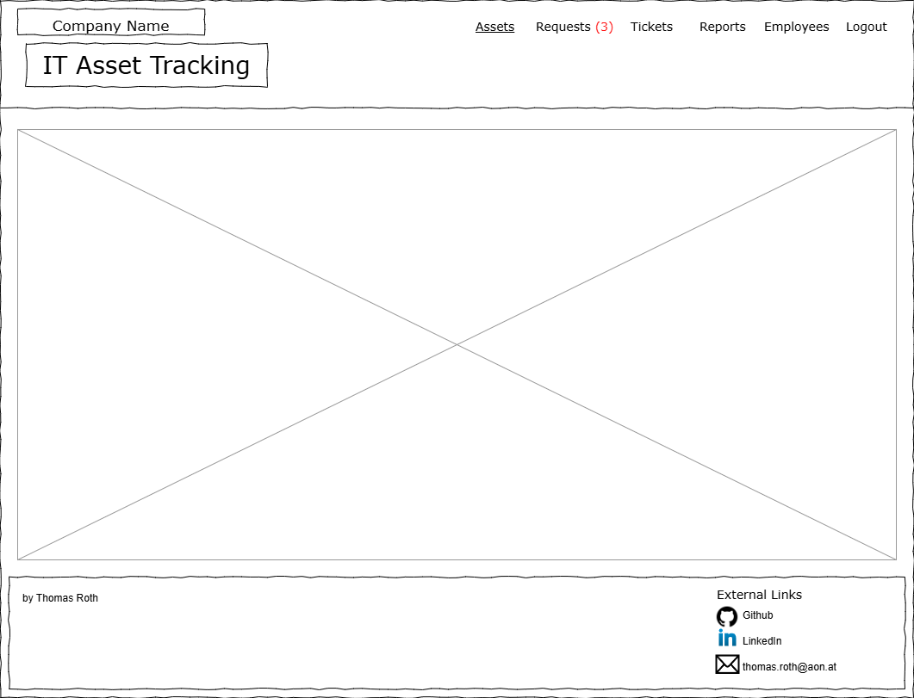
The Header contains links to the main sections of the Service.
- Assets => leads to the Assets Index Page
- Requests => Shows the number of open asset requests. Leads to the asset request page accessible to Asset Managers and Admins and read-only access for Department Managers.
- Tickets => Accessible to Help Desk Technicians. Leads to the Tickets Index Page
- Reports => Accessible to Auditors. Leads to the Reports Index Page
- Employees => Accessible to Admins only. Leads to Employee List.

The following wireframes represent the main section for each path.

The Assets Index Page simply contains three links.
“My Asset”, “Department Assets”, “All Assets“
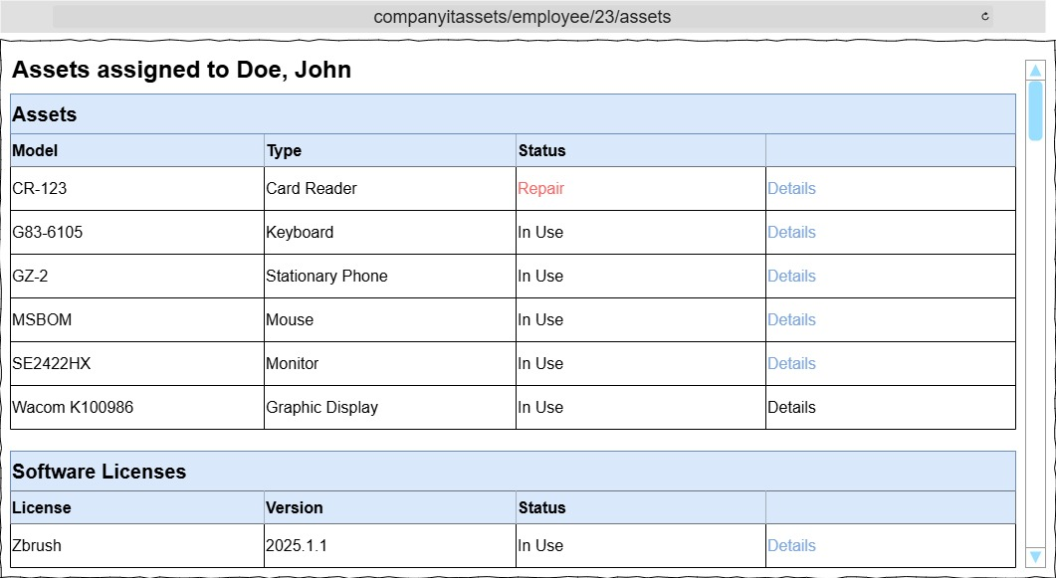
The ‘My Assets’ link redirects to a list of assets assigned to the currently logged in user. The list is ordered alphabetically by Model. As this should be a fairly short list of assets I choose to not implement a filter form here to avoid unnecessary cluttering.

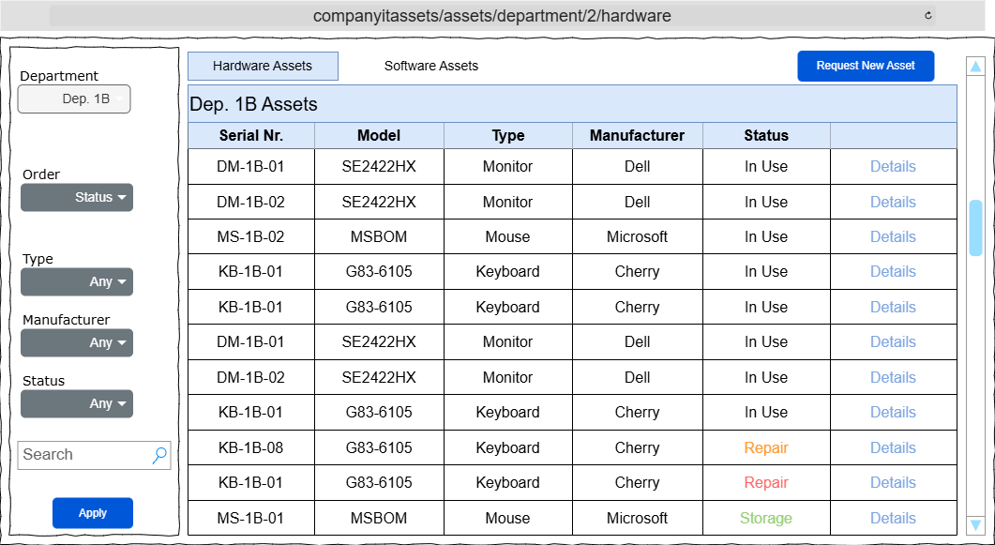
The ‘Department Assets’ link redirects to the page shown below. This page is accessible to department managers, asset managers and admins and shows all assets assigned to the selected department. For department managers the ‘Department Dropdown’ is greyed out and defaults to the department of the currently logged in user.

The ‘Request New Asset’ button redirects to a list of available or unassigned assets.
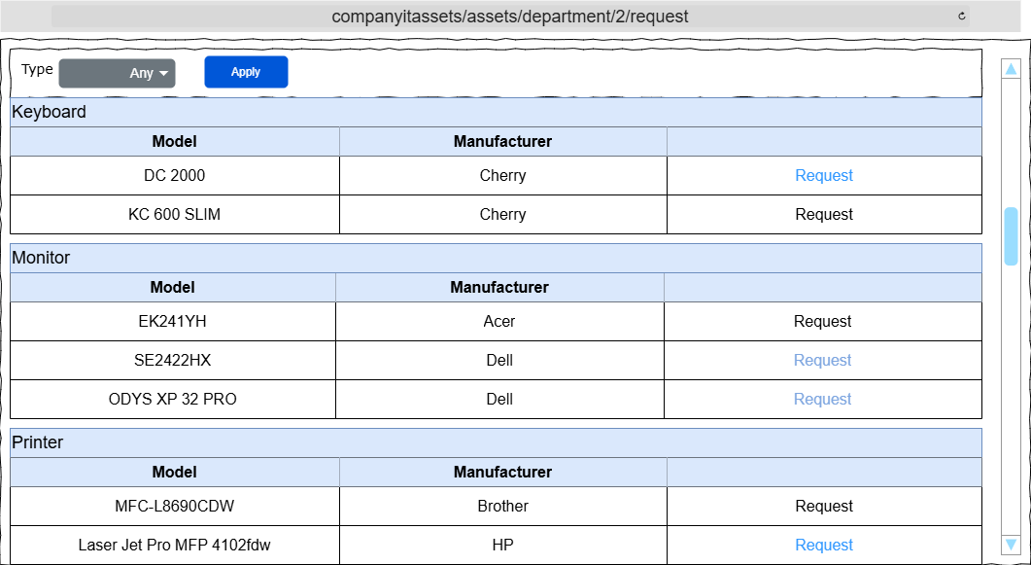
Clicking the Request Link will then redirect to a list of employees of the current department where optionally an employee to assign the requested asset to can be selected.

The ‘All Aseets’ link redirects to the Assets Index Page which is accessible to Asset Managers and Admins. Here all company assets are shown.
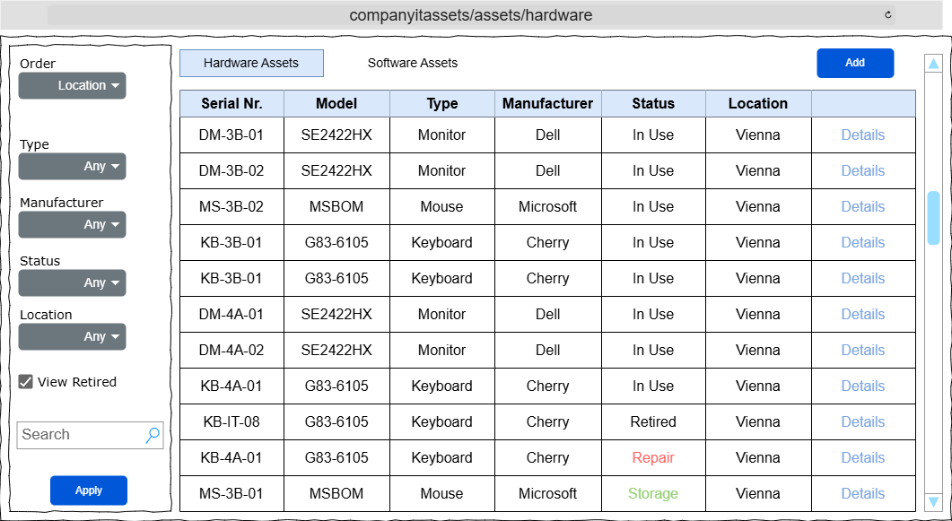

Clicking the ‘Add’ button will first redirect to a list of manufacturers to choose from and then to the ‘Add Asset’ form.
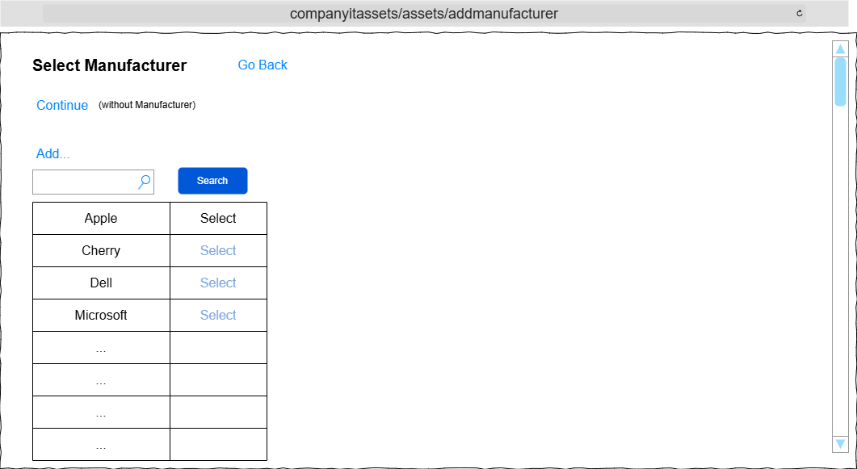
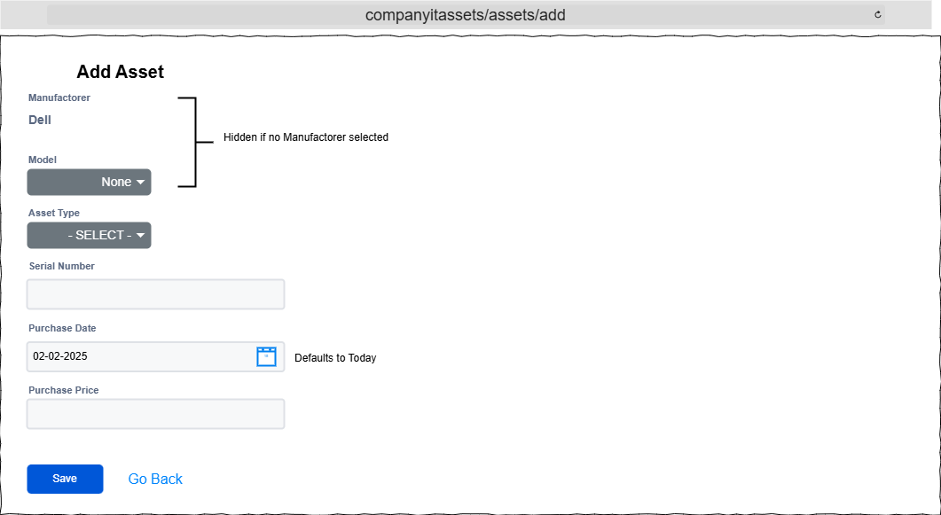

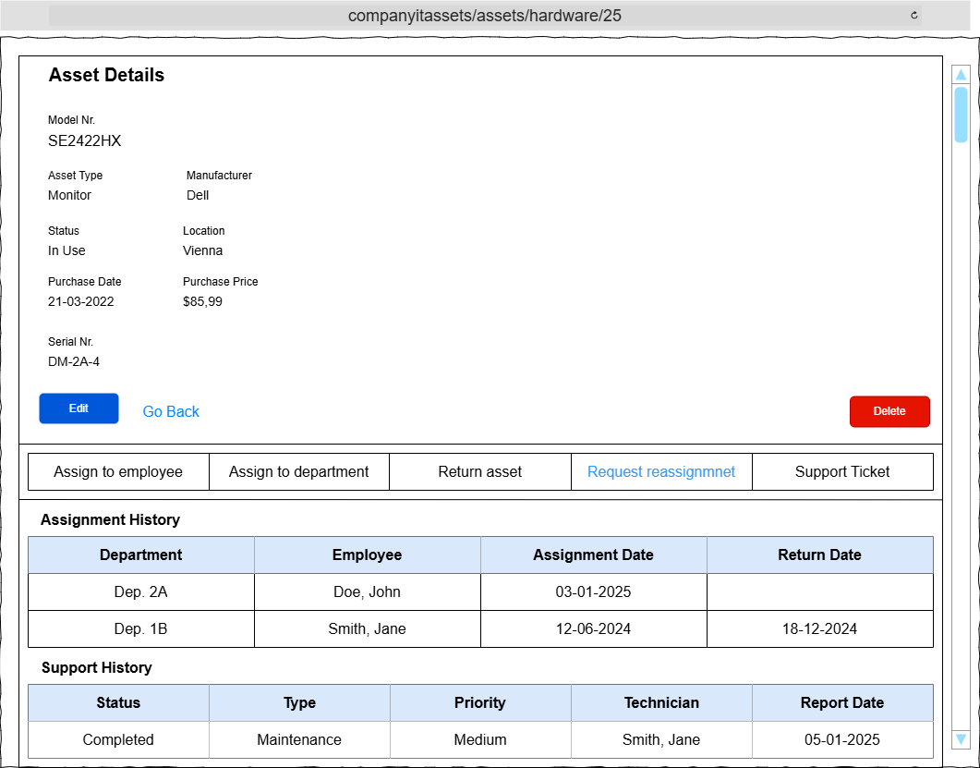
The Asset Details page shows various information of the selected asset including an assignment and support ticket history.
This page allows for various actions depending on the user’s role
Employees and Help Desk Technicians: Can create a support ticket
Asset Manager and Admin: Access to all options displayed in the Wireframe
Software License Manager: Access to all options displayed in the Wireframe (for software assets)
Department Manager: Can request an asset reassignment

The ‘Edit’ button leads to the Edit form which is similar to the ‘Add Asset’ form.
The ‘Delete’ button will redirect to a confirmation page before deleting the asset.

Assigning assets to employees or department can be done in two ways.
1. From the Asset Details Page:
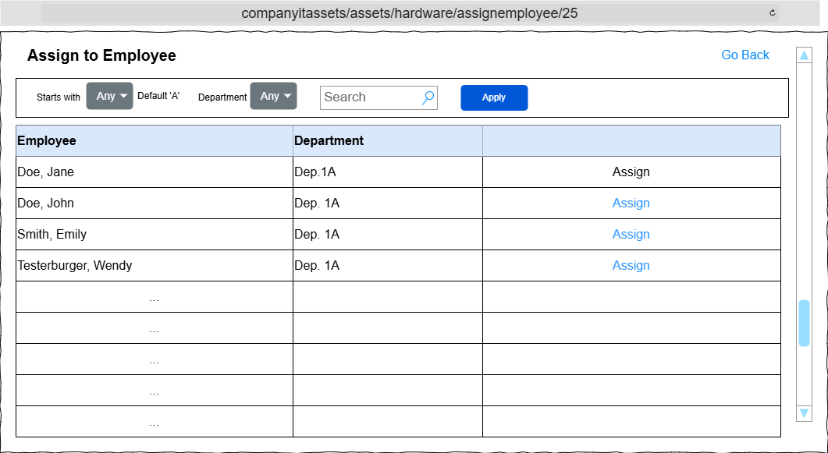
‘Assign to Employee’ will show a list of employees to choose from. The DepartmentID will be set to the chosen employees assigned department.

‘Assign to Department’ will instead show a list of Departments to choose from.

2. From an Asset Request

Asset Managers can access the header’s Requests link.
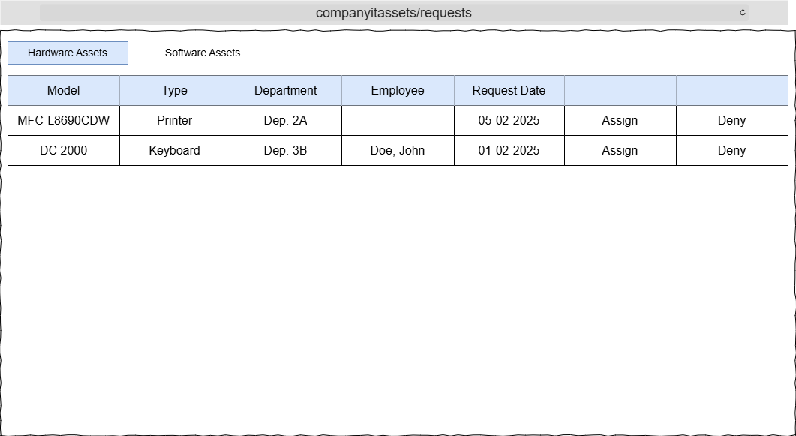

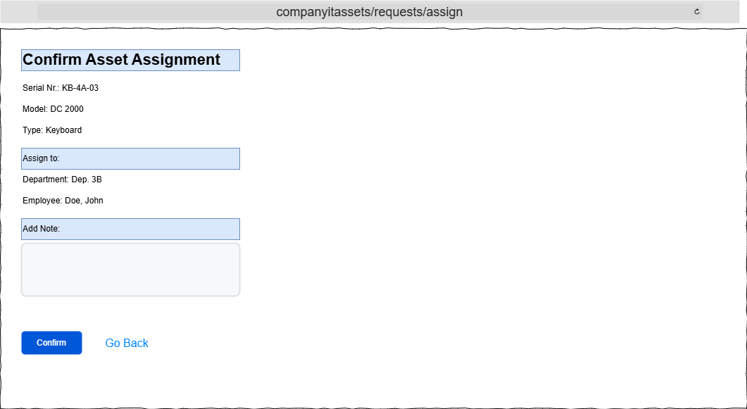
If the request is instead denied the confirmation page will be almost identical with red coloration instead.

From the Asset Details page you can also create a new support ticket

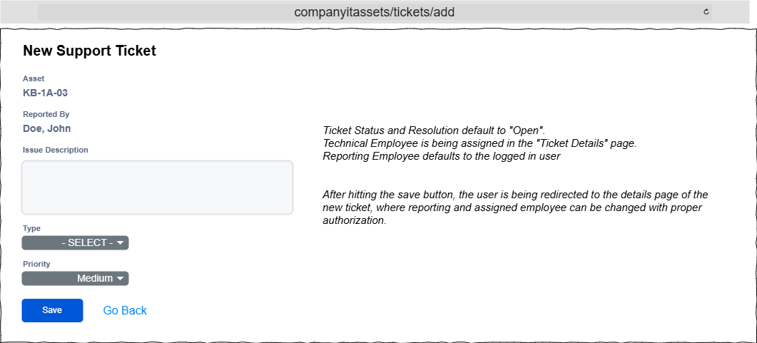
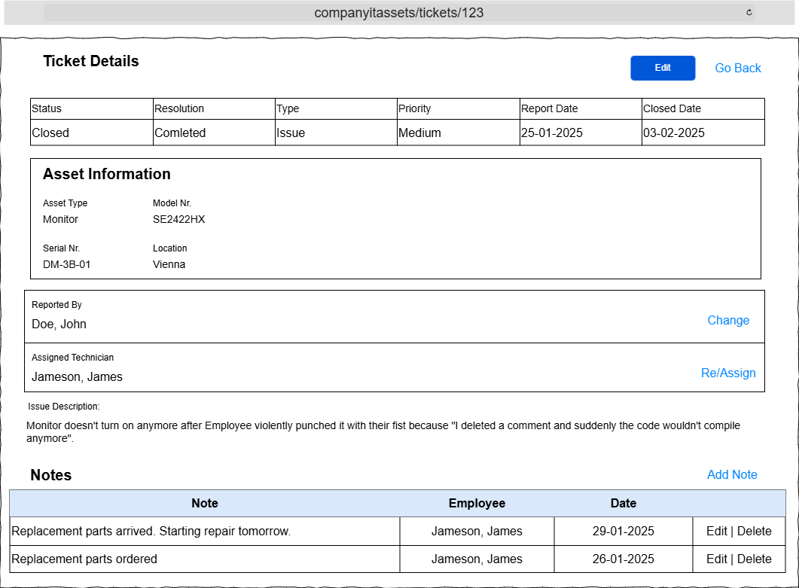
The ‘Tickets’ link in the header redirects to the tickets index page.

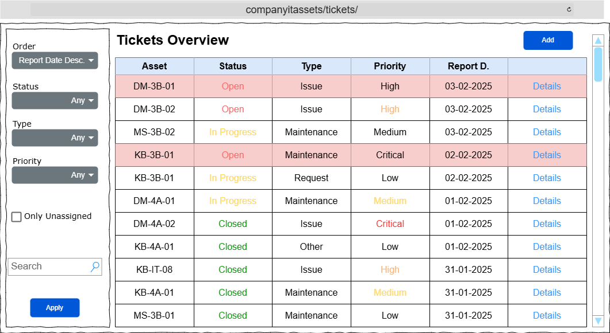
Tickets that are not assigned to a technician are displayed with a light red background.
Here clicking the “Add” button will simply redirect to the Assets Index Page where an asset can be searched for and a new ticket can be created via the asset’s details page.

Changing the assigned technician or reporting employee redirects to employee select page which is similar to the employee assign page shown in the asset assignment section above.

Users with the Department Manager Role also have read-only access to the Tickets page. However only tickets for assets assigned to their department will be shown.

Lastly and Auditor can create various reports from ‘Reports’ link in the header.
Asset Managers can create Hardware Asset Reports and Software License Managers can create Software Compliance reports

The reports index page will feature a simple interface where the user has multiple options to choose from:
- Hardware Assets Reports
  - Distribution
  - Status
  - Value
- Software Assets Reports
  - Distribution
  - Status
- Tickets

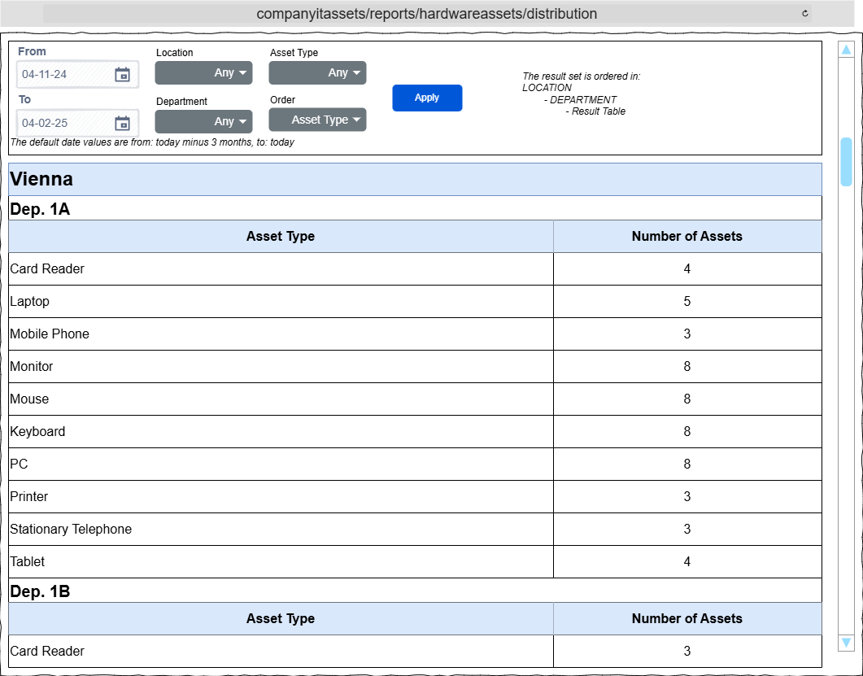
Example Hardware Distribution Reports

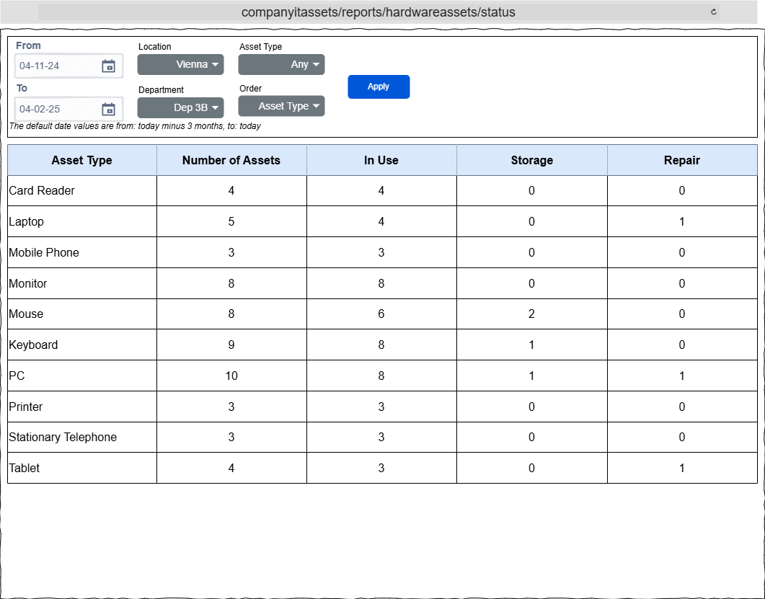

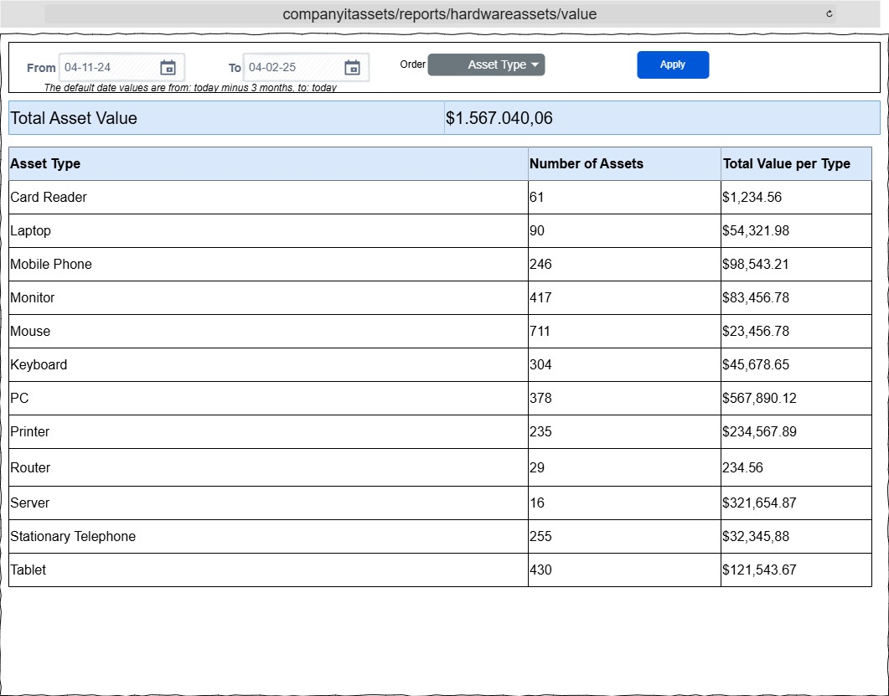

The Date Filter for all reports defaults to: From: Today – 3 Months To: Today

Software assets reports follow a similar pattern:
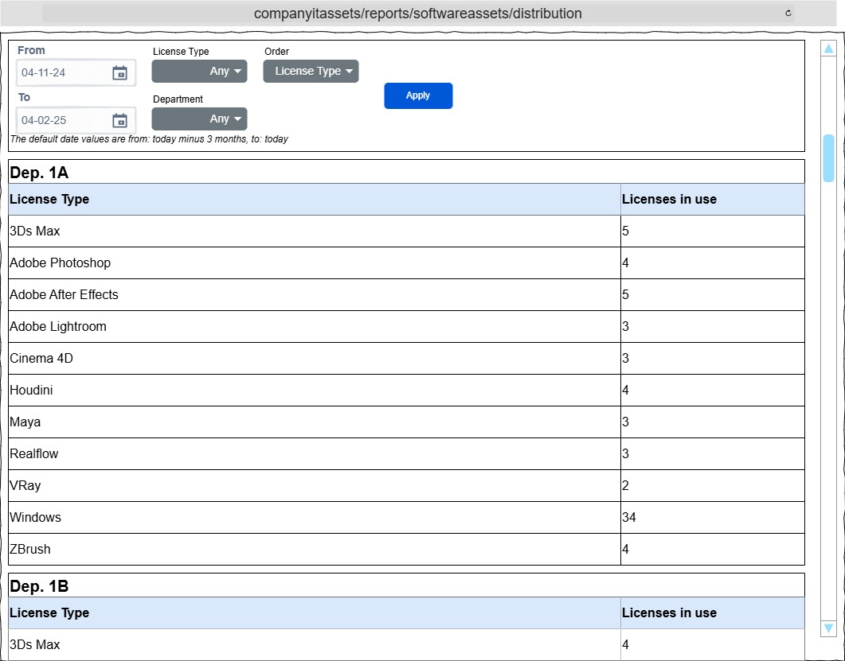
For Ticket reports all information is in one page:
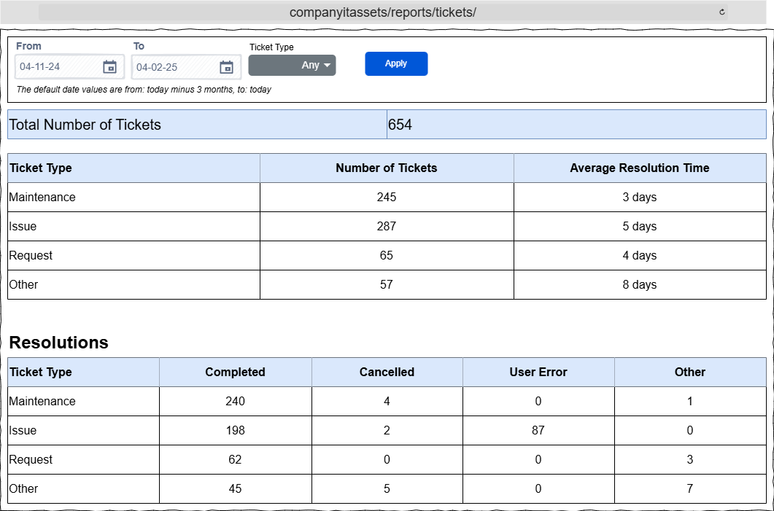
Admins can add or edit employee information and roles

The Employees Link in the header lead to the employees index page:

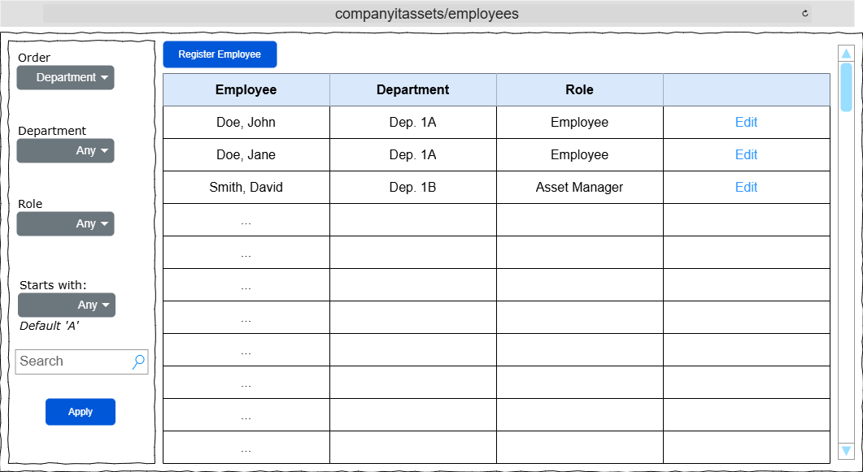
From here new Employees can be registered or existing ones edited
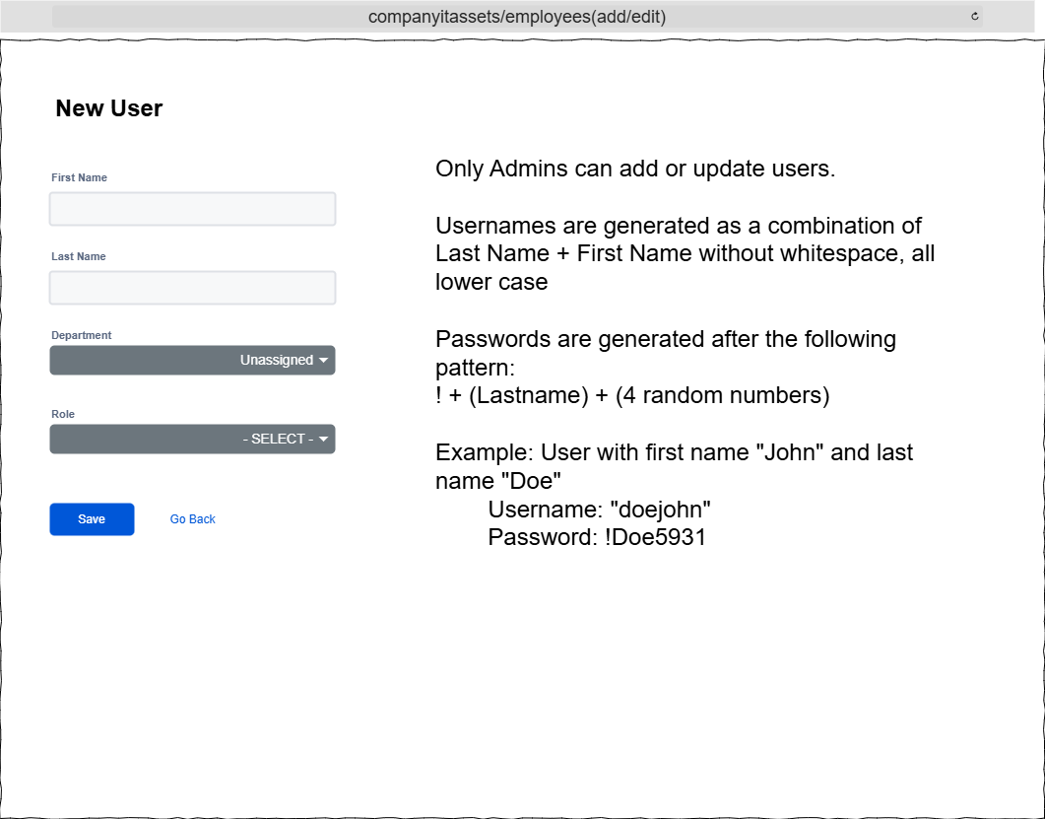

App Feedback and Error handling:

Error messages, as well as success or informational messages are displayed below the header.
Error messages are displayed with red background and white text while success or informational messages are displayed with green background and white text.
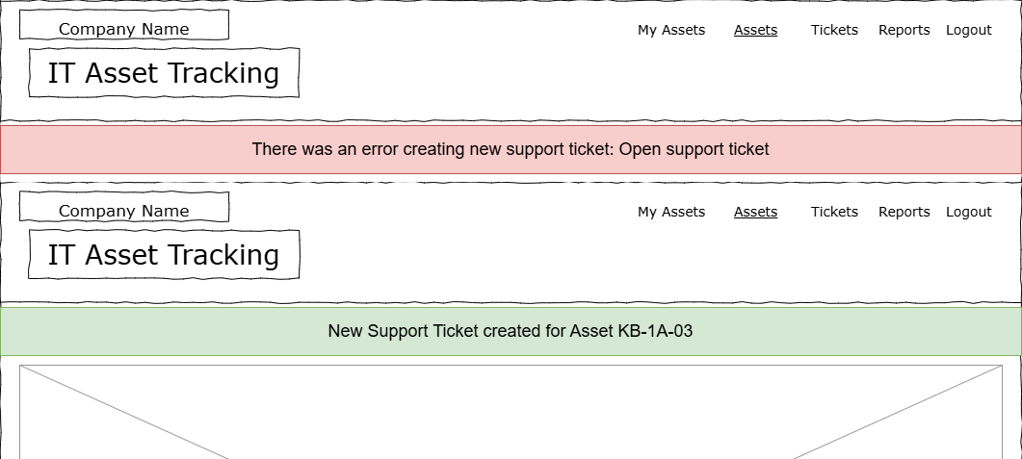
Error messages can be displayed for various reasons, like database connection errors, form invalidity, and database creating/updating/deleting errors.
Every success, information and error message is also being logged to the console.
Upon error the user is redirected to either the previous page, home page or form page where an error message, as described above will be displayed.

Rest API

CORS policies
If the environment is set to development the AllowAllOrigins policy is used. Which allows all origins as the name suggests.
In production, the app uses the AllowedOrigins policy which reads the allowed origins from the appsettings.json file.

Error Handling
Errors are being logged and controllers send an appropriate response of either 401 Unauthorized, 404 Not Found, 500 Internal Server Error etc.

The following pages contain a list of endpoints

API Endpoints

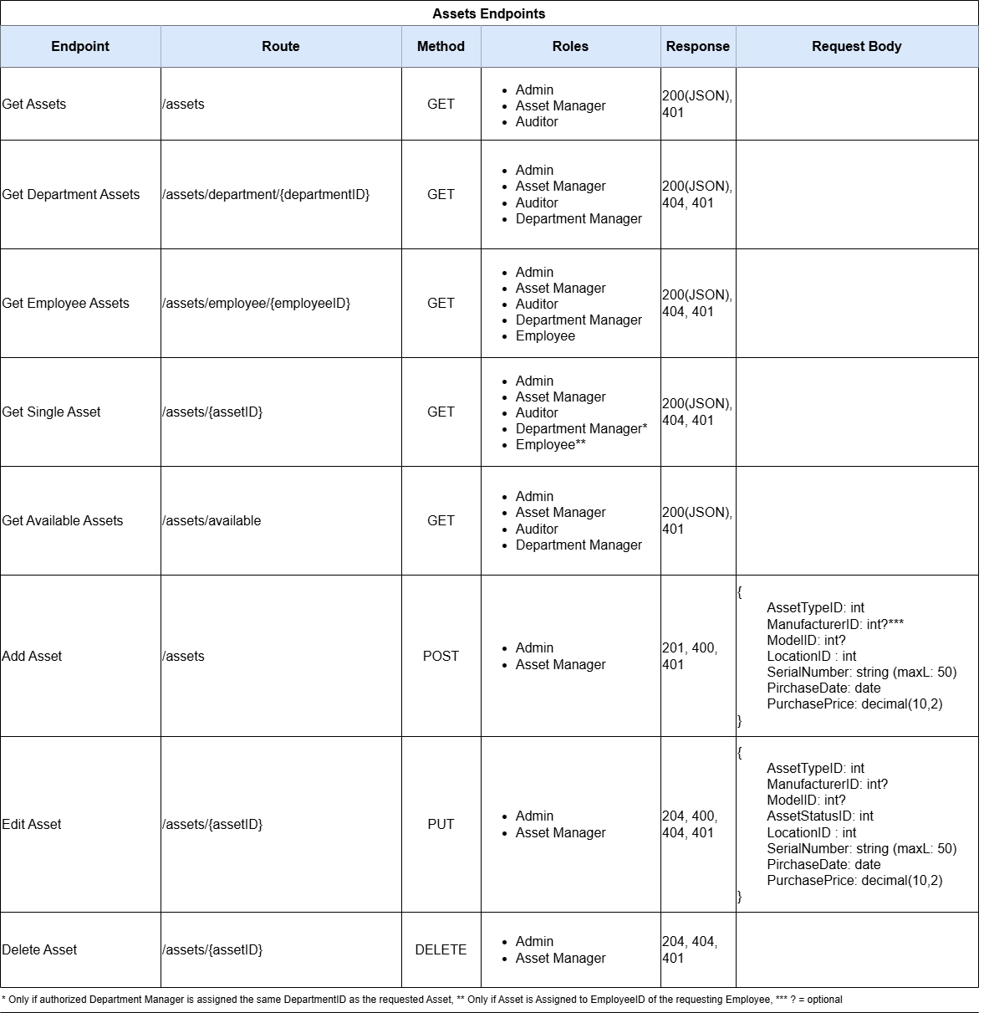
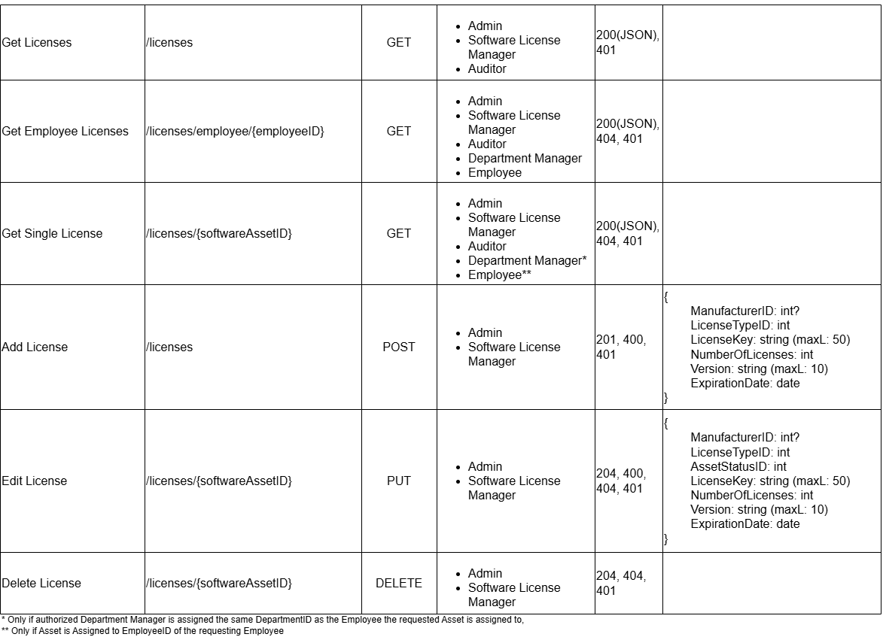

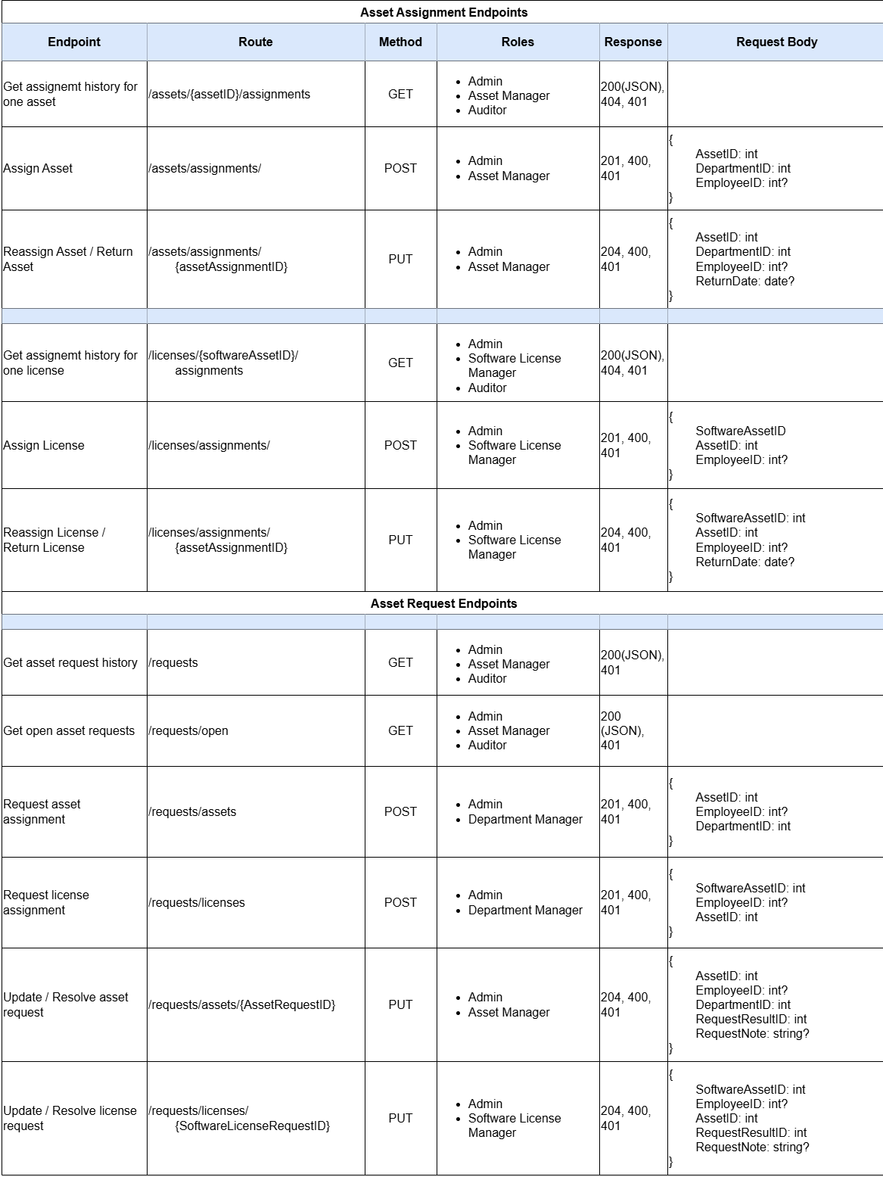
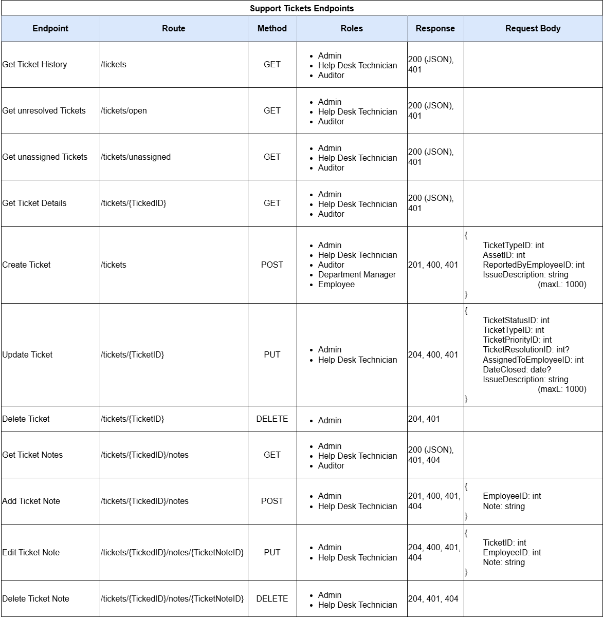

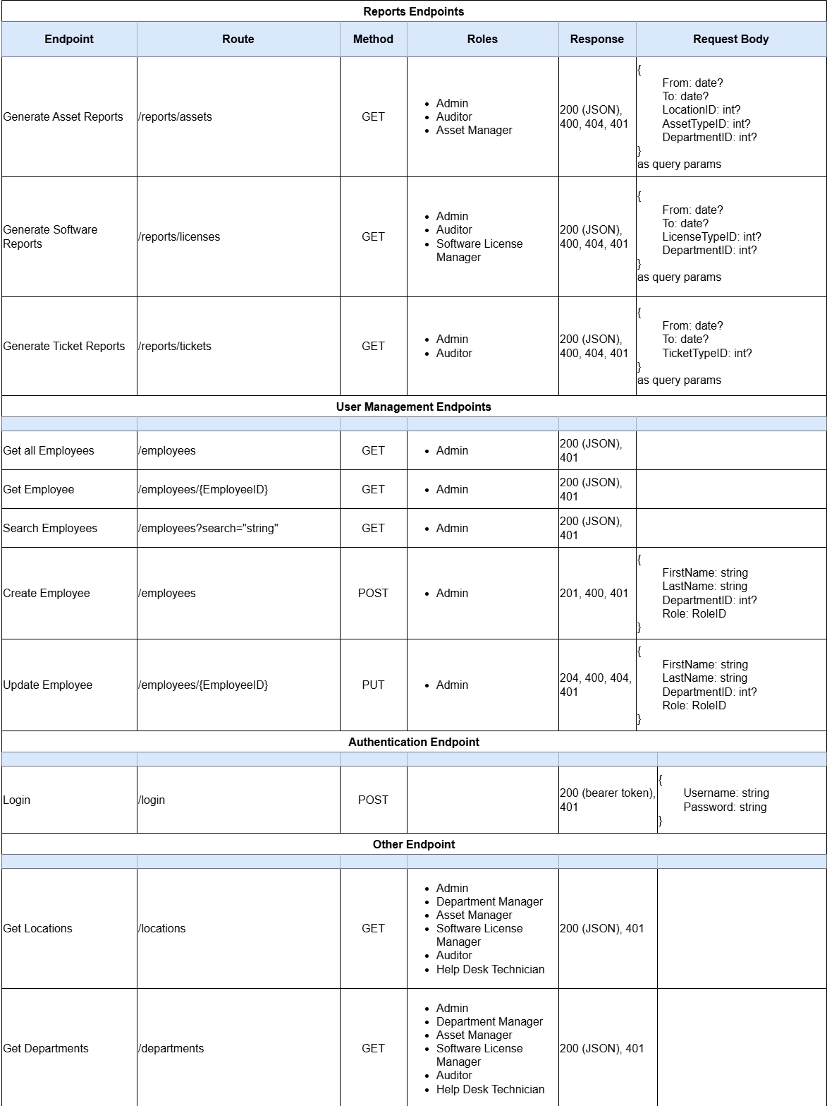

Security
The MVC and API will leverage ASP Identity Entity Framework to manage Accounts and Roles.

The Password requirements are:
- 8 characters minimal length
- Passwords are generated => ! + Lastname + 4RandomNumbers (!Doe5278)
- if the user’s last name is less than three characters long the generated password will substitute with additional random numbers at the end.
- at least one upper case character
- at least one lower case character
- at least one digit or other symbol

As described in the MVC users are assigned one of the following roles
- Admin: Access to all sites content and functionalities, can add or update users
- Asset Manager: Can add, edit and delete assets, assign assets, generate asset reports.
- Software License Manager: Manages software assets and their assignment, generate software compliance reports
- Help Desk Technician: Manage support tickets. Creating, updating, assigning and adding notes to tickets.
- Department Manager: View assets assigned to their department, request new assets or reassignments, view ticket status for their department’s assets
- Employee: View and create support tickets for their assigned assets.
- Auditor: Read-Only access to all asset and ticket information, generate and view any reports.

Only User with the Admin Role may assign roles to other users.
See MVC Layer and API Endpoints section for role restricted access.

Logging
The MVC and API, by default, log information level events and above to the console.
I use Serilog for logging with Console and MSSqlServer Sink

- Information Logs on Database changes like creating, updating or deleting data.
- Warning Logs for invalid or unauthorized http requests.
- Error Logs for caught exceptions.

The applications write logs to the console and optionally to the database.

Database Logging is configurable in the appsettings.json of each program within the “DbLogging” section:
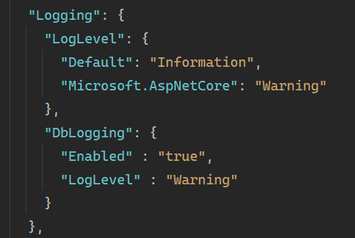
If “Enabled” is set to “true” the application writes events of the configured log level and above to the database.
The “LogLevel” can be set to:
- “Information”
- “Debug”
- “Warning”
- “Error”

The MVC and API write Logs to seperate Database Tables. “MVC_LogEvents”, “API_LogEvents”

TODO

Can a user have more than one role? Something to think about. The interface only supports a single role.

What is the plan for when there is a lot of assets re: lookups? If there are thousands, we don't want to pre-load assets, we probably want them to fill out some filters first.

Should we consider a paging strategy as well. This would be a good mini-research project on how to implement paging with EF Core.

