

Database fundementals II assignment



Ariel Rosenfeld

710567

Contents

Question 1 2

Question 2 3

LGBRAND 3

LGCUSTOMER 4

LGDEPARTMENT 4

LGEMPLOYEE 5

LGINVOICE 5

LGLINE 6

LGPRODUCT 7

LGSALARY_HISTORY 7

LGSUPPLIES 8

LGVENDOR 9

Question 3 10

Question 4 10

Question 5 10

Question 6 11

Question 7 11

Question 8 11

# Question 1

The Department Employs Employees.

Employees Manages The Department.

Employees Have Salaries.

Employees Completes Invoices.

Products Appear on Lines.

Customers Places Invoices.

Brands Includes Products.

Products Provided By Supplies.

Vendors Provides Supplies.

# Question 2

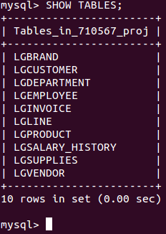

## LGBRAND

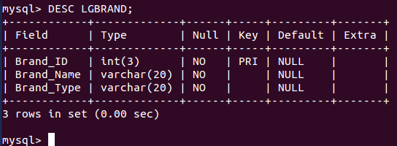

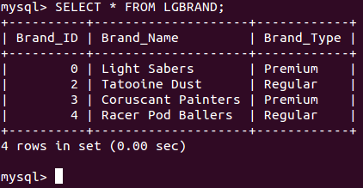

## LGCUSTOMER

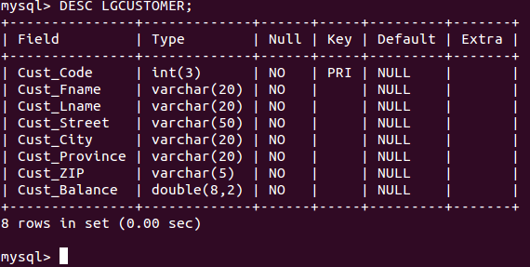

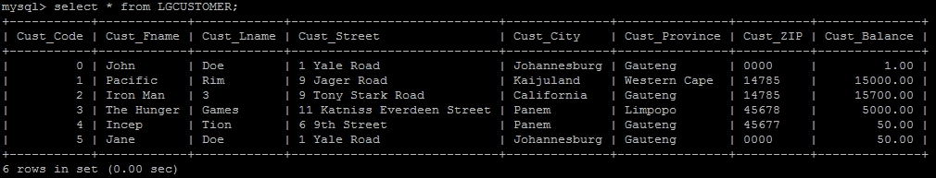

## LGDEPARTMENT

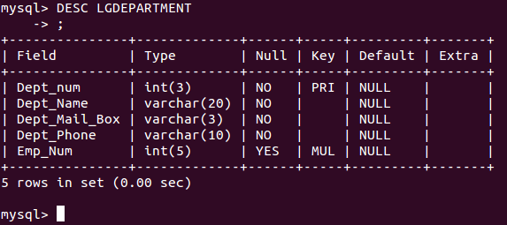

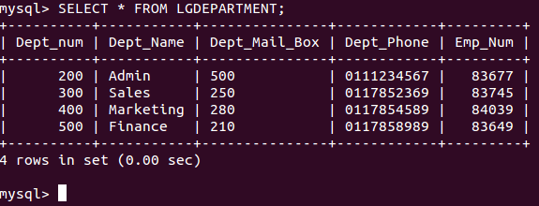

## LGEMPLOYEE

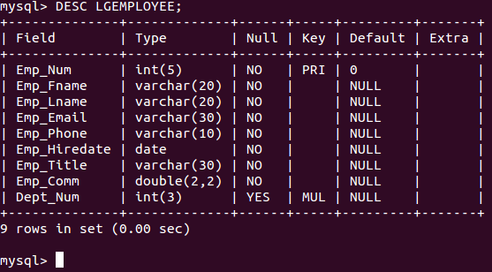

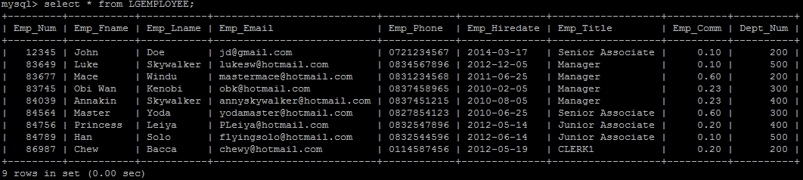

## LGINVOICE

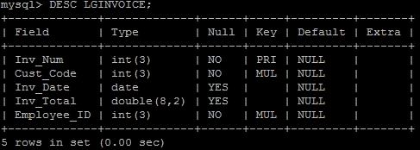

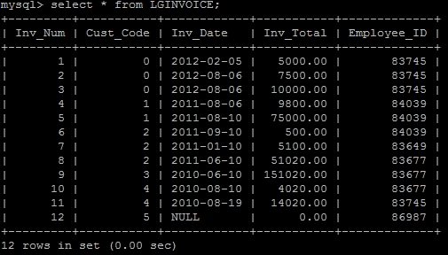

## LGLINE

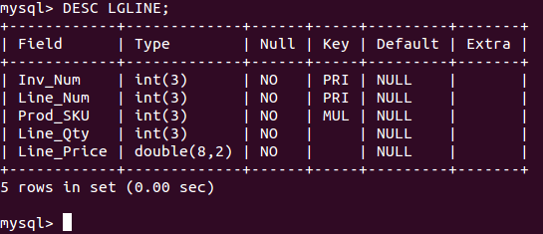

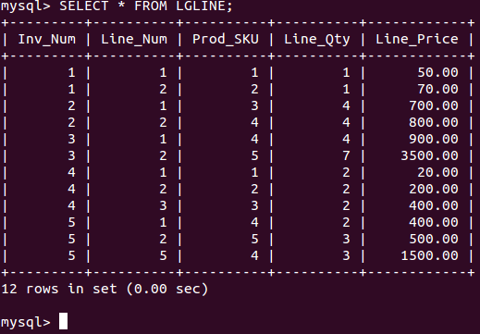

## LGPRODUCT

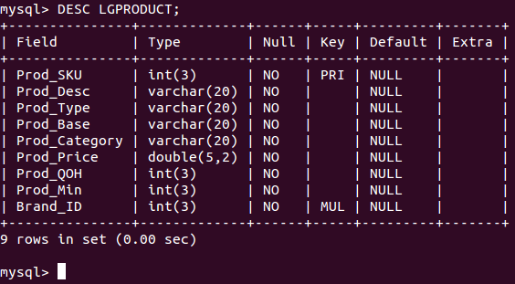

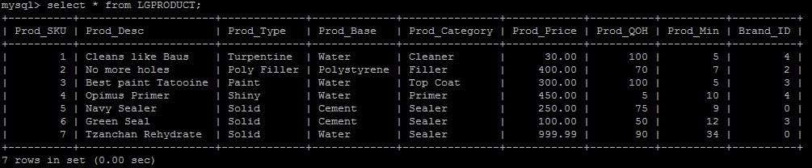

## LGSALARY_HISTORY

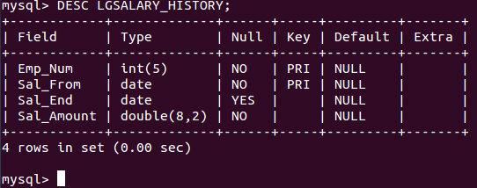

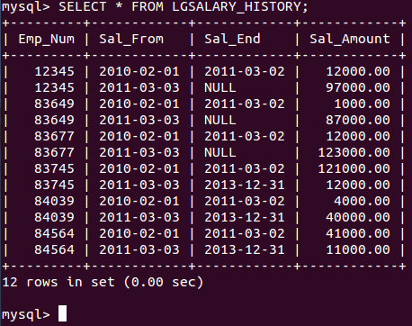

## LGSUPPLIES

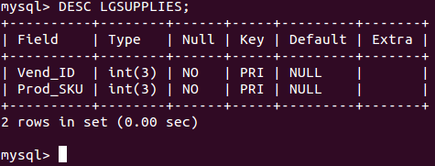

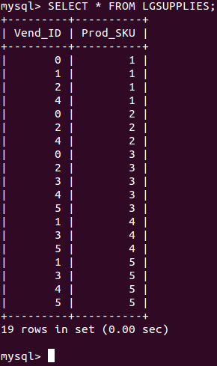

## LGVENDOR

