*COMS2002***Database Fundamentals II - Assignment**

<NAME> (<STUDENT NUMBER>)

15/03/2013

Table of Contents

Question 3 2

Question 4 4

Question 5 7

Query 7

Description 7

Question 6 7

Query 7

Description 7

Question 7 8

Query 8

Description 8

Question 8 9

Query 9

Description 9

Question 9 9

Query 9

Description 10

Question 10 10

Query 10

Description 10

Question 11 11

Query 11

Description 11

Question 12 12

Query 12

Description 12

Question 13 12

Query 12

Description 13

Question 14 13

Query 13

Description 14

Question 15 14

Query 14

Description 14

Question 16 15

Query 15

Description 15

Question 17 15

Query 15

Description 16

Question 18 17

Query 17

Description 17

# Question 3

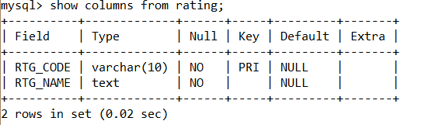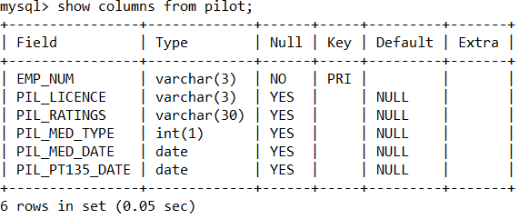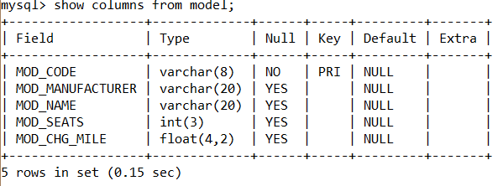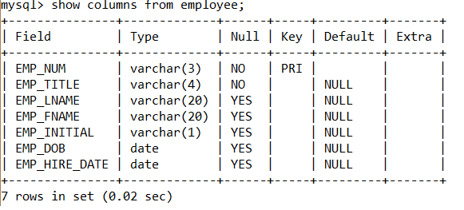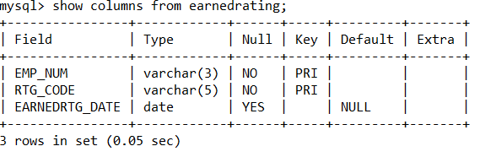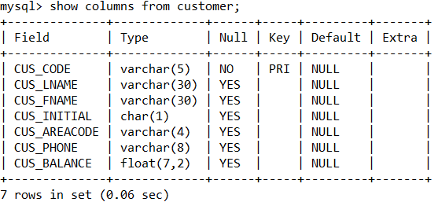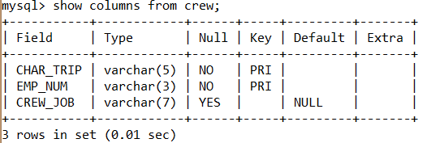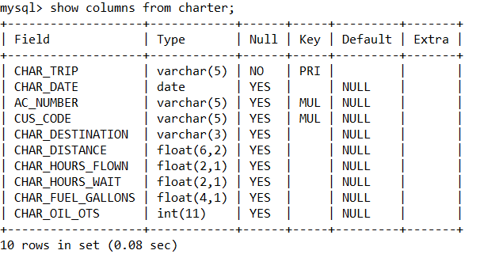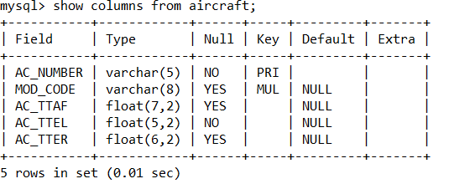

# Question 4

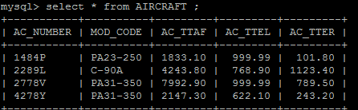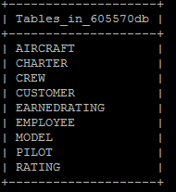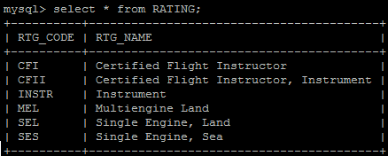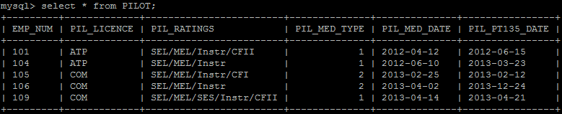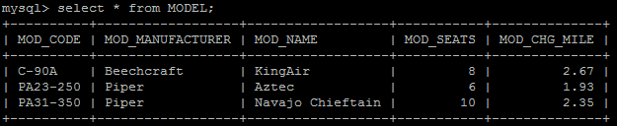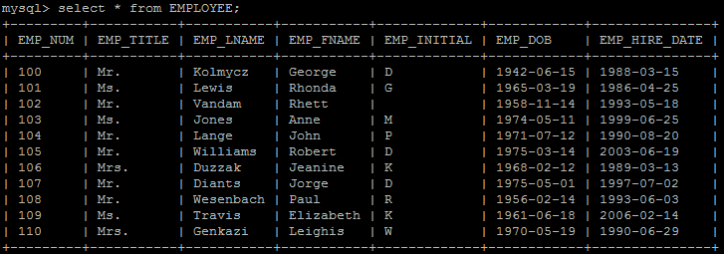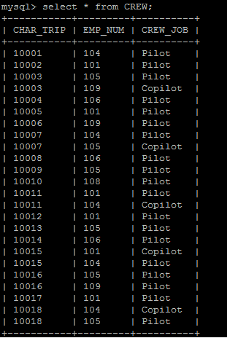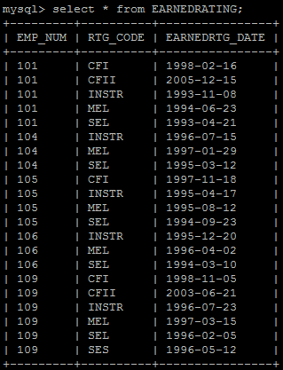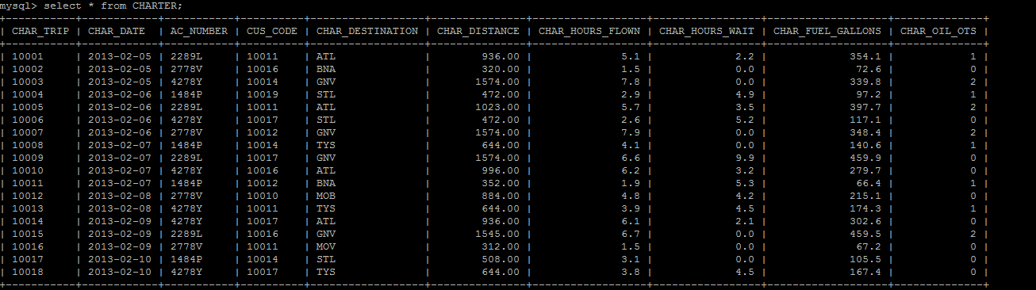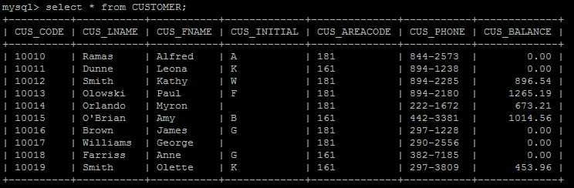

# Question 5

## Query

SELECT CHAR_TRIP,

CHAR_DATE,

AC_NUMBER,

CHAR_DESTINATION,

CHAR_DISTANCE,

CHAR_HOURS_FLOWN,

CHAR_HOURS_WAIT

FROM CHARTER;

## Description

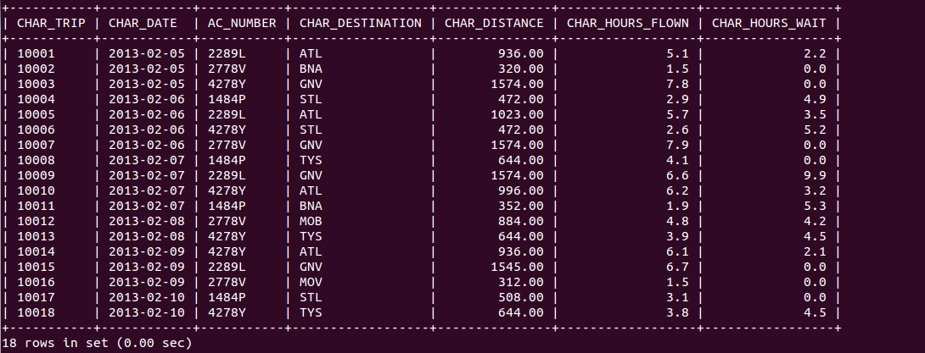

This SQL query will return the first seven attributes from the table know as CHARTER, and it will display all know data from the table Charter for the seven attributes.

# Question 6

## Query

SELECT Date_format(CHAR_DATE, '%d-%b-%y') AS CHAR_DATE,

AC_NUMBER,

CHAR_DESTINATION,

CHAR_DISTANCE,

CHAR_HOURS_FLOWN

FROM CHARTER

WHERE AC_NUMBER = '2778V';

## Description

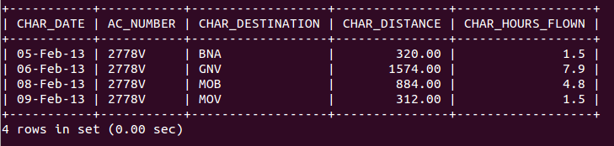

This simple query displays the requested fields from a single table (Charter). The conditions for the query are that AC_NUMBER=2778V. The WHERE clause is used to specify this.

# Question 7

## Query

CREATE VIEW AC_2778V AS SELECT CHAR_DATE, AC_NUMBER, CHAR_DESTINATION,

CHAR_DISTANCE, CHAR_HOURS_FLOWN FROM CHARTER WHERE AC_NUMBER = '2778V';

## Description

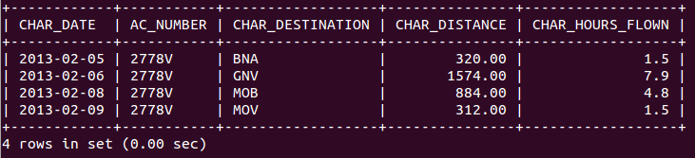

This SQL query will create a view, a view is a virtual table, it is a data object which does not contain any data. The difference between a view and a table is that views are definitions built on top of other tables. If data is changed in the underlying table, the same change is reflected in the view. This view is created with the name 'AC_2778V' and contains the specified requested attributes from the table named CHARTER providing the condition AC_NUMBER = '2778V' is met.

# Question 8

## Query

SELECT CHAR_DATE,

CHARTER.AC_NUMBER,

CHAR_DESTINATION,

CUS_LNAME,

CUS_AREACODE,

CUS_PHONE

FROM CHARTER

INNER JOIN CUSTOMER

ON CHARTER.CUS_CODE = CUSTOMER.CUS_CODE

INNER JOIN AIRCRAFT

ON CHARTER.AC_NUMBER = AIRCRAFT.AC_NUMBER

WHERE AIRCRAFT.AC_NUMBER = '2778V';

## Description

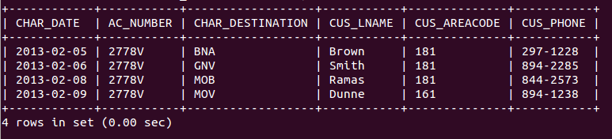

This SQL query selects and displays the specific attributes as requested for all the records that have an Aircraft Number of “2778V” and manages relations using the inner join function.

# Question 9

## Query

SELECT Date_format(CHAR_DATE, '%d-%b-%y') AS CHAR_DATE,

CHAR_DESTINATION,

CHARTER.AC_NUMBER,

MOD_NAME,

MOD_CHG_MILE

FROM CHARTER

INNER JOIN AIRCRAFT

ON CHARTER.AC_NUMBER = AIRCRAFT.AC_NUMBER

INNER JOIN MODEL

ON AIRCRAFT.MOD_CODE = MODEL.MOD_CODE

WHERE CHAR_DATE = '2013-02-06';

## Description

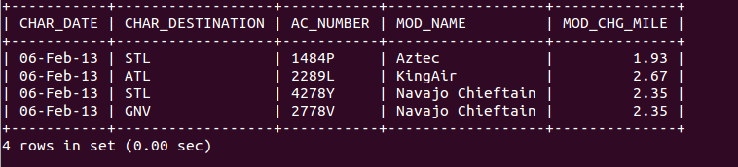

This SQL query returns the required fields from the CHARTER and MODEL tables whilst using the relationship between CHARTER, AIRCRAFT and MODEL tables; this is done so using an INNER JOIN statement matching AC_NUMBER from CHARTER to AIRCRAFT and MOD_CODE from AIRCRAFT to MODEL.

# Question 10

## Query

SELECT Date_format(CHAR_DATE, '%d-%b-%y') AS CHAR_DATE,

CHAR_DESTINATION,

CHARTER.AC_NUMBER,

MOD_NAME,

MOD_CHG_MILE,

CUS_LNAME

FROM CHARTER

INNER JOIN CUSTOMER

ON CHARTER.CUS_CODE = CUSTOMER.CUS_CODE

INNER JOIN AIRCRAFT

ON CHARTER.AC_NUMBER = AIRCRAFT.AC_NUMBER

INNER JOIN MODEL

ON AIRCRAFT.MOD_CODE = MODEL.MOD_CODE

WHERE CHAR_DATE >= '2013-02-09';

## Description

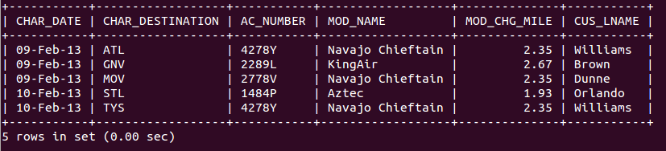

This query does the same as Question 9, however it restricts records to those created since 9 February by making sure that CHAR_DATE is greater than or equal to this date. It also requires an additional inner join to relate the customer codes in the CHARTER table to those found in the CUSTOMER table using the CUS_CODE field.

# Question 11

## Query

SELECT Date_format(CHAR_DATE, '%d-%b-%y') AS CHAR_DATE,

CHAR_DESTINATION,

CHARTER.AC_NUMBER,

MOD_CHG_MILE,

CHAR_DISTANCE,

EMPLOYEE.EMP_NUM,

CREW_JOB,

EMP_LNAME

FROM CHARTER

INNER JOIN CREW

ON CHARTER.CHAR_TRIP = CREW.CHAR_TRIP

INNER JOIN EMPLOYEE

ON CREW.EMP_NUM = EMPLOYEE.EMP_NUM

INNER JOIN AIRCRAFT

ON CHARTER.AC_NUMBER = AIRCRAFT.AC_NUMBER

INNER JOIN MODEL

ON AIRCRAFT.MOD_CODE = MODEL.MOD_CODE

WHERE CHAR_DATE >= '2013-02-09';

## Description

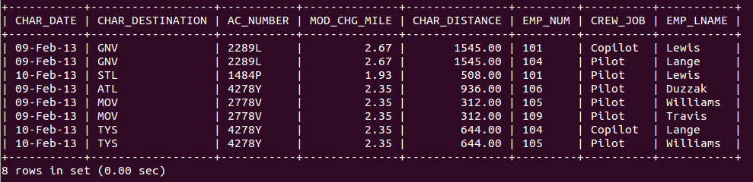

This SQL query displays the requested attributes from the different tables that were generated after 9 February 2013 and manages relations using the inner join function.

# Question 12

## Query

SELECT Date_format(CHAR_DATE, '%d-%b-%y') AS CHAR_DATE,

CHARTER.AC_NUMBER,

MOD_NAME,

CHAR_HOURS_FLOWN,

CHAR_FUEL_GALLONS,

( CHAR_FUEL_GALLONS / CHAR_HOURS_FLOWN ) AS FuelperGallon

FROM CHARTER

INNER JOIN AIRCRAFT

ON CHARTER.AC_NUMBER = AIRCRAFT.AC_NUMBER

INNER JOIN MODEL

ON AIRCRAFT.MOD_CODE = MODEL.MOD_CODE

WHERE CHAR_DATE = '2013-02-06';

## Description

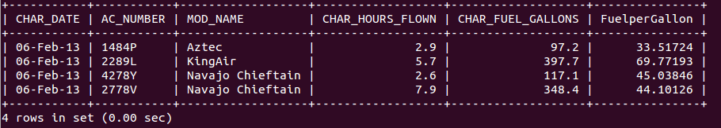

This query builds on much from Question 9, including constraints but has been slightly modified to return a calculated field, 'fuel per hour' (FuelperGallon) by dividing CHAR_FUEL_GALLONS by CHAR_HOURS_FLOWN. Contrary to Question 9, MOD_CHG_MILE has not been returned, whereas CHAR_FUEL_GALLONS and CHAR_HOURS_FLOWN has been returned.

# Question 13

## Query

SELECT CHAR_DATE,

CUS_LNAME,

CHAR_DISTANCE,

MOD_CHG_MILE,

( MOD_CHG_MILE * CHAR_DISTANCE ) AS MileageCharge

FROM CUSTOMER,

MODEL,

CHARTER,

AIRCRAFT

WHERE CHARTER.AC_NUMBER = AIRCRAFT.AC_NUMBER

AND AIRCRAFT.MOD_CODE = MODEL.MOD_CODE

AND CHARTER.CUS_CODE = CUSTOMER.CUS_CODE

AND CHAR_DATE >= '2013-02-09';

## Description

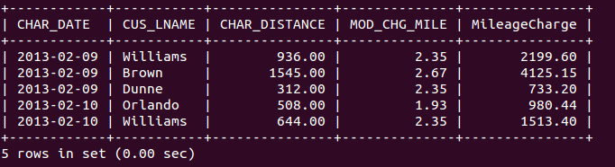

This SQL query selects 4 fields from the tables CHARTER and MODEL with the constraint that CHAR_DATE be after the 9th of Feb. It also calculates a field, MileageCharge, which is the product of MOD_CHG_MILE and CHAR_DISTANCE and joins tables AIRCRAFT, MODEL, CHARTER and CUSTOMER by equating primary keys to foreign keys.

# Question 14

## Query

SELECT CHAR_DATE,

CUS_LNAME,

( MOD_CHG_MILE * CHAR_DISTANCE ) AS

MileageCharge,

( CHAR_HOURS_WAIT * 50 ) AS

WaitingCharge,

( ( MOD_CHG_MILE * CHAR_DISTANCE ) + ( CHAR_HOURS_WAIT * 50 ) ) AS

TotalCharge

FROM CUSTOMER,

MODEL,

CHARTER,

AIRCRAFT

WHERE CHARTER.AC_NUMBER = AIRCRAFT.AC_NUMBER

AND AIRCRAFT.MOD_CODE = MODEL.MOD_CODE

AND CHARTER.CUS_CODE = CUSTOMER.CUS_CODE;

## Description

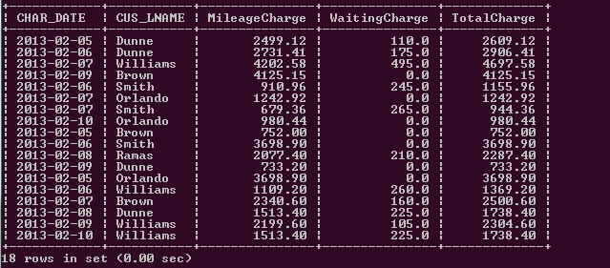

This SQL query selects 2 fields from tables CHARTER and CUSTOMER. It also calculates 3 fields, MileageCharge, WaitingCharge and TotalCharge where MileageCharge is the product of MOD_CHG_MILE and CHAR_DISTANCE, WaitingCharge is the CHAR_HOURS_WAIT multiplied by 50 and TotalCharge is the sum of MileageCharge and WaitingCharge. This query also joins tables CHARTER, AIRCRAFT, MODEL and CUSTOMER by equating primary keys to foreign keys.

# Question 15

## Query

SELECT CUS_LNAME,

CUS_FNAME,

CUS_INITIAL,

CUS_BALANCE

FROM CUSTOMER

WHERE CUS_BALANCE > 0;

## Description

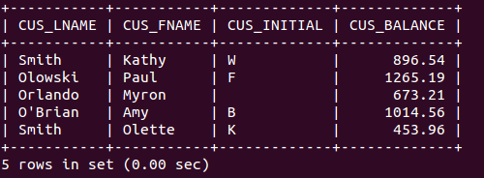

This simple query displays the requested field values from the CUSTOMER table if the balance of the customer (CUS_BALANCE) is not settled i.e. CUS_BALANCE>0.

# Question 16

## Query

SELECT Min(CUS_BALANCE) AS MIN_BALANCE,

Max(CUS_BALANCE) AS MAX_BALANCE,

Avg(CUS_BALANCE) AS AVG_BALANCE,

Sum(CUS_BALANCE) AS TOTAL_BALANCE

FROM CUSTOMER;

## Description

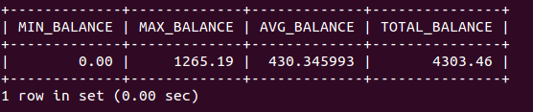

This SQL query displays the maximum, minimum, average and total balance from the CUSTOMER table using the following commands MAX(), MIN(), AVG() and SUM() respectively; and gives them their own heading using the “AS” command.

# Question 17

## Query

SELECT CHARTER.CHAR_TRIP,

Date_format(CHAR_DATE, '%d-%b-%y'),

CHARTER.AC_NUMBER,

MOD_NAME,

CHAR_HOURS_FLOWN,

EMP_LNAME,

CREW_JOB

FROM CHARTER

INNER JOIN AIRCRAFT

ON CHARTER.AC_NUMBER = AIRCRAFT.AC_NUMBER

INNER JOIN MODEL

ON AIRCRAFT.MOD_CODE = MODEL.MOD_CODE

INNER JOIN CREW

ON CHARTER.CHAR_TRIP = CREW.CHAR_TRIP

INNER JOIN EMPLOYEE

ON CREW.EMP_NUM = EMPLOYEE.EMP_NUM;

## Description

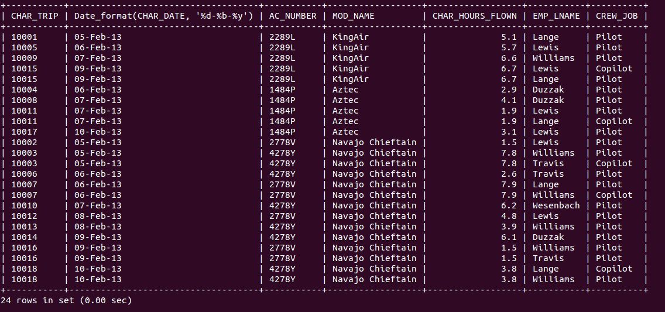

This SQL query will return information from 3 tables, namely: CHARTER, MODEL and EMPLOYEE by linking this tables using primary/foreign keys within those tables as well as from tables: AIRCRAFT and CREW. There are no specified constraints on the resultant data, so no 'WHERE' statement was used.

# Question 18

## Query

SELECT EMP_NUM,

EMP_LNAME,

EMP_FNAME,

EMP_HIRE_DATE,

EMP_DOB,

Curdate() AS

QueryDate,

Date_format(Now(), '%Y') - Date_format(EMP_DOB, '%Y') - (

Date_format(Now(), '00-%m-%d') < Date_format(EMP_DOB, '00-%m-%d') ) AS

EMP_AGE

FROM EMPLOYEE;

## Description

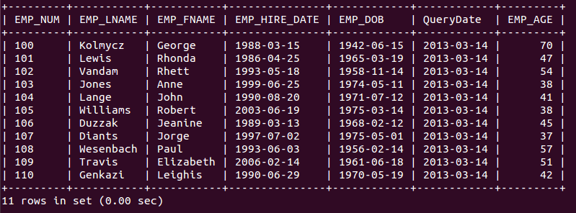

This SQL query selects and displays the specific attributes as requested, but adds onto those attributes the attribute QueryDate, which is just the date that the query was run on. Also added to these attributes is an attribute name EMP_AGE, which calculates the age of each employee by subtracting the current year from the given employee date of birth, and then checks if the current month and day is less than the birth month and day, and if this condition is true, it subtracts one from the initial age calculations regarding year because it hasn’t been that persons birthday in the current year yet.