Final Submission Document (to be saved as PDF):

Title: Timmy's Lost Dimension

Team Members:
Meredith Burgess
Jessica Evans
Cassie Souza
Tyler Glotz
Tyler Rostenbach

Project Tracker: Trello
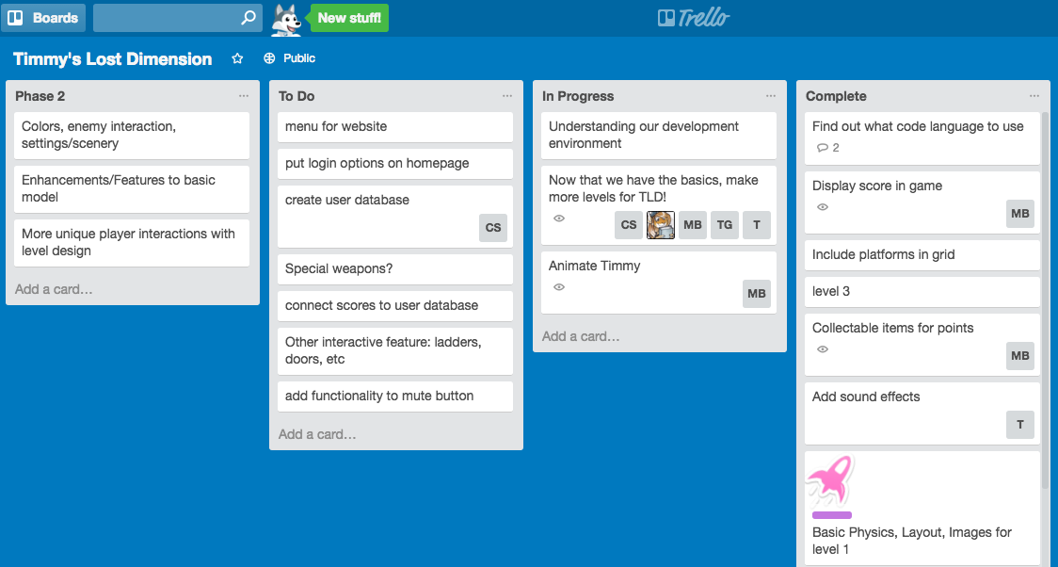
https://trello.com/b/KPJxUush/timmy-s-lost-dimension

Repository:
https://github.com/TRianR/CSCI3308_Project

Screenshots of each members contributions throughout semester:
** Please update your own with whatever you want **

Meredith Burgess
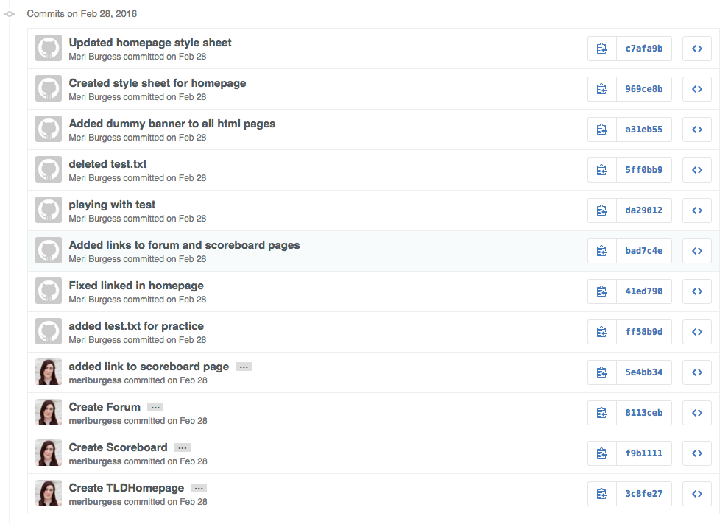
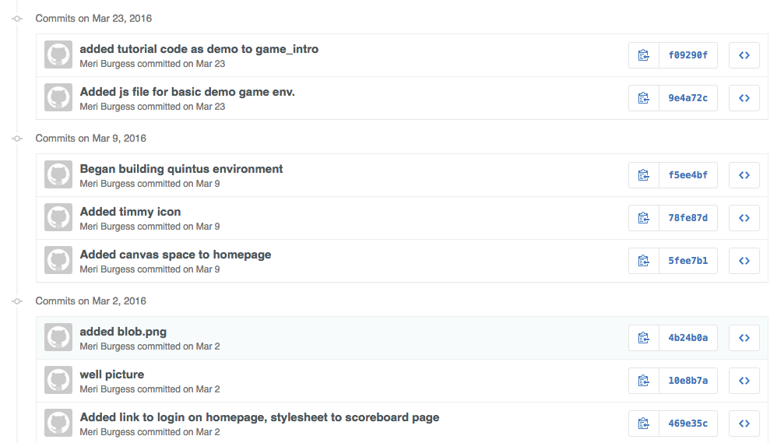
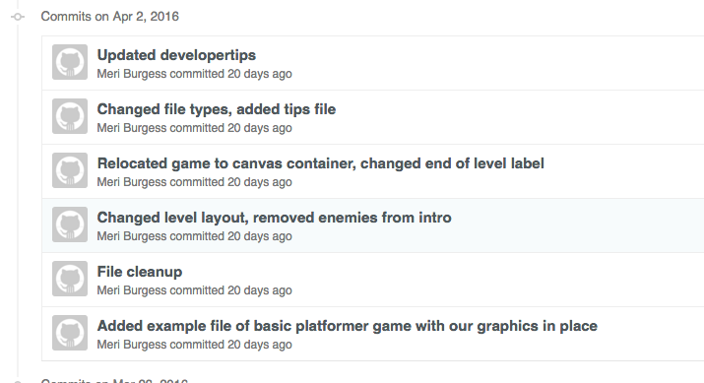
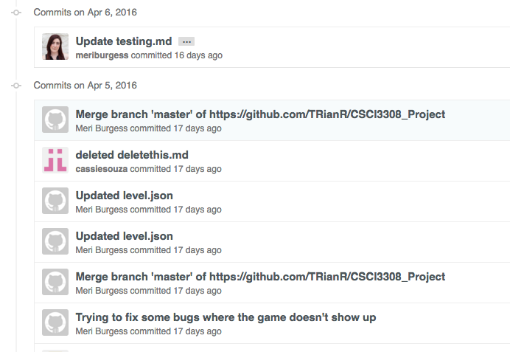
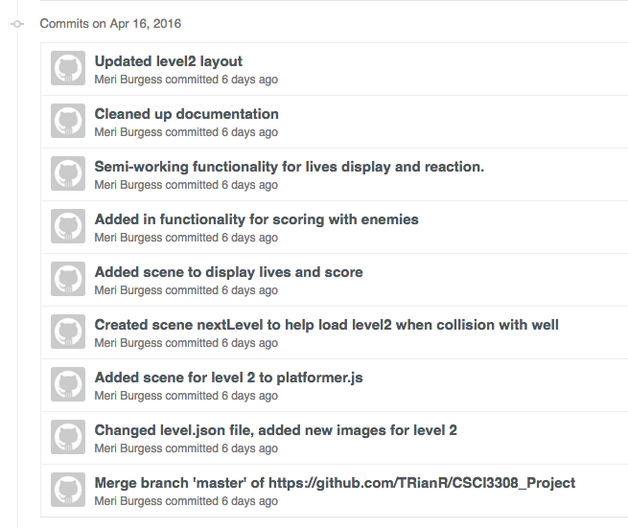
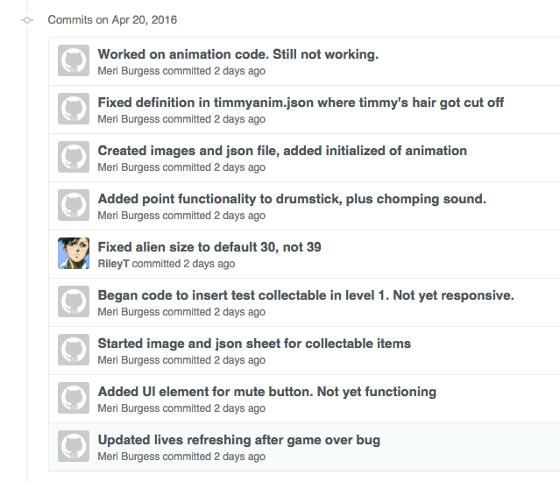
Tyler Glotz
Tyler Rostenbach - Both TRianR and RileyT
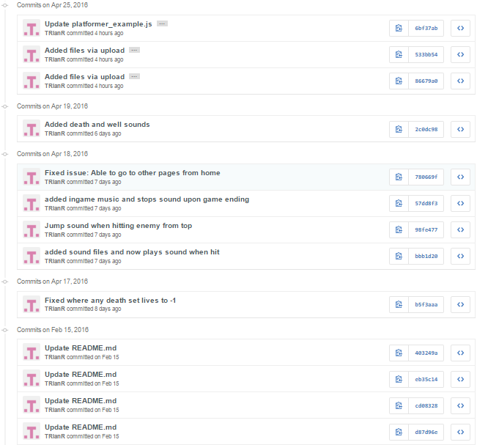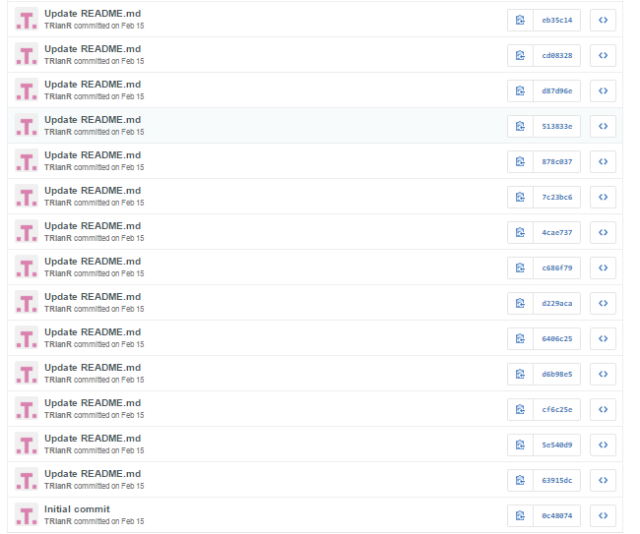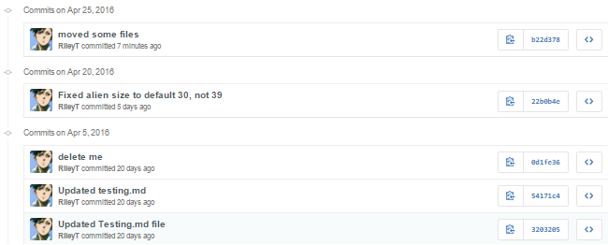
Cassie Souza

Jessica Evans

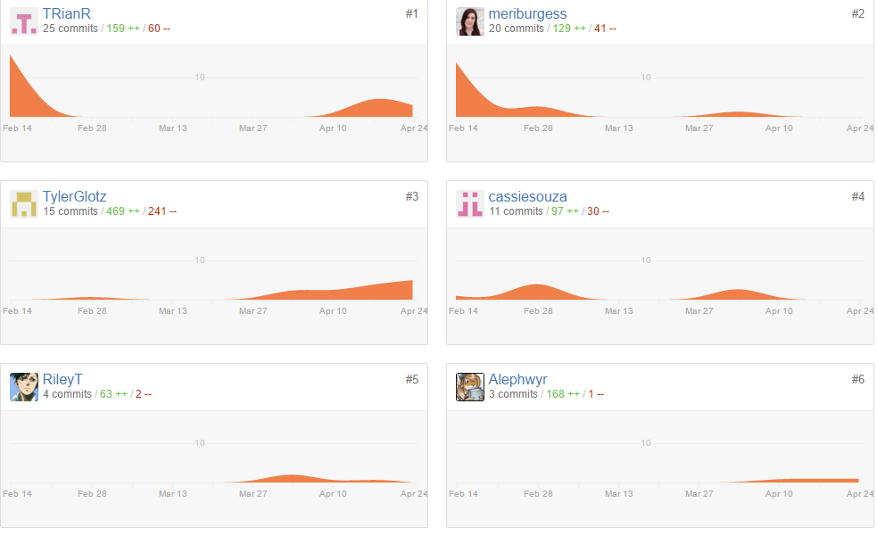
Deployment:
Github pages
http://trianr.github.io/CSCI3308_Project/index.html

Auto-Doc:
** Tool used **
** Link to auto-docs on repo***

