Herald College Kathmandu
(In academic partnership with the University of Wolverhampton)
Project and Professionalism (6CS007)
Final Year Project | Final Report
SOUND SCAPE
A Full-Stack Music Streaming, Discovery and
Vinyl-Commerce Platform with Rule-Based
Personalisation and Listening Analytics
Submitted by
[STUDENT NAME]
Student ID: [STUDENT ID] Group: [GROUP] Cohort: [COHORT]
Supervised by
[SUPERVISOR NAME]
Reader: [READER NAME]
Date of Submission: [DD / MM / YYYY]

Title and Declaration
Project Title: Sound Scape - A Full-Stack Music Streaming, Discovery and Vinyl-Commerce Platform with Rule-Based Personalisation and Listening Analytics.

Declaration
I declare that this Final Year Project report, and the software artefact it describes, are my own work and have been produced by me for the module Project and Professionalism (6CS007). All sources of information and material that have been used have been acknowledged in the text and listed in the References and Bibliography section.
I confirm that this work has not been submitted, in whole or in part, for any other award at this or any other institution. Where the work of others has been drawn upon, it has been properly cited. I understand that plagiarism and collusion are serious academic offences, and I confirm that this submission is free of both.
The third-party music catalogue metadata referenced by the artefact was obtained through the public Spotify Web API for academic and demonstration purposes only; no part of that metadata is claimed as original work, and no commercial use is made of it.

Field | Detail
Student Name | [STUDENT NAME]
Student ID | [STUDENT ID]
Group / Cohort | [GROUP] / [COHORT]
Supervisor | [SUPERVISOR NAME]
Reader | [READER NAME]
Module | Project and Professionalism (6CS007)
Word Count (Sections 5 to 11) | [WORD COUNT]
Date of Submission | [DD / MM / YYYY]

Signature: .................................................. Date: ..................................................

Abstract
Sound Scape is a full-stack web application that unifies four capabilities that mainstream music services normally keep apart: on-demand music streaming, personalised discovery, the sale of physical vinyl records, and listener-facing analytics. It is built on a JavaScript stack, a React 19 single-page client, an Express 5 REST API, and a MongoDB database accessed through the Mongoose object-document mapper, and it operates over a catalogue of more than three thousand tracks whose metadata was imported from the Spotify Web API.
The central problem the project addresses is that the personalisation engines of commercial streaming platforms are opaque, proprietary and inseparable from a paid subscription, which makes them unsuitable for an independent catalogue owner or for academic study. Sound Scape responds with a deliberately transparent, rule-based personalisation strategy: during onboarding a listener declares an explicit taste profile, and a deterministic query-matching recommender uses that profile, together with a catalogue-wide taxonomy of genre, mood, category and language, to assemble a personalised home feed whose reasoning can be inspected and explained.
The artefact was produced incrementally using a Scrum-based agile process, and it delivers six integrated sub-systems: authentication and account management, including JSON Web Token sessions, e-mail one-time-password verification and an OTP-gated password change; music streaming and playback; personalisation and onboarding; a vinyl store with Khalti payment-gateway integration; an administrative management console; and a listening-analytics dashboard. Testing was carried out throughout development against functional requirements. The report concludes that an explicit, rule-based personalisation approach is a viable and far more transparent alternative to machine-learning recommenders for a self-hosted streaming platform of this scale.

Table of Contents

Table of Figures

Table of Screenshots

5. Introduction

5.1 Project Briefing
Sound Scape is a full-stack web application that brings four normally separate music experiences together in a single product: streaming recorded music on demand, discovering new music through personalised recommendation, buying physical vinyl records, and reviewing one’s own listening behaviour through analytics. The platform is built end to end in JavaScript. The client is a React 19 single-page application bundled with Vite; the server is an Express 5 REST API; and persistent data is held in a MongoDB database reached through the Mongoose object-document mapper. A catalogue of more than three thousand tracks, several hundred artists and several hundred albums was imported from the public Spotify Web API so that the artefact could be exercised against a realistic body of content rather than a handful of seed records.
A listener arriving at Sound Scape is greeted by a cinematic landing page and can create an account, verify it through an e-mailed one-time password, and then complete a short onboarding step in which they declare the genres, moods, languages and descriptive tags they enjoy. From that point the home page is assembled for them: a personalised section is produced by matching their declared taste profile against the catalogue. They can play tracks through a persistent player, like songs, build playlists, search and filter the catalogue by category, browse and purchase vinyl editions through the Khalti payment gateway, and open an analytics dashboard that visualises the songs and genres they have been playing. A separate administrative console allows catalogue staff to manage artists, albums, songs, vinyls and lyrics, to control the visibility of catalogue entities, and to maintain the taxonomy that personalisation depends upon.

5.1.1 Problem Domain
The problem domain of this project is digital music distribution and discovery. Music consumption has moved decisively to streaming, and the dominant platforms are large, closed, subscription-funded systems. Their strength is also their constraint. The recommendation engines that decide what a listener sees are proprietary, machine-learning black boxes: a listener cannot inspect why a track was suggested, and a small catalogue owner cannot reuse that engine on their own content. These platforms also draw a hard line between streaming and the physical-format economy. An artist or independent label that wants to both stream a catalogue and sell a vinyl pressing of it must operate two disconnected systems, and neither system gives the everyday listener a clear, first-person view of their own habits.
The problem this project sets out to solve, therefore, is the absence of a lightweight, self-hostable platform that treats streaming, transparent discovery, physical-format commerce and listener analytics as one connected product over a single catalogue. Sound Scape is the technical solution to that problem. It demonstrates that a conventional web stack can host a unified catalogue, personalise discovery through an explainable rule-based recommender rather than an opaque model, attach a vinyl storefront directly to that catalogue, and return listening insight to the listener, all within one coherent application that an independent operator could realistically run.
This project does not implement an artificial-intelligence or machine-learning component. The personalisation it provides is delivered by a deterministic, rule-based recommender that matches an explicitly declared taste profile against a structured catalogue taxonomy. Because there is no learned model, no training data and no inference engine, the AI-specific guidance in the project template, which addresses natural-language processing, computer vision, supervised or unsupervised learning, agent design, confusion matrices and ROC curves, does not apply, and those sub-sections are intentionally omitted. The decision to keep personalisation rule-based is itself a considered design position, and it is examined directly in the academic question in Section 5.5.

5.2 Aims
The aim of this project is to design and develop a unified, self-hostable web platform that delivers personalised music streaming, physical-vinyl commerce and transparent listening analytics over a single catalogue, using an explainable rule-based personalisation strategy rather than an opaque machine-learning recommender.
The aim is stated deliberately at a general level. It expresses the overall intent of the project, what the finished system is for, without describing the individual problems that must be solved to reach it. Those specific, measurable targets are set out separately as objectives in the next section.

5.3 Objectives
The following objectives express the concrete problems the system is built to solve. Each was treated as a deliverable target during development and each is revisited in the Conclusion to judge whether it was met.
- Personalise the listener’s home experience by capturing an explicit taste profile during onboarding and surfacing catalogue content, through a personalised feed, that demonstrably matches the listener’s declared genres, moods, languages and tags.
- Protect user accounts and sensitive actions through layered authentication: stateless JSON Web Token sessions, e-mail one-time-password verification at sign-up, third-party Google sign-in, and an OTP-gated password change that confirms the account holder before any credential is altered.
- Make a large imported catalogue consistently discoverable by enforcing a single shared taxonomy of genre, mood, category and language across every track, so that browsing, searching and personalisation all operate on the same reliable classification.
- Allow the catalogue to be monetised through physical formats by offering vinyl editions tied to albums and songs, and by completing real purchases through an integrated third-party payment gateway.
- Return listening insight to the listener by recording playback events and aggregating them into an analytics dashboard that reports listening hours, favourite genres and artists, activity trends and a listening streak.
- Keep catalogue and platform state under administrative control by providing an administrative console through which staff manage catalogue entities, govern the visibility of artists, albums and songs, and maintain the taxonomy that the rest of the system relies on.

5.4 Artefact
The artefact is the Sound Scape platform itself: a working full-stack web application comprising a React client, an Express REST API and a MongoDB database, together with the imported catalogue and the supporting administrative tooling. As a whole, the system can be understood as a layered web application. The presentation layer is a single-page React client that holds interface state in React Context stores and communicates with the server only through a dedicated API service module. The application layer is an Express REST API organised into routes, middleware and controllers, where middleware enforces authentication and authorisation and controllers hold the business logic. The data layer is a MongoDB database of thirteen Mongoose-modelled collections, supported by a static file store for audio and image media. Three external services are integrated: the Khalti payment gateway for vinyl purchases, the Spotify Web API for catalogue metadata synchronisation, and an SMTP service for transactional and one-time-password e-mail.
To make the system tractable it was decomposed into six functional sub-systems. The Functional Decomposition Diagram in Figure 1 shows the platform broken down into those sub-systems and the principal functions each one carries out.
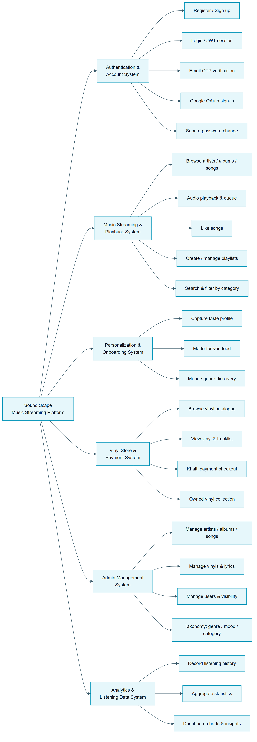
Figure : Functional Decomposition Diagram (FDD) of the Sound Scape platform
The high-level architecture of the platform, its three layers and the external services it depends on, is shown in Figure 2.
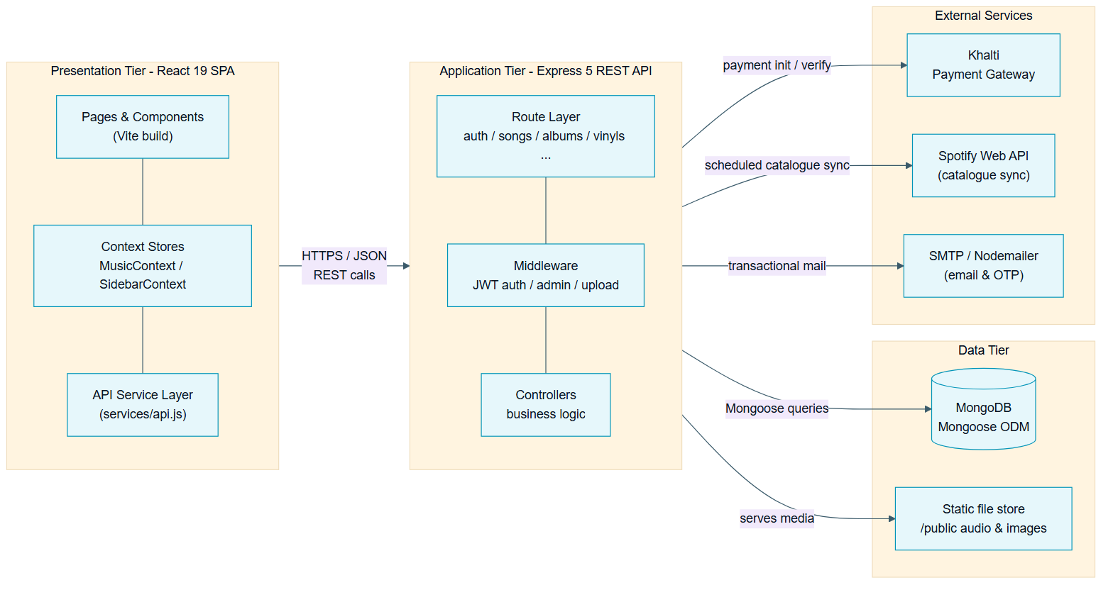
Figure : Three-tier system architecture of Sound Scape
The six sub-systems identified in the decomposition are as follows.
- Authentication and Account System. Handles registration, e-mail OTP verification, login with JWT access and refresh tokens, Google OAuth sign-in, and the secure, OTP-gated password-change flow. It is the gatekeeper for every protected action in the platform.
- Music Streaming and Playback System. Handles browsing of artists, albums and songs, audio playback through a persistent player with a queue, liking of songs, creation and management of playlists, and catalogue search with category filtering.
- Personalisation and Onboarding System. Captures the listener’s taste profile during onboarding and produces the personalised feed by matching that profile against the catalogue taxonomy. It also drives mood- and genre-based discovery.
- Vinyl Store and Payment System. Presents the vinyl catalogue, renders individual vinyl pages with their tracklists, processes purchases through the Khalti payment gateway, and maintains each listener’s owned-vinyl collection.
- Admin Management System. Provides authenticated staff with create, read, update and delete control over artists, albums, songs, vinyls and lyrics, governs entity visibility, and maintains the genre, mood, category and language taxonomy.
- Analytics and Listening Data System. Records every authenticated playback event as listening history, aggregates that history into statistics, and presents it to the listener as a dashboard of animated cards and charts.

5.5 Academic Question
The academic question that this project investigates is:
How effectively can a transparent, rule-based personalisation strategy, driven by an explicitly declared user taste profile and a unified catalogue taxonomy, support music discovery in a self-hosted streaming platform, in comparison with the opaque machine-learning recommenders used by mainstream services?
The question matters because personalisation is now the defining feature of a music platform, yet on the dominant services it is delivered by collaborative-filtering and deep-learning models that are proprietary and unexplainable. Those models are powerful, but they carry well-documented costs. They require large volumes of behavioural data before they produce useful output, the so-called cold-start problem; they can narrow a listener’s exposure into a filter bubble; and crucially they cannot tell the listener why anything was recommended. For an independent catalogue owner, or for a project of academic scale, that approach is also simply unavailable: there is neither the behavioural data nor the infrastructure to train such a model.
Sound Scape therefore takes the opposite position. Instead of inferring taste from behaviour, it asks the listener to declare it explicitly at onboarding, and it matches that declaration against a taxonomy that is enforced uniformly across the whole catalogue. The academic question asks how well that deliberately simple, fully transparent strategy actually performs as a discovery mechanism. Investigating it requires several things to be examined: whether an explicit taste profile is rich enough to produce a feed the listener finds relevant; whether a rule-based matcher can stay useful when a strict match returns too few results, which the design addresses through a tiered query that progressively relaxes its filters; whether the approach sidesteps the cold-start problem that affects behavioural models, since it needs no prior listening history; and what the strategy gives up in return, namely the serendipity and the continuous adaptation that a learned model provides. The literature review in Section 6 establishes the basis for this comparison, and the Conclusion returns to the question in the light of the completed artefact.

5.6 Scope and Limitations

5.6.1 Scope
The following capabilities are within the scope of the delivered artefact:
- Account lifecycle: registration, e-mail OTP verification, JWT-based login, Google OAuth sign-in, and an OTP-gated secure password change with an e-mailed confirmation and account-recovery link.
- A preference-driven onboarding flow and a rule-based personalised home feed.
- Music browsing and playback: artist, album and song pages, a persistent audio player with a queue, liked songs, and user-created playlists.
- Catalogue search with a category filter, and mood- and genre-based discovery pages.
- A vinyl storefront with individual vinyl pages and real checkout through the Khalti payment gateway.
- An administrative console for managing catalogue entities, entity visibility and the catalogue taxonomy.
- A listening-analytics dashboard for the signed-in user, with hero statistics, charts and an activity timeline.
- A responsive, collapsible glassmorphism navigation shell presenting a single, consistent visual identity.

5.6.2 Limitations
The following constraints bound what the artefact can do:
- Personalisation is rule-based and deterministic. The system does not learn from behaviour over time and does not adapt automatically; it reflects only the preferences the listener explicitly declared.
- The catalogue is metadata imported from the Spotify Web API. Only a subset of tracks has an uploaded, playable audio file; the remainder exist as catalogue records without streamable audio.
- The platform is online-only. Because data is held in MongoDB and media is served over HTTP, it cannot function without network connectivity, and no offline playback is provided.
- Payment integration uses the Khalti gateway, which is region-specific; the storefront therefore assumes a Nepal-based payment context.
- Analytics are built from playback events recorded after the feature was enabled; they cannot reconstruct earlier listening, so the dashboard becomes meaningful only as usage accumulates.
- The artefact is a single-operator academic deliverable. It has not been hardened or load-tested for large-scale concurrent production traffic.

5.7 Report Structure
The remainder of this report is organised as follows. Section 6, the Literature Review, examines comparable platforms and relevant research on recommender systems and establishes the basis for answering the academic question. Section 7 explains the project methodology and justifies the choice of an agile, Scrum-based process. Section 8 presents the technologies and tools used and the reasons each was selected. Section 9, Artefact Designs, is the core technical section: it documents each of the six sub-systems through its requirements, its design and modelling diagrams, and its testing. Section 10 draws conclusions by returning to the aims, objectives and academic question. Section 11 is a critical evaluation of the project and includes a personal self-reflection. Section 12 presents the evidence of project management, Section 13 lists the references, and Section 14 contains the appendices.

6. Literature Review
This section reviews the systems and research that the rest of the report builds upon. It examines four comparable platforms and a body of recommender-systems research. The purpose is not to answer the academic question here, but to establish the evidence and the conceptual vocabulary that the question will later be answered with. Where possible the review compares and contrasts what is found rather than merely describing it.

6.1 Review of Similar Systems

6.1.1 Spotify
Spotify is the reference point for modern music streaming and the clearest example of the model that this project reacts against. Its catalogue is vast, its playback experience is mature, and its personalisation, surfaced through features such as the algorithmically generated daily mixes and the weekly discovery playlist, is widely regarded as the strongest in the market. That personalisation is produced by a combination of collaborative filtering, content analysis of the audio itself, and natural-language processing of text written about music on the web. The relevant observation for this project is what the listener cannot see or do. The reasoning behind a recommendation is never exposed; the engine cannot be pointed at a different catalogue; and the experience is inseparable from a paid subscription. Spotify also keeps streaming entirely separate from the sale of physical formats. Spotify therefore demonstrates both the appeal of strong personalisation and, by omission, the gap that a transparent, self-hostable, catalogue-agnostic platform could fill.

6.1.2 Bandcamp
Bandcamp is the closest comparator to Sound Scape because it is the one well-known platform that already joins streaming to physical-format commerce. On Bandcamp a listener can stream an album in the browser and, on the same page, buy it as a digital download or as a physical record. This validates the central premise of the present project, that streaming and physical sales belong together rather than in separate systems. However, Bandcamp deliberately offers very little algorithmic personalisation; discovery is driven by editorial features, tags and fan activity rather than by a per-listener recommended feed. It also provides the listener with no analytics about their own habits. Bandcamp therefore confirms the value of unifying streaming and commerce, while leaving open exactly the two areas, per-listener personalised discovery and listener-facing analytics, that Sound Scape adds.

6.1.3 SoundCloud
SoundCloud occupies a middle position. It streams a very large, largely independent catalogue and layers a personalised feed and social features on top. Its relevance to this project is its handling of catalogue quality. Because anyone may upload, SoundCloud must work hard to keep its content consistently classified and discoverable, and inconsistent tagging is a recurring weakness of the platform. This is directly informative for Sound Scape, whose catalogue was imported in bulk from an external source and therefore arrived with uneven classification. SoundCloud illustrates why a uniformly enforced taxonomy, rather than free-form tagging, is a precondition for reliable browsing and personalisation.

6.1.4 Apple Music
Apple Music is included as a second mainstream comparator to show that the closed, subscription-locked, opaquely personalised model is an industry pattern and not a single company’s choice. Apple Music blends algorithmic recommendation with human editorial curation, and its hybrid approach is a useful counterpoint: it shows that personalisation need not be purely algorithmic to be effective. Sound Scape draws on that insight in a modest way, since its administrative console allows staff to control which catalogue entities are visible and featured, giving the operator an editorial lever alongside the rule-based feed.

6.1.5 Comparative Discussion
Placed side by side, the four systems map out the design space cleanly. Spotify and Apple Music supply powerful but opaque, subscription-bound personalisation and keep physical formats out of scope. Bandcamp unifies streaming with physical commerce but offers little personalisation and no listener analytics. SoundCloud shows what happens to discovery when catalogue classification is not enforced. No single reviewed system combines unified streaming and vinyl commerce, transparent personalisation, an enforced taxonomy, and listener-facing analytics. That combination is the gap Sound Scape targets, and the comparison is summarised in Table 1.
Capability | Spotify | Apple Music | Bandcamp | SoundCloud | Sound Scape
On-demand streaming | Yes | Yes | Yes | Yes | Yes
Per-listener personalised feed | Yes (opaque) | Yes (hybrid) | Limited | Yes | Yes (rule-based, transparent)
Physical vinyl commerce | No | No | Yes | No | Yes
Listener-facing analytics | Limited | Limited | No | Limited | Yes
Self-hostable / catalogue-agnostic | No | No | No | No | Yes
Explainable recommendations | No | No | n/a | No | Yes

6.2 Review of Relevant Research

6.2.1 Content-Based and Collaborative Filtering
Recommender-systems research conventionally divides approaches into two families. Collaborative filtering recommends to a listener what similar listeners enjoyed, learning patterns purely from behavioural data; content-based filtering recommends items whose attributes resemble items the listener already likes. Mainstream music services rely heavily on collaborative filtering because, at their scale, behavioural data is abundant and the patterns it reveals are rich. The rule-based recommender in Sound Scape is best understood as a deliberately simplified, explicit form of content-based filtering: rather than inferring an attribute profile from behaviour, it takes the attribute profile directly from the listener and matches it against item attributes, namely the catalogue taxonomy. This framing matters because the documented strengths and weaknesses of content-based filtering, strong transparency and controllability on the one hand, limited novelty and a tendency toward over-specialisation on the other, are exactly the trade-offs the academic question asks about.

6.2.2 The Cold-Start Problem
A central, well-documented difficulty for behavioural recommenders is the cold-start problem: a new user, or a newly added item, has no interaction history, so a collaborative model has nothing to reason from and its early recommendations are poor. Services mitigate this with onboarding questionnaires and with content-based fallbacks. This research is directly relevant because Sound Scape’s explicit-preference approach is, in effect, a cold-start solution promoted to a first-class strategy: by asking the listener to declare their taste before they have listened to anything, the system produces a relevant feed from the very first session. The literature thus supports the claim, tested later in the report, that an explicit-preference recommender is inherently immune to user-side cold start.

6.2.3 Transparency, Explainability and the Filter Bubble
A growing strand of research argues that recommender systems should be explainable, that a user should be able to see and ideally influence why something was recommended, and that opaque engines can produce a filter bubble in which a listener is shown an ever-narrowing slice of content. These concerns motivate the design of Sound Scape directly. Because its recommender is a rule that matches declared preferences to a visible taxonomy, every item in the personalised feed can be explained in one sentence, and the listener can change the feed at any time simply by editing their declared preferences. The same literature, however, identifies the cost of this transparency: a purely declarative, rule-based system cannot surprise the listener with material outside their stated taste, and so it forgoes the serendipity that a well-tuned behavioural model can provide. The Conclusion weighs this trade-off when it returns to the academic question.

6.2.4 Synthesis
Taken together, the reviewed systems and research support three positions that the rest of the report depends on. First, unifying streaming with physical-format commerce is a proven and worthwhile model, demonstrated by Bandcamp. Second, an enforced catalogue taxonomy is a precondition for reliable discovery, demonstrated negatively by SoundCloud and positively by the content-based filtering literature. Third, an explicit, rule-based recommender is a legitimate and transparent design choice whose principal trade-off, the loss of serendipity, is understood in advance. These positions frame the methodology, the design and the eventual answer to the academic question.

7. Project Methodology
This section explains why a particular development methodology was chosen for the project. It focuses on the reasons for the choice and on how the chosen approach suited the nature of this system, rather than on describing the methodology in the abstract.

7.1 Why an Agile, Scrum-Based Approach
The project was developed using an agile process built around Scrum. The decisive reason was the nature of the requirements. Sound Scape was not specified completely in advance; its requirements were expected to, and did, evolve as the system was built and exercised. Features were repeatedly refined in response to problems discovered only once the platform held a realistic catalogue, for example the need to enforce a uniform taxonomy across thousands of imported tracks, the need to make the personalised feed degrade gracefully when a strict match returned too little, and the need to make the vinyl page resilient when a linked album was hidden. A methodology that assumes requirements are fixed at the outset would have been a poor fit for this reality.
The waterfall model was considered and rejected for exactly that reason. Waterfall is a strictly linear sequence in which each phase is completed and frozen before the next begins, and it is appropriate only when requirements are stable and well understood from the start. Applying it here would have forced the design to be finalised before the catalogue-driven problems above could possibly have been discovered, and accommodating those discoveries would then have meant costly backward revision. Scrum, by contrast, is iterative and incremental and is built to absorb change between iterations, which matched the project precisely.
Scrum also suited the delivery shape of the project. The work decomposed naturally into the six sub-systems identified in Section 5.4, and each could be planned, built, tested and reviewed as a self-contained increment before the next was started. This produced a working, demonstrable artefact early and kept it working as it grew. Finally, the project is supervised, with regular meetings at which progress is reviewed and direction is adjusted; the cadence of Scrum, with its short iterations and built-in review points, aligned cleanly with that supervisory rhythm, allowing supervisor feedback to be folded into the next iteration rather than deferred.

7.2 Product and Sprint Backlog
Requirements were captured as a product backlog of user stories, each describing a capability from the point of view of the listener or the administrator, and each carrying a MoSCoW priority that recorded whether it was a Must, Should, Could or Would-not for the current scope. The prioritised backlog determined the order of work and is reflected in the per-sub-system requirements tables presented in Section 9. Each iteration drew the highest-priority stories it could accommodate into a sprint backlog, which fixed what would be designed, built and tested within that iteration. This kept every iteration scoped to a deliverable increment and protected the overall timetable.

7.3 Project Schedule
The major milestones and deliverables of the project, from initial title research through to the final report and presentation, are shown as a Gantt chart in Figure 12, in Section 12, Evidence of Project Management. Only the principal milestones are shown there; a finer-grained schedule was maintained alongside the backlog throughout development.

8. Technology and Tools
This section presents the technologies and tools used to build Sound Scape and, for each, the reason it was chosen for this system. The emphasis is on justification rather than definition.

8.1 Programming Language and Overall Stack
The platform is implemented entirely in JavaScript, on a MongoDB, Express, React and Node.js stack. A single language across the client, the server and the database query layer was chosen so that data structures, validation logic and developer effort could be shared across the whole system rather than translated across a language boundary. Because MongoDB stores documents as JSON-like structures, the same shape of object travels from the database, through the Express API, to the React client without transformation, which materially reduced the friction of moving a large, irregular imported catalogue through the system.

8.2 Front-End Technologies
- React 19. Chosen for the client because the interface is highly stateful, a persistent audio player, a live queue, a collapsible navigation shell and reactive personalised sections, and React’s component model with its declarative re-rendering manages that interacting state cleanly. React Context is used for cross-cutting state such as the music player and the sidebar, avoiding the need for a heavier external state-management library.
- Vite. Chosen as the build tool and development server for its near-instant start-up and hot-module replacement, which kept the iterative, Scrum-based workflow fast, and for its straightforward production bundling.
- Tailwind CSS. Chosen so that the dark, neon-accented glassmorphism identity could be applied consistently and rapidly through utility classes, keeping the single visual identity uniform across every screen without a sprawl of bespoke stylesheets.
- Framer Motion. Chosen to deliver the smooth, modern transitions the interface depends on, the collapsing sidebar, the animated analytics cards and the page transitions, declaratively and with controlled, consistent easing.
- Recharts. Chosen for the analytics dashboard because it renders responsive, animated charts as native React components, so the listening-trend area chart, the genre donut and the hourly bar chart integrate directly into the component tree.
- React Router. Chosen to give the single-page application real, shareable URLs for every artist, album, vinyl and analytics view, and to support guarded routes for authenticated and administrative areas.

8.3 Back-End Technologies
- Express 5. Chosen as the server framework for its minimal, unopinionated routing and middleware model, which let the REST API be organised cleanly into routes, authentication and authorisation middleware, and controllers.
- MongoDB with Mongoose. A document database was chosen because the imported catalogue is irregular: tracks vary in which metadata fields they carry. A fixed relational schema would have fought that irregularity. Mongoose adds a schema and validation layer on top of MongoDB, giving the catalogue enough structure to be reliable while keeping the flexibility the data needed.
- JSON Web Tokens and bcrypt. Stateless JWT access and refresh tokens were chosen so the API could authorise requests without server-side session storage; bcrypt was chosen to hash passwords with a salt so that credentials are never stored or comparable in plain text.
- Passport with Google OAuth 2.0. Chosen to offer a trusted third-party sign-in option, lowering the barrier to account creation and removing the need for some users to manage another password.
- Nodemailer. Chosen to send transactional e-mail, the sign-up verification code, the password-change one-time password and the password-change confirmation with its recovery link, all of which are integral to the security flows.
- Multer. Chosen to handle multipart file uploads so that administrators can attach audio files and cover images to catalogue entities.

8.4 External Services and Integration Libraries
- Khalti payment gateway. Chosen to process real vinyl purchases. Integrating an external gateway keeps card and wallet handling, and its security burden, outside the application while still delivering a complete checkout.
- Spotify Web API, via spotify-web-api-node. Chosen to populate the platform with a realistic catalogue of thousands of tracks, so the system could be designed and tested against production-scale data rather than a handful of seed records.
- node-cron. Chosen to schedule periodic catalogue synchronisation so that imported metadata could be refreshed without manual intervention.

8.5 Development Tools
- Visual Studio Code. Chosen as the IDE for its strong JavaScript and React tooling, integrated terminal and built-in Git support.
- Git. Chosen for version control so that every increment was committed with a meaningful history, providing both a safety net and an auditable record of progress aligned with the Scrum iterations.
- npm. Chosen as the package manager for both the client and the server, managing all third-party dependencies through a single, reproducible manifest per package.
- Mermaid. Chosen to author the design and modelling diagrams in this report as version-controlled text, so that the FDD, ERD, class, use-case, activity and sequence diagrams could be regenerated consistently whenever the design changed.

8.6 Testing Approach
Testing was carried out continuously and incrementally rather than as a single closing phase, consistent with the Scrum methodology. Each sub-system was verified against its functional requirements as it was completed, using functional and exploratory testing of the running application and direct exercise of the REST API endpoints. The defects found and resolved this way, several of which are documented in the testing tables in Section 9, were a direct input to subsequent iterations. Icon assets are drawn from a consistent open icon set and the interface uses the Poppins and Inter typefaces to maintain visual consistency.

9. Artefact Designs
This section is the core technical record of the project. It documents each of the six sub-systems identified in Section 5.4 in turn. For each sub-system it presents a software requirements specification in the form of a prioritised requirements table, the design and modelling diagrams relevant to that sub-system, screenshots of the implemented interface, and a record of testing. Requirement types are abbreviated as F for functional, NF for non-functional and UR for usability. Requirement priority follows the MoSCoW scheme: Must, Should, Could and Would-not. Design and modelling diagrams are numbered as Figures; screenshots of the running artefact are numbered separately as Screenshots.
The platform presents itself to a first-time visitor through a cinematic landing page, shown in Screenshot 1, which introduces the product before any account is created.
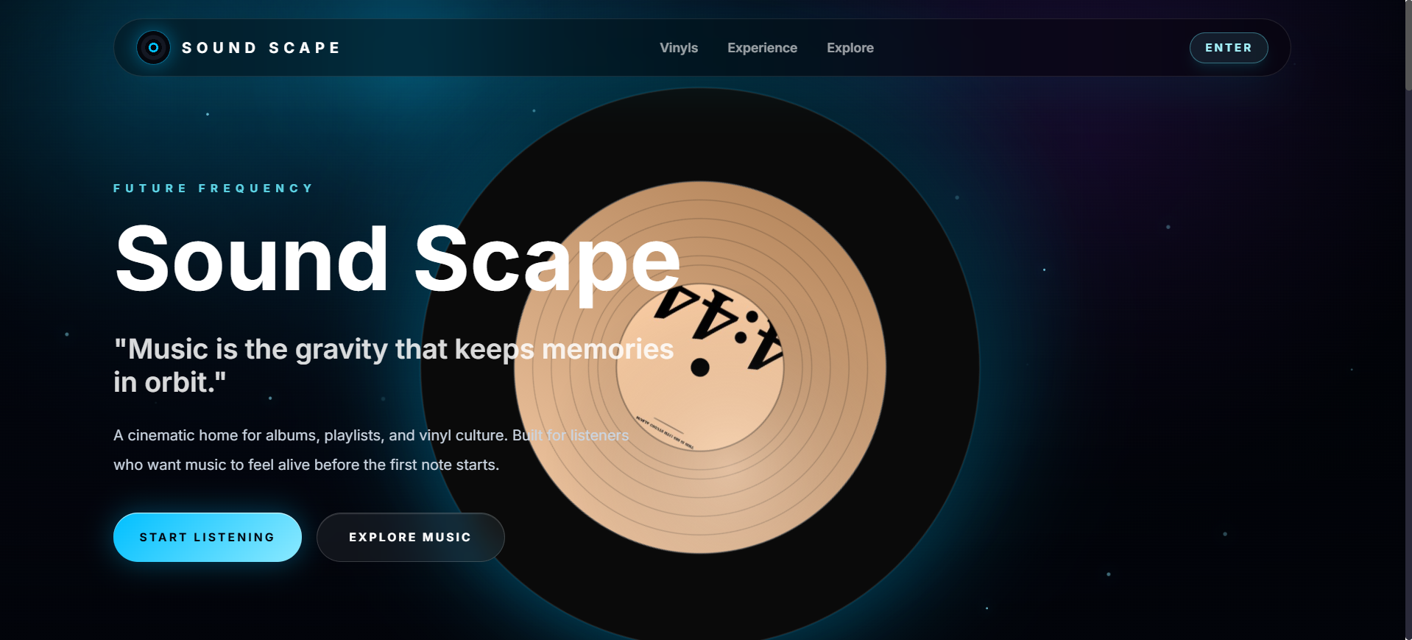
Screenshot : The public landing page introducing the Sound Scape platform

9.1 System-Wide Models
Three models describe the system as a whole and apply across every sub-system, so they are presented once here rather than repeated. The use-case diagram in Figure 3 shows the actors of the platform, the guest, the registered user, the administrator and the external Khalti gateway, together with the use cases each one participates in.
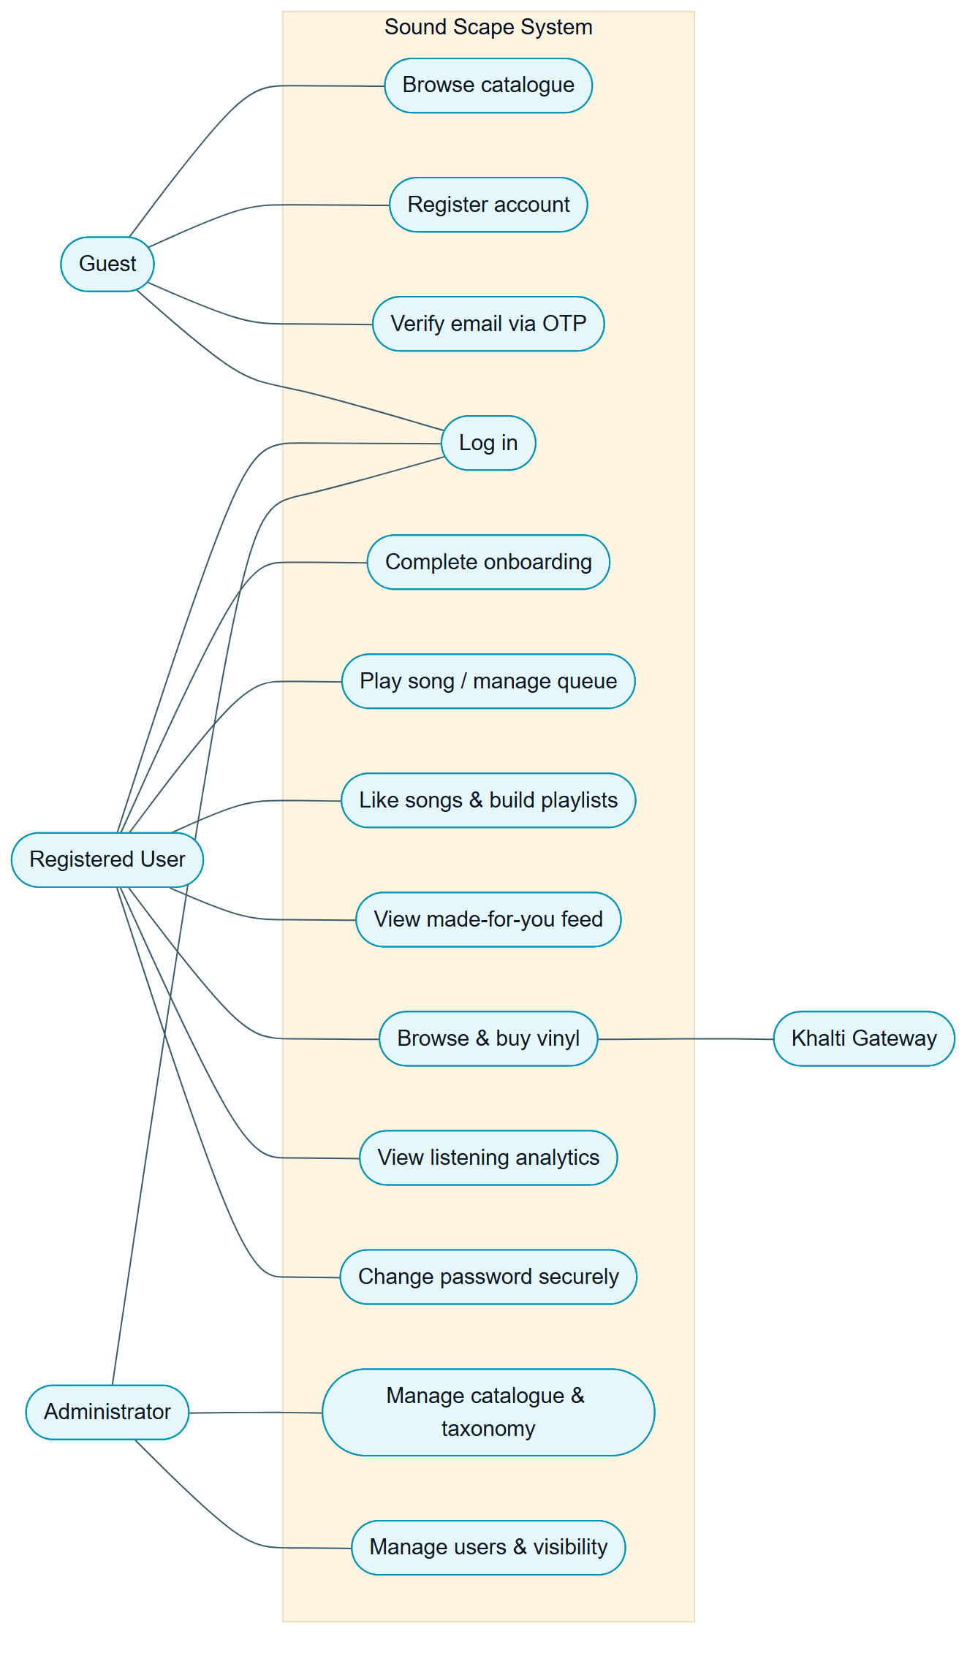
Figure : System-wide use-case diagram for Sound Scape
The data model is shown as an entity-relationship diagram in Figure 4. It records the principal collections held in MongoDB and the relationships between them: users own playlists, generate listening history and make payment transactions; artists release albums which contain songs; vinyls are pressed from albums or songs; and many-to-many relationships connect users to the songs they like, the artists they follow and the vinyls they purchase.
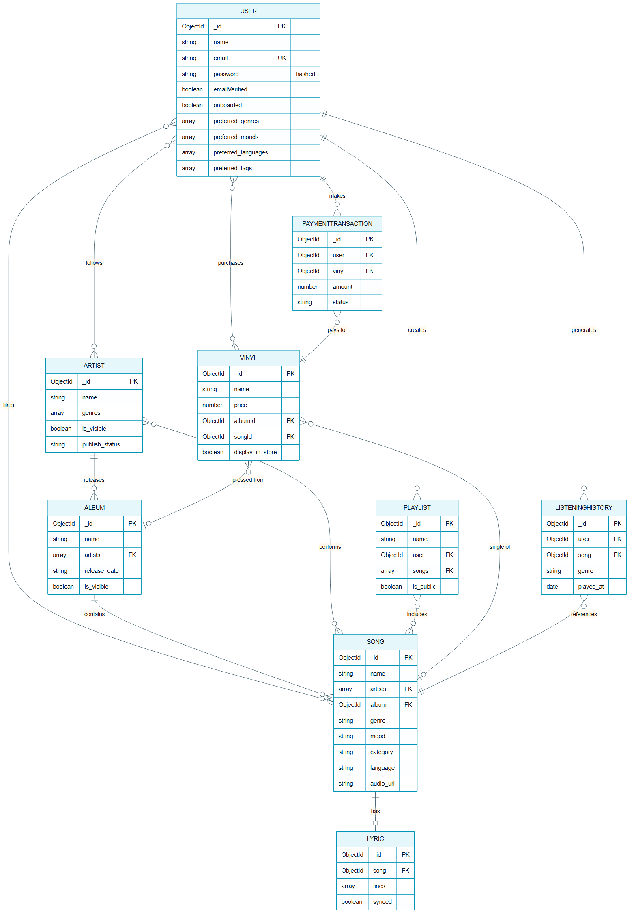
Figure : Entity-relationship diagram of the Sound Scape data model
The corresponding class diagram in Figure 5 expresses the same domain as the Mongoose model classes used in the application layer, including their principal attributes and the multiplicities between them.
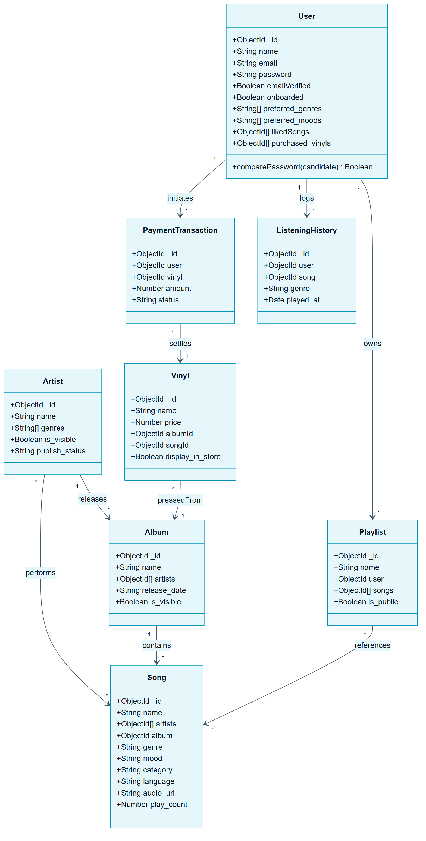
Figure : Class diagram of the Sound Scape domain model

9.2 Authentication and Account System
The Authentication and Account System is the gatekeeper of the platform. It governs how an account is created, verified, authenticated and recovered, and it secures the most sensitive action a user can take, changing their password. Its requirements are set out in Table 2.
Ref. | Requirement | Type | MoSCoW
AAS-F-1 | A visitor must be able to register an account with a name, e-mail address and password. | F | Must
AAS-F-2 | The system must hash every password with a salt before storage so credentials are never held in plain text. | F | Must
AAS-F-3 | The system must verify a new account by e-mailing a six-digit one-time password the user must enter. | F | Must
AAS-F-4 | A verified user must be able to log in and receive a JWT access token and refresh token. | F | Must
AAS-F-5 | A user must be able to sign in with a Google account through OAuth 2.0. | F | Should
AAS-F-6 | A user must be able to change their password only after confirming a one-time password e-mailed to them. | F | Must
AAS-F-7 | On a successful password change the system must e-mail a confirmation containing a one-hour account-recovery link. | F | Should
AAS-NF-1 | Sensitive flows must be rate-limited to resist brute-force and abuse. | NF | Should
AAS-UR-1 | The change-password page must show password strength and validate input before the form can be submitted. | UR | Should

9.2.1 Design
Registration and account verification, followed by the onboarding hand-off, are modelled in the activity diagram in Figure 6. The flow shows validation of the registration form, creation of the user with a hashed password, generation and e-mailing of the verification code, the verify-and-resend loop, and the transition into onboarding once the e-mail is confirmed.
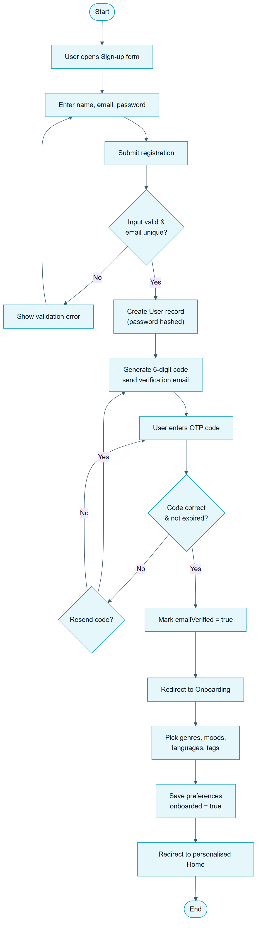
Figure : Activity diagram for registration, e-mail verification and onboarding
Authentication itself is modelled in the sequence diagram in Figure 7, which traces a login request from the React client, through the Express API, to the database and back, including the bcrypt comparison and the issuing of the access and refresh tokens.
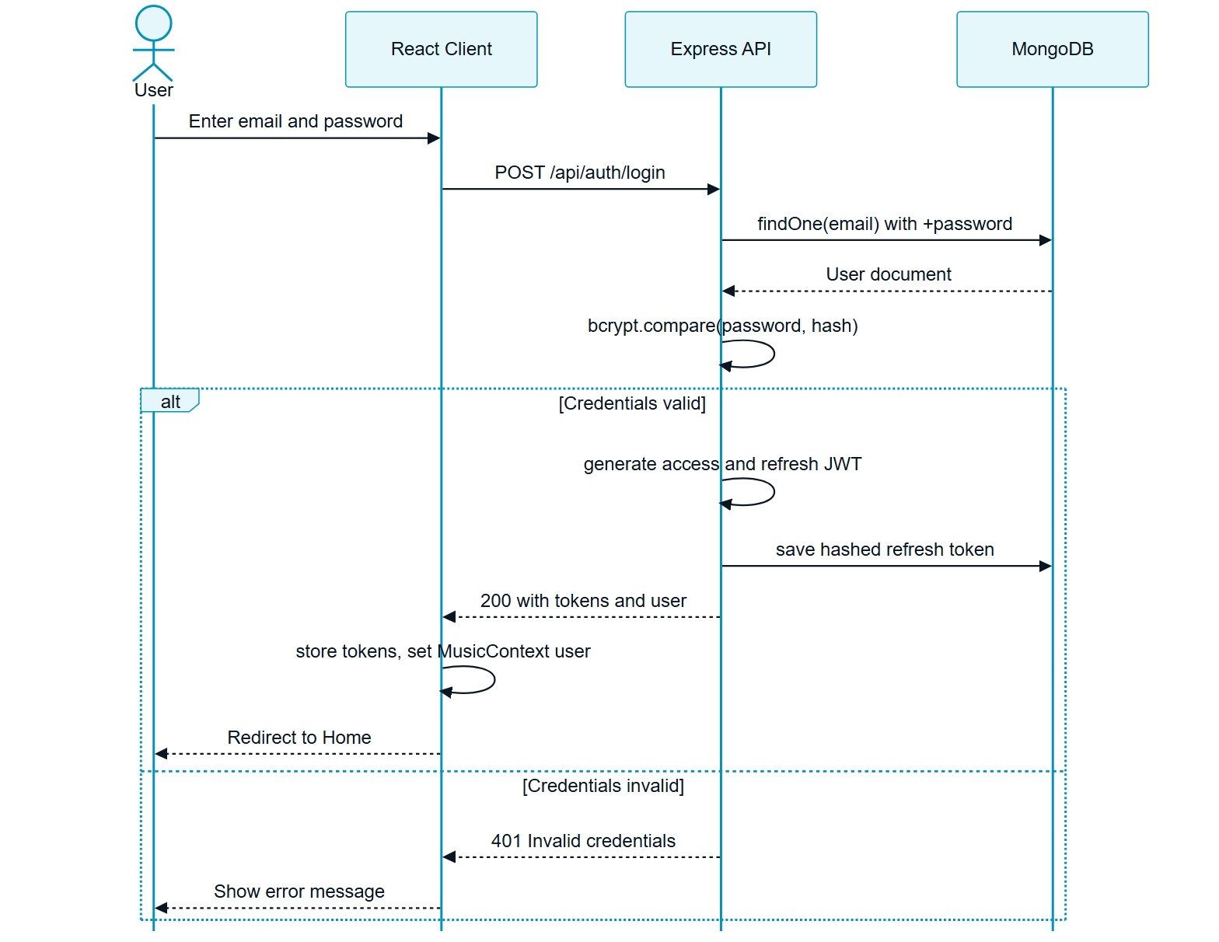
Figure : Sequence diagram for user login and JWT issuance
The secure password-change flow is the most security-sensitive part of the sub-system and is modelled separately in the activity diagram in Figure 8. The user must first prove knowledge of the current password; the system then e-mails a one-time password; only after that code is verified is the new password, which must pass a strength check, accepted. On success the system revokes existing refresh tokens, e-mails a confirmation with a recovery link, and signs the user out.
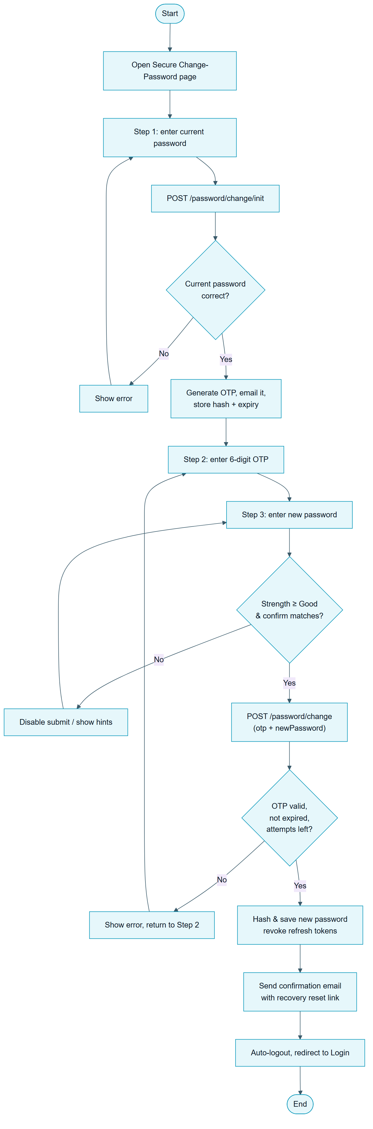
Figure : Activity diagram for the OTP-gated secure password change

9.2.2 Implemented Interface
The implemented authentication screens follow the design above. A visitor creates an account through the registration form, then signs in through the login form, both of which carry the consistent dark, neon-accented identity of the platform.
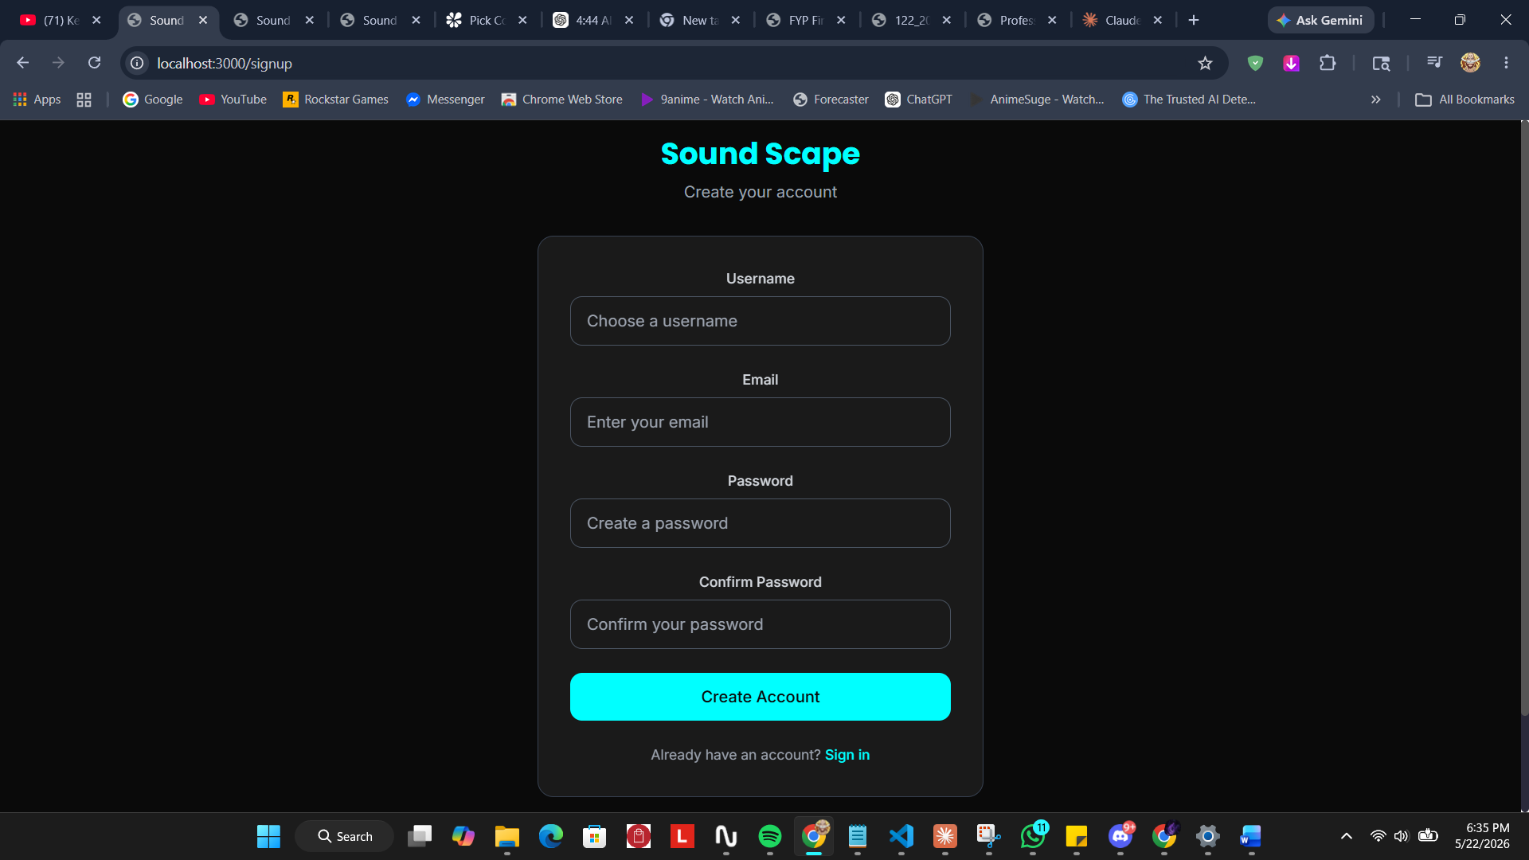
Screenshot : Account registration form
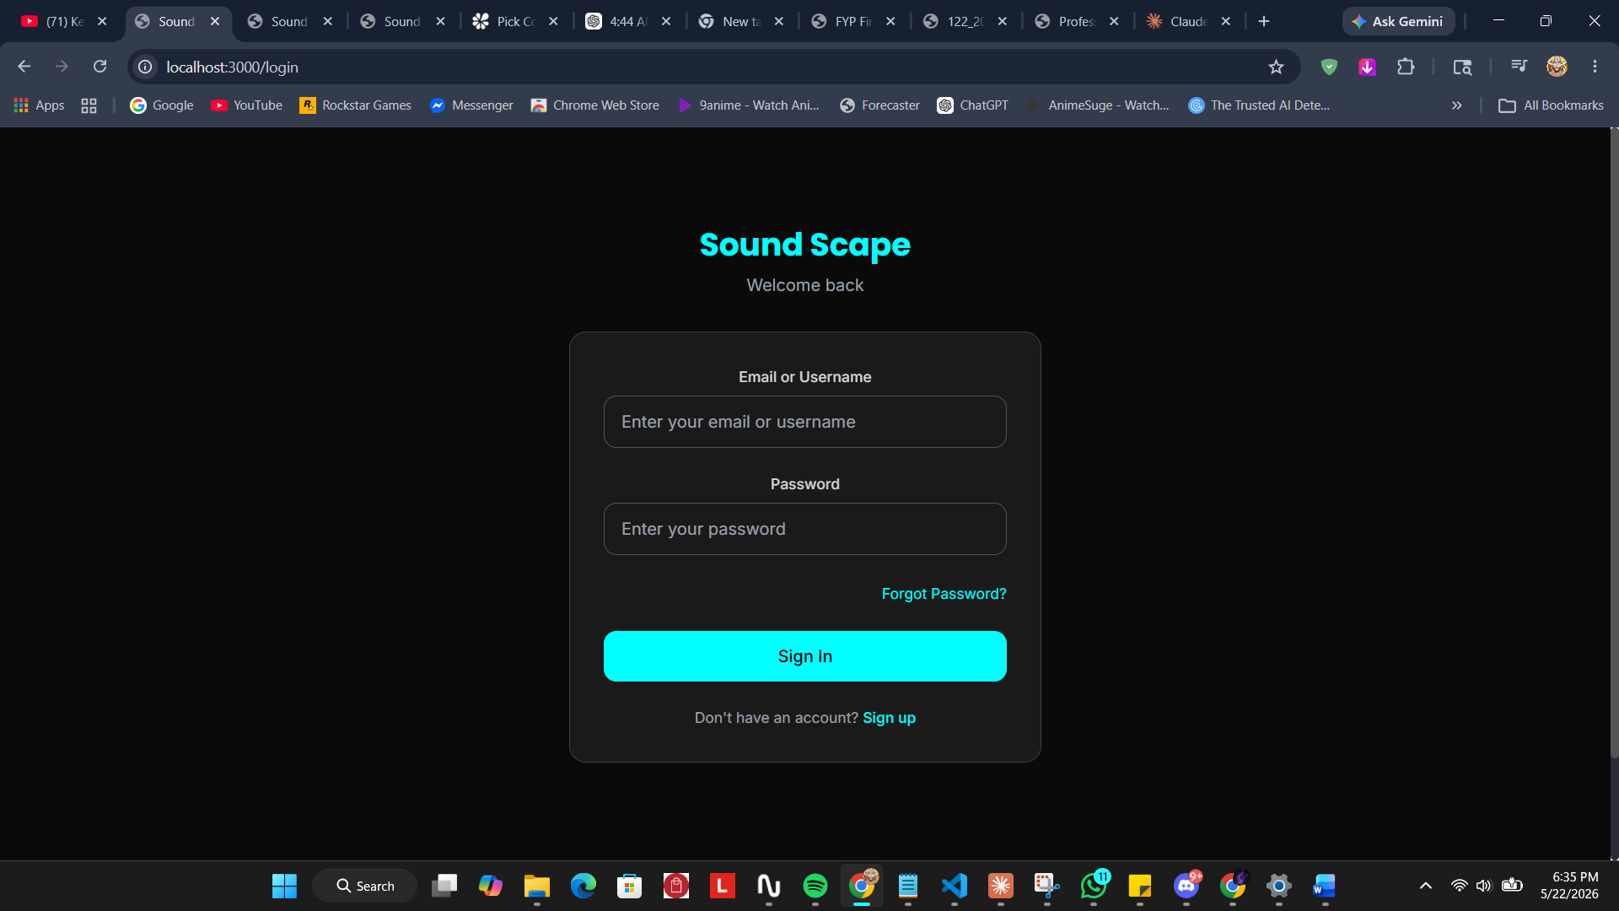
Screenshot : Login screen with access to password recovery
After registration the user must confirm ownership of the e-mail address by entering the six-digit one-time password that the system sends. The verification screen and the corresponding e-mail are shown below.
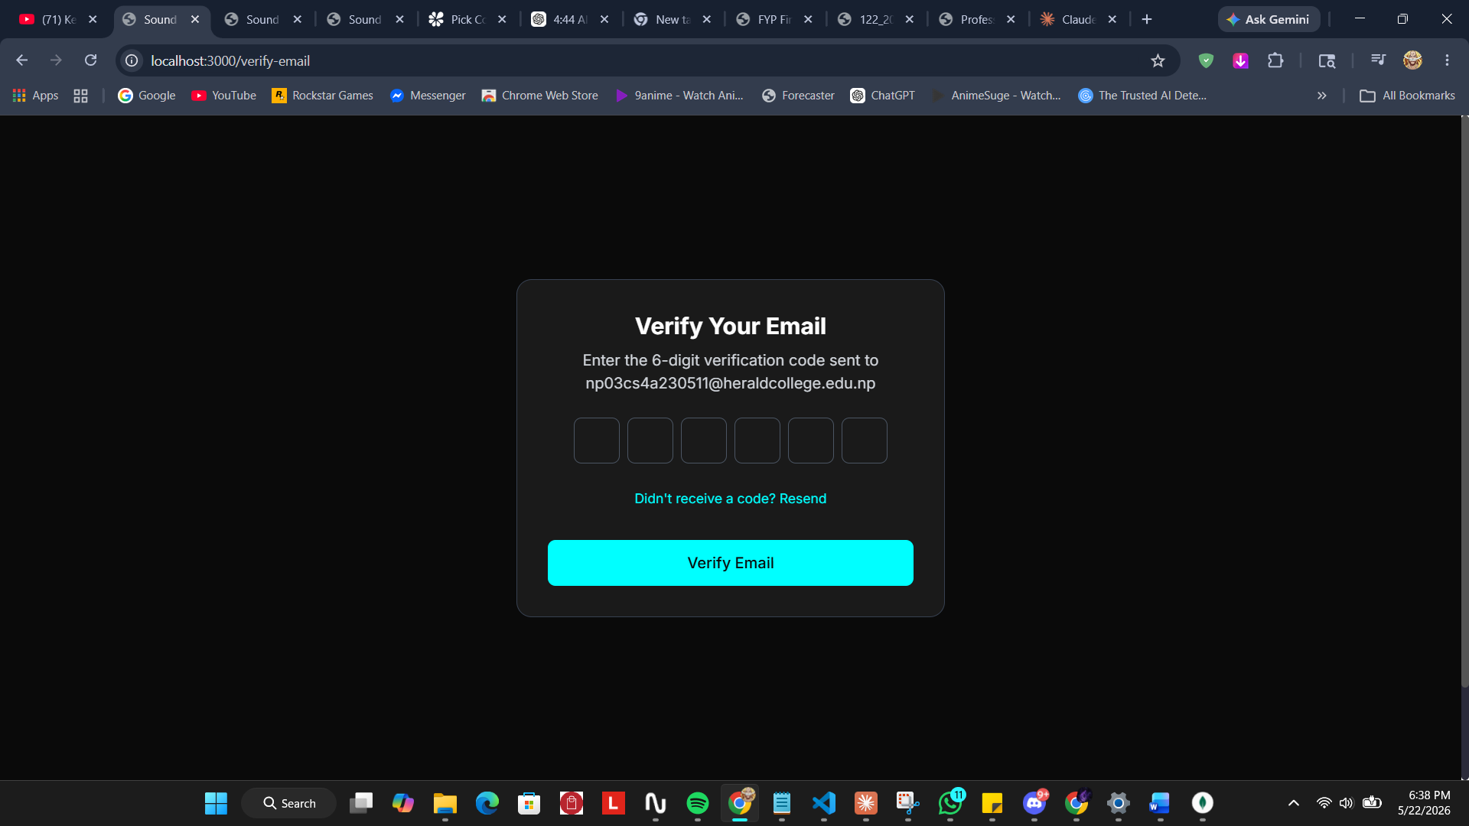
Screenshot : E-mail verification screen with six-digit one-time password entry
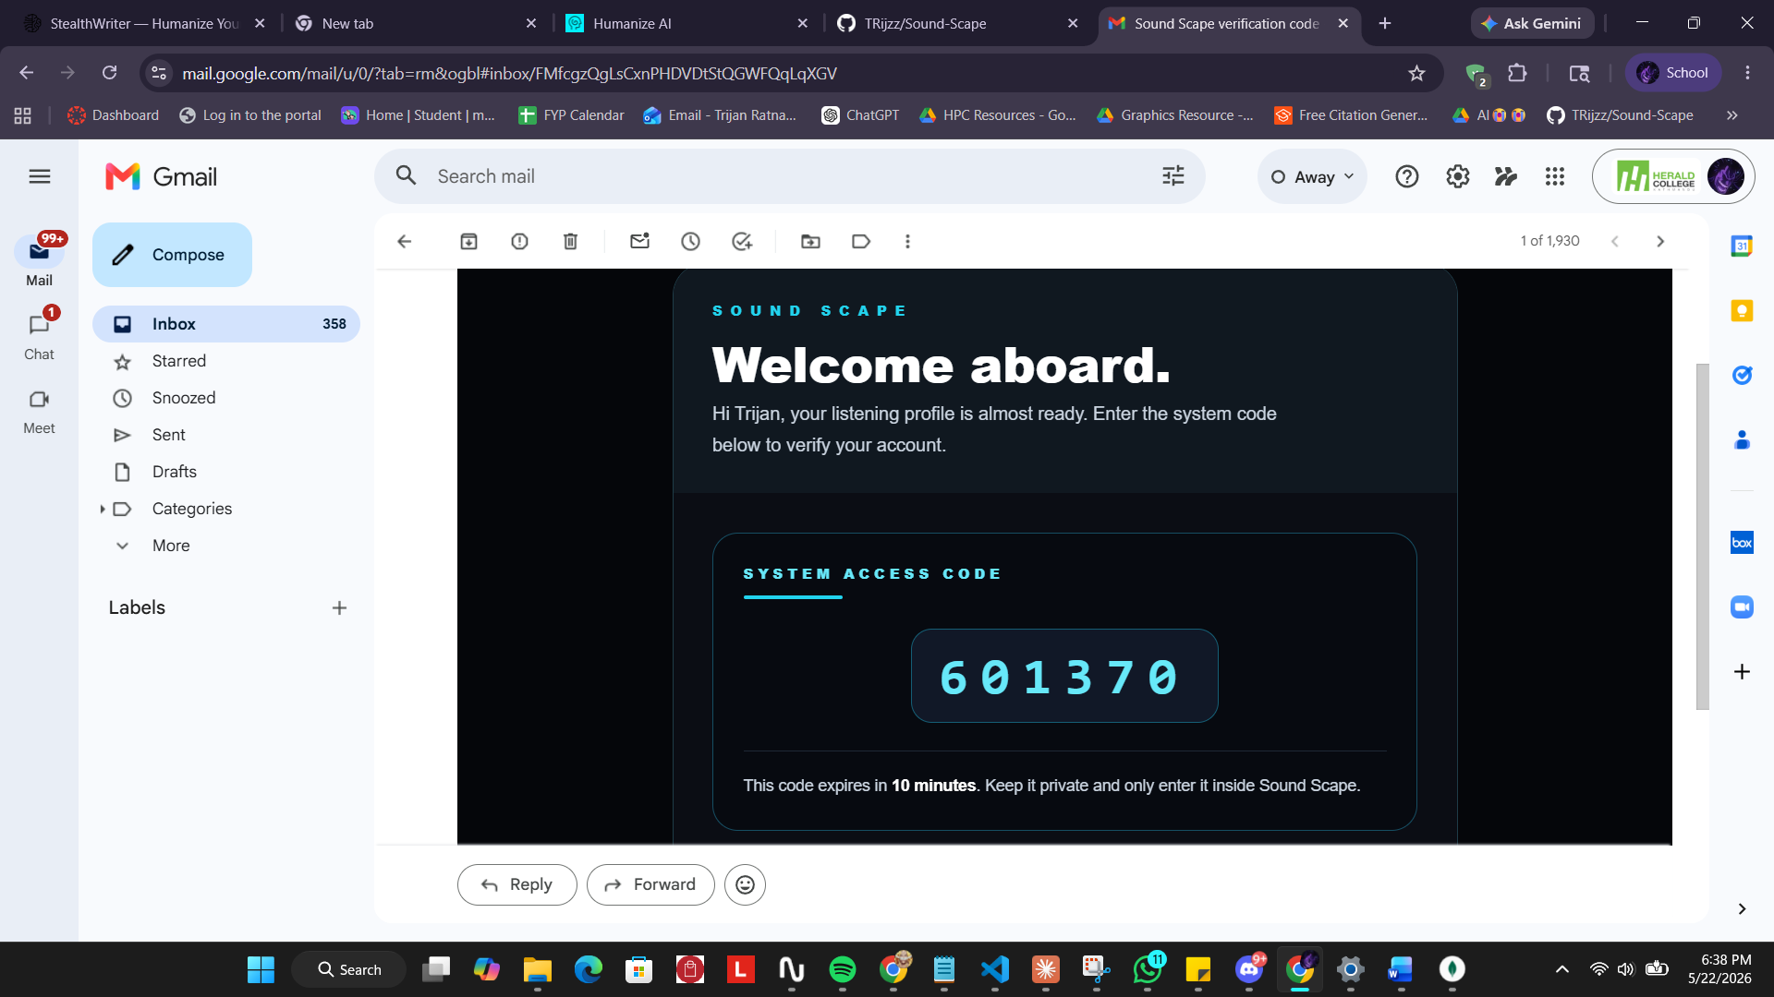
Screenshot : The verification e-mail delivered to the user, carrying the system access code

9.2.3 Testing
Table 3 records representative tests carried out against this sub-system.
ID | Test Case | Expected Result | Actual | Status
T1.1 | Register with an e-mail that is already in use. | Registration is rejected with a clear error. | As expected | Pass
T1.2 | Submit the wrong verification code. | Code is rejected; resend option offered. | As expected | Pass
T1.3 | Log in with a correct e-mail and password. | Access and refresh tokens are issued; user reaches the home page. | As expected | Pass
T1.4 | Log in with an incorrect password. | Login is rejected with a 401 and no token is issued. | As expected | Pass
T1.5 | Request a password change with the wrong current password. | No OTP is sent; an error is shown. | As expected | Pass
T1.6 | Complete a password change with a valid OTP and a strong new password. | Password updates; confirmation e-mail with recovery link is sent; user is signed out. | As expected | Pass

9.3 Music Streaming and Playback System
The Music Streaming and Playback System is the heart of the everyday listener experience. It governs how the catalogue is browsed and searched and how audio is played, queued and collected into playlists. Its requirements are set out in Table 4.
Ref. | Requirement | Type | MoSCoW
MSS-F-1 | A user must be able to browse artists, albums and songs in the catalogue. | F | Must
MSS-F-2 | A user must be able to play a track through a persistent player available on every page. | F | Must
MSS-F-3 | The player must support a queue with next, previous and continuous playback. | F | Must
MSS-F-4 | A signed-in user must be able to like songs and view their liked songs. | F | Must
MSS-F-5 | A signed-in user must be able to create, rename, delete and populate playlists. | F | Must
MSS-F-6 | A user must be able to search the catalogue and filter results by category. | F | Should
MSS-F-7 | Each playback event must be reported to the server so it can be counted and recorded. | F | Must
MSS-NF-1 | Hidden or unavailable catalogue entities must not appear to ordinary users. | NF | Must
MSS-UR-1 | The player must persist its visible state as the user navigates between pages. | UR | Should

9.3.1 Design
Playback and the recording of a play event are modelled in the sequence diagram in Figure 9. When the user selects a track the client begins playback locally and, in parallel, reports the play to the server; the server increments the play count and, when the request is authenticated, records the event in the listening-history collection that feeds the analytics dashboard.
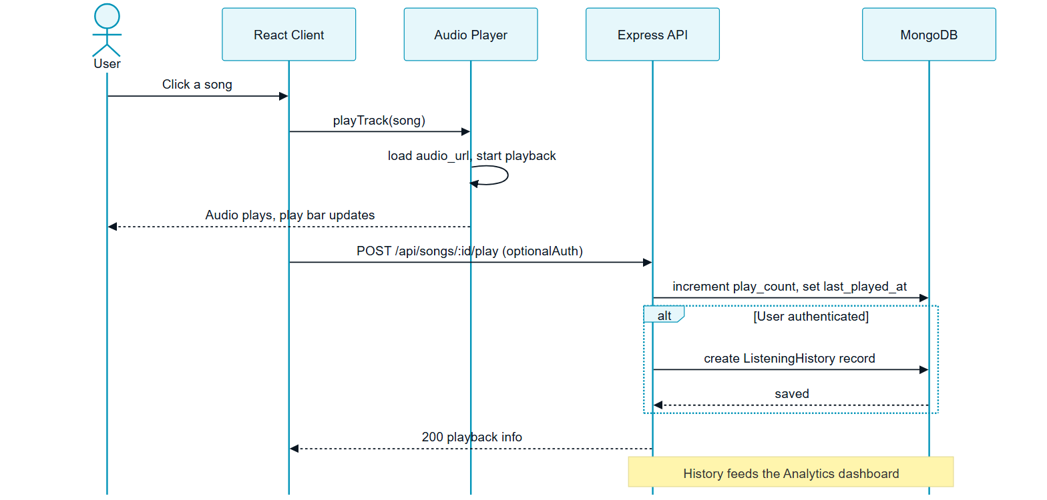
Figure : Sequence diagram for song playback and play-event recording

9.3.2 Implemented Interface
The home page is the listener’s point of entry to the catalogue. It presents a persistent player and surfaces catalogue content, and the player remains docked at the foot of every page as the listener navigates.
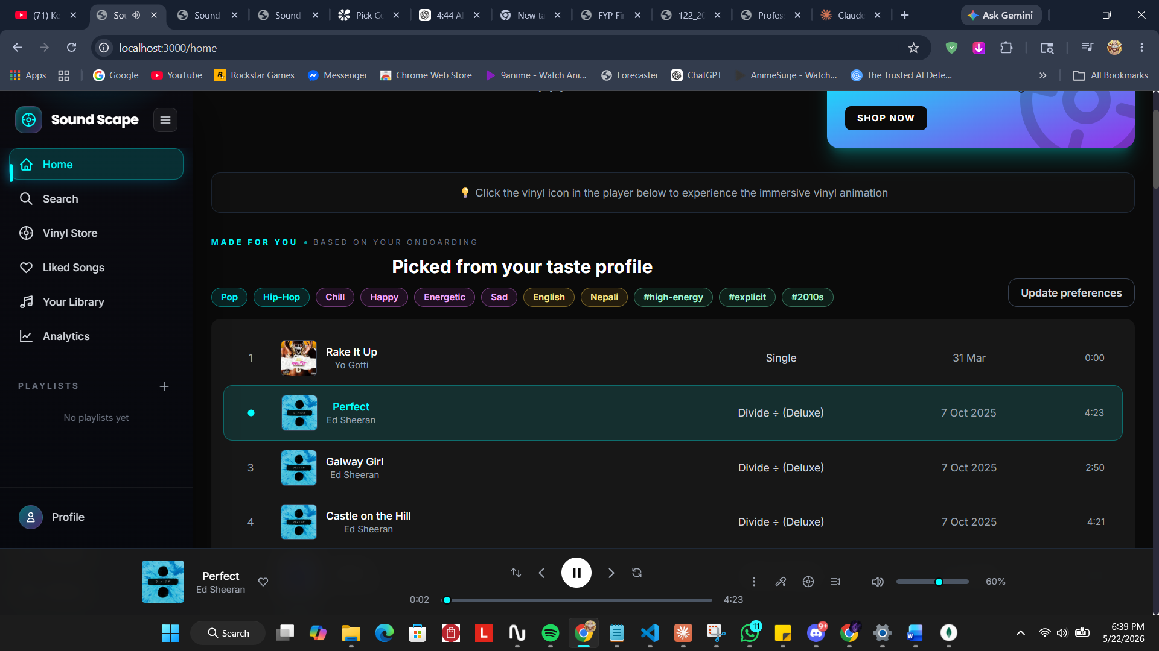
Screenshot : The home page with the persistent player active during playback
The platform also offers an immersive full-screen vinyl player, in which the currently playing track is rendered as a rotating record with a tonearm, reinforcing the vinyl identity of the product.
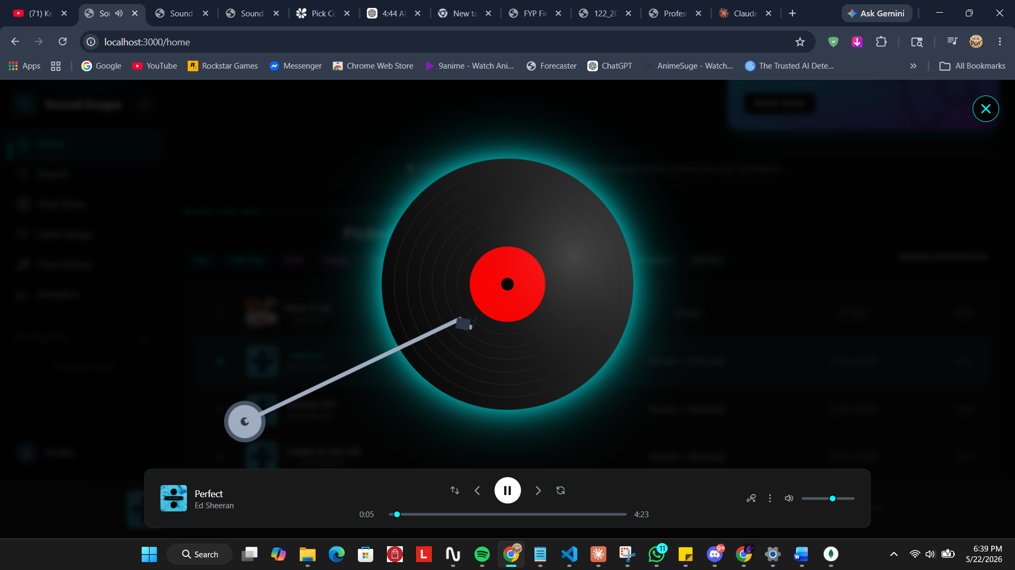
Screenshot : The immersive vinyl player overlay for the currently playing track
Playback is queue-driven. The listener can inspect what is playing now and what is coming next, and can act on any track through a context menu to add it to the queue or to a playlist.
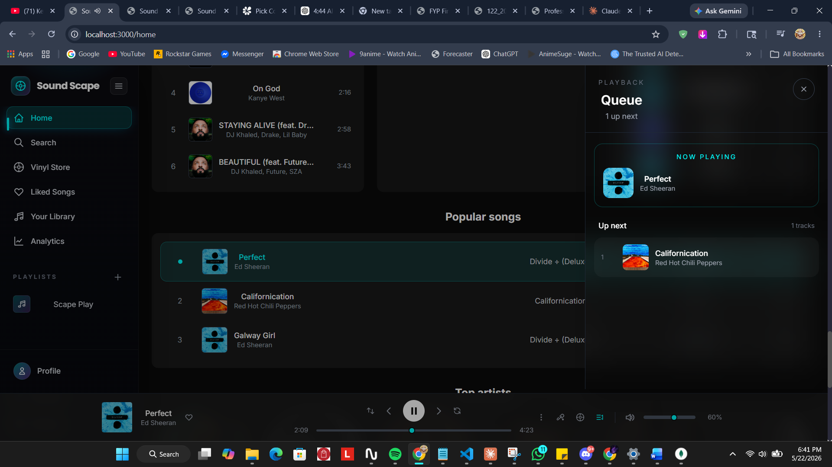
Screenshot : The playback queue panel showing the current and upcoming tracks
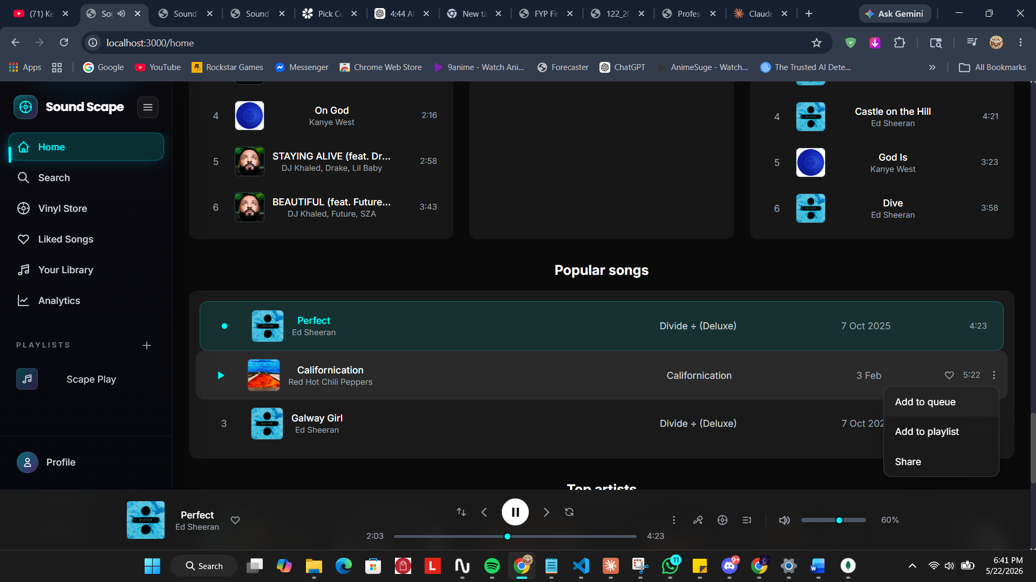
Screenshot : The per-track context menu for queue and playlist actions
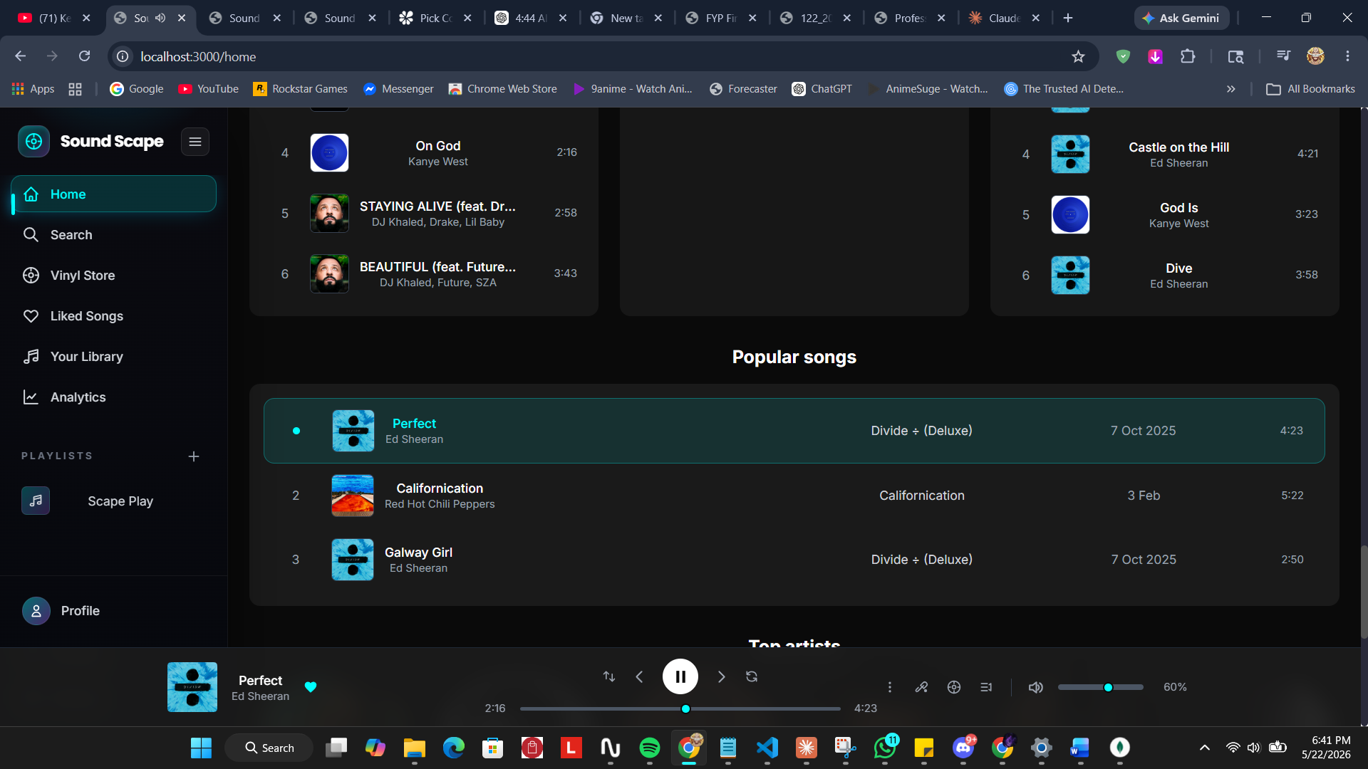
Screenshot : The popular songs section of the home page
Signed-in listeners can collect music in two ways: by liking individual songs, which gathers them into a dedicated view, and by creating their own playlists.
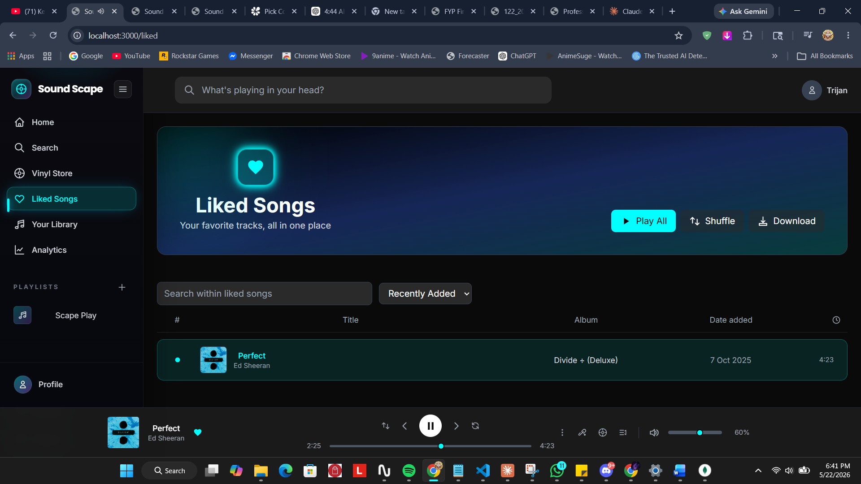
Screenshot : The Liked Songs view collecting the listener’s favourite tracks
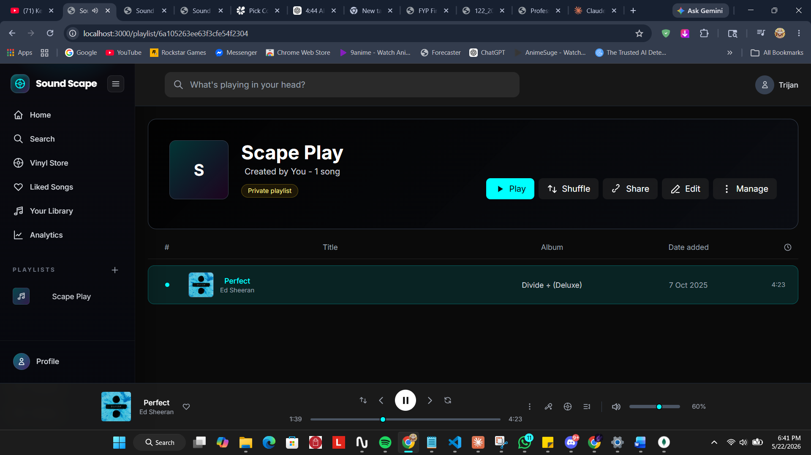
Screenshot : A user-created playlist with its own management controls
Catalogue search supports a free-text query and a category filter. The listener can pick a category from the taxonomy and the results are restricted accordingly; searching also resolves artists and individual songs to a best match.
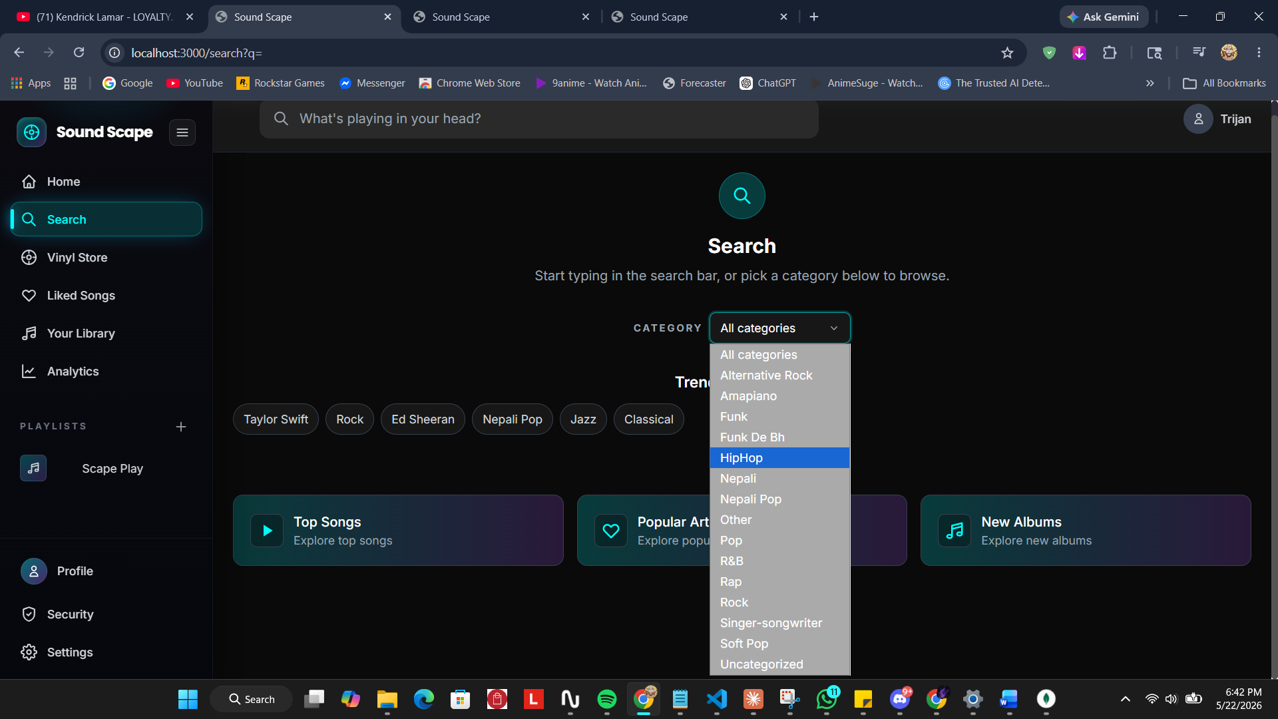
Screenshot : Catalogue search with the category filter open
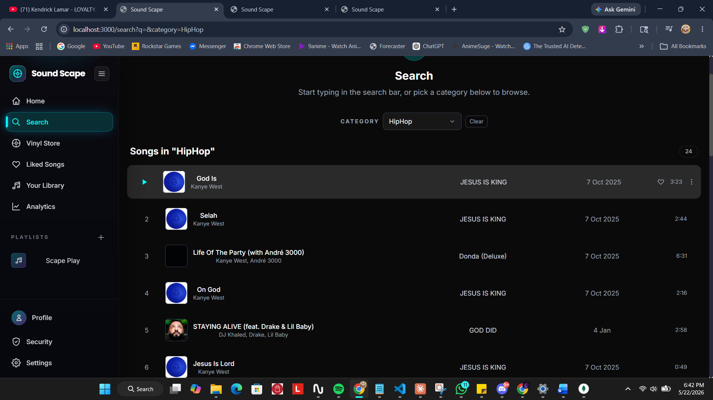
Screenshot : Search results restricted by the HipHop category filter
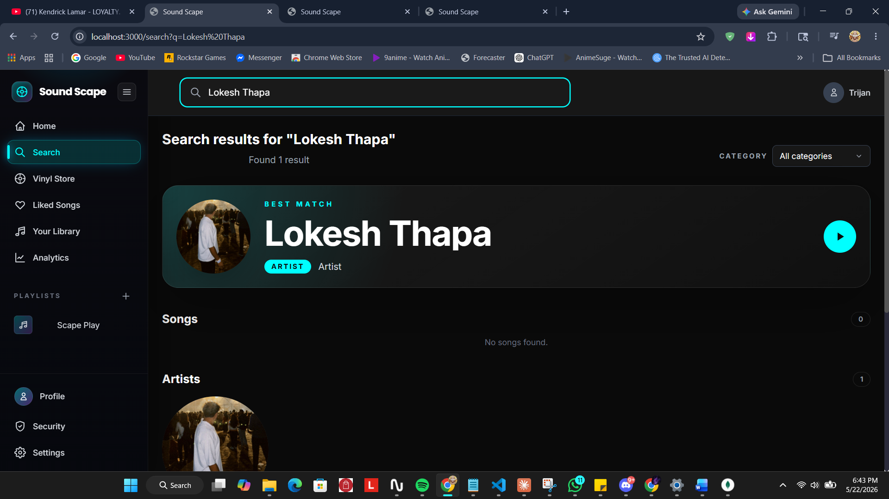
Screenshot : A search resolving to an artist as the best match
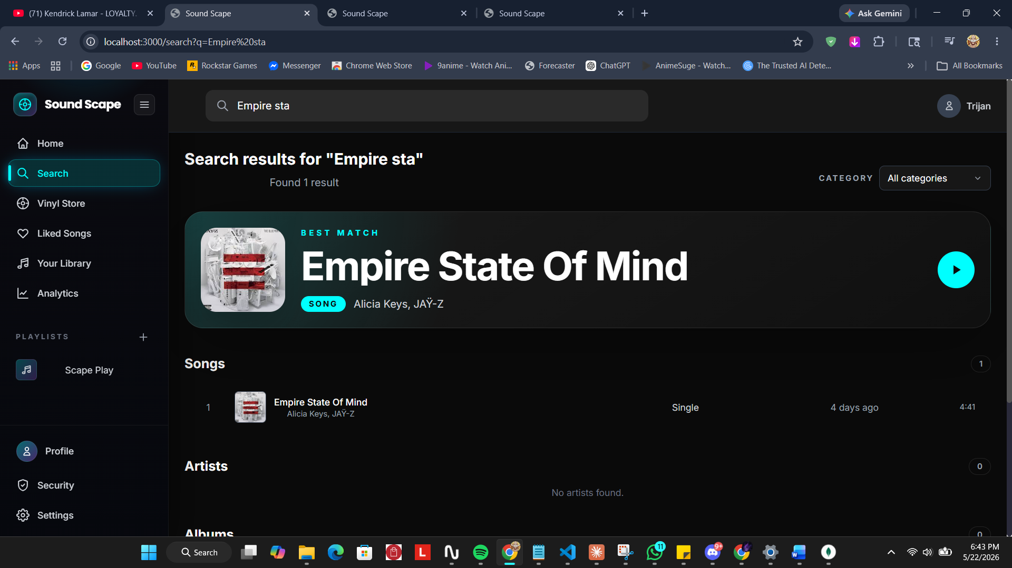
Screenshot : A search resolving to an individual song as the best match
Each listener also has a public profile page that presents their identity, declared genres and playlists.
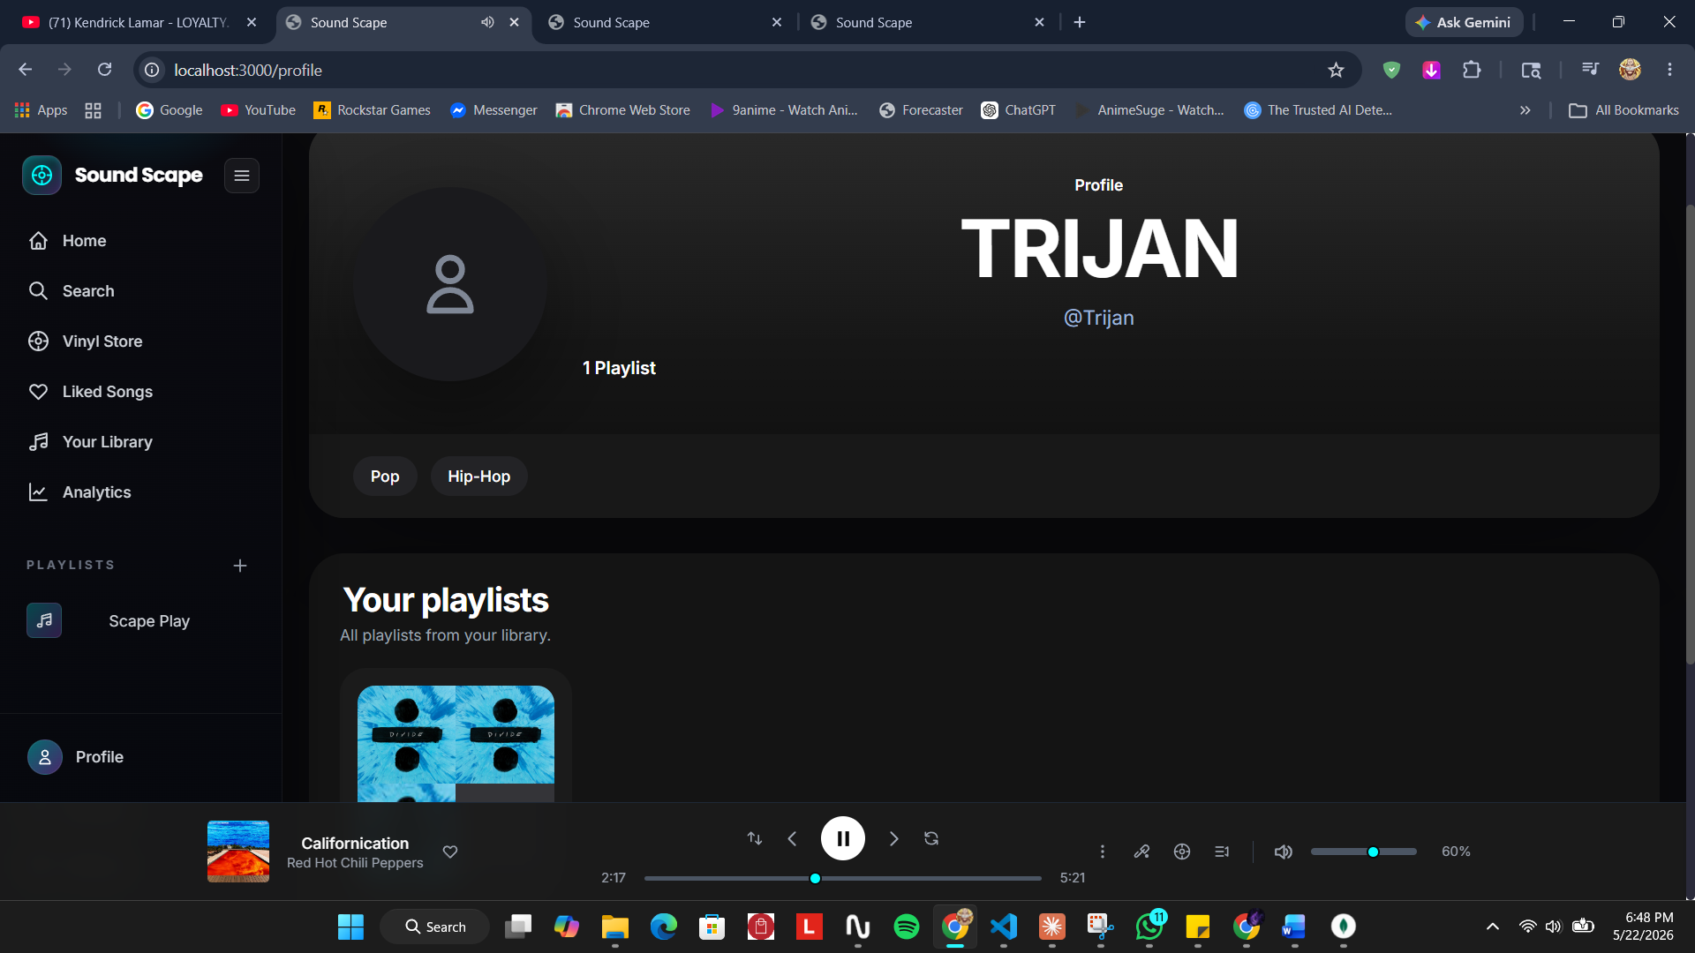
Screenshot : The listener profile page showing identity, taste tags and playlists

9.3.3 Testing
Table 5 records representative tests carried out against this sub-system.
ID | Test Case | Expected Result | Actual | Status
T2.1 | Play a track that has an uploaded audio file. | Audio plays; the persistent player updates. | As expected | Pass
T2.2 | Navigate to another page during playback. | Playback continues uninterrupted; player state persists. | As expected | Pass
T2.3 | Like a song and open the liked-songs view. | The song appears in the liked-songs list. | As expected | Pass
T2.4 | Create a playlist and add songs to it. | The playlist is created and lists the added songs. | As expected | Pass
T2.5 | Search for a term and apply a category filter. | Results are restricted to the chosen category. | After fix, as expected | Pass
T2.6 | Play a track while signed in. | A listening-history record is created for the user. | After fix, as expected | Pass
Two defects were found and resolved during testing of this sub-system. The category filter initially searched only the songs already loaded into the client, so matches beyond the first page were missed; the fix raised the catalogue page size for administrative and search contexts. Separately, play events were not being recorded for signed-in users because the play endpoint applied no authentication middleware and so never identified the user; adding optional authentication to that route corrected it and is the reason the analytics dashboard now receives data.

9.4 Personalisation and Onboarding System
The Personalisation and Onboarding System captures what a listener likes and turns it into a personalised home experience. It implements the rule-based recommendation strategy that the academic question examines. Its requirements are set out in Table 6.
Ref. | Requirement | Type | MoSCoW
POS-F-1 | A new user must be guided through an onboarding step after verifying their account. | F | Must
POS-F-2 | During onboarding a user must be able to declare preferred genres, moods, languages and tags. | F | Must
POS-F-3 | The system must persist the declared taste profile against the user account. | F | Must
POS-F-4 | The home page must present a personalised feed of catalogue content matching the taste profile. | F | Must
POS-F-5 | When a strict match yields too few results, the matcher must progressively relax its filters. | F | Should
POS-F-6 | A user must be able to revisit onboarding and update their preferences at any time. | F | Should
POS-NF-1 | Every item in the personalised feed must be attributable to a declared preference. | NF | Should
POS-UR-1 | The personalised section must clearly show which preferences produced it. | UR | Could

9.4.1 Design
Assembly of the personalised feed is modelled in the sequence diagram in Figure 10. When an onboarded user opens the home page the client requests the personalised feed; the server reads the stored taste profile and builds a tiered query that first matches on all declared dimensions at once. If that strict query returns too few songs, the server relaxes the query in stages, dropping tags, then language, then mood, until enough results are gathered. This tiered relaxation is the mechanism by which a deterministic rule-based recommender remains useful even against an unevenly classified catalogue.
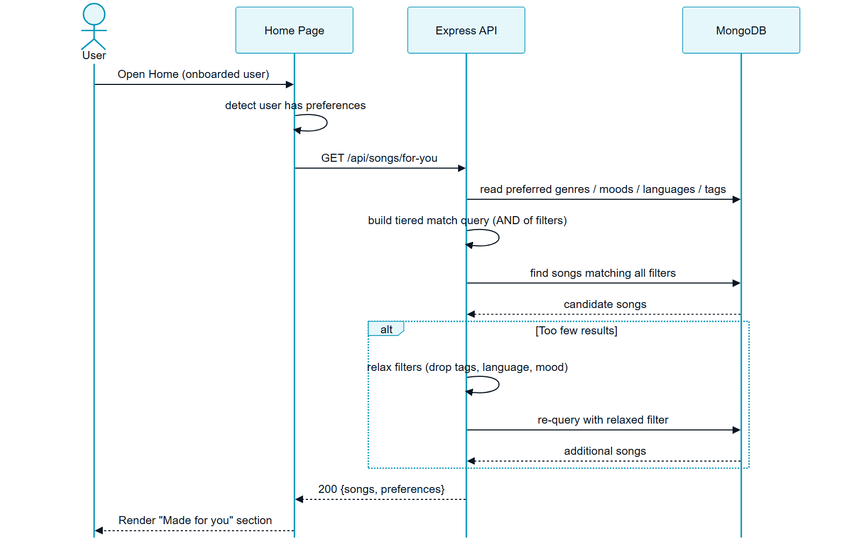
Figure : Sequence diagram for assembly of the rule-based personalised feed

9.4.2 Implemented Interface
Immediately after verifying their account, a new listener is guided through the onboarding screen, where they declare the genres, moods, languages and tags they enjoy. This explicit declaration is the entire input to the rule-based recommender.
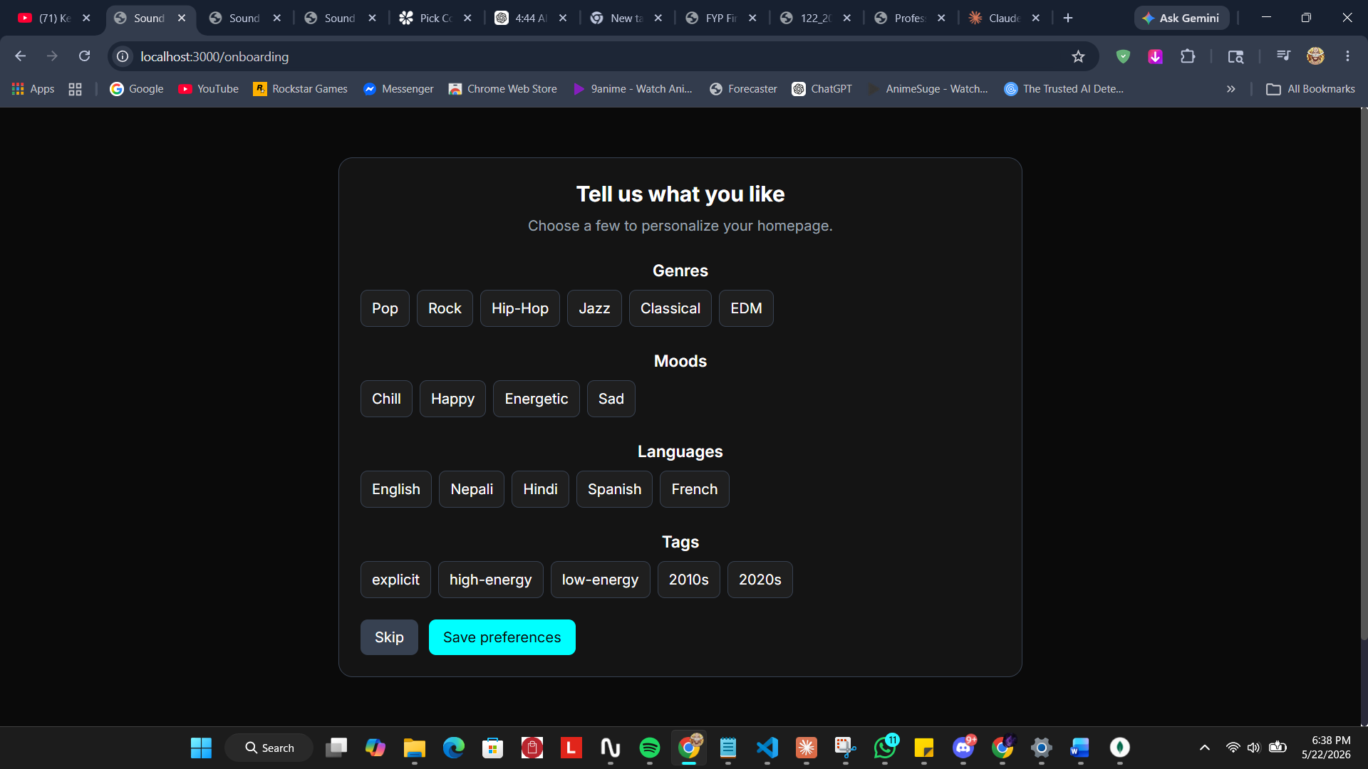
Screenshot : The onboarding screen where the listener declares an explicit taste profile
Once onboarding is complete the home page presents the personalised section. It is labelled so that the listener can see it was produced from their taste profile, and the declared preferences that drove it are displayed as chips above the results, making the recommendation transparent and explainable.
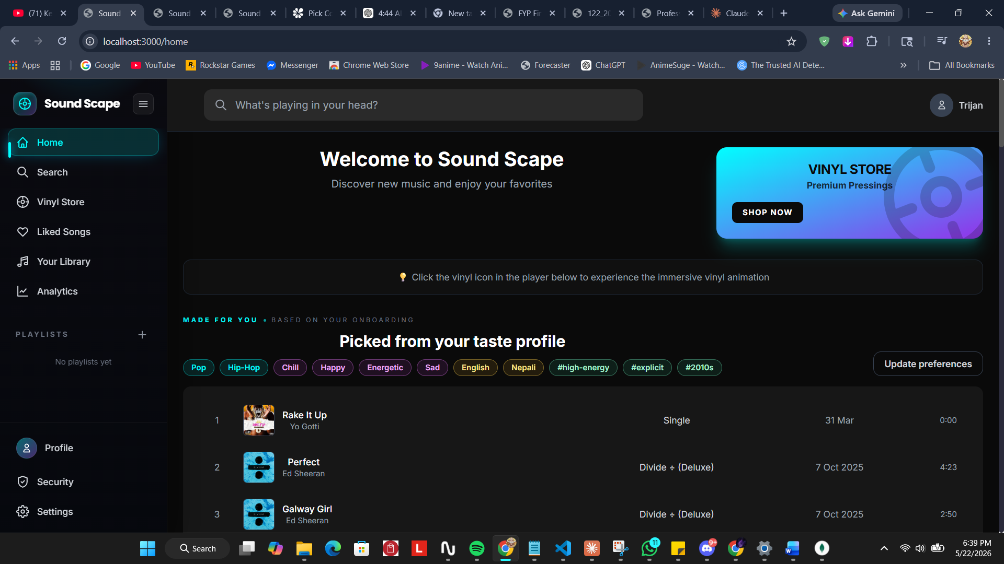
Screenshot : The personalised home feed assembled from the declared taste profile
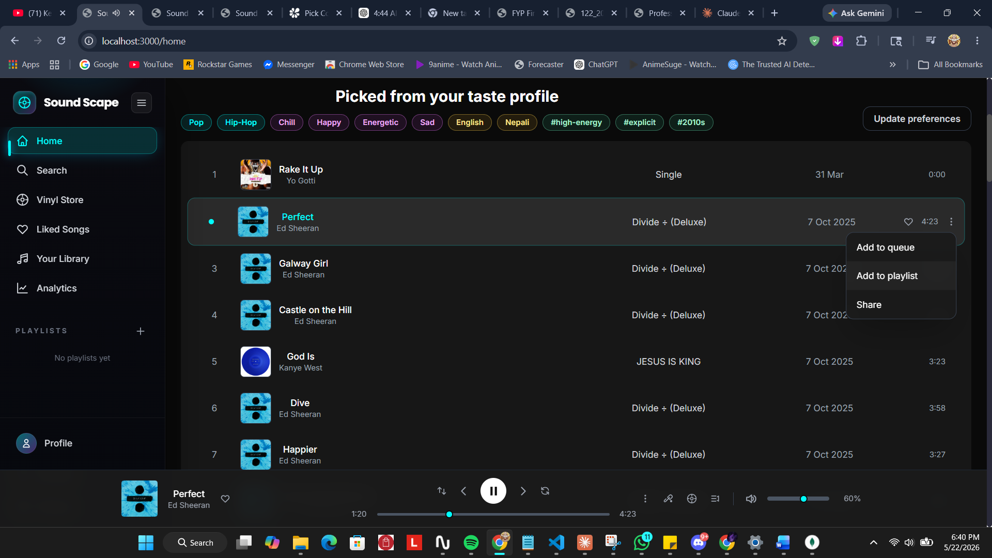
Screenshot : The personalised feed with its preference chips and per-track actions

9.4.3 Testing
Table 7 records representative tests carried out against this sub-system.
ID | Test Case | Expected Result | Actual | Status
T3.1 | Complete onboarding with a set of preferences. | Preferences are saved; onboarded flag is set. | As expected | Pass
T3.2 | Open the home page as an onboarded user. | A personalised section matching the preferences is shown. | After fix, as expected | Pass
T3.3 | Choose a very narrow combination of preferences. | The matcher relaxes filters and still returns results. | As expected | Pass
T3.4 | Edit preferences and reload the home page. | The personalised feed reflects the updated preferences. | As expected | Pass
T3.5 | Sign in as a returning user whose token lacks preference fields. | The client re-syncs the profile so the feed still renders. | After fix, as expected | Pass
Testing revealed that the personalised section did not appear for some users because the login response omitted the preference and onboarding fields; the feed therefore had nothing to render. The fix enriched the authentication response with those fields and added a client-side re-sync as a safeguard, after which the personalised feed rendered reliably.

9.5 Vinyl Store and Payment System
The Vinyl Store and Payment System attaches a physical-format storefront to the same catalogue, and completes real purchases through an external payment gateway. Its requirements are set out in Table 8.
Ref. | Requirement | Type | MoSCoW
VSS-F-1 | A user must be able to browse a catalogue of vinyl editions. | F | Must
VSS-F-2 | A user must be able to open a vinyl page showing its details and tracklist. | F | Must
VSS-F-3 | A signed-in user must be able to purchase a vinyl through the Khalti payment gateway. | F | Must
VSS-F-4 | On a verified payment the system must record the transaction and add the vinyl to the user collection. | F | Must
VSS-F-5 | A user must be able to view the vinyls they own. | F | Should
VSS-NF-1 | A vinyl page must still load if its linked album or tracklist source is unavailable. | NF | Should
VSS-UR-1 | A vinyl already owned must be presented differently from one available to buy. | UR | Could

9.5.1 Design
The purchase journey is modelled in the activity diagram in Figure 11. The flow covers opening a vinyl page, the best-effort resolution of its tracklist, the requirement to be signed in, the check for an edition the user already owns, initiation of the Khalti payment, the gateway redirect, and the verification callback that records the transaction and grants ownership.
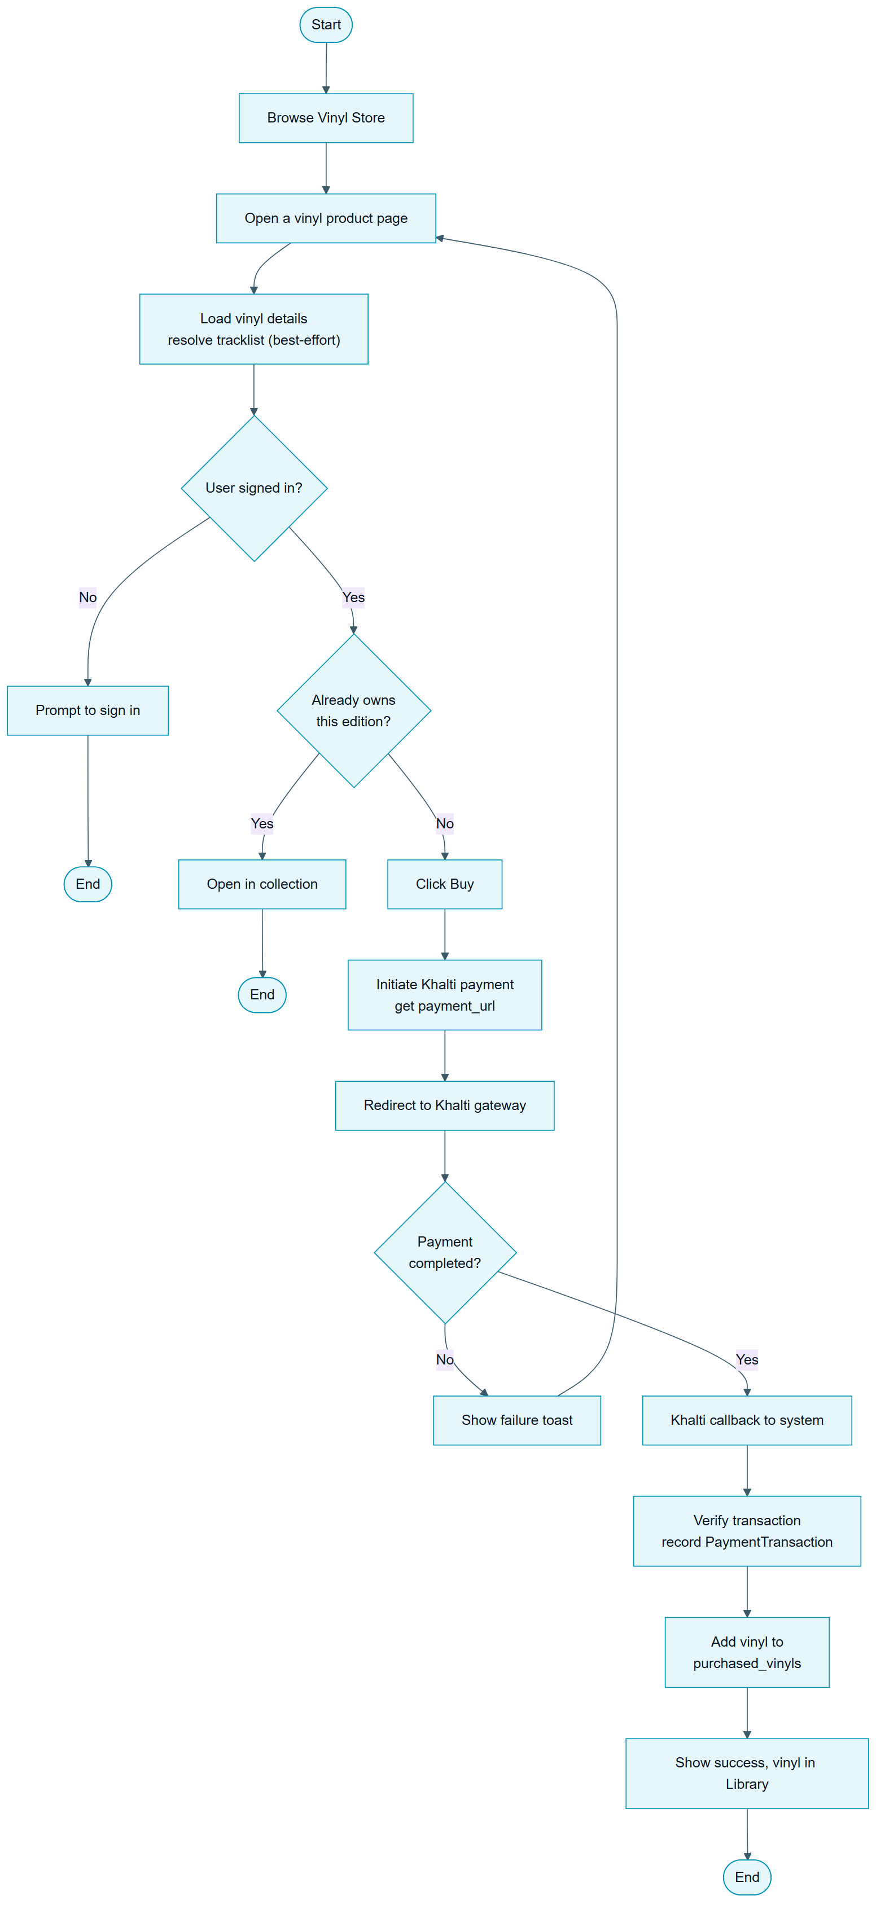
Figure : Activity diagram for browsing and purchasing a vinyl

9.5.2 Implemented Interface
The Vinyl Store presents the physical-format catalogue. Its landing view highlights featured pressings, and a browse view lists every available vinyl edition with its price and availability.
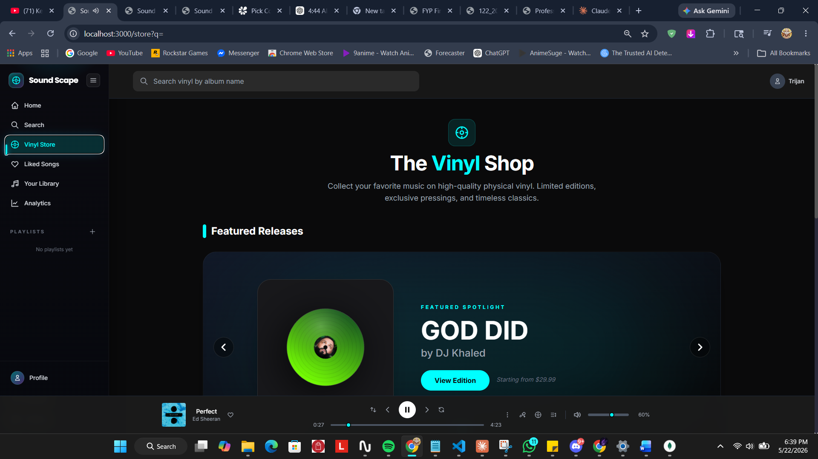
Screenshot : The Vinyl Store front page highlighting featured releases
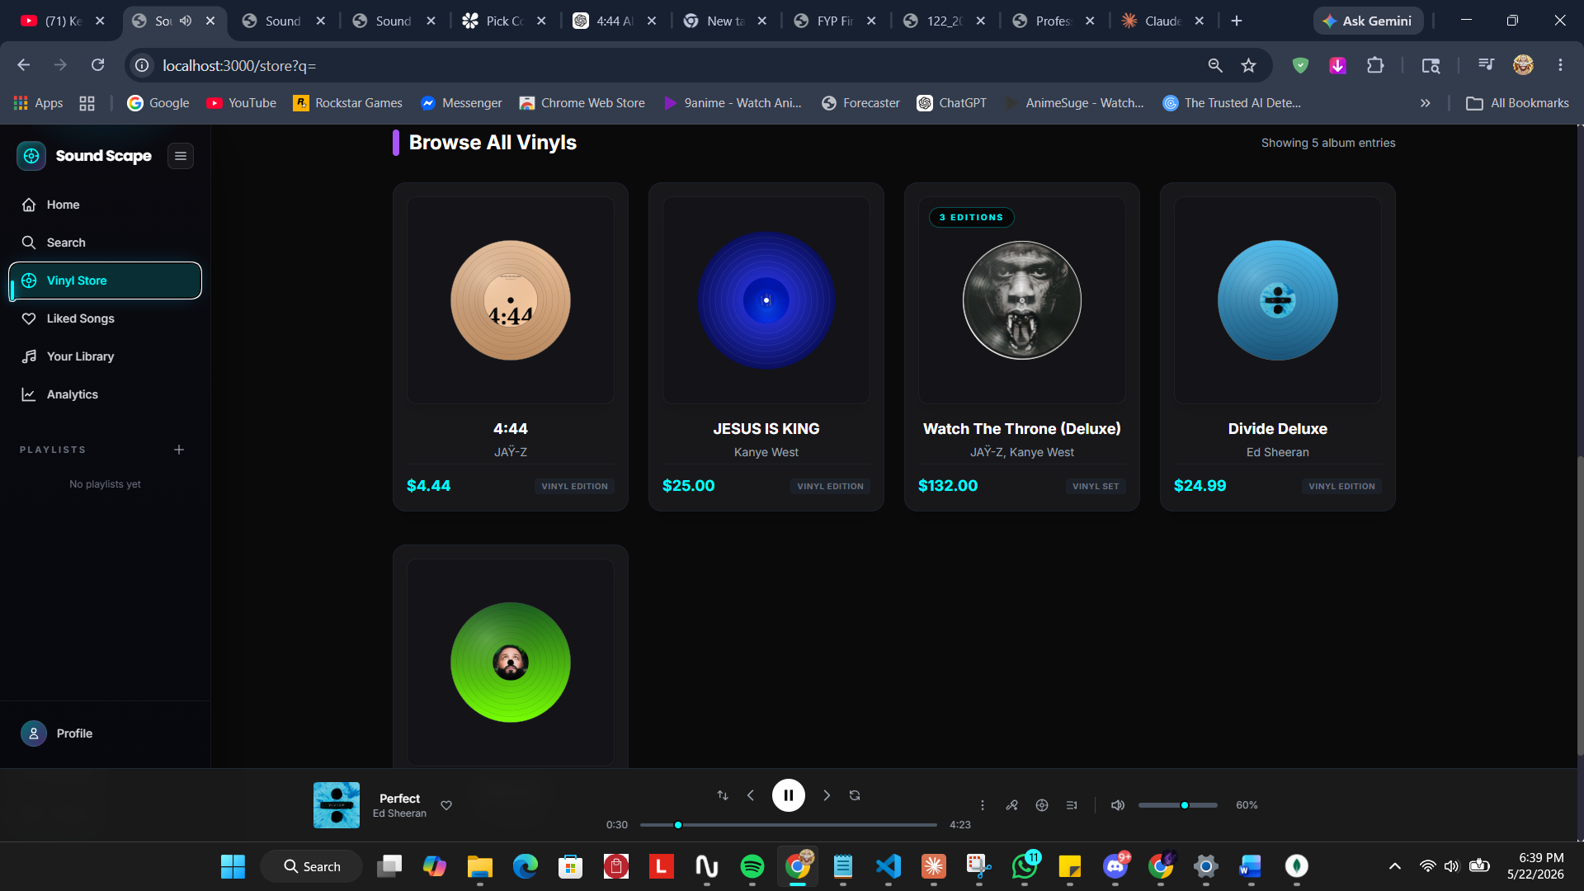
Screenshot : The browse view listing all available vinyl editions
Selecting a vinyl opens its product page, where the record is rendered as a rotating disc alongside its details and tracklist, and from which the purchase is started. Vinyls a listener already owns are gathered into a collection in their library.
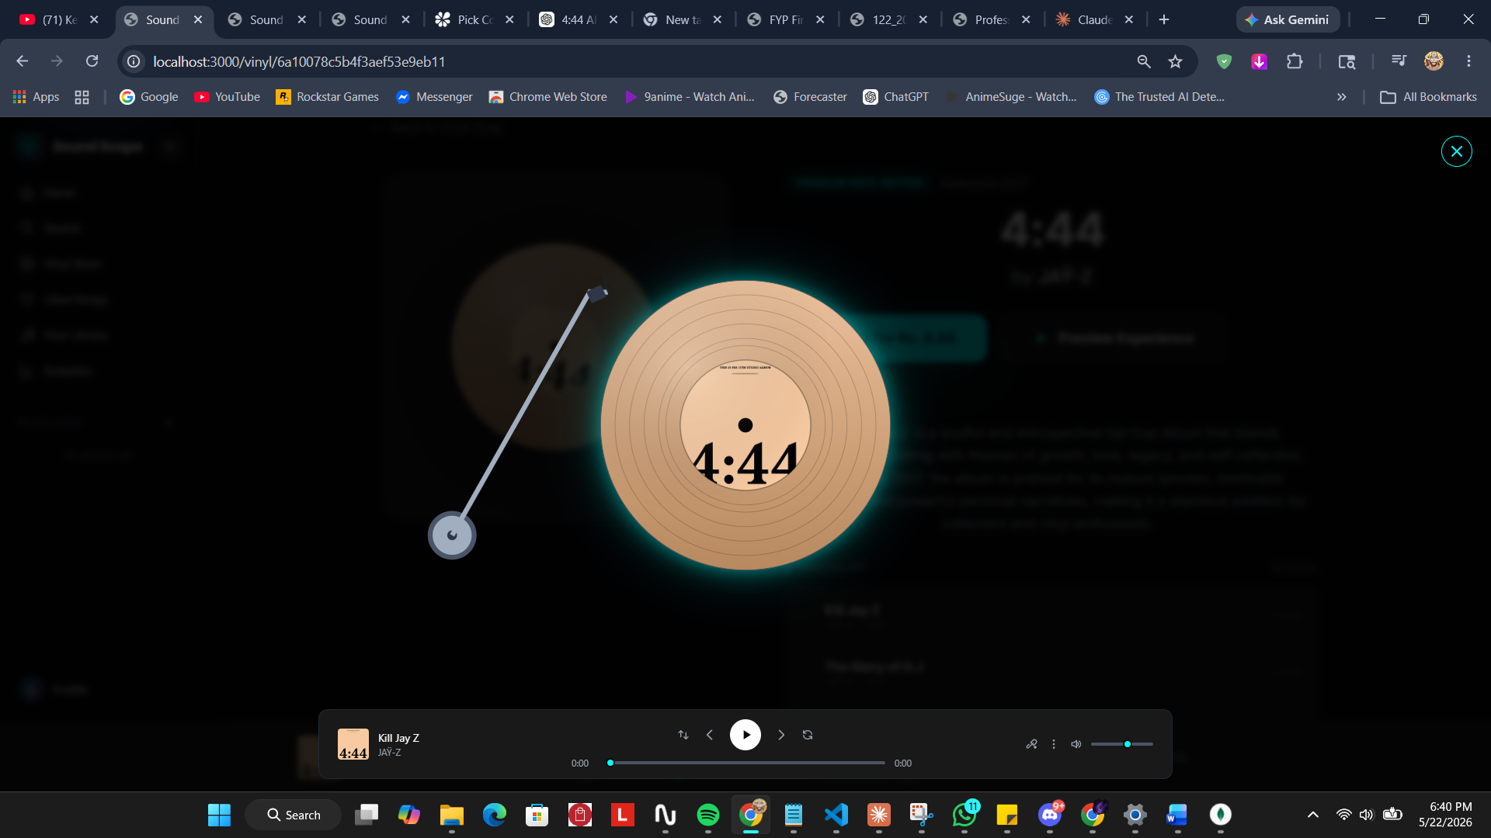
Screenshot : An individual vinyl product page with its rotating-disc presentation
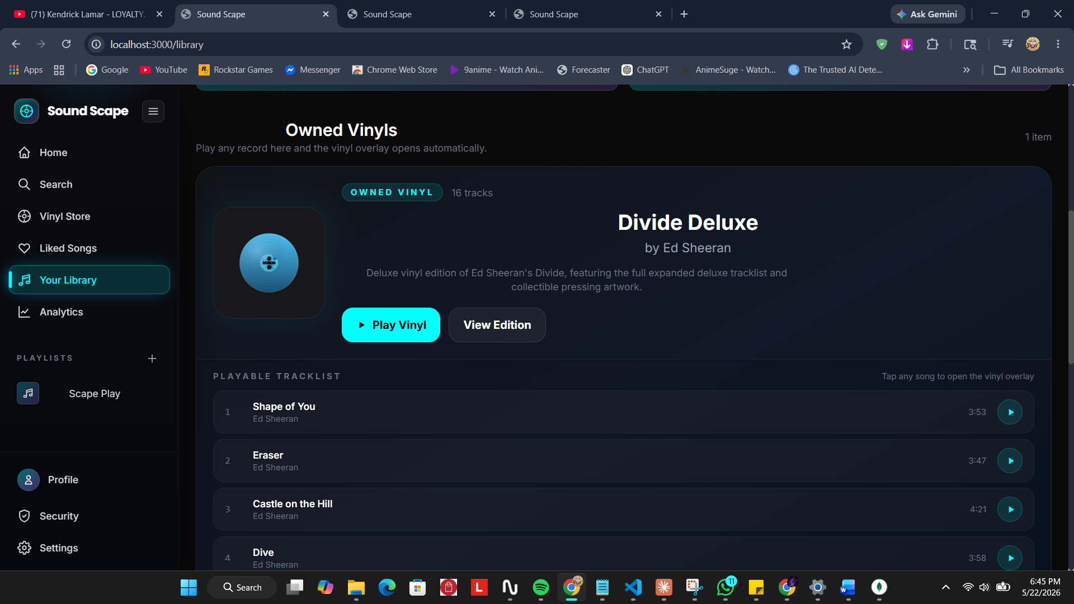
Screenshot : The owned-vinyl collection in the listener’s library

9.5.3 Testing
Table 9 records representative tests carried out against this sub-system.
ID | Test Case | Expected Result | Actual | Status
T4.1 | Open a vinyl whose linked album is hidden. | The vinyl page still loads; only the tracklist is unavailable. | After fix, as expected | Pass
T4.2 | Start a purchase while signed out. | The user is prompted to sign in first. | As expected | Pass
T4.3 | Complete a Khalti payment for a vinyl. | The transaction is recorded; the vinyl joins the collection. | As expected | Pass
T4.4 | Open a vinyl already owned. | The page offers to open it in the collection rather than to buy. | As expected | Pass
T4.5 | Open a vinyl page from a scrolled position. | The page opens scrolled to the top. | After fix, as expected | Pass
Testing of this sub-system surfaced a significant defect: a vinyl whose linked album had been hidden failed to open at all, because the tracklist lookup raised an error that replaced the whole page. The fix made tracklist resolution best-effort so that a missing or hidden source no longer prevents the vinyl, and its purchase button, from rendering.

9.6 Admin Management System
The Admin Management System gives catalogue staff control over the platform’s content and over the taxonomy that the rest of the system depends on. Its requirements are set out in Table 10.
Ref. | Requirement | Type | MoSCoW
AMS-F-1 | An administrator must authenticate before reaching any administrative function. | F | Must
AMS-F-2 | An administrator must be able to create, read, update and delete artists, albums and songs. | F | Must
AMS-F-3 | An administrator must be able to manage vinyl products and song lyrics. | F | Must
AMS-F-4 | An administrator must be able to control the visibility and publish status of catalogue entities. | F | Must
AMS-F-5 | An administrator must be able to maintain the genre, mood, category and language taxonomy. | F | Must
AMS-F-6 | An administrator must be able to search the full catalogue, not only a first page of it. | F | Should
AMS-NF-1 | Administrative endpoints must reject requests that do not carry administrative authority. | NF | Must
AMS-UR-1 | Bulk catalogue operations must report clearly how many records were affected. | UR | Could

9.6.1 Design
The Admin Management System operates on the same domain model already shown in the entity-relationship and class diagrams in Section 9.1, so those models are not repeated here. Its distinctive design characteristic is that visibility is treated as a first-class property of catalogue entities: artists, albums and songs each carry visibility and publish-status fields, and the public-facing sub-systems filter on those fields so that hidden content never reaches an ordinary user. The taxonomy that the Personalisation system depends upon, genre, mood, category and language, is also maintained here, which makes this sub-system the foundation on which reliable browsing and personalisation rest.

9.6.2 Implemented Interface
The administrative console is reached through a separate, dedicated login that is independent of the ordinary user authentication. Once authenticated, the administrator is presented with a dashboard that summarises the catalogue, the total number of artists, uploaded audio files and vinyl products, and provides entry points to every management area.
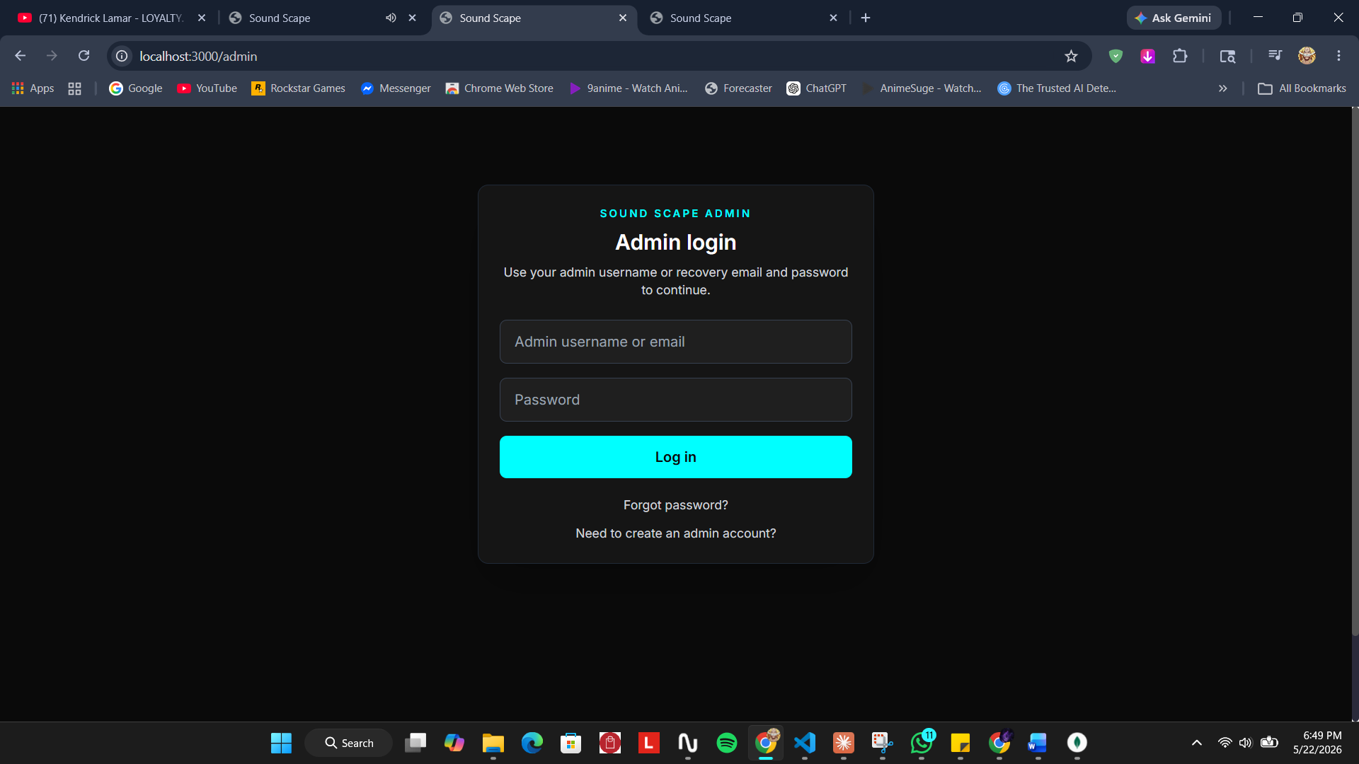
Screenshot : The dedicated administrator login screen
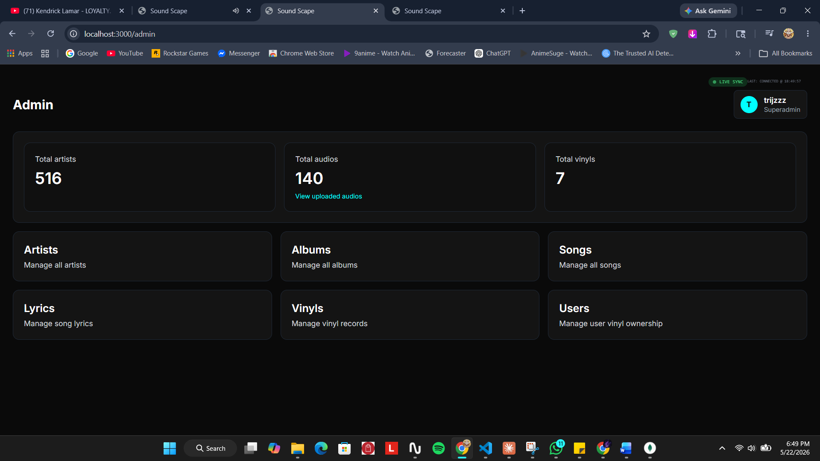
Screenshot : The administrative dashboard summarising the catalogue and management areas
The artist management console lists every artist and supports search, filtering, bulk operations and quick edits. Each artist can be published, hidden or featured, and the console separates unhidden artists from those that are hidden or in draft, making entity visibility directly governable.
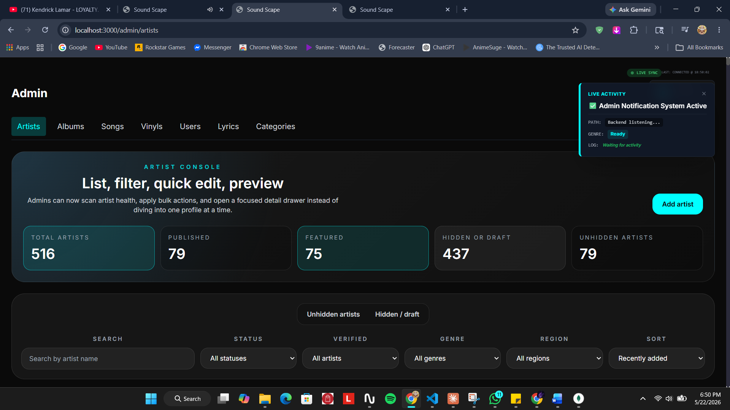
Screenshot : The artist management console with catalogue health statistics
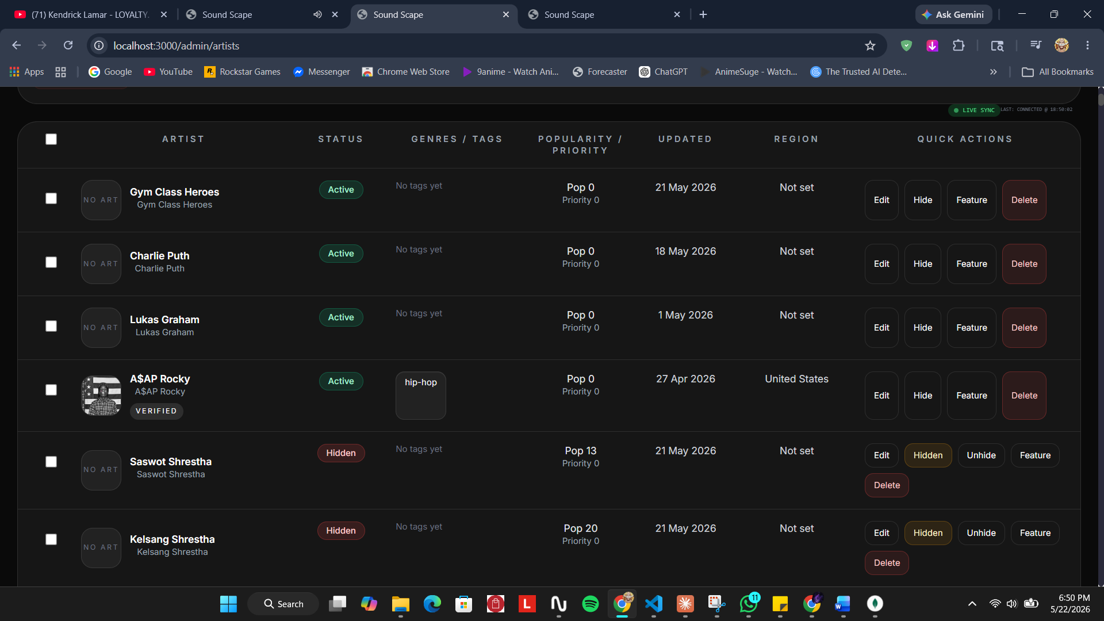
Screenshot : The artist listing with per-row status and quick actions
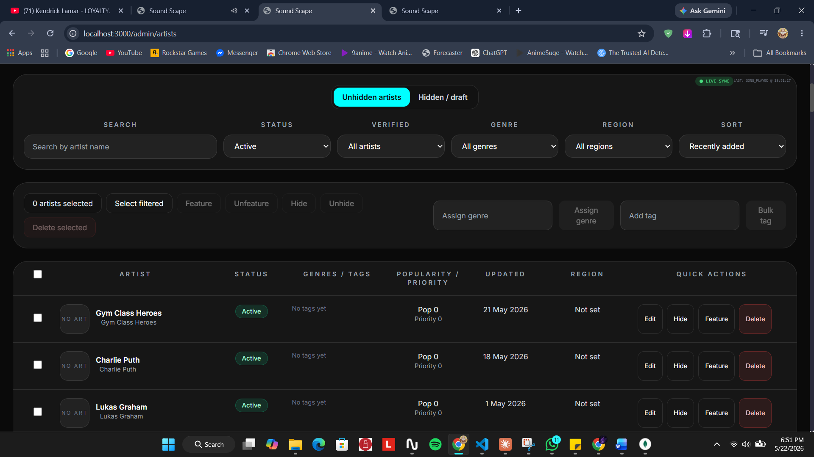
Screenshot : The unhidden-artists view with bulk visibility and tagging actions
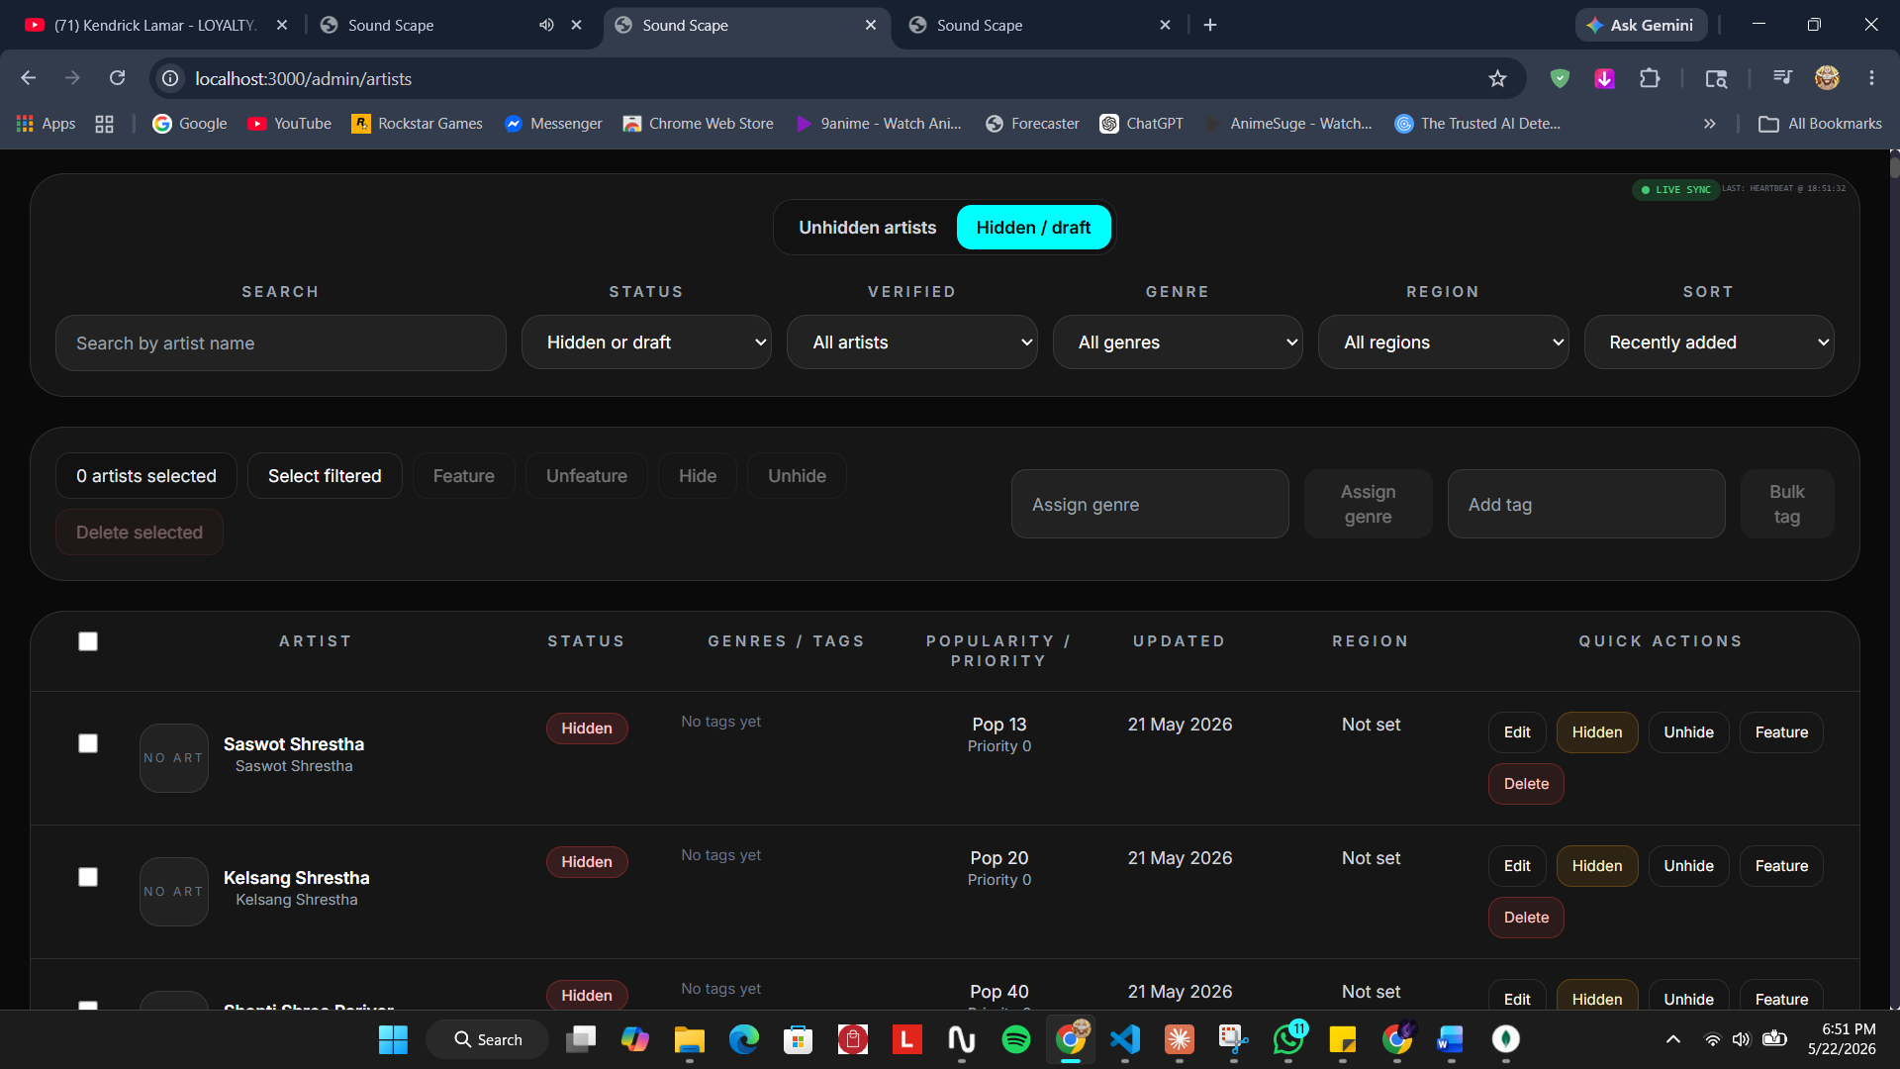
Screenshot : The hidden and draft artists view
Parallel consoles manage the remaining catalogue entities. Vinyl products, song lyrics and the catalogue taxonomy are each maintained through their own dedicated console.
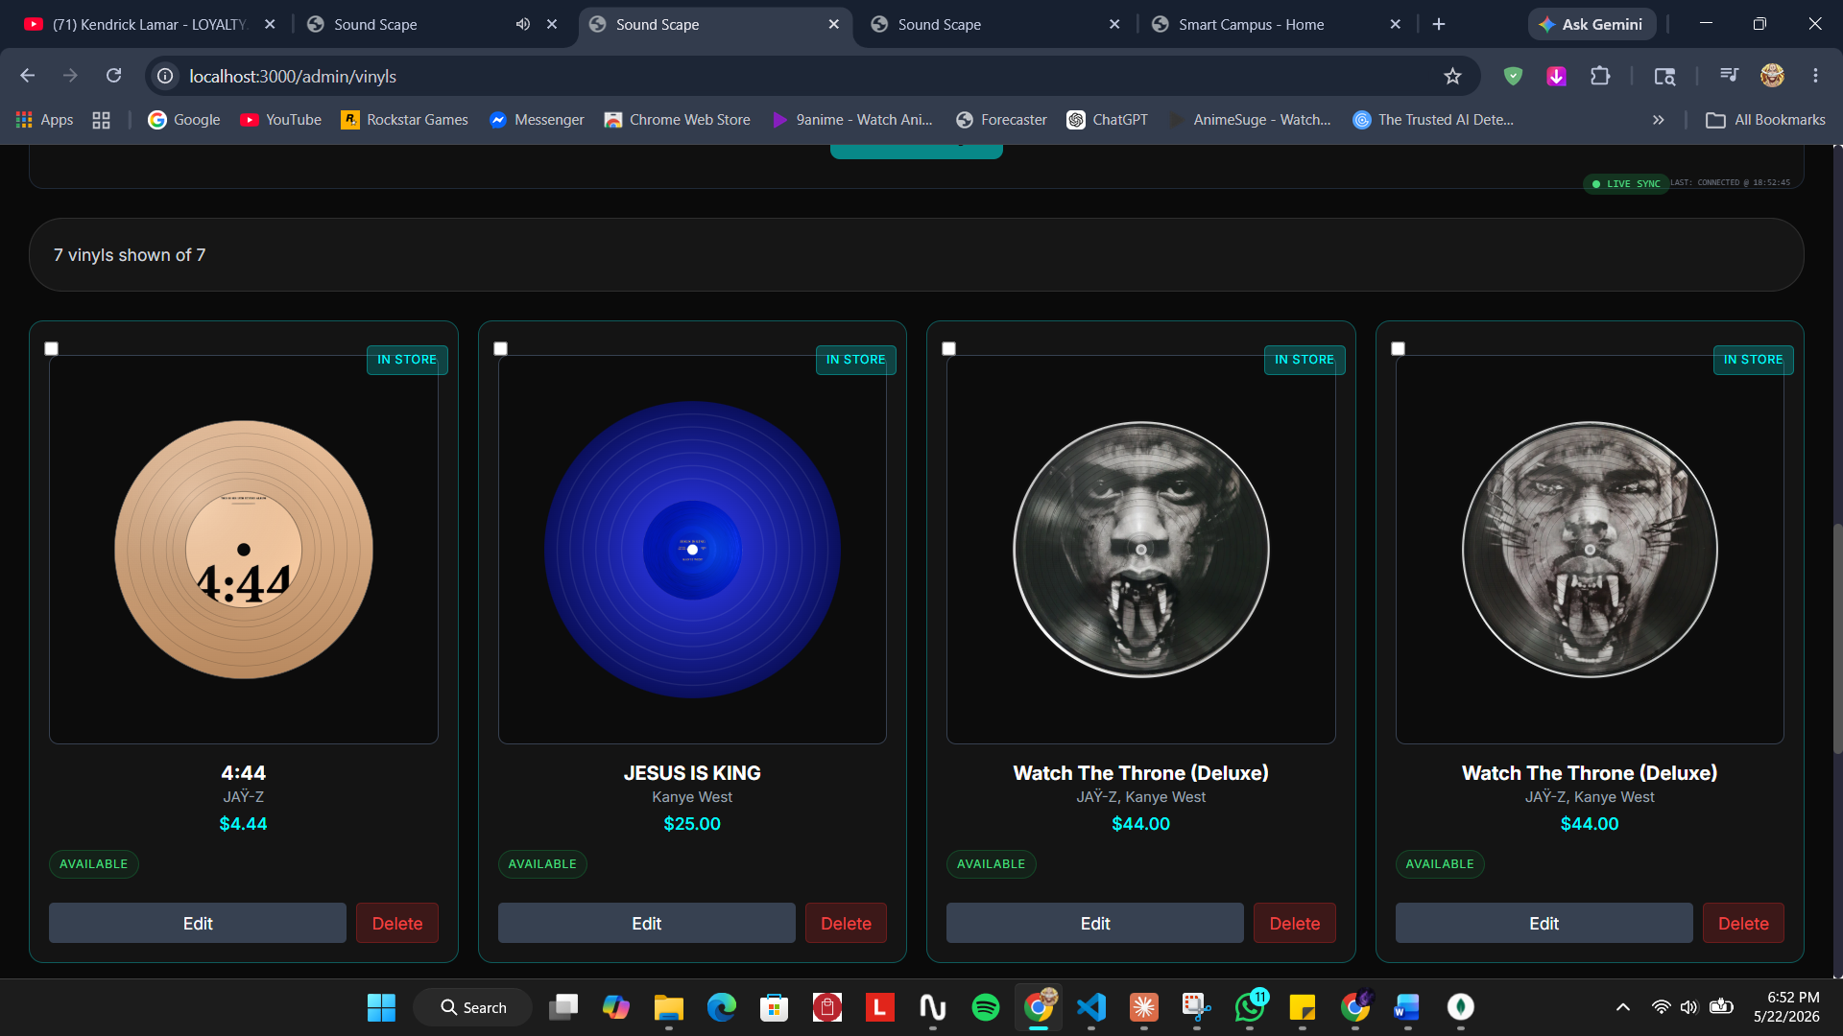
Screenshot : The vinyl management console listing all vinyl products
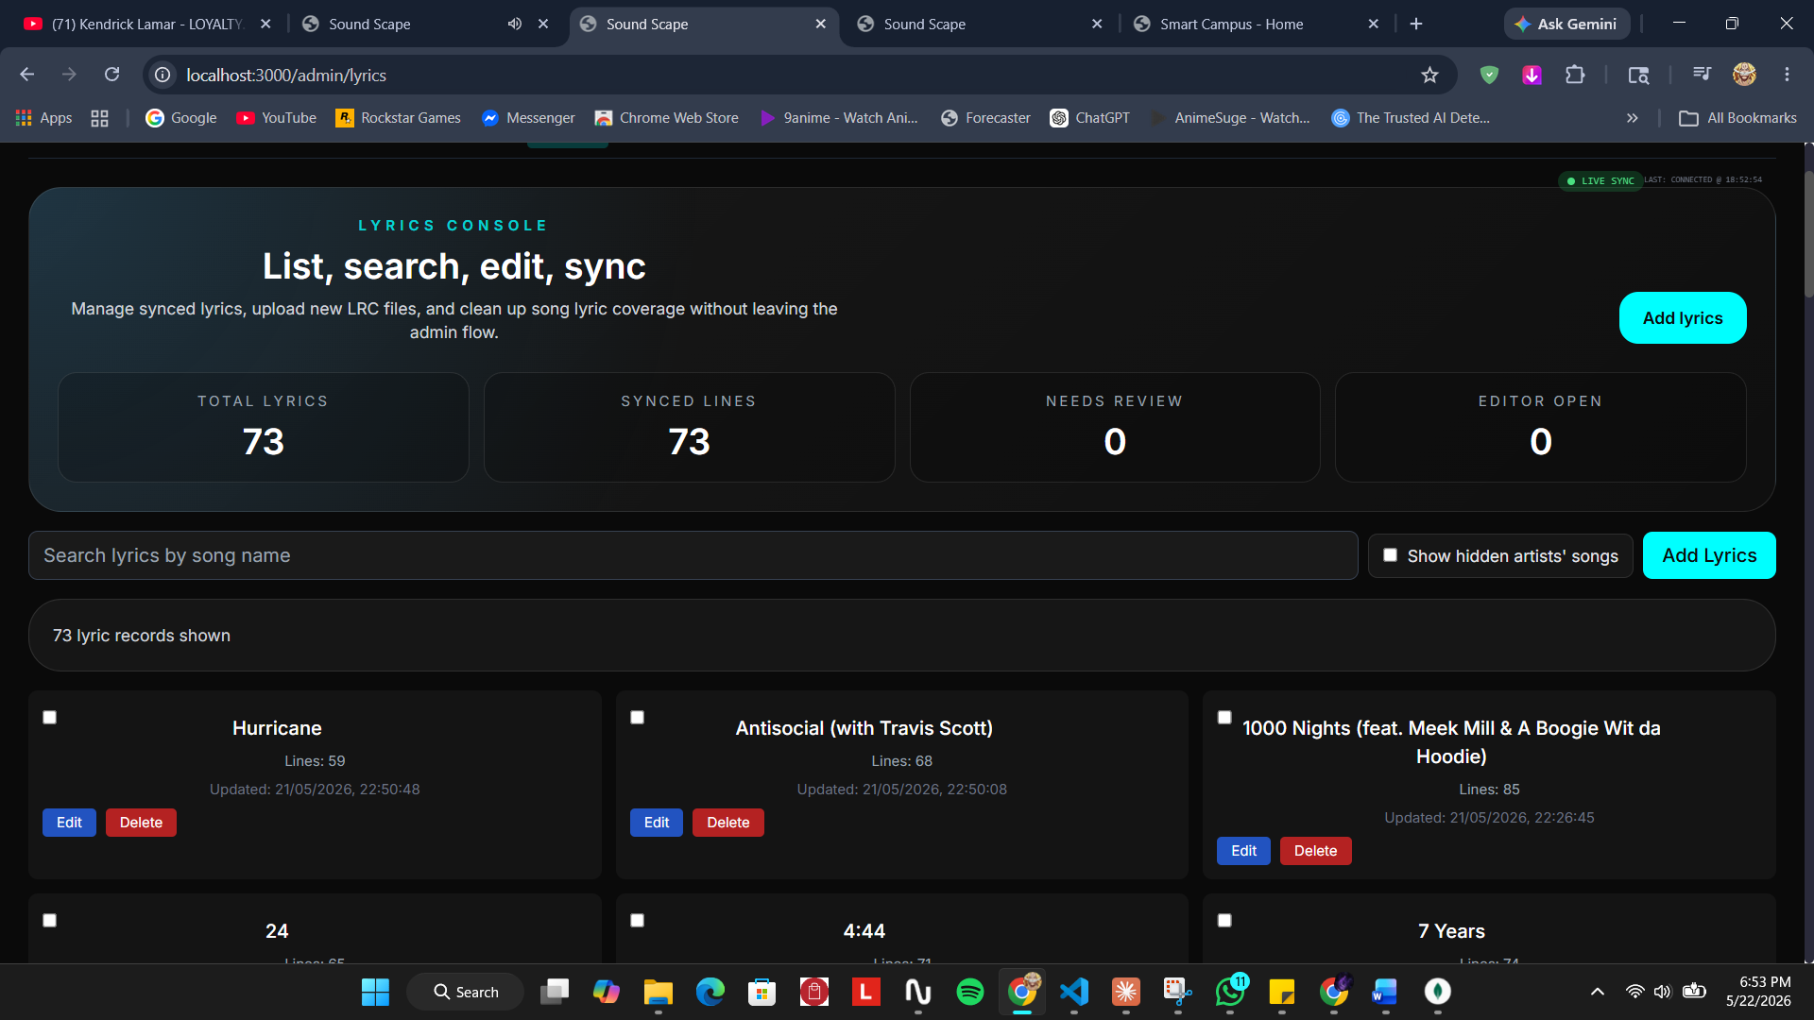
Screenshot : The lyrics console for managing and synchronising song lyrics
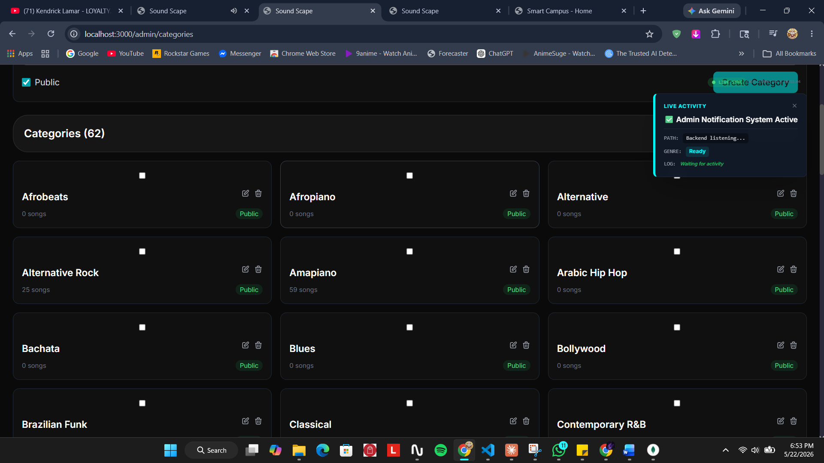
Screenshot : The categories console maintaining the catalogue taxonomy

9.6.3 Testing
Table 11 records representative tests carried out against this sub-system.
ID | Test Case | Expected Result | Actual | Status
T5.1 | Reach an administrative page without administrative authority. | Access is refused. | As expected | Pass
T5.2 | Create, edit and delete a song through the console. | The catalogue reflects each change. | As expected | Pass
T5.3 | Hide an artist and view the catalogue as an ordinary user. | The hidden artist and its songs do not appear. | As expected | Pass
T5.4 | Search the song catalogue for a track beyond the first page. | The track is found. | After fix, as expected | Pass
T5.5 | Assign taxonomy values across the catalogue in bulk. | Every targeted record is updated; a count is reported. | As expected | Pass
Testing showed that some songs could not be found through the administrative search because the catalogue endpoint capped the number of records returned, so tracks beyond that cap were never loaded into the client to be searched. Raising the cap for authenticated administrative requests resolved it.

9.7 Analytics and Listening Data System
The Analytics and Listening Data System closes the loop by returning insight to the listener. It records playback events and aggregates them into a dashboard of the listener’s own habits. Its requirements are set out in Table 12.
Ref. | Requirement | Type | MoSCoW
ALS-F-1 | The system must record each authenticated playback as a listening-history record. | F | Must
ALS-F-2 | The system must aggregate listening history into per-user statistics. | F | Must
ALS-F-3 | The dashboard must present headline statistics: listening hours, songs played, favourite genre and artist. | F | Must
ALS-F-4 | The dashboard must present charts of weekly activity, genre distribution and listening by hour. | F | Should
ALS-F-5 | The dashboard must show recently played tracks and an activity timeline. | F | Should
ALS-F-6 | The system must compute a listening streak of consecutive active days. | F | Could
ALS-NF-1 | Aggregation must execute server-side so the client only receives prepared figures. | NF | Should
ALS-UR-1 | Statistic cards must animate on load and numbers should count up. | UR | Could

9.7.1 Design
The data foundation of this sub-system is the listening-history collection, which is populated by the play-event sequence already shown in Figure 9. A dedicated analytics endpoint reads a user’s listening history and aggregates it server-side into headline statistics, a weekly trend, a genre distribution, an hourly distribution, a recently played list and a listening streak. The client renders this prepared data as a cinematic dashboard: animated hero cards with count-up numbers, an area chart, a donut chart and a bar chart drawn with Recharts, a horizontal recently played strip, and an activity timeline of generated insights.

9.7.2 Testing
Table 13 records representative tests carried out against this sub-system.
ID | Test Case | Expected Result | Actual | Status
T6.1 | Play several tracks while signed in, then open the dashboard. | The plays are reflected in the statistics and charts. | As expected | Pass
T6.2 | Open the dashboard with no listening history. | The dashboard renders with empty, non-error states. | As expected | Pass
T6.3 | Verify the weekly-trend and genre charts. | Charts render with hover tooltips and animate on load. | As expected | Pass
T6.4 | Listen on consecutive days. | The listening streak increases accordingly. | As expected | Pass
T6.5 | Open the dashboard while signed out. | A prompt to sign in is shown instead of the dashboard. | As expected | Pass
The most important finding during testing of this sub-system was that the dashboard was initially empty for every user. The cause was traced not to the analytics code but to the playback sub-system, where, as noted in Section 9.3.2, play events were never being attributed to a user. Once that was corrected the analytics pipeline received data and the dashboard populated as designed, which illustrates how closely the sub-systems depend on one another.

10. Conclusion
This project set out to design and develop Sound Scape, a unified, self-hostable web platform for personalised music streaming, vinyl commerce and listening analytics. With the artefact complete, this section returns to the aims, the objectives and the academic question set out in Section 5 and judges what has been achieved.
The aim of the project has been met. A working full-stack platform was delivered that, over a catalogue of more than three thousand imported tracks, streams music, personalises discovery through a transparent rule-based recommender, sells vinyl through an integrated payment gateway, and returns listening insight to the listener, all within one coherent application that an independent operator could realistically run.
Each of the six objectives can also be assessed against the artefact. The first, personalising the listener’s home experience, was achieved through the onboarding flow and the rule-based personalised feed. The second, protecting accounts and sensitive actions, was achieved through JWT sessions, e-mail OTP verification, Google OAuth sign-in and the OTP-gated password change. The third, making a large imported catalogue consistently discoverable, was achieved by enforcing a uniform genre, mood, category and language taxonomy across every track. The fourth, monetising the catalogue through physical formats, was achieved by the vinyl storefront and its Khalti checkout. The fifth, returning listening insight to the listener, was achieved by recording playback events and aggregating them into the analytics dashboard. The sixth, keeping catalogue and platform state under administrative control, was achieved through the administrative console and its visibility and taxonomy controls. All six objectives were therefore satisfied by the delivered system.
On the academic question, the project found that a transparent, rule-based personalisation strategy is a viable and, in several respects, advantageous alternative to an opaque machine-learning recommender for a platform of this scale. The strategy proved genuinely transparent: because the personalised feed is produced by matching declared preferences against a visible taxonomy, every recommendation can be explained in a single sentence and the listener can reshape the feed at will simply by editing those preferences. It proved immune to the user-side cold-start problem, since it requires no prior listening history and produces a relevant feed from the very first session. It also proved practical: the tiered query, which progressively relaxes its filters when a strict match returns too little, kept the recommender useful even against an unevenly classified catalogue. The cost, anticipated from the literature, was confirmed in practice: a purely declarative recommender cannot surprise the listener with material outside their stated taste, so it forgoes the serendipity that a well-tuned behavioural model provides. The conclusion is therefore measured rather than absolute. For a self-hosted, independently operated platform that values explainability, listener control and freedom from large behavioural datasets, the rule-based strategy is well suited; where the goal is open-ended musical discovery at very large scale, a learned model retains a clear advantage. A productive direction, noted again in the evaluation, would be to combine the two: keep the transparent rule-based feed as the explainable core and add a behavioural layer for serendipity.

11. Critical Evaluation of the Project
This section reflects critically on the project: on the report itself, on the findings and the development process, on the delivered system, and on the planning and management of the work. It closes with a personal self-reflection.

11.1 The Report
The report follows the structure prescribed by the project template and, on reflection, succeeds in presenting the project as a coherent argument rather than a list of features. Its main strength is that a single thread, the case for transparent rule-based personalisation, runs from the problem domain, through the academic question and the literature review, into the design of the Personalisation sub-system, and back out in the Conclusion. The system-wide and per-sub-system diagrams give the technical sections a consistent visual backbone. If the report has a weakness, it is that the six sub-systems are necessarily described to differing depths, since the Authentication and Personalisation sub-systems carried more design risk and so attracted more diagrams and discussion than the others.

11.2 Findings and Process
The most valuable finding of the project was not anticipated at the outset: that the sub-systems are far more interdependent than a clean decomposition suggests. The clearest example was the analytics dashboard appearing empty. The fault lay not in the analytics code but in the playback route, which never identified the user, so no listening history was ever recorded. A defect in one sub-system surfaced as a visible failure in another. The development process, incremental and test-as-you-go, was what made this tractable: because each sub-system was exercised as it was built, such cross-cutting defects were caught and traced rather than accumulating silently.

11.3 The System
The delivered system is strongest in its breadth and its coherence: six non-trivial sub-systems work together over a realistic catalogue behind a single, consistent interface. The personalisation pipeline, with its tiered query relaxation, and the layered, OTP-gated security flows are the parts that best repay close inspection. The system is honestly limited in the ways already set out in Section 5.6. The most consequential limitation is that only a subset of the imported catalogue has playable audio, which is a direct consequence of sourcing the catalogue as metadata; and the personalisation, being purely declarative, cannot adapt on its own. Neither limitation undermines the artefact as a demonstration of the project’s aim, but both would matter for real-world deployment.

11.4 Planning and Management
The agile, Scrum-based plan suited the project well. Organising the work as six sub-system increments meant a working artefact existed early and stayed working as it grew, and the iterative cadence absorbed the steady stream of requirement changes that emerged once the platform held real data. The quality of sources used in the literature review was sound, drawing on established platforms and on recognised recommender-systems literature. With hindsight, the schedule under-estimated the effort of catalogue data quality: cleaning, classifying and governing the visibility of thousands of imported records consumed more time than planned, and a future plan would budget an explicit iteration for catalogue preparation.

11.5 Self-Reflection
Undertaking this project was a substantial piece of professional development. The most important lesson was the discipline of working on a system large enough that no part of it can be held in the head at once: it forced a habit of decomposition, of clear interfaces between sub-systems, and of methodical tracing when a fault in one area surfaced in another. Building the layered security flows developed a genuine understanding of why authentication is designed the way it is, rather than a recipe to be copied. Carrying a project from a problem statement, through a literature-grounded design, to a tested artefact and a written defence of it also strengthened skills that are not purely technical: scoping work realistically, writing for assessment, and reflecting honestly on what fell short. Equally valuable was learning to make and defend a design decision: choosing a transparent rule-based recommender over a machine-learning one was a position that had to be justified against the literature and then lived with through the trade-offs it imposed. That experience, of owning a decision rather than defaulting to the most fashionable option, is the part of the project most likely to carry into future professional work.

12. Evidence of Project Management
This section presents the evidence of how the project was managed. It is exempt from the report word count.

12.1 Supervisor Log Sheet
Throughout the project, progress was reviewed in regular meetings with the project supervisor. Each meeting was recorded on a log sheet capturing the date, the work discussed, the feedback given and the actions agreed for the next iteration, and each entry was signed by the supervisor. The signed and scanned log sheets are provided in Appendix B. The summary below records the meeting cadence.
Meeting | Focus of the Iteration Reviewed | Outcome
1 | Project title, problem domain and initial scope | Title and academic question approved
2 | Proposal, aims, objectives and initial artefact design | Proceed to literature review and design
3 | Literature review and methodology | Comparator set and Scrum plan confirmed
4 | Sprint 1: authentication and streaming sub-systems | Increment accepted; proceed to discovery
5 | Sprint 2: personalisation, onboarding and search | Tiered-query approach reviewed and approved
6 | Sprint 3: vinyl store, payment and admin console | Increment accepted; proceed to analytics
7 | Sprint 4: analytics dashboard, testing and bug fixing | Artefact accepted as feature-complete
8 | Final report draft and presentation preparation | Report and presentation approved for submission

12.2 Gantt Chart
The Gantt chart in Figure 12 shows the project schedule across its principal phases and the four development sprints, from initial title research through to the final report and presentation.
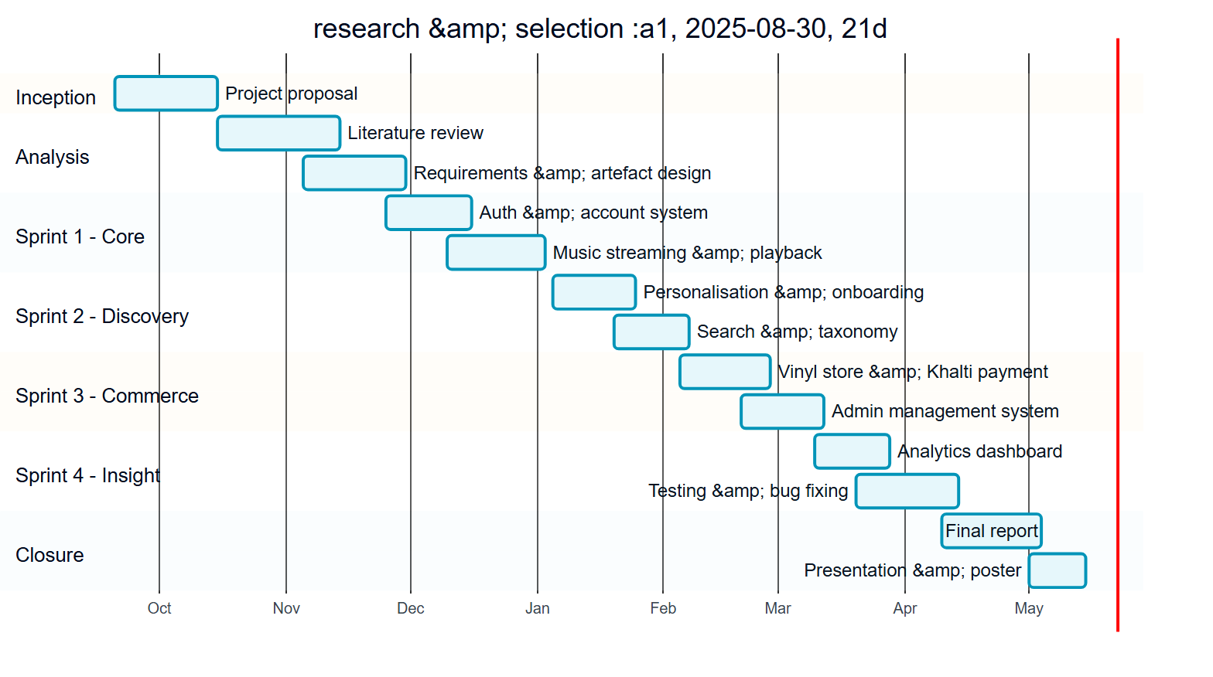
Figure : Gantt chart of the Sound Scape project schedule

13. References and Bibliography
The following sources were referred to during the research, design and development of the project. References are presented in the Harvard style. This section is exempt from the report word count.
Bandcamp (2024) About Bandcamp. Available at: https://bandcamp.com/about (Accessed: 2025).
Express (2024) Express 5.x API Reference. OpenJS Foundation. Available at: https://expressjs.com (Accessed: 2025).
Herlocker, J.L., Konstan, J.A. and Riedl, J. (2000) ‘Explaining collaborative filtering recommendations’, Proceedings of the ACM Conference on Computer Supported Cooperative Work, pp. 241-250.
JWT.io (2024) Introduction to JSON Web Tokens. Auth0. Available at: https://jwt.io/introduction (Accessed: 2025).
Khalti (2024) Khalti Payment Gateway Developer Documentation. Available at: https://docs.khalti.com (Accessed: 2025).
Lops, P., de Gemmis, M. and Semeraro, G. (2011) ‘Content-based recommender systems: state of the art and trends’, in Ricci, F. et al. (eds.) Recommender Systems Handbook. Boston: Springer, pp. 73-105.
Meta Open Source (2024) React Documentation. Available at: https://react.dev (Accessed: 2025).
MongoDB Inc. (2024) MongoDB Manual. Available at: https://www.mongodb.com/docs/manual (Accessed: 2025).
Mongoose (2024) Mongoose ODM Documentation. Available at: https://mongoosejs.com/docs (Accessed: 2025).
OWASP Foundation (2024) Password Storage Cheat Sheet. Available at: https://cheatsheetseries.owasp.org (Accessed: 2025).
Pariser, E. (2011) The Filter Bubble: What the Internet Is Hiding from You. New York: Penguin Press.
Ricci, F., Rokach, L. and Shapira, B. (eds.) (2015) Recommender Systems Handbook. 2nd edn. New York: Springer.
Schafer, J.B., Frankowski, D., Herlocker, J. and Sen, S. (2007) ‘Collaborative filtering recommender systems’, in The Adaptive Web. Berlin: Springer, pp. 291-324.
Schwaber, K. and Sutherland, J. (2020) The Scrum Guide: The Definitive Guide to Scrum. Available at: https://scrumguides.org (Accessed: 2025).
Spotify (2024) Spotify for Developers: Web API Reference. Available at: https://developer.spotify.com/documentation/web-api (Accessed: 2025).
Tailwind Labs (2024) Tailwind CSS Documentation. Available at: https://tailwindcss.com/docs (Accessed: 2025).
Vite (2024) Vite: Next Generation Frontend Tooling. Available at: https://vitejs.dev (Accessed: 2025).

14. Appendices
The appendices contain supporting material that is referenced from the body of the report. This section is exempt from the report word count.

Appendix A: User Manual
This appendix outlines how an end user operates the Sound Scape platform.

A.1 Creating and Verifying an Account
- Open the platform and select Sign Up from the landing page.
- Enter a name, e-mail address and password, and submit the form.
- Retrieve the six-digit verification code from the confirmation e-mail and enter it when prompted.
- Once verification succeeds, the onboarding screen is shown automatically.

A.2 Onboarding and Personalisation
- On the onboarding screen, select the genres, moods, languages and tags you enjoy.
- Save the preferences; you are taken to the home page.
- The personalised section on the home page now reflects the chosen preferences.
- Preferences can be changed at any time by reopening onboarding from the settings or sidebar.

A.3 Playing Music and Building Playlists
- Browse artists, albums or songs, or use the search bar with its category filter.
- Select a track to begin playback; the player remains visible on every page.
- Use the heart control to like a song; liked songs are collected in their own view.
- Create a playlist from the sidebar and add songs to it.

A.4 Buying a Vinyl
- Open the Vinyl Store and select a vinyl to view its details and tracklist.
- Select Buy; if you are not signed in you will be asked to sign in first.
- Complete the payment through the Khalti gateway.
- On a successful payment the vinyl is added to your collection.

A.5 Changing Your Password Securely
- Open the secure change-password page from the security area of the account.
- Enter your current password; a one-time password is e-mailed to you.
- Enter the one-time password, then set a new password that meets the strength indicator.
- On success you are signed out and a confirmation e-mail, containing a recovery link, is sent.

A.6 Viewing Listening Analytics
- Open the Analytics page from the navigation sidebar while signed in.
- Review the headline statistics, the activity and genre charts, the recently played strip and the activity timeline.
- Analytics become richer as more listening is recorded.

Appendix B: Supervisor Log Sheets
The signed and scanned supervisor meeting log sheets are to be appended here. [INSERT SCANNED LOG SHEETS]

Appendix C: System Configuration
This appendix records the configuration required to run the artefact.
- Runtime: Node.js with npm; a running MongoDB instance reachable by the server.
- Server environment variables: MongoDB connection string; JWT access and refresh secrets; SMTP credentials for transactional e-mail; Google OAuth client credentials; Khalti payment gateway keys; Spotify API client credentials.
- Client configuration: the base URL of the REST API.
- Start-up: install dependencies for the client and the server, start the Express API, then start the React client; the client communicates with the API over HTTP.

Appendix D: Diagram Index
All design and modelling diagrams in this report, Figures 1 to 12, were authored as version-controlled Mermaid source and rendered to images, so that they can be regenerated consistently if the design changes.

