Wednesday 26th, September 2014

Win-Win Negotiation Session #1

- The client attended the Win-Win session scheduled with the TA.

- The client created an account on Winbook.

- The TA, developers, and the client edited the Program Model, Business Model and Result Chain presented.

- The client comes up with the value propositions:

i. Increase camaraderie between Trojans

ii. One-stop shop to answer any USC related query

iii. Increase communication between students across school

- The followings are the list of assumptions

i. USC students need a central platform to connect, share, and like information with each other

ii. Reward point system will work as the important incentives for users to join the network

- The basic entities of the “WAT” network were identified and acknowledged by all stakeholders:

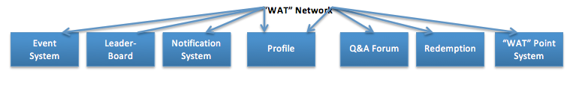

- A list of Win-Win conditions were discussed and put up on the Winbook.

- The win conditions were categorized by the shaper/IV&V validator respectively

- The Winbook tool was used to sort the MMF, and obtain a clear perspective of what features are essential for the system.

New Requirements From the client:

- Divide the “WAT” point system into three categories namely

i. Lifetime Points; record all the points since the beginning

ii. Semester Points: reset to 0 at the beginning of each semester

iii. Usable Points: points that can be used to redeem gifts

- The forum will have a dislike function for a post. If user dislikes a post subtract 1 point from the user points. Also, keep in mind that a single post should not provide negative points to the user.

For the next meeting:

* Attend Win-Win Session Round #2 with the TA
* Identify how we will carry out the “WAT” point system
* Develop a UI prototype for acquiring feedbacks from the client, as GUI is crucial to our system.
* Identify approach to add a dislike functionality to the forum