# System and Software Architecture Description (SSAD)

**We Are Trojans (WAT) Network**

**Team01**

|  |  |
| --- | --- |
| **Team members** | **Roles** |
| **Eirik Skogstad** | Project Manager, Life Cycle Planner |
| **Min Li** | Feasibility Analyst, Operational Concept Engineer |
| **Pittawat Pamornchaisirikij** | NDI/NCS Acquirer & Evaluator, Tester |
| **Punyawee Pakdiying** | System Architect, Feasibility Analyst |
| **Saloni Priya** | Requirement Engineer, UML Modeler |
| **Ameer Elkordy** | IIV&V, Quality Focal Point |
| **Suleyman Erten** | Operation Concept Engineer, Requirements Engineer |
| **Kamonphop Srisopha** | Prototyper, UML Modeler |

**11/05/14**

# Version History

| Date | Author | Version | Changes made | Rationale |
| --- | --- | --- | --- | --- |
| 10/13/14 | PP, SP | 0.5 | * Create initial SSAD document for Fundamental Commitment Package | * Used in Fundamental Commitment Package |
| 10/19/14 | PP, SP | 1.0 | * Update system context, artifact and information, and use-case diagrams * Update wording to have consistency across documents * Update use-case diagrams and its course of action | * Further understandings regarding the project and documents are acquired * There is inconsistency in terminologies used in each document * Update the document according to the comment in the ARB session and a better understanding toward the project |
| 11/30/14 | PP, SP | 1.5 | * Update use-case diagrams according to more understanding * Update process flows * Add designed class diagram * Add deployment diagrams * Add software component class diagrams * Add hardware component class diagrams * Add design rationales * Add process realization sections | * Some more requirements have been added to the project. * Finish designing the fist version of the class diagram. * Prepare the DCP for moving to the development phase. |
| 11/05/14 | PP | 2.0 | * Update deployment diagram for both technology-dependent and -independent sections * Update hardware component class Diagrams * Update design class diagram * Update use case process tables | * Found a flaw in class diagram that does not support some functionality. * Update data according to the comments in the DCP ARB session. |

# Table of Contents

System and Software Architecture Description (SSAD) i

Version History ii

Table of Contents iii

Table of Tables iv

Table of Figures v

1. Introduction 1

1.1 Purpose of the SSAD 1

1.2 Status of the SSAD 1

2. System Analysis 2

2.1 System Analysis Overview 2

2.2 System Analysis Rationale 16

3. Technology-Independent Model 17

3.1 Design Overview 17

3.2 Design Rationale 22

4. Technology-Specific System Design 24

4.1 Design Overview 24

4.2 Design Rationale 31

5. Architectural Styles, Patterns and Frameworks 32

# Table of Tables

Table 1: Actors Summary 3

Table 2: Artifacts and Information Summary 6

Table 3: Hardware Component Description 18

Table 4: Software Component Description 18

Table 5: Design Class Description 21

Table 6: Hardware Component Description 26

Table 7: Software Component Description 26

Table 8: Design Class Description 28

Table 9: Architectural Styles, Patterns, and Frameworks 32

# Table of Figures

Figure 1: System Context Diagram 3

Figure 2: Artifacts and Information Diagram 5

Figure 3: Use-Case Diagram for “We Are Trojans” Network System 6

Figure 4: Hardware Component Class Diagram 17

Figure 5: Software Component Class Diagram 17

Figure 6: Deployment Diagram 18

Figure 7: Design Class Diagram 20

Figure 8: Process Realization Diagram of Liking Thread 22

Figure 9: Process Realization Diagram of Creating Thread 22

Figure 10: Hardware Component Class Diagram 24

Figure 11: Software Component Class Diagram 25

Figure 12: Deployment Diagram 25

Figure 13: Design Class Diagram 28

Figure 14: Process Realization Diagram 30

Figure 15: Process Realization Diagram 30

### Introduction

#### Purpose of the SSAD

* The report demonstrates the whole picture of the project, which includes a synopsis of the key features and people who will be involved in the “WAT” Network.
* The report summarizes the architectures, both software and hardware, used in the project.
* The report presents essential details about the system to be developed, and avoids the generic introduction relating to our project.
* The SSAD presents the system structure independent of the implementation technology, and provides a clear picture of what needs to be done rather than how things need to be done.

#### Status of the SSAD

Currently, we have updated the SSAD report to include the System Context diagram, Use Case diagram, and the some essential processes of the system in accordance with to our project “WAT” Network.

### System Analysis

#### System Analysis Overview

The primary purpose of “We Are Trojans” Network is to provide a platform where students can interact with fellow Trojans. The system provides users with an online forum, where users can interact via posting on the forum. The forum allows the users to comment on threads, like posts, and dislike posts. To encourage more and more people to join the forum, the system uses a WAT Points. The WAT Points are awarded to a particular user when other users like his post on the forum. The points can be earned to gain recognition on the leaderboard as well as can be used to redeem USC items/ USC Bookstore gift cards via the website.

##### System Context

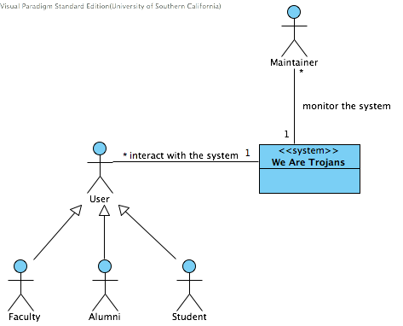

Figure : System Context Diagram

Table : Actors Summary

| **Actor** | **Description** | **Responsibilities** |
| --- | --- | --- |
| User  (Student, Faculty, Alumni) | USC students, faculty, and alumni who participate in the Trojan network | * Start a thread and post on a thread. * Like, dislike a post/thread in the system to give credibility of the post and thread. * Redeem gift cards and/or items from points earned in the system * Update their own profiles reflecting their personal information |
| Maintainer | Selected personnel to maintain the system | * Review and delete rule-violating posts * Pin important posts * Create categories for the threads * Arrange posts to a categories * Manage users’ accounts |

##### Artifacts & Information

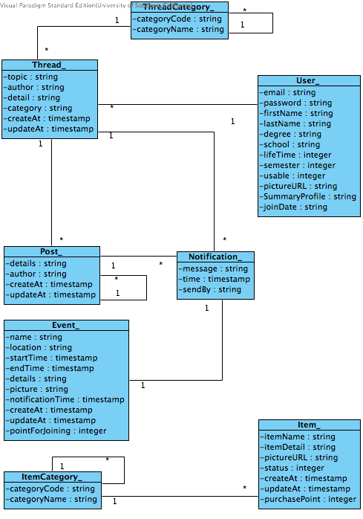

Figure : Artifacts and Information Diagram

Table : Artifacts and Information Summary

|  |  |
| --- | --- |
| **Artifact** | **Purpose** |
| Thread Category | Group of related threads that will help user find information that related to their interest easier. |
| Thread | Threads posted by users. This includes a posting time, a title, and details of a particular thread. |
| User | User information. Storing all user information that need for the system. |
| Post | Answer of a thread by various users. It also includes time and author of the post. |
| Notification | This includes notification to a user from threads, special events, and other possible notifications such as some users like the user thread/post. It will notify the user with information of what is happening. |
| Event | This is an announcement from maintainer. It can award some points to a group of users that fulfill the event. |
| Item Category | This is similar to Thread Category except this is a group of items, which help users find an item that related to their interest easier. |
| Item | Items that user can redeem using their points in our system. It contains picture, price, and status of the items. |

##### Behavior

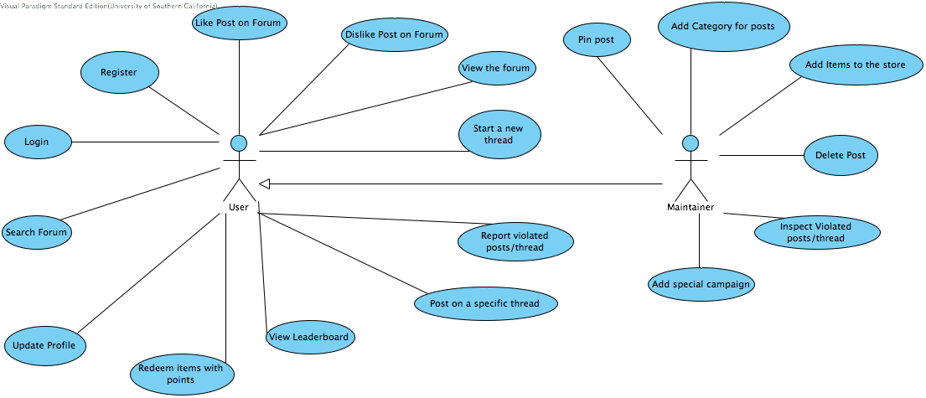

**Figure 3: Use-Case Diagram for “We Are Trojans” Network System**

###### Capability We Are Trojans (WAT) Network

Process of We Are Trojans (WAT) Network

1. **User can start a thread**

|  |  |
| --- | --- |
| User can start a thread | |
| **Actor** | User |
| **Identifier** | UC01- User can start a thread |
| **Purpose** | The user starts a new thread on the system for other users to view, like, dislike, and post on this thread. |
| **Development Risks** | The interface designed for the purpose might be complicated for the user to use. |
| **Preconditions** | The user is logged in the system and chooses to start a new thread on the forum |
| **Flow of Events** | |  |  |  | | --- | --- | --- | |  | Actor Input | System Response | | 1 | The user enters texts to be posted on the forum. |  | | 2 | The user clicks the post button on the forum. |  | | 3 |  | The system checks the contents of the thread whether there are some words violating the rules of the forum or any system restricted statements, such as SQL injections or not. | | 4 |  | The system posts the thread on the forum. | | 5 |  | The system shows thread was posted successfully feedback message to the user. | |
| **Post-conditions** | The thread is posted on the forum for other users to view, like, dislike and post comments. |
| **Alternate course of action** | |  |  |  | | --- | --- | --- | |  | Actor Input | System Response | | 1 | The user enters texts to be posted on the forum. |  | | 2 | The user clicks the post button on the forum. |  | | 3 |  | The system does not display the new thread on the forum. | |
| **Alternate course of action 2** | |  |  |  | | --- | --- | --- | |  | Actor Input | System Response | | 1 | The user enters texts to be posted on the forum. |  | | 2 | The user clicks the post button on the forum. |  | | 3 |  | The system finds some words violating the rules of the forum. | | 4 |  | The system rejects the thread and displays errors. | |
| **Alternate course of action 3** | |  |  |  | | --- | --- | --- | |  | Actor Input | System Response | | 1 | The user enters texts to be posted on the forum. |  | | 2 | The user clicks the post button on the forum. |  | | 3 |  | The system finds some statements which can cause harm to the system. | | 4 |  | The system rejects the thread and displays errors. | |

**2. User can search the forum**

|  |  |
| --- | --- |
| User can search the forum | |
| **Actor** | User |
| **Identifier** | UC02- User can search the forum |
| **Purpose** | User can search the forum for particular thread they are interested in. |
| **Development Risk** | The interface designed may not allow user to navigate through easily. |
| **Preconditions** | User is registered to WAT point system  User is logged in to the WAT system |
| **Flow of Events** | |  |  |  | | --- | --- | --- | |  | Actor Input | System Response | | 1 | User enter data specific to their search in the search text-area |  | | 2 | User clicks the search button on the page |  | | 3 |  | System searches for the relevant posts and display the result in the page in sorted format based on certain criterion. | |
| **Post-conditions** | The list of posts that is relevant to the search keywords is shown and sorted by relevance. |
| **Alternate course of action** | |  |  |  | | --- | --- | --- | |  | Actor Input | System Response | | 1 | User enter data specific to their search in the search text-area |  | | 2 | User clicks the search button on the page |  | | 3 |  | System can not find the relevant posts to the keywords. the system shows the “There is no relevance post” error | |
| **Alternate course of action 2** | |  |  |  | | --- | --- | --- | |  | Actor Input | System Response | | 1 | User enter data specific to their search in the search text-area |  | | 2 |  | System does not allow user to click on the search button, the search button is disables even when user has entered some text in the search text-area. | |

**3. User can like a thread or a post.**

|  |  |
| --- | --- |
| User can like a thread or a post | |
| **Actor** | User |
| **Identifier** | UC03- User can like a thread or a post |
| **Purpose** | By liking a thread and comment, the user would give WAT points to the author of the threads and posts, and increase credibility of the user and the thread and comment. It is also an important part to create a competitive environment among peers. Posts with more likes will be presented on top. |
| **Development Risks** | This functionality will be merged with the WAT point system. The development risk will mainly come from the WAT point system. |
| **Preconditions** | User enters the forum page and wants to give a like to the thread or a post he/she sees. |
| **Flow of Events** | |  |  |  | | --- | --- | --- | |  | Actor Input | System Response | | 1 | User clicks the like button |  | | 2 |  | The system makes the like button greyed | | 3 |  | The system makes the number of like in that thread/post goes up by one. | | 4 |  | The system calculates points of the owner of the thread or post. | |
| **Post-conditions** | 1. After clicking a like button, the like button will be greyed out.  2. The number of likes in that thread/post goes up by one. 3. Semester points and total points of the owner of the thread or post calculated. If the the post is less than one month old, the point will be in its pending period. |
| **Alternate course of action** | |  |  |  | | --- | --- | --- | |  | Actor Input | System Response | | 1 | User clicks the dislike button |  | | 2 |  | The system makes the does not grey out the dislike button, allows user to still click dislike | | 3 |  | Correspondingly the points get deducted from the user of the specific thread. | |

1. **User can dislike a thread or a post**

|  |  |
| --- | --- |
| User can dislike a thread or post | |
| **Actor** | User |
| **Identifier** | UC04-User can dislike a thread or post |
| **Purpose** | The dislike functionality is important to avoid users from randomly making any post on the forum. As dislike will reduce user WAT point.  With reduction in WAT point he will loose his chance to use the online store redemption functionality.  Increase credibility of information, as more dislike means information not true. |
| **Development Risks** | This functionality will be merged with the WAT point system. The development risk will mainly come from the WAT point system. |
| **Preconditions** | User enters the forum page and wants to give a dislike to the thread or a post he thinks is not appropriate. |
| **Flow of Events** | |  |  |  | | --- | --- | --- | |  | Actor Input | System Response | | 1 | User clicks the dislike button |  | | 2 |  | The system makes the dislike button greyed out | | 3 |  | The system makes the number of dislike in that post/thread goes up by 1 | | 4 |  | The system calculates points of the owner of the thread by subtracting point of the dislike. | |
| **Post-conditions** | 1. After clicking a dislike button, the dislike button will be greyed out.  2. The number of dislikes in that thread/post goes up by one. 3. Pints will be reduced from the user usable points. |
| **Alternate course of action** | |  |  |  | | --- | --- | --- | |  | Actor Input | System Response | | 1 | User clicks the dislike button |  | | 2 |  | The system greys out the dislike button | | 3 |  | The system does not decrease the point for the user of the thread  (or)  Decrease points for the points making it go below 0 | |

1. **User can view the forum**

|  |  |
| --- | --- |
| User can View the Forum | |
| **Actor** | User |
| **Identifier** | UC05- User can view the Forum |
| **Purpose** | The forum consists of thread posted by users, the user based on his interest read specific thread/posts on forum to get information |
| **Developmental Risks** | * Realization that it would have been easier and faster to built the forum from scratch rather than using COTS. However, to implement all functionality of the forum requires a lot of effort. |
| **Preconditions** | The user is on the forum page |
| **Flow of Events** | |  |  |  | | --- | --- | --- | |  | Actor Input | System Response | | 1 | The user is on the forum page |  | | 2 |  | The system displays all the thread in a sorted format based on likes | | 3 | The user is able to view the threads |  | |
| **Post-conditions** | * The user is able to see all the threads. * On selection of specific thread user is able to see all the post relating to that thread. |
| **Alternate course of action** | |  |  |  | | --- | --- | --- | |  | Actor Input | System Response | | 1 | The user is on the forum page |  | | 2 |  | The user is unable to see any thread  (or)  A feedback message saying there are no thread please be the first one to start a thread. | |

1. **User can post**

|  |  |
| --- | --- |
| User can post to a specific thread on forum | |
| **Actor** | User |
| **Identifier** | UC06-User can post to a specific thread on forum |
| **Purpose** | To establish communication among Trojans, our system provides the user with the functionality of posting comments on a thread on forum. |
| **Development Risk** | The NDI/NCS used would not have inbuilt functionality to allow user to post on threads. |
| **Preconditions** | The user is on the forum page, where he will be able to see all the threads |
| **Flow of Events** | |  |  |  | | --- | --- | --- | |  | Actor Input | System Response | | 1 | User visit the forum |  | | 2 | Select a specific thread |  | | 3 | Wants to post on the specific thread, and write the data to be posted |  | | 4 | Click post |  | | 5 |  | The post is posted on the forum under the specific thread | |
| **Post-conditions** | * User selects the option of comment for a specific thread, write the comment and hit post. * The post is posted on the forum under the specific thread. |
| **Alternate course of action** | |  |  |  | | --- | --- | --- | |  | Actor Input | System Response | | 1 | User visit the forum |  | | 2 | Select a specific thread |  | | 3 | Wants to post on the specific thread, and write the data to be posted |  | | 4 | Click post |  | | 5 |  | The post is not visible on the forum | |

##### User can redeem points.

|  |  |
| --- | --- |
| User can use points to redeem gift items and gift cards | |
| **Actor** | User |
| **Identifier** | UC07- User can use points to redeem gift items or gift cards |
| **Purpose** | The users will be able to use their usable points to redeem items. This will serve as an incentive for user to participate in our system and earn more points for good gifts. |
| **Developmental Risk** | The clients’ requirements for the redemption are not very clear.  Not clear how both gift card redemption and online store should be included in our system. |
| **Preconditions** | User enters the redemption page and is able to view the option of either use points for a gift or get a gift card. |
| **Flow of Events** | |  |  |  | | --- | --- | --- | |  | Actor Input | System Response | | 1 | User clicks the redeem gift option |  | | 2 |  | The system directs the user to the online store page | | 3 |  | The page loads the details from the database and displays it on the online store page. | | 4 | User selects an item he is interested in and clicks the option to redeem my points |  | | 5 |  | The system checks if the user has enough points to redeem the item selected by the user. | | 6 |  | The system decreases the usable points for the specific user. | | 7 |  | The system decreases or update information of specific item on the online store. | | 8 | The user receives feedback that his item is redeemed and details relating to next step |  | |
| **Post-conditions** | 1. User clicks on Redeem gift option and is directed to the online store.  2. The page displays all the available items that the user can redeem. The page display the details about each item and list he required WAT points needed for redemption. |
| **Alternate course of action** | |  |  |  | | --- | --- | --- | |  | Actor Input | System Response | | 1 | User clicks the redeem gift option |  | | 2 |  | The system directs the user to the online store page | | 3 |  | The page loads the details from the database and displays it on the online store page. | | 4 | User selects an item he is interested in and clicks the option to redeem my points |  | | 5 |  | The system checks if the user has enough points to redeem the item selected by the user. | | 6 |  | The user points are not enough to redeem selected item | | 7 | The user receives a feedback from the system that you don’t have enough points to redeem this item |  | |

1. **User can view the leaderboard**

|  |  |
| --- | --- |
| User can view the leaderboard | |
| **Actor** | User |
| **Identifier** | UC08: User can view the leaderboard |
| **Purpose** | To establish a competition among trojans and an incentive to encourage trojans to participate more on our system. |
| **Developmental Risk** | The leaderboard should have search functionality, for user to find specific friends. |
| **Preconditions** | The user has entered the url for our web-application |
| **Flow of Events** | |  |  |  | | --- | --- | --- | |  | Actor Input | System Response | | 1 | The user enters the url of our web-page |  | | 2 |  | The system displays the homepage | | 3 |  | There is a leaderboard on our homepage for user to view the participants ranking and points | |
| **Post-conditions** | The user is on the system homepage, and is able to view the leaderboard. |
| **Alternate course of action** | |  |  |  | | --- | --- | --- | |  | Actor Input | System Response | | 1 | The user enters the url of our web-page |  | | 2 |  | The system displays the homepage | | 3 |  | There is no leaderboard on homepage | |
| **Alternate course of action 2** | |  |  |  | | --- | --- | --- | |  | Actor Input | System Response | | 1 | The user enters the url of our web-page |  | | 2 |  | The system is unable to load the homepage for the WAT network | |

1. **User can update his/her profile**

|  |  |
| --- | --- |
| User can update his/her profile | |
| **Actor** | User |
| **Identifier** | UC09-User can update his/her profile |
| **Purpose** | * This allows user to choose what information he/she wants to share on our system for fellow trojans to view * Information about specific school of USC would enable unknown people know other people in their school * Increase camaraderie among users |
| **Developmental Risk** | * User will enter large file like image file in summary portion. We might need a caching mechanism for our system |
| **Preconditions** | * The user clicks the option of edit profile from profile page |
| **Flow of Events** | |  |  |  | | --- | --- | --- | |  | Actor Input | System Response | | 1 | The user clicks on profile option on homepage |  | | 2 |  | System loads the profile page | | 3 |  | There is an edit option on profile page | | 4 | User clicks the edit option |  | | 5 |  | The system directs user to the profile edit page | | 6 | User enters data he wish to edit/update on his profile |  | | 7 | Clicks make changes button |  | | 8 |  | System update user profile information in database  System gives user the feedback that your profile is updated | | 9 | User clicks ok button on the feedback message |  | | 10 |  | The system directs user to the profile page where user is able to view the updates | |
| **Post-conditions** |  |
| **Alternate course of action** | |  |  |  | | --- | --- | --- | |  | Actor Input | System Response | | 1 | The user clicks on profile option on homepage |  | | 2 |  | System loads the profile page | | 3 |  | There is an edit option on profile page | | 4 | User clicks the edit option |  | | 5 |  | The system directs user to the profile edit page | | 6 | User enters data he wish to edit/update on his profile |  | | 7 | Clicks make changes button |  | | 8 |  | System update user profile information in database | | 9 |  | System gives user the feedback that your profile is updated | | 10 | User clicks ok button on the feedback message |  | | 11 |  | The system directs user to the profile page where the user is not able to view the changes he made | |
| **Alternate course of action 2** | |  |  |  | | --- | --- | --- | |  | Actor Input | System Response | | 1 | The user clicks on profile option on homepage |  | | 2 |  | System loads the profile page | | 3 |  | There is no edit option on profile page for the user | |

##### Modes of Operation

The system will not have multiple modes. Therefore, no description could be stated in this section.

#### System Analysis Rationale

The major operational stakeholders of the system are the USC students, USC faculty and USC alumni. These are the users who will become the members of the system. The users will be authenticated by the system via USC email.  The “WAT” Network profile would be created once the user is validated.

The points system is a critical feature of the system. It serves as the base for the development of other features of the system such as the leaderboard and the like/dislike functionality for a post. The users actions in our system are associated with earning points. The more the users participate with the system the more points they can earn and gain recognition on leaderboard or redeem items for store or redeem a gift card.

### Technology-Independent Model

#### Design Overview

##### System Structure

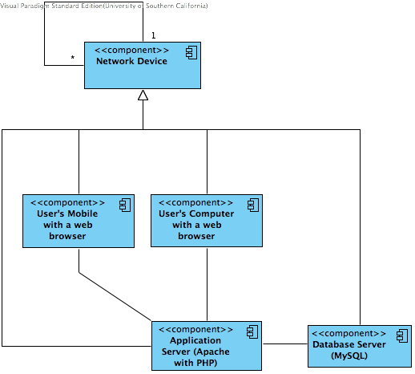

**Figure 4: Hardware Component Class Diagram**

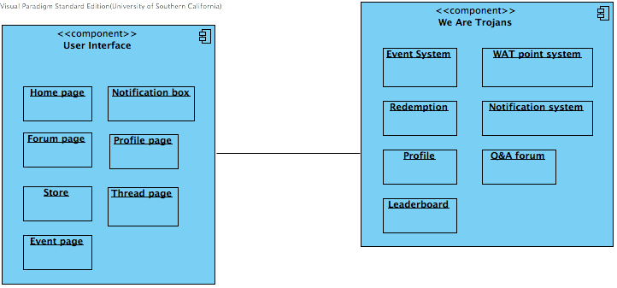

**Figure 5: Software Component Class Diagram**

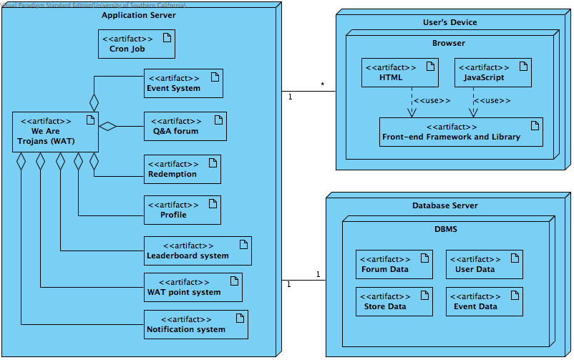

**Figure 6: Deployment Diagram**

Table : Hardware Component Description

|  |  |
| --- | --- |
| **Hardware Component** | **Description** |
| Trojans’ Computer | User computer |
| Trojans’ Mobile | User mobile device |
| Application server | Server used to host the web application |
| Database server | Server used to host DBMS |

Table : Software Component Description

|  |  |
| --- | --- |
| **Software Component** | **Description** |
| Event System | The system handles both adding special events by the maintainers and showing events to users |
| WAT point system | The system handles giving points, deducting points for the users. |
| Redemption | The system handles using points to redeem items in the store. |
| Notification system | The system handles notification of both events and situation in the thread and posts of the users. |
| Profile | The system handles adding/editing/showing users’ profile. |
| Q&A forum | The forum system handle all starting thread/posting/liking/disliking in the system |
| Leaderboard | The leaderboard shows list of the users ordered by their scores |
| Home page | Home page consists of hot thread from the forum, users’ brief profile, and leaderboard |
| Forum page | Forum page consists of pinned thread and all threads separated by their categories. |
| Store | Store consists of available items for the users to redeem. |
| Event page | Event consists of all events posted by the maintainers. |
| Notification box | Notification box shows what happened with a specific threads and posts of the users. |
| Profile page | Profile page allows users’ to share their information and show their information to other users. |
| Thread page | Thread page shows a specific thread’s information including posts and their authors’ information. |

##### Design Classes

###### We Are Trojans (WAT) Network Classes

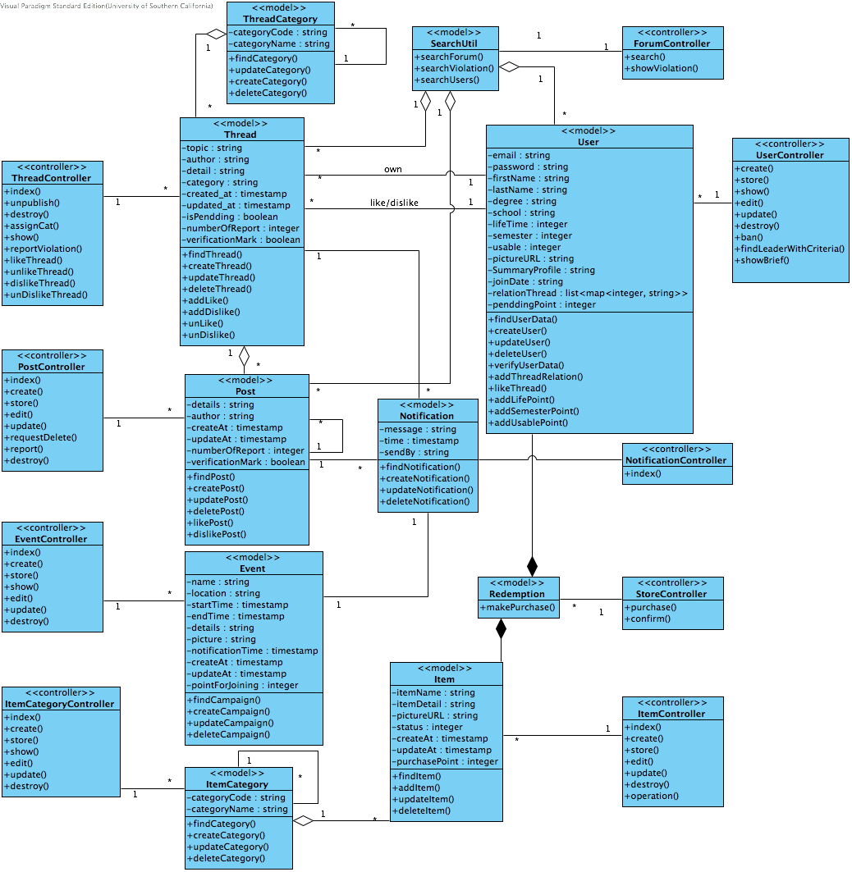

**Figure 7: Design Class Diagram**

Table : Design Class Description

|  |  |  |
| --- | --- | --- |
| **Class** | **Type** | **Description** |
| ThreadCategory | Model | This model consists threads’ category data that can be nested and its business logics. |
| Thread | Model | This model consists thread data and its business logics. |
| Post | Model | This model consists post data and its business logics. |
| Event | Model | This model consists event data and its business logics. |
| ItemCategory | Model | This model consists items’ category data that can be nested and its business logics. |
| Item | Model | This model consists item data and its business logics. |
| SearchUtil | Model | This utility class provides a method to search users, thread/posts. The logical methods in this class are separated from other to provide changeability. |
| User | Model | This model consists users’ data and its business logics. |
| Notification | Model | This model consists notification data and its business logics. |
| Payment | Model | This model consists payment data and its business logics. |
| ForumController | Controller | This controller handles all searching functionalities in the forum. |
| ThreadController | Controller | This controller handles all requests regarding thread functionalities in the forum. |
| PostController | Controller | This controller handles all requests regarding post functionalities in the forum. |
| EventController | Controller | This controller handles all requests regarding event functionalities. |
| ItemCategoryController | Controller | This controller handles all requests regarding event functionalities. |
| ItemController | Controller | This controller handles all requests regarding item functionalities in the store. |
| UserController | Controller | This controller handles all requests regarding user functionalities in the store. |
| StoreController | Controller | This controller handles all requests regarding purchase functionality in the store. |
| NotificationController | Controller | This controller handles all requests regarding notification functionalities. |

##### Process Realization

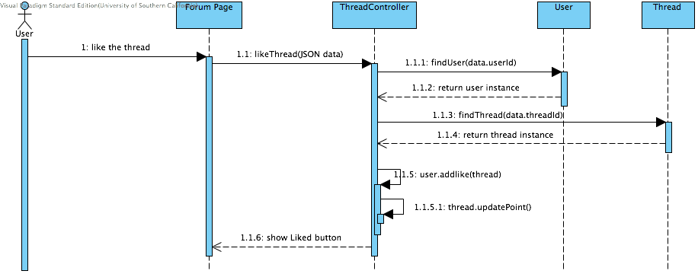

Figure 8: Process Realization Diagram of Liking Thread

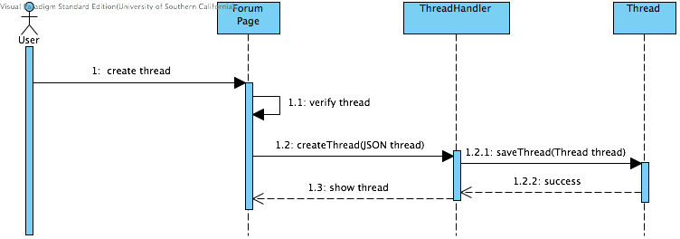

**Figure 9: Process Realization Diagram of Creating Thread**

#### Design Rationale

Model-View-Controller architecture was chosen for our system design, because we wanted a flexible and modular structure, as described below section. This approach will help us develop the system in separated layers, and revise the structure and the system design clearly. In addition, it will make the system more feasible for future adaptations.  
 MySQL database management system was chosen in order to reduce the effort of implementation data storage and management.

* Model
  + ThreadCategory
  + Thread
  + Post
  + Event
  + ItemCategory
  + Item
  + SearchUtil
  + User
  + Notification
  + Payment
* View
  + User Interface Component (HTML/JavaScript files)
* Controller
  + ForumController
  + ThreadController
  + PostController
  + EventController
  + ItemController
  + UserController
  + StoreController
  + NotificationController

Model-View-Controller architecture provides separation among controller logics, view components, and models. Each controller component is designed to handle different functionality in the system. Similarly, model components are also separately defined to reflect data storage and comprise of business logics of each model. Eventually, model and controller components can be used independently with the different parts of the view components.

### Technology-Specific System Design

#### Design Overview

##### System Structure

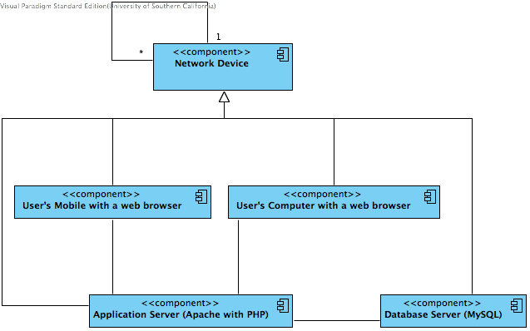

Figure 10: Hardware Component Class Diagram

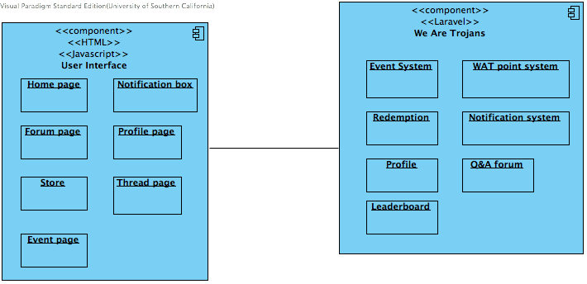

Figure 11: Software Component Class Diagram

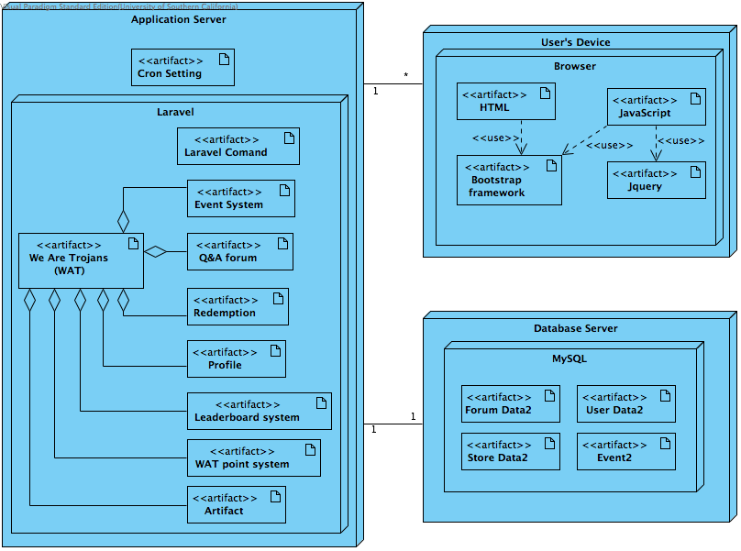

Figure 12: Deployment Diagram

Table : Hardware Component Description

|  |  |
| --- | --- |
| **Hardware Component** | **Description** |
| Trojans’ Computer | User computer with a web browser |
| Trojans’ Mobile | User mobile device with a web browser |
| Application server | Server used to host the web application with PHP configuration |

Table : Software Component Description

(These components and descriptions are the same as the technology-independent section except that all components in interface will be developed with HTML and JavaScript and all components in “We are Trojans” will be developed based on the Laravel framework)

|  |  |
| --- | --- |
| **Software Component** | **Description** |
| Event System | The system handles both adding special events by the maintainers and showing events to users |
| WAT point system | The system handles giving points, deducting points for the users. |
| Redemption | The system handles using points to redeem items in the store. |
| Notification system | The system handles notification of both events and situation in the thread and posts of the users. |
| Profile | The system handles adding/editing/showing users’ profile. |
| Q&A forum | The forum system handle all starting thread/posting/liking/disliking in the system |
| Leaderboard | The leaderboard shows list of the users ordered by their scores |
| Home page | Home page consists of hot thread from the forum, users’ brief profile, and leaderboard |
| Forum page | Forum page consists of pinned thread and all threads separated by their categories. |
| Store | Store consists of available items for the users to redeem. |
| Event page | Event consists of all events posted by the maintainers. |
| Notification box | Notification box shows what happened with a specific threads and posts of the users. |
| Profile page | Profile page allows users’ to share their information and show their information to other users. |
| Thread page | Thread page shows a specific thread’s information including posts and their authors’ information. |

##### Design Classes

###### We Are Trojans (WAT) Network Classes

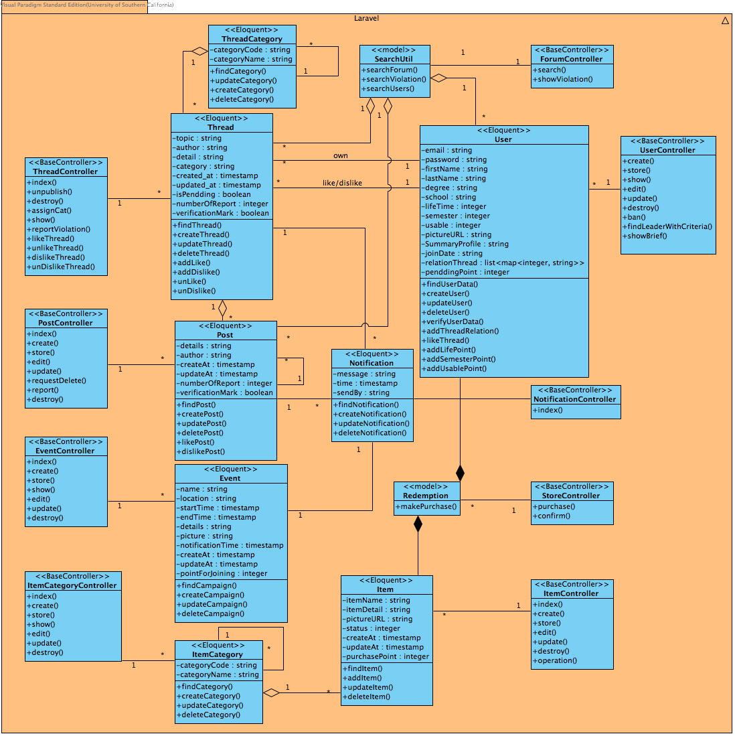

Figure 13: Design Class Diagram

Table : Design Class Description

|  |  |  |
| --- | --- | --- |
| **Class** | **Type** | **Description** |
| ThreadCategory | Model | This model extending Eloquent class from the Laravel framework consists threads’ category data which can be nested and its business logics. |
| Thread | Model | This model extending Eloquent class from the Laravel framework consists thread data and its business logics. |
| Post | Model | This model extending Eloquent class from the Laravel framework consists post data and its business logics. |
| Event | Model | This model extending Eloquent class from the Laravel framework consists event data and its business logics. |
| ItemCategory | Model | This model extending Eloquent class from the Laravel framework consists items’ category data that can be nested and its business logics. |
| Item | Model | This model extending Eloquent class from the Laravel framework consists item data and its business logics. |
| SearchUtil | Model | This utility class provides a method to search users, thread/posts. The logical methods in this class are separated from other to provide changeability. |
| User | Model | This model extending Eloquent class from the Laravel framework consists users’ data and its business logics. |
| Notification | Model | This model extending Eloquent class from the Laravel framework consists notification data and its business logics. |
| Payment | Model | This model extending Eloquent class from the Laravel framework consists payment data and its business logics. |
| ForumController | Controller | This controller extending BaseController class from the Laravel framework handles all searching functionalities in the forum. |
| ThreadController | Controller | This controller extending BaseController class from the Laravel framework handles all requests regarding thread functionalities in the forum. |
| PostController | Controller | This controller extending BaseController class from the Laravel framework extending BaseController class from the Laravel framework handles all requests regarding post functionalities in the forum. |
| EventController | Controller | This controller extending BaseController class from the Laravel framework handles all requests regarding event functionalities. |
| ItemCategoryController | Controller | This controller extending BaseController class from the Laravel framework handles all requests regarding event functionalities. |
| ItemController | Controller | This controller extending BaseController class from the Laravel framework handles all requests regarding item functionalities in the store. |
| UserController | Controller | This controller extending BaseController class from the Laravel framework handles all requests regarding user functionalities in the store. |
| StoreController | Controller | This controller extending BaseController class from the Laravel framework handles all requests regarding purchase functionality in the store. |
| NotificationController | Controller | This controller extending BaseController class from the Laravel framework handles all requests regarding notification functionalities. |

##### Process Realization

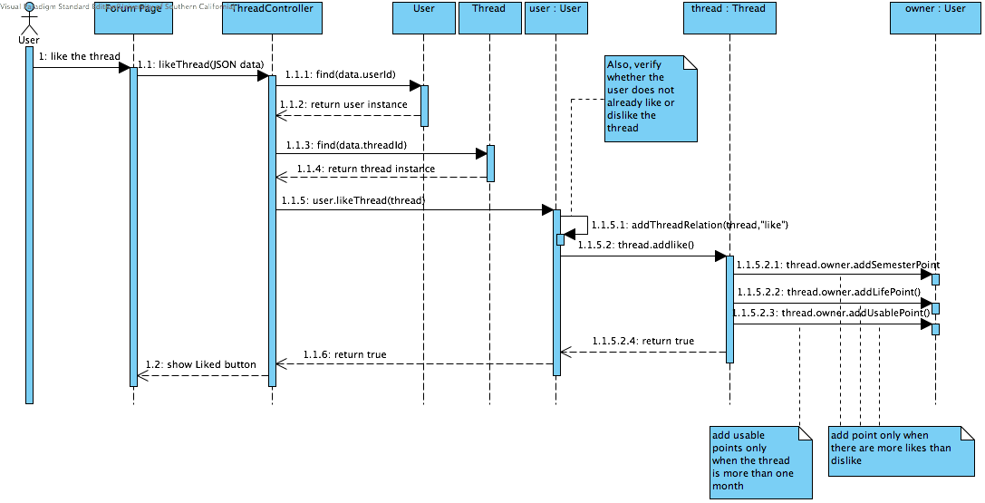**Figure 14: Process Realization Diagram**

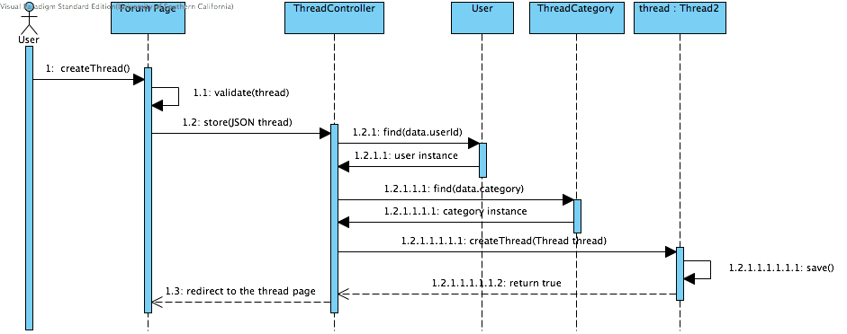

**Figure 15: Process Realization Diagram**

#### Design Rationale

As shown on Figure 14, design class diagram is similar to design class diagram in section 3.2. In order to implement Model-View-Controller architecture, Laravel was chosen as a framework. According to that, in technology dependent design class diagram, all controllers extend the BaseController Class, which is provided by the framework, and models extend Eloquent Class, which is also provided by the Laravel framework.

### Architectural Styles, Patterns and Frameworks

Table : Architectural Styles, Patterns, and Frameworks

|  |  |  |
| --- | --- | --- |
| **Name** | **Description** | **Benefits, Costs, and Limitations** |
| 3-tier architecture | Separate 3 the application to be 3 tiers: a presentation tier using with a web browser, a logic tier with a PHP server, and a data tier with MySQL. | - Using web browser allows the user to use any devices that they want, resulting in no need to maintain users’ devices.  - Any change made in the application in the server will be automatically presented to the users.  - There is no cost for adopting the architecture.  - Need to acquire servers for application and database. |
| MVC | Models, Views, and Controller pattern | - MVC has separate layers for each specific responsibility, resulting in great structures and ease of modifying.  - There are no costs for the pattern.  - If the application is complex, the model layer will be very complicated. |
| Laravel | Laravel is a PHP web application framework | - Laravel has very good knowledge documents, tutorials, and community.  - Laravel is open source and free for using.  - The team needs to study the framework and good practice before developing the application. |