# System and Software Architecture Description (SSAD)

**We Are Trojans**

**Team01**

|  |  |
| --- | --- |
| **Team members** | **Roles** |
| **Eirik Skogstad** | Project Manager, Life Cycle Planner |
| **Min Li** | Feasibility Analyst, Operational Concept Engineer |
| **Pittawat Pamornchaisirikij** | NDI/NCS Acquirer & Evaluator, Tester |
| **Punyawee Pakdiying** | System Architect, Feasibility Analyst |
| **Saloni Priya** | Requirements Engineer, UML Modeler |
| **Ameer Elkordy** | IIV&V, Quality Focal Point |
| **Suleyman Erten** | Operational Concept Engineer, Requirements Engineer |
| **Kamonphop Srisopha** | Prototyper, UML Modeler |

10/13/2014

# Version History

| Date | Author | Version | Changes made | Rationale |
| --- | --- | --- | --- | --- |
| 10/13/14 | PP, SP | 0.5 | * Create initial SSAD document for Fundamental Commitment Package | * Used in Fundamental Commitment Package |

# Table of Contents

System and Software Architecture Description (SSAD) i

Version History ii

Table of Contents iii

Table of Tables iv

Table of Figures v

1. Introduction 1

1.1 Purpose of the SSAD 1

1.2 Status of the SSAD 1

2. System Analysis 2

2.1 System Analysis Overview 2

2.2 System Analysis Rationale 4

3. Technology-Independent Model 5

3.1 Design Overview 5

3.2 Design Rationale 6

4. Technology-Specific System Design 7

4.1 Design Overview 7

4.2 Design Rationale 8

5. Architectural Styles, Patterns and Frameworks 9

# Table of Tables

Table 1: Actors Summary 2

Table 2: Artifacts and Information Summary 2

Table 3: Process Description 3

Table 4: Typical Course of Action 3

Table 5: Alternate Course of Action 3

Table 6: Exceptional Course of Action 3

Table 7: Hardware Component Description 5

Table 8: Software Component Description 5

Table 9: Supporting Software Component Description 6

Table 10: Design Class Description 6

Table 11: Hardware Component Description 7

Table 12: Software Component Description 7

Table 13: Supporting Software Component Description 8

Table 14: Design Class Description 8

Table 15: Architectural Styles, Patterns, and Frameworks 9

# Table of Figures

Figure 1: System Context Diagram 2

Figure 2: Artifacts and Information Diagram 2

Figure 3: Process Diagram 3

Figure 4: Hardware Component Class Diagram 5

Figure 5: Software Component Class Diagram 5

Figure 6: Deployment Diagram 5

Figure 7: Supporting Software Component Class Diagram 5

Figure 8: Design Class Diagram 6

Figure 9: Process Realization Diagram 6

Figure 10: Hardware Component Class Diagram 7

Figure 11: Software Component Class Diagram 7

Figure 12: Deployment Diagram 7

Figure 13: Supporting Software Component Class Diagram 7

Figure 14: Design Class Diagram 8

Figure 15: Process Realization Diagram 8

### Introduction

#### Purpose of the SSAD

* The report demonstrates the whole picture of the project, which includes a synopsis of the key features and people who will be involved in the “WAT” Network.
* The report summarizes the architectures, both software and hardware, used in the project.
* The report presents essential details about the system to be developed, and avoids the generic introduction relating to our project.
* The SSAD presents the system structure independent of the implementation technology, and provides a clear picture of what needs to be done rather than how things need to be done.

#### Status of the SSAD

Currently we have updated the SSAD report to include the System Context diagram and Use Case diagram i.e. Section 2 in accordance with to our project “WAT” Network. This is the initial version of SSAD.

### System Analysis

#### System Analysis Overview

The primary purpose of “We Are Trojans” Network is to provide a platform where students can interact with fellow Trojans. The system provides users with an online forum, where users can interact via posting on the forum. The forum allows the users to comment on threads, like posts, and dislike posts. To encourage more and more people to join the forum, the system uses a WAT Points. The WAT Points are awarded to a particular user when other users like his post on the forum. The points can be earned to gain recognition on the leaderboard as well as can be used to redeem USC items/ USC Bookstore gift cards via the website.

##### System Context

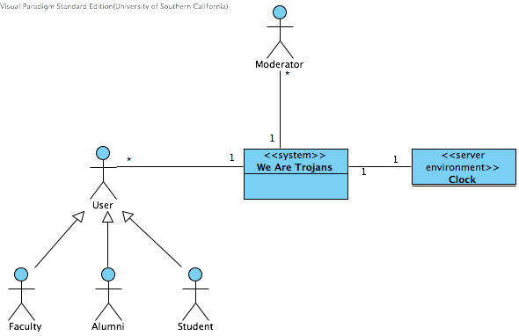

Figure 1: System Context Diagram

Table 1: Actors Summary

| **Actor** | **Description** | **Responsibilities** |
| --- | --- | --- |
| User  (Student, Faculty, Alumni) | USC students, faculty, and alumni who participate in the Trojan network | * Start a thread and post on a thread. * Like, dislike a post/thread in the system to give credibility of both posts and threads * Redeem a gift card, items from points earned in the system * Update their own profiles reflecting their personal information |
| Moderator | Selected personnel to maintain the system | * Review and delete rule-violating posts * Pin important posts * Create categories for the posts * Arrange posts to a categories * Manage users’ accounts |
| Clock | System Clock | Provide the system time |

##### Artifacts & Information

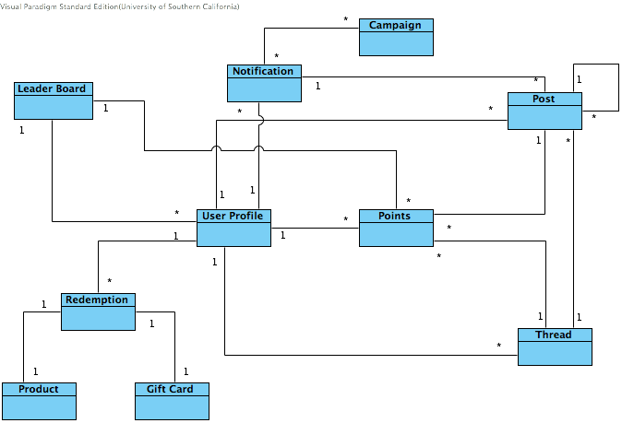

Figure 2: Artifacts and Information Diagram

Table 2: Artifacts and Information Summary

|  |  |
| --- | --- |
| **Artifact** | **Purpose** |
| Leaderboard | Contain all information, personal profile, classes and points, about the user |
| Redemption | Contain all information regarding redemption for users |
| Product | Contain all information about items to be redeemed. This could include a list of available items and points for a particular item. |
| Gift Card | Contain all information about gift cards to be redeemed. This could include a list of available gift cards and points for a particular card. |
| User Profile | Contain all details about users. There is both prerequisite information set by a system and user-created fields for their special information. |
| Points | Contain all points in each system of a user. |
| Thread | Contain all thread posted by users. This includes a posting time, a title, and details of a particular thread. |
| Post | Contain all post created by users. This includes a posting time, a title, and details of a particular post. |
| Notification | This includes notification form threads, special events, and other possible notifications. |

##### Behavior

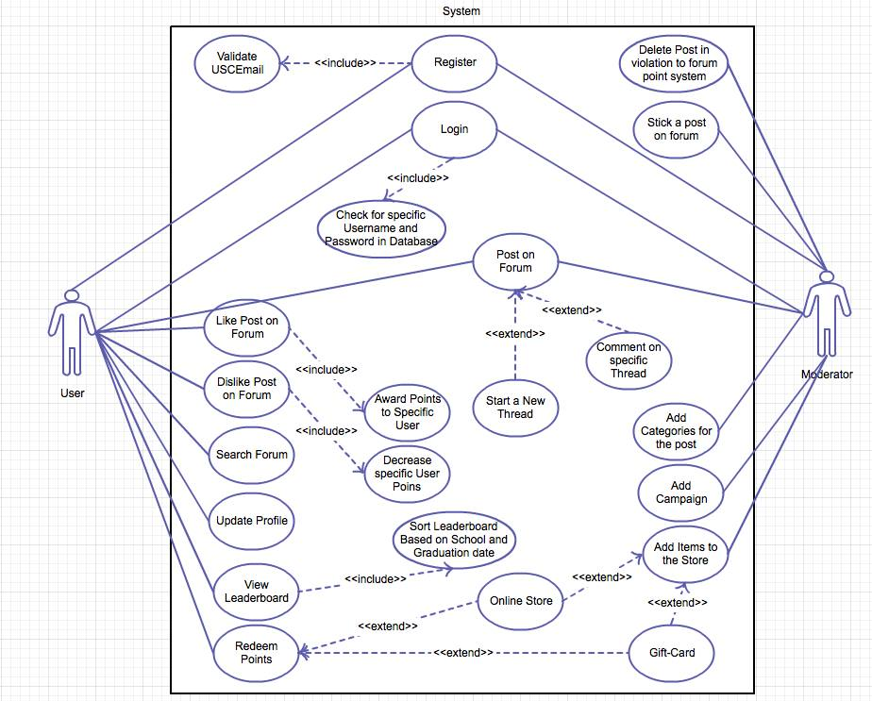

Figure 3: Use-Case Diagram for “We Are Trojans” Network System

###### Capability x

Process y

Table 3: Process Description

|  |  |
| --- | --- |
| **Identifier** | User and Moderator |
| **Purpose** | To illustrate all the functionalities that a user and a moderator can do with the system |
| **Requirements** | 1. User/Moderator can create his profile on forum. 2. User/Moderator can post on the forum and receive likes and dislikes. 3. User can earn points and redeem them in online store or get gift cards using the system. 4. Moderator can delete post violating forum ethics. 5. Moderator can add categories for the posts on the forum 6. Moderator can add new items or gift cards for user to redeem points. 7. Moderator can add campaigns to the system. 8. Moderator can pin a post on the forum. 9. User can Login using his username and password. 10. User can search the forum, the post based on his search is founded will be loaded. |
| **Development Risks** | Risk with the User System Implementation:   1. The users might not like the graphical user interface for the systems 2. The point system might not be enough to encourage users to join the system 3. Changes in requirements   Risk Associated with Moderator:   1. Deciding the criteria to be used by the moderator to validate his action of deleting a post. |
| **Pre-conditions** | 1. The user joins the system and would like to interact with peers by posting on the forum. 2. The moderator joins the system. |
| **Post-conditions** | 1. The users are able to post on the forum, comment and like/dislike specific posts. they earn points and also give points to other users by liking their posts. 2. The moderator deletes specific posts from the forum to avoid damage to the point system. Update the leaderboard and the usable points on monthly basis. |

Table 4: Typical Course of Action

|  |  |  |
| --- | --- | --- |
| **Seq#** | **Actor’s Action** | **System’s Response** |
| **1** | Joins the System by creating Profile/Register. | The system validate user by  USC email and create a user profile. |
| **2** | User/Moderator Login to the system | The Password and Username validated via database and homepage is loaded. |
| **3** | User/Moderator write a post on the system and click Post. | The Post is posted on the Forum for other users to read and assess the user post. |
| **4** | User Likes (or) Dislikes a particular post. | The system searches for the person who wrote that post. Award points (or) Deduct Points to that user and update his usable points and send notification to both the current user and the user whose post was liked. |
| **5** | User used points to redeem items at the online store | The system subtracts specific number of points from the users usable points. |
| **6** | Moderator add items on the online store/ Campaign Events in the system | * The item is visible on the online store page and ready for the users to redeem points via purchasing that item. * The campaign event is added and a notification is sent to users. |
| **7** | Users can view leaderboard and search based on schools or graduation date. | The leaderboard displays the result specific to user search. |
| **8** | User can search the forum and view posts specific to his search. | The system loads the posts specific to users’ search. If the posts specific to the search are not found the system displays a message saying no posts found for the particular search. |
| **9** | Users can view other users profile and see their “WAT” Points | The users’ were able to view other users profile. |
| **10** | The users can view the leaderboard and can make selection to view the board | The leaderboard display the sorted results based on user selection in the leaderboard. |

Table 5: Alternate Course of Action

|  |  |  |
| --- | --- | --- |
| **Seq#** | **Actor’s Action** | **System’s Response** |
| **1** | Joins the System by creating Profile/Register. | The system rejects the user as USC email could not be validated. |
| **2** | User/Moderator Login in the system | The Username or Password Invalid message displayed, as the entries were not found in database |
| **3** | User/Moderator write a post on the system and click Post. | The post is not visible on the forum page. |
| **4** | User Likes (or) Dislikes a particular post. | The points were not awarded for the post. |
| **5** | User used points to redeem items at the online store | The usable points remain did not change even after redemption. |
| **6** | Moderator add items on the online store/ Campaign Events in the system | * The item did not show up on the online store page. * The campaign event notification was not sent to all users. |
| **7** | Users can view leaderboard and search based on schools or graduation date. | Users’ actions do not result in any change in to the Leaderboard. |
| **8** | User can search the forum and view posts specific to his search. | The system loads all the posts it did not perform the search operation. |
| **9** | Users can view other users profile and see their “WAT” Points | The system did not direct the page to other users profile when users made selection to view their profile via the “WAT” Network. |
| **10** | The users can view the leaderboard and can make selection to view the board based on graduation year or schools. | When user selected to view leaderboard based on criteria, the user board did not reload to display the specific result. The sorting functionality was not being implemented. |

Table 6: Exceptional Course of Action

|  |  |  |
| --- | --- | --- |
| **Seq#** | **Actor’s Action** | **System’s Response** |
| **1** | Joins the System by creating Profile/Register. | The user was able to create profile without a valid USC email. |

##### Modes of Operation

The system will not have multiple modes. Therefore, no description could be stated in this section.

#### System Analysis Rationale

The major operational stakeholders of the system are the USC students, USC faculty and USC alumni. These are the users who will become the members of the system. The users will be authenticated by the system via USC email.  The “WAT” Network profile would be created once the user is validated.

The points system is a critical feature of the system. It serves as the base for the development of other features of the system such as the leaderboard and the like/dislike functionality for a post. The users actions in our system are associated with earning points. The more the users participate with the system the more points they can earn and gain recognition on leaderboard or redeem items for store or redeem a gift card.

### Technology-Independent Model

#### Design Overview

##### System Structure

<< This section should contain

* a UML hardware component class diagram
* a UML software component class diagram
* a UML deployment diagram
* If necessary, a class diagram for the system's supporting software infrastructure
* and descriptions of the hardware components, software components, and, if necessary, the supporting software infrastructure components of the technology/platform-independent system architecture

More information and example can be found in **ICM EPG> Task:** **Define Technology-Independent Architecture >>**

<<Hardware Component Class Diagram>>

Figure 4: Hardware Component Class Diagram

<<Software Component Class Diagram>>

Figure 5: Software Component Class Diagram

<<Deployment Diagram>>

Figure 6: Deployment Diagram

<<Optional: Supporting Software Infrastructure Diagram>>

Figure 7: Supporting Software Component Class Diagram

Table 7: Hardware Component Description

|  |  |
| --- | --- |
| **Hardware Component** | **Description** |
|  |  |
|  |  |
|  |  |

Table 8: Software Component Description

|  |  |
| --- | --- |
| **Software Component** | **Description** |
|  |  |
|  |  |
|  |  |

Table 9: Supporting Software Component Description

|  |  |
| --- | --- |
| **Support Software Component** | **Description** |
|  |  |
|  |  |
|  |  |

##### Design Classes

This section should contain:

* UML class diagrams showing all the boundary, entity, and control classes in the design of the system being developed
* and a description of each class in the diagram

More information and example can be found in **ICM EPG> Task:** **Define Technology-Independent Architecture >>**

###### <Classes n>

<<Design Classes Class Diagram>>

Figure 8: Design Class Diagram

Table 10: Design Class Description

|  |  |  |
| --- | --- | --- |
| **Class** | **Type** | **Description** |
|  |  |  |
|  |  |  |
|  |  |  |

##### Process Realization

<< This section shows how the proposed architecture can be realized by constructing sequence diagrams. More information and example can be found in **ICM EPG> Task:** **Define Technology-Independent Architecture >>**

<<Process Realization Diagram>>

Figure 9: Process Realization Diagram

#### Design Rationale

<< This section should contain an explanation of how/why the architecture/design described in previous sections was chosen. More information and example can be found in **ICM EPG> Task:** **Define Technology-Independent Architecture >>**

### Technology-Specific System Design

<< Once you know specific technology that you team is going to use, design the system and software architecture and document them in this section. >>

#### Design Overview

##### System Structure

<<Hardware Component Class Diagram>>

Figure 10: Hardware Component Class Diagram

<<Software Component Class Diagram>>

Figure 11: Software Component Class Diagram

<<Deployment Diagram>>

Figure 12: Deployment Diagram

<<Optional: Supporting Software Infrastructure Diagram>>

Figure 13: Supporting Software Component Class Diagram

Table 11: Hardware Component Description

|  |  |
| --- | --- |
| **Hardware Component** | **Description** |
|  |  |
|  |  |
|  |  |

Table 12: Software Component Description

|  |  |
| --- | --- |
| **Software Component** | **Description** |
|  |  |
|  |  |
|  |  |

Table 13: Supporting Software Component Description

|  |  |
| --- | --- |
| **Support Software Component** | **Description** |
|  |  |
|  |  |
|  |  |

##### Design Classes

###### <Classes n>

<<Design Classes Class Diagram>>

Figure 14: Design Class Diagram

Table 14: Design Class Description

|  |  |  |
| --- | --- | --- |
| **Class** | **Type** | **Description** |
|  |  |  |
|  |  |  |
|  |  |  |

##### Process Realization

<<Process Realization Diagram>>

Figure 15: Process Realization Diagram

#### Design Rationale

### Architectural Styles, Patterns and Frameworks

<< Describe any implementation architecture styles (e.g. the Prism style and 3-tier architecture), patterns (e.g. pipe-and-filter and client-server), or frameworks (e.g. Java and CORBA) used to describe the system architecture. >>

Table 15: Architectural Styles, Patterns, and Frameworks

|  |  |  |
| --- | --- | --- |
| **Name** | **Description** | **Benefits, Costs, and Limitations** |
|  |  |  |
|  |  |  |
|  |  |  |