BrainBlitz
Real-Time Competitive Mathematics Battle Application
Application Documentation
Web & Desktop Application React + Vite • Node.js + Express + Socket.io

1. Introduction
BrainBlitz is a real-time, two-team competitive mathematics battle game designed for classrooms, colleges, competitions, and educational events. The application runs as a cross-platform desktop application using Electron, with a React + Vite interface and a built-in Node.js/Express/Socket.io game server. A host can operate the game from a laptop or computer connected to a projector, while students can participate either directly on the host screen or from their mobile phones by scanning a QR code over the same network.
The central gameplay mechanic is a mathematical tug-of-war. Two teams answer questions in real time. A correct answer pulls the virtual rope toward the answering team's side, and the first team to move the rope beyond the winning boundary wins the contest.
The Electron main process starts the game server automatically and creates the desktop application window, so the host does not need to manually start a separate server terminal in the production application.

2. Electron.js Part and Application Architecture
The Electron layer acts as the desktop wrapper and connects the React user interface with the local Node.js game server. The main Electron process is responsible for starting the server and creating the application window. The preload layer exposes safe functionality to the renderer through Electron's contextBridge.
- electron.js — Main Electron process; starts the game server and creates the desktop window.
- preload.js — Provides the contextBridge and exposes the required window.electronAPI interface.
- server/server.js — Express + Socket.io game server used for real-time communication.
- src/App.jsx — Controls the application screen flow and persistent socket connection.
- Electron 29 — Desktop application wrapper.
- Production builds can generate a Windows NSIS installer, a portable Windows executable, and macOS packages.
The application flow is: Launch → IntroScreen → Quick Play or Custom Contest → SetupScreen → GameScreen → ResultScreen. In Multi-Device mode, the flow additionally uses the QR Lobby, where phones connect to the host's game session through Socket.io.

3. Interface
The interface is organized into several screens so that the host can configure, conduct, and finish a complete mathematics battle.
- Intro Screen: Animated landing screen with Quick Play and Custom Contest options.
- Admin Panel: Question-bank manager for adding, editing, deleting, filtering, and importing questions.
- Setup Screen: Team-name configuration, Same Screen/Multi-Device selection, and question-count selection.
- QR Lobby: Generates team-specific QR codes, displays player counts and connection status, and allows the host to start the battle.
- Game Screen: Displays questions, scores, timer, team status, animated tug-of-war arena, pause controls, and administrative controls.
- In-Game Admin: Provides player management, team limits, and the ability to add questions during a live game.
- Result Screen: Displays the winner, final scores, rope position, confetti animation, and Play Again/Home controls.
- Mobile Player Interface: Lets players enter their name, select a team, answer MCQs or subjective questions, and receive real-time feedback.

4. Interface Screenshots / Video
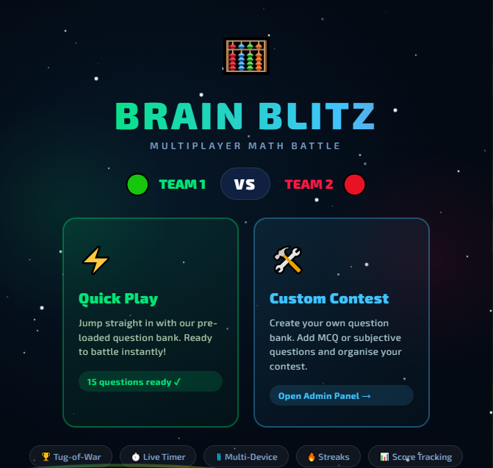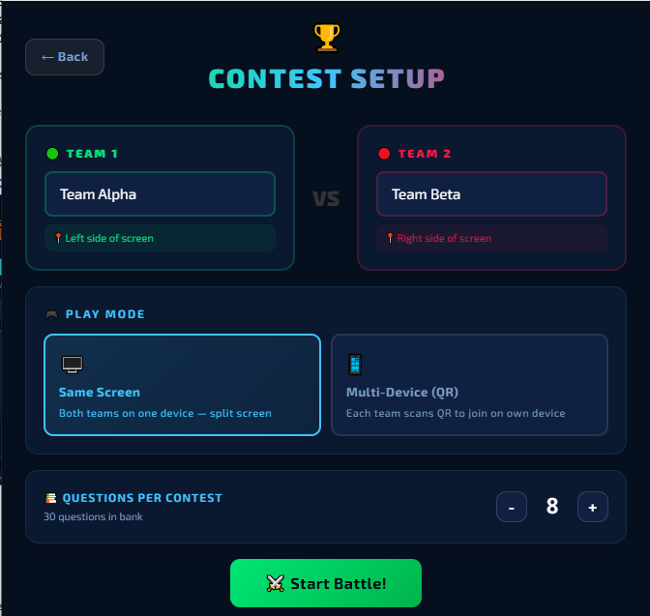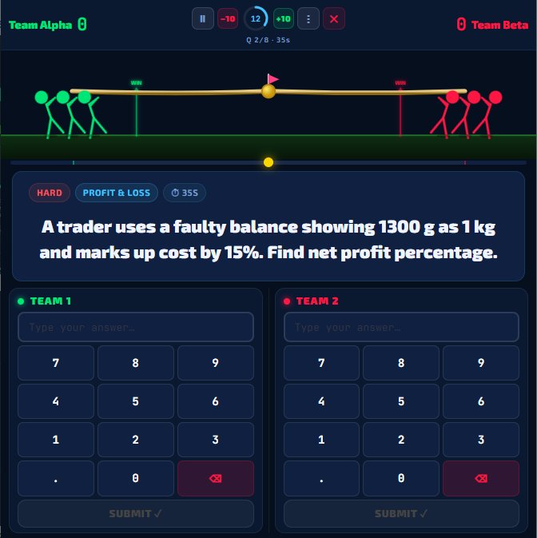
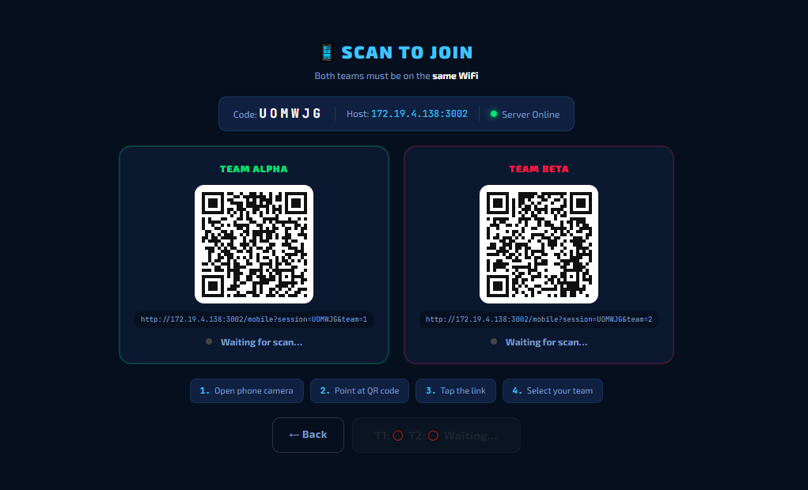
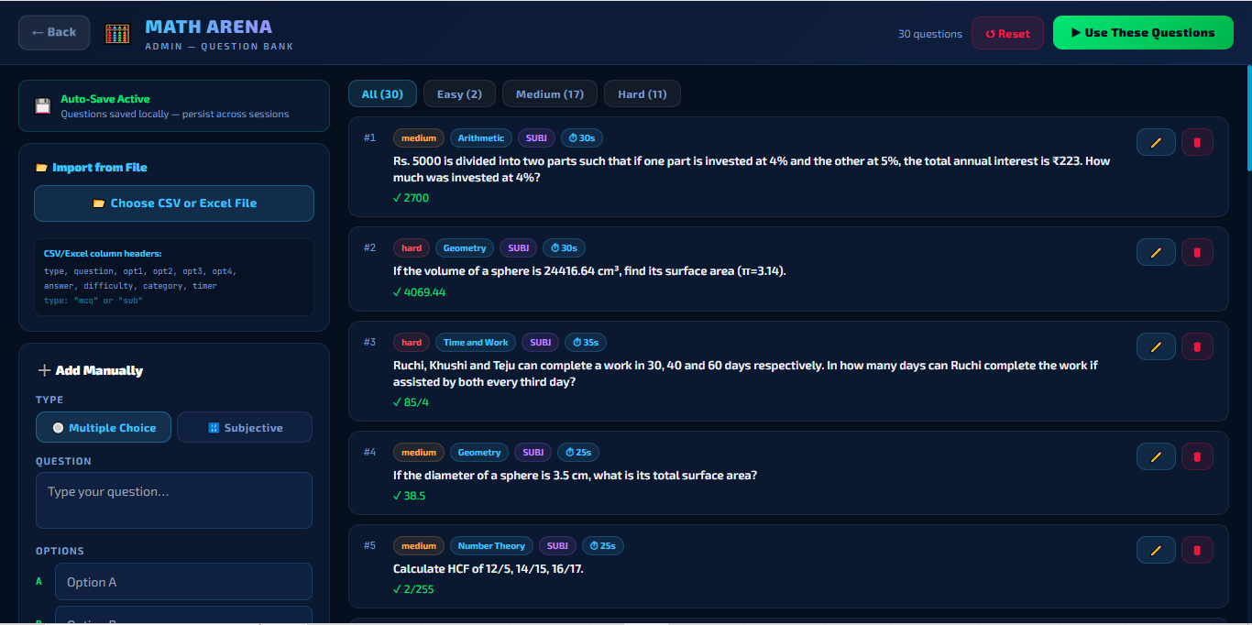

5. Objective
- To create an interactive and competitive platform for practicing mathematics.
- To make mathematical learning more engaging through real-time team competition and game mechanics.
- To provide a simple desktop-based host application that can be operated during classroom or college events.
- To support both same-screen participation and multi-device participation using students' smartphones.
- To provide administrators with flexible question-bank and live-game management features.
- To demonstrate the practical use of Electron, React, Node.js, Express, Socket.io, and QR-based device connectivity in an educational application.

6. Expected Outcomes
- Students receive an engaging environment for practicing mathematical problem solving.
- Teachers or event organizers can conduct quick mathematics competitions with minimal setup.
- Multiple mobile players can participate in a synchronized game through a common Wi-Fi network.
- Question banks can be customized and reused using local storage and CSV/Excel import.
- Real-time scores, timers, answer status, and game events remain synchronized across connected devices.
- The application can be packaged as an installable or portable desktop application for practical deployment.

7. Required Hardware and Infrastructure
For the AWS-based deployment of BrainBlitz, the Electron application should act primarily as the host/admin interface, while the Node.js + Express + Socket.io game server is deployed on AWS. Mobile players then connect to the cloud server through HTTPS/WSS instead of depending on the host computer's local Wi-Fi server.
- Compute: Amazon Lightsail Linux/Unix Small plan with 2 vCPUs and 2 GB RAM for the initial deployment. AWS currently lists this plan at US$12/month with 60 GB SSD storage; the standard bundle has 3 TB monthly transfer, while AWS states that Mumbai receives half the displayed transfer allowance, so approximately 1.5 TB/month should be assumed for Mumbai. citeturn0search0turn1search3
- RAM: 2 GB is a suitable starting point for the Node.js/Express/Socket.io server and a small-to-medium college deployment. Upgrade to 4 GB when concurrent sessions, database services, monitoring, or additional APIs are introduced.
- CPU: 2 vCPUs are sufficient for the initial real-time game server because the workload is primarily network/I/O driven.
- Storage: 60 GB SSD is sufficient for the application, deployment files, logs, and small data. Persistent databases and backups should be separated as the system grows.
- Operating System: Ubuntu/Linux server is recommended for low cost and straightforward Node.js process management.
- Internet at deployment site: Use a reliable 50 Mbps or higher connection for the host/admin environment. For large events or multiple simultaneous contests, 100 Mbps+ is recommended.
- Mobile connectivity: Players require stable 4G/5G or Wi-Fi access to the AWS server. The application sends small real-time game messages, so high bandwidth per player is not required.
- AWS bandwidth: The 2 GB Lightsail plan has a 3 TB standard transfer allowance; because Mumbai gets half the displayed allowance, plan for approximately 1.5 TB/month of bundled transfer. citeturn0search0turn1search3
- Public endpoint: Use a static public IP and a domain such as game.example.com for a stable connection endpoint.
- Security: Use HTTPS/WSS, allow port 443 publicly, and restrict SSH (port 22) to administrator IPs where possible.
- Monitoring and backup: Configure application logs, health checks, monitoring, alerts, and scheduled backups/snapshots before production use.
- Database: The current application uses browser localStorage for the question bank. For cloud deployment, migrate questions, users, sessions, scores, and results to Amazon RDS or DynamoDB.
Important deployment change: the current specification starts the game server from Electron for local operation. For AWS deployment, separate this responsibility so Electron connects to the AWS Socket.io endpoint while AWS continuously runs the Node.js server. This permits mobile devices to connect from outside the host's local network.

8. Estimated Budget
This budget focuses on the actual AWS deployment cost and excludes laptops, projectors, routers, and student smartphones. AWS prices are shown in USD and converted using approximately ₹95.7/USD, close to the August 21, 2026 USD/INR market rate. Actual billing can vary with taxes, exchange rate, usage, backups, and additional AWS services. citeturn1search1turn1news24
Deployment Item | Plan / Quantity | Approx. Cost | Purpose
Application/Game Server | Lightsail Linux 2 GB, 2 vCPU | US$12/month ≈ ₹1,150/month | Node.js + Express + Socket.io server; 60 GB SSD
Data Transfer | Included in Lightsail | Included | 3 TB standard; approximately 1.5 TB bundled allowance in Mumbai
Domain Name | 1 domain | ~₹800–₹1,500/year | Stable public URL
SSL/TLS | Let's Encrypt / equivalent | ₹0 for certificate | HTTPS/WSS secure communication
Basic backup/monitoring | Initial setup | ~₹0–₹800/month* | Logs, snapshots and monitoring depending on configuration
Recommended initial deployment | 1 production server | ~₹1,500–₹2,000/month + domain/year | Small-to-medium college deployment

*Backup and monitoring costs depend on the exact AWS services and retention period selected. AWS currently lists the 2 GB Linux Lightsail bundle at US$12/month and the 4 GB bundle at US$24/month. citeturn0search1turn0search0
Therefore, a practical starting budget for BrainBlitz cloud deployment is approximately ₹1,500–₹2,000 per month, plus the annual domain fee, assuming a single Lightsail server and no managed database.

9. Upgrade Plan
The upgrade plan is designed to scale BrainBlitz from a college-level deployment to a multi-institution platform without unnecessarily increasing infrastructure cost at the beginning.
- Phase 1 – Initial Production: Deploy the Node.js + Express + Socket.io server on 2 GB Lightsail. Add HTTPS, domain, process manager, health checks, logging and basic backups.
- Phase 2 – Higher Concurrent Usage: Upgrade to the 4 GB Lightsail plan with 2 vCPUs, 4 GB RAM and 80 GB SSD. AWS currently lists it at US$24/month, approximately ₹2,300/month at ₹95.7/USD. citeturn0search0turn1search1
- Phase 3 – Cloud Database: Replace localStorage-only question storage with a persistent database for question banks, users, contests, scores, match history and analytics.
- Phase 4 – Reliability: Add automated backups, monitoring, alerting, structured logs and a staging environment.
- Phase 5 – Horizontal Scaling: Move to Amazon EC2 when multiple simultaneous events or unpredictable traffic require independent scaling. Use a load balancer with multiple Node.js instances.
- Phase 6 – Socket.io Scaling: Add Redis/ElastiCache as a shared Socket.io adapter so multiple server instances can synchronize real-time events.
- Phase 7 – Static Content Optimization: Move React/static assets to Amazon S3 + CloudFront where appropriate.
- Phase 8 – Security Upgrade: Add AWS WAF, rate limiting, stronger authentication, secure session tokens, secrets management, encryption and stricter network rules.
- Phase 9 – Product Features: Add tournaments, class/college leaderboards, student profiles, performance analytics, teacher dashboards, result exports, multilingual questions and additional question types.
- Phase 10 – Enterprise/Institutional Deployment: Use multi-AZ architecture, auto scaling, managed database services, centralized monitoring and disaster-recovery backups for large inter-college or public events.
Upgrade trigger: increase server capacity when CPU/RAM remains consistently high, latency increases during live contests, or load testing shows that the current instance cannot safely support the expected concurrent sessions. Capacity should be determined through testing rather than by assuming a fixed number of players.

10. Technical Summary
Layer | Technology / Component
Frontend | React 18, Vite 5, TailwindCSS 3
Desktop Wrapper | Electron 29
Game Server | Node.js + Express + Socket.io
Mobile Client | Vanilla HTML/JavaScript served by Express
QR Generation | qrcode npm library
Excel/CSV Import | xlsx npm library
Local Persistence | Browser localStorage
Build | electron-builder / NSIS / Portable EXE / macOS package

11. Conclusion
BrainBlitz combines competitive mathematics, real-time communication, and an interactive desktop interface into a single educational application. Its Electron architecture allows the host application and local game server to operate together, while Socket.io enables synchronized participation from multiple smartphones. The application can therefore be used as a practical platform for classroom activities, college events, mathematics competitions, and future educational gaming extensions.

