 Nandha Engineering College   
**(*An Autonomous Institution*), Erode -52.  
Approved by AICTE, New Delhi, Accredited by NAAC & NBA**

**Affiliated to Anna University, Chennai.**

**[NEAI007] - VIRTUAL MOUSE AND DRAWING SYSTEM USING HAND GESTURES**

Mrs. Senthamarai .M, M.E, Assistant Professor, Artificial Intelligence and Data Science

Jagadeeswaran V P, 3rd Year, Artificial Intelligence and Data Science

**Abstract:**

This project introduces a real-time virtual mouse and drawing application utilizing hand gestures. Leveraging the Mediapipe library for hand tracking, the system enables users to control a virtual cursor and perform drawing tasks through intuitive gestures. The application offers tools like line drawing, rectangle creation, freehand drawing, circle formation, and an eraser, accessed by positioning the hand within specific regions of the screen. Additionally, the project incorporates a gesture-controlled volume adjustment feature, allowing users to manipulate audio volume by tracking hand landmarks. The application's versatility extends to virtual design, interactive presentations, accessibility tools and gesture-controlled music players. This code provides a foundation for developers to explore gesture recognition applications, enhancing user interaction across various domains.

**Need of Project & Social Relevance:**

This project addresses the growing demand for natural and intuitive human-computer interfaces. By developing a real-time virtual mouse and drawing system using hand gestures, the project aims to streamline interactions with digital devices. The relevance of this project lies in its potential to simplify and enhance user experiences, fostering a more seamless and efficient computing environment. The project's social impact is rooted in providing an accessible and user-friendly solution for a wide range of applications, contributing to the evolution of technology towards more intuitive interfaces.

**Description:**

Virtual mouse and drawing system using hand gestures leverage computer vision and gesture recognition to enable users to control a virtual mouse cursor and create digital paintings through hand movements. By employing a camera or sensor to capture and interpret predefined hand gestures in real-time, the system allows users to manipulate a virtual cursor on the screen, mimicking mouse functions. This technology enhances user interaction with digital environments, finding applications in digital art creation, design, and computer-aided modeling, offering a more intuitive and immersive experience for tasks traditionally performed with physical input devices.

**Photo:**

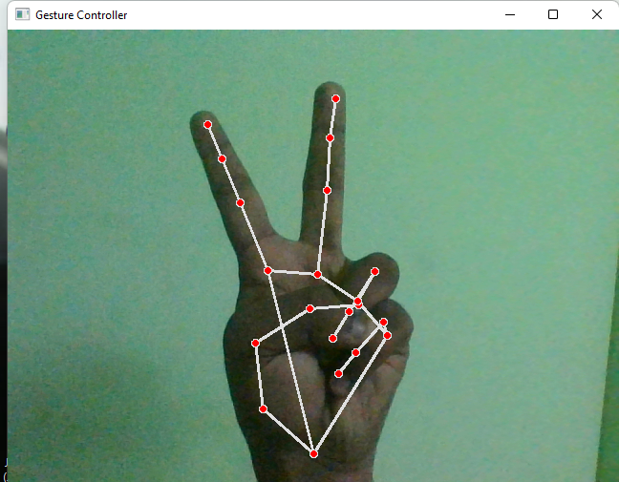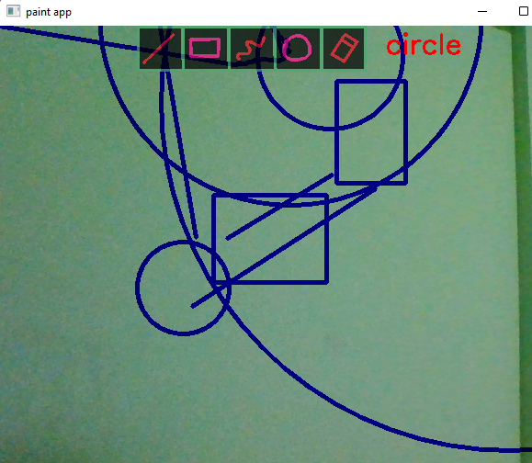

**Conclusion:**

In conclusion, the project introduces a virtual mouse and drawing app using hand gestures. The code allows users to control a virtual cursor and draw on a digital canvas with various tools. Additionally, it includes a feature to adjust volume using hand gestures. The project's significance lies in its potential applications, from creative design tools to interactive presentations. This code provides a foundation for developers to explore gesture-based interactions, contributing to more natural and engaging computing experiences.

**Future Scope:**

The future scope of this project involves refining gesture recognition algorithms for increased accuracy and exploring machine learning integration to adapt to users' unique gestures over time. Further development could expand drawing tools, introducing advanced features like colour selection and object recognition, transforming the application into a comprehensive digital design tool. Collaborative functionalities, compatibility with augmented or virtual reality environments, and integration with voice commands or smart devices offer avenues for diverse and innovative applications. The continuous evolution of this project has the potential to contribute to the advancement of natural and intuitive human-computer interaction, fostering creative and immersive computing experiences.