Cyber Security Fundamentals :TASK 01
Date : 15/01/2025

- CIA TRIAD :
CIA Triad is a common model that forms the foundation of development of security. CIA Triad stands for Confidentiality, Integrity, Availability
Where these are explained as,
C-CONFIDENTIALITY :
It focuses on protecting the sensitive data, keeping it private, and also safe from the unknown access(unauthorized access).
I-INTEGRITY :
It focuses on protecting the sensitive data from the modification or deletion.
A-AVAILBILITY :
It focuses on providing the sensitive data at any times and reliable for the access to the users.

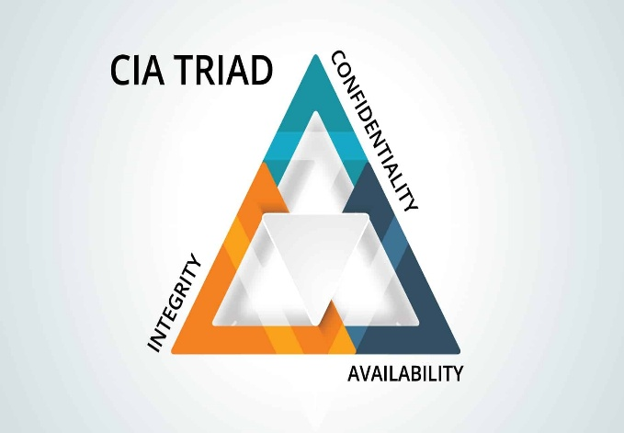

- TYPES OF CYBER ATTACKS :
- SCRIPT KIDDIES :
These are the hackers with very less technical knowledge who uses pre-made technical tools, scripts or software. They don’t know how those attacks are happening but they just do it for the sake of fun, curiosity and to show off.
- INSIDERS :
These are the hackers who have access to the authorized surface already, Because they are the trusted users, They are very difficult to find but they cause a sever damage to the organization.
- HACKTIVIST :
These are the hackers who are motivated by political, social, or ideological causes rather than financial gain. Their goal is usually to spread a message, protest against something or gain a public attention.
- NATION-STATE ACTORS :
These are the hackers who are sponsored or supported by governments. They target critical infrastructure, defense systems, financial institutions, and other countries data.

- ATTACK SURFACES :
- WEB APPLICATION :
Web applications rank high among common attack vectors because THEY are accessible via the internet. Attackers always focus on web application attack vectors such as login forms, input fields, and authentication processes, where they seek to exploit weaknesses such as SQL injection, cross-site scripting, and inadequate authentication.
- MOBILE APPLICATION :
The attack surface may also result from mobile applications if they are insecurely storing sensitive data or transmitting data to servers insecurely. They will also use these applications to go around security measures if the encryption method of the applications is weak.
- API :
Application Programming Interfaces (APIs) serve as a middleware layer for applications and backend services. Hence, APIs are a vital component of the attack surface. Insecure APIs may pose a threat to sensitive data if proper measures are not taken for implementing authentication and authorization. Malicious persons take advantage of insecure applications with weak access control, excessive data exposure, or insecure API endpoints.
- NETWORKS :
The networks are said to be vulnerable when open ports, poor firewall configurations, or insecure channels of communication are involved. Such vulnerable points can be abused using man-in-the-middle, sniffing attacks, or via unauthorized access to the network. Also, poor segmentation of networks enhances the effects of a successful attack.
- CLOUD INFRASTRUCTURE :
Poor configuration of services and improper setting of access permissions make the cloud infrastructure an attack surface. Publicly exposed storage buckets, weak identity and access management policies, and insecure virtual machines are also common targets. In cloud environments, attackers usually attack configuration errors rather than technical vulnerabilities.

- OWASP :
OWASP Top 10 is considered some of the most serious common problems encountered in web applications. These vulnerabilities pose great threats because most of them are often exploited by hackers with malicious intent to access, steal, or damage applications. It is important to understand why these vulnerabilities pose threats in creating safe applications.

- MAPPING :
Depending on the storage, processing, and transfer of the data, daily use apps present varied attack surfaces.

Email Applications - Prone to phishing attacks, malicious attachments and emails, identity theft, and account hijacking because of weak authentication and awareness.

WhatsApp Applications - Vulnerable To social-engineering attacks, account hijacking, and session hijacking, as well as insecure backup and associated device exploitation.

Banking Applications - Vulnerable to API misuse, Man in the Middle Attacks, Insecure Data Transmission, & Authentication Bypass that may result in financial frauds.

Such a mapping can help in understanding how malicious users may be exploiting common applications.

- APPLICATION DATA FLOW :
The usual flow of data in a typical application is much organized.
It would be through an interface with which the user fills in data, say a login form or a transaction page. The application processes the data and sends it to the server, which in turn performs the business logic intended and necessary validations. Further, the server would talk to the database to store or retrieve the information as needed. This flow is common across web, mobile, and cloud-based applications.

User → Application → Server → Database

- SUMMARY :
Cyber security is all about safeguarding computer systems and data from unauthorized access, use, and disruption. The CIA triad paradigm outlines the basic principles of security requirements for confidentiality, integrity, and availability. There exist different categories of attackers that target different attack points such as apps, networks, API, and cloud infrastructure. Having basic knowledge about data flow through the application and where the threats exist is crucial for recognizing threats and implementing better security measures.

