1. **Identify Relationships in the following diagrams**

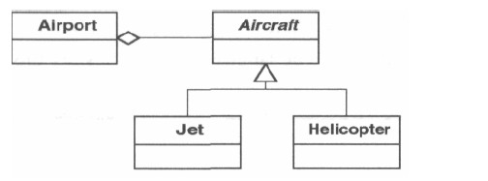

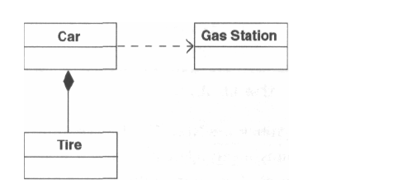

Jet and helicopter inherits from aircraft. (is-a)

Airport holds aircrafts (has-a relationship, aggregators)

Car uses gas station (dependency)

Car contains Tire (has-a relationship, composition)

1. **Identify the Pattern**

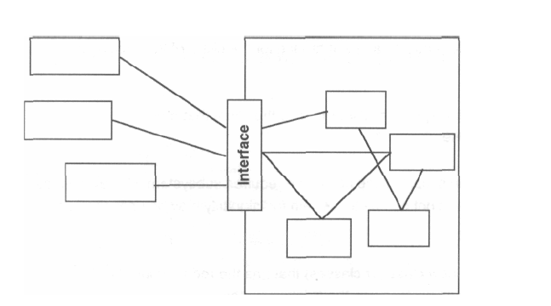

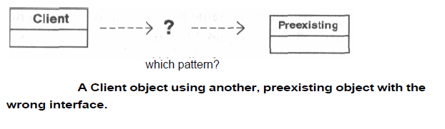

Ans: Abstract factory

1. **Refactor the Design and Name the pattern**

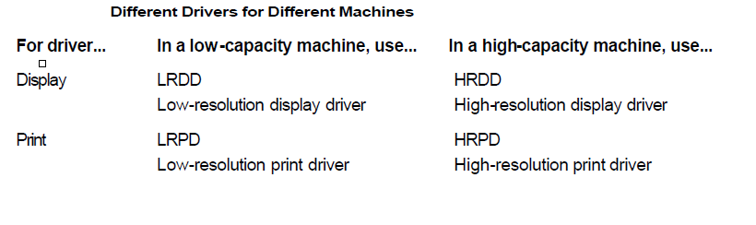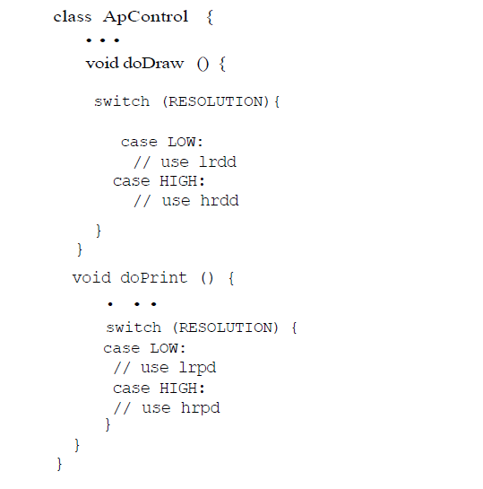

Ans: Strategy Pattern

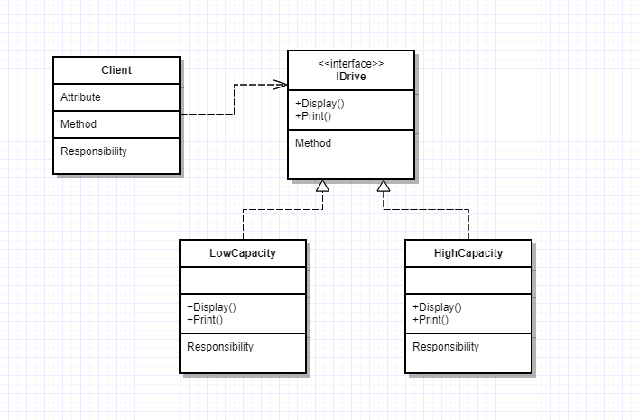

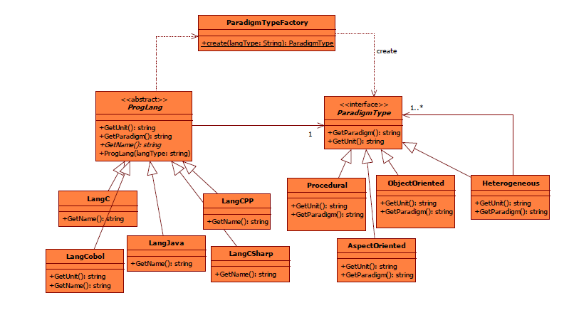

Ans: Factory pattern

1. **Identify the patterns in the following design:**
2. **Which of the SOLID principle violated in the following code and Refactor the Design**

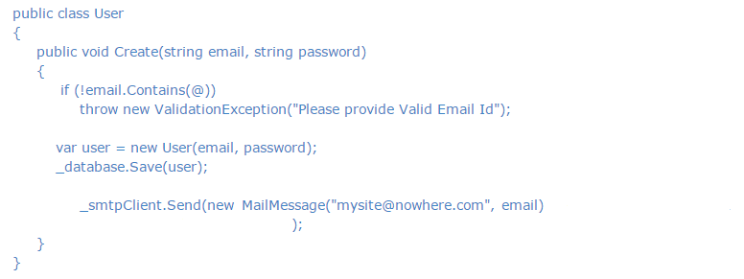

Ans: Single responsibility principle

1. **Which best defines the use of the Composite Design Pattern?**
   1. The Composite design pattern allows the clients to build a complex object of smaller different ones
   2. The Composite design pattern allows adding and removing functionality dynamically
   3. the Composite design pattern allows the clients to treat individual objects and compositions uniformly

**Ans**: c. the Composite design pattern allows the clients to treat individual objects and compositions uniformly

1. **___________The relationship used to represent a class invoking static methods of another class is**
   1. association
   2. contains
   3. comoposition
   4. inheritance

Ans: Association

1. **Which of the following pattern works as a bridge between two incompatible interfaces?**
   1. Builder Pattern
   2. Adapter Pattern
   3. Prototype Pattern
   4. Bridge Pattern

Ans: Adapter Pattern

1. **Which of the following pattern is primarily used to reduce the number of objects created and to decrease memory footprint and increase performance?**
   1. Composite Pattern
   2. Facade Pattern
   3. Flyweight Pattern
   4. Decorator Pattern

Ans: Flyweight pattern

1. **It is also known as Wrapper, it is used when sub classing is not possible or practical to add functionality and it is used to add functionality at runtime. This pattern is :**
   1. Composite
   2. Adapter
   3. Decorator
   4. Proxy

Ans: Decorator pattern

1. A typical product database consists of two types of product components — product categories and product items. A product category is generally composite in nature. It can contain product items and also other product categories as its subcategories. Example Product Categories: a. Computers b. Desktops c. Laptops d. Peripherals e. Printers f. Cables the Computers product category contains both the Desktops and the Laptops product categories as its subcategories. The Desktop category can contain a product item such as Compaq Presario 5050. Product items are usually individual, in the sense that they do not contain any product component within. Design and implement an application to list the dollar value of a product component. Use the appropriate pattern to allow the client application to refer to both the product categories and the product items in a uniform manner

Ans: Composite design pattern

1. Suggest the Correct Pattern

Let us build a sales reporting application for the management of a store with multiple departments. The features of the application include:

* 1. Users should be able to select a specific department they are interested in.
  2. Upon selecting a department, two types of reports are to be displayed:
     1. Monthly report — A list of all transactions for the current month for the selected department.
     2. YTD sales chart — A chart showing the year-to-date sales for the selected department by month.

Whenever a different department is selected, both of the reports should be refreshed with the data for the currently selected department.

Ans: Observer pattern using command pattern

1. Refactor the Design using Appropriate Pattern

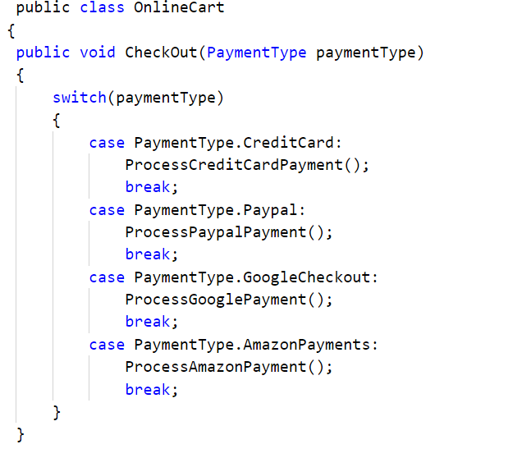

Ans: Strategy pattern

