Answers:

1.Relationship between:

a. Aircraft-Jet-Helicopter: Jet and Helicopter **inherits** from Aircraft

b. Airport-Aircraft: Airport **Has** instance of Aircraft (**Aggregation**)

c. Car-Tire: Car **has** instance of Tire. (**Composition**)

d. Car- Gas Station: **Dependency**. Car can use instance of Gas station

2. Façade pattern

3. Refactoring using Visitor Pattern:

4. Abstract Factory Design pattern

5. Its violating **S**ingle **R**esponsibility **P**rinciple (SRP). The function create is performing multiple functions like: a. Validation of the email id

b. Creating the email id

c. Sending a test mail (welcome mail)

6. **c. (**the Composite design pattern allows the clients to treat individual objects and compositions uniformly)

7. **a.** Association pattern

8. **b.** Adapter pattern

9. **c.** Flyweight Pattern

10. **d.** Proxy Pattern

11. Composite Design Pattern:

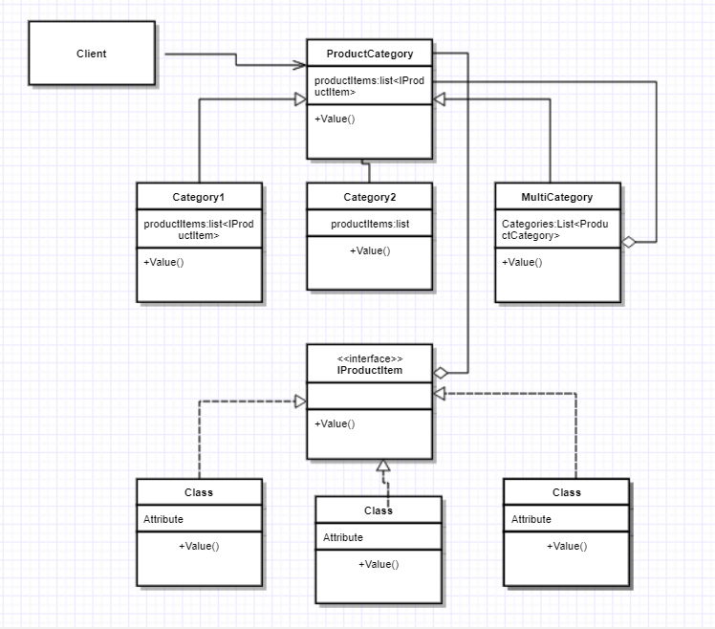

12.Composite observer pattern

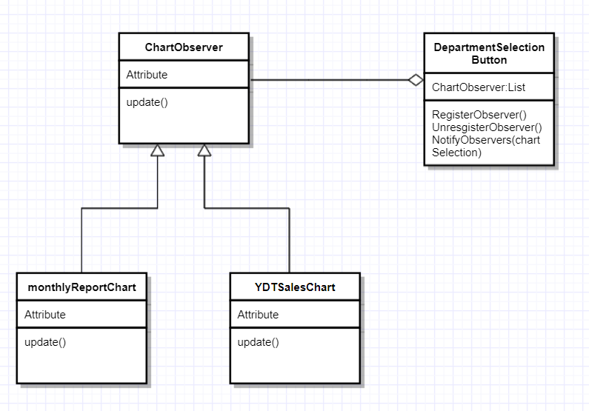

13.Strategy Pattern

