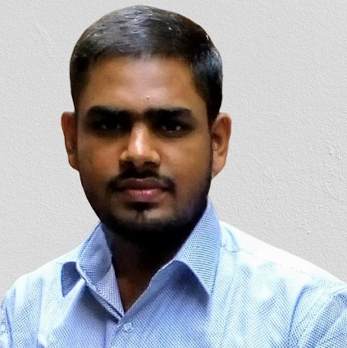

**SHUBHAM TIWARI**

shubhamtiwari93312@gmail.com

**SHREE MAHESHWARI VIDYALAYA**

**SHREE MAHESHWARI VIDYALAYA**

* C
* CORE JAVA
* WEB DEVELOPMENT
* DATABASE MANAGEMENT SYSTEM

**INTERESTS**

* 30 Days Training on J2EE

**PROJECT AND TRAINING**

West Bengal Board of Secondary Education

Madhyamik Pariksha ( Secondary Examination ) ,2015

Scored-75.71%

West Bengal Council of Higher Secondary Education

Higher Secondary Examination ,2017

Scored-73.8%

Bachelor of Technology

- Computer Science and Engineering –

8.25 CGPA until 5th Semester

**ACADEMIC PROFILE**

**SWAMI VIVEKANANDA INSTITUTE OF SCIENCE AND TECHNOLOGY**

* **MOBILE NO.:**9831444069
* **EMAIL:** shubhamtiwari93312@gmail.com
* **ADDRESS:** 28, a Balaram Dey Street,

Kolkata-700006

* Playing Cricket
* Playing Cards
* Reading Motivational Quotes

**HOBBIES**

* Good conceptual and analytical skills
* Good time management skills

**CERTIFICATES**

**SKILLS AND ABILITIES**

* Online Certified by NPTEL for the course – “Programming in JAVA”.
* Online Certified by COURSERA for the course –“Learn to Program: The Fundamentals”(BASIC PYTHON).
* Career Edge - Knockdown the Lockdown online course offered by TCS Ion(SOFT SKILL).

**CONTACT DETAILS**

* To be able to utilize the knowledge already gained, in a responsible and proper manner resulting in a value add to the organization and to reach the apex of my career in the process.

**PERSONAL PROFILE**