  - AN END-TO-END DATA ANALYTICS CASE STUDY

Banking Risk Analytics
Customer segmentation • Credit risk • Loan portfolio • Branch performance • Transaction operations

TOOLS
MySQL Workbench | Python (Pandas, NumPy, Seaborn, Matplotlib) | Jupyter Notebook | Power BI Desktop

Executive summary
This project integrates customer, loan, branch and transaction analysis to describe portfolio composition, identify credit exposure and monitor payment operations. The available source files contain 5,000 customers and 6,500 loans; the transaction measures in the supplied consolidated dataset total 30,000 records. Results are descriptive, not a predictive credit model.
Key indicator | Verified result
Customers (source) | 5,000
Loans | 6,500
Total loan principal | ₹556.62 crore
Defaulted loans | 616 (9.48% of loans)
Principal on defaulted loans | ₹51.91 crore
Total outstanding balance | ₹198.65 crore
Transactions (consolidated data) | 30,000
Failed transactions (consolidated data) | 1,066 (3.55%)

Interpretation: The default rate is a count-based proportion of loans flagged Defaulted. Defaulted principal is original loan amount for those loans, not realized credit loss or recoverable outstanding.

1. Business questions
How large is the lending portfolio?
Which products and customer segments show elevated defaults?
Where is outstanding exposure concentrated?
How does the customer base differ by geography and credit score?
Which transaction channels and operational patterns merit attention?

2. Data inventory and preparation
Dataset | Scope / role
Customers CSV | 5,000 customer profiles; demographics, credit score, segment and branch
Loans CSV | 6,500 loans; type, status, amount, balance, risk band
Consolidated analytics CSV | 5,000 customer-level rows; 20 columns including loan and transaction aggregates
SQL screenshots / dashboard | Evidence of MySQL queries, ranking, monthly and channel reporting, Power BI visuals

Python workflow: imported source files, inspected dtypes and missing values, removed unnamed empty columns, aggregated loans and transactions by customer, then left-joined these features to the customer table. The notebook showed 27.96% missingness in loan-derived features because many customers had no matched loans. Median filling was applied, followed by dropna, leaving 4,988 rows in the notebook. This treatment must be documented because a missing loan is not necessarily an unknown loan amount; for counts and totals, zero is generally a better representation for no-loan customers. The separately supplied consolidated CSV retains 5,000 rows and has no nulls.

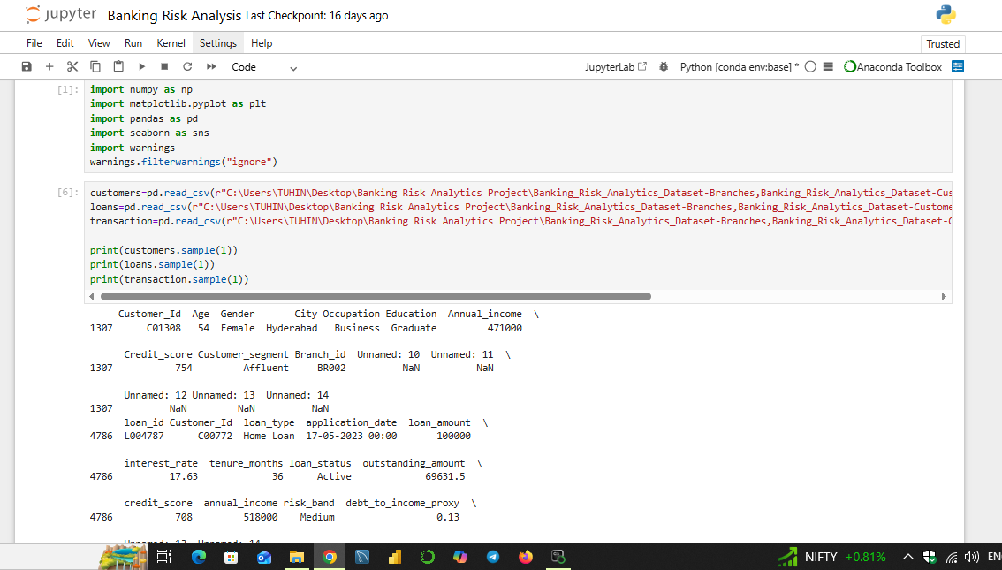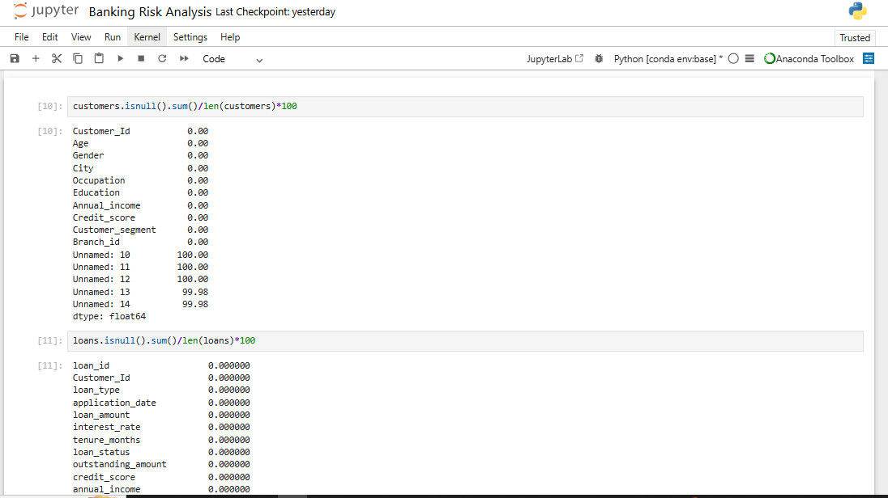
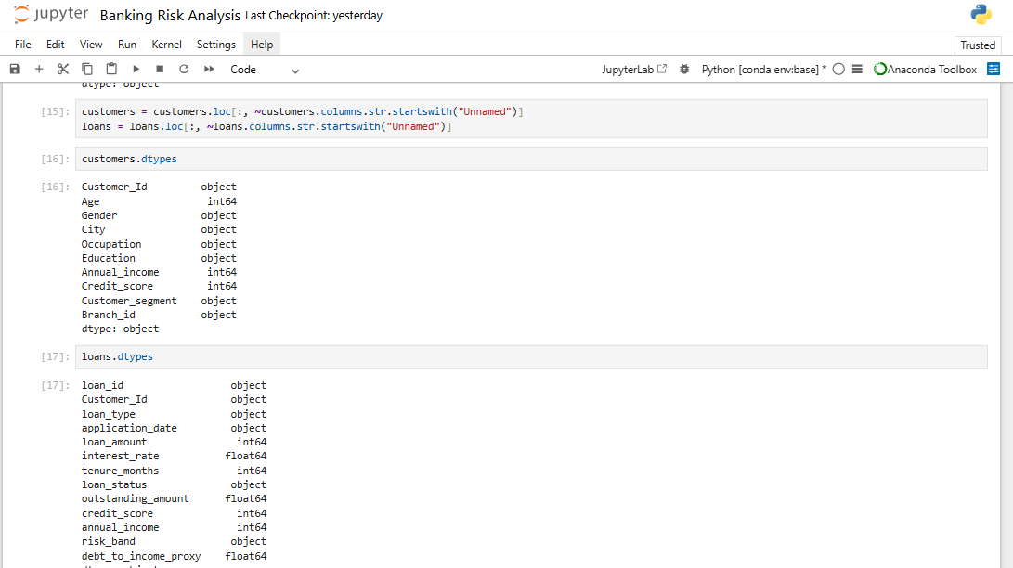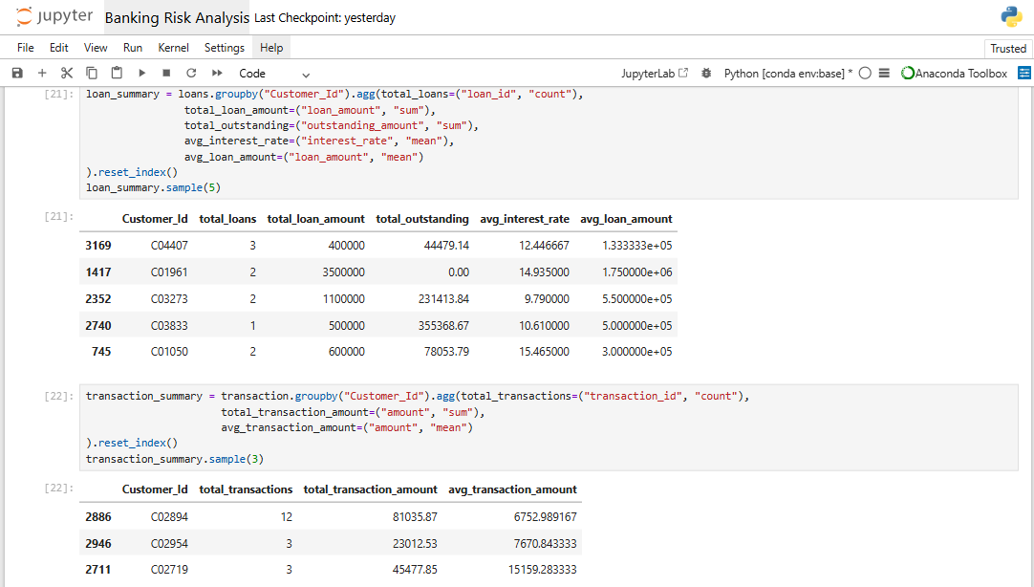
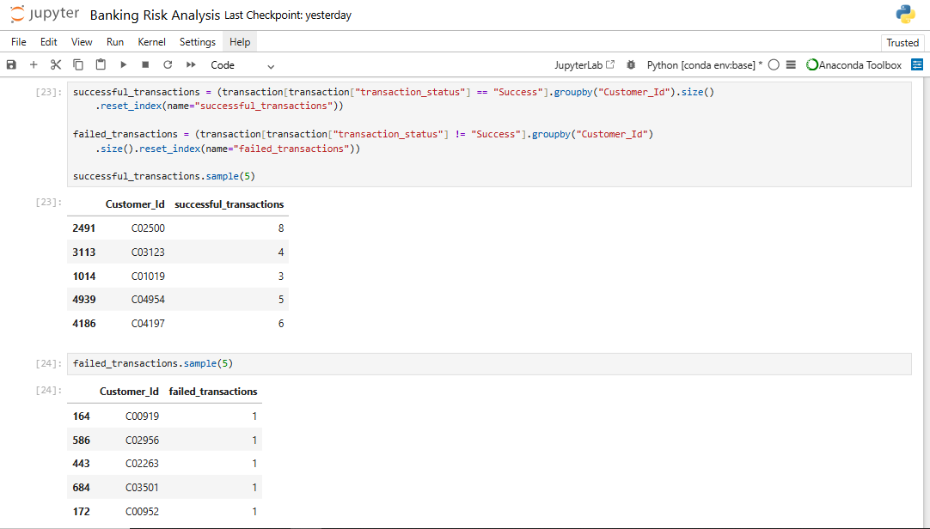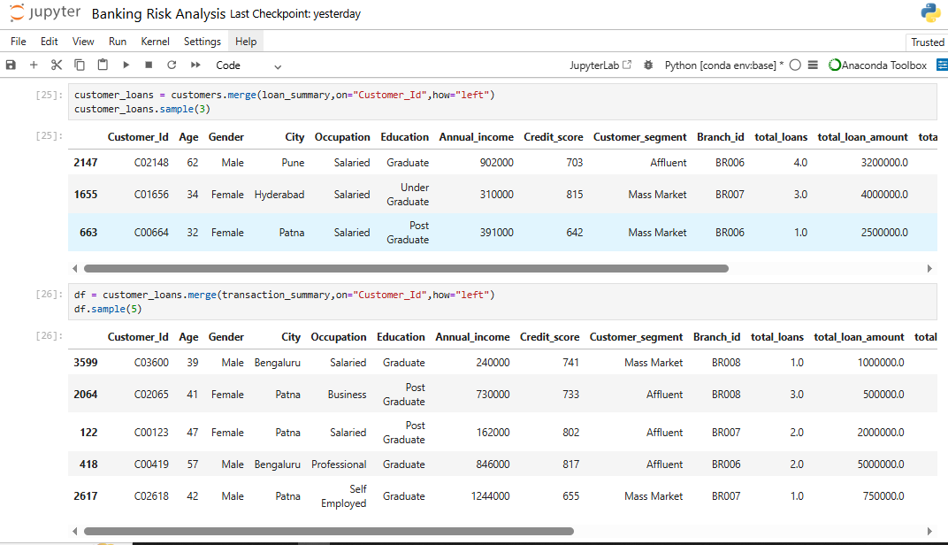

3. Customer portfolio and credit quality
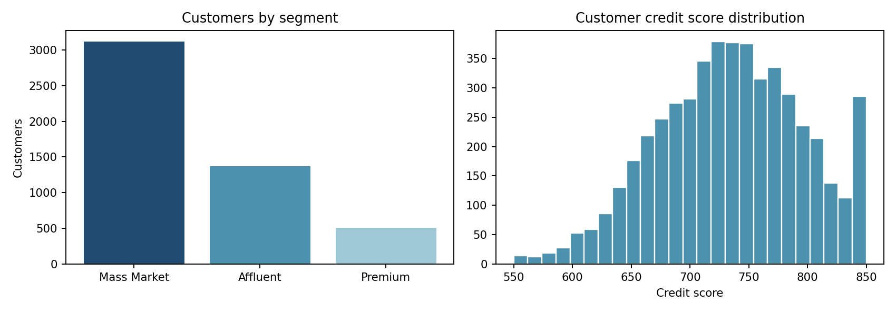
Customer segment | Customers | Share
Mass Market | 3,121 | 62.42%
Affluent | 1,369 | 27.38%
Premium | 510 | 10.20%

Customer locations are comparatively balanced: the largest city is Delhi (518 customers), while Bhubaneswar has 466. Mass Market is the dominant segment. This describes customer mix, not segment profitability.
Credit scores across all 5,000 original customers average 734.12, with a median of 735. In the 4,988-row notebook screenshot, the mean was 734.21 and median 735; these figures differ because the underlying customer populations differ. A credit score distribution cannot independently establish default risk.

4. Lending portfolio and defaults
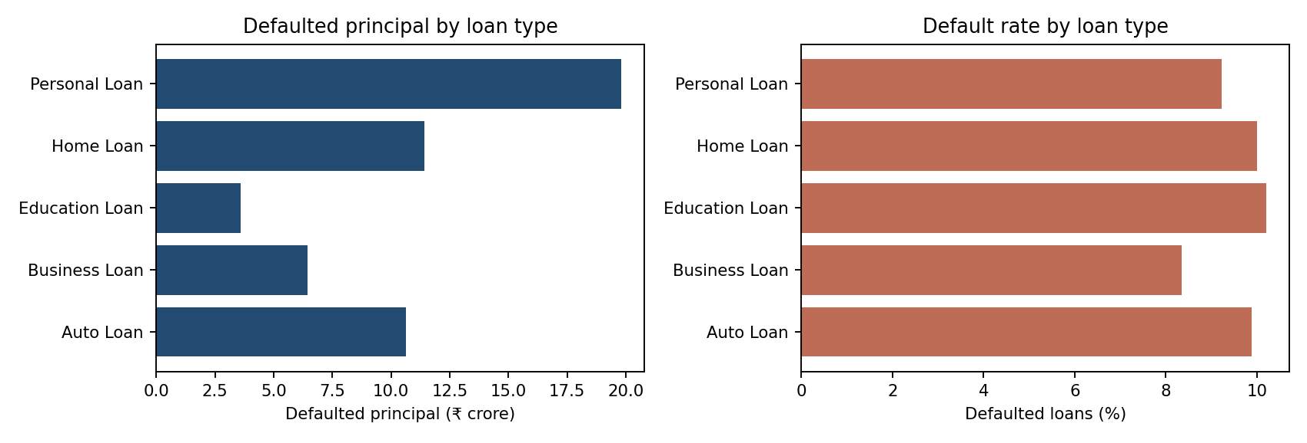
Loan product | Loans | Defaults | Default rate | Defaulted principal
Auto Loan | 1,295 | 128 | 9.88% | ₹10.64 cr
Business Loan | 911 | 76 | 8.34% | ₹6.45 cr
Education Loan | 500 | 51 | 10.20% | ₹3.60 cr
Home Loan | 1,409 | 141 | 10.01% | ₹11.42 cr
Personal Loan | 2,385 | 220 | 9.22% | ₹19.80 cr

SQL Analysis ---
Personal Loans account for the greatest absolute defaulted principal (₹19.81 crore), followed by Home Loans (₹11.42 crore) and Auto Loans (₹10.64 crore). A high defaulted amount can reflect portfolio size, default frequency, or typical loan size; the rate chart helps distinguish these drivers.
Default Amount By Each Loan type-
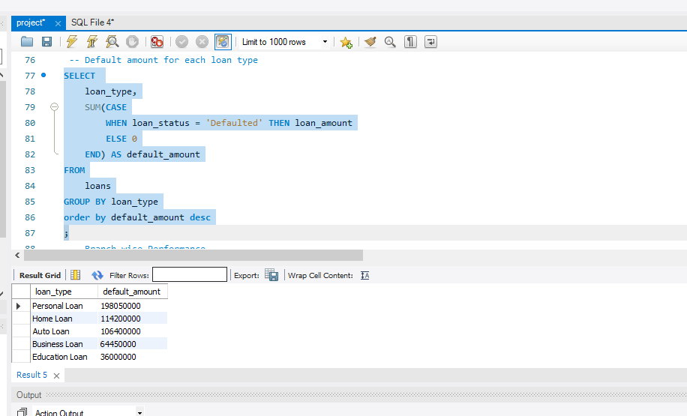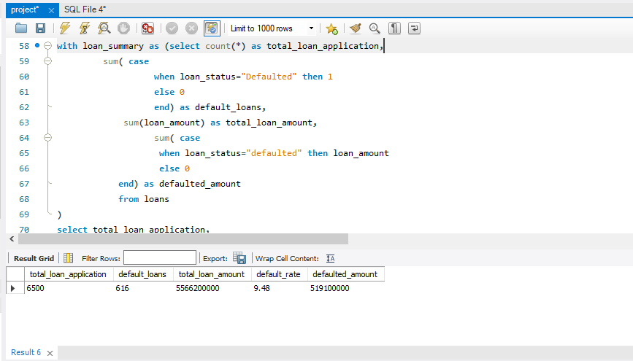
Customer Segmentation By Risk- Monthly Transaction Trend
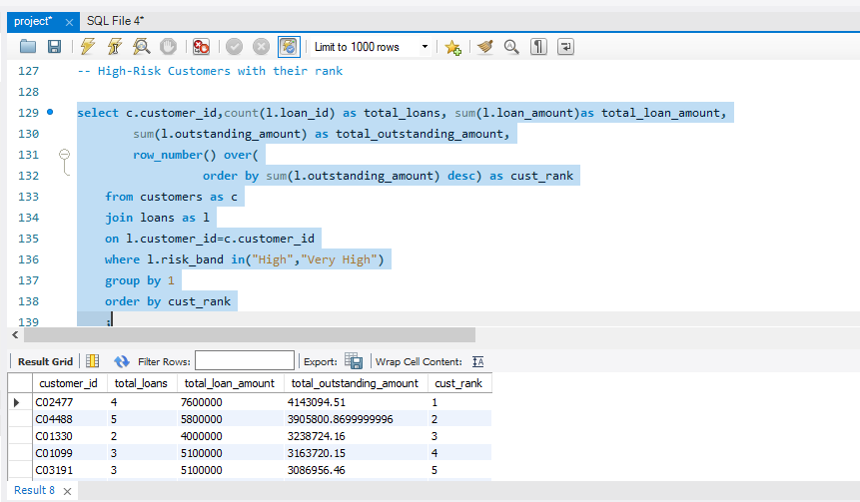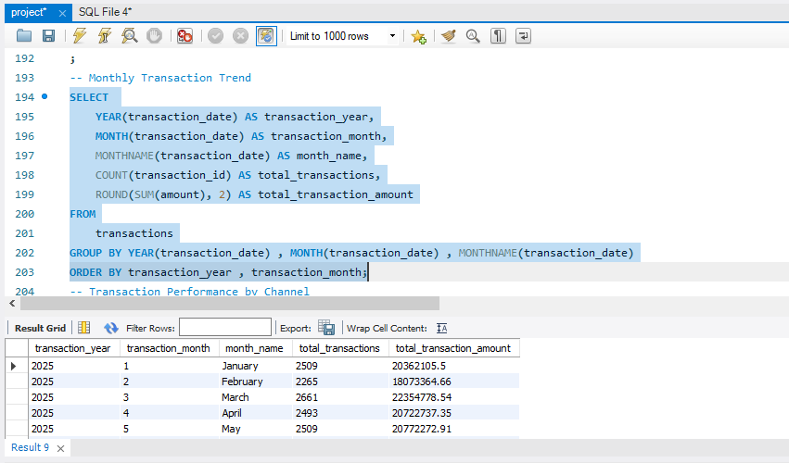
Transaction Performance By Channels

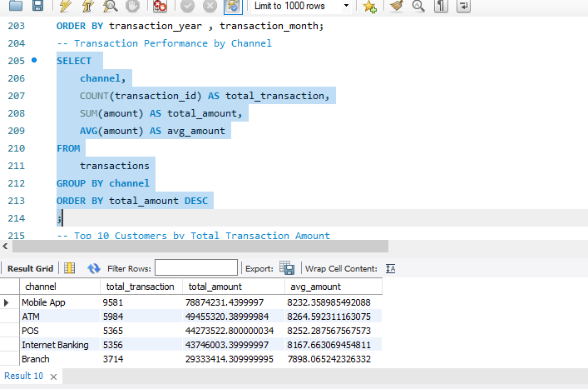

5. Risk segmentation and customer exposure
Segment | Loans | Defaulted loans | Loan default rate
Affluent | 1,747 | 165 | 9.44%
Mass Market | 4,118 | 386 | 9.37%
Premium | 635 | 65 | 10.24%

Segment default rates are calculated at loan level after matching customer IDs. They should not be interpreted as the percentage of unique customers who defaulted. Credit-score bands and risk-band labels can support additional monitoring, but should be tested against actual defaults before being treated as risk predictions.
Source risk band | Loan count | Default rate
High | 1,240 | 7.66%
Low | 1,680 | 10.77%
Medium | 1,952 | 9.12%
Very High | 612 | 8.17%
Very Low | 1,016 | 11.02%

High-risk customer ranking was implemented in SQL with ROW_NUMBER() ordered by summed outstanding balances for loans tagged High or Very High. This is an exposure prioritization tool, not a probability-of-default model.

6. Branch and transaction performance
The SQL work included branch-wise loan principal, outstanding amount, defaulted principal and customer counts; monthly transaction trends; transaction-channel volume and value; and top customers by transaction amount. Screenshots show five channels: Mobile App, ATM, POS, Internet Banking and Branch. Mobile App had the highest observed channel volume (9,581) and transaction value (approximately ₹7.89 crore) in the displayed SQL results.
The consolidated file records 28,934 successful and 1,066 failed transactions, equivalent to a 3.55% failed share. In the Power BI screenshot, city failure rates appear around 3%–4%, but the rounded labels are not precise enough for a reliable city ranking. Failure rates should be calculated as failed transactions divided by all transactions and formatted as percentages, not raw decimals.
Branch reporting caveat: COUNT(c.customer_id) after joining branches → customers → loans counts customer-loan rows, not distinct customers. Use COUNT(DISTINCT c.customer_id) for unique borrower counts. Include branches with no loans through left joins when completeness matters.

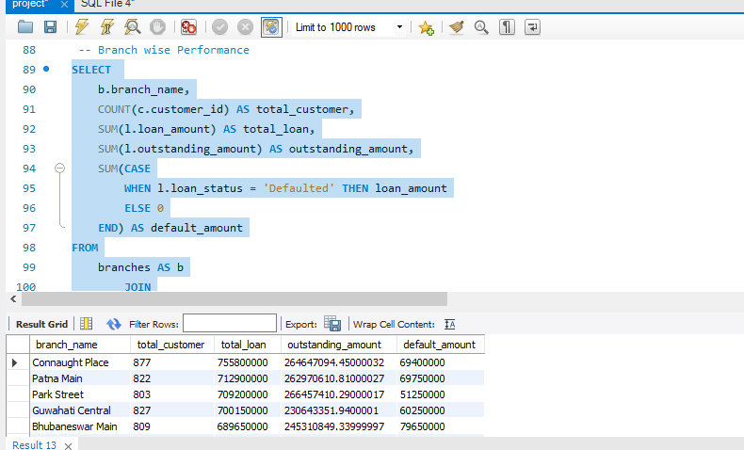

7. Dashboard design and delivery
The Power BI report was used to communicate lending KPIs, risk distributions and transaction performance. Recommended final navigation: Executive Overview; Loan & Credit Risk; Transaction & Branch Performance. Include slicers for city, branch, loan type and customer segment, with clearly labelled currency units, percentage formats and reporting period
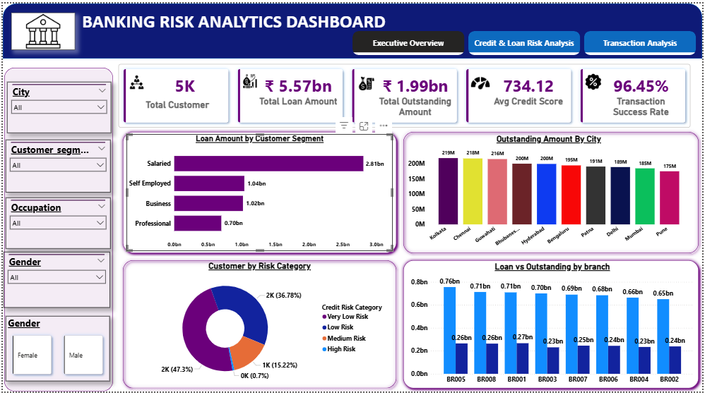
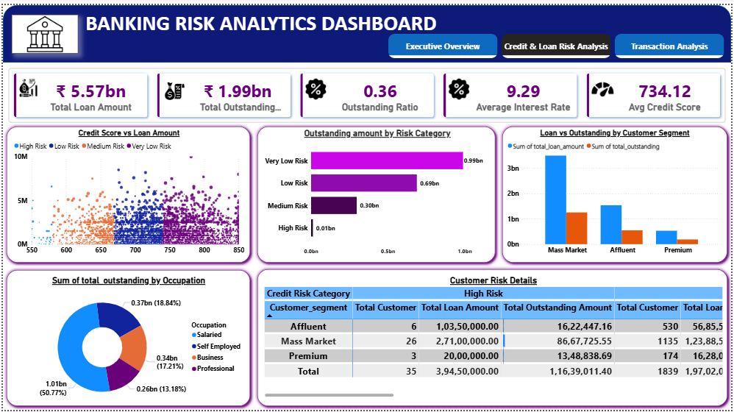

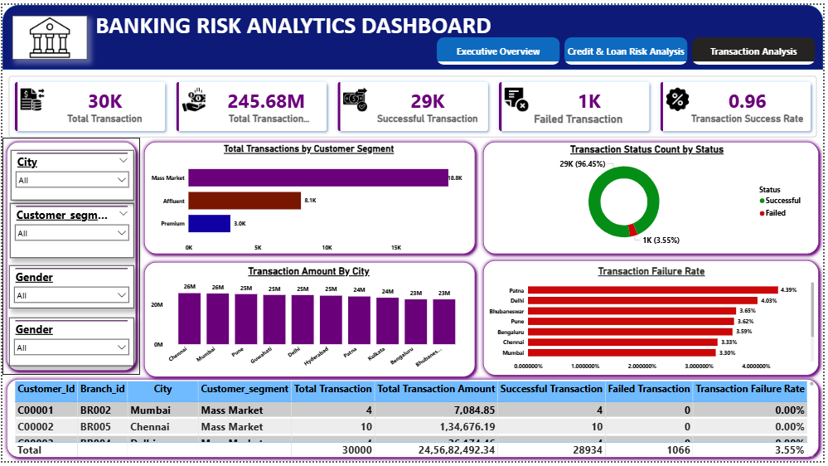

8. Business recommendations

Prioritize default monitoring
Track default rates and principal on defaulted loans by product, branch and segment. Use both rates and amounts to avoid overemphasizing large portfolios.

Validate credit-risk signals
Compare actual defaults across credit-score ranges, source risk bands and debt-to-income proxy groups before setting lending thresholds.

Focus operational investigation
Review transaction failures by channel and city, and compare failure counts with total transaction volumes.

Improve data governance
Preserve no-loan customers as zero exposure rather than replacing missing loan aggregates with the median; keep a clear data dictionary and reconciliation checks.

Strengthen dashboard usability
Use correctly formatted percentages, distinct-customer measures, consistent denominators and a visible data refresh date.

9. Limitations and analytical integrity
This case study uses supplied project data, not live bank records. There is no evidence of recoveries, write-offs, net interest income, regulatory capital or realized loss-given-default. Consequently, the report does not estimate profitability, expected credit loss, or regulatory non-performing asset ratios. Transaction source rows and the branch master file were not available as separate CSVs in the working files; detailed transaction/channel and branch observations are therefore attributed to the screenshots, while customer, loan and consolidated totals were verified against CSV files.
The notebook screenshot reports 4,988 complete rows after dropna, while the consolidated CSV has 5,000. Metrics should not be mixed across these populations without labeling the denominator. Source loan risk-band labels are descriptive categories; no independent validation of their calibration was provided.

10. Conclusion
The analysis demonstrates an end-to-end workflow from raw data inspection and cleaning to SQL-based portfolio analysis, Python EDA and Power BI presentation. The most material observed signals are a 9.48% loan default incidence, ₹51.91 crore of original principal associated with defaulted loans, concentration of customers in the Mass Market segment, and measurable transaction failures. The next step for a production-grade banking risk system would be validated definitions, temporal trend monitoring, and evidence-based risk models.

Appendix: SQL and Python techniques demonstrated
SQL: joins, conditional SUM(CASE WHEN ...), GROUP BY, CTEs, COUNT, SUM, AVG, ROW_NUMBER, RANK, date functions, customer ranking and channel analysis. Python: read_csv, dtypes, isnull, drop, groupby/agg, merge, fillna, dropna, value_counts, descriptive statistics and histogram/bar/pie visualizations.
Sources: supplied Customers CSV, Loans CSV, Final CSV, SQL Workbench screenshots, Jupyter screenshots and Power BI dashboard screenshot. All monetary values are assumed to be INR based on project context; currency metadata was not independently supplied.

