**Part 1: Cassandra Setup on Kubernetes**

kubectl create -f cassandra.yaml

kubectl get pods

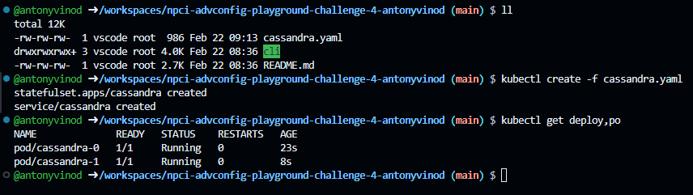

kubectl logs cassandra-0

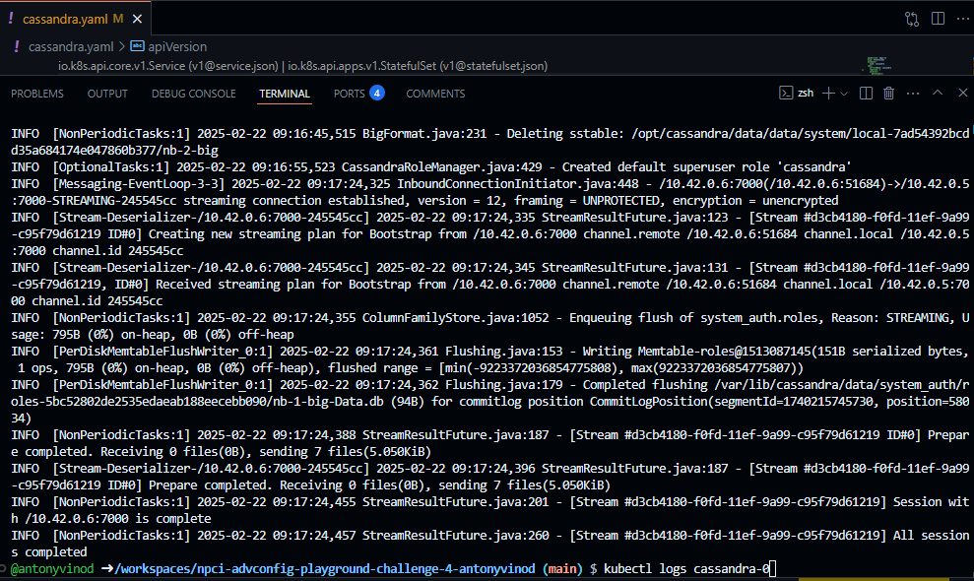

kubectl get pods -l app=cassandra

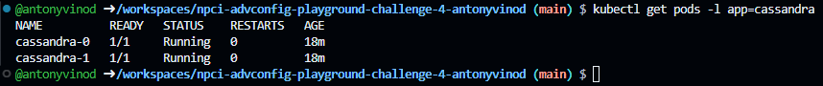

**Part 2: Cassandra Cluster Monitoring**

kubectl exec -it cassandra-0 -- nodetool status

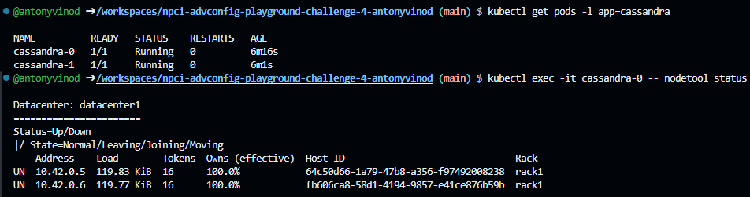

kubectl exec -it cassandra-0 -- cqlsh

DESCRIBE CLUSTER;

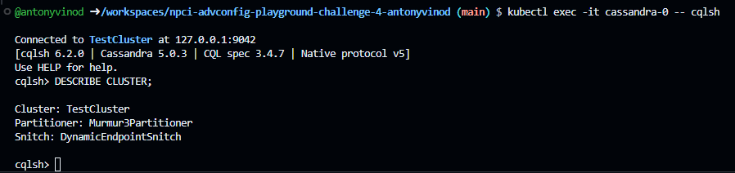

kubectl exec -it cassandra-0 -- nodetool info

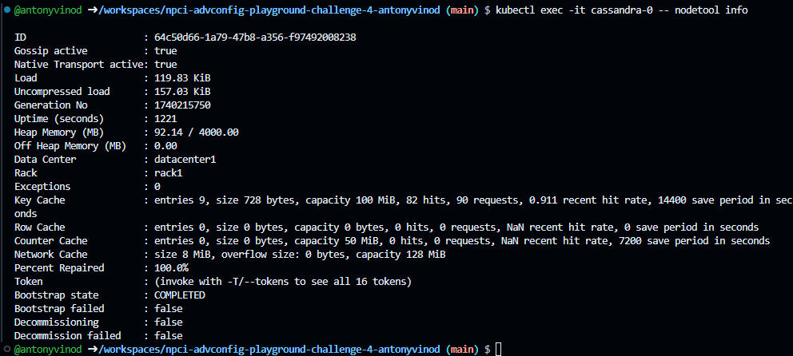

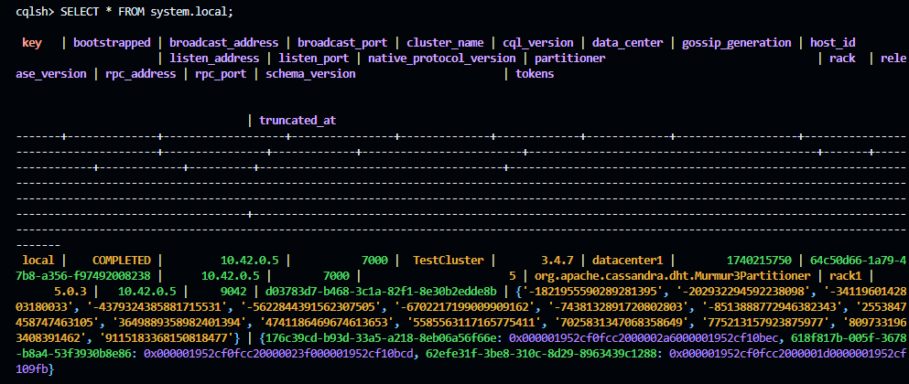

Part 3: Running CQL Basic Commands

kubectl exec -it cassandra-0 -- cqlsh

CREATE KEYSPACE user_data WITH replication = {'class': 'NetworkTopologyStrategy', 'datacenter1': 2};

CREATE TABLE users (id UUID PRIMARY KEY,name TEXT,email TEXT);

INSERT INTO users (id, name, email) VALUES (uuid(), 'Alice', 'alice@example.com');

INSERT INTO users (id, name, email) VALUES (uuid(), 'Terence', 'terence@example.com');

INSERT INTO users (id, name, email) VALUES (uuid(), 'Mike', 'mike@example.com');

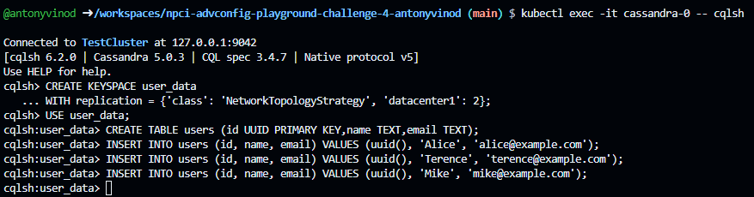

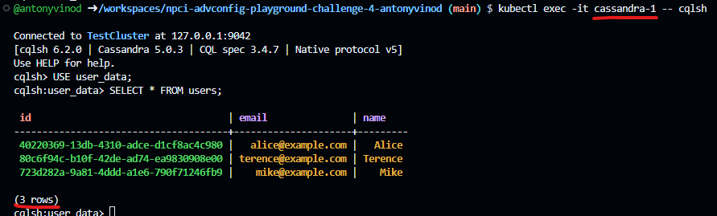

Part 4: Performance Optimization

ALTER TABLE users WITH caching = {'keys': 'ALL', 'rows_per_partition': '10'};

CREATE INDEX email_idx ON users(email);

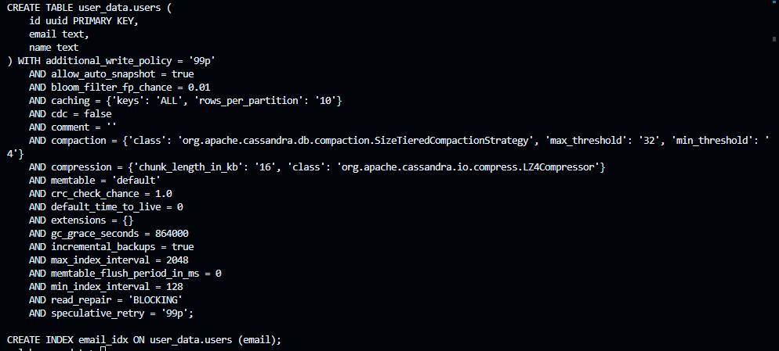

INSERT INTO users (id, name, email) VALUES (uuid(), 'Priya', 'priya@example.com');

INSERT INTO users (id, name, email) VALUES (uuid(), 'Shahid', 'shahid@example.com');

