1. Computer hardware
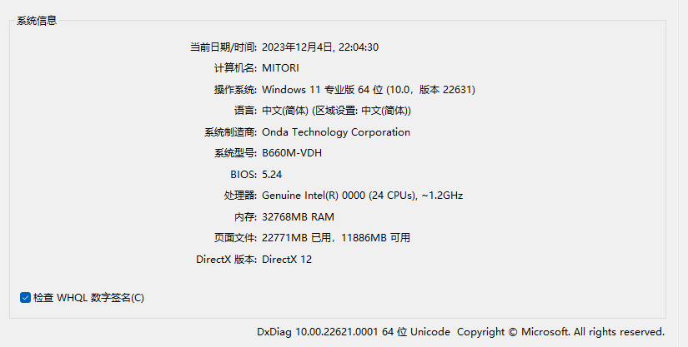 - GPU：RTX 3070

2. Computer software
- OS：Windows 11
- NVIDIA Driver：460.67
- CUDA：11.0
- cuDNN：8.0
- torch：1.7.1 + cu110
- torchvision：0.8.2 + cu110
- torchaudio：0.7.2
- scikit_learn：無指定版本
- matplotlib：無指定版本
- numpy：無指定版本
- pandas：無指定版本
- tqdm：無指定版本

3. Data Preprocessing
Since I thought that numerical training might be ineffective, and the results of the test were true, I did some algorithms on the raw data and added a few columns of values that I thought would be useful for stock prediction. Here is the list:
- Length: High - Low, is a numeric value.
- BarLength: Close - Open, is a numeric value.
- RodLength: High - max(Open, Close), is a value.
- PinLength: Low - min(Open, Close), is a value.
- OpenRatio: Today's Open ÷ Yesterday's Close, which is a ratio.
- HighRatio: High ÷ Open, is a ratio.
- LowRatio: Low ÷ Open, which is a ratio.
- CloseRatio: Close ÷ Open, belongs to the ratio.
- RiseFall: (Close - Open) ÷ Open, belongs to the ratio.
- BarRatio: BarLength ÷ Length if Length ! = 0 else 0, it is a ratio.
- RodRatio: RodLength ÷ Length if Length ! If Length != 0 else 0, it is a ratio.
- PinRatio: PinLength ÷ Length if Length ! If Length != 0 else 0, it is a ratio.
- RSI_5: 5-day relative strength indicator.
- RSI_10: 10-day relative strength indicator.
With the addition of these columns, the original data will be expanded from 5 columns (Date, Open, High, Low, Close) to 19 columns. And by combining Taiwan County's own data with the broader market data, the input data will be up to 37 columns (19 × 2 - repeated Date).

4. Model architecture
The model architecture I have chosen is Informer, which is a modification of the Transformer architecture and will be released in 2020.
Informer is currently the first in the Time Series Forecasting project on the paper with code website, with the highest accuracy of all datasets.
Here is the URL of Informer paper on paper with code website: https://paperswithcode.com/paper/informer-beyond-efficient-transformer-for

The operation mode of this architecture is Encoder-Decoder.
The inputs and answers required for the training of this framework are quite special, so we use train_X and train_Y to represent the inputs and answers, and use A, B and C to represent the length of a certain period of time.
Here, we use train_X and train_Y to represent the inputs and answers, and A, B, and C to represent a certain length of time. train_X is a sequence of data with length A+B, and train_Y is a sequence of data with length B+C. The special thing is that C is the part of the answer that we are going to predict, and A and B can be specified freely.
So if I want to predict the next 5 days of data today, I will feed the model train_X of length A+B and train_Y of length B+5.
The Encoder will first concentrate the train_X through the neural network and let the Decoder learn the correlation between the train_Y and the train_X. In this way, the Decoder will be able to peek at the past data and get a longer-term summary information, which will strengthen its ability to predict the future trend, i.e., the ability to project the answer to the last length of train_Y as C. The Decoder will be able to use the same framework to predict the future trend.
When predicting with this framework, the model is also fed with train_X of length A+B and train_Y of length B+C, but the model ignores the numerical data of the part of train_Y with the last length C (not the date data), so the data there can be assigned any number (e.g., 0) as it likes. However, be careful when populating the C part, because this framework will process time and include it in the training parameters, so the date data in the C part should still be correct. An example is shown below:

In this project, I set the A value to 20, the B value to 40, and the C value to 5.
This is a very powerful framework, but after all, it is not a model that specializes in predicting stocks, but rather in predicting cyclical long time series. So it's not surprising that a primitive moving average or a simple and crude neural network with a few layers of neural networks can outperform it. I just wanted to take the opportunity to learn a new and more complex technique.
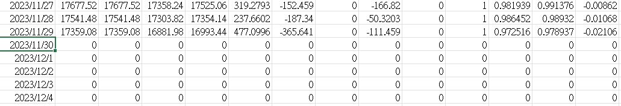

5. Training Chart
