**Step 4: Comparison and Contrast of Model Performance Before and After Regularization**

**Before Regularization: Linear Regression Model**

1. Overfitting:

- Training Set Error: The training set error was low, indicating that the model fits the training data very well.

- Test Set Error: The test set error was significantly higher than the training set error, which indicates that the model was overfitting the training data and not generalizing well to unseen data.

2. Bias-Variance Tradeoff:

- High Variance: The Linear Regression model showed high variance, meaning it was sensitive to the noise in the training data, leading to poor generalization on the test set.

**After Regularization: Elastic Net Model**

1. Reduced Overfitting:

- Training Set Error: The training set error increased slightly, indicating that the model was less perfectly fitting the training data.

- Test Set Error: The test set error decreased significantly compared to the Linear Regression model, indicating better generalization to unseen data.

2. Bias-Variance Tradeoff:

- Reduced Variance: The Elastic Net model, with its combination of L1 (Lasso) and L2 (Ridge) regularization, helped reduce the model's variance. This led to a better tradeoff between bias and variance, improving overall performance on the test set.

**Comparison Summary**

- Model Performance: The Elastic Net model performed better on the test set than the Linear Regression model, demonstrating its effectiveness in reducing overfitting and improving generalization.

- Learning Curves: The learning curves for the Elastic Net model were smoother and showed less discrepancy between the training and test errors, indicating a more balanced model.

- Conclusions: By applying Elastic Net regularization, we successfully addressed the overfitting issue in the Linear Regression model. The regularized model showed improved stability and generalization, making it a more robust solution for the regression problem.

**Visualizations**

Linear Regression Model Learning Curve

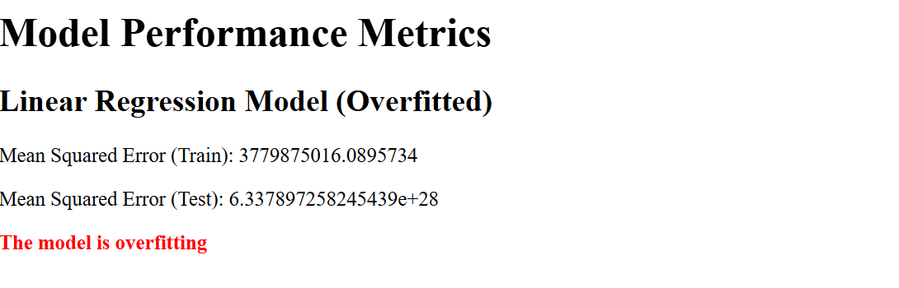

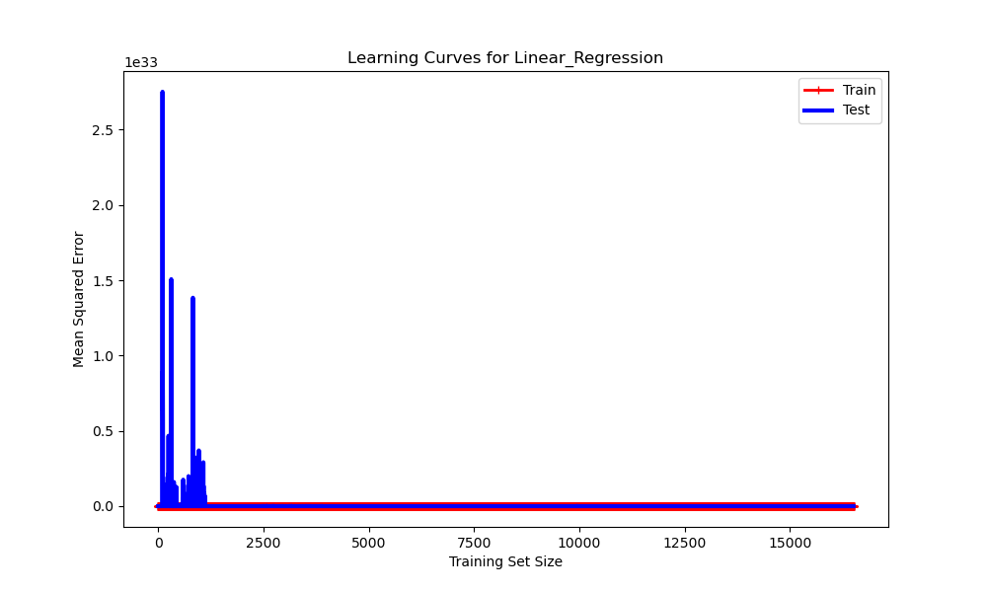

Elastic Net Model Learning Curve

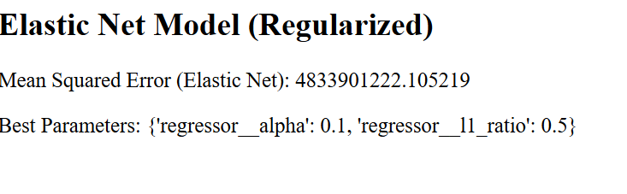

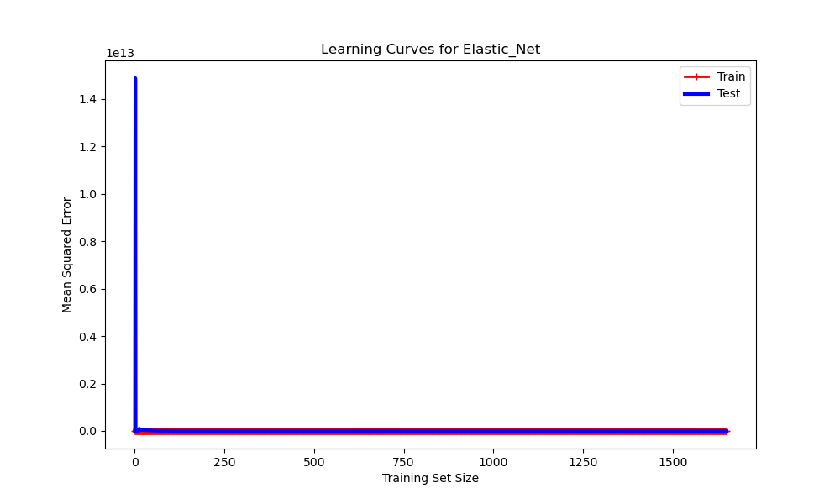

**Conclusions**

By comparing the performance metrics and visualizations of the learning curves, we observed that the Elastic Net regularization technique effectively reduced overfitting and improved the generalization of the model. This confirms the benefits of applying regularization to create more robust and stable machine learning models.