**Elastic Net Regularization**

**Step 1.**    explain the purpose, how it works, its best use case and its limitations. Also explain bias and variance tradeoff  **(5pts)**

**Purpose:**

Elastic Net is a regularization technique in machine learning that combines the properties of both L1 (Lasso) and L2 (Ridge) regularization. It aims to improve model performance by preventing overfitting and underfitting, ensuring better generalization on unseen data.

**How It Works:**

Elastic Net adds both the L1 and L2 penalties to the loss function used to train the model. The loss function for Elastic Net regularization is defined as:

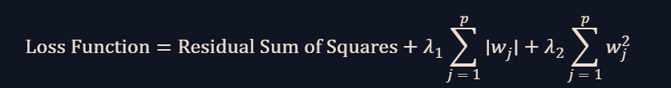

Where:

·         λ1and λ2are the regularization parameters that control the strength of the L1 and L2 penalties, respectively.

·         wj are the model's weights (coefficients).

·         p is the number of features.

By adjusting λ1 and λ2, Elastic Net balances the benefits of both Lasso and Ridge regularization, allowing for a more flexible model.

**Best Use Case:**

Elastic Net is particularly useful in the following scenarios:

- When you have a dataset with many features, some of which are highly correlated.

- When you want the benefits of both feature selection (via Lasso) and regularization (via Ridge) to improve model performance.

- When pure Lasso (L1) or Ridge (L2) regularization is not sufficient to achieve the desired balance between model complexity and prediction accuracy.

**Limitations:**

- Elastic Net requires tuning of two regularization parameters (λ1and λ2), which can be computationally expensive.

- It may not be suitable for all types of datasets, particularly those where neither Lasso nor Ridge regularization is effective.

- Interpretability of the model can be more challenging compared to simpler regularization techniques.

**Bias-Variance Tradeoff:**

The bias-variance tradeoff is a fundamental concept in machine learning that describes the tradeoff between a model's ability to fit the training data (bias) and its ability to generalize to unseen data (variance).

- High Bias: When a model is too simple, it may not capture the underlying patterns in the data, leading to high bias and underfitting.

- High Variance: When a model is too complex, it may capture noise and random fluctuations in the training data, leading to high variance and overfitting.

Elastic Net regularization helps manage the bias-variance tradeoff by introducing penalties that control the complexity of the model. By doing so, it reduces the risk of overfitting while maintaining the model's ability to generalize well to new data.

**Step 2.**    Implement a ML algorithm to solve a regression/classification problem. Your model should be conditioned so that it is susceptible to overfitting or underfitting. Using a commonly used evaluation metric like Accuracy or more, ***record*** and ***visualize*** the performance of this overfitted/underfitted model of yours. **(5pts)**

**Step 3.**    Apply the regularization technique, specifically assigned to you, to the above overfitted/underfitted model you have implemented in Q#2. Record and visualize the performance of the model after regularization is applied using the same metric you used above. (3pts)

**Step 4.**    Compare and contrast the performance of your model before and after regularization. Explain why that happened and make your conclusions. **(2pts)**