**AIM**-**Design a luminous intensity meter, such that light intensity falling on LDR is sensed and displayed on the serial monitor upon the press of a switch.**

**CIRCUIT DIAGRAM-**

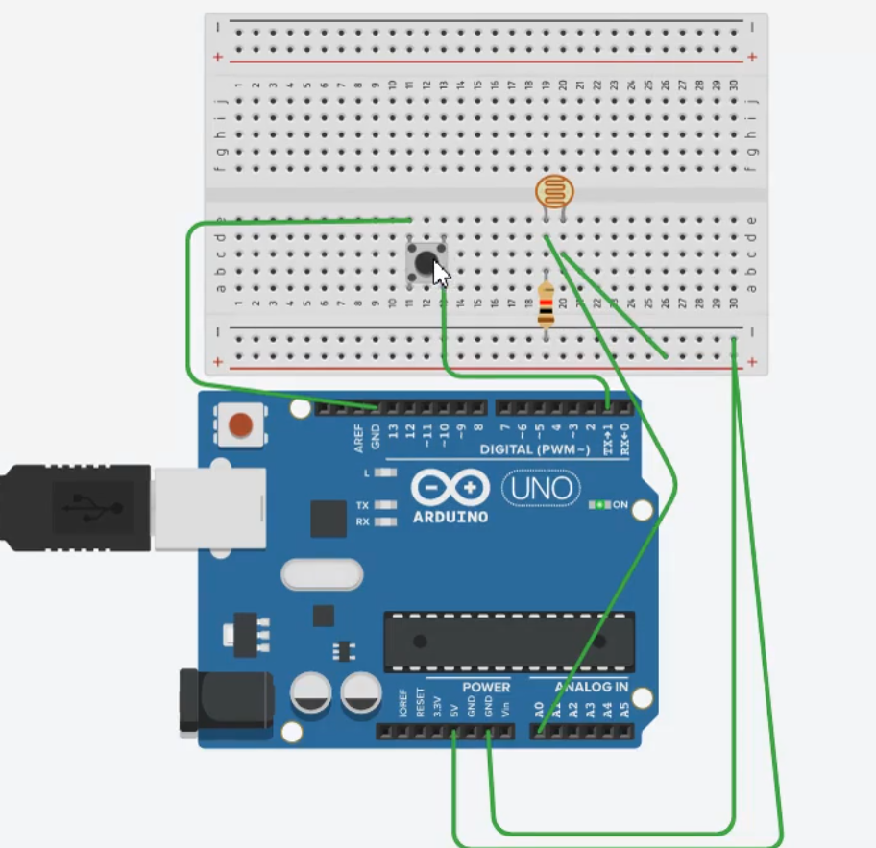

**THEORY-**

A Light Dependent Resistor (LDR) is also called a photo resistor or a cadmium sulfide (CdS) cell. It is also called a photoconductor. It is basically a photocell that works on the principle of photoconductivity. The passive component is basically a resistor whose resistance value decreases when the intensity of light decreases. This opotoelecronic device is mostly used in light varying sensor circuit, and light and dark activated switching circuits. Some of its applications include camera light meters, street lights, clock radios, light beam alarms, reflective smoke alarms, and outdoor clocks.

**Learning Outcomes-**

After completing this experiment, we learnt about the basic concept of LDR and how it can be used as a sensor and light intensity calculator.

**Problems and Troubleshooting-**

Improper wiring and incorrect terminal connection can cause problem, which can be solved, by properly watching and reviewing the connections made.

**Precautions-**

1. Connections should be made properly in breadboard and the Arduino.
2. Basic Syntax mistakes should be avoided which writing the code
3. The Analog and Digital pins should not be confused.