1. 总共25种不同的船型，每种一只，且两种算法都到收敛为止
2. 贪婪三闸

all_brake_boat {

0: {

'brake_boat': {

13: [(0, 0), (94.86, 20.49)],

7: [(94.86, 0), (113.22, 16.63)],

0: [(94.86, 16.63), (85.5, 16.3)],

1: [(180.36, 16.63), (99.3, 16.92)]

},

'best_use_rate': 0.7248252100840337

},

1: {

'brake_boat': {

2: [(0, 0), (119.53, 22.5)],

9: [(119.53, 0), (121.51, 22.48)]

},

'best_use_rate': 0.5694296008403362

},

2: {

'brake_boat': {

22: [(0, 0), (126.07, 21.29)],

18: [(126.07, 0), (111.43, 22.95)]

},

'best_use_rate': 0.5505618487394958

}

}

1. 并行三闸

无权重

all_brake_boat11 {

0: {

'brake_boat': {

14: [(0, 0), (127.37, 22.55)],

21: [(127.37, 0), (119.88, 22.18)]

},

'best_use_rate': 0.58100125

},

1: {

'brake_boat': {

16: [(0, 0), (96.7, 21.89)],

7: [(96.7, 0), (92.26, 17.42)],

0: [(96.7, 17.42), (85.5, 16.3)],

13: [(188.96, 0), (86.38, 22.18)]

},

'best_use_rate': 0.7388120378151262

},

2: {

'brake_boat': {

4: [(0, 0), (110.0, 17.2)],

2: [(110.0, 0), (119.53, 22.5)],

9: [(0, 17.2), (108.65, 16.51)]

},

'best_use_rate': 0.6696676995798321

}

}

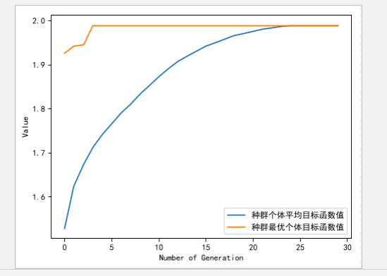

有权重

all_brake_boat11 {

0: {

'brake_boat': {

14: [(0, 0), (94.56, 20.59)],

7: [(94.56, 0), (113.22, 16.63)],

1: [(94.56, 16.63), (99.3, 16.92)],

0: [(193.86, 16.63), (85.5, 16.3)]

},

'best_use_rate': 0.7251727941176471

},

1: {

'brake_boat': {

2: [(0, 0), (119.53, 22.5)],

22: [(119.53, 0), (126.07, 21.29)]

},

'best_use_rate': 0.5644385819327731

},

2: {

'brake_boat': {

18: [(0, 0), (111.43, 22.95)],

9: [(111.43, 0), (121.51, 22.48)]

},

'best_use_rate': 0.5555528676470588

}

}

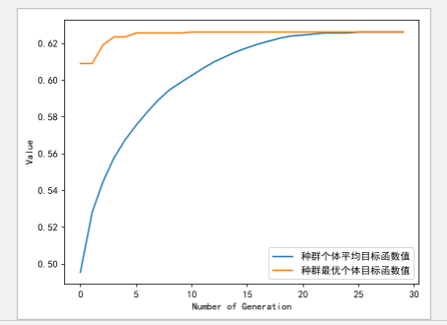

all_brake_boat {

0: {

'brake_boat': {

4: [(0, 0), (110.0, 17.2)],

8: [(110.0, 0), (110.52, 16.93)],

0: [(0, 17.2), (85.5, 16.3)],

1: [(110.0, 16.93), (99.3, 16.92)]

},

'best_use_rate': 0.7181627731092437

},

1: {

'brake_boat': {

13: [(0, 0), (129.81, 21.48)],

14: [(129.81, 0), (124.6, 20.91)]

},

'best_use_rate': 0.5665656302521008

},

2: {

'brake_boat': {

5: [(0, 0), (91.07, 18.68)],

11: [(91.07, 0), (94.3, 22.16)],

18: [(185.37, 0), (91.66, 17.91)],

16: [(185.37, 17.91), (93.87, 16.06)]

},

'best_use_rate': 0.7289977310924369

}

}

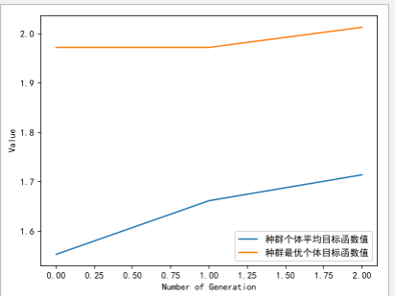

1. 总共25种不同的船型，每种10只，且两种算法都到收敛为止
2. 贪婪三闸
3. 并行三闸