Acronym | Full Form
ITSM | Information Technology Service Management
PCR | Post Change Review
TRB | Technical Review Board
CAB | Change Advisory Board
CI | Configuration Items
P1 | Priority 1
P2 | Priority 2
P3HiPo | Priority 3 High Potential
IBS | Important Business Services
eCAB | Emergency Change Advisory Board
SLA | Service Level Agreement
CTASK | Change Task

What is a CHANGE?
In the realm of IT Service Management, a change is defined as: "An addition, modification, or removal of anything that can have an effect on IT services, systems, or processes." This could be a new software feature, a patch, a hardware replacement, or moving infrastructure to the cloud. It applies across on-premises systems, cloud platforms, applications, networks, and databases. Change can originate from both Project & non-Project activities.

Failure to follow Change Management process may result in compliance violations, service disruptions, and potential disciplinary actions.

RISK for non-adherence to Change Management Process
Change management is essential to reducing operational risk and aligning IT services with business needs. Non-adherence to the Change Management Process can lead to:
Regulatory & Compliance Issues
- Non-compliance with regulatory requirements can lead to financial penalties and reputation damage
- Security risks due to unauthorized or undocumented changes
Increased Downtime & Business Disruptions
- Unplanned changes can lead to system failures, service outages and productivity losses
- Lack of coordination may cause scheduling conflicts or dependency failures
Higher Incident & Operational Risks
- Poorly planned changes increase the likelihood of service Incidents
- Inadequate testing or documents can lead implementation or rollback failures
Loss of Customer Trust & Confidence
- Frequent service disruptions impact user experience and damage brand reputation
- Clients expect stability and unreliable services affect customer retention
Inefficient Service Delivery
- A structured Change Management process improves collaboration across teams
- Standardized procedures ensure faster more reliable deployments

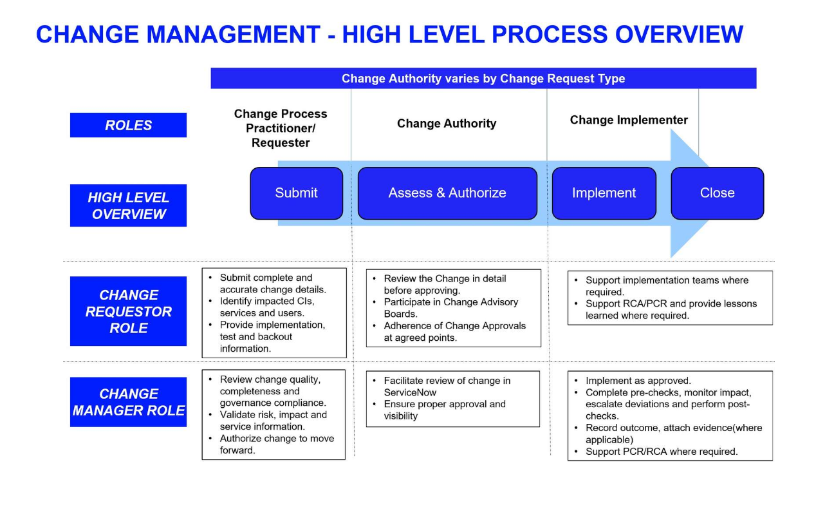

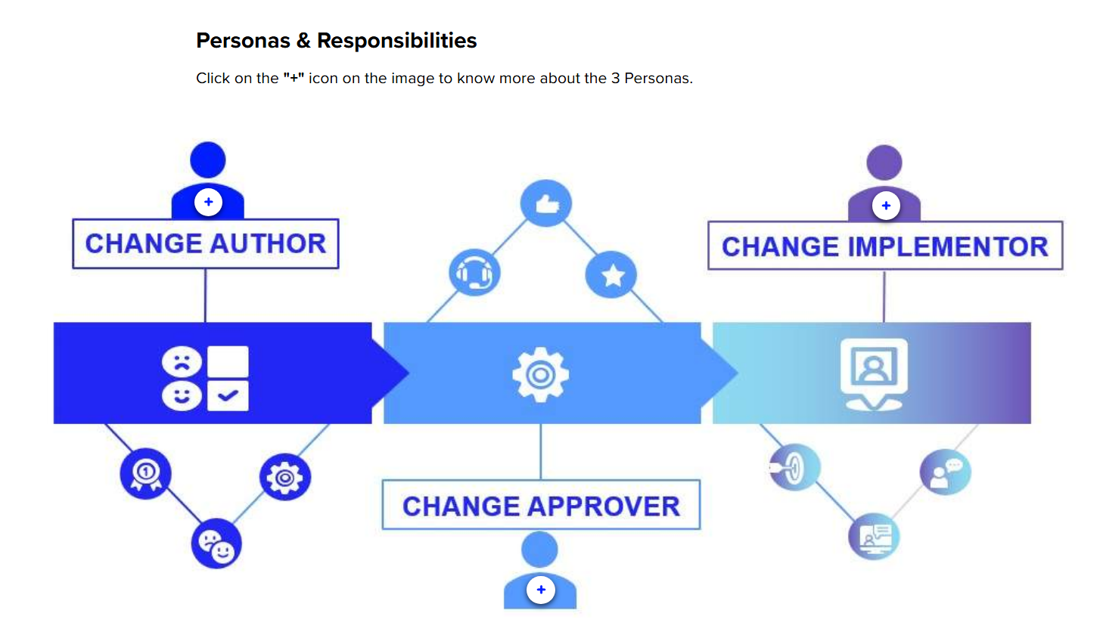
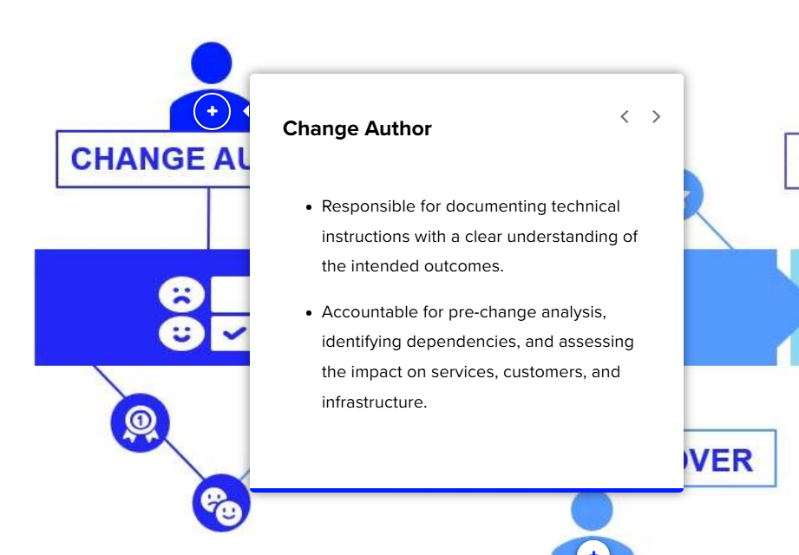

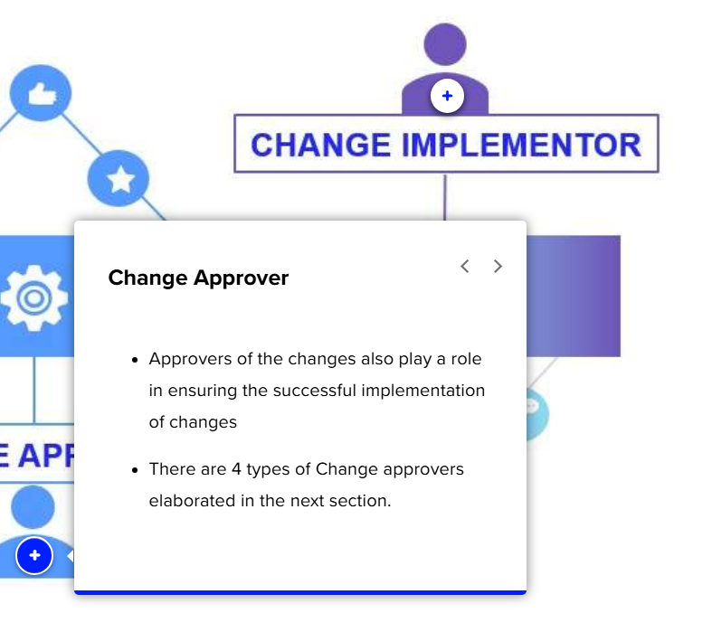
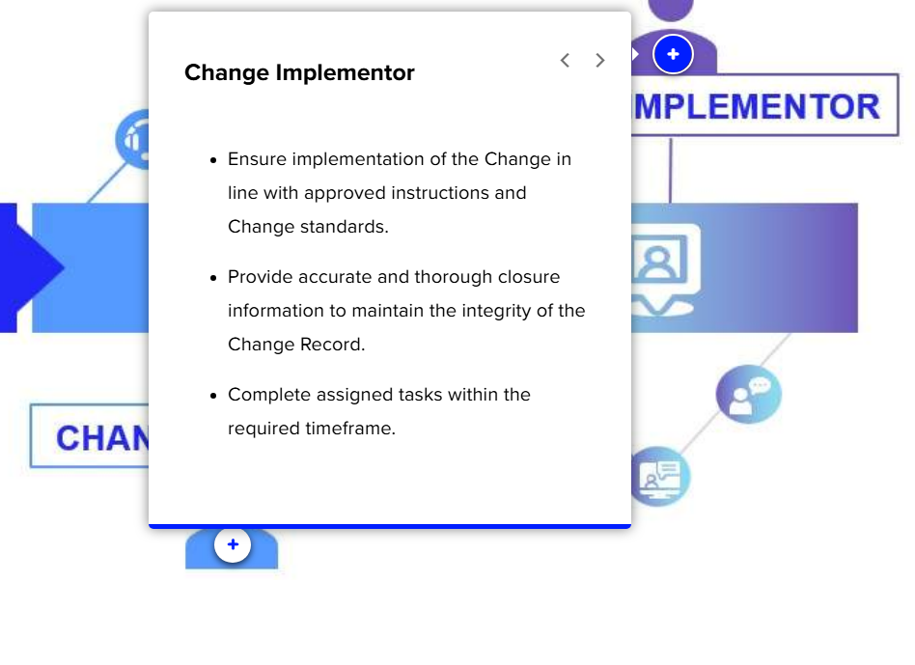

Change Models
In this lesson, we will understand the different Change Models with examples.
Normal
These are planned changes that are implemented with minimum lead time. These should be assessed and authorized.
Examples:
- Software upgrade/deployment
- Migration of on-prem services/devices to cloud
- Application release

Emergency
Emergency change is used to break fix P3 & above incidents
Examples:
- Ongoing P1/P2 Service Incidents & Issue which is impacting customers
- Ongoing P3 Incidents on weekend which if not fixed will lead to customer impact
Expedite
These are normal changes which don't meet the required lead time. Expedite changes should be avoided.
This is not a categorical Model in ServiceNow, but an attribute under Normal Change.
Examples:
- Changes raised to support exchange driven event which was not communicated earlier.
- Changes raised to resolve P3/P4 incidents which has a potential to impact if not actioned.
Retrospective
Retrospective changes are type of emergency changes which can be recorded after the change implementation. These changes receive approval off tool e.g., on service recovery call or email.
- Retrospective Changes can ONLY be created from an Incident record with Priority P1, P2, or P3 HiPo.
- Click "request Approval" to move the change to the authorize state, once approved, it will automatically move to the review state.
Example:
- A network engineer performs an urgent firewall rule removal during a P1 incident bridge & raises the change post-implementation for tracking & approval
- An application team restarts a critical service outside the approved window to recover from an outage during P1 INC & documents it later as a retrospective change.
Zero Touch
A fully automated model designed to support DevOps deployments, where changes are initiated exclusively through ServiceNow API integrations. This model eliminates manual intervention, has no lead time, and streamlines approvals to only those services and Important Business Services (IBS) directly impacted.
Examples:
- A configuration-as-code update automatically modifies cloud infrastructure settings and logs the update in ServiceNow via API.
- A CI/CD pipeline automatically deploys a microservice update to a production environment after passing all automated tests and logs the update in ServiceNow via API.
CMDB
A CMDB change is a CMDB update model used to update specific fields in the CMDB.
It can be created by following same initial steps as raising by choosing "CMDB Update".
Examples:
- Update CI status (i.e. update to Operational​ status).
- Update a group on a Network Device​
- Change the Environment attribute of a Server​.
Pre-Authorized
- Pre-Authorized (aka Standard Changes) are raised from a pre-approved template.
- These are used for low risk and no impact repeatable Change.
Examples:
- Daily health checks to ensure system is up and running
- Hot swap hardware replacement
- Upgrading configuration for a single client based on the client request
- Client on boarding/ off boarding
- Service restart
There are three more Change Models to be aware of.
- Non-Prod: It can only be used for a Non-Prod Environment
- Informational: It is used to record a Key event to be included in forward schedule of change. This is not an authority to do the change e.g. Year End change restrictions, Key application release scheduled in next 3 months, Special Trading days etc.
- Unauthorized: The unauthorized change model is used to capture the change executed without approved change record. Any change raised through this model is marked unauthorized and reported to the senior management.

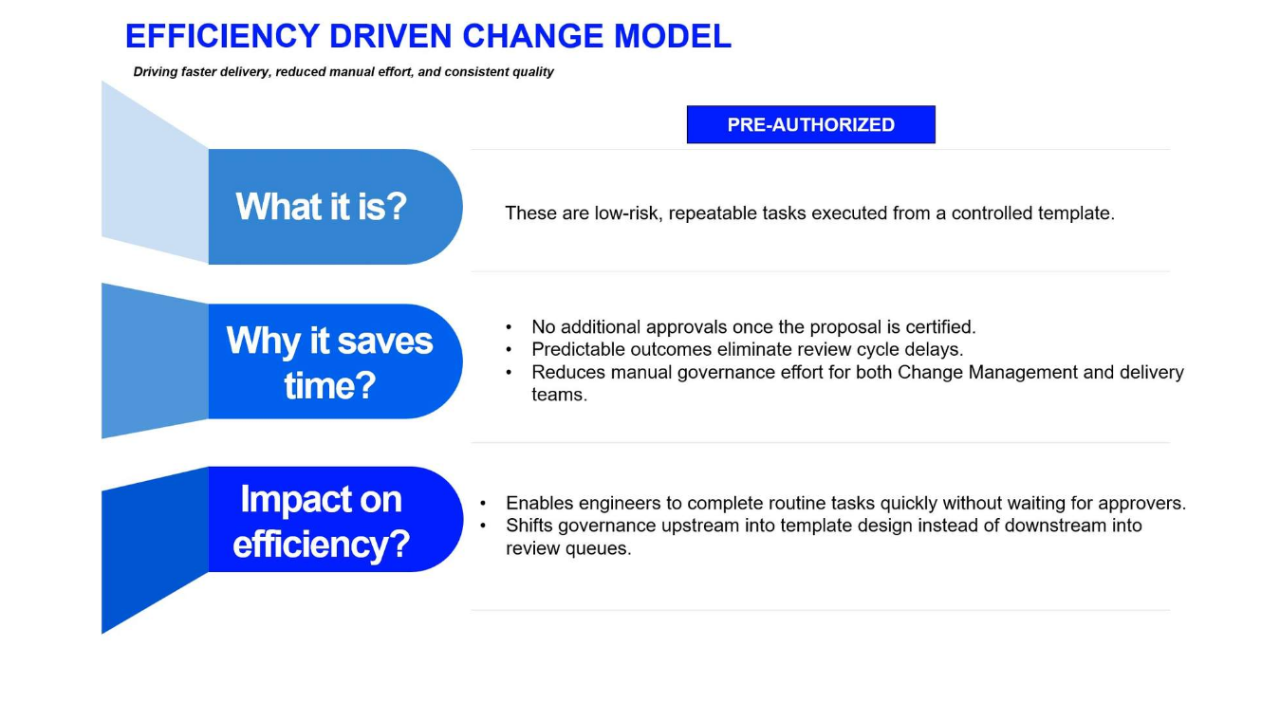
Minimum Lead Time
Minimum Lead Time ensures that every change has sufficient time for proper assessment, risk evaluation, approvals, scheduling, communication, and coordination with impacted teams. It helps prevent rushed changes, reduces the likelihood of failure, avoids operational conflicts, and ensures all stakeholders are prepared for the implementation.
Changes must follow a Lead time, measured in calendar days, which is determined by the Change's Risk and Impact Score. Lead time is calculated from the time the Change enters the Assess state to its Planned Start Date. If the minimum Lead time isn't met, the Change is marked as Expedited, requiring justification and approval from Expedite CAB group (where applicable) or Director/Delegate Director is required.

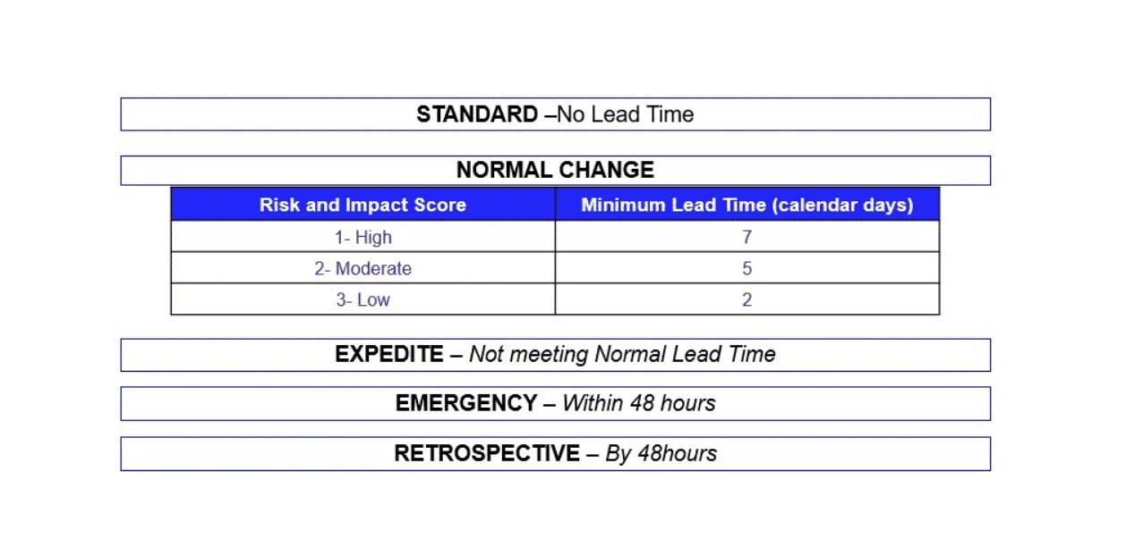

Change Workflows
In this lesson, we will discuss the various workflows involved in Change Management, including the Change Request Lifecycle in ServiceNow, Change Approval flow, and Change Implementation. Let's begin with the Change Request Lifecycle - ServiceNow.
Change Request Lifecycle - ServiceNow
The change lifecycle is made up of six distinct stages, known as change states. Each state serves a specific purpose, and the states may vary depending on the type of change. Let's explore the lifecycle of each type of change request and the states they must go through, as illustrated in the image below.
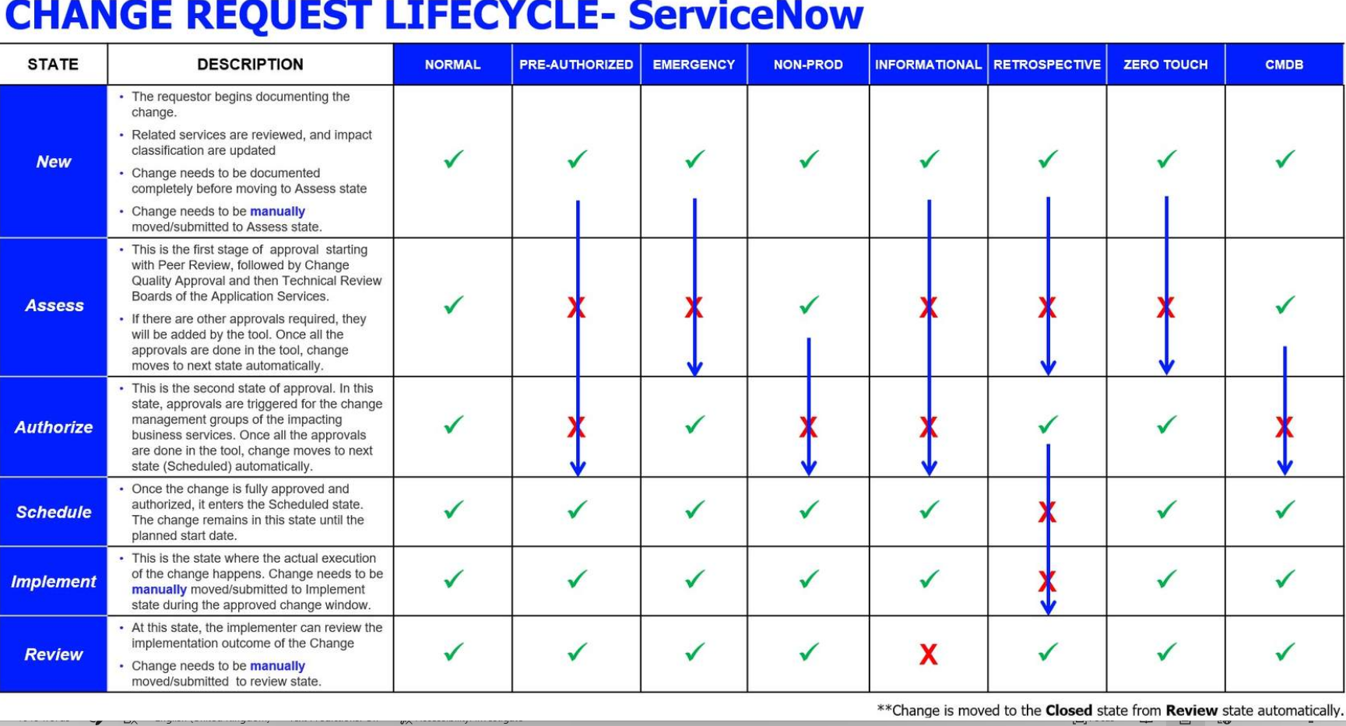

Change Approval Workflow
- Change approvals are auto generated based on the impacted services listed in the change, except for the Peer Review approval which is generated to the team implementing the change.
- The Change Approval is sequential. This means that the next set of approvals are generated after the first set of the approvals are completed.
- Change approvals are derived from the below Service Types
Application Service
- An application service is a logical representation of a deployed system or an application stack and is different from an application.
- Application services will be derived from the environment options, e.g. Prod, Dev, Test.
It generates approval in assess state for Change Governance Group and TRBs, Expedite and Emergency approval
Business Service
- A service provided by the firm to an external customer/user or business users, with those users clearly identifiable, and the impacts of disruption are clear.
- Business Services can be further sub classed as Important Business Services (IBS) or Internal (Enterprise) Services
It generates approval in Authorize state for Business Approval.
Segregation of Approval Duties-Normal Change
To enforce segregation of duties, reduce approval conflicts, and strengthen governance in the change lifecycle, approval restrictions have been implemented across all approval stages to ensure that individuals who have already approved a change in earlier stages (Peer Review, TRB, Change Governance, etc.) cannot approve it again in any state.
The system will automatically detect if an approver has already approved the change in an earlier stage, mark their subsequent approval as “No Longer Needed,” and add a comment explaining why they are not permitted to authorize it again.
Change Approval States
Purpose of the Approval Flow
- Ensures every change is validated from multiple lenses — technical, application, business, and governance — before implementation.
- Helps identify Configuration inaccuracy, overlooked dependencies, conflicts, and customer-impacting failures.
How It Prevents Failures
- Each stage checks a different dimension of risk.
- Issues caught early reduce rework, rollbacks, and unplanned incidents.
- Protects critical services and customer experience.

Peer review - Technical accuracy & completeness
Purpose:
Ensures that the change has been technically validated by authorized peer before it moves further in the approval workflow.
How it prevents failures:
- Catches incorrect instructions, missing steps, or overlooked dependencies early
- Confirms risk assessments and pre-checks are complete & realistic.
Mandatory Peer Review Checklist:
Reviewers must confirm each checkpoint before approving — approval remains locked if any item is unchecked. Drives structure, consistency, and real technical challenge into the review process.
Peer Review Checklist - Key Confirmations
- I confirm that the implementation steps are technically correct, complete and in the right sequence of execution. Appropriate implementation CTASKs (where applicable) are created with clear instructions.
- I confirm that the backout steps are technically correct, complete and can be executed as stated in the Backout plan of Change.
- I confirm that I have verified that the change risk and impact is accurately assessed and change is scheduled appropriately.
- I confirm that all the affected CI, impacted services and dependencies are correctly identified and added in the change (Includes upstream/downstream, services).
- I confirm that the pre-and post-change verification steps are clearly defined and executable (covering both functional and non-functional testing).
- I confirm that known risks, constraints, and assumptions are explicitly documented in the ticket.
Impact if this stage is weak:
Incorrect configuration, missing details, or unverified steps lead directly to high-severity incidents, rollbacks, and customer impacting disruptions.
Change Approval Flow for Normal, Emergency, Non-Prod & Zero Touch Model
Now, let's go through an image to understand the change approval flow for normal, emergency, non-prod & Zero Touch Model

Change governance approval - operational & risk flow
Purpose:
Confirms adherence to change process, risk assessment, and governance controls. It ensures that every change getting implemented meets company standards for control, compliance, service stability, and business impact.
Change Governance ensures that:
- All changes are carried out in a controlled, coordinated, and auditable manner.
- Risk, impact, quality, conflict, and readiness are assessed.
- Regulatory, operational, and audit expectations are met consistently.
How it prevents failures:
- Flags changes with incomplete documentation or insufficient testing.
- Strong governance ensures:
  - Implementation and backout steps are clear, accurate, and executable
  - Pre- and post-checks are defined
  - Impacted CI/services are correct
  - Risks and dependencies are properly assessed
Impact if this stage is weak:
Higher rate of failed changes
- Increased escalations to leadership
- Greater regulatory and audit findings
- Poor visibility and misalignment across service owners, impacted teams and customers

TRB Approval - Service level validation
Purpose:
Validates that the change is appropriate for the application it impacts and aligns with application-specific architecture, dependencies, and release cycles.
How it prevents failures:
- Ensures application owners confirm compatibility with other components.
- Avoids outages caused by overlooked upstream/downstream integration issues.
- Confirms testing evidence and rollback feasibility from an application lens.
Impact if this stage is weak:
Application-level outages, broken integrations, customer impact, and long restoration times.
Business Approval - Customer & Business Impact Protection
Purpose:
Assesses whether the change could affect business-critical functions or customers.
How it prevents failures:
- Ensures timing avoids major events (trading hours, regulatory windows, etc.).
- Ensures communication plans or customer notifications are in place when required.
- Reduces revenue, regulatory, or reputational risk.
Impact if this stage is weak:
Service degradation during critical windows, major customer impact, and regulatory impact.

Change Approval Flow for Normal, Emergency, Non-Prod & Zero Touch Model
Now, let's go through an image to understand the change approval flow for normal, emergency, non-prod & Zero Touch Model
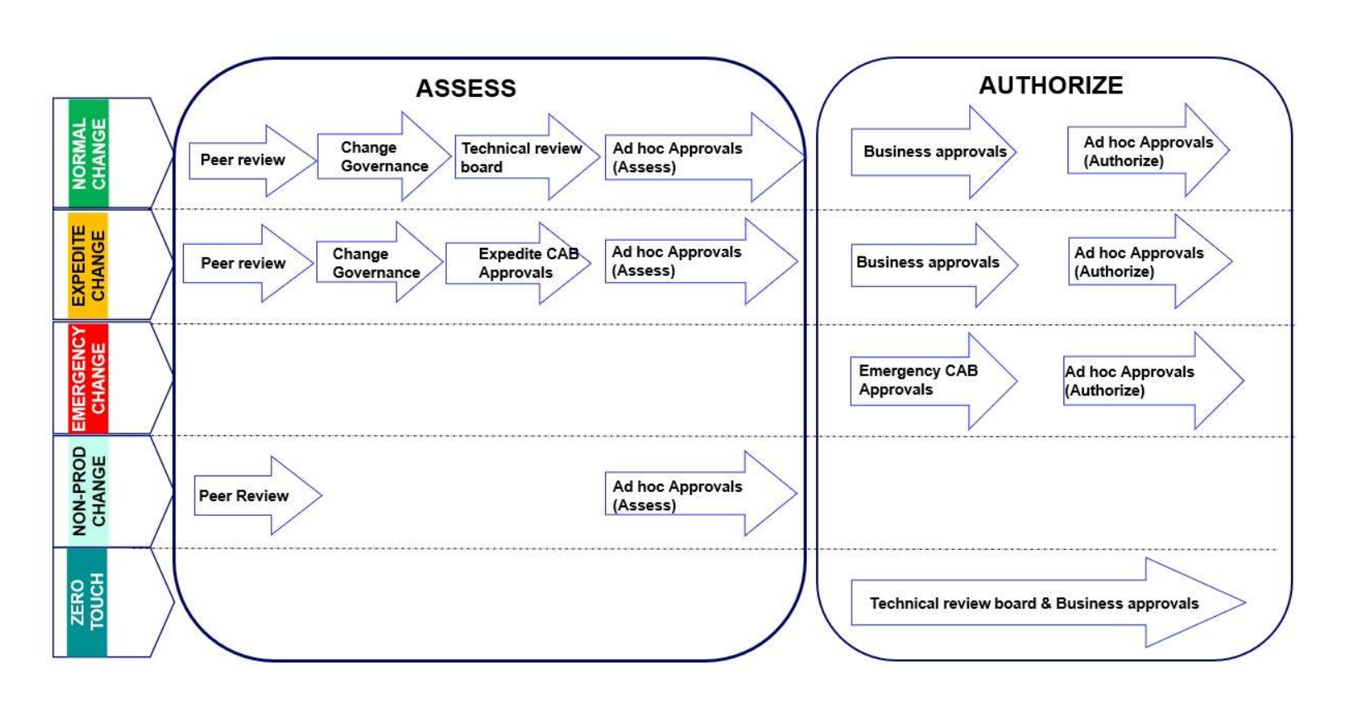

- Ad Hoc approvals will be generated only if they are manually added in the Change
- Change can be rejected at any approval level, if rejected will move back to the NEW state
- Retrospective Change Approvals are obtained in AUTHORIZE State itself

Change Implementation
Please follow the points outlined below during the change implementation.
Fully Approved
All changes must be fully approved in ServiceNow before any deployment, as only the approved change request is the sole authority to proceed.
Scheduled State Validation
Ensure the change request is in the "Scheduled" state prior to starting any implementation activities.
Adherence to the Approved Procedures
Change implementation should strictly follow the approved instructions and timelines, with any deviations documented within the change request.
Manual State Transitions
Manually move the change to the implementation state before beginning work and manually transition it to the Review state upon completion.
Post Change Verification
Conduct thorough testing and validation to confirm the change functions as intended and promptly cancel any scheduled requests that are no longer proceeding.

The only exceptions to approvals not obtained in tool before proceeding with a change are:
- Pre-Authorize changes that have already been prior approved through the Standard Change Proposal.
- Retrospective Emergency Change: For production incidents classified as P1 or P2 or P3 HiPo, an emergency-retrospective urgent break-fix change must be approved by a senior authority before deployment. Once the urgent fix is implemented, an Emergency Retrospective Change is then recorded in the tool.

Change Violation Control & PCR Change Task
In this lesson, we will discuss about the Change Violation Control, Post Change Review (PCR) Change Task, and Best Practices. Let's begin with the Change Violation Control.
Change Violation Control
The ServiceNow tool has an ability to detect and mark the following change policy violations:
- Change Window Violation: This is detected, when the change is implemented outside the approved window.
- Unauthorized Change: The change which violates the change policies.
  - Executing the change without authorization (inclusive to using retrospective change for incidents other than P1, P2, & P3 HiPo)
  - Implementing a change without a change record
  - Gross & intentionally understating the risk & impact of the change leading to misguidance
  - Using the standard change outside the scope of approved template

Post Change Review (PCR) Change Task
Purpose of PCR
Identify Root Cause | Mitigate Risks | Ensure Compliance | Continuous Improvement
Understand why the change failed or deviated to prevent recurrence | Reduce the impact on services & avoid future disruptions by learning | Enforce adherence to policies & regulatory requirements | Refine, enhance and improve change quality & processes

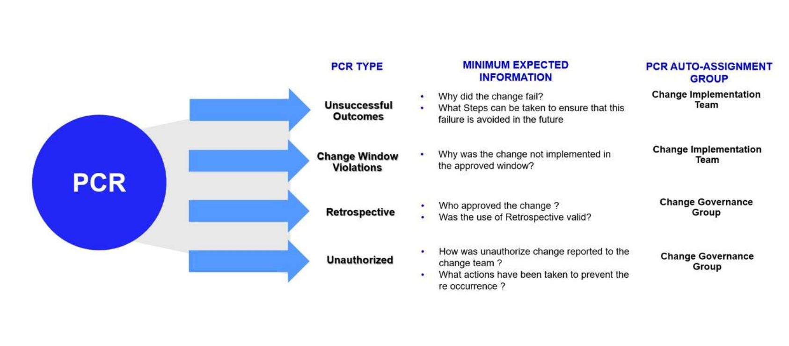

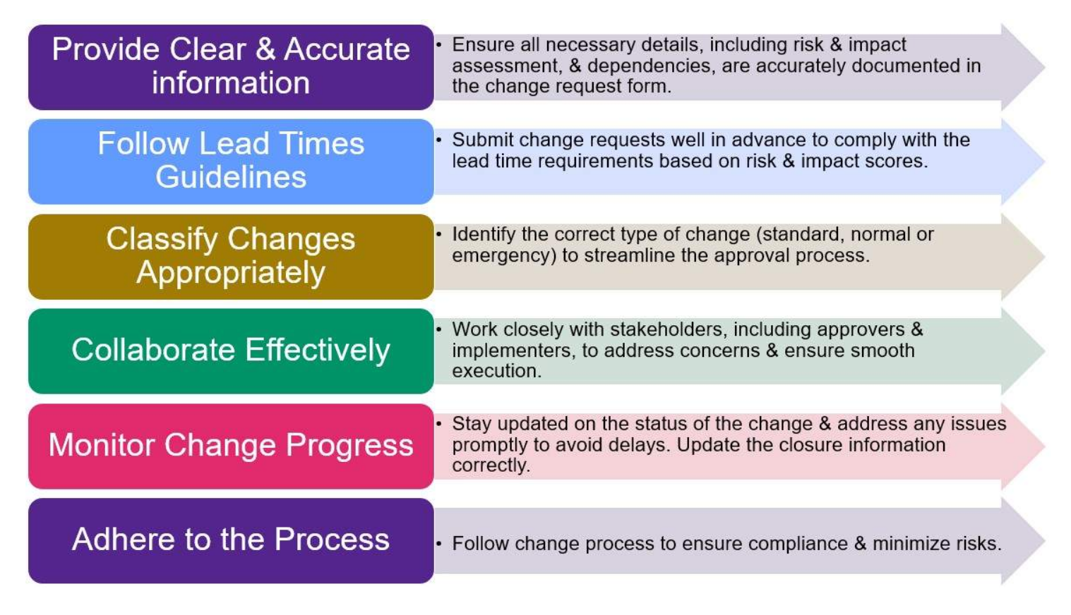

In this section, we will learn about the steps/processes for Change Creation, Change Assessment, Change Authorize, Change Schedule & Implement, Change Review, and Pre-Authorized Change & Template Management. Let's start with the process for Change Request Creation.

Change Request Creation
Let's learn how to create a new Change request using ServiceNow.

Change Form
- Here we´ve the Change Status Bar - While the form is being filled, the change status is NEW (at each step of the change, the bar will be selected automatically)
- Change Number (automatically generated for the system)
- The field Requested by could be maintained or changed (if the requester needs to open a change for another requester)
- Select the Service, Service Offering and Application Service that will be affected by the change.
- Enter the Configuration Item to be Updated.
- Select the Assignment Group and Assigned to, responsible for implementing the change (Implementer).
- Add a summary of the change (Short Description) and detailed Description of the change. (Hover over the highlighted label to get help with the field.)
- Click the tabs to open more detailed sections.
Note: If the Change selected was “Preapproved”, some fields will be greyed out. If these fields need to be changed, a “Normal” Change should be selected instead.

Planning
When you open the Planning tab, you will view these options.
- Detail the Justification why the change should be performed.
- Details about Implementation plan.
- Answer Risk and Impact questions after hovering on the “Risk & Impact details and Mitigation plan” tab.
- Provide Backout information.
- Provide Verification Plan post implementation.
- Confirm if the Change possess any Cyber Security Risks.

Risk & Impact Assessment
For all Change Models except Informational and Preapproved, a Risk Assessment must be completed before progressing to the Assess state. This involves clicking the “Risk and Impact Assessment” button to answer a questionnaire, after which a banner displays the updated Risk and Impact score. The latest answers are accessible through the “Completed Risk & Impact Assessment” related link, while previous assessments can be viewed in the “Assessment Instances” related list.
New read-only fields auto populated from RIA responses:
- Additional Risk & Impact Details
- Additional Backout Plan Details
Testing Information Fields:
The fields “Has this change been tested?” and “Testing evidence” field are auto filled based on your RIA responses.
Testing Evidence' field can be edited after it has been auto-populated from RIA and subsequently amended.

Change Templates
Templates can be used to streamline the process of filling out a Change.
- To access the Template Bar, click the three dots on the header bar and select "Toggle Template Bar"
- Select a template in blue text to apply it, and use the buttons to add, edit, or view the full list of templates.

Retrospective Change Request Creation - From Another Record
Retrospective changes can only be created via eligible Incident records (Priority P1, P2, or P3 HiPo).
Follow these steps:
- Open the Eligible Incident
  - Navigate to the incident record in ServiceNow.
  - Ensure the Incident is Priority P1, P2, or P3 HiPo. (P3 & P4 incidents are not eligible
- Select “Create Retrospective Change”
  - From the Incident menu, click Create Retrospective Change.
(As shown in the screenshot, this option appears in the Incident action menu).

Retrospective Change Request Creation - From Another Record
- Confirm Action
- A pop-up will appear:
"Do you want to Raise a Retrospective change?"
- Click OK to proceed.
- Complete Change Details
- A new Change Request form will open with the Model = Retrospective and Type = Emergency pre-selected.
- Fill in all mandatory fields.
- Approver:
  - Change requestor, implementor and user who opened the ticket cannot be added as the approver of the ticket.
  - Field, Who Approved Change Execution will not accept change Requester, Assigned To, or Opened By as valid values.
- Ensure Planned Start and End Date reflect the actual time the change was implemented.
- Request Approval
  - Click Request Approval to move the change to the Authorize state.
  - Once approved, the system will automatically move the change to Review state.
Technical Incident Manager (TIM) Role in Retrospective Changes
The Technical Incident Manager (TIM) has been formally designated as the authorizing authority for Retrospective Changes carried out during incident recovery. This update strengthens governance alignment between Incident Management and Change Management, ensuring that retrospective changes are authorized by the individual accountable for service recovery decisions.
TIM Accountability in Recovery
The Technical Incident Manager is responsible for:
- Driving focus on service recovery, not root cause
- Ensuring the right SMEs are engaged at the right time
- Acting as recovery owner for the impacted application or service
  - For multi-application incidents, the TIM is assigned from I&C
- Determining and managing TRC participants
- Reviewing recent changes for potential impact
- Assessing availability of workaround or BAU failover
- Overseeing service restoration planning and execution
- Continuously assessing severity, scope, and priority
- Leading escalation decisions where required
- Sole approver for Retrospective Changes executed during recovery
The Technical Incident Manager (TIM) recorded in the Incident (INC) record should be the same person Users should be adding to the “Who approved Change execution” field for Retrospective Changes.
Key Training Takeaway:
- Retrospective Changes are recovery decisions.
- The TIM owns recovery decisions.
- Therefore, the TIM should be the accountable approving authority on Retrospective Changes.

From Another Record
Changes can be initiated directly from an Incident record. Using the context menu or header bar, you can select:
- "Create Normal Change" or "Create Emergency Change" to open the Change Form.
- "Create Standard Change" to access the Standard Change Catalogue and choose a pre-authorized template.

Related Records & Lists
Change Related Records:
The Related Records section displays associated records. If the record is known, enter its number directly, or use the magnifying glass to filter & select from available records. These fields auto-populate when a Change is created from another record.
Change Related Lists:
At the bottom of the Change form are multiple related lists. These are used to refer to multiple records which are related to the Change.

Related Lists
Affected Configuration Items (CIs):
The related list contains Configuration Items (CIs) impacted by the Change. The CI chosen in the Configuration Item field is automatically included, while additional CIs can be added using the Add button. To refine the selection, use the filter (funnel icon) or manually select specific CIs using checkboxes, then click "Add Selected" or "Add All.“
Related Services:
The related list holds Services associated with the Change. It automatically includes selected and related Services from the main form, with the option to add more. Impacted Services can be logged by double-clicking on "Impact Classification." Use checkboxes to select impacted Services and choose an action: "Materially Impacted," "Not Materially Impacted," or "No Impact."
"Not Impacted" will remove a service from the approvers list.
When leaving the New state, a confirmation pop-up ensures all impacted Services are logged. Maintenance window of the service will also show under the related services.

Related Lists: Approvers & Change Task
Approvers:
These lists track the users and groups who have been sent an approval for the Change, and whether each approval has been approved, rejected, yet to answer, or is no longer required.
Change Tasks
If multiple groups need to work on a Change at the same time, or if the Change work should be broken into smaller tasks, Change Tasks can be used to associate pieces of work assigned to different assignment groups to the Change.

Related Lists
Problems Fixed by Change, Incidents Fixed by Change, Incidents Caused by Change
The lists track Incidents and Problems linked to the Change. Use the "New" button to create and save a new record or the "Edit" button to associate or remove existing records. The "Edit" option opens a “Slushbucket”, where records from the left box can be filtered, selected, and moved to the right box using the arrow button. Click "Save" after selecting the required records.

Related Lists - Outages
Change Outages:
If the Change will cause an outage, this is logged in the Outages related list. To create a new Outage, click “New” in the Outages related list.
This will open the Outage Form.
The Outage form should be completed with the Configuration Item (CI), an informational message, and the beginning and end dates and times of the outage. The duration will automatically be calculated.
When completed, click the “Submit” button on the header bar.
The Outage will then be associated with the Change.
Active Incidents & Problems
These lists contain all Incidents and Problems that are currently logged against the CI or Service listed in the Change. These are populated automatically.

Scheduling & Conflicts
When creating a new Change, the Planned Start and End Dates are essential and found under the "Schedule" tab. The minimum required lead time is auto calculated based on these dates. The lead time also factors Risk and Impact Score. ServiceNow automatically detects conflicts, which are listed in the conflicts section. Conflicts may arise if the selected CI, its Parent/Child, or the assigned user is scheduled elsewhere. Conflict is also detected if the change is schedule outside the maintenance window of the services if the maintenance window is configured in SNOW (refer below section on Maintenance windows) The conflict checker runs automatically or can be triggered manually. Conflicts do not prevent the Change from proceeding.
Maintenance Window & Conflict Calendar
Maintenance Window
Maintenance Windows are the agreed period during which it is considered safe to perform maintenance against a particular service or to components that make up and/or support that service. Maintenance Windows, defined by service owners and recorded in ServiceNow. They can be accessed via the Change section → Schedules → Maintenance Schedules. If a change is scheduled outside these windows, a maintenance window conflict is flagged under the Conflicts tab. While these conflicts do not require additional approvals, requesters must consult with service owners to mitigate risks. A warning pop-up is displayed at submission, prompting users to either adjust timings or proceed with further discussions.
Throughout the change lifecycle, maintenance window conflicts remain visible, via a banner notification to anyone viewing the change. Approvers and reviewers should carefully evaluate the risk of executing changes outside the agreed maintenance windows, ensuring necessary actions have been taken to mitigate potential impact.
Clicking on request approval UI page to confirm and then change will move to assess.

Conflict Calendar
The Conflict Calendar provides a visual representation of scheduling conflicts and can be accessed via the "Conflict Calendar" button in the Change header bar. When a conflict occurs, the Scheduling Assistant helps identify a suitable time without conflicts. It is accessible from both the Conflict Calendar and the banner displayed on the Change form when a conflict is detected. Users can adjust planned start and end dates accordingly.

Approvals
Group Approvals & Approvers:
The Assess state involves technical and quality approval of the Change, with sequential approvals:
Peer Review -> Change Quality Approval -> Technical Review Board -> Ad Hoc Approval.

If an approval is rejected during the Assess or Authorise states, the Change reverts to the New state, and the rejection reason is noted in the Additional Comments. Approval groups are listed under the "Approval" tab, and generated approvals appear in the "Approvers" and "Group Approvers" related lists.

AdHoc Approvers:
Use the "Ad Hoc Approvers (Assess)" padlock to add, remove, or manage groups for approvals, then save the record to finalize ad-hoc approvals.
For all adhoc approvals, a work note is mandatory to explain why the approval has been added.

Approval | Approval Groups | Change Models/Attributes | Notes
Peer Review | Peer Review Approvers | Normal/ Non Prod | Change Assignment group, excluding Assigned to and requester & open by person
Governance Check | Change Governance Approvers | All except non-production (We do this only under Normal, Expedited, & Standard Template)
Technical Review Board | Technical Review board Approvers (This should be approval group of the application service listed under the related service tab) | Normal. non-expedited
AdHoc | AdHoc Approvers (Assess state) | All
Expedited | Expedited CAB Approvers (of application service) | Expedited

The above approvals are not required for Retrospective, Informational, Unauthorized or Pre-authorized changes.

Approving a Change Record
If an approval task has been assigned to you, it will be visible in Self-Service > My Approvals.
If an approval is marked as “No longer required”, it means someone else from the approval group has already approved or rejected the approval, and it can be ignored.
Click on a “Requested” approval to open it.
The Approval record includes details of the record being approved.
Use the "i" button to access the record. Approvals can be approved or rejected, with rejection comments added to the Comments field, which are copied to the Change comments.

Change Authorize
Let's move to the next state from "Assess" to "Authorize".

Approving a Change Record
The Authorize state is used for business approval when in-tool approval for an Important Business Service is applicable. Without in-tool approval, Normal changes move directly from Assess to Scheduled. Preauthorised changes skip this state and move to Scheduled, while Retrospective and Unauthorised changes skip this state and move to Review.

Approval | Approval Groups | Change Models/Attributes | Notes
Business Approval | Business Approvers | Normal | The Business Approver group associated with the Service (if one exists. If not, this approval is skipped)
Emergency Change Advisory Board (eCAB) | Emergency CAB Approvers | Emergency
Ad Hoc Approval | Ad Hoc Approvers (Authorize) | Normal, Non-production, Emergency

Reverting to New
At any point before the Implement state, the Change can be reverted to the New state without rejection. This may occur if details of the Change alter.
To revert to New, add the explanation into the Work Notes and click the “Revert to New” button in the header bar.
This will reset all approvals. A work note must be added to explain why the Change is being reverted to New.

Change Schedule, Implement and Review
Change Schedule & Implement
Let's move to the next two states from "Authorize" to "Schedule & Implement".

Schedule & Implement
When all required approvals have been completed, the Change will automatically move into Scheduled state. (Retrospective Changes will move straight to the Review state).
Once the Change Window is reached—meaning the period falls after the Planned Start Date and before the Planned End Date—the change must be manually moved into the "Implement" state. This can be done by clicking the "Implement" button located in the header bar.
When the “Implement” button is clicked, the Actual Start Date will automatically populate.
If the implementation is outside the approved change window, the Change will be marked for Change Window Violation, and a reason must be provided during the review phase.

Change Window Violation - Key Points
Starting Early (Before Planned Start)
- Clicking Implement early triggers a Change Window Violation pop-up.
- User must provide a reason and click Implement again.
- Move to Implement only at/after the approved start time unless early start is justified and safe.
Closing Late (After Planned End)
- Clicking Review late triggers the violation pop-up.
- User must record a reason under Closure Information.
- Move to Review on/before the approved end time unless extension is required and safe.
Applicable To
- Normal, Emergency, Pre-authorized, and Non-Production Change Models.

Change Task
Different Types of Change Task

Change Task Type | Purpose | Change State  (Task can be opened by user in below state) | Change State  (User cannot transition into this state, with these open task)
CAB Action | Task to capture & execute any actions from the CABs | New, Assess, Authorize | Implement
Implement | Task to capture & execute change implementation | New, Assess | Review
Data Source Update | Task to capture & execute any CMDB update that needs to be as part of the change | New, Assess | Review
Service Checks | Task to capture & execute any post & pre-checks of the change | New, Assess, Authorize | Closed
Documentation | Task to capture & execute any documentation update that needs to be done because of the change | New, Assess, Authorize | Closed
Post Change Review | Created automatically once the change is moved to review | Review | Closed
Fix Forward | Task to capture & execute additional steps that needs to be performed as a part of fix forward. This CTASK can only be created if the fix forward box is checked in the change | Implement, Review | Closed

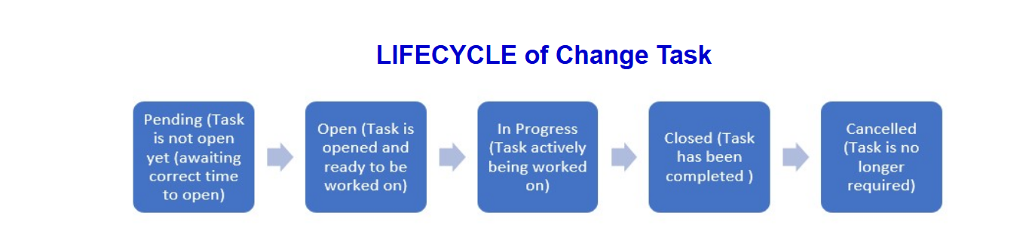
Change Task
Only Post Change Review Tasks are created automatically when the relevant conditions are met. Change Tasks can also be created manually where required.
To create a Change Task manually, click the “New” button at the top of the Change Tasks related list.

Change Review State
Let's move to the next stage from "Schedule & Implement" to "Review".
Change Closure
When the Change implementation is complete, the Change can be moved into the Review state by clicking the “Review” button on the header bar.
The mandatory fields in the “Closure Information” tab must be filled in.

Change Review State - Post Change Review (PCR)
Change Post Change Review
If any of the below statements are true, a Post-Change Review Change Task will be automatically generated for further review if:
Please click in the Links below for detailed guidance.
- Post Change Review for Unsuccessful change(opens in a new tab)
- Post Change Review for Change window violation(opens in a new tab)
- Post Change Review for Retrospective Change(opens in a new tab)
- Post Change Review for an Unauthorized Change(opens in a new tab)
Change Post Change Review Task UPDATE
- Change the PCR CTASK status from Open to In-Progress, assign yourself (if not already done), and save the task.
- Review and answer the PCR questions listed in the Description field. Ensure detailed responses, including the Preventive Action field.
- Update the Close Code and Close Notes accurately. and save the recode and then follow the next steps.
- Use the “Assign to Change Team” button to reassign the task to the Change Governance Group. This replaces the manual reassignment process.
*Only the Change Management team can close the PCR CTASK.
Change Post Change Review Task Closure
The change remains in review state for 30 days, during this time open CTASKs like service checks, PCR Tasks (if any) should be closed. After 30 days if all the open CTASKs are closed or cancelled, change will move to the Closed state.
SLA: There is a 5-day SLA for implementer to reply to the questions & 4 days for the Change Team to ask additional questions for closing the PCR.

Change Cancellation
Changes can be cancelled at any point from New state until Implement state. To cancel a Change, select an option from the “Cancellation Reason” dropdown, then click the "Cancel Change" button on the header bar.
Cancel Change during "Implement State"
Changes can be cancelled only for 2 reasons during Implement State using the dropdown.

Preapproved Changes & Template Management
What are Preapproved Changes?
Preapproved changes are low risk, have no impact, follow predetermined procedures, and yield predictable outcomes.
They require no additional approvals beyond the initially approved proposal. Preapproved changes are executed without any additional approvals against the proposal approved.
Any Normal change candidates presented for Preapproved change should have been implemented successfully at least three times without an incident in the past.
All Preapproved changes are raised from an approved proposed template.
All the Preapproved templates are reviewed and recertified once a year unless otherwise agreed. All the Preapproved proposals are approved by Change Management, Change Implementation team and business where applicable.
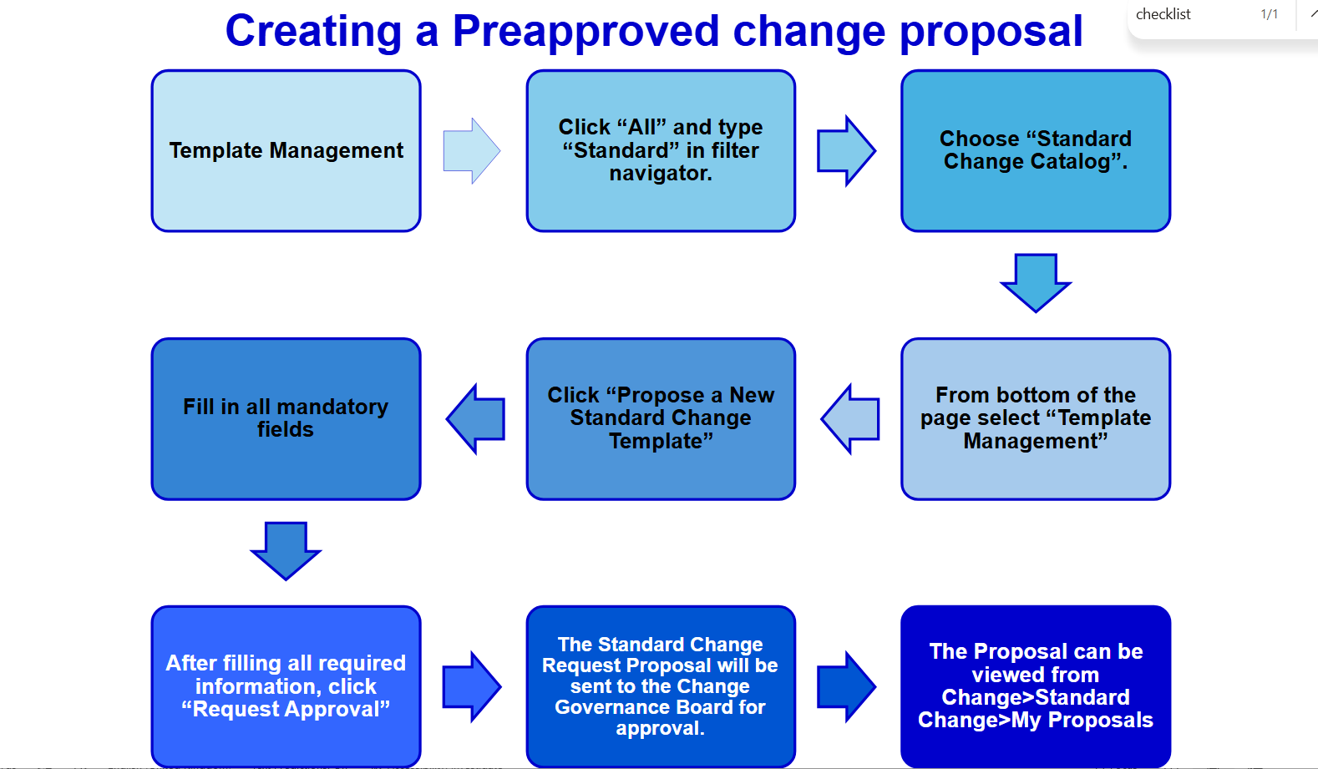
Proposal Analysis from Change Management
- The Quality of the mandatory minimum fields mentioned must be as per the Quality Guidelines in the Resource Section under Important Links.
- Category field should be selected as “Standard Changes”.
- Three sample changes are required and must be successfully deployed models, preferably Normal.
- In the Proposal tab, the Description and Business Justification fields must provide accurate details about the work.
- Group Name: Enter the name for the "Team Requesting Standard Change" template.
- Sponsor: Provide the approved sponsor’s name (as per Delegate Director approval).
- Service Owner/Director Approval: Secure approval from the Implementation Team and the impacted Important Business Services. Determine if approval is needed from outside the requesting division (e.g., when deploying to an entity’s IBS or other critical services).
- External Implementation: If a different entity or division implements the pre-approved change, confirm that the implementing team is aware, and their management has accepted.
- Service Issue Fix: If the change addresses a known service issue, specify the ETA for resolution. Confirm if I&C/Inf Shared Services is applying the fix and if the implementing team’s authority has approved.
- Recertification Date: Some proposals may require a recertification period shorter than the standard 12 months to reflect when the permanent fix will be delivered.
- Next Review Date: Indicate whether the default 12-month review applies or if a sooner recertification (e.g., three months) is necessary.

Preapproved templates will be reviewed on the "Next review date" which is set on the Preapproved template. Unless otherwise agreed templates are reviewed annually.

Modify/Retire/Deactivate a Preapproved Change Template
Modify Template
- Request alterations to an existing Preapproved Change Template.
- These modifications will trigger approval to the Change Management team.
- Kindly use the following link to Modify a Standard Template(opens in a new tab) as per requirement once training is complete
Retire Template
- Request for an existing Preapproved template to be retired when it is no longer required or no longer acceptable as a preapproved Change.
- This request for retiring a template will trigger approval to Change Management team.
- Kindly use the following link to Retire a Standard Template(opens in a new tab) as per requirement once training is complete
Deactivate Template
- A Preapproved Change Template can also be Deactivated in cases the template is under investigation of an incident, conflicts with other changes, pending modifications.
- Deactivation will not delete or retire the template.
- The deactivate option in a Preapproved Change Template can be seen in the screenshot.

Creation of Preapproved Change
After approval by the Change Governance Board, a Preapproved change can be created via the Preapproved section (opens in a new tab)in the "Create a Change Request Section" or the Standard Change Template Library(opens in a new tab). The requester must complete the required fields as per guidelines before submission.
To raise a Preapproved change in ServiceNow:
- Open ServiceNow
- Click "All" & Type "change" in the filter navigator.
- Select "Create New"
- Choose "Preapproved" and the appropriate Preapproved change template
Or you can find all Preapproved template under "Standard Change Catalog" by "Click All" & type "standard" in filter Navigator. Choose "Standard Change Catalog".

Creation of Preapproved Change
Then choose Preapproved change template that related to your change.
Then the change ticket in new state will be created. Fill in all mandatory fields to submit the ticket.
Once updated, click "Schedule". Ticket will move from New state to Scheduled state.

