TSM User Guide
Table of Contents
Turnpike State Model (TSM) - User Interface 6
Introduction 6
1. General & Project Settings 6
General Configuration 6
Scenario Specs 6
2. Editors 7
SE Data Editor 7
Multi-Spatial Resolution (MSR) 7
Database Review 7
GeoMaster Editor 7
3. The “Black Box” 7
Network Modeler 7
Demand Model 7
Route Choice Models 8
4. The “Analyst” 8
Summarization 8
Visualizations 8
Importance and Efficiency 8
Time Savings 8
Additional Notes 9
GUI Screenshot 9
TSM Main Panel User Guide 11
Introduction 11
Panel Overview 11
1. General & Project Settings 11
2. Editors 11
3. The “Black Box” 11
4. The “Analyst” 12
Widget Interaction 12
Importance and Efficiency 12
Additional Notes 12
General Configuration Widget 13
Introduction 13
GUI Overview 13
Configuration Components 13
Saving or Cancelling Changes 13
Apply and Save Changes 13
Cancel Changes 14
GUI Screenshot 14
Additional Notes 14
Project Settings Widget 15
Introduction 15
GUI Overview 15
Scenario Configuration 15
Geographic Coverage 15
Input Layers 15
Output Configuration 16
Black Box Steps 16
Saving or Cancelling Changes 16
Apply and Save Changes 16
Cancel Changes 16
GUI Screenshot 16
Additional Notes 17
PopulationSIM Widget 18
Introduction 18
GUI Overview 18
Standard Run Configuration 18
Incremental Run Configuration 18
Running PopulationSIM 19
Steps to Execute 19
GUI Screenshot 19
Additional Notes 20
Skimmy Widget 21
Introduction 21
GUI Overview 21
Input Configuration 21
Coefficient Parameters 21
Output Configuration 21
Execution and Saving 22
Run Skimmy 22
Save or Cancel Configuration 22
GUI Screenshot 22
Additional Notes 22
SDT Resident Widget 24
Introduction 24
GUI Overview 24
Data Input Configuration 24
Telework Scenario 24
Output Directory 24
Execution and Saving 25
Run SDT Resident 25
Save or Cancel Configuration 25
GUI Screenshot 25
Additional Notes 25
SDT Visitor Widget User Guide 27
Introduction 27
GUI Overview 27
Data Input Configuration 27
Output Directory 27
Execution and Saving 27
Run SDT Visitor 27
Save or Cancel Configuration 27
GUI Screenshot 28
Additional Notes 28
Long-Distance Travel (LDT) Resident Widget 29
Introduction 29
GUI Overview 29
Input Configuration 29
Output Configuration 29
Execution and Saving 29
GUI Screenshot 30
Additional Notes 30
Long-Distance Travel (LDT) Visitor Widget 31
Introduction 31
GUI Overview 31
Input Configuration 31
Output Configuration 31
Calibration Settings 31
Execution and Saving 32
GUI Screenshot 32
Additional Notes 33
TSM Traffic Assignment Widget 34
Introduction 34
GUI Overview 34
Input Configuration 34
Analysis Tools 34
Execution and Saving 35
GUI Screenshot 36
Additional Notes 36
Network Editor Tool User Guide 37
Introduction 37
Key Functionalities 37
Layer Selection 37
Automated Processing 37
Integration with QGIS 37
Importance 37
Time Savings 38
Additional Notes 38
Many-to-One (Link Consolidator) Widget 39
Introduction 39
GUI Overview 39
Scenario Configuration 39
Input Configuration 39
Advanced Options 39
Settings and Output 40
Execution and Saving 40
GUI Screenshot 40
Additional Notes 41
TSM Subarea Extraction Widget 42
Introduction 42
GUI Overview 42
Basic Configuration 42
Additional Options 42
Settings Management 42
Output Configuration 43
Execution and Saving 43
GUI Screenshot 43
Additional Notes 44
GUI: User Settings 45

Turnpike State Model (TSM) - User Interface

Introduction
This comprehensive user guide compiles detailed descriptions and functionalities of the Turnpike State Model (TSM) tools and widgets, organized according to the TSM Main Panel structure. It facilitates streamlined workflow and effective utilization of the TSM.

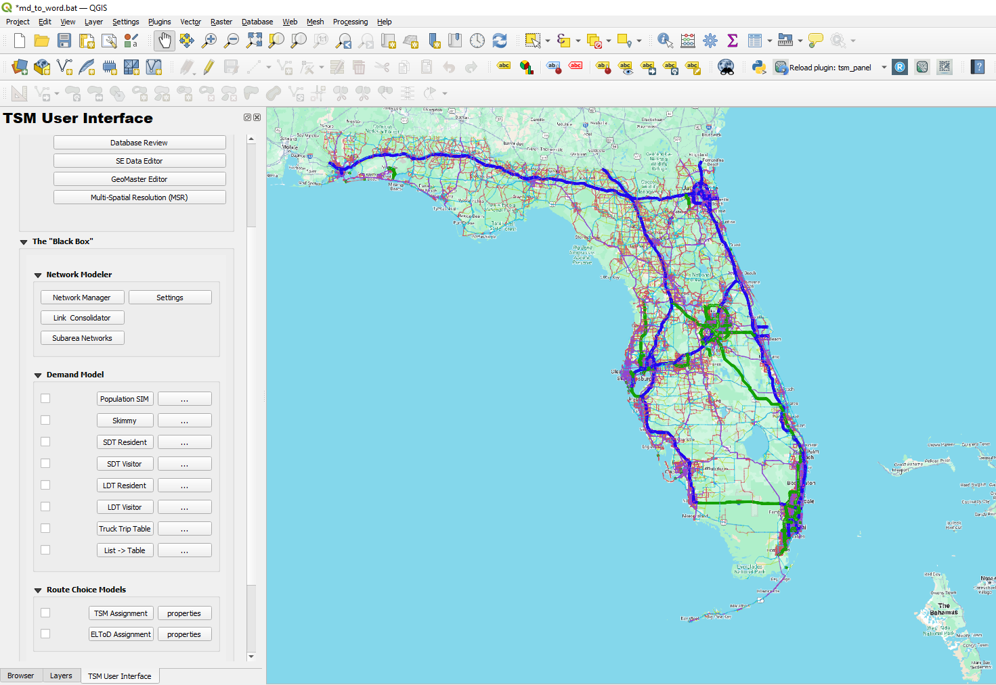

1. General & Project Settings

General Configuration
Manage key dependencies, including paths to Java, RScript, and TSM directories, as well as processor allocation.

Scenario Specs
Define scenario-specific details, geographic coverage, input layers, and model execution steps.

2. Editors

SE Data Editor
Edit socio-economic data vital for accurate modeling.

Multi-Spatial Resolution (MSR)
Manage and analyze spatial data at multiple resolutions.

Database Review
Review databases for accuracy and consistency.

GeoMaster Editor
Edit and manage GeoMaster datasets efficiently.

3. The “Black Box”

Network Modeler

Network Editor Tool
- Quickly select and edit network layers.
- Automate link and node updates.
- Integrate seamlessly with QGIS for improved workflow efficiency.

Link Consolidator (Many-to-One)
- Simplify networks by merging multiple links.
- Reduce computational load without sacrificing geometric accuracy.

Subarea Networks
- Efficiently extract subarea networks and manage node consistency across scenarios.

Demand Model

Population SIM
- Generate synthetic population data using specified configurations.

Skimmy
- Create skim matrices based on network attributes.

Short Distance Travel (SDT)
- SDT Resident: Model resident short-distance travel.
- SDT Visitor: Model visitor short-distance travel within and outside Florida.

Long Distance Travel (LDT)
- LDT Resident: Analyze Florida resident long-distance travel patterns.
- LDT Visitor: Analyze long-distance travel for out-of-state (non-Florida) US visitors.

Truck Trip Table
- Generate detailed truck trip tables.

List -> Table
- Convert trip lists into structured tables for analysis.

Route Choice Models

TSM Assignment
- Execute detailed traffic assignment tasks.

ELToD Assignment
- Perform advanced assignment analyses with ELToD.

4. The “Analyst”

Summarization
Aggregate and summarize key modeling outcomes.

Visualizations
Develop intuitive visual representations to enhance analysis and reporting.

Importance and Efficiency
Utilizing the TSM Main Panel and associated widgets:
- Enhances model accuracy and consistency.
- Streamlines workflow by automating repetitive tasks.
- Facilitates detailed analysis through structured summarization and visualization.

Time Savings
By centralizing access to modeling components, automating network editing, and simplifying data management, the TSM suite significantly reduces time spent on manual coding and troubleshooting, allowing users more time for strategic analysis and decision-making.

Additional Notes
- Regularly update and verify configurations to ensure modeling accuracy.
- Utilize built-in tools for automated error checking and correction.
- Leverage visualizations to effectively communicate results.

GUI Screenshot
Below is an illustration of the TSM user interface, clearly indicating all model steps, settings and options to perform a model run :

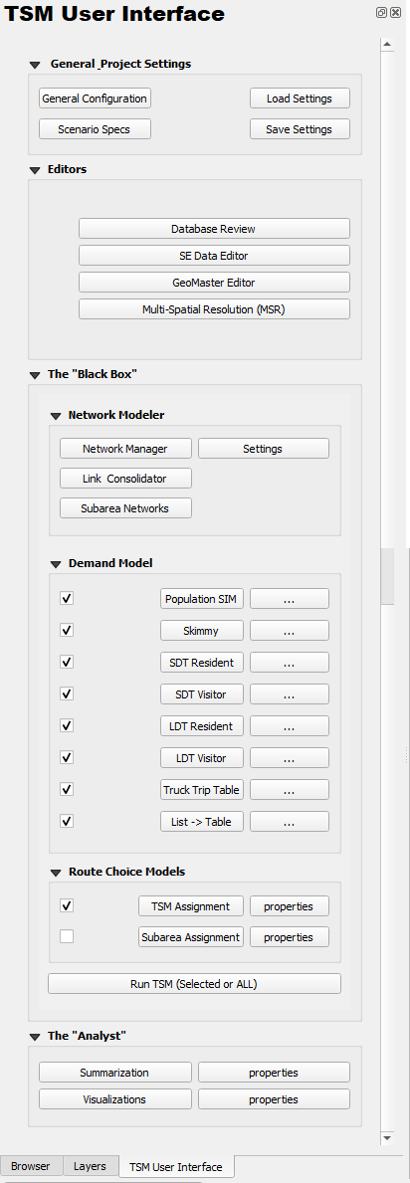

TSM Main Panel User Guide

Introduction
The Main Panel serves as the central hub for managing and operating various components of the Turnpike State Model (TSM). It offers structured navigation through General & Project Settings, Editors, the “Black Box,” and the “Analyst,” streamlining workflows and enhancing accessibility for users.

Panel Overview

1. General & Project Settings
- General Configuration: Access settings related to general model dependencies and paths.
- Load Settings: Load previously saved model configurations.
- Scenario Specs: Define specific scenario parameters.
- Save Settings: Save current configurations for future use.

2. Editors
- SE Data Editor: Edit socio-economic data crucial for model accuracy.
- Multi-Spatial Resolution (MSR): Manage multi-level spatial data resolutions.
- Database Review: Review and verify database integrity and consistency.
- GeoMaster Editor: Edit and manage GeoMaster data layers.

3. The “Black Box”
This section houses essential model processes divided into specialized groups:

Network Modeler
- Network Manager: Manages overall network structure and attributes.
- Settings: Configure specific network modeling options.
- Link Consolidator (Many-to-One): Reduce network complexity by consolidating links.
- Subarea Networks: Extract and manage subarea networks.

Demand Model
- Population SIM: Generate synthetic population data.
- Skimmy: Develop network skim matrices.
- SDT Resident: Model short-distance resident travel.
- SDT Visitor: Model short-distance visitor travel.
- LDT Resident: Analyze long-distance resident travel.
- LDT Visitor: Analyze long-distance visitor travel.
- Truck Trip Table: Generate truck-specific travel tables.
- List -> Table: Convert trip lists into structured tables.

Route Choice Models
- TSM Assignment: Execute traffic assignment within TSM.
- ELToD Assignment: Run advanced assignment modeling using ELToD.

4. The “Analyst”
- Summarization: Aggregate and summarize model results.
- Visualizations: Create visual representations of modeling outcomes for analysis.

Widget Interaction
- Each widget provides intuitive buttons and dropdowns for quick access.
- Collapsible group boxes help organize and simplify panel navigation.
- Checkboxes and action buttons facilitate easy toggling of features and execution of model tasks.

Importance and Efficiency
The Main Panel significantly enhances the usability and efficiency of TSM: - Centralizes management of all critical TSM functions. - Streamlines workflow, enabling quicker execution and better organization. - Reduces complexity and user effort through a structured and interactive interface.

Additional Notes
- Regularly save and load settings to streamline repeated model runs.
- Ensure accuracy and consistency by routinely verifying configurations within the General & Project Settings.
- Leverage the Analyst section for comprehensive analysis and effective communication of modeling results.

General Configuration Widget

Introduction
The General Configuration widget manages key dependencies and paths for running the Turnpike State Model (TSM). It is essential for ensuring the correct execution of simulation tasks and scripts.

GUI Overview

Configuration Components

1. JAVA Path
- Description: Specifies the directory of the installed Java Development Kit (JDK). The JDK is necessary for executing Java-based applications within the TSM.
- Interaction:
  - Enter the path manually or click Browse to select the JDK directory.

2. RScript Path
- Description: Defines the path to the Rscript executable, required for running R scripts that handle data processing within TSM.
- Interaction:
  - Enter the path manually or click Browse to select the Rscript executable.

3. TSM Location
- Description: Points to the root directory of the Turnpike State Model. This location is used by various scripts and components of TSM.
- Interaction:
  - Enter the path manually or click Browse to select the TSM directory.

4. Number of Processors to Use
- Description: Sets the number of processor cores allocated for simulation tasks. Optimizing this setting improves simulation performance.
- Interaction:
  - Enter the number of processors directly into the provided field.

Saving or Cancelling Changes

Apply and Save Changes
- Click OK to confirm and save your configurations.

Cancel Changes
- Click Cancel to discard any changes and close the widget without saving.

GUI Screenshot
Below is an illustration of the General Configuration widget interface, clearly indicating all necessary fields and buttons:
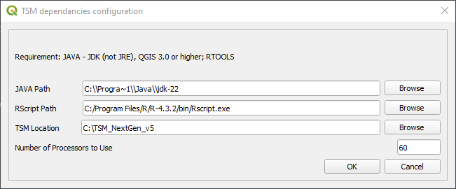

Additional Notes
- Ensure paths to JAVA and RScript executables are correctly specified.
- Verify processor allocation matches available system resources.
- Review configurations periodically to maintain optimal simulation performance.

Project Settings Widget

Introduction
The Project Settings widget manages scenario configurations for running the Turnpike State Model (TSM). It defines the scenario details, geographic coverage, input layers, and specific model steps to execute.

GUI Overview

Scenario Configuration

1. Scenario Name
- Description: Defines a unique name for the current scenario.
- Interaction: Enter a descriptive scenario name in the provided text field.

2. Select Year
- Description: Chooses the year associated with the scenario.
- Interaction: Select the scenario year from the dropdown menu.

3. Scenario Description
- Description: Provides additional context or notes about the scenario.
- Interaction: Enter detailed notes in the text area provided.

Geographic Coverage
- Description: Determines the geographic scope of the scenario.
- Interaction:
  - Select Statewide for broader coverage.
  - Select Subarea for focused geographic analyses.

Input Layers

1. Network Link File
- Description: Specifies the network line (link) layer for analysis.
- Interaction: Select the appropriate layer from the dropdown menu.

2. Network Node File
- Description: Identifies the network node (point) layer.
- Interaction: Choose the correct layer from the provided dropdown menu.

3. SE Data Polygon File
- Description: Selects the socio-economic (SE) data polygon layer for scenario processing.
- Interaction: Use the dropdown menu to select the relevant layer.

Output Configuration

Output Directory
- Description: Sets the directory for storing scenario outputs.
- Interaction: Enter the directory manually or click Browse to select the destination folder.

Black Box Steps
- Description: Selects specific model steps for scenario execution.
- Available Options:
  - Population SIM
  - LDT Resident
  - TSM Assignment
  - SDT Resident
  - LDT Visitor
  - SDT Visitor
  - TripList2Table
- Interaction: Check the boxes for desired steps to include in the scenario run.

Saving or Cancelling Changes

Apply and Save Changes
- Click OK to confirm and save your scenario configurations.

Cancel Changes
- Click Cancel to discard changes and exit the widget without saving.

GUI Screenshot
Below is an illustration of the Project Settings widget interface, clearly identifying all key components and options:
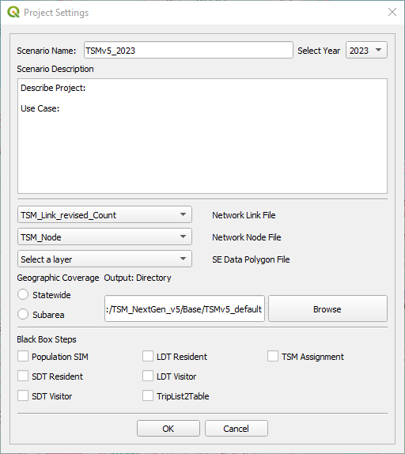

Additional Notes
- Verify layer selections match scenario requirements.
- Regularly update scenario details for clarity and accuracy.
- Confirm output paths are accessible and have sufficient storage capacity.

PopulationSIM Widget

Introduction
The PopulationSIM widget is part of the ActivitySIM framework used in the Turnpike State Model (TSM). This widget allows users to generate synthetic population data from land-use layers and manage incremental updates efficiently.

GUI Overview
The GUI consists of two main sections:

Standard Run Configuration

1. Land-use Layer
- Description: Select a polygon land-use layer from QGIS layers.
- Interaction: Use the dropdown menu to select the desired polygon layer.

2. Output File: Households (HH)
- Description: Specify the output file for synthesized household data.
- Interaction: Click Browse to select or specify a destination file.

3. Output File: Persons (PER)
- Description: Specify the output file for synthesized population data.
- Interaction: Click Browse to select or specify a destination file.

4. GQ Included in POP
- Description: Indicates if Group Quarters (GQ) are included within the total population.
- Interaction: Check to enable automatic internal handling; uncheck to exclude GQ.

Incremental Run Configuration

1. Run Incremental
- Description: Enables incremental synthesis mode, updating based on differences between two land-use datasets.
- Interaction: Check to enable incremental configuration; this activates additional reference file settings.

Incremental Configuration (Active if checked):
- Reference File: LU
  - Select the reference land-use polygon layer from the dropdown.
- Reference File: HH
  - Click Browse to select the reference household data file.
- Reference File: PER
  - Click Browse to select the reference population data file.

Running PopulationSIM

Steps to Execute
- Set all required configurations:
  - Select land-use layers.
  - Specify file paths for synthetic output (and reference data if incremental).
  - Adjust checkbox settings as required (GQ, Incremental).
- Click “Run POPSIM”:
  - Initiates the synthetic population generation.
  - Monitors for the creation of output files, indicating successful completion.
- Finalize or Cancel:
  - Click OK to save current settings and close.
  - Click Cancel to discard changes and close without saving.

GUI Screenshot
Below is an illustration of the PopulationSIM widget interface, showcasing all key components clearly:
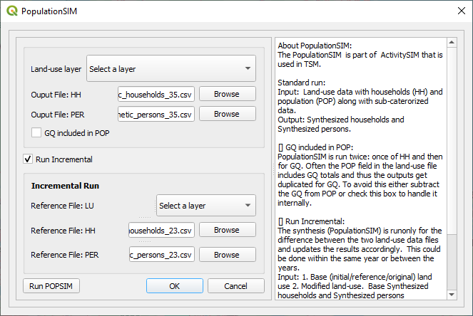

Additional Notes
- Ensure the Rscript executable path is correctly set in your general configuration.
- For incremental runs, ensure proper baseline and modified land-use data alignment.
- Watch for on-screen prompts indicating progress or errors during execution.

Skimmy Widget

Introduction
The Skimmy widget facilitates the generation of network skim matrices based on link and node datasets in the Turnpike State Model (TSM). Users can define network attributes and produce output skims in OMX or CSV formats.

GUI Overview

Input Configuration

1. Link Layer
- Description: Specifies the polyline network layer used for skimming.
- Interaction: Select the appropriate line layer from the dropdown.

2. Node Layer
- Description: Specifies the point layer representing network nodes.
- Interaction: Select the appropriate node layer from the dropdown.

Coefficient Parameters

1. Distance Coefficient
- Description: Weight applied to distance for skim calculation.
- Interaction: Enter a numeric value directly into the provided field.

2. Time Coefficient
- Description: Weight applied to time for skim calculation.
- Interaction: Enter a numeric value directly into the provided field.

3. Cost Coefficient
- Description: Weight applied to cost for skim calculation.
- Interaction: Enter a numeric value directly into the provided field.

Output Configuration

1. Output Skim
- Description: Destination file for the generated skim matrix.
- Interaction: Click the Browse button to specify a file path and name.

2. Output Format
- Description: Choose the file format for the output skim (OMX or CSV).
- Interaction: Select the preferred format from the dropdown menu.

Execution and Saving

Run Skimmy
- Click Run to initiate skim generation based on specified configurations.

Save or Cancel Configuration
- Click Save to retain settings for future runs.
- Click Cancel to discard unsaved changes and exit the widget.

GUI Screenshot
Below is an illustration of the Skimmy widget interface, clearly displaying all essential configuration elements:
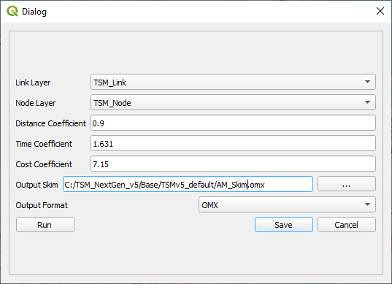

Additional Notes
- Ensure input layers are properly formatted and contain all necessary attributes.
- Validate coefficient values to reflect accurate network travel characteristics.
- Monitor progress or errors through on-screen prompts during execution.

SDT Resident Widget

Introduction
The SDT Resident widget manages the Short Distance Travel (SDT) modeling for residents within the Turnpike State Model (TSM). It utilizes land-use data, synthetic household/population data, and skim matrices to evaluate travel patterns based on selected telework scenarios.

GUI Overview

Data Input Configuration

1. Land-use Layer
- Description: Selects the polygon land-use layer at the regional planning level, aggregated internally to TSM zones.
- Interaction: Choose the appropriate polygon layer from the dropdown menu.

2. Synthetic Household File
- Description: Specifies the synthetic household dataset generated from PopulationSIM.
- Interaction: Click Browse to select the file.

3. Synthetic Person File
- Description: Defines the synthetic population dataset produced from PopulationSIM.
- Interaction: Click Browse to choose the file.

4. Skim File
- Description: Provides the skim matrix (distance table) essential for travel modeling.
- Interaction: Click Browse to specify the skim file.

Telework Scenario
- Description: Adjusts the telework share percentage, influencing travel demand.
- Interaction: Select the desired telework percentage (7%, 10%, 15%, 20%, or 25%) from the dropdown menu.

Output Directory
- Description: Directory where model outputs will be stored.
- Interaction: Enter the directory path manually or click Browse to select.

Execution and Saving

Run SDT Resident
- Click Run SDT to execute the model based on configured inputs and telework scenario.

Save or Cancel Configuration
- Click OK to save settings for future runs.
- Click Cancel to discard unsaved changes and exit the widget.

GUI Screenshot
Below is an illustration of the SDT Resident widget interface, clearly showing essential configuration options:
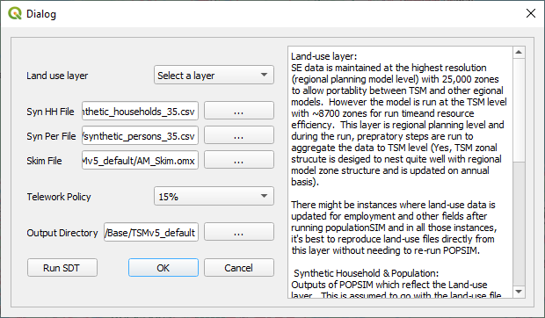

Additional Notes
- Ensure all input datasets match and are correctly synchronized.
- Telework settings significantly impact travel model outputs; verify selected percentages align with scenario goals.
- Regularly review output directory for successful model execution and results.

SDT Visitor Widget User Guide

Introduction
The SDT Visitor widget facilitates modeling Short Distance Travel (SDT) specifically for visitors within the Turnpike State Model (TSM). It leverages regional land-use data and travel skim matrices to predict visitor travel patterns and demands.

GUI Overview

Data Input Configuration

1. Land-use Layer
- Description: Chooses the polygon land-use layer, initially at the regional planning model resolution, which is internally aggregated to the TSM zoning system.
- Interaction: Select an appropriate polygon land-use layer from the dropdown menu.

2. Skim File
- Description: Provides the necessary skim matrix containing distance tables used for visitor travel modeling.
- Interaction: Click Browse to select the required skim file.

Output Directory
- Description: Specifies the directory where model outputs will be saved.
- Interaction: Enter the directory manually or click Browse to choose the location.

Execution and Saving

Run SDT Visitor
- Click Run SDT Vis to execute the visitor model using the configured settings.

Save or Cancel Configuration
- Click OK to save the current settings for future runs.
- Click Cancel to discard unsaved changes and close the widget.

GUI Screenshot
Below is an illustration of the SDT Visitor widget interface, clearly identifying all essential inputs and configurations:
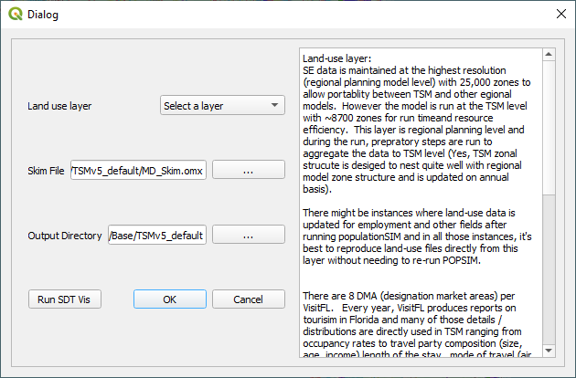

Additional Notes
- Ensure the selected land-use layer and skim file accurately represent visitor characteristics and travel patterns.
- Confirm the output directory has adequate storage capacity and is accessible.
- Regularly review VisitFL and FDOT data to maintain updated visitor modeling assumptions and inputs.

Long-Distance Travel (LDT) Resident Widget

Introduction
The LDT Resident widget manages the modeling of long-distance travel specifically for Florida residents within the Turnpike State Model (TSM). This configuration utilizes Florida-specific data inputs to forecast travel behavior.

GUI Overview

Input Configuration
- Input Directory: Directory containing necessary input files.
  - Interaction: Click Browse to select the directory.
- Road LOS (Skim): Road level-of-service skim file.
  - Interaction: Click Browse to select the skim file.
- Rail LOS (Skim): Rail level-of-service skim file.
  - Interaction: Click Browse to select the skim file.
- Air LOS (Skim): Air travel level-of-service skim file.
  - Interaction: Click Browse to select the skim file.
- Land-use (FL): Florida-specific land-use data file.
  - Interaction: Click Browse to choose the file.
- Synthetic HH (FL): Florida synthetic household data file.
  - Interaction: Click Browse to choose the file.
- Number of Households (FL):
  - Interaction: Enter manually or check Auto compute to automatically calculate from synthetic HH data.

Output Configuration
- Output Directory: Destination folder for model results.
  - Interaction: Click Browse to select or enter manually.

Execution and Saving
- Click Run to execute the LDT Resident model.
- Use Save to store current settings or Cancel to discard changes.

GUI Screenshot
Below is an illustration of the LDT Resident widget interface, clearly identifying all essential inputs and configurations:
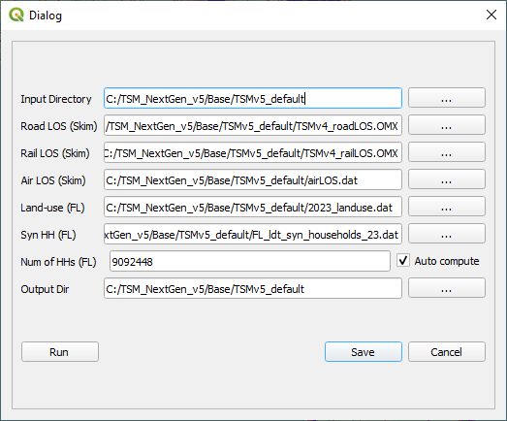

Additional Notes
- Ensure all skim and land-use data files are accurately selected and compatible.
- Regularly update synthetic household data to reflect current demographics.

Long-Distance Travel (LDT) Visitor Widget

Introduction
The LDT Visitor widget models long-distance travel specifically for out-of-state (non-Florida) US visitors within the Turnpike State Model (TSM). This setup uses unique parameters tailored for visitors distinct from Florida residents.
Note: Visitor in this context refers explicitly to Out-of-State (non-Florida) US residents. This is different from Short-Distance Travel (SDT) visitors who include both Florida residents and US residents.

GUI Overview

Input Configuration
- Input Directory: Directory with visitor-specific input files.
  - Interaction: Click Browse to choose the directory.
- Road LOS (Skim): Visitor-specific road skim file.
  - Interaction: Click Browse to select the skim file.
- Rail LOS (Skim): Rail skim data for visitor travel.
  - Interaction: Click Browse to choose the skim file.
- Air LOS (Skim): Air travel skim file relevant to visitors.
  - Interaction: Click Browse to select the file.
- Land-use (FL/US): Combined Florida and US land-use data.
  - Interaction: Click Browse to select the appropriate data file.
- Synthetic HH (FL/US): Synthetic household file representing visitors.
  - Interaction: Click Browse to select the file.
- Number of Households (US-FL):
  - Interaction: Enter manually or use Auto compute to auto-generate from synthetic household data.

Output Configuration
- Output Directory: Directory where visitor-specific model results are saved.
  - Interaction: Click Browse to select or enter manually.

Calibration Settings
- External Station Counts (Count Year & Future Year):
  - Define external station count year and future projection year.
  - Enter counts and compound annual growth rates (CAGR) for I-75, I-10, and I-95.

Execution and Saving
- Click Run to start the LDT Visitor model execution.
- Click Save to preserve your settings or Cancel to discard them.

GUI Screenshot
Below is an illustration of the LDT Visitor widget interface, clearly identifying all essential inputs and configurations:
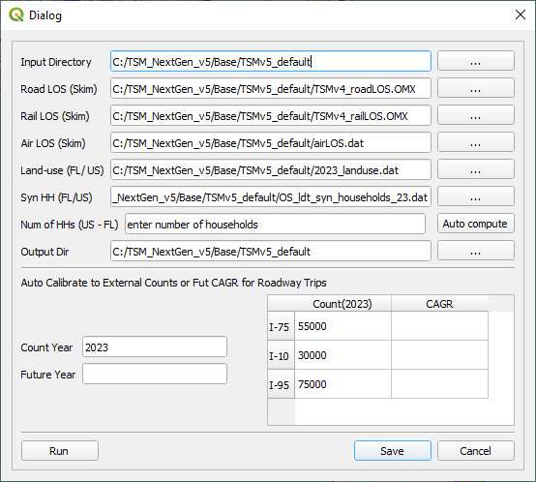

Additional Notes
- Confirm the selected files are correct and tailored specifically for visitor analysis.
- Ensure calibration settings accurately reflect external travel growth expectations.

TSM Traffic Assignment Widget

Introduction
The Traffic Assignment widget within the Turnpike State Model (TSM) performs essential tasks for assigning traffic flows on network links using specified trip tables and network layers. It provides functionalities such as Select Link Analysis, Select Trip Tables, Subarea Trip Table Extraction, and Turning Movement Analysis.

GUI Overview

Input Configuration

1. TSM Link Layer
- Description: Network link layer (LineString geometry).
- Interaction: Select the appropriate link layer from the dropdown.

2. TSM Node Layer
- Description: Network node layer (Point geometry).
- Interaction: Choose the correct node layer from the dropdown.

3. TSM Trip Table
- Description: CSV file containing origin-destination trip data.
- Interaction: Click Browse to select the trip table.

4. Output Volume File
- Description: File for saving traffic assignment results.
- Interaction: Click Browse to specify an output file.

5. Max Iterations
- Description: Maximum number of iterations for traffic assignment convergence.
- Interaction: Enter a numerical value (default is 10).

Analysis Tools

1. Select Link Analysis
- Description: Filters assignment results based on specific links.
- Interaction:
  - Specify Select Links (Link A-B).
  - Choose logical conditions (AND, OR, or single Select Link).
  - Set output directory for the Select Link results.

2. Select Trip Table
- Description: Extracts specific trip tables based on Select Link criteria.
- Interaction:
  - Define Select Links.
  - Choose logical conditions (AND, OR).
  - Specify output directory for the resulting trip table.

3. Subarea Trip Table Extraction
- Description: Extracts trip tables for a defined subarea.
- Interaction:
  - Specify boundary link list file.
  - Enter the number of subarea zones.
  - Define the output file for the subarea trip table.

4. Turning Movement Analysis
- Description: Analyzes traffic turning movements at specified nodes.
- Interaction:
  - Provide a node list file.
  - Specify the output directory for turning movement data.

Execution and Saving
- Click Run to execute the traffic assignment process.
- Click Save to retain configuration settings for future runs.
- Click Cancel to discard unsaved changes and exit.

GUI Screenshot
Below is a visual illustration of the Traffic Assignment widget, highlighting essential elements and interaction points: 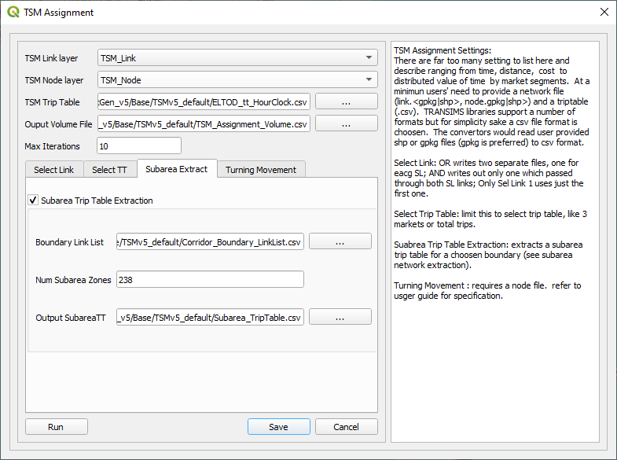

Additional Notes
- Ensure input layers and files match expected formats.
- Regularly verify convergence parameters (max iterations) for efficient processing.
- Validate outputs regularly, especially for Select Link and Turning Movement analyses.

Network Editor Tool User Guide

Introduction
The Network Editor tool is an essential feature of the Turnpike State Model (TSM) designed to facilitate and expedite network coding tasks. This powerful tool streamlines the process of updating and managing transportation network links and nodes, significantly reducing manual editing effort and improving overall efficiency.

Key Functionalities

Layer Selection
- Link and Node Layer Selection: Easily select existing network link (LineString) and node (Point) layers within your GIS environment.
- Interaction: Intuitive dropdown menus to quickly identify and select required layers for editing.

Automated Processing
- Update Links & Nodes: Automatically updates the network topology, ensuring consistent connectivity and accurate attribute coding.
- Geometry Validation: Maintains geometric accuracy by validating and automatically correcting common topological errors.

Integration with QGIS
- Dynamic Layer Management: Seamless integration into QGIS enables automatic loading and visualization of edited network layers.
- External Processing Integration: Effectively integrates external scripts (R scripts) to enhance network data management capabilities.

Importance
The Network Editor significantly enhances the accuracy, consistency, and efficiency of transportation network modeling: - Accuracy and Consistency: Ensures that edits and updates maintain the structural and attribute integrity of the network. - Automated Error Detection: Minimizes human errors through automatic detection and correction of network inconsistencies. - Improved Workflow: Streamlines complex editing processes into manageable, user-friendly operations.

Time Savings
The tool markedly reduces the time required for network coding tasks by: - Automating repetitive manual editing tasks. - Rapidly validating and updating network geometries and attributes. - Simplifying interactions and reducing the number of steps needed to perform complex network updates.
Overall, the Network Editor tool offers substantial time savings, allowing users to focus on higher-level analytical tasks rather than manual network maintenance.

Additional Notes
- Ensure selected layers correspond accurately to the desired modeling scenarios.
- Regularly utilize built-in validations to maintain network quality and consistency.
- Leverage external processing scripts for enhanced functionality and improved automation.

Many-to-One (Link Consolidator) Widget

Introduction
The Many-to-One tool, colloquially known as the Link Consolidator, streamlines extensive roadway networks used in transportation modeling. It merges multiple links into fewer segments, significantly reducing computational load while preserving essential geometric detail for accurate path distance and travel time calculations.
Link Consolidation converts extensive link and node databases from sources like Navteq, OSM, Google, and Bing Maps into manageable networks suitable for modeling purposes.

GUI Overview

Scenario Configuration

1. Scenario Name
- Description: Assign a unique identifier to the consolidation scenario.
- Interaction: Enter the scenario name into the text field.

2. Select Year
- Description: Select the scenario year for the consolidated dataset.
- Interaction: Use the dropdown menu to choose the year.

3. Max Internal Zones
- Description: Define the maximum number of internal zones considered.
- Interaction: Enter the maximum number of zones directly into the field (default is 8721).

Input Configuration

1. GeoMaster Line Layer
- Description: Select the network line (link) layer.
- Interaction: Use the dropdown to select the appropriate line layer.

2. GeoMaster Node Layer
- Description: Select the network node layer.
- Interaction: Use the dropdown to select the node layer.

Advanced Options
- Keep Counts: Maintain count attributes during consolidation.
- Turn Off ThruLanes: Option to disable the consolidation of through lanes.
- Check Lanes: Validate the consistency and accuracy of lane attributes.
- Write Interim Files: Save interim files created during the consolidation process.
- Load Output Files: Automatically load resulting output files into the current GIS session.

Settings and Output

Save Settings File
- Description: Store current consolidation configuration settings.
- Interaction: Click Browse to specify or select a file.

Output Directory
- Description: Choose the directory where consolidated network files will be saved.
- Interaction: Click Browse to select or enter manually.

Execution and Saving
- Click OK to execute the Link Consolidation.
- Click Cancel to close without execution.

GUI Screenshot
Below is a visual overview of the Many-to-One (Link Consolidator) widget interface, highlighting essential components and interactions:
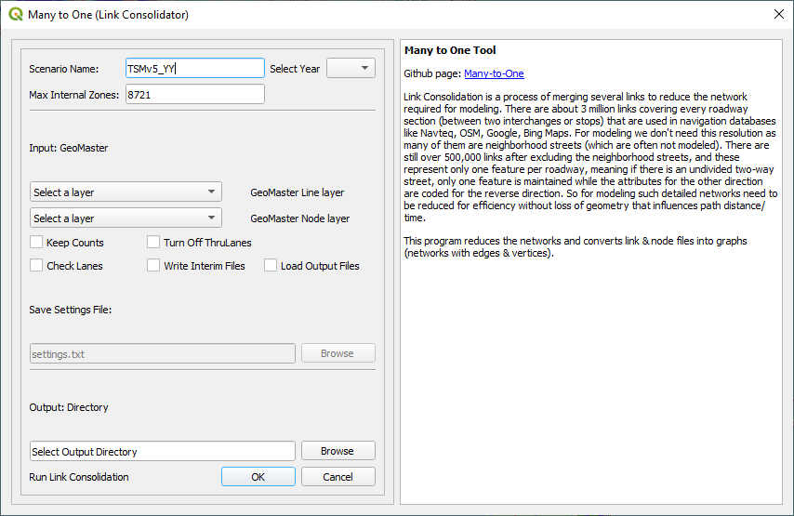

Additional Notes
- Ensure selected network layers accurately reflect the current modeling scenario.
- Regularly manage and update consolidation settings files for streamlined repeated operations.
- Review and verify interim files if enabled, to ensure optimal network integrity.

TSM Subarea Extraction Widget

Introduction
The Subarea Extraction widget is part of the Turnpike State Model (TSM), designed to efficiently extract subarea networks and associated trip tables. This tool supports managing and maintaining subarea consistency through node crosswalk files across different scenario years.

GUI Overview

Basic Configuration

1. Subarea Name
- Description: Defines a unique identifier for the subarea extraction.
- Interaction: Enter the subarea name in the provided text field.

2. Network Layers
- Network Link File: Select the appropriate link layer (LineString).
- Network Node File: Select the appropriate node layer (Point).
- Subarea Boundary File: Choose the polygon layer representing subarea boundaries.
- Interaction: Select layers from the respective dropdown menus.

Additional Options

1. Use Selected Subarea Polygon
- Description: Allows the selection of specific polygon features for subarea extraction.
- Interaction: Check to activate subarea extraction based on currently selected polygons.

2. Node Consistency Across Years
- Description: Maintains node numbering consistency over multiple scenario years.
- Interaction: Check to activate consistency management.
  - Read Node Crosswalk: Specify the file path to an existing crosswalk file.
  - Save Node Crosswalk: Specify the file path to save a new crosswalk file.

Settings Management

Save Settings File
- Description: Stores current configurations in a settings file for future use.
- Interaction: Click Browse to specify the settings file.

Output Configuration

Output Directory
- Description: Defines the directory to store subarea extraction results.
- Interaction: Click Browse to select or enter manually.

Execution and Saving
- Click OK to run the subarea extraction process.
- Click Cancel to exit without running the process.

GUI Screenshot
Below is a visual representation of the Subarea Extraction widget, highlighting critical configuration elements:
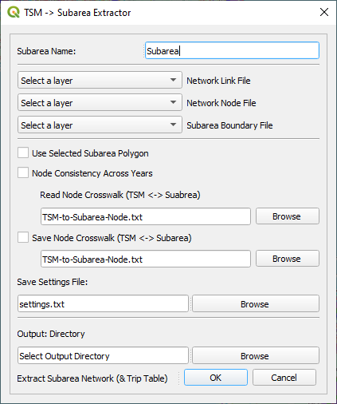

Additional Notes
- Ensure selected input layers are accurate and compatible.
- Regularly update and manage node crosswalk files for accurate long-term scenario analysis.
- Verify the output directory and settings file paths before execution.

GUI: User Settings

Steps | GUI Buttons/Checkboxes | Keys | Values
General & Project Settings | General Configuration | jdk_path | C:\Progra~1\Java\jdk-22
 |  | rscript_path | C:/Program Files/R/R-4.3.2/bin/Rscript.exe
 |  | tsm_location | C:\TSM_NextGen_v5
 |  | num_processors | 60
 | Scenario Specs | scenarioName | TSMv5_2023
 |  | scenarioYear | 2023
 |  | scenarioDir | C:/TSM_NextGen_v5/Base/TSMv5_default
 |  | scenarioDescription | This is my test
 |  | tsm_landuse_path | C:/TSM_NextGen_v5/Base/TSMv5_default/tsm_landuse.csv
Network Modeler | Link Consolidator (Many-to-One) | link_layer | TSM_Link
 |  | output_format | OMX
 | Subarea Networks | Subarea_boundaryList | C:/TSM_NextGen_v5/Base/TSMv5_default/Corridor_Boundary_LinkList.csv
 |  | Subarea_maxZones | 238
 |  | Subarea_TT_out | C:/TSM_NextGen_v5/Base/TSMv5_default/Subarea_TripTable.csv
 |  | runSubExtTT | true
Demand Model | Population SIM | synHH_file | C:/TSM_NextGen_v5/Base/TSMv5_default/synthetic_households_35.csv
 |  | synPer_file | C:/TSM_NextGen_v5/Base/TSMv5_default/synthetic_persons_35.csv
 |  | landuse_layer | TSMv5_MPO_full_2035
 |  | runPopsim_incrementally | true
 |  | refSynHH_file | C:/TSM_NextGen_v5/Base/TSMv5_default/synthetic_households_23.csv
 |  | refSynPer_file | C:/TSM_NextGen_v5/Base/TSMv5_default/synthetic_persons_23.csv
 |  | ref_landuse_layer | TSMv5_MPO_full_2023
 | Skimmy | skim_file | C:/TSM_NextGen_v5/Base/TSMv5_default/skim3.omx
 |  | dist_coeff | 0.9
 |  | time_coeff | 1.631
 |  | cost_coeff | 7.15
 | SDT Resident | skim | C:/TSM_NextGen_v5/Base/TSMv5_default/AM_Skim.omx
 |  | telework_share | 15%
 |  | SDT_res_OutDir | C:/TSM_NextGen_v5/Base/TSMv5_default
 | SDT Visitor | visitor_skim | C:/TSM_NextGen_v5/Base/TSMv5_default/MD_Skim.omx
 |  | SDT_visitor_OutDir | C:/TSM_NextGen_v5/Base/TSMv5_default
 | LDT Resident | LDT_resident_InputDir | C:/TSM_NextGen_v5/Inputs/LDT_Skims_LU_SynHH
 |  | LDT_resident_RoadSkim | C:/TSM_NextGen_v5/Inputs/LDT_Skims_LU_SynHH/TSMv4_roadLOS.omx
 |  | LDT_resident_RailSkim | C:/TSM_NextGen_v5/Inputs/LDT_Skims_LU_SynHH/TSMv4_railLOS.omx
 |  | LDT_resident_AirSkim | C:/TSM_NextGen_v5/Inputs/LDT_Skims_LU_SynHH/airLOS.dat
 |  | LDT_resident_Landuse | C:/TSM_NextGen_v5/Inputs/LDT_Skims_LU_SynHH/2023_landuse.dat
 |  | LDT_resident_SynHH | C:/TSM_NextGen_v5/Inputs/LDT_Skims_LU_SynHH/FL_ldt_syn_households_23.dat
 |  | LDT_resident_OutDir | C:/TSM_NextGen_v5/Base/TSMv5_default
 |  | LDT_resident_nHH | 9092448
 | LDT Visitor | LDT_visitor_InputDir | C:/TSM_NextGen_v5/Inputs/LDT_Skims_LU_SynHH
 |  | LDT_visitor_RoadSkim | C:/TSM_NextGen_v5/Inputs/LDT_Skims_LU_SynHH/TSMv4_roadLOS.omx
 |  | LDT_visitor_RailSkim | C:/TSM_NextGen_v5/Inputs/LDT_Skims_LU_SynHH/TSMv4_railLOS.omx
 |  | LDT_visitor_AirSkim | C:/TSM_NextGen_v5/Inputs/LDT_Skims_LU_SynHH/airLOS.dat
 |  | LDT_visitor_Landuse | C:/TSM_NextGen_v5/Inputs/LDT_Skims_LU_SynHH/2023_landuse.dat
 |  | LDT_visitor_SynHH | C:/TSM_NextGen_v5/Inputs/LDT_Skims_LU_SynHH/OS_ldt_syn_households_23.dat
 |  | LDT_visitor_OutDir | C:/TSM_NextGen_v5/Base/TSMv5_default
 |  | LDTExtCountYear | 2023
Route Choice Models | TSM Assignment | triptable_file | C:/TSM_NextGen_v5/Base/TSMv5_default/ELTOD_tt_HourClock.csv
 |  | volume_file | C:/TSM_NextGen_v5/Base/TSMv5_default/TSM_Assignment_Volume.csv
 |  | max_iterations | 10

