TABLE CREATION

create table marks ( ROLLNO int, MARKS int )

insert into marks values

(1000,45),

(1001,56),

(1002,75),

(1003,96),

(1005,23),

(1006,82),

(1007,65),

(1008,13),

(1009,42),

(1010,66)

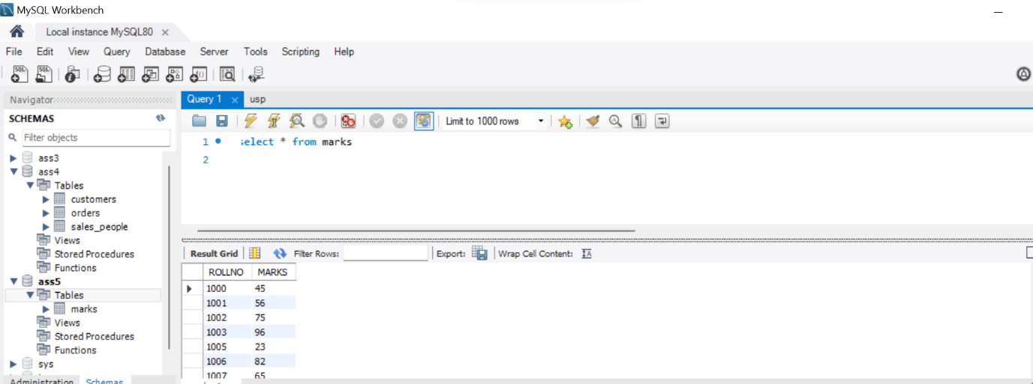

Q1.

select rollno,marks,

case

when marks<40 then 'F'

when marks>=40 and marks <60 then 'C'

when marks>=60 and marks <80 then 'B'

when marks >= 80 then 'A'

end as grades

from marks;

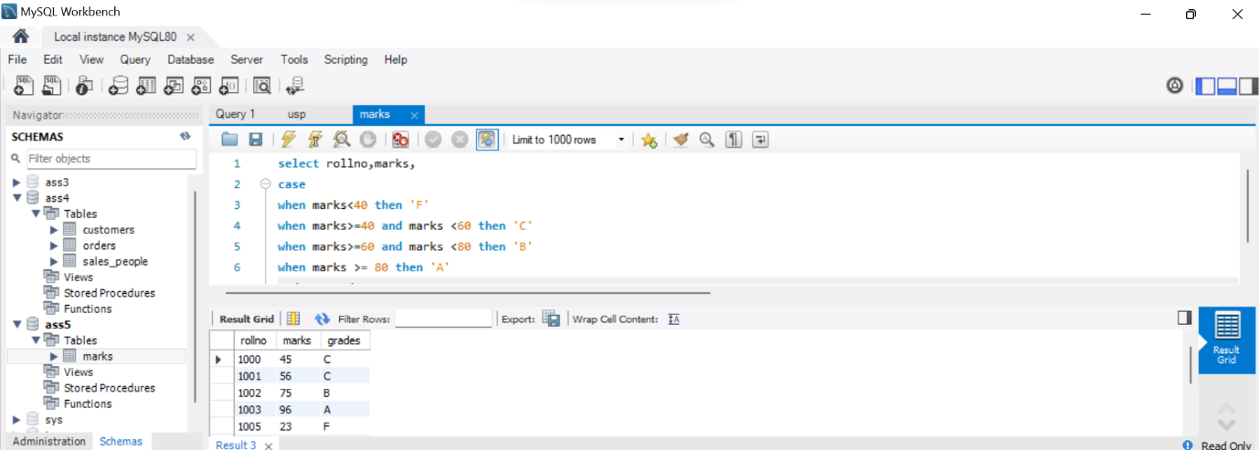

Q2.

select grades, count(*) as numstudents

from(

select rollno,

case

when marks<40 then 'F'

when marks>=40 and marks <60 then 'C'

when marks>=60 and marks <80 then 'B'

when marks >= 80 then 'A'

end as grades

from marks

)as gtable

group by grades

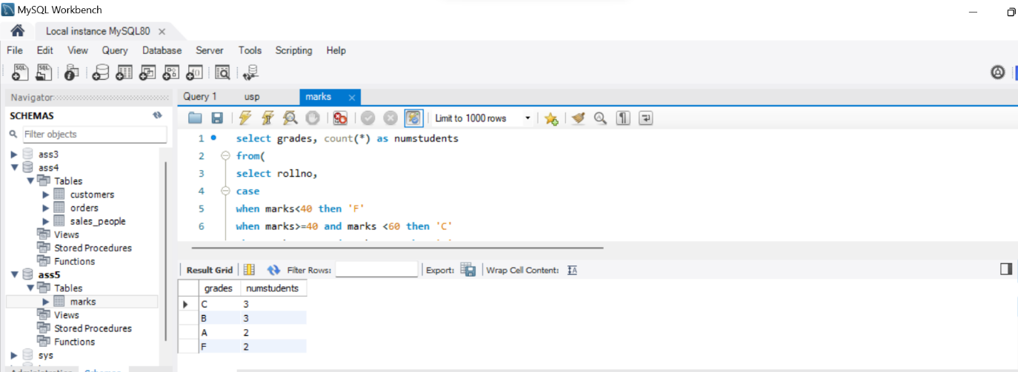

Q2

create table orders as select * from ass4.orders

create table customers as select * from ass4.customers

create table SALES_PERSON as select * from ass4. SALES_PERSON

Q2

a.

SELECT c.*

FROM customers c

JOIN orders o ON c.c_num = o.c_num

WHERE o.amt > 5000

AND YEAR(o.ORDER_DATE) = 2024;

b.

SELECT c.*

FROM customers c

LEFT JOIN orders o ON c.c_num = o.c_num

WHERE o.c_num IS NULL;

c.

SELECT c_name, city

FROM customers

WHERE rating = (SELECT rating FROM customers WHERE c_name = 'Hoffman');

d.

SELECT s_num, SUM(amt) AS total_amount

FROM orders

GROUP BY s_num

HAVING SUM(amt) > (SELECT MAX(amt) FROM orders);

OUTPUTS:

