TABLE CREATION:

create table customers as select * from ass4.customers

create table SALES_PERSON as select * from ass4. SALES_PERSON

create table orders as select * from ass4.orders

A.

update customers set city="Texas"

where C_NAME="Liu"

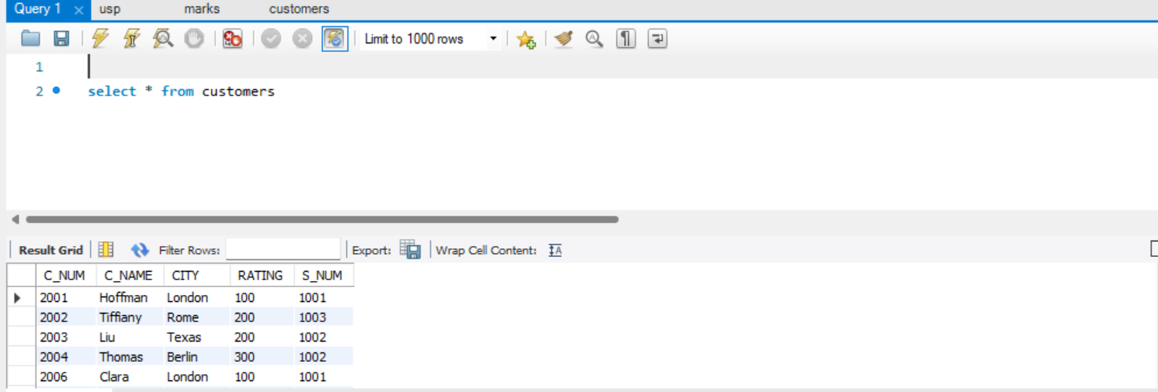

B.

delete from orders

where str_to_date(ORDER_DATE,'%d-%M-%Y') < str_to_date('2022-06-15','%Y-%m-%d');

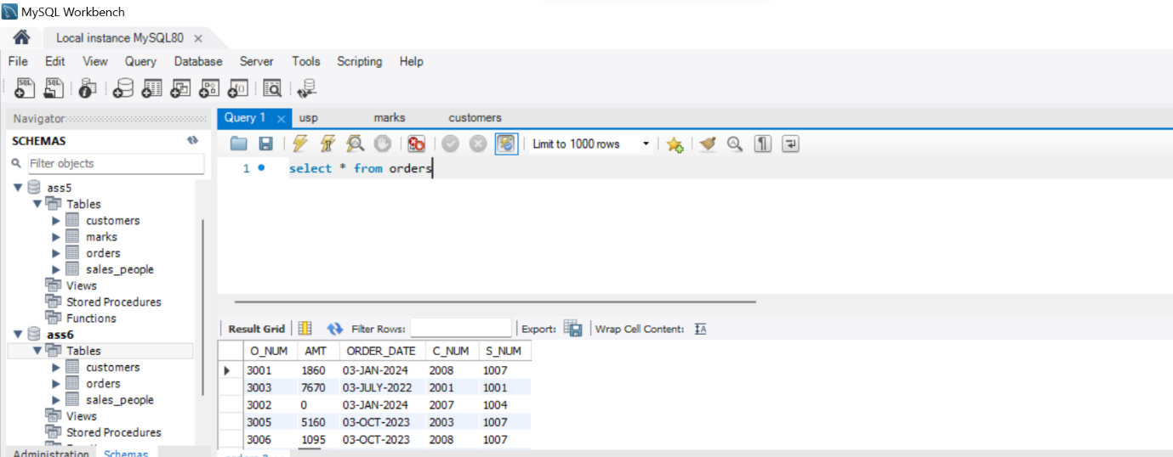

C.

SELECT sp.S_NUM AS salesperson_id, sp.S_NAME AS salesperson_name,

cp.C_NUM AS customer_id, cp.C_NAME AS customer_name,

cust_avg.avg_order_amount AS customer_avg_order_amount,

sp_avg.avg_order_amount AS salesperson_avg_order_amount

FROM sales_people AS sp

JOIN customers AS cp ON sp.S_NUM = cp.S_NUM

JOIN (

SELECT c.S_NUM, c.C_NUM, AVG(o.AMT) AS avg_order_amount

FROM customers AS c

JOIN orders AS o ON c.C_NUM = o.C_NUM

GROUP BY c.S_NUM, c.C_NUM

) AS cust_avg ON cp.S_NUM = cust_avg.S_NUM AND cp.C_NUM = cust_avg.C_NUM

JOIN (

SELECT c.S_NUM, AVG(AMT) AS avg_order_amount

FROM customers AS c

JOIN orders AS o ON c.C_NUM = o.C_NUM

GROUP BY c.S_NUM

) AS sp_avg ON sp.S_NUM = sp_avg.S_NUM

WHERE cust_avg.avg_order_amount > (

SELECT AVG(AMT)

FROM orders

);

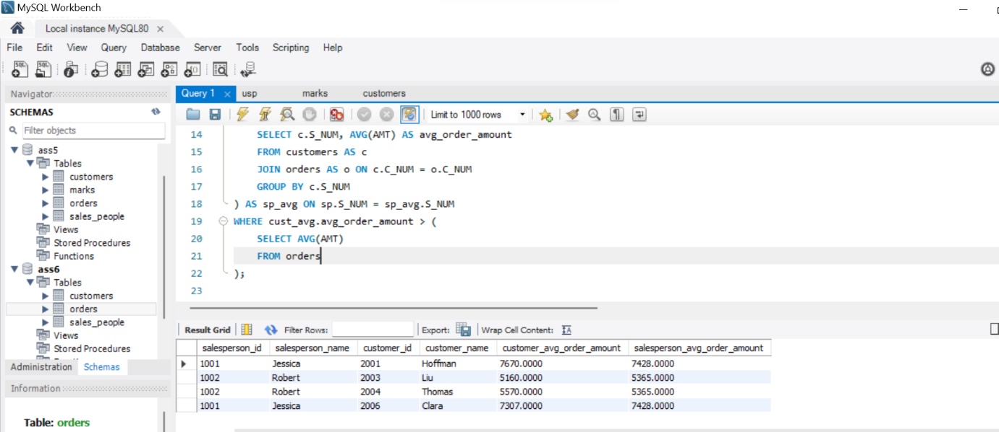

D,

SELECT S_NUM AS ID, S_NAME AS Name

FROM sales_people

WHERE S_NUM IN (

SELECT S_NUM

FROM orders

GROUP BY S_NUM

HAVING COUNT(*) > 1

)

UNION

SELECT C_NUM AS ID, C_NAME AS Name

FROM customers

WHERE C_NUM IN (

SELECT C_NUM

FROM orders

GROUP BY C_NUM

HAVING COUNT(*) > 1

)

ORDER BY Name;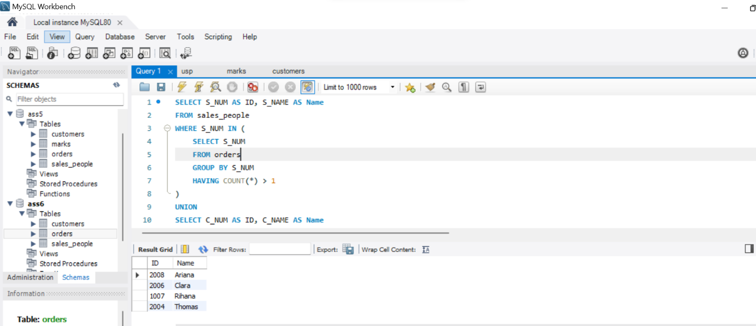

E.

SELECT C_NAME, rating

FROM customers

WHERE city = 'London'

AND rating > 200

AND city <> 'Berlin';

F.

SELECT C_NAME, rating

FROM customers

WHERE rating >= (SELECT rating FROM customers WHERE C_NAME = 'Tiffiany');

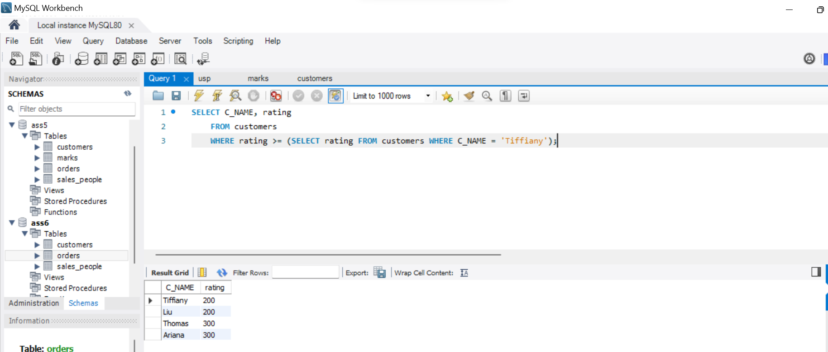

G.

SELECT s.S_NUM, s.S_NAME, s.CITY

FROM sales_people s

WHERE s.CITY NOT IN (SELECT DISTINCT CITY FROM customers);

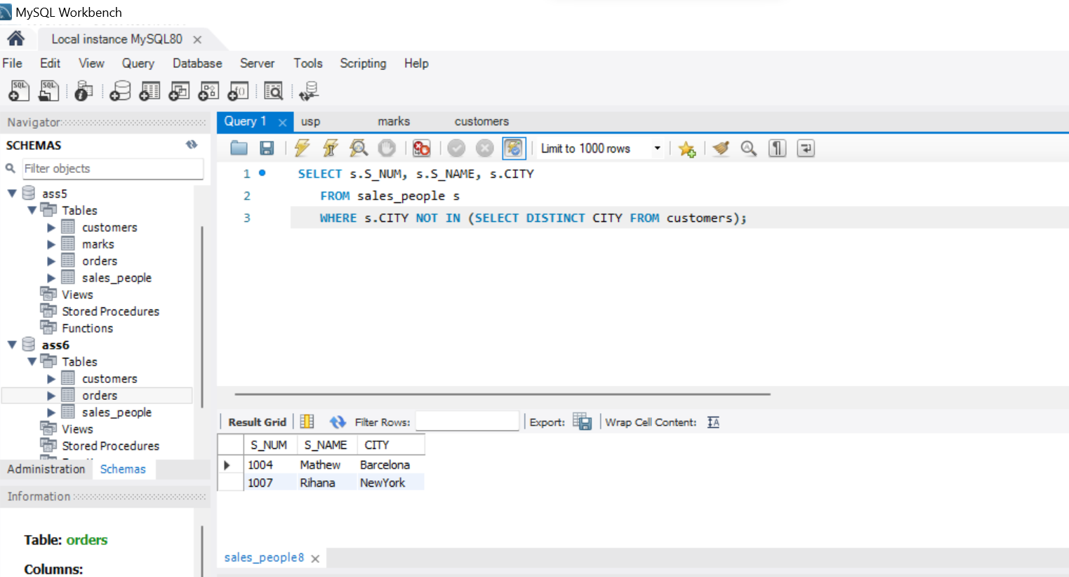

H.

SELECT O_NUM, AMT, ORDER_DATE, C_NUM, S_NUM

FROM orders

WHERE AMT > (

SELECT MAX(o2.AMT)

FROM orders o2

JOIN customers c ON o2.C_NUM = c.C_NUM

WHERE c.CITY = 'Rome'

);

