SecAgentBench as a Simulation-Based Study for Adversarial Robustness of LLM-Based Security Agents
A Monte Carlo Evaluation of Data-Plane, Control-Plane, and Logic-Plane Attacks in Multi-Agent SOC Pipelines
Phan Thanh Son
Faculty of Information Technology and Semiconductor, Thai Binh Duong University, Khanh Hoa, Vietnam
Email: son.pt@tbd.edu.vn
Ha Van Muon
Faculty of Information Technology, Telecommunications University, Khanh Hoa, Vietnam
Email: muonha@mail.ru
Truong Phi Ho
Department of Information Security, Academy of Cryptography Techniques, Hanoi, Vietnam
Email: hotp.gvm@actvn.edu.vn

Abstract
LLM-based agents are increasingly deployed in security operations center (SOC) workflows for alert triage, incident investigation, and response orchestration. Testing their adversarial robustness at scale is difficult in live environments due to safety, cost, and reproducibility constraints. This paper reformulates SecAgentBench as a Monte Carlo simulation study of attacks and defenses against LLM-based security agents. We model a three-agent SOC pipeline and evaluate threats at three layers — the data plane, control plane, and logic plane — using a synthetic incident generator that produces benign and adversarial cases under controlled assumptions. Defense modules are parameterized across deployment strength and attacker adaptivity levels. The simulation estimates attack success, alert suppression, defense effectiveness, cross-layer amplification, and overhead. Logic-plane and control-plane attacks cause the highest disruption in undefended conditions; layered defenses substantially reduce attack success but add measurable overhead.
Keywords— LLM-based security agents; adversarial robustness; simulation study; security operations center; prompt injection; tool poisoning; multi-agent systems; privilege escalation

Tóm tắt
Các tác nhân dựa trên mô hình ngôn ngữ lớn (LLM) đang ngày càng được cân nhắc áp dụng trong các quy trình của trung tâm điều hành an toàn thông tin, bao gồm phân loại cảnh báo, điều tra sự cố và điều phối ứng phó. Tuy nhiên, việc đánh giá thực nghiệm quy mô lớn về độ vững trước tấn công đối kháng trong các môi trường SOC vận hành thật gặp nhiều khó khăn do ràng buộc về an toàn, chi phí, tính tái lập và khả năng truy cập hạ tầng. Bài báo này chuyển SecAgentBench sang hướng nghiên cứu mô phỏng nhằm phân tích các tấn công và cơ chế phòng thủ đối với các tác nhân an ninh dựa trên LLM. Nghiên cứu mô hình hóa một pipeline SOC gồm ba tác nhân và xem xét các mối đe dọa trên ba lớp: mặt phẳng dữ liệu, mặt phẳng điều khiển và mặt phẳng logic. Bộ sinh sự cố tổng hợp được sử dụng để tạo các tình huống lành tính và đối kháng dưới các giả định có kiểm soát, trong khi các cơ chế phòng thủ được tham số hóa để biểu diễn các mức độ triển khai khác nhau và các mức thích ứng của kẻ tấn công. Trên các kịch bản Monte Carlo, nghiên cứu ước lượng xác suất tấn công thành công, mức che giấu cảnh báo, hiệu quả phòng thủ, mức khuếch đại xuyên lớp và chi phí hệ thống.
Từ khóa— tác nhân an ninh dựa trên LLM; độ vững đối kháng; nghiên cứu mô phỏng; trung tâm điều hành an toàn thông tin; prompt injection; đầu độc công cụ; hệ đa tác nhân; leo thang đặc quyền

1. Introduction

1.1 Motivation and deployment context
LLM-based agents are moving from research prototypes into production cybersecurity workflows. In security operations centers (SOCs), they are already being used for alert triage, evidence correlation, case summarization, and response orchestration. The pull is straightforward: analyst headcount has not kept pace with alert volumes, and shortening mean time to detect and respond matters a great deal at enterprise scale.
Contemporary SOC platforms are already incorporating agentic workflows that receive alerts, invoke security APIs, retrieve contextual knowledge, and recommend or execute downstream actions. The value of LLM-based agents here is not mainly in text generation. It is in their ability to coordinate decisions across tools, data sources, and investigation stages.

1.2 Security-specific risk of LLM-based SOC agents
The security domain exposes LLM-based agents to threat models that differ fundamentally from those of general-purpose assistants. A coding assistant can refuse to open unknown files or avoid interacting with suspicious content. By contrast, a security agent must routinely process adversary-controlled artifacts as part of its intended function, including SIEM events, IDS alerts, DNS responses, malware indicators, HTTP headers, email metadata, and external threat intelligence feeds.
Security agents are therefore more exposed to indirect prompt injection than most LLM deployments. An attacker can hide instructions inside log fields, alert metadata, or knowledge-base entries so that the agent misclassifies a real attack, suppresses an alert, or diverts attention to a decoy. If the agent also invokes tools or talks to peer agents, a compromise at data ingestion can propagate to the tool layer and then to the reasoning layer via collusion, delegation abuse, or goal hijacking.

1.3 Research gap and objectives
Existing LLM agent security benchmarks focus on general-purpose settings: web browsing, e-commerce, software engineering, office tasks. Those studies surface real problems with prompt injection, tool misuse, and coordination failures, but none model the scenario where agents must defend security infrastructure while continuously ingesting attacker-controlled data.
This paper introduces SecAgentBench as a simulation-based evaluation framework targeting that gap. The core questions are: how effective are attacks across the data, control, and logic planes; how well do defenses contain them; and do chained attacks amplify adversarial impact in multi-agent SOC pipelines.

1.4 Contributions and paper organization
The main contributions of this study are summarized as follows.
1. A security-specific threat taxonomy for LLM-based agents. The study organizes adversarial risks in agentic SOC environments into three layers: the data plane, control plane, and logic plane.
2. A simulation-based formulation of SecAgentBench. The paper reformulates SecAgentBench as a Monte Carlo simulation study suitable for ethically valid and reproducible robustness evaluation.
3. A synthetic incident generator and attack-defense scenario model. The study defines benign and adversarial incident generation together with parameterized models of nine attacks and six defenses.
4. A results framework for robustness, defense trade-offs, and attack chaining. The paper reports simulated attack success, detection, false positives, overhead, and cross-layer amplification.

2. Related Work

2.1 Agent security benchmarks
Several benchmarks now test LLM-based agents against prompt injection, unsafe tool use, and adversarial task manipulation across general-purpose settings such as web browsing, shopping, coding, and finance. These studies confirmed that agents are vulnerable at the workflow level, not just at the language level: a compromised model output can cascade through tool invocations into consequential downstream actions.
The gap is that none of these benchmarks model operational security work. In a multi-agent SOC pipeline, a poisoned alert can shape the investigation context, which then steers tool selection, response validation, and potentially high-privilege containment actions. A benchmark that captures that chain is missing.

2.2 Prompt injection attacks and defenses
Prompt injection remains one of the most widely studied threats to LLM-based systems. More recent work shows that indirect prompt injection is especially dangerous in agentic settings because malicious instructions can be hidden inside retrieved documents, emails, log entries, web content, or tool outputs. In these cases, the agent may interpret adversarial content as operational context and then modify its reasoning or actions without an explicit malicious user request.
Most prompt injection studies do not model the constraints of security operations. In SOC environments, the agent cannot avoid reading suspicious logs or adversarial artifacts because those are the things it is supposed to analyze. Filtering harmful text is not a viable defense here: you need the hostile data for the investigation. The real problem is stopping the agent from following instructions embedded in it.

2.3 MCP and tool-level security
The emergence of tool-augmented agents has shifted part of the attack surface from prompt processing to the interface between models and external tools. Tool poisoning is especially concerning because it can be carried out without directly changing the visible task presented to the user. In security applications, these risks are amplified by the nature of the tools involved. APIs for malware scanning, IP reputation, DNS resolution, host inventory, or containment actions are not merely informational; they can shape high-consequence security decisions.
Existing tool-security work covers integrity protection, runtime verification, and defense placement, but it is scoped to individual tool interactions. None of it sits inside a broader multi-agent security operations benchmark.

2.4 Multi-agent collusion and privilege escalation
Multi-agent architectures introduce attack surfaces that have no analog in single-agent systems. Agents can coordinate harmful behavior through covert or weakly observable patterns: word choices, message formatting, selective evidence presentation.
In SOC pipelines this matters more than most settings, because agents hold differentiated privileges. A lower-privilege agent does not need to compromise a higher-privilege one directly; it only needs to manipulate the reasoning chain that authorizes an action.

2.5 Positioning of SecAgentBench
SecAgentBench sits at the intersection of agent security, cybersecurity automation, and multi-agent robustness evaluation. Existing benchmarks study agents as users of tools. This benchmark studies agents that are themselves the defensive infrastructure, processing hostile inputs as a routine job requirement. And where prior work addresses one layer at a time (prompt-only or tool-only), this framework models attacks across all three connected layers.

3. Methodology

3.1 Study design
This work is designed as a simulation-based evaluation of adversarial robustness in LLM-based security agents rather than as a live operational benchmark. Direct experimentation with attack chains against production-grade SOC pipelines raises ethical and operational concerns, while simulation allows systematic variation of attack intensity, defense coverage, privilege structure, and attacker knowledge under reproducible conditions.

3.2 Simulated SOC architecture
The simulated environment models a three-stage SOC pipeline composed of a Triage Agent, an Investigation Agent, and a Response Agent. Each simulated agent is represented by a probabilistic decision module with a baseline benign-case accuracy, a susceptibility profile to each attack layer, and a defense-adjusted robustness term.

3.3 Threat model and attack parameterization
The simulation preserves the original three-layer threat taxonomy. Data-plane attacks include SIEM injection, adversarial alert crafting, and context poisoning. Control-plane attacks include tool poisoning, rug pulls, and response spoofing. Logic-plane attacks include collusion, privilege escalation, and goal hijacking. Each attack is parameterized by activation probability, payload strength, stealthiness, target-stage specificity, and attacker adaptivity.

3.4 Synthetic incident generation
Synthetic incidents are generated as benign or adversarial cases. Each incident contains alert features, contextual evidence, tool query opportunities, downstream dependencies, and ground-truth labels. Environmental covariates such as workload intensity, tool reliability, and background false-positive rate are sampled to produce stochastic but reproducible scenario diversity.

3.5 Defense modeling
Six defense mechanisms are modeled: input sanitization, tool attestation, response verification, agent isolation, consensus control, and behavioral monitoring. Each defense is associated with detection sensitivity, mitigation strength, false-positive tendency, and overhead. Defense bundles are modeled with partial redundancy and interaction effects to represent realistic defense-in-depth behavior.

3.6 Experimental factors and scenario grid
The factorial scenario grid varies along platform profile, attack type, defense configuration, attacker knowledge, and workload intensity. Monte Carlo repetition is used to estimate stable averages for the principal robustness metrics.

3.7 Outcomes and estimands
The primary simulated outcomes are Attack Success Rate (ASR), Alert Suppression Rate (ASupR), Defense Detection Rate (DDR), False Positive Rate of Defense (FPR-D), Privilege Escalation Probability (PEP), Cross-Layer Amplification Factor (CLAF), and Defense Overhead Index (DOI).

4. Simulation Results and Analysis

4.1 Baseline platform characteristics
Table 1 summarizes the three abstract platform profiles used in the simulation. These parameters are simulation inputs rather than empirical measurements.
Table 1. Baseline platform characteristics.
Platform | Benign accuracy | Coordination strictness | Tool reliability | Baseline latency
P1 | 0.920 | 0.780 | 0.880 | 1.000
P2 | 0.900 | 0.820 | 0.910 | 1.100
P3 | 0.860 | 0.700 | 0.830 | 0.900

4.2 Isolated attack effectiveness
Table 2. Simulated attack success rates (ASR) across three abstract platform profiles under undefended, static-attacker, medium-workload conditions.
Attack | Layer | P1 | P2 | P3
A1: SIEM Injection | Data | 0.790 | 0.774 | 0.822
A2: Alert Crafting | Data | 0.754 | 0.722 | 0.744
A3: Context Poisoning | Data | 0.712 | 0.714 | 0.772
A4: Tool Poisoning | Control | 0.800 | 0.802 | 0.848
A5: Rug Pull | Control | 0.710 | 0.674 | 0.730
A6: Response Spoofing | Control | 0.782 | 0.772 | 0.830
A7: Collusion | Logic | 0.754 | 0.754 | 0.788
A8: Privilege Escalation | Logic | 0.778 | 0.770 | 0.828
A9: Goal Hijacking | Logic | 0.770 | 0.762 | 0.792

4.3 Defense effectiveness
Table 3. Simulated defense effectiveness on Platform P2.
Defense configuration | DDR | Residual ASR | FPR-D | DOI
Bundle All | 0.275 | 0.352 | 0.121 | 1.628
Bundle D1+D3+D4+D6 | 0.238 | 0.453 | 0.094 | 1.441
D1: Input Sanitization | 0.131 | 0.685 | 0.050 | 1.243
D2: Tool Attestation | 0.153 | 0.606 | 0.019 | 1.221
D3: Response Verification | 0.148 | 0.639 | 0.032 | 1.265
D4: Agent Isolation | 0.100 | 0.671 | 0.022 | 1.232
D5: Consensus Protocol | 0.148 | 0.644 | 0.061 | 1.331
D6: Behavioral Monitoring | 0.125 | 0.692 | 0.041 | 1.210
No Defense | 0.000 | 0.818 | 0.000 | 1.155
*DDR: Defense Detection Rate; ASR: residual attack success rate; FPR-D: false-positive rate of defense; DOI: defense overhead index.

4.4 Adaptive attacker analysis
Table 4. Simulated residual attack success rate under increasing attacker knowledge on Platform P2 under medium workload.
Defense configuration | Adaptive | Defense-aware | Static
No Defense | 0.918 | 0.818 | 0.749
Bundle All | 0.469 | 0.352 | 0.281
Bundle D1+D3+D4+D6 | 0.529 | 0.453 | 0.355

4.5 Cross-layer chaining
The simulation also models representative chained attacks to estimate cross-layer amplification.
Table 5. Representative cross-layer attack chains.
Chain | Layers | Chained_ASR | CLAF | Detection_Probability
A1→A4→A8 | Data-Control-Logic | 0.710 | 1.240 | 0.390
A3→A6→A9 | Data-Control-Logic | 0.670 | 1.180 | 0.420
A2→A4→A9 | Data-Control-Logic | 0.640 | 1.150 | 0.450

4.6 Main findings
The simulation yields three main findings. First, undefended multi-agent SOC pipelines are highly sensitive to attacks at the control and logic planes, with several isolated attacks exceeding a simulated mean ASR of 0.60 on the weakest platform profile. Second, layered defense bundles reduce residual attack success substantially, but this improvement is accompanied by measurable overhead and false positives. Third, adaptive attackers erode a meaningful portion of the defense advantage, and chained attacks remain more dangerous than isolated attacks because they exploit dependencies across ingestion, tool usage, and delegated action stages.
Figure 1. Simulated attack success heatmap.
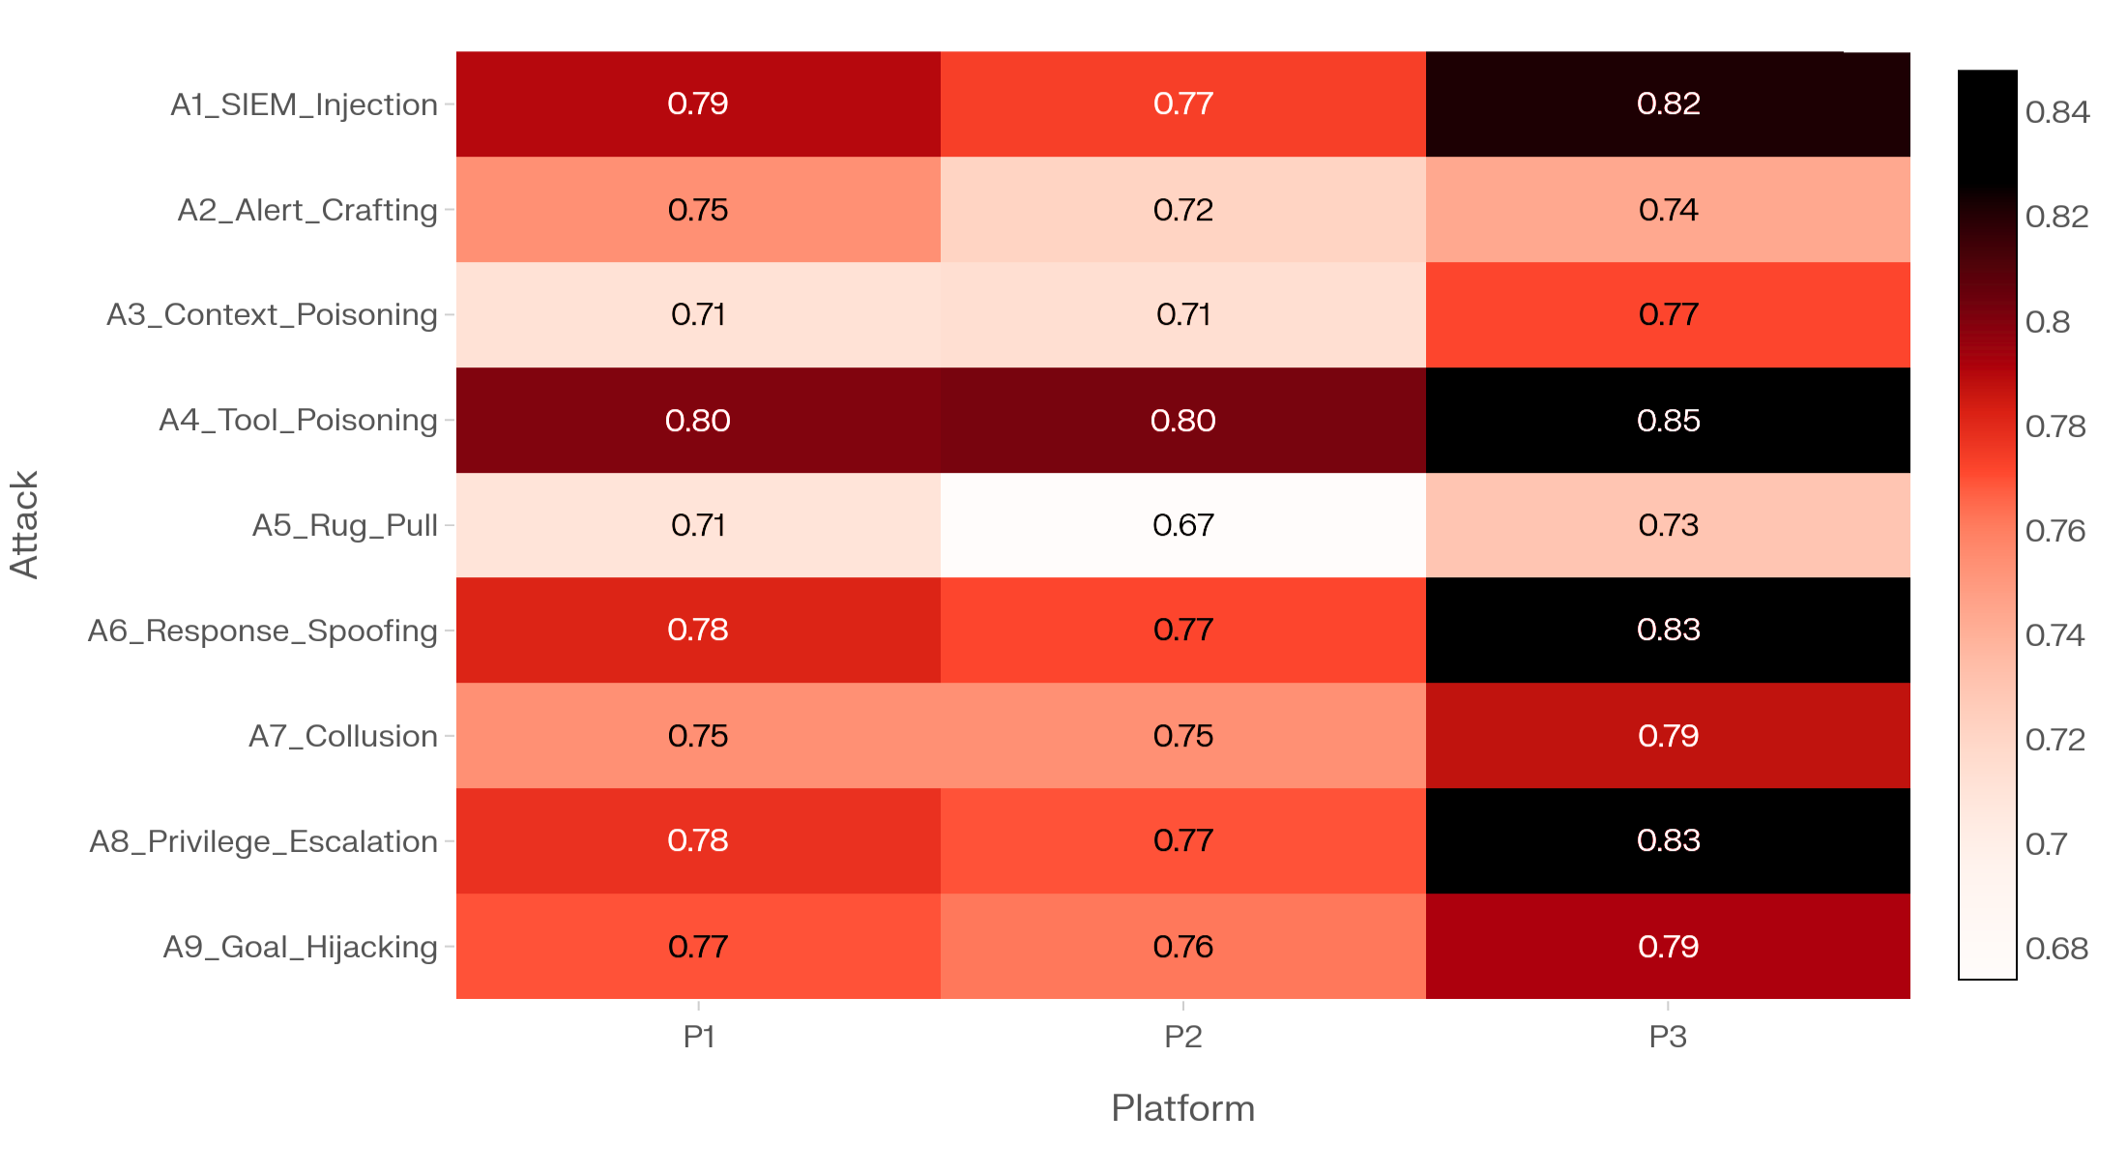
Figure 2. Defense trade-off between residual ASR and overhead.
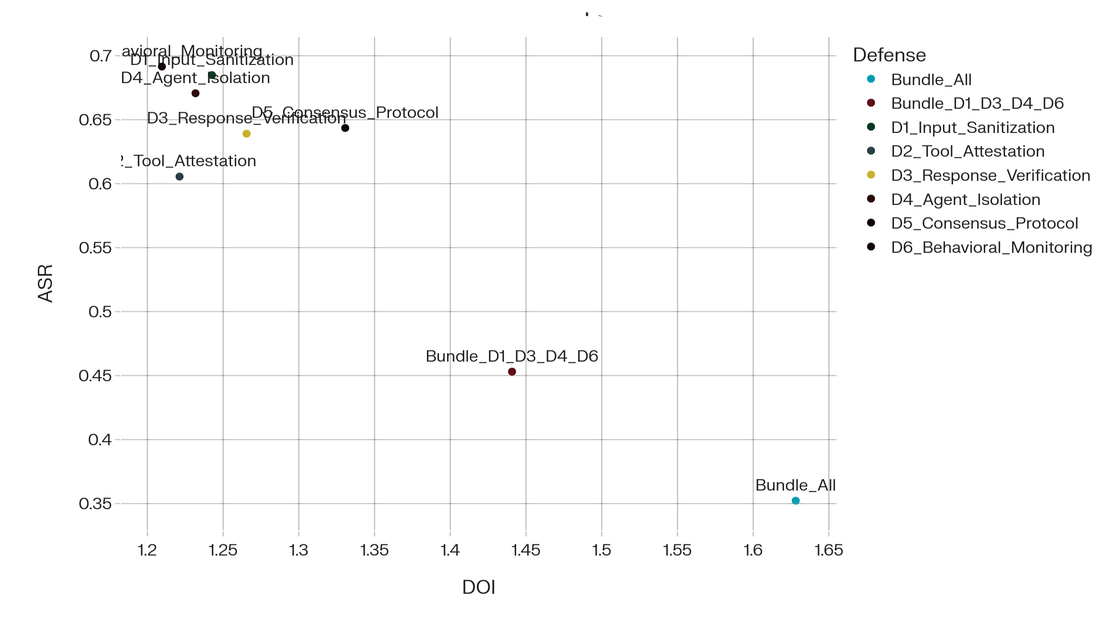
Figure 3. Adaptive attacker impact on residual ASR.
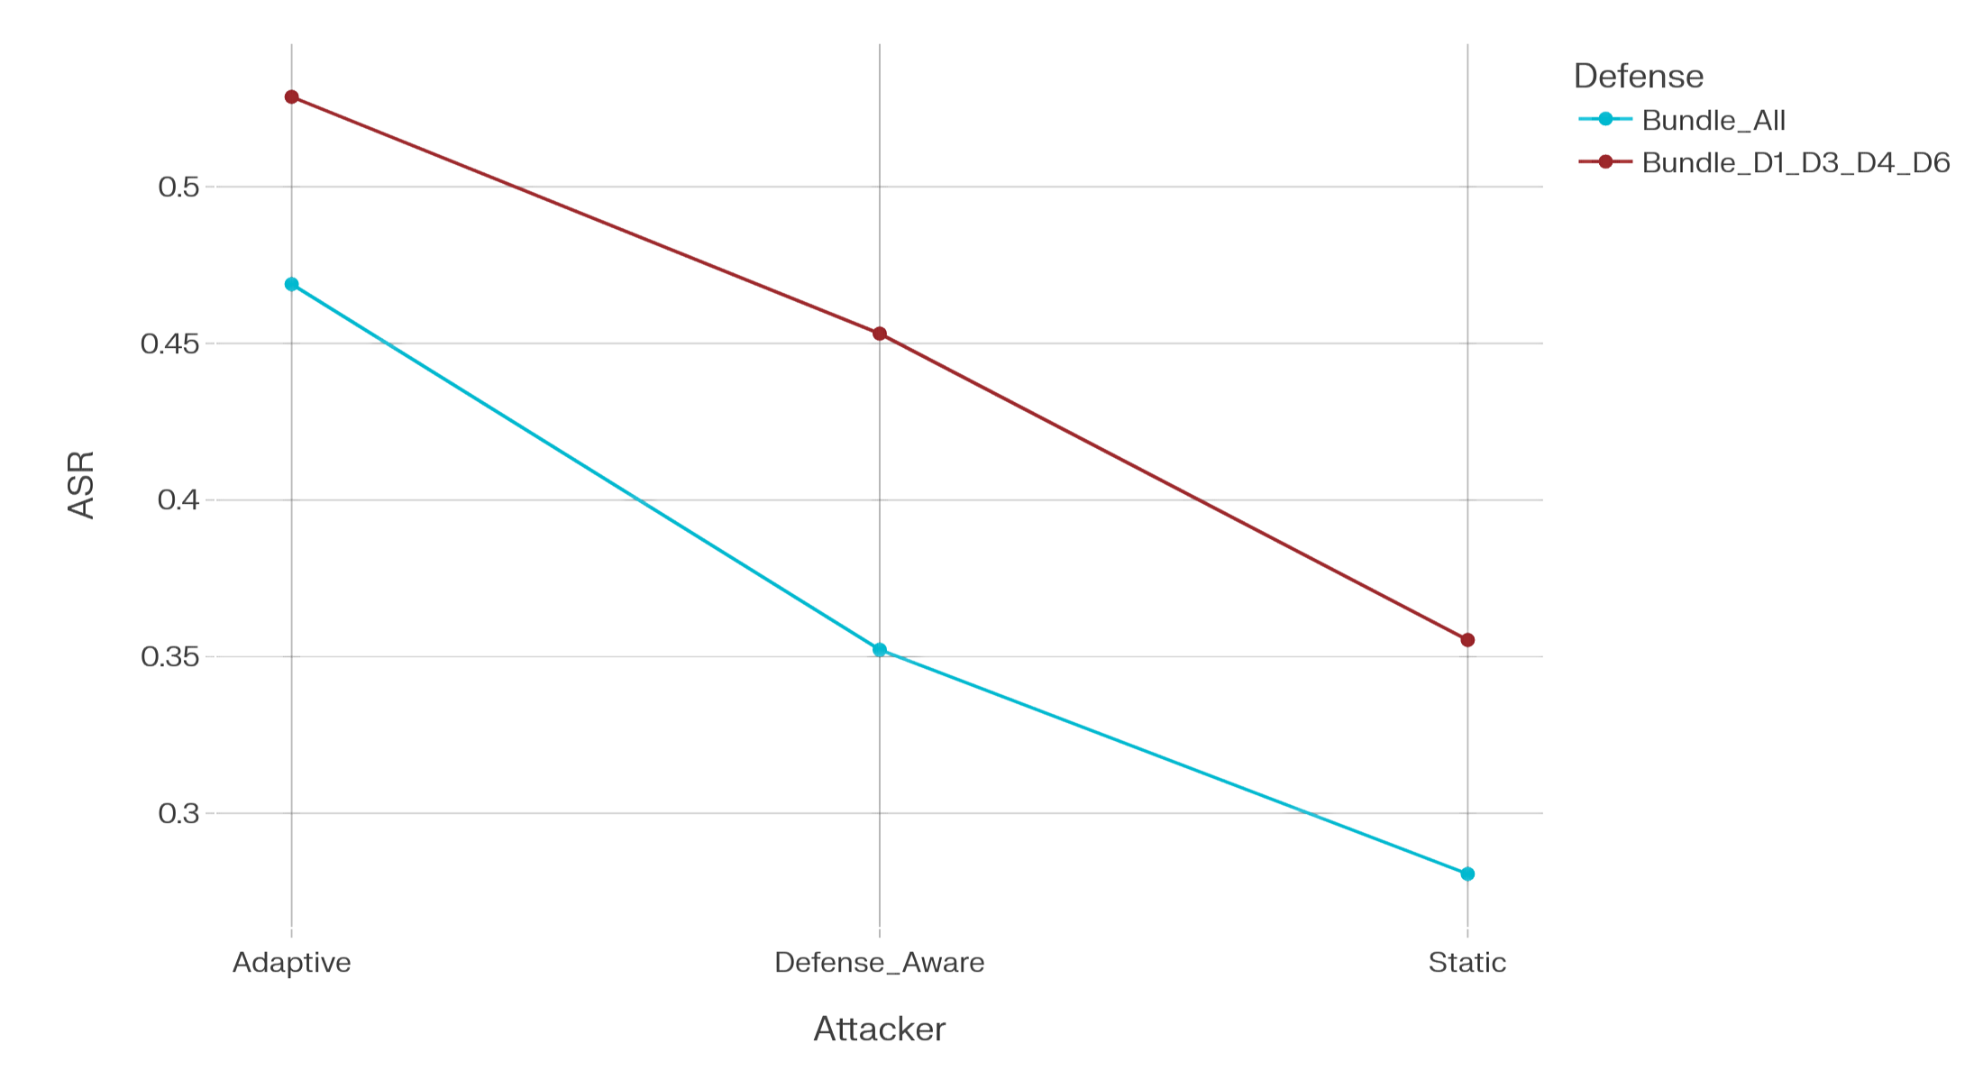

5. Discussion
Simulation is a practical substitute for live robustness testing when direct experimentation with production SOC pipelines is too risky or too expensive. Separating the attack surface into three layers made it possible to compare individual vulnerabilities and, more usefully, to identify the conditions under which cross-layer chains emerge.
The results suggest single-point defenses are not enough. Input filtering misses tool poisoning; tool verification misses reasoning-level manipulation and privilege abuse. Defense-in-depth is the only strategy that addresses all three layers, though the latency and false-positive cost is real and not trivial.
Three limitations are worth naming directly. Platform profiles are abstract and miss model-specific and framework-specific behaviors. The incident generator uses structured stochastic templates rather than real production traces, which limits how well the scenarios reflect operational conditions. And the reported values are simulation outputs, not measurements, so they need validation against real benchmarks before being treated as more than directional estimates.

6. Conclusion
SecAgentBench models a multi-agent SOC pipeline under adversarial conditions across three layers: the data plane, where hostile context enters the system; the control plane, where tools and interfaces can be manipulated; and the logic plane, where reasoning and delegated actions can be subverted. Running it as a Monte Carlo simulation rather than a live operational test keeps the evaluation reproducible and avoids the ethical and safety risks of attacking production infrastructure.
Three results stand out. Control-plane and logic-plane attacks cause the highest disruption when defenses are absent, though data-plane attacks still matter because they degrade triage quality and suppress alerts. Layered defense bundles outperform any single defense, but at a measurable cost in latency and false positives. And adaptive attackers plus chained attacks remain dangerous even against full bundles, which means robustness evaluation on isolated attack surfaces understates real risk.
These are simulation results, not measurements of deployed systems. They are best read as directional: they point to where the fragile stages are and help scope early defense planning. The next steps are to calibrate the parameters against published benchmark data, expand the incident generator with more complex attack paths, and run selected scenarios on controlled SOC testbeds.

References
[1] Chen et al., “AgentDyn: A Dynamic Open-Ended Benchmark for Evaluating Prompt Injection Attacks of Real-World Agent Security Systems,” arXiv preprint, 2026.
[2] “A Multi-Agent LLM Defense Pipeline Against Prompt Injection Attacks,” arXiv preprint, 2025.
[3] “Detecting Multi-Agent Collusion Through Multi-Agent Interpretability,” arXiv preprint, 2026.
[4] Invariant Labs, “MCP Security Notification: Tool Poisoning Attacks,” 2025.
[5] Iqbal et al., “Prompt Injection Attacks in Large Language Models and AI Agent Systems: A Comprehensive Review,” Information, vol. 17, no. 1, 2026.
[6] “Multi-Agent LLM Orchestration Achieves Deterministic, High-Quality Decision Support for Incident Response,” arXiv preprint, 2025.
[7] Jin et al., “Taming Various Privilege Escalation in LLM-Based Agent Systems: A Mandatory Access Control Framework,” arXiv preprint, 2026.
[8] Kumar et al., “PromptArmor: Simple Yet Effective Prompt Injection Defenses,” arXiv preprint, 2026.
[9] Lee et al., “Model Context Protocol Threat Modeling and Analyzing Vulnerabilities to Prompt Injection with Tool Poisoning,” arXiv preprint, 2026.
[10] Liu et al., “The Attack and Defense Landscape of Agentic AI: A Comprehensive Survey,” arXiv preprint, 2026.
[11] “MASpi: A Unified Environment for Evaluating Prompt Injection Robustness in LLM-Based Multi-Agent Systems,” 2026.
[12] “MCP-DPT: A Defense-Placement Taxonomy and Coverage Analysis for Model Context Protocol Security,” arXiv preprint, 2026.
[13] “MCP-SafetyBench,” in Proc. International Conference on Learning Representations (ICLR), 2026.
[14] “Systematic Analysis of MCP Security,” arXiv preprint, 2025.
[15] “MCPTox: A Benchmark for Tool Poisoning Attacks on Real-World MCP Servers,” arXiv preprint, 2025.
[16] Motwani et al., “Secret Collusion Among AI Agents: Multi-Agent Deception via Steganography,” in Advances in Neural Information Processing Systems (NeurIPS), 2024.
[17] OWASP, “Top 10 for Agentic Applications,” 2026.
[18] “Prompt Flow Integrity to Prevent Privilege Escalation in LLM Agents,” arXiv preprint, 2025.
[19] “AI-Augmented SOC: A Survey of LLMs and Agents for Security Automation,” Journal of Cybersecurity and Privacy, vol. 5, no. 4, 2025.
[20] Tao et al., “Audit the Whisper: Detecting Steganographic Collusion in Multi-Agent LLMs,” arXiv preprint, 2025.
[21] Wang et al., “Breaking Agent Backbone,” in Proc. International Conference on Learning Representations (ICLR), 2026.
[22] Zhang et al., “Agent Security Bench: Formalizing and Benchmarking Attacks and Defenses in LLM-Based Agents,” in Proc. International Conference on Learning Representations (ICLR), 2025.
[23] Zhou and Lin, “Lying with Truths: Open-Channel Multi-Agent Collusion for Belief Manipulation via Generative Montage,” arXiv preprint, 2026.

About the Authors
Author 1 is Phan Thanh Son (Corresponding). Research interests: Conceptualization, threat taxonomy design, formal threat modeling, Writing – original draft (Sections 1–3), Writing – review and editing. Project administration.
Author 2 is Ha Van Muon. Research interests: Simulation methodology, Software (simulation_core.py), Formal analysis, Validation, Visualization (Figures 1–3),Writing – original draft (Sections 4–5).
Author 3 is Truong Phi Ho. Research interests: Related work review, Writing – original draft (Section 2), Writing – review & editing, Supervision, Project administration.
All authors have read and agreed to the published version of the manuscript.

Appendix A. Monte Carlo Simulation Procedure
This appendix summarizes the core procedure used to generate the simulated results reported in the main paper. The purpose of the appendix is to improve reproducibility without overloading the main narrative with implementation details.

A.1 Algorithmic overview
Algorithm 1. Monte Carlo evaluation of SecAgentBench
Input: platform profile P, attack type A, defense configuration D, attacker knowledge level K, workload level W, number of repetitions N, random seed s.
Output: estimated values of ASR, DDR, FPR-D, PEP, ASupR, and DOI.
1. Initialize the random seed and load the parameter set associated with P, A, D, K, and W.
2. For each repetition i = 1, ..., N: (a) generate a synthetic incident instance; (b) sample attack activation, payload strength, and stealthiness; (c) compute defense detection probability; (d) apply mitigation strength; (e) sample task-level outcomes including attack success, alert suppression, privilege escalation, and latency overhead.
3. Aggregate all sampled outcomes across repetitions.
4. Compute mean estimates for ASR, DDR, FPR-D, PEP, ASupR, and DOI.
5. Export the aggregated results as tabular outputs for analysis and visualization.

A.2 Simplified implementation logic
The simulation uses probabilistic abstractions rather than token-level LLM execution. Each platform profile is defined by baseline benign-case accuracy, coordination strictness, tool reliability, and baseline latency. Each attack is characterized by layer, severity, stealthiness, and target stage. Each defense is modeled by sensitivity, mitigation strength, false-positive tendency, and overhead. During each Monte Carlo repetition, these parameters interact to produce synthetic outcome samples that are then aggregated into the reported performance metrics.

Appendix B. Parameterization and Reproducibility Notes

B.1 Platform profiles
Platform | Benign accuracy | Coordination strictness | Tool reliability | Baseline latency
P1 | 0.92 | 0.78 | 0.88 | 1.00
P2 | 0.90 | 0.82 | 0.91 | 1.10
P3 | 0.86 | 0.70 | 0.83 | 0.90

B.2 Attacker knowledge levels
The simulation models three attacker settings: Static, Defense-aware, and Adaptive. The static attacker does not account for deployed defenses. The defense-aware attacker partially adjusts payload design to known defenses. The adaptive attacker represents the strongest simulated adversary and is assumed to optimize behavior against the defense configuration.

B.3 Workload settings
Three workload levels are used: Low, Medium, and High. These settings influence alert pressure, detection difficulty, and defense overhead. The results emphasized in the main paper are primarily reported under medium workload unless otherwise noted.

B.4 Defense bundles
In addition to individual defenses, the study evaluates two bundled configurations: Bundle D1+D3+D4+D6 and Bundle All. These bundles are intended to capture practical defense-in-depth strategies rather than idealized perfect protection.

B.5 Reproducibility artifacts
The simulation outputs are stored as CSV tables corresponding to baseline platform characteristics, isolated attack success rates, defense effectiveness, adaptive attacker analysis, and representative chained attacks. The visual figures in the manuscript are generated directly from these CSV outputs. The implementation used a fixed random seed for reproducibility and was executed in Python using common scientific computing libraries.

Appendix C. Illustrative Python Snippet
The following shortened snippet illustrates the structure of the Monte Carlo implementation used to generate the result tables.
for platform in platforms:
for attack in attacks:
for defense in defenses:
for attacker_model in attacker_levels:
for workload in workloads:
outcomes = []
for _ in range(N):
detected = sample_detection(attack, defense, attacker_model)
mitigated = apply_mitigation(attack, defense, detected)
result = sample_outcomes(platform, attack, defense, workload, mitigated)
outcomes.append(result)
summarize(outcomes)
This code listing is intentionally compact and illustrative. A full implementation should expose all parameter values, random seeds, and export routines in a public repository or supplementary material package.

Code Availability
The simulation code, parameter configurations, generated CSV tables, and chart scripts used in this study can be released as supplementary material or deposited in a public repository upon submission or acceptance.

