LOAN DEFAULT PREDICTION USING
BIG DATA ANALYTICS
BDE ASSIGNMENT REPORT
Classification and Clustering Analysis

Submitted by: [Student Name(s)]
Course: Big Data Engineering
Dataset: Home Credit Default Risk (Kaggle)
Repository: https://github.com/TSR0705/BIG_DATA_PROJECT
Date: October 2026

Table of Contents
1. Introduction 4
2. Dataset Overview 4
3. Classification 5
3.1 Classification Problem Statement 5
3.2 Classification Objective 5
3.3 Data Preparation 5
3.4 Classification Models 7
3.5 Model Justification 7
3.6 Classification Implementation 7
3.7 Model Selection 9
3.8 Classification Results 10
3.9 Classification Analysis 11
3.10 Classification Inference 13
4. Clustering 15
4.1 Clustering Problem Statement 15
4.2 Clustering Objective 15
4.3 Clustering Data Preparation 15
4.4 Clustering Model 16
4.5 Model Justification 16
4.6 Clustering Implementation 16
4.7 Selection of Number of Clusters 17
4.8 Clustering Results 18
4.9 Cluster Analysis 19
4.10 Clustering Inference 19
5. Overall Analysis and Discussion 20
6. Assignment Requirement Mapping 21
7. Conclusion 21
8. Implementation and Repository 22
References 22
Appendix — Selected Code 23

List of Figures
Figure 1. Class distribution of TARGET in application_train 5
Figure 2. ROC-AUC and PR-AUC by model on validation and test sets 9
Figure 3. ROC curves of the four models on the test set 10
Figure 4. Precision–Recall curves of the four models on the test set 11
Figure 5. Confusion matrix of baseline XGBoost on the test set at threshold 0.50 11
Figure 6. Precision, recall and F-scores of tuned XGBoost against decision threshold 12
Figure 7. Reliability diagram of tuned XGBoost before and after calibration 13
Figure 8. SHAP global importance — mean |SHAP| for the top features 14
Figure 9. SHAP waterfall for the high-risk applicant (ID 332851) 15
Figure 10. Elbow curve and silhouette score for K = 2 to 8 17
Figure 11. Cluster sizes for K-Means with K = 4 18
Figure 12. PCA projection of the clustered applicants 18
Figure 13. Cluster profiles across the eleven clustering features 19
Figure 14. Post-hoc default rate by cluster 20

List of Tables
Table 1. Source tables of the Home Credit Default Risk dataset 4
Table 2. Stratified train / validation / test split 6
Table 3. Preprocessing applied before model training 6
Table 4. Classification models evaluated 7
Table 5. Phase 7 model comparison on validation and test sets 9
Table 6. Phase 8 results of the selected XGBoost model on the test set 10
Table 7. Operating points of the tuned model on the test set 12
Table 8. Calibration methods compared on the validation set 12
Table 9. Top ten features by mean absolute SHAP value 13
Table 10. Local explanations for three applicants 14
Table 11. Features used for clustering 16
Table 12. Inertia and silhouette score for K = 2 to 8 17
Table 13. Cluster sizes 18
Table 14. Cluster profiles (mean of each feature per cluster) 19
Table 15. Post-hoc default rate by cluster 20
Table 16. Classification and clustering compared 20
Table 17. Assignment requirement coverage 21

1. Introduction
Lending institutions decide every day whether to approve a loan application, and the central risk in that decision is default: the borrower failing to repay. A default costs the lender the outstanding principal, the interest it expected, and the cost of recovery. Predicting default before approval is therefore one of the oldest applications of statistics in banking, and the quality of that prediction directly shapes who receives credit and on what terms.
The information available at application time is wide but fragmented. The applicant's own form gives income, employment, family and housing details; credit bureaus hold the applicant's history with other lenders; and the lender's own records hold previous applications, monthly instalment behaviour, point-of-sale loans and credit-card balances. These sources sit in different tables, at different grains, and some of them run to tens of millions of monthly rows. Turning them into a single applicant-level view that a model can learn from is a data engineering problem before it is a modelling problem.
This project uses Apache Spark to perform that integration on the Home Credit Default Risk dataset — eight tables totalling 58,489,893 rows — and then trains and compares supervised models to estimate the probability of default. Alongside that, an unsupervised clustering branch segments the same applicants by their financial and behavioural characteristics without reference to the outcome, to understand what kinds of applicants exist in the portfolio.
The objective of this assignment is to demonstrate both supervised classification for loan-default prediction and unsupervised clustering for applicant segmentation, with each component covering its problem statement, model justification, implementation, results and inference as required by the marking scheme.

2. Dataset Overview
The Home Credit Default Risk dataset was published on Kaggle by Home Credit Group in 2018. It describes loan applications to a consumer-finance lender, together with each applicant's history across several related tables. Table 1 lists the eight source tables with the row and column counts measured during profiling with Spark.
Table 1. Source tables of the Home Credit Default Risk dataset
Table | Rows | Columns | Purpose
application_train | 307,511 | 122 | Application spine with TARGET label
application_test | 48,744 | 121 | Inference only; no label
bureau | 1,716,428 | 17 | Credit-bureau loans per applicant
bureau_balance | 27,299,925 | 3 | Monthly bureau loan status history
previous_application | 1,670,214 | 37 | Earlier Home Credit applications
installments_payments | 13,605,401 | 8 | Instalment payment history
credit_card_balance | 3,840,312 | 23 | Monthly credit-card balances
POS_CASH_balance | 10,001,358 | 8 | Monthly POS / cash loan history
Total | 58,489,893 | — | Eight relational tables

The table of interest for supervised learning is application_train, with 307,511 applicants and the binary label TARGET. The other six history tables are keyed to it through SK_ID_CURR either directly or through an intermediate loan identifier, and are many-to-one: a single applicant has many bureau loans, and each bureau loan has many monthly status rows. application_test carries no label and is used only for inference, never for evaluation.
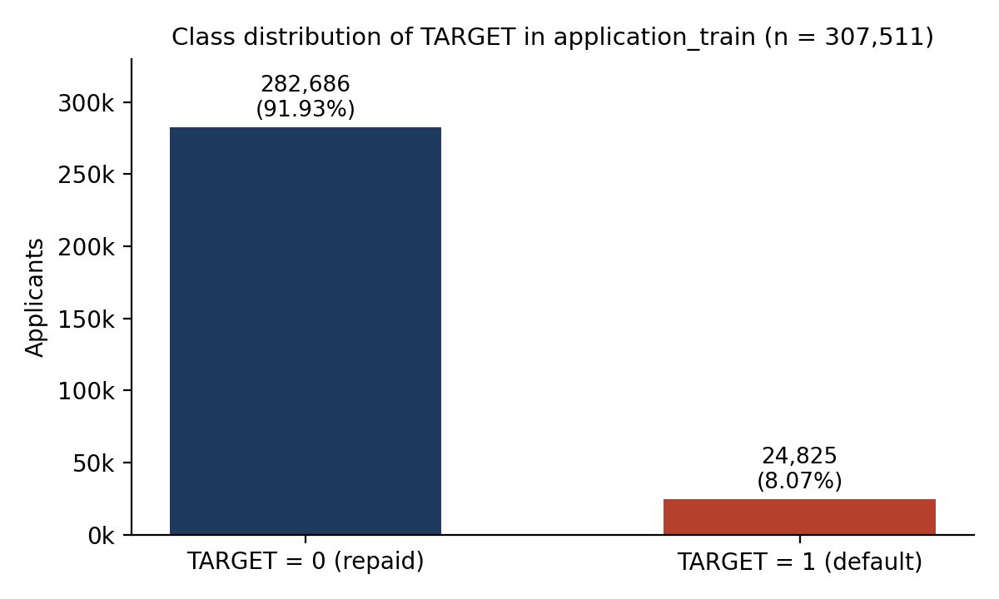
Figure 1. Class distribution of TARGET in application_train
Of the 307,511 applicants, 24,825 (8.07%) defaulted and 282,686 (91.93%) repaid. The positive class is a little over one in twelve. This has a direct consequence for evaluation: a model that predicts "repaid" for every applicant achieves 91.9% accuracy while identifying no defaults at all. Accuracy is therefore not a useful headline metric for this problem, and the classification sections report ranking metrics (ROC-AUC and PR-AUC) and threshold-dependent metrics (precision, recall, F1) separately.

3. Classification

3.1 Classification Problem Statement
Given an applicant's application details and their historical credit behaviour, predict whether the applicant will default on the loan.
- Input X: applicant-level features assembled from the application form and from aggregated bureau, previous-application, instalment, credit-card and POS history (256 model features after engineering).
- Target Y: TARGET ∈ {0, 1}, where 1 denotes a default (payment difficulty) and 0 denotes repayment.
- Output: the estimated probability P(Y = 1 | X), which is converted to a class decision by applying a threshold.
This is a binary classification problem on tabular data with a class imbalance of roughly 11.4 non-defaults for every default in the training set.

3.2 Classification Objective
The objective is to distinguish applicants who will default from those who will repay, and to estimate how likely each applicant is to default. A probability is more useful than a bare class label for two reasons. First, lending decisions are not all-or-nothing: an applicant with a 30% estimated default probability may be offered a smaller loan or a higher rate rather than declined. Second, the threshold that converts a probability into a decision can be set according to the lender's own costs of a missed default versus a wrongly declined customer, which is a business choice rather than a modelling one. Section 3.9 examines that trade-off with measured values.

3.3 Data Preparation
The eight raw CSV files were processed through three storage layers with Spark. The Bronze layer converts each CSV to typed Parquet with an explicit schema and a row-count assertion. The Silver layer applies cleaning: the DAYS_EMPLOYED sentinel value of 365,243 is nulled, placeholder strings such as XNA are normalised, and data-quality checks are recorded. The Gold layer aggregates every history table to one row per applicant and left-joins the results onto the application spine, producing 307,511 rows and 241 columns.
Aggregation is performed before joining. Joining a 27-million-row monthly table onto the application spine and aggregating afterwards would multiply the spine's rows by the number of history rows per applicant; aggregating first keeps every join at one row per applicant. Each join carries an assertion that the output row count equals the spine row count, and all ten joins in the audit record a row increase of zero.
Feature engineering then adds ratio and interaction features — payment rate, goods-to-credit ratio, bureau debt-to-credit ratio, an external-score mean, a derived payment-discipline score — bringing the matrix to 258 columns, of which SK_ID_CURR and TARGET are excluded from the model input. A leakage audit confirmed that no column is derived from TARGET and that the test inference set contains no label.
Table 2. Stratified train / validation / test split
Partition | Rows | Defaults | Default rate
Train | 215,257 | 17,377 | 8.07%
Validation | 46,127 | 3,724 | 8.07%
Test | 46,127 | 3,724 | 8.07%
Total | 307,511 | 24,825 | 8.07%

The split is 70 / 15 / 15, stratified on TARGET with random_state = 42. The three partitions are disjoint (zero overlapping identifiers) and together reconstruct the full dataset; the default rate differs between partitions by at most 4.8e-06. Validation is used for model selection, threshold choice and calibration; the test set is touched only for final reporting.
Table 3. Preprocessing applied before model training
Step | Logistic Regression | Tree models (RF, LightGBM, XGBoost)
Numeric imputation | Median (fitted on train only) | Native missing-value handling
Numeric scaling | StandardScaler | None — trees are scale-invariant
Categorical imputation | Most frequent | Native / ordinal handling
Categorical encoding | One-hot, handle_unknown = ignore, min_frequency = 0.01 | Native categorical
Feature count | 240 numeric + 16 categorical → 330 columns | 240 numeric + 16 categorical
Class imbalance | — | Addressed in Phase 8 (scale_pos_weight, thresholds)

Two preprocessing pipelines are used because the models have different needs. A linear model requires numeric inputs on a comparable scale and cannot consume categorical strings, so it receives imputed, standardised and one-hot-encoded features. Tree ensembles split on the ordering of values, so scaling changes nothing, and they handle missing values and categories natively. Every fitted transformer is fitted on the training partition only.

3.4 Classification Models
Table 4. Classification models evaluated
Model | Type | Why included
Logistic Regression | Linear | Interpretable baseline; establishes what a linear decision boundary achieves
Random Forest | Bagging ensemble | Non-linear reference that averages many deep trees
LightGBM | Gradient boosting | Efficient histogram-based boosting, strong on large tabular data
XGBoost | Gradient boosting | Regularised boosting with strong ranking performance on tabular data

3.5 Model Justification
Four models were compared rather than one chosen in advance, because the right choice depends on properties of this dataset that are only known once measured. The feature matrix mixes raw application fields with aggregated history and engineered ratios; relationships such as "a low external score matters more when bureau debt is high" are interactions that a linear model cannot represent without hand-built terms. The logistic regression therefore sets a floor: the performance available from a linear boundary on well-engineered features.
Random Forest provides a non-linear reference. It is robust and needs little tuning, but it averages fully grown trees fitted independently, so it tends to rank the rare positive class less sharply than boosting on an imbalanced problem. LightGBM and XGBoost both fit trees sequentially, each one correcting the residual errors of the ensemble so far, which is well suited to learning the interaction structure described above. They differ mainly in tree-growth strategy and regularisation, and were both included so that the choice between them rests on measurement rather than preference.

3.6 Classification Implementation
The listings below are excerpts from the project source. Fuller versions appear in the Appendix.
Listing 1. Spark session configuration src/common/spark_session.py
spark = (
SparkSession.builder
.appName(app)
.master(master) # local[*]
.config("spark.driver.memory", driver_mem) # 8g
.config("spark.sql.shuffle.partitions", shuffle_parts)
.config("spark.sql.adaptive.enabled", adaptive)
.getOrCreate()
)
Listing 1 shows the single Spark entry point used by every pipeline stage. Driver memory, shuffle partitions and adaptive query execution are read from configs/spark.yaml so the same job runs unchanged on a larger machine. This demonstrates the Big Data processing component of the implementation.
Listing 2. Explicit-schema CSV ingestion to Parquet (Bronze) src/ingestion/bronze.py
df_csv = (
spark.read
.option("header", "true")
.schema(expected_schema) # frozen schema from Phase 1, no inference
.csv(csv_path)
)
source_count = df_csv.count()
(df_csv.repartition(target_partitions).write
.mode("overwrite").option("compression", "snappy").parquet(bronze_path))
bronze_count = spark.read.parquet(bronze_path).count()
if bronze_count != source_count:
raise AssertionError(f"[{name}] Row count mismatch!")
Listing 2 converts each raw CSV to columnar Parquet with a schema declared in advance, so Spark never has to scan a file twice to infer types, and asserts that no rows were lost. Parquet is the storage format for every later layer.
Listing 3. Aggregate-before-join: monthly bureau history to one row per loan src/features/gold.py
def aggregate_bureau_balance(df_bb: DataFrame) -> DataFrame:
return df_bb.groupBy("SK_ID_BUREAU").agg(
F.count("*").alias("BURO_BAL_MONTH_COUNT"),
F.min("MONTHS_BALANCE").alias("BURO_BAL_MONTHS_MIN"),
F.sum(F.when(F.col("STATUS").isin("1","2","3","4","5"), 1)
.otherwise(0)).alias("BURO_BAL_DPD_COUNT"),
).withColumn("BURO_BAL_DPD_RATIO",
safe_divide(F.col("BURO_BAL_DPD_COUNT"), F.col("BURO_BAL_MONTH_COUNT")))
Listing 3 collapses the 27.3-million-row bureau_balance table to one row per bureau loan before it is joined to anything. The safe_divide helper returns NULL rather than infinity when a denominator is zero, so no non-finite values reach the model.
Listing 4. Left join onto the application spine with a row-explosion assertion src/features/gold.py
for feat_name, feat_df in feature_tables:
joined_df = current_df.join(feat_df, on="SK_ID_CURR", how="left")
output_rows = joined_df.count()
row_increase = output_rows - current_rows
is_pass = (row_increase == 0) and (output_rows == expected_rows)
join_audit.append({"join": f"{spine_name} + {feat_name}",
"row_increase": row_increase,
"status": "PASS" if is_pass else "FAIL"})
Listing 4 joins each aggregated feature table onto the applicant spine and records whether the row count changed. All ten joins in reports/gold/join_audit.json report zero increase, which is the evidence that the multi-table integration preserved exactly one row per applicant.
Listing 5. Stratified 70 / 15 / 15 split src/ml/split.py
train_df, temp_df = train_test_split(
pdf, test_size=temp_ratio, random_state=random_state,
stratify=pdf[target_col])
val_df, test_df = train_test_split(
temp_df, test_size=test_rel_ratio, random_state=random_state,
stratify=temp_df[target_col])
Listing 5 is the two-stage stratified split. Stratifying on TARGET keeps the default rate equal across partitions, and fixing the seed makes the partitions reproducible; the split report verifies that they are disjoint.
Listing 6. XGBoost training (Phase 7 baseline) src/ml/baseline_models.py
model = XGBClassifier(
objective="binary:logistic",
n_estimators=300, max_depth=6, learning_rate=0.05,
subsample=0.8, colsample_bytree=0.8,
random_state=random_state, n_jobs=-1, eval_metric="logloss",
)
model.fit(X_train_tree, y_train)
Listing 6 trains the gradient-boosted model that was later selected. Phase 8 tuned these hyper-parameters with a randomised search scored on average precision (Section 3.9).
Listing 7. Evaluation on validation and test partitions src/ml/model_utils.py
y_pred = (y_prob >= threshold).astype(int)
roc_auc = roc_auc_score(y_true, y_prob)
pr_auc = average_precision_score(y_true, y_prob)
loss = log_loss(y_true, y_prob)
prec = precision_score(y_true, y_pred, zero_division=0)
rec = recall_score(y_true, y_pred, zero_division=0)
f1 = f1_score(y_true, y_pred, zero_division=0)
Listing 7 separates the ranking metrics computed from probabilities (ROC-AUC, PR-AUC, log loss) from the threshold-dependent metrics computed from class decisions (precision, recall, F1). The same function evaluates every model on both partitions.

3.7 Model Selection
All four models were trained on the training partition and evaluated on validation and test with the metrics in Listing 7. Table 5 reports the ranking metrics.
Table 5. Phase 7 model comparison on validation and test sets
Model | Val ROC-AUC | Val PR-AUC | Test ROC-AUC | Test PR-AUC | Test log loss
Logistic Regression | 0.7763 | 0.2692 | 0.7773 | 0.2517 | 0.2417
Random Forest | 0.7467 | 0.2437 | 0.7454 | 0.2271 | 0.2545
LightGBM | 0.7886 | 0.2880 | 0.7877 | 0.2749 | 0.2376
XGBoost | 0.7897 | 0.2896 | 0.7893 | 0.2772 | 0.2369

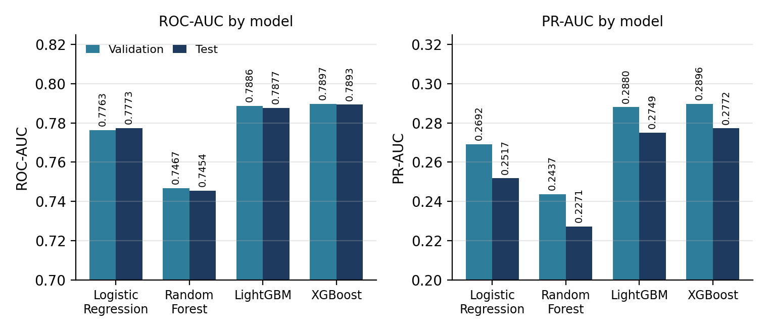
Figure 2. ROC-AUC and PR-AUC by model on validation and test sets
XGBoost achieved the highest validation ROC-AUC (0.7897) and PR-AUC (0.2896), with LightGBM close behind (0.7886 and 0.2880). The ordering is the same on the held-out test set, which indicates the validation ranking was not an artefact of that particular partition. Logistic Regression trails the boosting models by about 0.013 ROC-AUC, and Random Forest is lowest on both metrics (0.7454 test ROC-AUC).
PR-AUC is reported alongside ROC-AUC because it is the more sensitive of the two under imbalance. ROC-AUC rewards ranking defaults above non-defaults across the whole population, where the large negative class dominates; PR-AUC concentrates on how well the model concentrates true defaults among the applicants it ranks highest, which is what a lender acts on. Both metrics are independent of any threshold.
XGBoost was selected as the primary classification model because it produced the strongest ranking performance among the four evaluated models on both ROC-AUC and PR-AUC, on both the validation and test partitions, with the lowest log loss. Accuracy was not used for selection: every model scores between 0.919 and 0.921 at the default threshold, which is barely above the 0.919 obtained by predicting "repaid" for everyone, so it does not separate the models.

3.8 Classification Results
Phase 8 tuned the selected model with a randomised hyper-parameter search (20 configurations, 3-fold cross-validation, scored on average precision), chose decision thresholds on the validation set, and compared calibration methods. Table 6 reports the tuned model on the held-out test set.
Table 6. Phase 8 results of the selected XGBoost model on the test set
Metric | Baseline XGBoost (threshold 0.50) | Tuned XGBoost (threshold 0.50) | Tuned XGBoost (threshold 0.17)
ROC-AUC | 0.7893 | 0.7898 | 0.7898
PR-AUC | 0.2772 | 0.2790 | 0.2790
Log loss | 0.2369 | 0.2367 | 0.2367
Brier score | 0.0660 | 0.0660 | 0.0660
Precision | 0.5571 | 0.5030 | 0.2824
Recall | 0.0419 | 0.0446 | 0.4143
F1 | 0.0779 | 0.0819 | 0.3359
F2 | 0.0514 | 0.0545 | 0.3789
Specificity | 0.9971 | 0.9961 | 0.9076
Balanced accuracy | 0.5195 | 0.5204 | 0.6609

The first four rows do not change between the two tuned columns because they are computed from the probabilities, not from the class decisions. The remaining rows change substantially: moving the threshold from 0.50 to 0.17 raises recall from 4.5% to 41.4% and lowers precision from 50.3% to 28.2%.
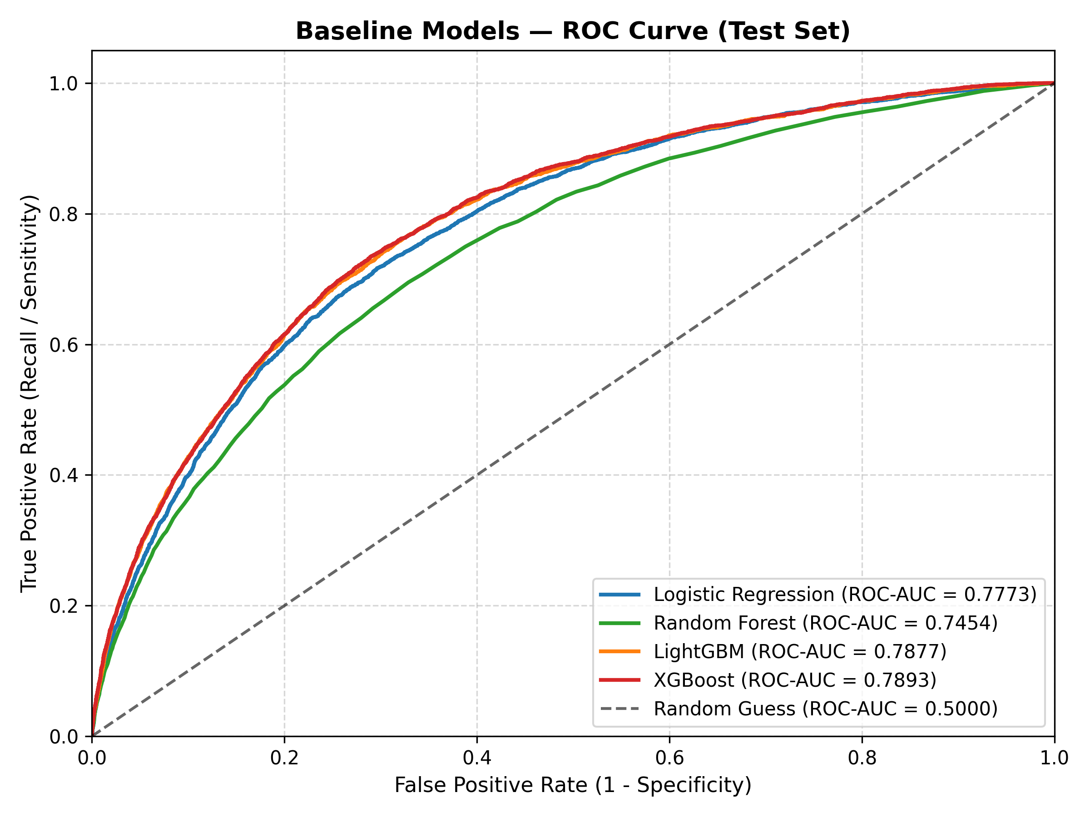
Figure 3. ROC curves of the four models on the test set
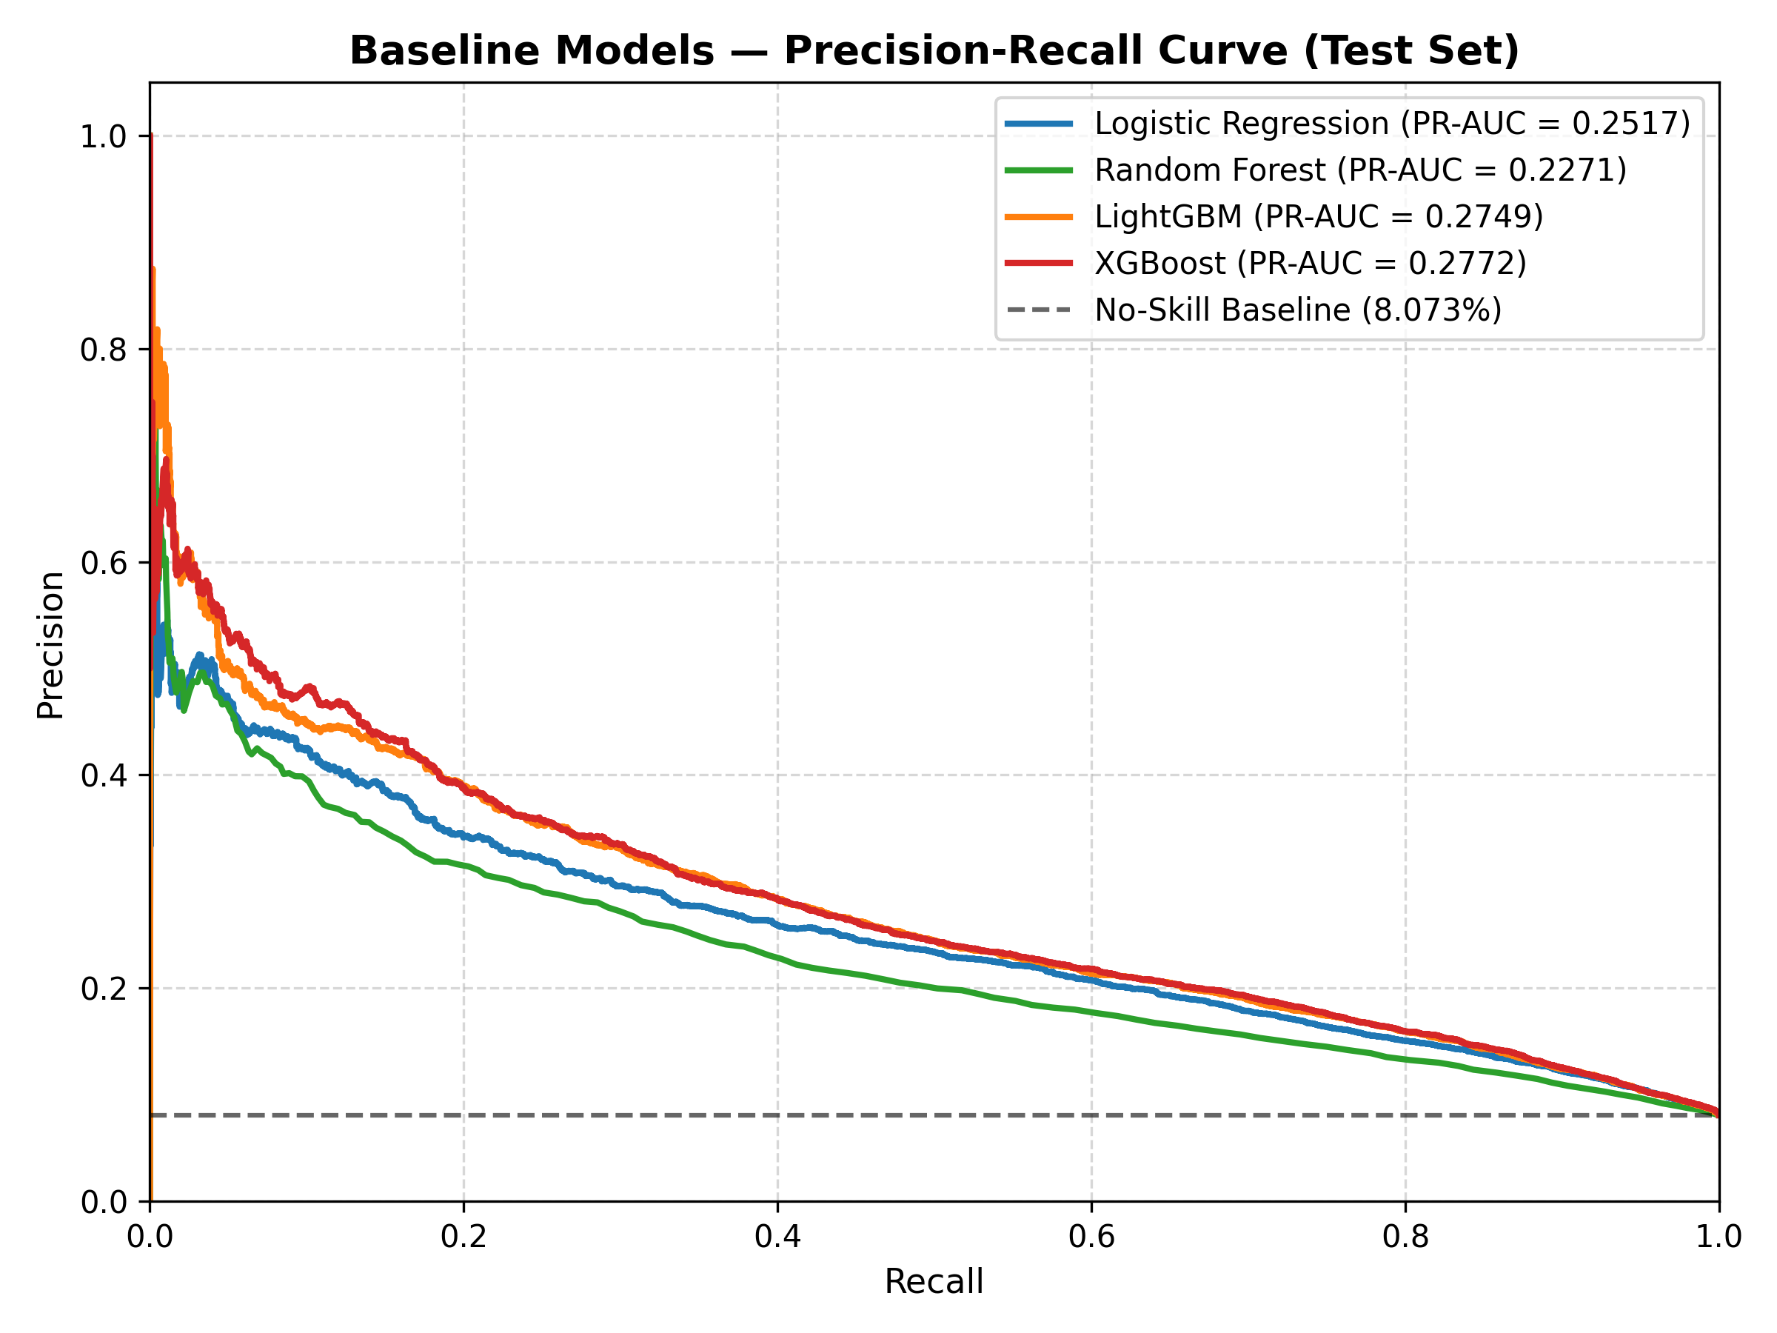
Figure 4. Precision–Recall curves of the four models on the test set
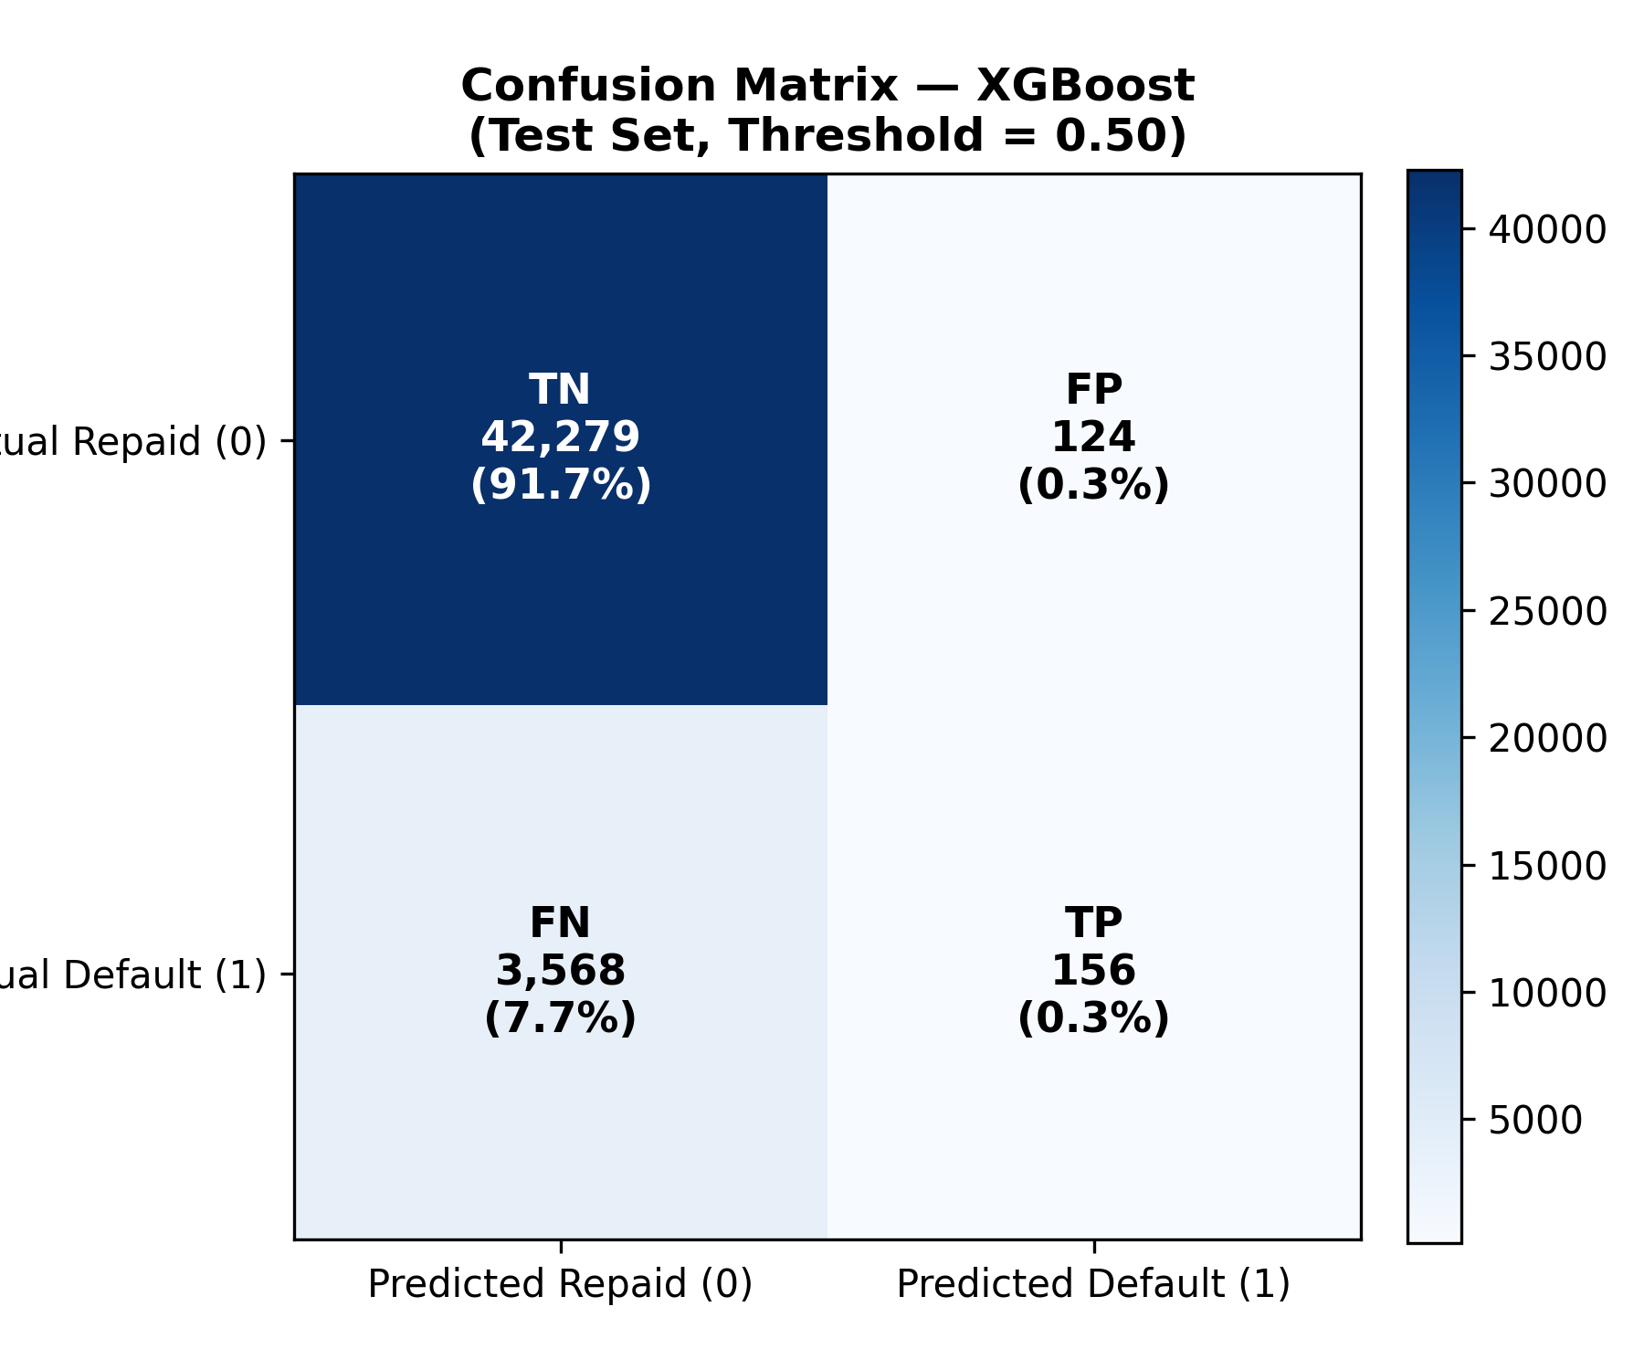
Figure 5. Confusion matrix of baseline XGBoost on the test set at threshold 0.50
Figure 5 makes the threshold issue concrete. At the default cutoff of 0.50 the baseline model flags only 280 of 46,127 test applicants as defaults and catches 156 of the 3,724 actual defaults. The remaining 3,568 defaults are classified as "repaid". Accuracy is 92.0%, almost entirely because the 42,279 true negatives dominate the count.

3.9 Classification Analysis
The training partition contains 197,880 non-defaults and 17,377 defaults, a ratio of 11.39 : 1. Three responses to this imbalance were measured.
Hyper-parameter tuning. The randomised search selected a shallower, more heavily regularised model (max_depth 3, 500 trees, min_child_weight 10). On the validation set the tuned model reaches ROC-AUC 0.7911 and PR-AUC 0.2914, against 0.7897 and 0.2896 for the Phase 7 baseline. The gain is small, which is consistent with a problem whose difficulty lies in the data rather than in the model configuration.
Class weighting. Setting scale_pos_weight to the class ratio raised test recall at the default threshold from 4.2% to 65.8%, but at the cost of precision (20.1%) and a much worse log loss (0.4968 against 0.2369): the weighted model's probabilities are no longer calibrated. Ranking performance was essentially unchanged (ROC-AUC 0.7888).
Threshold selection. Because the probabilities from the unweighted tuned model are well-ranked, the more direct response is to keep the model and move the decision threshold. Table 7 shows the operating points chosen on the validation set and evaluated on test.
Table 7. Operating points of the tuned model on the test set
Strategy | Threshold | Precision | Recall | F1 | F2
Default cutoff | 0.5000 | 0.5030 | 0.0446 | 0.0819 | 0.0545
Validation-optimal F1 | 0.17 | 0.2824 | 0.4143 | 0.3359 | 0.3789
Cost-sensitive 1 : 5 | 0.16 | 0.2697 | 0.4347 | 0.3329 | 0.3874
Validation-optimal F2 | 0.09 | 0.1971 | 0.6799 | 0.3057 | 0.4564

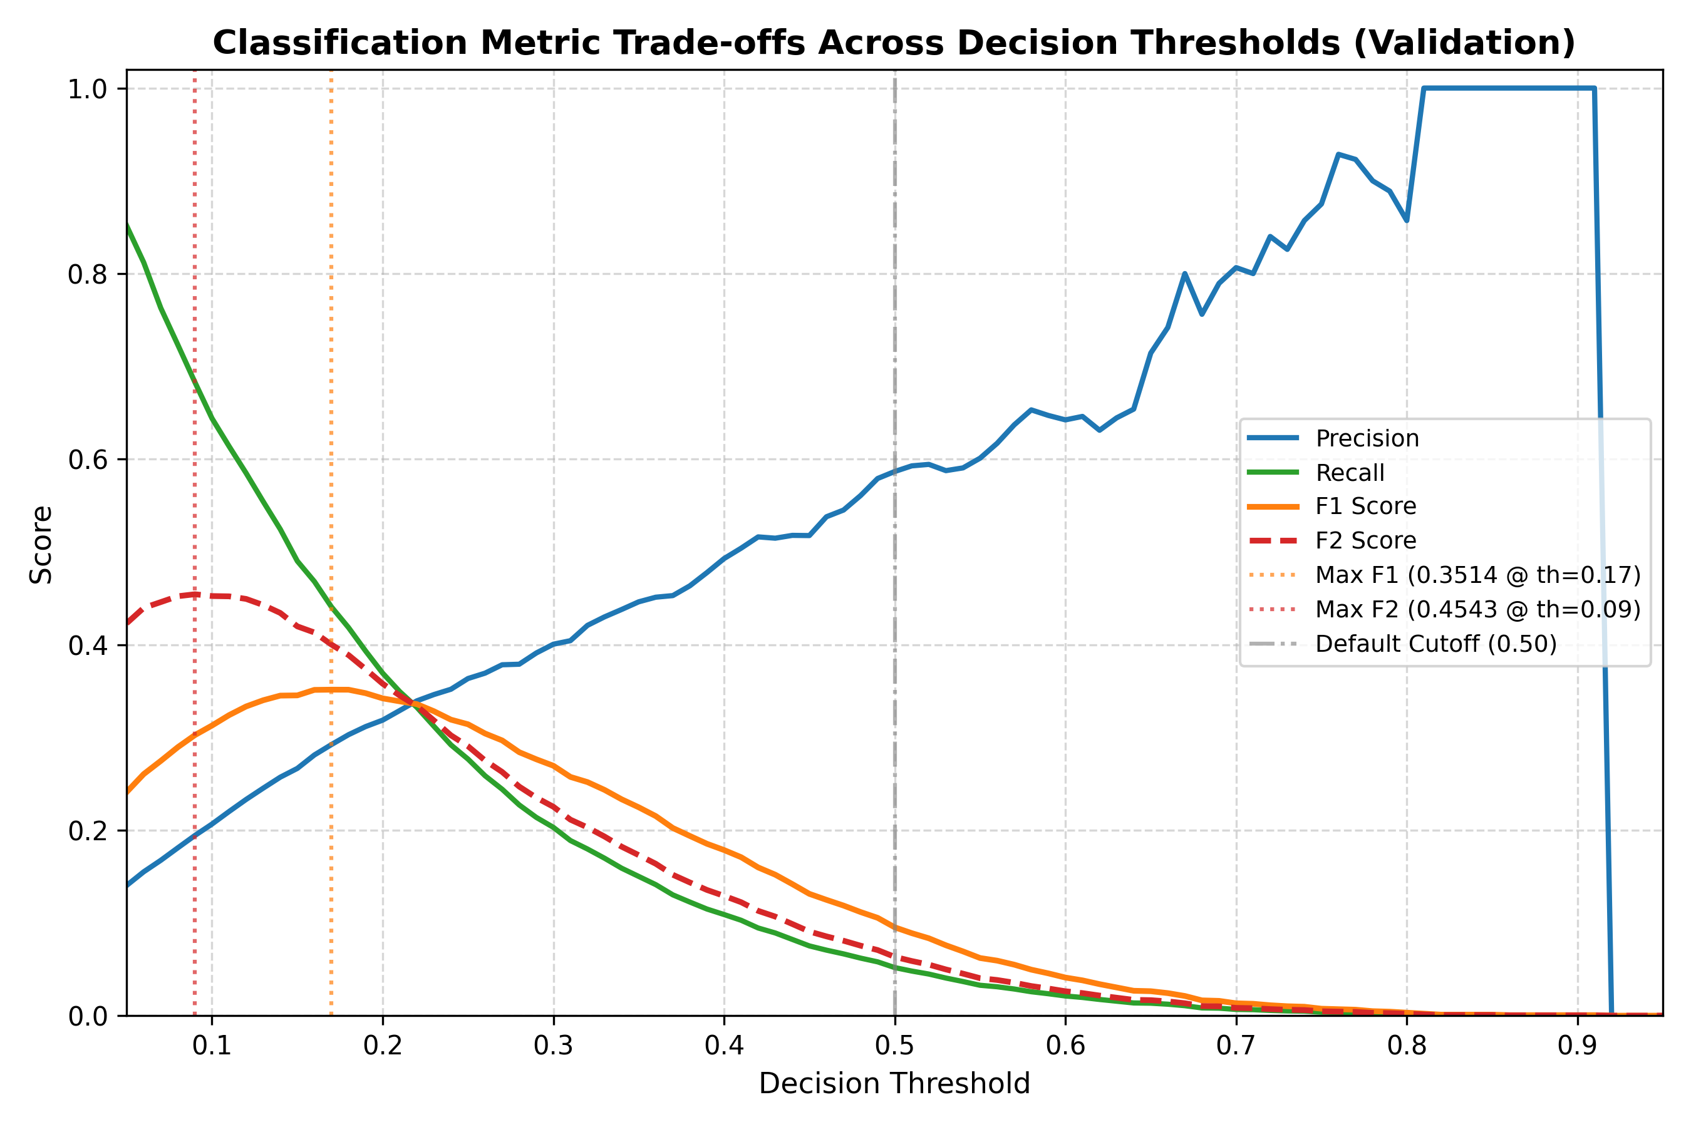
Figure 6. Precision, recall and F-scores of tuned XGBoost against decision threshold
Threshold selection is a decision problem rather than a modelling one. The F1-optimal cutoff of 0.17 balances precision and recall; the F2-optimal cutoff of 0.09 weights recall twice as heavily and catches 68.0% of test defaults while flagging roughly one applicant in four. Which point is appropriate depends on the relative cost of a missed default and a declined good customer; the cost-sensitive 1 : 5 cutoff of 0.16 encodes one such assumption. None of these choices alters ROC-AUC or PR-AUC.
Calibration. Three options were compared on the validation set (Table 8). Isotonic regression gave the lowest Brier score (0.0652 against 0.0654 uncalibrated) and the lowest log loss, and was selected. Its validation PR-AUC is slightly lower (0.2850 against 0.2914), which illustrates that calibration improves the reliability of the probabilities without necessarily improving — and sometimes slightly reducing — their ranking quality. The two are separate properties.
Table 8. Calibration methods compared on the validation set
Method | Brier score | Log loss | ROC-AUC | PR-AUC
Uncalibrated | 0.0654 | 0.2353 | 0.7911 | 0.2914
Sigmoid (Platt) | 0.0667 | 0.2422 | 0.7911 | 0.2914
Isotonic | 0.0652 | 0.2342 | 0.7928 | 0.2850

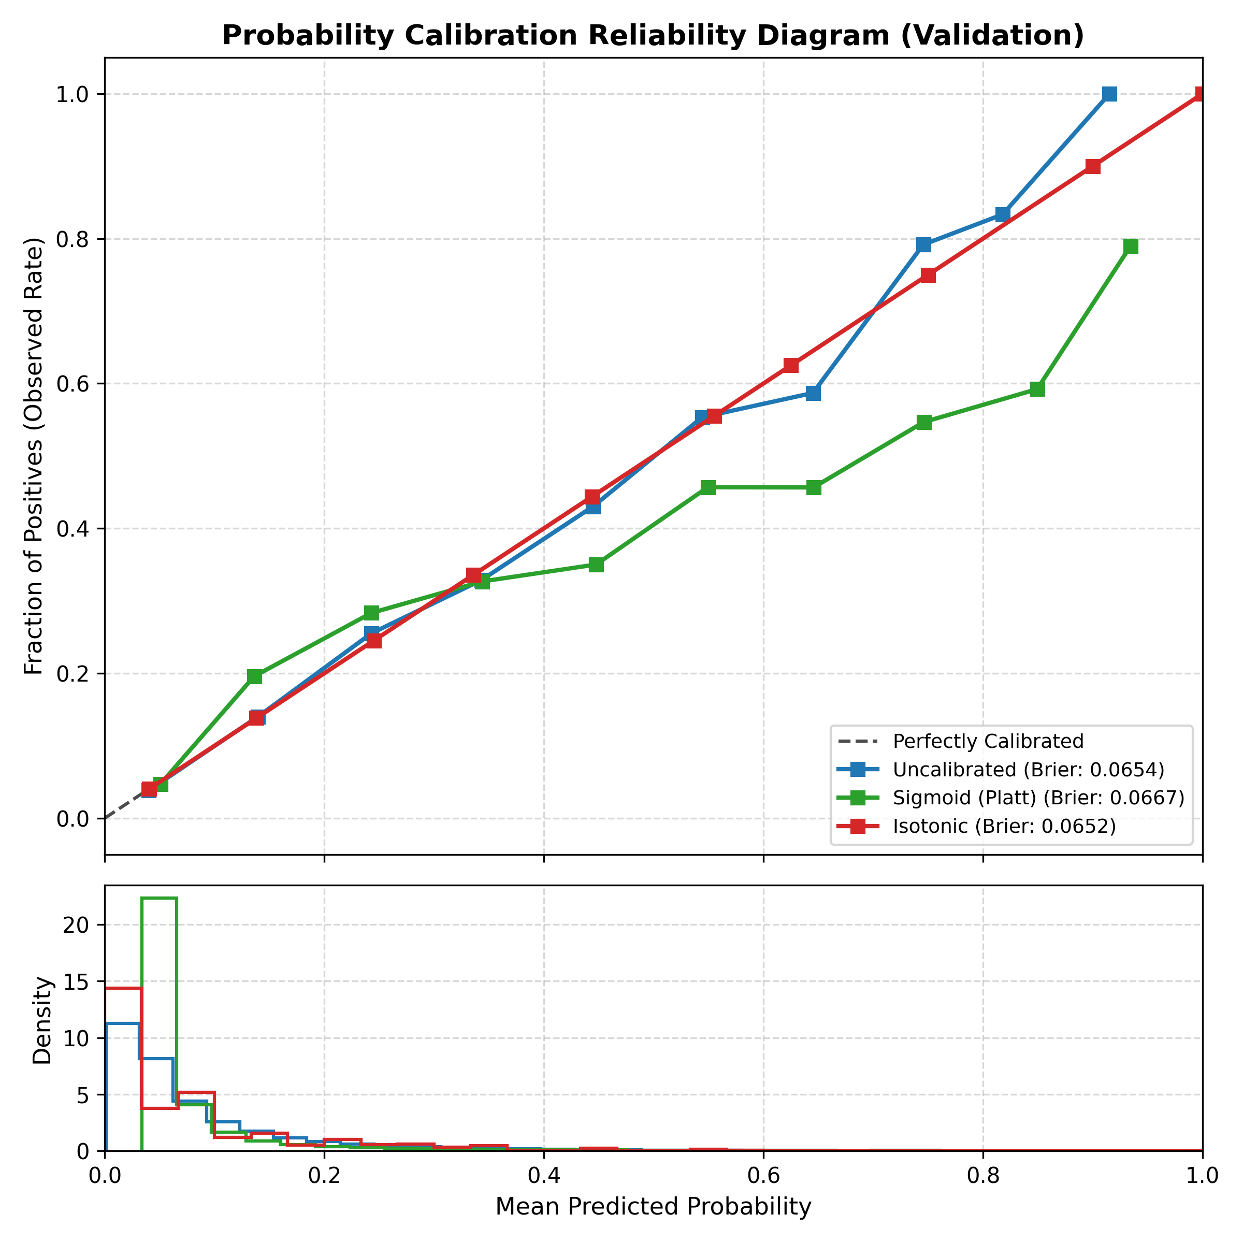
Figure 7. Reliability diagram of tuned XGBoost before and after calibration

3.10 Classification Inference
The model's output for an applicant is a probability of default. SHAP values (Shapley additive explanations, computed with shap.TreeExplainer on a validation sample of 5,000 applicants, seed 42) decompose each prediction into a contribution from every feature, so the probability can be read alongside the reasons for it. Positive SHAP values push the prediction towards default; negative values push it towards repayment. Table 9 lists the ten features with the largest mean absolute contribution across the sample.
Table 9. Top ten features by mean absolute SHAP value
Rank | Feature | Mean |SHAP| | XGBoost gain rank
1 | APP_EXT_SOURCES_MEAN | 0.4440 | 1
2 | CODE_GENDER | 0.1201 | 10
3 | POS_COMPLETION_RATE_MEAN | 0.1184 | 23
4 | APP_PAYMENT_RATE | 0.1062 | 24
5 | DERIVED_PAYMENT_DISCIPLINE_SCORE | 0.1039 | 4
6 | APP_GOODS_TO_CREDIT_RATIO | 0.0974 | 7
7 | NAME_EDUCATION_TYPE | 0.0902 | 2
8 | AMT_ANNUITY | 0.0888 | 36
9 | INST_AMT_PAYMENT_SUM | 0.0754 | 19
10 | BURO_DEBT_TO_CREDIT_RATIO | 0.0743 | 13

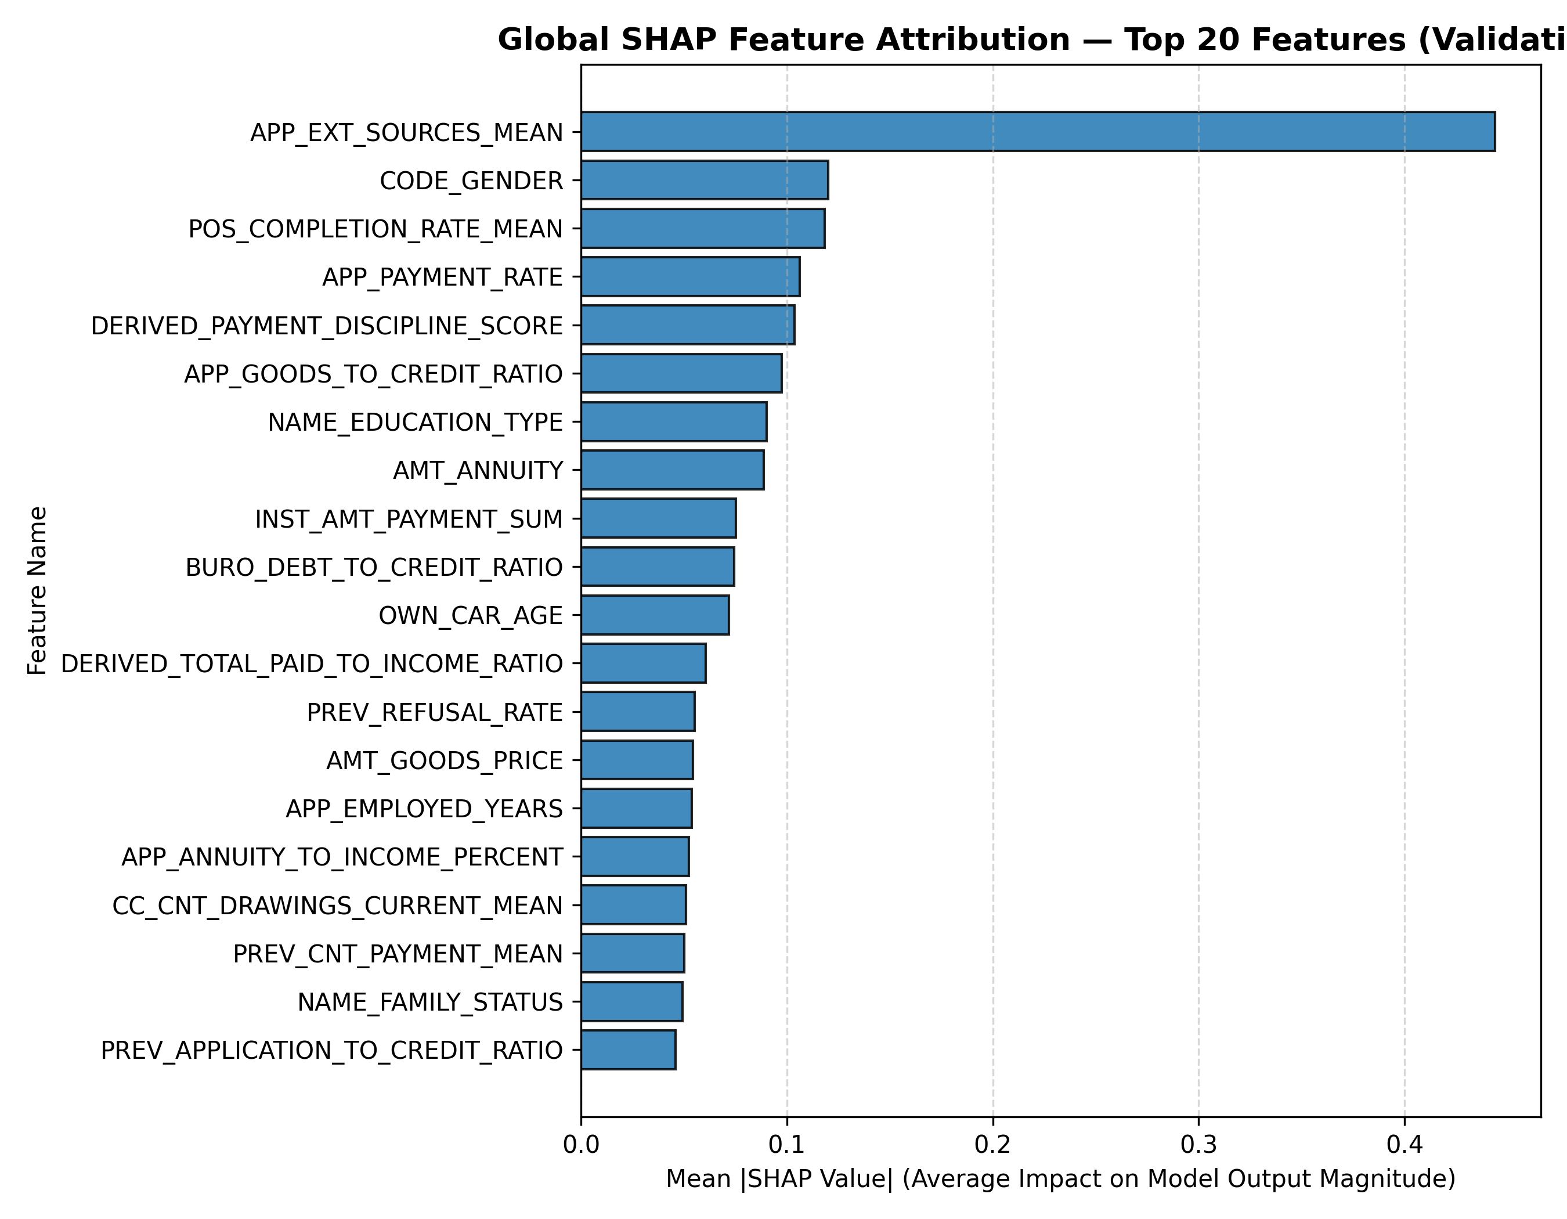
Figure 8. SHAP global importance — mean |SHAP| for the top features
The external-score mean dominates, with a mean absolute contribution more than three times that of the next feature. Several of the top ten are engineered from the history tables — POS completion rate, payment rate, payment-discipline score, instalment payment sum, bureau debt-to-credit ratio — which is direct evidence that the multi-table aggregation contributed features the model relies on. The rightmost column shows that SHAP and the model's own gain-based importance rank features differently (AMT_ANNUITY is 8th by SHAP and 36th by gain); gain measures how much a feature reduced training loss when chosen for splits, SHAP measures how much it moves actual predictions, and the two need not agree.
Table 10. Local explanations for three applicants
Applicant | P(default) | Actual | Largest risk-increasing feature | Largest risk-decreasing feature
332851 | 0.9153 | 1 | APP_EXT_SOURCES_MEAN (+1.27) | DAYS_BIRTH (-0.12)
133546 | 0.1700 | 1 | CC_CNT_DRAWINGS_CURRENT_MEAN (+0.56) | CODE_GENDER (-0.13)
183579 | 0.0013 | 0 | BURO_AMT_CREDIT_SUM_SUM (+0.17) | APP_EXT_SOURCES_MEAN (-0.98)

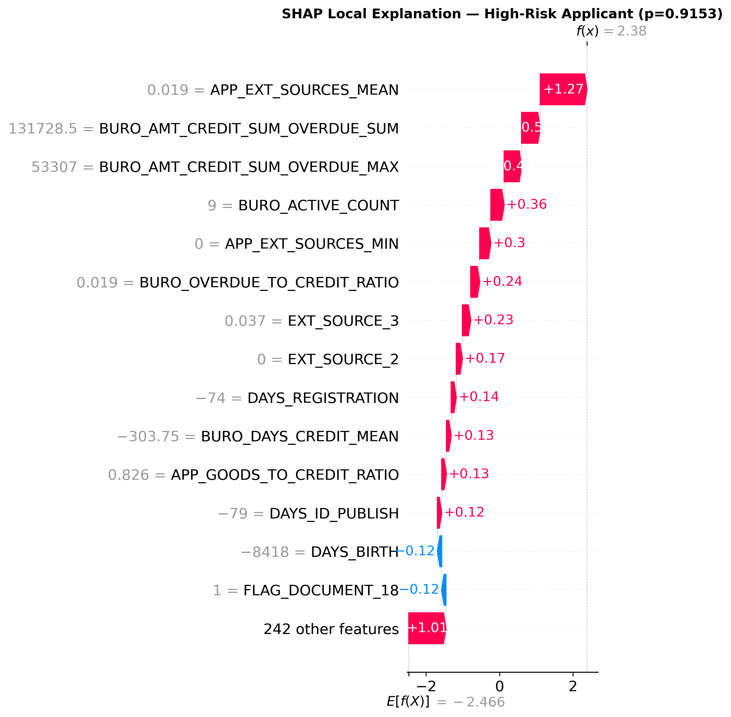
Figure 9. SHAP waterfall for the high-risk applicant (ID 332851)
Applicant 332851 received a default probability of 0.9153 and did default. The largest contribution is a very low external-score mean (0.019), followed by overdue bureau credit (131,728 in total). Applicant 183579 received 0.0013 and repaid; a high external-score mean (0.789) is the dominant risk-reducing factor. The borderline applicant 133546 at 0.1700 sits almost exactly at the F1-optimal threshold and did default, which is the kind of case where threshold choice decides the outcome.
These are analytical illustrations of how the model reaches its output, not lending decisions. SHAP attributes a prediction to features; it does not establish that changing a feature would change the real-world outcome.

4. Clustering

4.1 Clustering Problem Statement
Can applicants be grouped into meaningful segments based on their financial, demographic and historical credit characteristics, without using the known default outcome?
This is an unsupervised learning problem. No label is provided to the algorithm; it receives only applicant features and must discover structure in them. TARGET and the identifier SK_ID_CURR are excluded from the feature matrix.

4.2 Clustering Objective
The objective is segmentation rather than prediction: to find a small number of applicant groups whose members resemble one another more than they resemble members of other groups, and to describe each group in terms a credit analyst would recognise. Such segments can support portfolio analysis, differentiated product design, and exploration of where risk concentrates — the last of these being checked, after the fact, against the observed default rate.

4.3 Clustering Data Preparation
The clustering branch reads the same engineered applicant-level matrix as the classifier but is otherwise separate from the supervised pipeline. Eleven numeric features were selected to cover capacity (income, credit amount, annuity), affordability ratios, external credit scores, demographics and repayment behaviour (Table 11).
Table 11. Features used for clustering
Feature | What it measures
AMT_INCOME_TOTAL | Annual income
AMT_CREDIT | Loan amount requested
AMT_ANNUITY | Annual repayment amount
APP_EXT_SOURCES_MEAN | Mean of the three external credit scores
APP_PAYMENT_RATE | Annuity / credit — the fraction repaid per year
APP_GOODS_TO_CREDIT_RATIO | Price of goods / credit amount
APP_AGE_YEARS | Applicant age
APP_EMPLOYED_YEARS | Years in current employment
BURO_DEBT_TO_CREDIT_RATIO | Outstanding bureau debt / bureau credit
POS_COMPLETION_RATE_MEAN | Share of POS loans completed
DERIVED_PAYMENT_DISCIPLINE_SCORE | Engineered on-time payment score

Missing values were imputed with the column median. The four monetary and ratio columns with long upper tails were clipped at the 99.5th percentile so that a handful of extreme incomes could not form clusters of their own. All features were then standardised with StandardScaler, which is necessary because K-Means measures Euclidean distance: without scaling, income in hundreds of thousands would dominate ratios that lie between 0 and 1.

4.4 Clustering Model
K-Means was used. It partitions the standardised feature space into K groups by assigning each applicant to the nearest of K centroids and moving the centroids to the mean of their members until the assignment stabilises. It suits this assignment because it is simple to explain, scales linearly in the number of applicants, works directly on standardised numeric features, and produces centroids that can be read as a profile of each segment.

4.5 Model Justification
Three families were considered. Hierarchical clustering builds a tree of merges and gives a dendrogram, but its standard implementation needs a pairwise distance matrix that grows with the square of the number of applicants — infeasible at 307,511 rows without sampling. DBSCAN finds arbitrarily shaped dense regions and marks outliers, but on standardised financial features the data form a continuum rather than well-separated dense regions, and its two parameters are hard to set defensibly. K-Means runs on the full dataset without sampling, has a single parameter that can be chosen by measurement, and its centroids provide the profile table that the cluster analysis requires. It was chosen on those grounds.

4.6 Clustering Implementation
Listing 8. Feature selection, TARGET exclusion, imputation, clipping and scaling src/ml/clustering.py
table = pq.read_table(model_input_path,
columns=["SK_ID_CURR", "TARGET"] + features)
df = table.to_pandas()
X_raw = df[features].copy() # strictly excludes SK_ID_CURR and TARGET
imputer = SimpleImputer(strategy="median")
X_imputed = pd.DataFrame(imputer.fit_transform(X_raw), columns=features)
for col in ["AMT_INCOME_TOTAL", "AMT_CREDIT", "AMT_ANNUITY",
"BURO_DEBT_TO_CREDIT_RATIO"]:
X_imputed[col] = X_imputed[col].clip(upper=X_imputed[col].quantile(0.995))
X_scaled = StandardScaler().fit_transform(X_imputed)
Listing 8 builds the clustering matrix. TARGET is read only so that it can be used for the post-hoc analysis in Section 4.10; the feature matrix X_raw is built from the eleven selected columns alone.
Listing 9. Evaluating K from 2 to 8 src/ml/clustering.py
for k in range(2, 9):
km = KMeans(n_clusters=k, random_state=42, n_init=10)
km.fit(X_scaled)
labels_sample = km.predict(X_sample) # 25,000-row sample
sil = silhouette_score(X_sample, labels_sample)
records.append({"k": k, "inertia": km.inertia_, "silhouette_score": sil})
Listing 9 fits K-Means for every candidate K and records inertia (within-cluster sum of squares) on the full data and the silhouette score on a 25,000-row sample, because the silhouette computation is quadratic in sample size.
Listing 10. Fitting the selected model, PCA projection and cluster profiling src/ml/clustering.py
km = KMeans(n_clusters=k, random_state=42, n_init=10)
df["cluster"] = km.fit_predict(X_scaled)
coords = PCA(n_components=2, random_state=42).fit_transform(X_scaled)
df["pca_x"], df["pca_y"] = coords[:, 0], coords[:, 1]
profile = df.groupby("cluster")[features].mean()
profile["count"] = df.groupby("cluster").size()
# Post-hoc TARGET analysis (strictly NOT used in cluster generation)
profile["default_rate_pct"] = df.groupby("cluster")["TARGET"].mean() * 100
Listing 10 fits the final model, projects the standardised features to two principal components for visualisation only, and computes the per-cluster mean of every feature. The default rate is appended last, after the clusters exist.

4.7 Selection of Number of Clusters
Table 12. Inertia and silhouette score for K = 2 to 8
K | Inertia | Silhouette score
2 | 2,910,482 | 0.1505
3 | 2,680,611 | 0.1171
4 | 2,535,097 | 0.1138
5 | 2,394,055 | 0.1189
6 | 2,219,875 | 0.1122
7 | 2,103,617 | 0.1162
8 | 2,012,210 | 0.1167

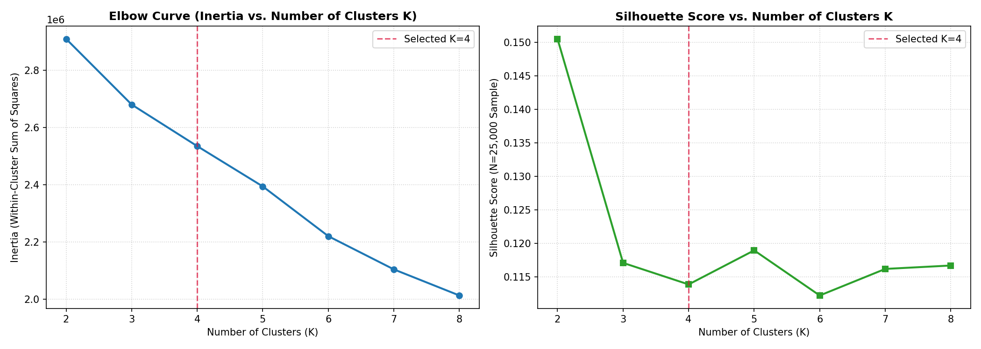
Figure 10. Elbow curve and silhouette score for K = 2 to 8
K = 4 was used for the final model. The evidence for that choice needs to be stated carefully. The silhouette score is highest at K = 2 (0.1505) and lower for every larger K, settling into a narrow band between 0.1122 and 0.1189 from K = 3 onwards; K = 4 scores 0.1138. Inertia falls steadily without a sharp elbow. Two conclusions follow. First, all silhouette values are low, which means the applicants form a continuum in this feature space rather than well-separated groups; any K imposes boundaries on that continuum. Second, within the flat region from K = 3 to 8 the silhouette does not discriminate between candidates, so the choice among them rests on interpretability.
K = 2 was not adopted because a two-way split of a loan book offers little segmentation value. K = 4 was chosen as the smallest K within the plateau that yields distinct, nameable profiles (Section 4.9), and the post-hoc analysis in Section 4.10 shows that those four segments differ materially in observed default rate, which is evidence that the partition captures structure relevant to the business question even though its geometric separation is weak. A reader preferring the strict silhouette criterion would choose K = 2; the full evaluation table is reported so that the trade-off is visible.

4.8 Clustering Results
Table 13. Cluster sizes
Cluster | Applicants | Share of population
0 | 91,837 | 29.9%
1 | 98,997 | 32.2%
2 | 44,555 | 14.5%
3 | 72,122 | 23.5%

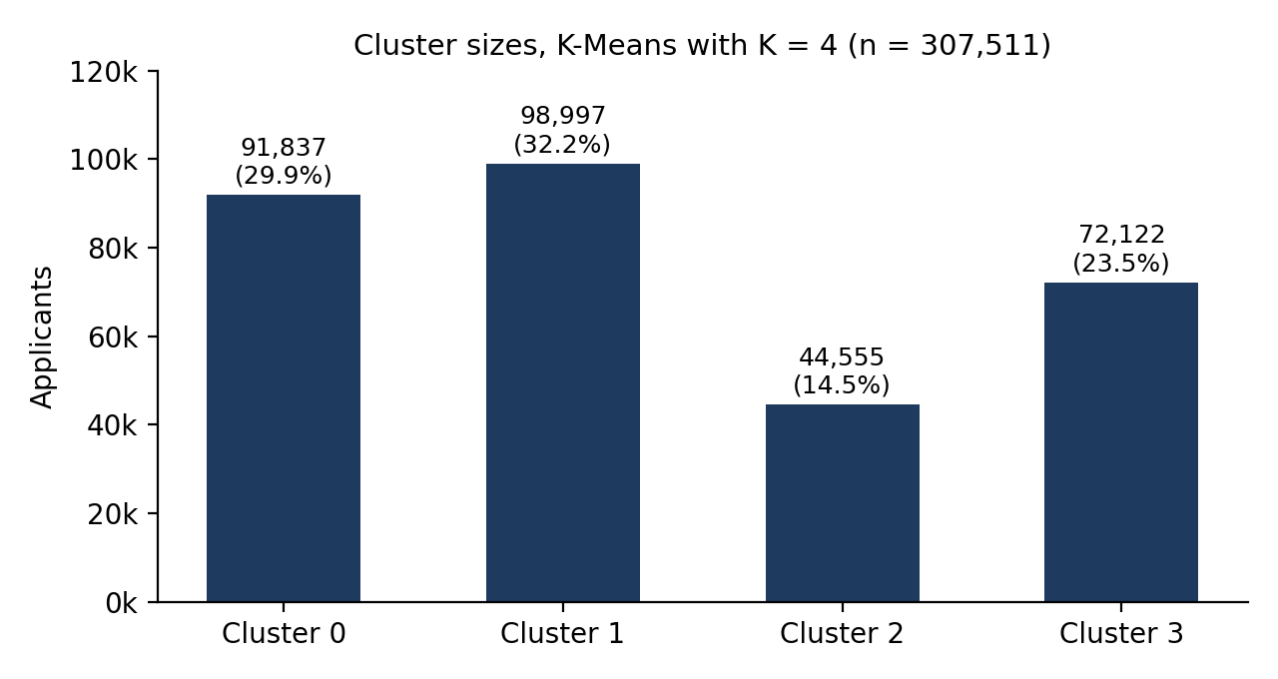
Figure 11. Cluster sizes for K-Means with K = 4
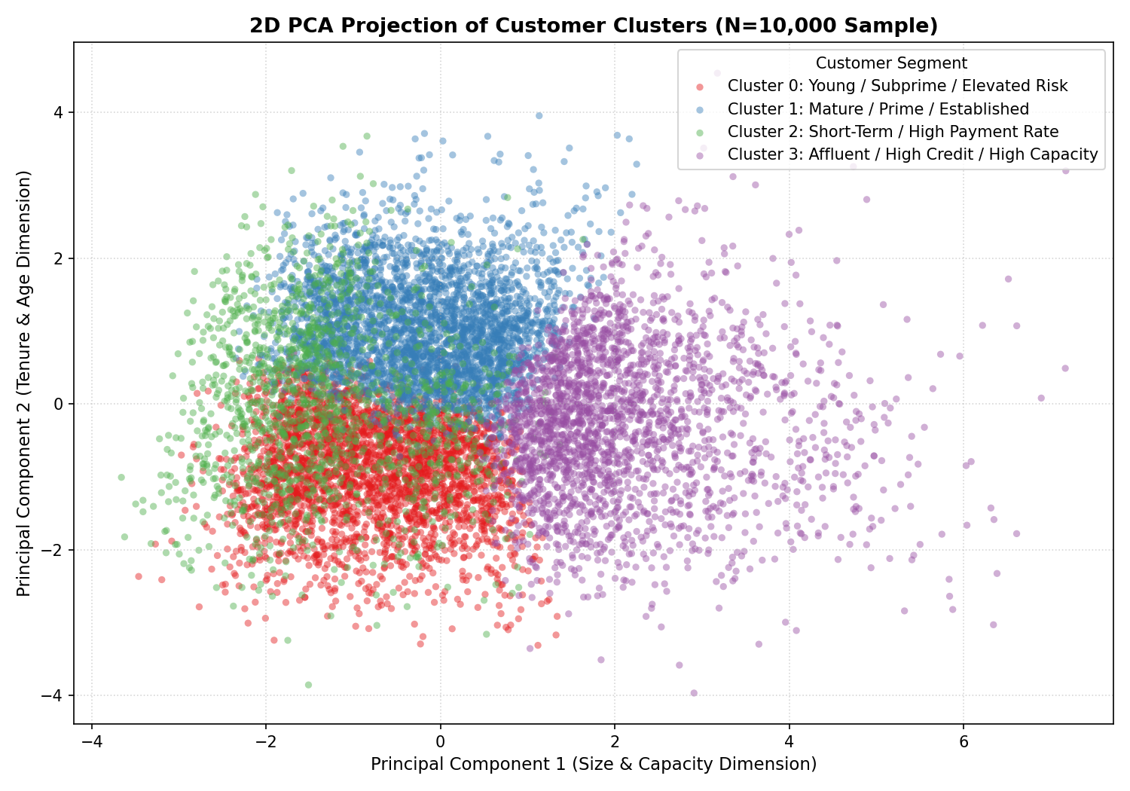
Figure 12. PCA projection of the clustered applicants
The four clusters range from 14.5% to 32.2% of applicants; no cluster is a residual catch-all and none is dominated by outliers. Figure 12 projects the eleven standardised features onto their first two principal components. The projection is for visualisation only — the clusters were fitted in the full eleven-dimensional space — and the overlap it shows is consistent with the low silhouette values: the segments are regions of a continuum, not islands.

4.9 Cluster Analysis
Table 14. Cluster profiles (mean of each feature per cluster)
Feature | Cluster 0 | Cluster 1 | Cluster 2 | Cluster 3
Income | 146,337 | 136,355 | 148,640 | 254,385
Credit amount | 453,799 | 494,793 | 255,503 | 1,139,244
Annuity | 21,623 | 20,802 | 24,048 | 44,640
External score (mean) | 0.395 | 0.571 | 0.529 | 0.558
Payment rate | 0.051 | 0.045 | 0.096 | 0.042
Goods / credit ratio | 0.889 | 0.891 | 0.931 | 0.910
Age (years) | 34.149 | 52.650 | 43.900 | 44.336
Employed (years) | 3.843 | 9.751 | 6.075 | 7.334
Bureau debt / credit | 0.384 | 0.247 | 0.228 | 0.271
POS completion rate | 0.418 | 0.379 | 0.435 | 0.409
Payment discipline score | 0.885 | 0.958 | 0.893 | 0.947

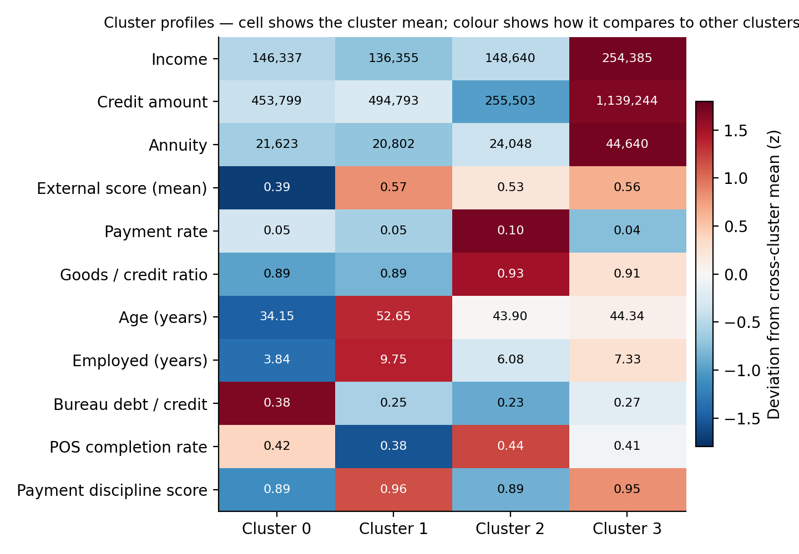
Figure 13. Cluster profiles across the eleven clustering features
Cluster 0 (91,837 applicants, 29.9%) is the youngest group (mean age 34.1) with the shortest employment (3.8 years), the lowest external-score mean (0.39) and the highest bureau debt-to-credit ratio (0.38). Income and loan size are around the population average.
Cluster 1 (98,997, 32.2%) is the oldest (mean age 52.6) and longest-employed (9.8 years) group, with the highest external-score mean (0.57) and the highest payment-discipline score (0.96). Its income is slightly below average.
Cluster 2 (44,555, 14.5%) takes the smallest loans (mean credit 255,503) at the highest payment rate (0.096), meaning shorter, faster-repaid credit, with the highest goods-to-credit ratio (0.93).
Cluster 3 (72,122, 23.5%) has by far the highest income (254,385), credit amount (1,139,244) and annuity (44,640) — roughly double the other clusters on each — with external scores and payment discipline close to Cluster 1.

4.10 Clustering Inference
Read from their statistics alone, the four segments can be named as follows.
- Cluster 0 — Younger, lower-score, higher-burden applicants. Early in their working life, with weaker external credit scores and proportionally more existing debt.
- Cluster 1 — Established, high-score applicants. Older, long-employed, with the strongest external scores and repayment record.
- Cluster 2 — Small, short-term borrowers. Modest loans repaid at a high annual rate.
- Cluster 3 — High-capacity, high-exposure borrowers. Substantially higher income taking substantially larger loans.
Table 15. Post-hoc default rate by cluster
Cluster | Applicants | Observed default rate
0 | 91,837 | 14.26%
1 | 98,997 | 5.02%
2 | 44,555 | 6.09%
3 | 72,122 | 5.61%

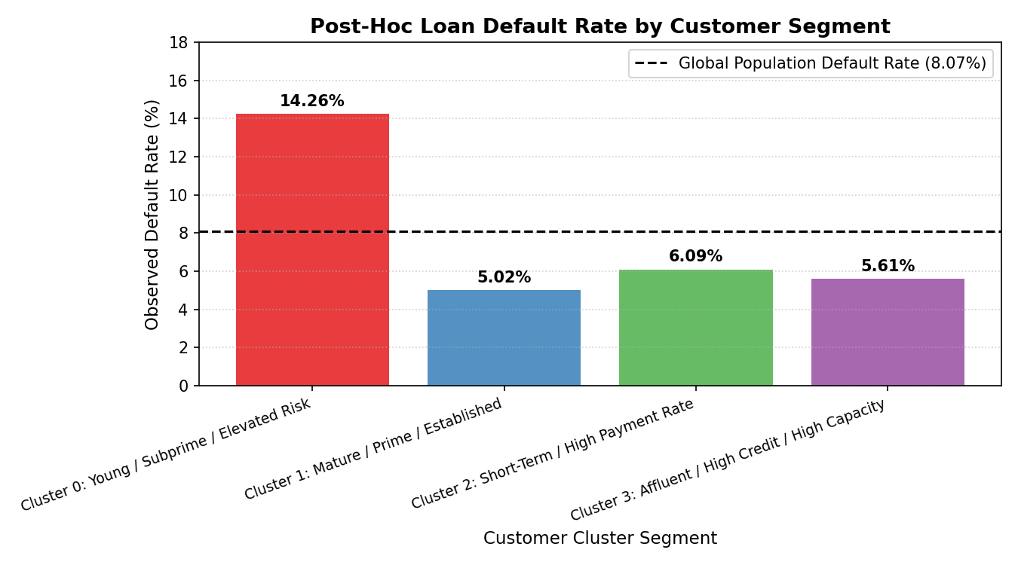
Figure 14. Post-hoc default rate by cluster
TARGET was not used to construct the clusters. It is examined here only after clustering, to see whether the independently derived segments differ in observed outcome. They do: Cluster 0's default rate of 14.26% is 2.8 times that of Cluster 1 (5.02%), with Clusters 2 and 3 in between at 6.09% and 5.61%. This is consistent with the classifier's SHAP ranking, in which the external-score mean is the most influential feature: the segment with the weakest scores is the one that defaults most. The association is descriptive, not causal — the clustering has identified a group in which defaults concentrate, not a mechanism that causes them.

5. Overall Analysis and Discussion
Table 16. Classification and clustering compared
Aspect | Classification | Clustering
Objective | Predict default | Segment applicants
Learning | Supervised | Unsupervised
TARGET | Used as the label | Excluded; examined post hoc only
Model | XGBoost (selected from four) | K-Means, K = 4
Features | 256 engineered features | 11 selected numeric features
Output | Probability of default and a class at a chosen threshold | Cluster membership
Evaluation | ROC-AUC, PR-AUC, log loss; precision, recall, F1 at a threshold | Inertia, silhouette score; post-hoc default rate
Business use | Risk scoring of an individual application | Portfolio and customer segmentation

The two approaches answer different questions from the same applicant-level matrix. Classification answers the question of who is likely to default — it scores an individual application and the lender acts on that score. Clustering answers the question of what types of applicants exist — it describes the population and the lender uses the description for planning. They are complementary rather than competing: the classifier can score a cluster's members and the clusters can explain where the classifier's high-risk predictions concentrate. In this project the two agree on the central fact of the data — the external credit scores carry most of the signal — through independent routes, one supervised and one not.
The Big Data component is the shared foundation. Neither model could have been trained without first reducing 58,489,893 rows across eight tables to 307,511 applicant rows with aggregated history. That reduction was performed with Spark using an aggregate-before-join pattern, Parquet storage at every layer, and row-count assertions at every join. The implementation ran on a single machine in Spark's local mode; the execution model is the same one that would run on a cluster, but no claim is made here about multi-node performance.

6. Assignment Requirement Mapping
Table 17. Assignment requirement coverage
Assignment requirement | Report section | Evidence
Classification — Problem Statement | 3.1, 3.2 | Binary default prediction, inputs, target and output defined
Classification — Model and justification | 3.4, 3.5 | Four models; dataset-specific rationale
Classification — Coding | 3.6, Appendix | Listings 1–7 from the project source
Classification — Results | 3.8 | Tables 5–8; Figures 2–7
Classification — Inference | 3.9, 3.10 | Threshold analysis; SHAP global and local explanations
Classification — Implementation URL | 8 | github.com/TSR0705/BIG_DATA_PROJECT
Clustering — Problem Statement | 4.1, 4.2 | Unsupervised segmentation without TARGET
Clustering — Model and justification | 4.4, 4.5 | K-Means; alternatives compared
Clustering — Coding | 4.6, Appendix | Listings 8–10 from the project source
Clustering — Results | 4.7, 4.8 | Elbow and silhouette; cluster sizes; PCA projection
Clustering — Inference | 4.9, 4.10 | Cluster profiles; named segments; post-hoc default rate
Clustering — Implementation URL | 8 | github.com/TSR0705/BIG_DATA_PROJECT
Presentation — Model Selection | 3.7, 4.7 | Measured comparison tables and the selection rationale
Presentation — Coding / Implementation | 3.6, 4.6 | Spark ETL and ML source excerpts
Presentation — Results, Analysis, Inference | 3.8–3.10, 4.8–4.10 | Metrics, figures and interpretation

7. Conclusion
The classification problem — predicting whether a loan applicant will default from application and historical credit data — was addressed by assembling 58,489,893 rows across eight tables into a 307,511-row applicant matrix with Spark, and comparing four supervised models on a stratified split. XGBoost was selected on measured ranking performance, reaching a test ROC-AUC of 0.7893 and PR-AUC of 0.2772 at baseline, and 0.7898 and 0.2790 after tuning. The analysis of imbalance showed that the decision threshold, not the model, governs the precision–recall trade-off: moving it from 0.50 to 0.17 raised test recall from 4.5% to 41.4% with no change to ROC-AUC. SHAP analysis identified the external-score mean as the dominant predictor and showed that several of the most influential features were built from the aggregated history tables.
The clustering problem — segmenting applicants without the outcome label — was addressed with K-Means on eleven standardised features. K = 4 was adopted from a flat silhouette plateau on interpretability grounds, and the resulting segments are distinct in age, employment, external score, loan size and credit burden. A post-hoc check found that the youngest, lowest-score, highest-burden segment defaults at 14.3%, nearly three times the rate of the established high-score segment, even though no outcome information entered the clustering.
The two components together show the value of the engineered applicant-level matrix: a supervised model and an unsupervised model, built on it independently, converge on the same structure in the data.

8. Implementation and Repository
GitHub repository: https://github.com/TSR0705/BIG_DATA_PROJECT
All source code, configuration, phase reports, figures and the trained model metadata are in the repository. The raw dataset is not redistributed; it is downloaded from Kaggle into dataset/.
The stack is Python 3.11 with Apache Spark 3.5 (PySpark, local mode) for ingestion and feature engineering, Parquet with Snappy compression for storage, scikit-learn 1.6.1, XGBoost 3.2.0 and LightGBM 4.7.0 for classification, SHAP (TreeExplainer) for explainability, scikit-learn KMeans and PCA for clustering, and Matplotlib for the figures. Listing 11 reproduces the assignment results from the repository root.
Listing 11. Reproduction commands scripts/
python scripts/run_phase2_bronze.py # CSV -> typed Parquet
python scripts/run_phase3_silver.py # cleaning and data-quality checks
python scripts/run_phase4_gold.py # aggregate-before-join to applicant grain
python scripts/run_phase5_features.py # feature engineering and leakage audit
python scripts/run_phase6_split.py # stratified 70/15/15 split, preprocessing
python scripts/run_phase7_baseline.py # four-model comparison (Section 3.7)
python scripts/run_phase8_optimization.py # tuning, thresholds, calibration (3.8-3.9)
python scripts/run_phase9_explainability.py # SHAP (3.10)
python scripts/run_clustering.py # K-Means evaluation and profiling (Section 4)
Each script writes its report under reports/ and its figures under reports/figures/; the tables in this document were read from those files.

References
Home Credit Group (2018). Home Credit Default Risk. Kaggle. https://www.kaggle.com/c/home-credit-default-risk
Chen, T. and Guestrin, C. (2016). XGBoost: A scalable tree boosting system. Proceedings of the 22nd ACM SIGKDD International Conference on Knowledge Discovery and Data Mining, 785–794.
Ke, G. et al. (2017). LightGBM: A highly efficient gradient boosting decision tree. Advances in Neural Information Processing Systems 30.
Lundberg, S. M. and Lee, S.-I. (2017). A unified approach to interpreting model predictions. Advances in Neural Information Processing Systems 30.
Pedregosa, F. et al. (2011). Scikit-learn: Machine learning in Python. Journal of Machine Learning Research 12, 2825–2830.
Zaharia, M. et al. (2016). Apache Spark: A unified engine for big data processing. Communications of the ACM 59(11), 56–65.
Rousseeuw, P. J. (1987). Silhouettes: A graphical aid to the interpretation and validation of cluster analysis. Journal of Computational and Applied Mathematics 20, 53–65.
Saito, T. and Rehmsmeier, M. (2015). The precision-recall plot is more informative than the ROC plot when evaluating binary classifiers on imbalanced datasets. PLoS ONE 10(3).

Appendix — Selected Code
Fuller excerpts of the implementation referenced in Sections 3.6 and 4.6, reproduced from the repository without modification beyond trimming of logging statements.
Listing 12. Bronze ingestion with schema validation and Parquet read-back src/ingestion/bronze.py
df_csv: DataFrame = (
spark.read
.option("header", "true")
.option("quote", "\"")
.option("escape", "\"")
.schema(expected_schema)
.csv(csv_path)
)
source_count = df_csv.count()
expected_ref = PHASE1_EXPECTED_COUNTS.get(name)
if expected_ref is not None and source_count != expected_ref:
raise AssertionError(f"[{name}] Source count {source_count} != Phase 1 {expected_ref}")
(df_csv.repartition(target_partitions)
.write.mode("overwrite").option("compression", "snappy").parquet(bronze_path))
bronze_df: DataFrame = spark.read.parquet(bronze_path)
bronze_count = bronze_df.count()
if bronze_count != source_count:
raise AssertionError(
f"[{name}] Row count mismatch! Source CSV has {source_count:,} rows, "
f"but Bronze Parquet has {bronze_count:,} rows."
)
Every table is read with a frozen schema, written as Parquet, read back, and its row count compared to both the source and the Phase 1 profile.
Listing 13. Safe division and bureau-balance aggregation src/features/gold.py
def safe_divide(numerator: Column, denominator: Column) -> Column:
"""Safe division returning NULL when denominator is NULL, 0, or NaN."""
return F.when(
(denominator.isNotNull()) & (denominator != 0) & (~F.isnan(denominator)),
numerator / denominator,
).otherwise(None)
def aggregate_bureau_balance(df_bb: DataFrame) -> DataFrame:
"""Aggregate bureau_balance from (SK_ID_BUREAU, MONTHS_BALANCE) grain to SK_ID_BUREAU grain."""
return df_bb.groupBy("SK_ID_BUREAU").agg(
F.count("*").alias("BURO_BAL_MONTH_COUNT"),
F.min("MONTHS_BALANCE").alias("BURO_BAL_MONTHS_MIN"),
F.max("MONTHS_BALANCE").alias("BURO_BAL_MONTHS_MAX"),
F.sum(F.when(F.col("STATUS") == "0", 1).otherwise(0)).alias("BURO_BAL_STATUS_0_COUNT"),
F.sum(F.when(F.col("STATUS") == "C", 1).otherwise(0)).alias("BURO_BAL_STATUS_C_COUNT"),
F.sum(F.when(F.col("STATUS") == "X", 1).otherwise(0)).alias("BURO_BAL_STATUS_X_COUNT"),
F.sum(F.when(F.col("STATUS").isin("1", "2", "3", "4", "5"), 1).otherwise(0)).alias("BURO_BAL_DPD_COUNT"),
).withColumn(
"BURO_BAL_DPD_RATIO",
safe_divide(F.col("BURO_BAL_DPD_COUNT"), F.col("BURO_BAL_MONTH_COUNT")),
)
The monthly status history is reduced to counts per loan, including a days-past-due ratio; the same pattern is applied to the other five history tables.
Listing 14. Join audit loop src/features/gold.py
def join_features_to_spine(spine_df, feature_tables, spine_name="application_train"):
"""Sequentially left-join applicant-level feature DataFrames onto application spine.
Strictly enforces zero row explosion (output rows == spine rows)."""
current_df = spine_df
current_rows = current_df.count()
expected_rows = current_rows
join_audit = []
for feat_name, feat_df in feature_tables:
right_rows = feat_df.count()
joined_df = current_df.join(feat_df, on="SK_ID_CURR", how="left")
output_rows = joined_df.count()
row_increase = output_rows - current_rows
is_pass = (row_increase == 0) and (output_rows == expected_rows)
join_audit.append({
"join": f"{spine_name} + {feat_name}", "join_key": "SK_ID_CURR",
"left_rows": current_rows, "right_rows": right_rows,
"output_rows": output_rows, "row_increase": row_increase,
"status": "PASS" if is_pass else "FAIL",
})
current_df = joined_df
return current_df, join_audit
Produces the join audit summarised in Section 3.3.
Listing 15. Clustering preparation, K evaluation and profiling src/ml/clustering.py
def load_and_preprocess_clustering_data(model_input_path, features=None, clip_percentile=0.995):
table = pq.read_table(model_input_path, columns=["SK_ID_CURR", "TARGET"] + features)
df = table.to_pandas()
X_raw = df[features].copy() # strictly excludes SK_ID_CURR and TARGET
imputer = SimpleImputer(strategy="median")
X_imputed = pd.DataFrame(imputer.fit_transform(X_raw), columns=features)
for col in ["AMT_INCOME_TOTAL", "AMT_CREDIT", "AMT_ANNUITY", "BURO_DEBT_TO_CREDIT_RATIO"]:
upper_bound = X_imputed[col].quantile(clip_percentile)
X_imputed[col] = X_imputed[col].clip(upper=upper_bound)
X_scaled = StandardScaler().fit_transform(X_imputed)
return df, X_scaled
def evaluate_k_range(X_scaled, k_range=range(2, 9), sample_size=25000, random_state=42):
sample_idx = np.random.choice(len(X_scaled), size=sample_size, replace=False)
X_sample = X_scaled[sample_idx]
records = []
for k in k_range:
km = KMeans(n_clusters=k, random_state=random_state, n_init=10).fit(X_scaled)
sil = silhouette_score(X_sample, km.predict(X_sample))
records.append({"k": k, "inertia": float(km.inertia_), "silhouette_score": float(sil)})
return pd.DataFrame(records)
def fit_and_profile_clusters(df, X_scaled, k=4, random_state=42):
km = KMeans(n_clusters=k, random_state=random_state, n_init=10)
df["cluster"] = km.fit_predict(X_scaled)
coords = PCA(n_components=2, random_state=random_state).fit_transform(X_scaled)
df["pca_x"], df["pca_y"] = coords[:, 0], coords[:, 1]
profile = df.groupby("cluster")[features].mean()
profile["count"] = df.groupby("cluster").size()
profile["pct"] = (profile["count"] / len(df)) * 100
# Post-hoc TARGET analysis (strictly NOT used in cluster generation)
profile["default_rate_pct"] = df.groupby("cluster")["TARGET"].mean() * 100
return km, df, profile
The complete clustering branch.

