# 

# Hospital Management System



# Life is precious! Cherish your health! Because life matters+

**Project Team Members:**

1. **Lokesh.V (Team Leader)**
2. **UdhayaRaj**
3. **Preethi**
4. **Divya**
5. **Lenin Kumar**
6. **SarathKrishnan**

# 1.0 DOCUMENT PURPOSE

This project will automate the daily operations of LIFE LINE hospital. The project keeps track of the staff and patient (in-patient, out-patient) details. It also takes care of the ward, medical, invoice and the doctor’s appointment details. The system generates the daily ward availability, the status of the operation theatres and ICU.

The Scope of the project takes care of the details of each and every department. These details give the doctor, staffs, specialists and patient details including their salary, attendance, doctor’s appointments and the billing system. The details of Doctor and staff help the hospital to maintain the record of every person. Their attendance details help them to know about their attentive presence while salary is calculated. The billing system provides an efficient way for calculating bill details of the patients.

This project includes modules such as

1) Admission

2) Staff

3) Billing

4) Appointment

5) Doctor Details

6) Ambulance Service

# 2.0 Module Use case

**2.1 Admission**

This module records basic patient related information, which is collected when the patient visits the hospital for the first time. Each patient is allocated a unique patient identification numbers also known as Hospital No.

* Inpatient
* Outpatient

**2.1.1 Patient Details**

It keeps track of all details about both in-patient and out-patient. Patient id, patient name, address, admitted date, doctor name, room no are entered in a form and stored for future reference. Also particular patient details can be viewed in the table using a separate form with an attribute patient id.

**2.1.2 Outpatient**

This module manages activities related to patient who visits the Hospital Resident Doctor or Consultant Doctor for Medical Consultations, diagnosis and treatment

**2.1.3 Inpatient**

Admission request will be made here. Request for admission is made before patient admitting the hospital

**2.2 Staff Details:**

It keeps track of all details about doctors and staffs of the hospital. staffs, Doctors, staff id, address, qualification, cell no, e-mail are entered and stored in a separate form. Individual staff details can be viewed in the table using a separate form with attribute Staff id.

**2.3 Salary Details:**

This module contains the details salary for the doctors and nurse. This salary calculated basic salary, PF, HRA, and year increment for the staffs from date of joining automatically calculated.

**2.4 Consultation Details:**

This module contains the details for the inpatient which includes disease name, type of treatment and medicine given to them.

**2.5 Billing Details:**

This module bills the both inpatient and outpatient who comes to hospital.

This module enters and stores the details about each ward of the hospital for future reference. Individual ward detail can be viewed in the table using ward id. The attributes used in storing a ward detail is ward id, ward name, floor no, no of rooms.

**2.6 Ambulance Services:**

Another service for Ambulance availability, out time, in time, search for the ambulance went to place for petrol and fuel expenses.

# 3.0 Design and Implementation Constraints

**3.1 Database:** The system shall use the MySQL Database, which is open source and free.

**3.2 Operating System:** The Development environment shall be Windows10

**3.3 Web-Based:** The system shall be a Web-based application ASP.Net

**4.0 Define module & Functionality:**

The system functions can be described as follows:

**Registration:** When a patient is admitted, the front-desk staff checks to see if the patient is already registered with the hospital. If he is, his/her Personal Health Number (PHN) is entered into the computer. Otherwise a new Personal Health Number is given to this patient. The patient’s information such as date of birth, address and telephone number is also entered into computer system.

**Login:** When Email Id and password is matched it allows the user to dashboard or else it denies the user to Enter into Application.

**5.0 System Analysis**

System analysis is the first and foremost step performed in developing the software to solve a particular problem. In the analysis part, a software developer examines the requirements. Carrying out preliminary investigation identifies these requirements

Analysis consists of two sub phases

1. Planning
2. Requirement definition

During planning phase, cost estimates and work schedules will be planned. Requirement definition is a specification that describes the processing environment, the required software functions, performance constraints (size, speed, machine configuration) and exception handling.

**SCREENSHOTS:**

**Login Module:**



**Registration Module:**

**View 1:**

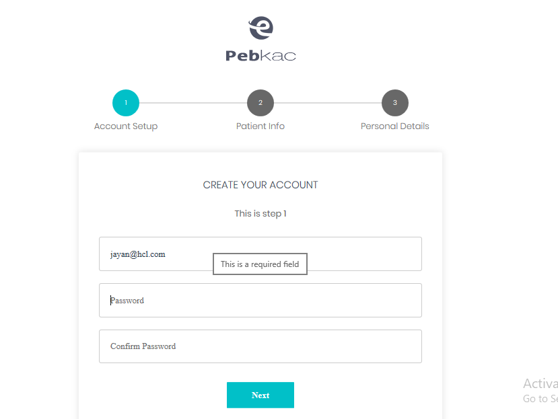

**View 2:**

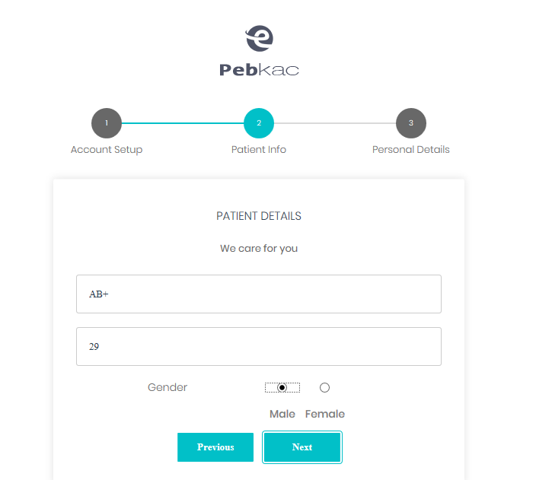

**View 3:**

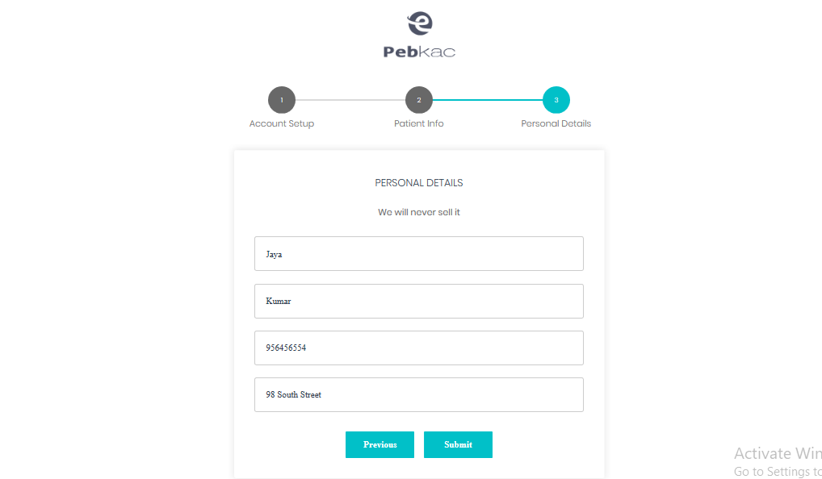

**After Login**: Its Altert a message

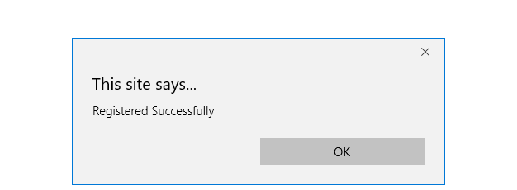

**Dashboard:**

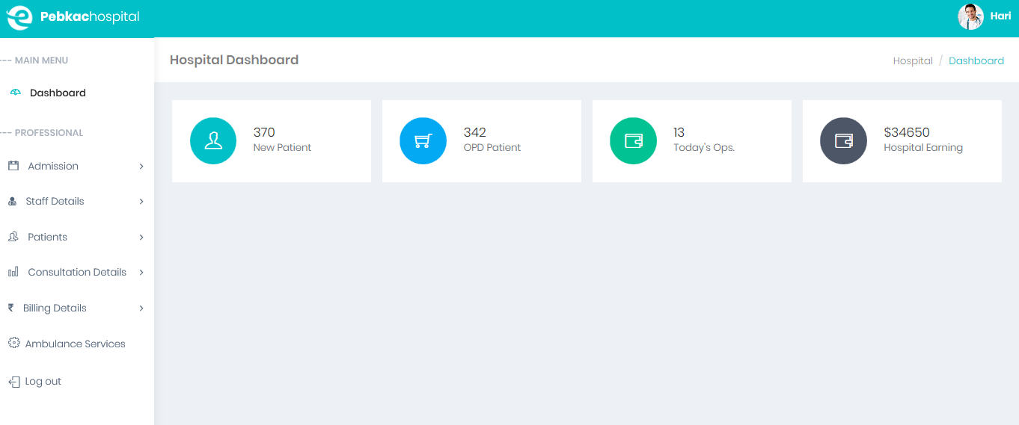

**Book Appointment:**

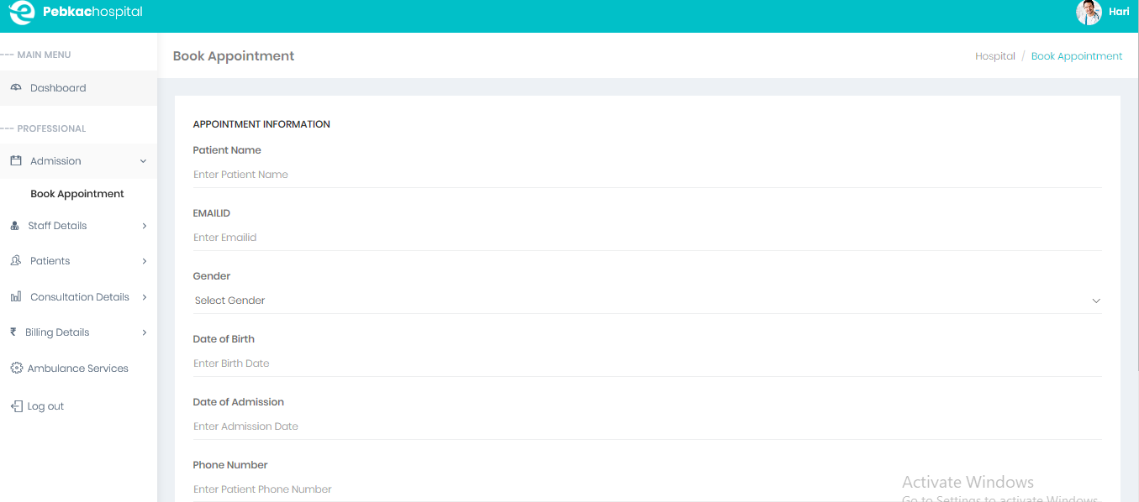

**Adding Patient Details:**

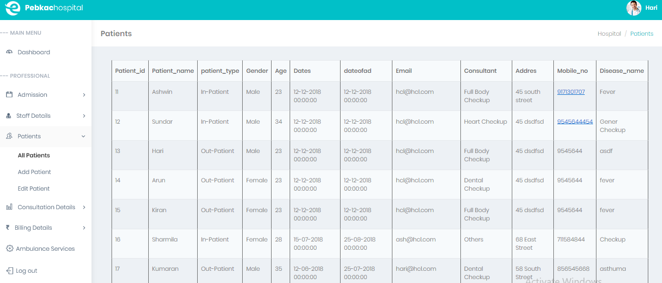

**Ambulance Details: Its Generate the Ambulance details for hospital**

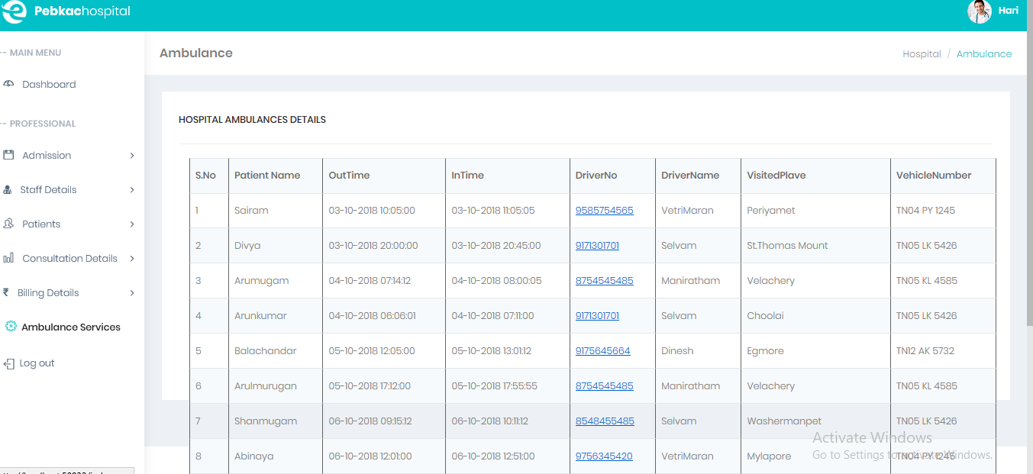

**Technical:**

1. **HTML 5**
2. **CSS**
3. **BOOTSTRAP v4**
4. **AJAX**
5. **JQUERY**
6. **SQL**
7. **ASP.NET**
8. **Validation**
9. **Grid view**
10. **Session**
11. **Master Page**

**Role for Team Members:**

* **Sarathkrishnan and Lenin Kumar Designed the DB Structure and also designed the grid view for pages**

1. Table Creation(SQL)
2. Ambulance Services
3. All Payment

* **Preethi and Divya Coded 3 Tire architecture and DB connection with each and every page**

1. Add Patient Module
2. Add Doctor Module
3. Book Appointment

* **Lokesh and UdhayaRaj Designed the each and every module of the program**

1. Login &Sign Up
2. Master Page
3. UI design

**SQL Data Table:**

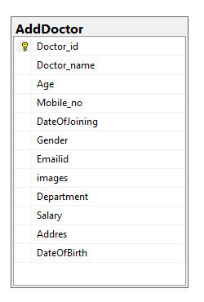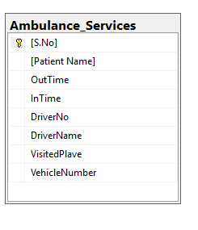

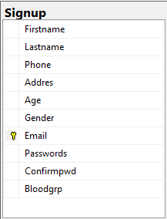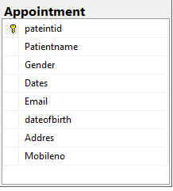

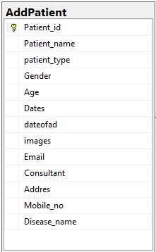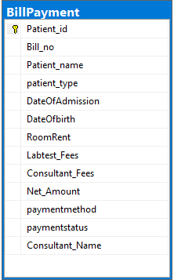

**CONCLUSION:**

1. It’s a great improvement over the manual system. The computerization of the system has speedup the process. It also provides billing facility on the basis of patient’s status whether it is an inpatient or outpatient. The system also provides the facility of backup as per the requirement.
2. It has user friendly application for hospital which reduces the burden and helps to manage all sections of hospital like Reception, Lab, In-Patient and Out-Patient, Management and Billing etc., which improve the processing efficiency.