LEARNZILLA

[Company name] | [Company address]

e-lEARNING WEB-PORTAL

2019

**LEARNZILLA E-LEARNING**

**1. DOCUMENT PURPOSE**

This document illustrates Basic Requirement Document of the **E-Learning Website** application. E-learning Website is a system used for managing the activities of an E-learning Training such as Registration Details of the user, Login/Signup, Batch Details, Course Details, Exams for the users, Feedback and Admin.

**1.1 OBJECTIVES:**

* + E-learning Process Work is fast.
  + Reduces the Time Period.
  + Paper work is removed.
  + Information stored in the database, which provides data security.

**2. HARDWARE AND SOFTWARE REQUIREMENTS:**

SOFTWARE REQUIREMENT:

* + Operating system (WINDOWS 10)
  + VISUAL STUDIO 2013 (ASP.NET)
  + SQL Server

HARDWARE REQUIREMENT:

| **COMPONENT** | **MINIMUM REQUIREMENT** |
| --- | --- |
| **Processor** | *64-bit, four-core, 2.5 GHz minimum per core (If your dataset size is significantly larger than the medium dataset, we recommend 8 cores.)* |
| **RAM** | *4 GB* |
| **Hard disk** | *80 GB* |

**4. SYSTEM ARCHITECTURE:**

E-learning System is developed using three-tier architecture. It is divided into 3 logic layers as:

• Presentation

• Business logic

• Data

**PRESENTATION TIER**

*ASP.net Web pages*

*ASP.NET web user controls*

**BUSINESS TIER**

***c# classes***

**DATA TIER**

***sql data***

**3. MODULES:**

**1. LOGIN/REGISTER**

**2. COURSE**

**3. EXERCISE**

**4. QUIZ**

**5. RESULT**

**6. FEEDBACK**

**LOGIN / REGISTER MODULE:**

Before login, we have to create user registration. After registration only login should happen. In order to store the registration details we have to use MS SQL Database. Then, we have to create table for user registration.

**Table for user registration:**

**Table Name: T_USER_MASTER**

|  |  |  |
| --- | --- | --- |
| **COLUMN NAME** | **DATA TYPES** | **NULLABLE** |
| USER_ID | INT | NO(PRIMARYKEY) |
| USER_NAME | NVARCHAR(50) | NO |
| USER_EMAIL _ID | NVARCHAR(50) | NO |
| USER_PASSWORD | NVARCHAR(50) | NO |
| USER_MOBILE_NO | NVARCHAR(10) | NO |

**Requirements:**

* During registration, the user’s password should be encrypted and saved into the database.

Before login, the user’s password is decrypted from database and it will check whether the entered password and decrypted password are equal. If it matches, it will allow the user to login else it will throw an error message.

**COURSE MODULE:**

After login, the user will be redirected to Home Page and when the user tries to use study material user can get study materials with the help of topics under the courses. Functionality:

* When user clicks on courses, topics related to that course will be displayed.
* User can choose the topic as per the wish and topic name which they need will be displayed.

**Table for User Course:**

**Table name: T_COURSE_MASTER**

|  |  |  |
| --- | --- | --- |
| **COLUMN NAME** | **DATA TYPES** | **NULLABLES** |
| COURSE_ID | NVARCHAR(50) | NO(PRIMARYKEY) |
| COURSE_NAME | NVARCHAR(50) | NO |

**Table name: T_TOPIC**

|  |  |  |
| --- | --- | --- |
| **COLUMN NAME** | **DATA TYPES** | **NULLABLES** |
| COURSEID | NVARCHAR(50) | NO |
| TOPICID | NVARCHAR(50) | NO(PRIMARYKEY) |
| TOPICNAME | NVARCHAR(50) | NO |

**EXERCISE MODULE:**

* In this module, user can take test after completion of each topic in the course.
* User undergoes operations like taking test, view their score and discuss their answers in the comment box.

**Requirements:**

After clicking Exercise module, questions must be loaded into the user page.

Functionality:

* User enters into exercise module; they have to choose in which topic they want to take test.
* After, choosing topic, questions get loaded and user starts answering.
* Each question contains options for the answer, user has to opt the correct answer and after clicking the option event triggered to show whether the answer is correct or not.
* It shows whether the opted answer is correct or not. If the answer is wrong, the correct answer is shown to user.

**Tables for Exercise Module:**

**Table_Excercise_Question:**

|  |  |  |
| --- | --- | --- |
| **COLUMN NAME** | **DATA TYPES** | **NULLABLES** |
| TOPIC_ID | NVARCHAR(50) | NO |
| EXERCISE_QUESTION_ID | NVARCHAR(50) | NO |
| EXERCISE_QUESTION | NVARCHAR(50) | NO |

**Table_Excercise_Answer:**

|  |  |  |
| --- | --- | --- |
| **COLUMN NAME** | **DATA TYPES** | **NULLABLES** |
| TOPIC_ID | NVARCHAR(50) | NO |
| EXERCISE_QUESTION_ID | NVARCHAR(50) | NO |
| EXERCISE_QUESTION | NVARCHAR(50) | NO |

**QUIZ MODULE:**

In this module, the user takes exams based on level of learning and they get their results.

* The system handles all the operations, and generates reports as soon as the test is finished, that includes name, mark, time spent to solve the exam.
* The user’s answers along with the correct answer will be displayed after the submission.

Functionality:

1. User have to select the course the page will redirect into the topic page.

2. Then the user can select the topic based on their choice.

3. It will redirect into questionnaire part user have to click answer in that page.

4. If they skip to choose the answer, error message will blink to click the answer.

5. Whenever they are clicking the answer, it would be submitted to result module.

6. If they completed all questions user has to click submission then all answer stored to result database.

Tables for Quiz Module:

QUIZ_TABLE:

|  |  |  |
| --- | --- | --- |
| **COLUMN NAME** | **DATA TYPES** | **NULLABLE** |
| LEVEL_ID | INT | NO |
| LEVEL_NAME | NVARCHAR(50) | NO |
| COURSE_ID | NVARCHAR(50) | NO |

QUIZ_LEVEL1_QTN_TABLE:

|  |  |  |
| --- | --- | --- |
| **COLUMN NAME** | **DATA TYPES** | **NULLABLE** |
| LEVEL_ID | INT | NO |
| LEVEL1_QTN_ID | INT | NO |
| LEVEL1_QTN | NVARCHAR(200) | NO |

QUIZ_LEVEL1__ANS_TABLE:

|  |  |  |
| --- | --- | --- |
| **COLUMN NAME** | **DATA TYPES** | **NULLABLE** |
| LEVEL_ID | INT | NO |
| LEVEL1_QTN_ID | INT | NO |
| LEVEL1_ANS | NVARCHAR(200) | NO |

QUIZ_LEVEL2_QTN_TABLE:

|  |  |  |
| --- | --- | --- |
| **COLUMN NAME** | **DATA TYPES** | **NULLABLE** |
| LEVEL_ID | INT | NO |
| LEVEL2_QTN_ID | INT | NO |
| LEVEL2_QTN | NVARCHAR(200) | NO |

QUIZ_LEVEL2__ANS_TABLE:

|  |  |  |
| --- | --- | --- |
| **COLUMN NAME** | **DATA TYPES** | **NULLABLE** |
| LEVEL_ID | INT | NO |
| LEVEL2_QTN_ID | INT | NO |
| LEVEL2_ANS | NVARCHAR(200) | NO |

QUIZ_LEVEL3_QTN_TABLE:

|  |  |  |
| --- | --- | --- |
| **COLUMN NAME** | **DATA TYPES** | **NULLABLE** |
| LEVEL_ID | INT | NO |
| LEVEL3_QTN_ID | INT | NO |
| LEVEL3_QTN | NVARCHAR(200) | NO |

QUIZ_LEVEL3__ANS_TABLE:

|  |  |  |
| --- | --- | --- |
| **COLUMN NAME** | **DATA TYPES** | **NULLABLE** |
| LEVEL_ID | INT | NO |
| LEVEL3_QTN_ID | INT | NO |
| LEVEL3_ANS | NVARCHAR(200) | NO |

**RESULT MODULE**

In this, module assessment result will be stored, user can view their results.

Functionality:

* After clicking submit button from Assement module, result module loaded into user page.
* User can view their result and also view their wrong answer given by them.

Table

Table for Result Module:

Table_Result:

|  |  |  |
| --- | --- | --- |
| **COLUMN** | **DATATYPES** | **NULLABLE** |
| USER_ID | INT | NO |
| LEVEL_ID | NVARCHAR(50) | NO |
| LEVEL_NAME | NVARCHAR(50) | NO |
| SCORE | INT | NO |

**Feedback Module:**

  Feedback activity helps in knowing how the content of the page helps the user and it enabled for each topic of course, this module also helps for the development of the Learnzilla e-Learning portal.

Functionality:

When user pressed the Feedback block, the Feedback Page will be opened and in that page user can give their feedback through Rating as well as Comment.

After giving the Feedback, User can submit his Feedback by clicking the submit button.

Tables for Feedback Module:

**Table: Feedback**

|  |  |  |
| --- | --- | --- |
| **Field Name** | **Field Type** | **Null able** |
| USERNAME | NVARCHAR(50) | NO |
| TOPICNAME | VARCHAR(50) | NO |
| RATING | INT | Yes |
| COMMENT | NVARCHAR(300) | Yes |

**LOGOUT:**

When user press Logout Button the page will redirect to Login page.

**ADMINISTRATOR:**

Updates the courses, creates exam questions, views the toppers list and updates the feedback.

**SCHEMA DIAGRAM:**

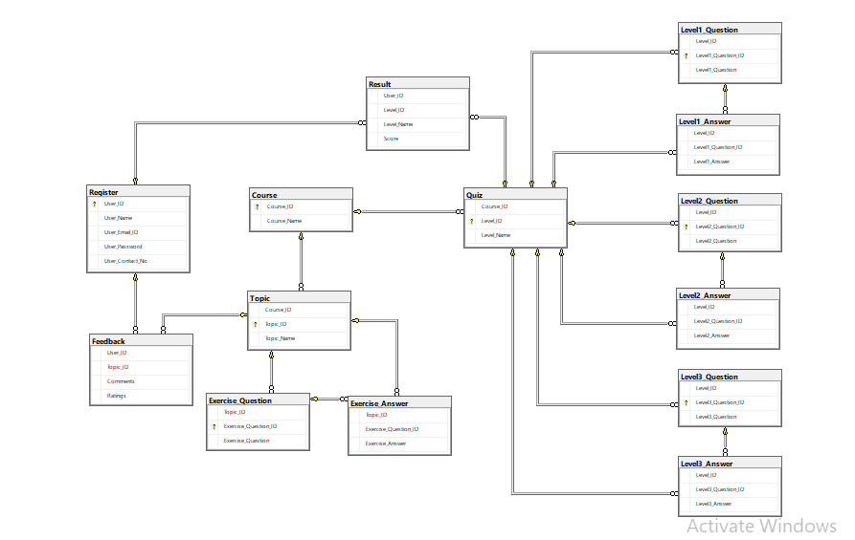

**Sequence Diagram:**

Store result in DB:

Enter user name and password

User

Login:

Select Course:

Select Topic DB:

Select Quiz-Level:

Verify

Request subject

Question master DB:

Invalid subject

Inactive subject

Verify

Verify

If Accept

Unavailable question

Unavailable question

Start exam

If Accept

If Accept

Finish the Exam and display the Result

**Created by: Ramya R ,**

**Ruthra A,**

**Sravanthi V**

**JanaPriya S,**

**Sahaya Shiny Pavitra A**