SOFTWARE ARCHITECTURE AND DESIGN SPECIFICATION
Student Record System (SRS-App)
Problem Statement No. 12
USN | TEAM MEMBER

Project: Student Record System (SRS-App)
Version: 1.0
Authors:
Date: 01-10-2026
Status: Draft
Based on: Student Record System SRS v1.0 (07-09-2026)

Revision History
Version | Date | Author | Change Summary | Approval
1.0 | 01-10-2026 | Team | Initial Software Architecture and Design Specification | Pending

Approvals
Role | Name | Signature/Date
Course Coordinator

1. Introduction

1.1 Purpose
This document specifies the architecture and design of the Student Record System (SRS-App): its components, chosen architectural pattern, data design, API design, sequence flows, and security architecture. It translates the functional and non-functional requirements in the SRS into an implementable, testable design.

1.2 Scope
Covers the web-based SRS-App services for authentication and RBAC, student record management, course and enrollment management, attendance, grading and GPA/CGPA, reporting/transcripts, fee-status visibility, academic configuration, audit logging, and the supporting notification service. Real payment processing, institutional SSO, and LMS/payroll/hostel/library integrations are outside scope, consistent with the SRS.

1.3 Audience
- Developers
- QA/Test engineers
- Security auditors (course evaluators)
- Instructors / Course Coordinator
- Maintenance team (future student batches)

1.4 Definitions
SRS (Student Record System / Software Requirements Specification, by context), RBAC (Role-Based Access Control), GPA/CGPA (Grade Point Average / Cumulative GPA), ADR (Architecture Decision Record), API (Application Programming Interface), PII (Personally Identifiable Information), TLS (Transport Layer Security), RTM (Requirements Traceability Matrix), STP (Software Test Plan), WCAG (Web Content Accessibility Guidelines), STRIDE (Spoofing, Tampering, Repudiation, Information disclosure, Denial of service, Elevation of privilege).

2. Document Overview

2.1 How to use this document
Section 3 describes the architecture: goals, stakeholders, the component diagram, the chosen pattern and its rationale, the technology stack, risks, requirement traceability, and the security architecture (threat model). Section 4 describes the design: two sequence diagrams for key flows, the REST API design, error handling/logging/monitoring, UX design notes, and open issues. Section 5 contains the glossary, references, and tools used to produce this document.

2.2 Related Documents
- Student Record System SRS v1.0 (07-09-2026) — functional and non-functional requirements
- Software Test Plan (STP) — Student Record System v1.0 — test strategy and test cases
- docs/Test_Plan/RTM.csv — requirements traceability matrix

3. Architecture

3.1 Goals & Constraints
Goals: secure handling of student PII and academic records; reliable and correct academic calculations (GPA/CGPA, attendance %); 99.5% monthly availability; response time under 3 seconds for 90% of requests; maintainable, modular codebase that a student team can build and demonstrate.
Constraints: relational database (MySQL); simple local authentication (no institutional SSO); fee data is read-only sample data, no live payment gateway; no microservices — single deployable application suitable for localhost demonstration; WCAG 2.1 AA accessibility.

3.2 Stakeholders & Concerns
Stakeholder | Concern
Students | Privacy of personal/academic data; availability and correctness of grades, attendance, transcripts
Faculty | Accurate, timely attendance and marks entry; clear grade-lock rules
Registrar / Admin | Data integrity, configurability (terms, grading scale, deadlines), auditability
Course Coordinator / Evaluator | Traceability to SRS, security correctness, maintainability, demonstrability
Developers (team) | Modularity, simple stack, clear API contracts, low setup effort
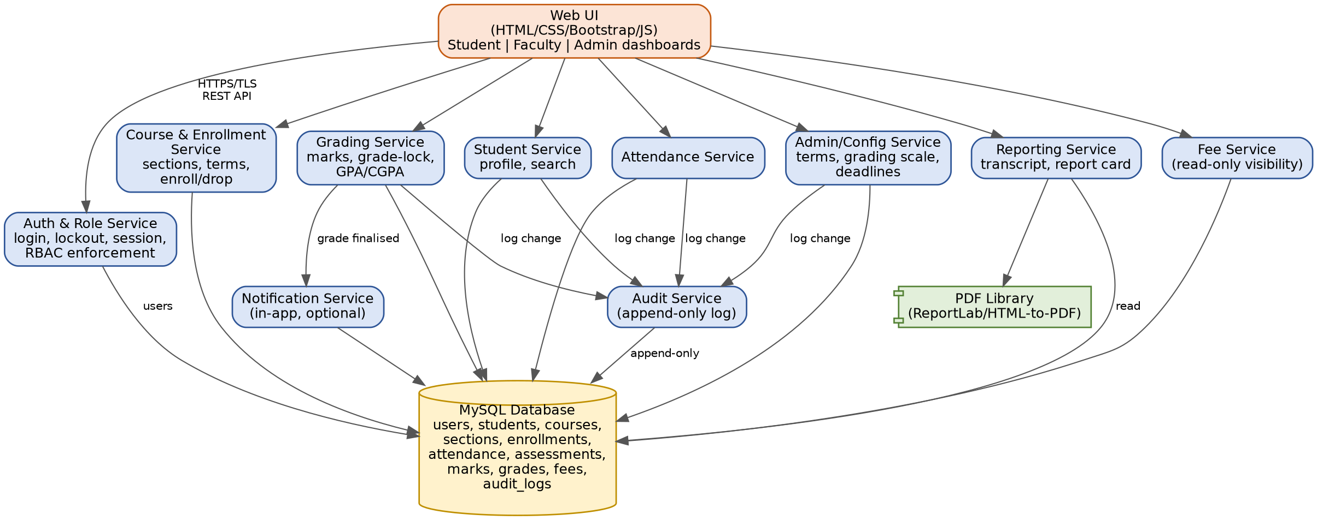
Figure 1 — Component Diagram: services, the web UI, and the MySQL database

3.4 Component Descriptions
Component | Responsibility | Maps to SRS module(s)
Web UI | Role-specific dashboards (Student, Faculty, Admin); form validation; calls the REST API over HTTPS | 3.1 User Interfaces
Auth & Role Service | Login, lockout after 5 failed attempts, session/idle-timeout, RBAC enforcement at the API layer | Auth Module (4.1, 6.2)
Student Service | Create/update/deactivate student records; self-service profile fields; student search | Student Module, Search Module (4.2)
Course & Enrollment Service | Course/section/term management; enrollment with seat and prerequisite checks; course drop within add/drop window | Course Module, Enrollment Module (4.3)
Attendance Service | Mark and retrieve attendance per session; compute attendance percentage | Attendance Module (4.4)
Grading Service | Marks entry before grade-lock; grade and GPA/CGPA computation | Grading Module (4.5)
Reporting Service | Generate unofficial transcript and official report card via the PDF library | Reporting Module (4.6)
Fee Service | Read-only fee balance/history; flags enrollment restriction above an overdue threshold | Fee Module (4.7)
Admin/Config Service | Academic terms, grading scale, add/drop and grade-lock deadlines | Admin Module (4.8)
Audit Service | Append-only log of create/update/deactivate/grade/attendance changes | Audit Module (4.8, 6.2)
Notification Service | In-app grade-posted notifications (optional extension) | Notification (4.5, 8.2)
MySQL Database | Persistent storage: users, students, courses, sections, enrollments, attendance, assessments, marks, grades, fees, audit_logs | Appendix B (SRS)

3.5 Chosen Architecture Pattern and Rationale
Chosen: a layered, modular-monolith architecture — a single Flask application organised into the service modules in Section 3.4, each with its own routes and data-access functions, all backed by one MySQL database.
Rationale: the SRS explicitly favors simplicity for a student project (Section 2.5, Appendix A) over distributed complexity. A layered monolith gives clean separation of concerns (UI, service logic, data access) and straightforward requirement traceability, while avoiding the operational overhead of service discovery, inter-service network calls, and distributed transactions.
Rejected: a microservices architecture was considered and rejected as over-engineered for this scale (a handful of developers, project-scale load of 1,000 concurrent users, single relational schema) — it would add deployment and consistency complexity without a corresponding benefit for this system.

3.6 Technology Stack & Data Stores
Layer | Choice | Reason
Frontend | HTML + CSS + Bootstrap + JavaScript | Simple, responsive forms and dashboards; matches SRS Appendix A
Backend | Python Flask (REST API) | Lightweight framework, easy to reason about and test
Database | MySQL | Fits the relational student/course/enrollment/grade schema in SRS Appendix B
Authentication | Local username/password with bcrypt/Argon2 hashing | Avoids SSO setup complexity; satisfies SRS-SR-003
Reports | ReportLab or HTML-to-PDF | Simple transcript and report-card generation
Transport security | TLS 1.2+ (HTTPS) for any deployed instance | Satisfies SRS-SR-001; localhost permitted for lab demonstration
Deployment | Localhost for demonstration | No cloud configuration required for the course deliverable

3.7 Risks & Mitigations
Risk | Mitigation
Single database/application instance is a single point of failure | Regular backups; document restore procedure; acceptable for an academic-scale deployment
Grade-lock and session-timeout logic is time-dependent and hard to test | Add a configurable clock / test hook so lock dates and idle timeouts can be simulated
Concurrent writes to enrollment (seat race condition) | Use a database transaction with a row lock or a unique constraint check on insert
PDF generation library limitations under load | Generate reports synchronously for the project scale; revisit async generation if needed
Team members unfamiliar with Flask/MySQL | Keep the stack small (Section 3.6); pair on the first module before splitting work

3.8 Traceability to Requirements
Selected examples; the complete mapping is in the SRS RTM (Section 9) and docs/Test_Plan/RTM.csv.
Req ID | Requirement (short) | Component
SRS-F-001 / F-002 / F-003 | Login, RBAC, lockout | Auth & Role Service
SRS-F-010–013 | Student CRUD, search | Student Service
SRS-F-020–022 | Courses, sections, enrollment, drop | Course & Enrollment Service
SRS-F-030 / F-031 | Attendance marking and percentage | Attendance Service
SRS-F-040–042 | Marks, GPA/CGPA, grade notification | Grading Service, Notification Service
SRS-F-050 / F-051 | Transcript, report card | Reporting Service
SRS-F-060 / F-061 | Fee visibility, enrollment restriction | Fee Service
SRS-F-070 / F-071 | Academic configuration, audit log | Admin/Config Service, Audit Service
SRS-SR-001–006 | TLS, RBAC at API, password hashing, PII encryption, session timeout, protected audit log | Auth & Role Service, Audit Service, MySQL Database, Deployment

3.9 Security Architecture
Threat Modeling (STRIDE):
STRIDE Category | Threat Example | Mitigation
Spoofing | Attacker reuses or guesses credentials to impersonate a user | Salted bcrypt/Argon2 password hashing (SRS-SR-003); account lockout after 5 failed attempts (SRS-F-003)
Tampering | Request modified in transit, or client-side field tampering (e.g. locked profile fields) | TLS 1.2+ in transit (SRS-SR-001); server-side re-validation of all whitelisted fields, not just UI validation
Repudiation | A user denies having changed a grade or attendance record | Protected, append-only audit log of grade/attendance/record changes with actor and timestamp (SRS-SR-006, SRS-F-071)
Information Disclosure | Unauthorized access to another student's grades/PII, e.g. via URL/ID manipulation | RBAC enforced at the API layer, not just the UI (SRS-SR-002); PII encrypted at rest (SRS-SR-004); no PII in logs/URLs
Denial of Service | Flooding the login or search endpoint | Rate limiting on authentication endpoints; input validation; performance targets validated under load (SRS-NF-001/006)
Elevation of Privilege | A Student role calls an Admin-only endpoint directly | RBAC checks on every API route (not only menu visibility); session expiry after 15 idle minutes (SRS-SR-005)

4. Design

4.1 Design Overview
The system is designed as layered modules (Web UI → service layer → MySQL) mirroring the components in Section 3.4, so each SRS module maps to one service with its own routes, validation, and data-access functions. This keeps responsibilities separated and each module independently testable, while the single Flask process and single database keep setup and deployment simple for the course deliverable.

4.2 UML Sequence Diagrams
Two sequence diagrams covering flows specific to this project: course enrollment, and marks entry through GPA finalisation and notification.
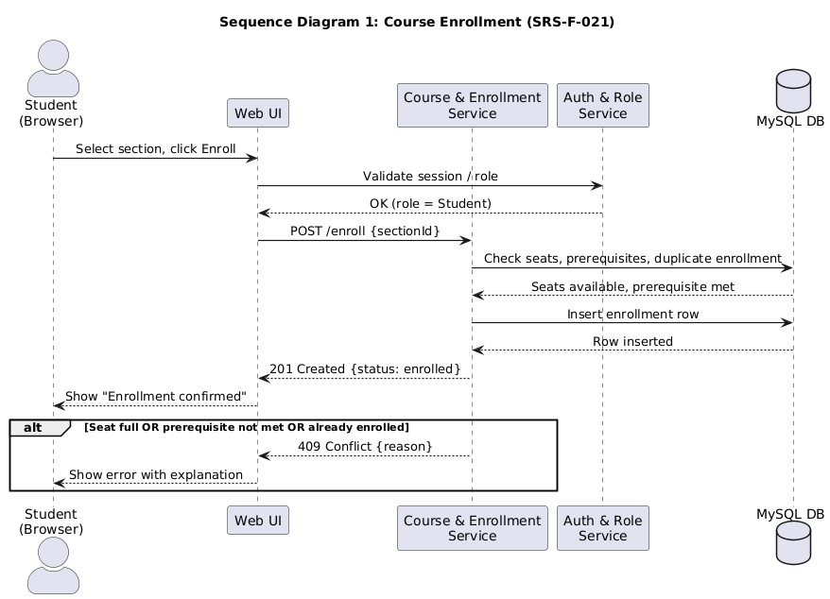
Figure 2 — Sequence Diagram 1: Course Enrollment (SRS-F-021)
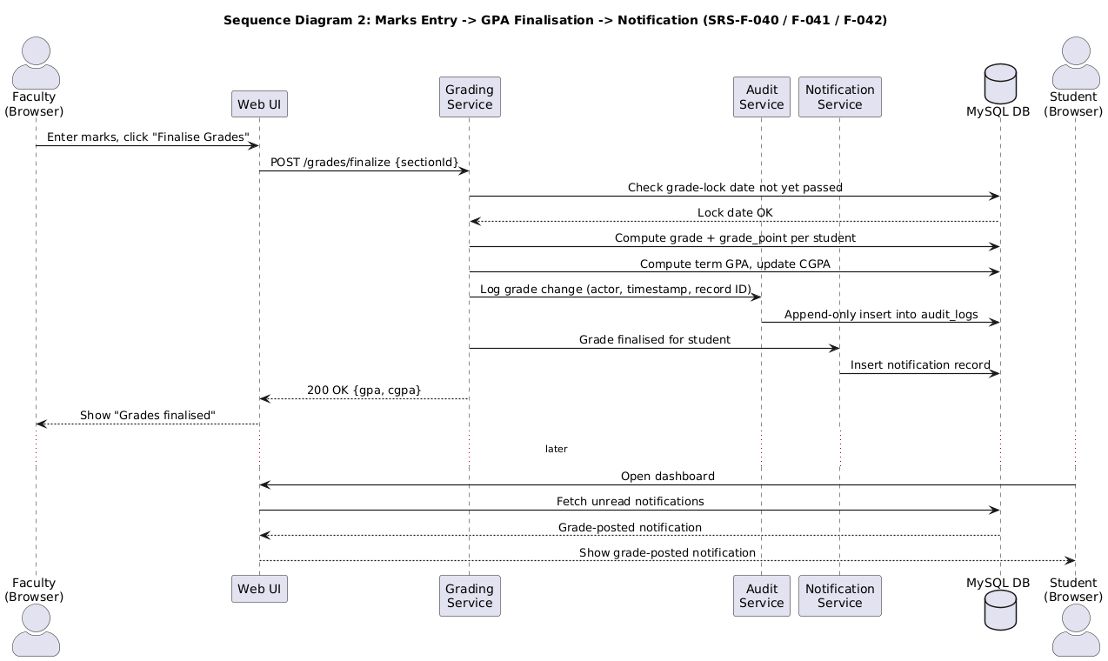
Figure 3 — Sequence Diagram 2: Marks Entry → GPA Finalisation → Notification (SRS-F-040 / F-041 / F-042)

4.3 API Design
REST endpoints for the service components listed in Section 3.4 (at least two components, per the template; all primary endpoints are listed here for completeness). All endpoints require a valid session token except /auth/login, and all enforce RBAC server-side per SRS-SR-002.
Endpoint | Method | Component | Request | Response | Errors
/auth/login | POST | Auth & Role Service | { username, password } | { token, role, expiresIn } | 401 Invalid credentials; 423 Account locked
/auth/logout | POST | Auth & Role Service | { } (session token in header) | { status: "ok" } | 401 No active session
/students | POST | Student Service | { name, email, phone, address, program, semester } | { studentId, status: "created" } | 400 Missing mandatory field; 409 Duplicate Student ID; 403 Not Admin
/students/{id} | GET | Student Service | (path param: id) | { studentId, name, program, semester, status, ... } | 403 Not authorized for this record; 404 Not found
/students/{id} | PUT | Student Service | { phone?, address?, status? } (role-restricted fields) | { status: "updated" } | 400 Attempt to edit locked field; 403 Not authorized
/students/search | GET | Search Module | ?q={studentIdOrName} | { results: [ {studentId, name, program} ] } | 403 Not authorized; 400 Empty query
/courses/sections | POST | Course & Enrollment Service | { courseId, term, facultyId, capacity } | { sectionId, status: "created" } | 400 Invalid course/term; 409 Duplicate section; 403 Not Admin
/enroll | POST | Course & Enrollment Service | { sectionId } | { enrollmentId, status: "enrolled" } | 409 Seat full / prerequisite unmet / duplicate enrollment; 403 Not Student
/enroll/{id} | DELETE | Course & Enrollment Service | (path param: enrollmentId) | { status: "dropped" } | 403 Drop window closed; 404 Enrollment not found
/attendance | POST | Attendance Service | { sectionId, date, records: [{studentId, status}] } | { status: "saved", count } | 400 Student not enrolled in section; 403 Not assigned Faculty
/attendance/{studentId}/summary | GET | Attendance Service | ?sectionId= | { present, absent, late, percentage } | 403 Not authorized
/grades/marks | POST | Grading Service | { assessmentId, studentId, score } | { status: "saved" } | 400 Score exceeds max marks; 403 Past grade-lock date
/grades/finalize | POST | Grading Service | { sectionId } | { status: "finalised", gpa, cgpa } | 403 Not assigned Faculty; 409 Already finalised
/reports/transcript/{studentId} | GET | Reporting Service | (path param: studentId) | application/pdf (unofficial transcript) | 403 Not own record (Student); 404 No records
/reports/report-card | GET | Reporting Service | ?studentId=&term= | application/pdf (official report card) | 403 Not Admin
/fees/{studentId} | GET | Fee Service | (path param: studentId) | { amountDue, amountPaid, status, history: [...] } | 403 Not authorized
/admin/config | PUT | Admin/Config Service | { gradingScale?, addDropDeadline?, gradeLockDate? } | { status: "updated" } | 403 Not Admin; 400 Invalid configuration
/audit-logs | GET | Audit Service | ?module=&from=&to= | { logs: [ {actor, action, recordType, recordId, timestamp} ] } | 403 Not Admin

4.4 Error Handling, Logging & Monitoring
- Standardized JSON error format: { error: { code, message } }; HTTP status codes used consistently (400 validation, 401/403 auth, 404 not found, 409 conflict)
- No sensitive information (passwords, full PII, session tokens) is ever written to logs, URLs, or error messages
- Every create/update/deactivate/grade/attendance mutation is written to the audit log (actor, action, record type, record ID, timestamp) per SRS-F-071 / SRS-SR-006
- Monitoring metrics: transaction/request failure rate, response time (P90), concurrent active sessions, and uptime, supporting SRS-NF-001, SRS-NF-002, and SRS-NF-006
- Failed login attempts and lockout events are logged for security review (SRS-F-003)

4.5 UX Design
- Separate, role-specific dashboards for Student, Faculty, and Admin, each showing only permitted functions (reduces accidental privilege confusion, reinforces RBAC visually)
- Clear, field-level success/error messages on every form, with mandatory fields marked
- Accessible font sizes, sufficient color contrast, keyboard navigability, and labelled form controls to meet WCAG 2.1 AA (SRS-NF-005)
- Read-only pages (fee status) are visually distinct from editable pages, so students do not expect to pay through the UI
- Grade-lock and add/drop deadlines are shown on the relevant screens so Faculty/Students understand why an action is blocked

4.6 Open Issues & Next Steps
- Confirm whether 'Late' attendance counts toward the attendance percentage (SRS-F-031) — currently assumed Present-only; to be confirmed with the SRS authors and reflected in the Test Plan assumptions
- Decide the exact seat-reservation mechanism for concurrent enrollment attempts (transaction isolation level vs. unique constraint)
- Future enhancement: email delivery for grade-posted notifications (currently in-app only, per SRS-F-042 comments)
- Future enhancement: Parent/Guardian read-only role, if enabled for a later iteration (SRS Section 2.3)
- Future enhancement: configurable multi-factor authentication for Admin accounts

5. Appendices

5.1 Glossary
SRS, RBAC, GPA, CGPA, PII, TLS, ADR, API, RTM, STP, WCAG, STRIDE — see Section 1.4 for full definitions.

5.2 References
- Student Record System SRS v1.0 (07-09-2026)
- IEEE 42010 (Systems and software engineering — Architecture description)
- OWASP Application Security Verification Standard (ASVS) / OWASP Top 10
- NIST SP 800-160 (Systems Security Engineering)
- WCAG 2.1

5.3 Tools
- Graphviz and PlantUML — component and sequence diagrams in this document
- draw.io / diagrams.net — optional further diagramming
- Swagger / OpenAPI — recommended for formalising the API design in Section 4.3
- Postman — API design verification and testing (shared with the Test Plan)

