SOFTWARE REQUIREMENTS SPECIFICATION
Student Record System
Problem Statement No. 12

USN | TEAM MEMBER
PES2UG24CS527 | SRUJAN YALLA
PES2UG24CS547 | T S SATHYA KIRAN
PES2UG24CS517 | SRI VAISHNAVI PERI
PES2UG24CS553 | TANUJ N

Version: 1.0
Date: 07-09-2026
Status: Final Draft / For Approval

Revision History
Version | Date | Author | Change Summary | Approval
1.0 | 07-09-2026 | Team | Final SRS for Student Record System | Pending

Approvals
Role | Name | Signature / Email | Date
Course Coordinator

Table of Contents
1. Introduction
2. Overall Description
3. External Interface Requirements
4. System Features (Detailed)
5. Non-Functional Requirements
6. Security
7. Quality Attributes & Acceptance Tests
8. System Models and Diagrams
9. Requirements Traceability Matrix (RTM)

1. Introduction

1.1 Purpose
This document specifies the functional and non-functional requirements for a Student Record System (SRS-App). The system provides a simple web-based way to manage student profiles, courses, enrollment, attendance, marks, grades, GPA/CGPA, and academic reports.

1.2 Scope
The system covers student registration and profile management, course and section management, enrollment, attendance tracking, assessment and grade entry, GPA/CGPA calculation, transcript/report generation, basic fee-status visibility, user roles, and audit logging. To keep implementation simple and suitable for a student project, payment processing itself is outside the system scope.

1.3 Audience
- Developers
- QA/Testers
- System Administrator / Registrar
- Faculty
- Students
- Assessment Evaluators

1.4 Definitions
Term | Definition
SRS | Student Record System / Software Requirements Specification, depending on context
RBAC | Role-Based Access Control
GPA | Grade Point Average
CGPA | Cumulative Grade Point Average
UI | User Interface
API | Application Programming Interface
PII | Personally Identifiable Information
TLS | Transport Layer Security
RTM | Requirements Traceability Matrix

2. Overall Description

2.1 Product Perspective
The Student Record System is a web application backed by a relational database. Students, faculty, and administrators use role-specific screens to access or modify records. The system is intentionally designed around standard CRUD operations, simple calculations, and report generation so that it can be implemented and demonstrated easily.

2.2 Major Product Functions
- User login and role-based access
- Student registration and profile management
- Student search and record viewing
- Course and section management
- Student enrollment and course drop
- Attendance recording and viewing
- Marks/assessment entry
- Grade and GPA/CGPA calculation
- Transcript/report-card generation
- Basic fee-balance visibility
- User and system configuration
- Audit logging

2.3 User Roles and Characteristics
Role | Main Responsibilities
Student | View profile, courses, enrollment, attendance, marks, grades, GPA/CGPA, and reports.
Faculty | View assigned students, record attendance, enter/update marks, and view class performance.
Admin / Registrar | Manage students, courses, sections, academic terms, users, roles, reports, and audit logs.
Parent / Guardian (optional) | Read-only access to linked student's attendance and grades, if enabled.

2.4 Operating Environment
The system shall run as a web application accessible through modern browsers on Windows, Linux, macOS, tablets, and mobile devices. A relational database shall store persistent records. The project can be deployed locally on a student laptop for demonstration.

2.5 Constraints and Simplifications
- Use a relational database such as MySQL.
- Use a simple local login system for the project implementation; institutional SSO is outside the minimum implementation scope.
- Fee information is read-only and can be maintained as sample/synchronised data; no real payment gateway is required.
- No LMS, payroll, hostel, or library functionality is required.
- Academic rules such as grading scale and add/drop dates are configurable by Admin.

3. External Interface Requirements

3.1 User Interfaces
The system shall provide a responsive web UI with separate dashboards for Student, Faculty, and Admin. Forms shall validate mandatory fields and display clear success/error messages.

3.2 Hardware Interfaces
No specialised hardware is required. The system can be accessed using a standard desktop, laptop, tablet, or mobile browser.

3.3 Software Interfaces
- Relational database (MySQL or equivalent).
- PDF generation library/service for transcripts and report cards.
- Optional email/notification service for grade-posted notifications.
- No live payment gateway is required for the minimum project implementation.

3.4 Communications
For a deployed version, HTTPS/TLS 1.2+ shall be used for client-server communication. For local laboratory demonstration, the application may run on localhost.

4. System Features (Detailed)
Each requirement has a unique ID, priority, acceptance criterion, and test-case reference.

4.1 Authentication & User Management
Req ID | Requirement (shall...) | Type | Priority | Source / Stakeholder | Acceptance criteria / Test case | Comments / Dependencies
SRS-F-001 | The system shall authenticate a user using a registered username/email and password before granting access. | Functional | High | Security / Admin | Valid credentials create a session. Test: TC-Auth-01 | Simple local authentication
SRS-F-002 | The system shall enforce role-based access for Student, Faculty, Admin, and optional Parent/Guardian roles. | Functional | High | Security | Each role can access only permitted functions. Test: TC-Auth-02 | RBAC configuration required
SRS-F-003 | The system shall temporarily lock a user account after 5 consecutive failed login attempts and record the event. | Functional | Medium | Security | 6th attempt is blocked and audit event exists. Test: TC-Auth-03 | Simple application-level lockout

4.2 Student Record Management
Req ID | Requirement (shall...) | Type | Priority | Source / Stakeholder | Acceptance criteria / Test case | Comments / Dependencies
SRS-F-010 | The system shall allow Admin to create a student record with mandatory personal and academic-program fields. | Functional | High | Registrar | Record saved with unique Student ID; missing fields are rejected. Test: TC-Stu-01 | Auto-generate or validate Student ID
SRS-F-011 | The system shall allow Admin to update or deactivate a student record while preserving historical academic data. | Functional | High | Registrar | Deactivated student retains history and cannot log in. Test: TC-Stu-02 | Use soft-delete/status flag
SRS-F-012 | The system shall allow a Student to view and update only approved self-service profile fields such as phone and address. | Functional | Medium | Student | Only whitelisted fields are editable. Test: TC-Stu-03 | Core academic fields remain locked
SRS-F-013 | The system shall allow authorized users to search students by Student ID or name. | Functional | High | Faculty / Admin | Matching records are displayed. Test: TC-Stu-04 | Indexed Student ID/name recommended

4.3 Course & Enrollment Management
Req ID | Requirement (shall...) | Type | Priority | Source / Stakeholder | Acceptance criteria / Test case | Comments / Dependencies
SRS-F-020 | The system shall allow Admin to create courses, sections, and academic terms. | Functional | High | Registrar | Course/section is visible with the correct term. Test: TC-Enr-01 | Term configuration
SRS-F-021 | The system shall allow a Student to enroll in a course section when seats are available and prerequisites are satisfied. | Functional | High | Student / Academic Policy | Enrollment succeeds only when conditions pass. Test: TC-Enr-02 | Simple prerequisite rules
SRS-F-022 | The system shall allow a Student to drop an enrolled course during the configured add/drop period. | Functional | Medium | Academic Policy | Drop after deadline is rejected. Test: TC-Enr-03 | Academic calendar

4.4 Attendance Management
Req ID | Requirement (shall...) | Type | Priority | Source / Stakeholder | Acceptance criteria / Test case | Comments / Dependencies
SRS-F-030 | The system shall allow Faculty to mark attendance as Present, Absent, or Late for each enrolled student per class session. | Functional | High | Faculty | Attendance is saved for correct date and section. Test: TC-Att-01 | Current roster required
SRS-F-031 | The system shall allow Students to view their attendance percentage for each course. | Functional | Medium | Student | Displayed percentage matches stored session records. Test: TC-Att-02 | Calculated from attendance table

4.5 Grades & Assessment Management
Req ID | Requirement (shall...) | Type | Priority | Source / Stakeholder | Acceptance criteria / Test case | Comments / Dependencies
SRS-F-040 | The system shall allow Faculty to enter and update assessment scores for enrolled students before the configured grade-lock date. | Functional | High | Faculty | Scores are editable before lock and read-only after lock. Test: TC-Grd-01 | Grade-lock date from calendar
SRS-F-041 | The system shall calculate term GPA and cumulative GPA after grades are finalised. | Functional | High | Registrar | GPA/CGPA matches weighted calculation for test data. Test: TC-Grd-02 | Configurable grading scale
SRS-F-042 | The system shall notify a Student when final grades are posted. | Functional | Medium | Student | Notification status is recorded after finalisation. Test: TC-Grd-03 | For easy implementation, in-app notification is sufficient

4.6 Reporting & Transcripts
Req ID | Requirement (shall...) | Type | Priority | Source / Stakeholder | Acceptance criteria / Test case | Comments / Dependencies
SRS-F-050 | The system shall generate an unofficial transcript containing completed terms, subjects, grades, and GPA/CGPA. | Functional | High | Student | PDF contains all completed terms and calculated GPA. Test: TC-Rep-01 | PDF library
SRS-F-051 | The system shall allow Admin to generate an official report card for a selected term. | Functional | Medium | Registrar | Report card contains institution/student details and term grades. Test: TC-Rep-02 | Digital signature/watermark optional

4.7 Fee Management (Visibility Only)
Req ID | Requirement (shall...) | Type | Priority | Source / Stakeholder | Acceptance criteria / Test case | Comments / Dependencies
SRS-F-060 | The system shall display a Student's current fee balance and payment-status history. | Functional | Medium | Finance / Student | Displayed balance matches stored fee record. Test: TC-Fee-01 | Read-only; no payment processing
SRS-F-061 | The system shall flag an enrollment restriction when a student's overdue fee balance exceeds the configured threshold. | Functional | Medium | Finance / Academic Policy | Enrollment is blocked and an explanation is shown. Test: TC-Fee-02 | Threshold configurable by Admin

4.8 Administration & System Maintenance
Req ID | Requirement (shall...) | Type | Priority | Source / Stakeholder | Acceptance criteria / Test case | Comments / Dependencies
SRS-F-070 | The system shall allow Admin to configure academic terms, grading scales, and add/drop deadlines. | Functional | High | Registrar | New configuration is used by applicable transactions. Test: TC-Adm-01 | Configuration module
SRS-F-071 | The system shall maintain an audit log for create, update, deactivate, grade, and attendance changes. | Functional | High | Compliance / Admin | Each mutation records actor, timestamp, action, and record ID. Test: TC-Adm-02 | Audit entries should be protected

5. Non-Functional Requirements
Req ID | Requirement | Category | Priority | Acceptance / Measurement
SRS-NF-001 | Page load and search operations shall complete within 3 seconds for 90% of requests under normal load. | Performance | High | 90th percentile ≤ 3s. Test: TC-Perf-01
SRS-NF-002 | The system shall provide 99.5% monthly availability, excluding scheduled maintenance. | Reliability | High | Monthly uptime ≥99.5%. Test: TC-Ops-01
SRS-NF-003 | Student PII shall be protected in transit and at rest, with access controlled by RBAC. | Security/Compliance | High | Security checklist passes. Test: TC-Sec-01
SRS-NF-004 | Audit logs and academic records shall be retained for at least 7 years, subject to institutional policy. | Data Retention | High | Archive/retrieval verified. Test: TC-Ops-02
SRS-NF-005 | The UI shall conform to WCAG 2.1 AA accessibility requirements where applicable. | Usability/Accessibility | Medium | Accessibility audit passes. Test: TC-UX-01
SRS-NF-006 | The system shall support at least 1,000 concurrent active users for project-scale peak-load testing. | Scalability | Medium | Load test sustains target with <3s response for target operations. Test: TC-Perf-02

6. Security

6.1 Security Objectives
- Protect the confidentiality of student PII and academic records from unauthorized access.
- Maintain the integrity of grades, attendance, enrollment, and transcript data.
- Ensure only authorised roles can perform sensitive operations.
- Maintain accountability through protected audit records of important changes.

6.2 Security Requirements
Req ID | Requirement (shall...) | Type | Priority | Acceptance Criteria / Test
SRS-SR-001 | TLS 1.2+ shall be mandatory for deployed client-server connections. | Security | High | TLS scan confirms no connections below 1.2. Test: TC-Sec-02
SRS-SR-002 | All student and grade data access shall be enforced through RBAC at the server/API layer, not only the UI. | Security | High | Unauthorized API/action returns 403 or equivalent. Test: TC-Sec-03
SRS-SR-003 | User passwords shall be stored only as salted secure hashes such as bcrypt or Argon2; plaintext storage is prohibited. | Security | High | Database inspection finds no plaintext passwords. Test: TC-Sec-04
SRS-SR-004 | Sensitive PII fields shall be encrypted at rest or protected by database/storage encryption. | Security | High | Storage/database protection is verified. Test: TC-Sec-05
SRS-SR-005 | User sessions shall expire after 15 minutes of inactivity and require re-authentication. | Security | Medium | Session becomes invalid after 15 idle minutes. Test: TC-Sec-06
SRS-SR-006 | Modifications to grades and attendance shall be recorded in a protected audit log that ordinary users cannot edit or delete. | Security | High | Audit records cannot be modified through application roles. Test: TC-Sec-07

7. Quality Attributes & Acceptance Tests

7.1 Quality Attributes
- Security — protected student data and role-restricted operations.
- Reliability — consistent academic records and correct calculations.
- Performance — measurable response-time targets.
- Usability — simple dashboards and clear validation messages.
- Maintainability — modular Student, Course, Enrollment, Attendance, Grading, Reporting, and Admin modules.
- Scalability — supports project-scale concurrent usage.

7.2 Acceptance Criteria
- All high-priority functional requirements are implemented and verified.
- All critical security requirements pass testing.
- GPA/CGPA calculations match expected results for test datasets.
- Student records remain consistent after create/update/deactivate operations.
- The RTM contains traceability from requirements to modules and test cases.
- No critical defects remain at final demonstration.

7.3 Acceptance Test Suites
- Authentication and RBAC
- Student Records
- Course and Enrollment
- Attendance
- Grades and GPA
- Reports and Transcripts
- Fee Visibility
- Security
- Performance
- Usability/Accessibility

8. System Models and Diagrams

8.1 UML Use-Case Diagram — Student & Faculty
This diagram shows the main interactions of Student and Faculty users with the system. Students primarily view and manage their own academic information, while Faculty record attendance and marks.
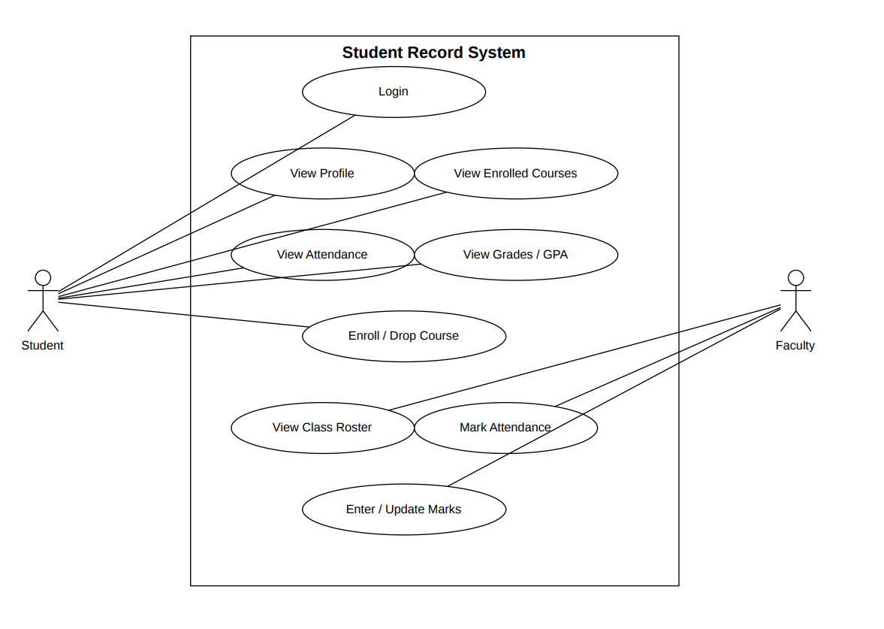

8.2 UML Use-Case Diagram — Admin / Registrar
This diagram shows administrative operations. The Notification Service is modeled as an external actor rather than the Student Record System itself. The notification use case is an optional extension of report generation.
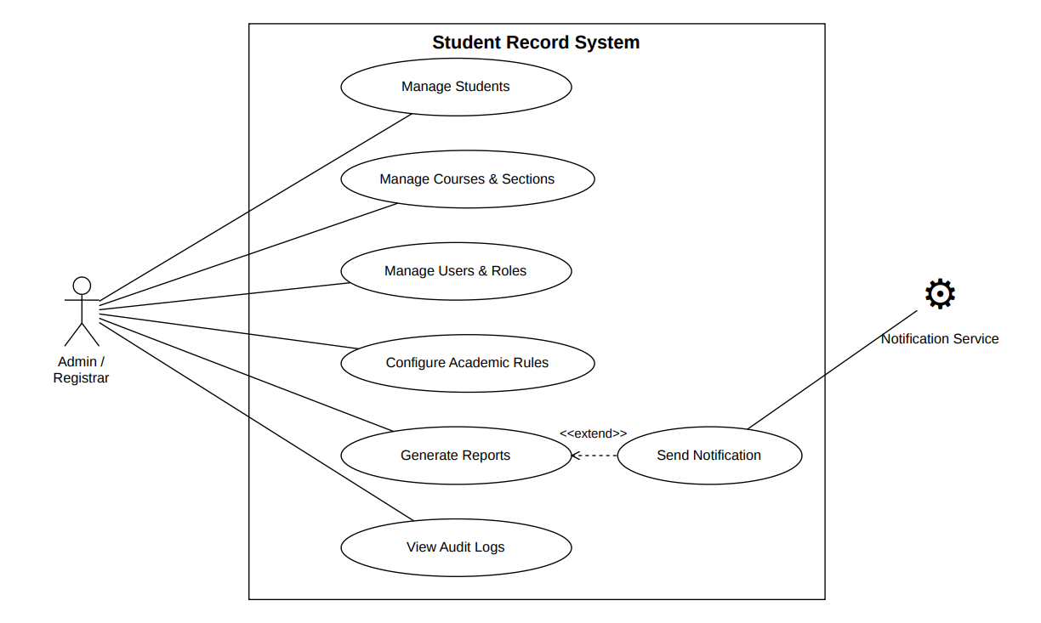

9. Requirements Traceability Matrix (RTM)
Status legend: N = Not tested, P = In progress, A = Passed.
Req ID | Requirement (short) | Section / Design Spec | Module | Test Case(s) | Status
SRS-F-001 | User login | 4.1 / DS-Auth-01 | Auth Module | TC-Auth-01 | N
SRS-F-002 | RBAC | 4.1 / DS-Auth-02 | Auth/Role Module | TC-Auth-02 | N
SRS-F-003 | Login lockout | 4.1 / DS-Auth-03 | Auth Module | TC-Auth-03 | N
SRS-F-010 | Create student | 4.2 / DS-Stu-01 | Student Module | TC-Stu-01 | N
SRS-F-011 | Update/deactivate student | 4.2 / DS-Stu-02 | Student Module | TC-Stu-02 | N
SRS-F-012 | Student profile update | 4.2 / DS-Stu-03 | Student Module | TC-Stu-03 | N
SRS-F-013 | Student search | 4.2 / DS-Stu-04 | Search Module | TC-Stu-04 | N
SRS-F-020 | Course/section management | 4.3 / DS-Enr-01 | Course Module | TC-Enr-01 | N
SRS-F-021 | Course enrollment | 4.3 / DS-Enr-02 | Enrollment Module | TC-Enr-02 | N
SRS-F-022 | Course drop | 4.3 / DS-Enr-03 | Enrollment Module | TC-Enr-03 | N
SRS-F-030 | Mark attendance | 4.4 / DS-Att-01 | Attendance Module | TC-Att-01 | N
SRS-F-031 | Attendance percentage | 4.4 / DS-Att-02 | Attendance Module | TC-Att-02 | N
SRS-F-040 | Enter/update marks | 4.5 / DS-Grd-01 | Grading Module | TC-Grd-01 | N
SRS-F-041 | GPA/CGPA | 4.5 / DS-Grd-02 | Grading Module | TC-Grd-02 | N
SRS-F-042 | Grade notification | 4.5 / DS-Grd-03 | Notification Module | TC-Grd-03 | N
SRS-F-050 | Unofficial transcript | 4.6 / DS-Rep-01 | Reporting Module | TC-Rep-01 | N
SRS-F-051 | Official report card | 4.6 / DS-Rep-02 | Reporting Module | TC-Rep-02 | N
SRS-F-060 | Fee status | 4.7 / DS-Fee-01 | Fee Module | TC-Fee-01 | N
SRS-F-061 | Fee restriction | 4.7 / DS-Fee-02 | Fee/Enrollment Module | TC-Fee-02 | N
SRS-F-070 | Academic configuration | 4.8 / DS-Adm-01 | Admin Module | TC-Adm-01 | N
SRS-F-071 | Audit logging | 4.8 / DS-Adm-02 | Audit Module | TC-Adm-02 | N
SRS-NF-001 | Response time | 5 / DS-Perf-01 | WebUI / API | TC-Perf-01 | N
SRS-NF-002 | Availability | 5 / DS-Ops-01 | Deployment | TC-Ops-01 | N
SRS-NF-003 | PII protection | 5 / DS-Sec-01 | Database/Security | TC-Sec-01 | N
SRS-NF-004 | Record retention | 5 / DS-Ops-02 | Database/Backup | TC-Ops-02 | N
SRS-NF-005 | Accessibility | 5 / DS-UX-01 | WebUI | TC-UX-01 | N
SRS-NF-006 | Concurrency | 5 / DS-Perf-02 | WebUI / API | TC-Perf-02 | N
SRS-SR-001 | TLS 1.2+ | 6.2 / DS-Sec-02 | Deployment/Security | TC-Sec-02 | N
SRS-SR-002 | RBAC at server/API | 6.2 / DS-Sec-03 | Auth/API | TC-Sec-03 | N
SRS-SR-003 | Password hashing | 6.2 / DS-Sec-04 | Auth Module | TC-Sec-04 | N
SRS-SR-004 | PII encryption | 6.2 / DS-Sec-05 | Database | TC-Sec-05 | N
SRS-SR-005 | Session timeout | 6.2 / DS-Sec-06 | Auth Module | TC-Sec-06 | N
SRS-SR-006 | Protected audit log | 6.2 / DS-Sec-07 | Audit Module | TC-Sec-07 | N

Appendix A — Recommended Simple Implementation
The project is intentionally kept simple enough for a student team to implement and demonstrate locally. The following stack avoids unnecessary external dependencies while still satisfying the SRS.
Layer | Recommended Choice | Reason
Frontend | HTML + CSS + Bootstrap + JavaScript | Simple forms, dashboards, and responsive UI
Backend | Python Flask | Small and easy-to-understand web framework
Database | MySQL | Fits relational student/course/enrollment data
Authentication | Local username/password + bcrypt/Argon2 | Avoids SSO setup complexity
Reports | ReportLab or HTML-to-PDF | Simple transcript/report generation
Deployment | Localhost for demonstration | No cloud configuration required initially

Appendix B — Suggested Core Database Tables
Table | Important Fields
users | user_id, username, password_hash, role, status
students | student_id, name, email, phone, address, program, semester, status
courses | course_id, course_code, course_name, credits
sections | section_id, course_id, term, faculty_id, capacity
enrollments | enrollment_id, student_id, section_id, status
attendance | attendance_id, enrollment_id, date, status
assessments | assessment_id, section_id, name, max_marks
marks | mark_id, assessment_id, student_id, score
grades | grade_id, student_id, section_id, grade, grade_point
fees | fee_id, student_id, amount_due, amount_paid, status
audit_logs | log_id, user_id, action, record_type, record_id, timestamp

The design intentionally avoids microservices, live payment processing, institutional SSO, and other integrations that would increase implementation effort without adding much value to the academic demonstration.

