

PointerBreak
Documentation
Table of Contents
1. Project Overview 2
1.1 Introduction 3
1.2 The Assignment and How We Meet It 3
1.3 Key Features 3
2. Technical Specifications 3
2.1 Technology Stack 4
2.2 Game Parameters 4
3. Application Description 4
3.1 Game Rules and Controls 4
3.2 Screens and Menu 5
3.3 Difficulty Levels 5
3.4 Scoring System 6
3.5 Input Validation 6
4. Implementation Details 6
4.1 Architecture 6
4.2 File Structure 7
4.3 Core Data Structures 7
4.4 Maze Generation 7
4.5 Special Doors 8
4.6 Shortest Path (BFS) 8
4.7 Dynamic Memory 9
4.8 Camera and Smooth Movement 9
4.9 Table of Functions 9
5. Development Process 10
5.1 Workflow 10
5.2 Main Stages 10
5.3 Milestones 11
5.4 Collaboration Tools 11
6. Team 11
6.1 Team Members 11
6.2 Roles and Responsibilities 12
6.3 Who Wrote What 12
7. Quality Assurance 12
7.1 Strategy 12
7.2 Automatic Tests 12
7.3 Manual Tests 13
7.4 Memory Check 13
7.5 Results 13
8. Additional Work (project website) 13
9. Conclusion 13
10. References 14

1. Project Overview
1.1 Introduction
PointerBreak is a retro arcade maze game written in C++17 with the raylib graphics library. The player controls a pixel-art monster that starts in the top-left corner of a randomly generated maze and has to reach the exit in the bottom-right corner. The maze can be anything from 10×10 to 50×50 cells, and the player chooses the size before every game.
1.2 The Assignment and How We Meet It
Requirement of the assignment | How it is done in PointerBreak
A maze game that the player must pass to win | The player has to reach the green exit; a win screen shows the moves, the time and the score
Dynamic arrays; size from 10×10 to 50×50 chosen by the player | The maze is an int** grid created with new and freed with delete[]; the size is chosen on the Size screen
Start at (0,0) in the top-left, exit in the bottom-right | The player always starts in cell (0,0); the exit is cell (size−1, size−1)
The maze is shown with the current position after every move | The maze is redrawn 60 times per second with the player on it
A text maze, seen from above | The key T switches to a text maze (# wall, D door, @ player, E exit)
The player sees the layout: walls, openings and the exit | The whole maze is shown while M is held, and by the hint; the exit is green
A new maze every time the program runs | The Recursive Backtracker generator creates a new random maze for every game
Arrow keys; no walking through walls, except special doors | Arrow keys move the player; walls block; blinking orange walls are doors (shortcuts)
Functions for keeping and drawing the maze | MazeGenerator keeps the maze; GameplayScreen::DrawMaze and UiHelper draw
Game logic functions without cin / cout | GameLogic, MazeGenerator, PlayerAvatar and ScoreBoard use no raylib and no cin / cout
A menu | Main menu, size, difficulty and avatar screens, help, best scores, pause
Validation of the entered data | Size limited to 10–50, names of 3 letters, checked score file, missing files handled

1.3 Key Features
- Random mazes from 10×10 to 50×50 with a guaranteed way out
- Special doors: blinking orange walls that can be crossed as shortcuts, placed only where they really save steps
- Smooth camera that follows the player and zooms out to the whole maze on request
- One hint per game that shows the shortest path to the exit for 3 seconds
- Three difficulty levels that change the time limit and the number of doors
- Six pixel-art avatars, scaled to the cell size
- High score table: top 5 for every difficulty, saved in a file, with 3-letter arcade names
- Text view of the maze, pause screen and a help screen
- Full input validation: the game never crashes on wrong input or missing files
2. Technical Specifications
2.1 Technology Stack
Category | Tools / Technologies
Programming Language | C++
Graphics Library | raylib: window, drawing, textures, keyboard and mouse
Build System | CMake
Development Tools | Visual Studio 2022, GitHub
Documentation | Microsoft Word, PowerPoint, Excel
Communication | Microsoft Teams
Font | Press Start 2P (SIL Open Font License)
Graphics | Six pixel-art monsters (PNG, 192×192 pixels)

2.2 Game Parameters
Parameter | Value
Window | 1280 × 720 pixels, fixed size
Cell size | 64 × 64 pixels: an avatar is exactly three times bigger, so the pixel art stays sharp
Maze size | from 10×10 to 50×50 cells, chosen by the player (20×20 by default)
Walking speed | one step every 0.13 s while an arrow key is held
Hint | 3 seconds, once per game, costs 20% of the score
Doors per maze | Easy: the size of the maze · Medium: size ÷ 2 · Hard: size ÷ 5 (at least 2)
Shortcut rule | a door is placed only if walking around its wall takes at least 10 steps
Time limit | Easy: none · Medium: 4 s per step of the shortest path · Hard: 2 s per step
Score | up to 1000 points; the best 5 results of every difficulty are saved

3. Application Description
3.1 Game Rules and Controls
The player starts in the top-left corner of the maze (cell 0,0) and has to reach the green exit in the bottom-right corner. Walls cannot be crossed, except the blinking orange walls, which are special doors and work as shortcuts. Easy has no time limit; on Medium and Hard the game is lost when the time runs out.
Key | Action
Arrow keys | Move the player one cell; hold the key to keep walking
M (hold) | Show the whole maze. The player cannot move, but the timer keeps running
H | Hint: shows the path to the exit for 3 seconds (once per game)
T | Switch between the graphic view and the text view
P or ESC | Pause (the maze is hidden while the game is paused)
Mouse | Click the buttons in the menus and choose the avatar

3.2 Screens and Menu
- Main Menu: New Game, How to Play, Best Scores, Exit; the six monsters are shown under the title
- Choose Size: buttons − and +, the arrow keys and quick buttons 10, 20, 30, 40, 50
- Choose Difficulty: Easy, Medium or Hard, each with a short description
- Choose Avatar: six cards; the chosen monster gets a frame in its own color
- Game: the maze and a top bar with the time, the moves, the hint status and the difficulty
- Pause: Resume, Restart or Menu; the maze is hidden so the pause cannot be used to plan the route
- You Escaped / Time Is Up: result of the game, name entry for the score table, Play Again
- How to Play and Best Scores: the rules and the three top 5 tables
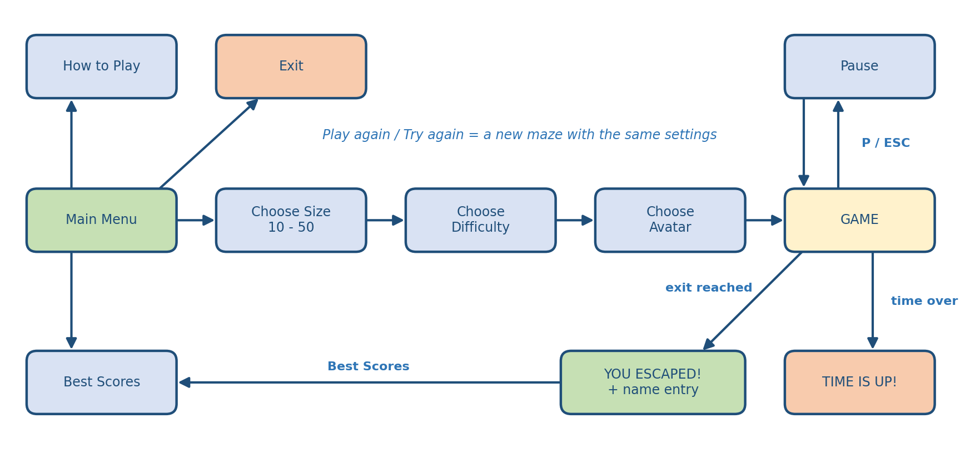

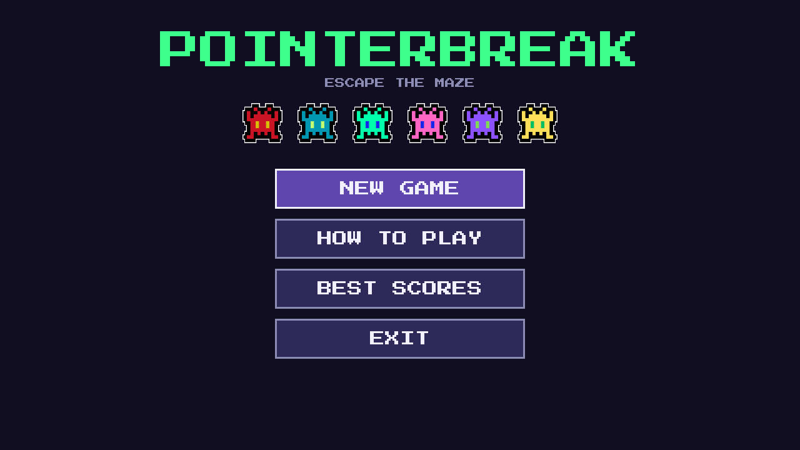  Main menu | 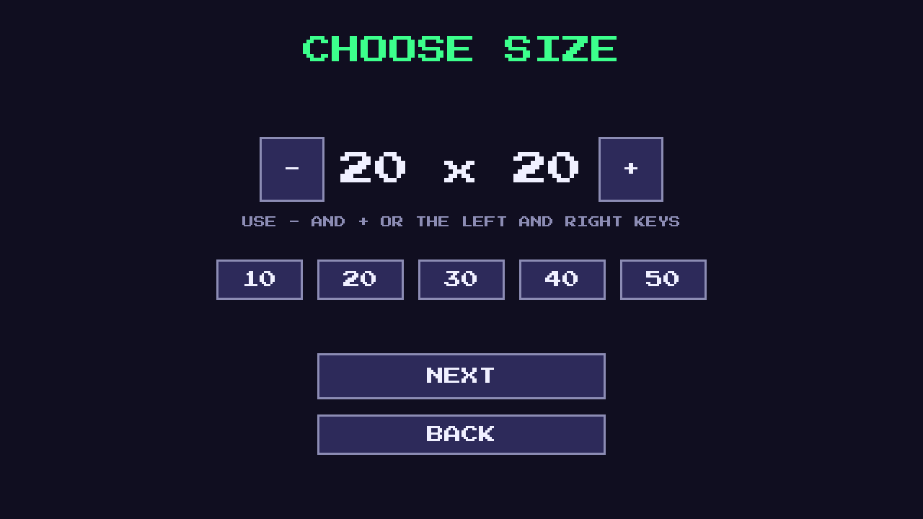  Choose size | 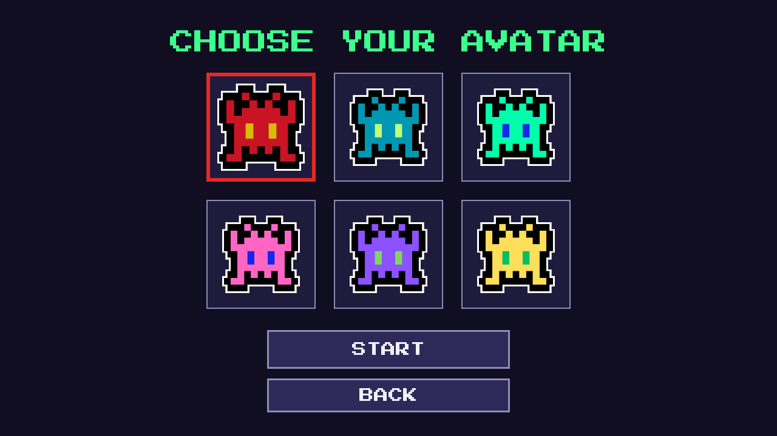  Choose avatar
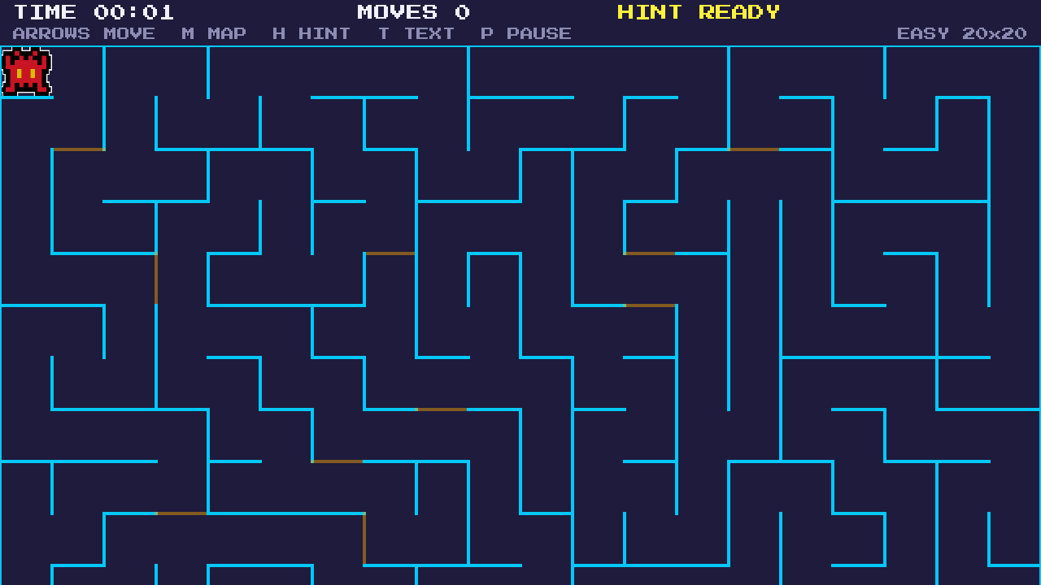  Gameplay | 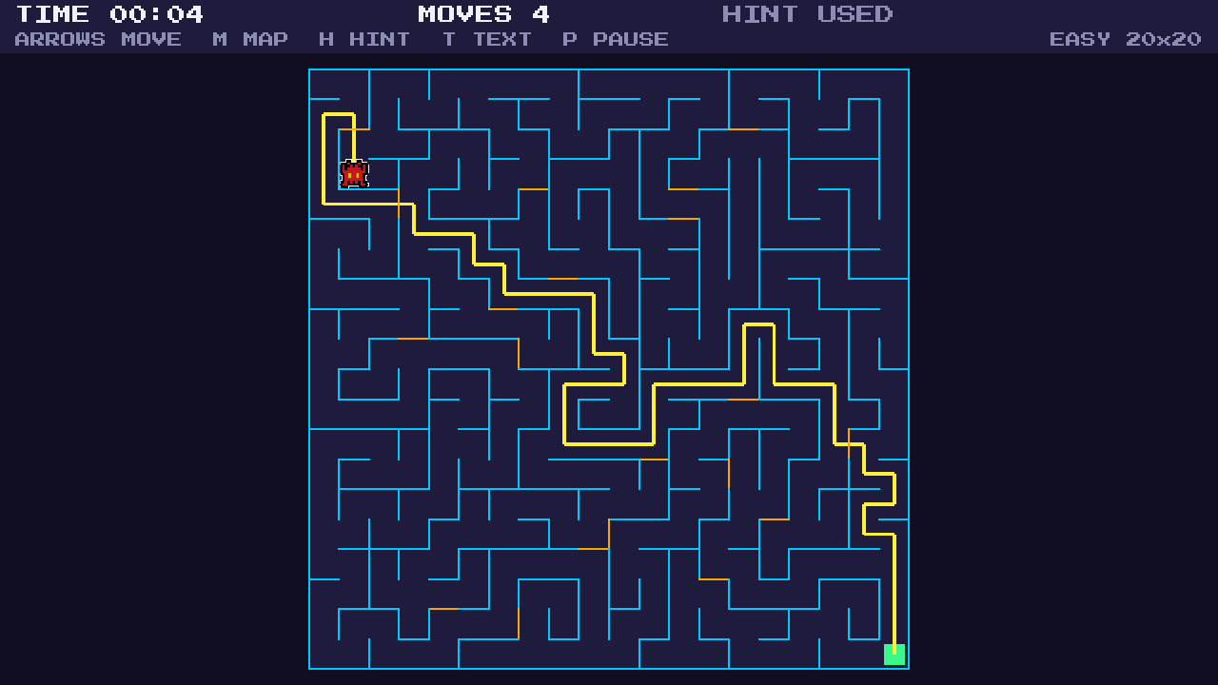  The hint | 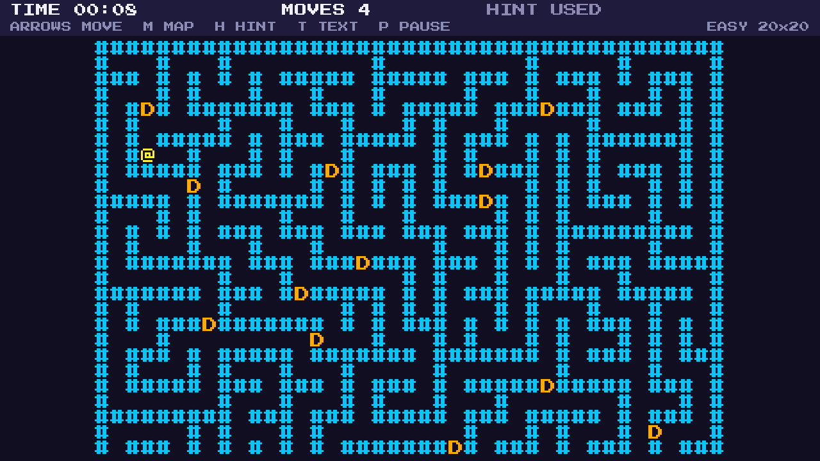  Text view

3.3 Difficulty Levels
Level | Time limit | Doors | Idea
Easy | none | many (as many as the size of the maze) | relax and look for shortcuts
Medium | generous: 4 s per step of the shortest path | some (size ÷ 2) | a balance between time and shortcuts
Hard | tight: 2 s per step of the shortest path | few (size ÷ 5, at least 2) | every second counts
The limit is calculated from the shortest path of the generated maze (found with BFS), so it is fair for every maze size.
3.4 Scoring System
The score is calculated when the player reaches the exit and has two equal parts:
- Route: shortest path ÷ moves made (at most 1). A player who never takes a wrong turn gets the full part.
- Speed: shortest path × 0.4 s ÷ time used (at most 1).
- Score = 1000 × (0.5 × Route + 0.5 × Speed). If the hint was used, the result is multiplied by 0.8.
If the score is good enough, the player enters a name of three letters (A-Z) and the result is saved in the table of the chosen difficulty. A * after the score shows that the hint was used.
3.5 Input Validation
Input | Rule | What happens
Maze size | only 10 to 50 | the buttons and the keys cannot go outside the limits
Player name | exactly 3 letters A-Z | other keys are ignored; Enter works only with 3 letters
Scores.txt | every line is checked | broken lines and wrong values are skipped; a missing file gives empty tables
Avatar image, font | the file may be missing | colored squares and the default font are used, no crash
Avatar number | only 0 to 5 | other numbers are ignored

4. Implementation Details
4.1 Architecture
The program is split in two parts. The game logic (GameLogic, MazeGenerator, PlayerAvatar, ScoreBoard) knows nothing about the window: it does not use raylib and it never uses cin or cout, as the assignment requires. The graphics and controls (GameManager, GameplayScreen, Screens, AvatarRenderer, UiHelper) draw everything, read the keyboard and the mouse, and call the logic. Because of this separation the logic can be tested without opening a window.
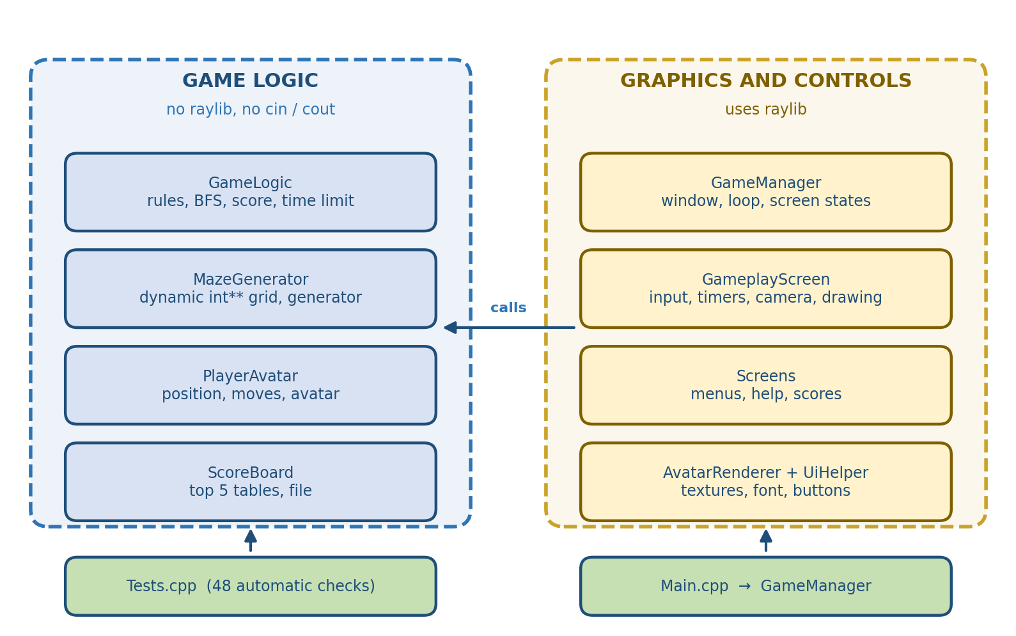
4.2 File Structure
PointerBreak/
├── Assets/ avatars (PNG) and the Press Start 2P font
├── Include/ header files (.h)
│ ├── Constants.h shared constants and small types
│ ├── GameLogic.h pure game calculations
│ ├── MazeGenerator.h dynamic maze grid and generation
│ ├── PlayerAvatar.h data of the player
│ ├── ScoreBoard.h high score tables
│ ├── AvatarRenderer.h drawing the avatars
│ ├── UiHelper.h colors, text and buttons
│ ├── Screens.h simple menu screens
│ ├── GameplayScreen.h the game screen
│ └── GameManager.h window, loop and state machine
├── Src/ source files (.cpp, same names) and Main.cpp
├── Tests/ Tests.cpp (the QA test functions)
├── Docs/ documentation and QA files
├── Media/ images for the README and the website
├── CMakeLists.txt build configuration
└── README.md

4.3 Core Data Structures
- Cell: every cell of the maze is one int: bits 0-3 are the walls (up, right, down, left), bits 4-7 are doors on the same sides, bit 8 is a temporary “visited” flag used only while the maze is generated.
- Maze grid: int** grid, a dynamic two-dimensional array used as grid[y][x].
- Direction: enum with DIR_UP, DIR_RIGHT, DIR_DOWN, DIR_LEFT; the arrays DIR_DX and DIR_DY give the step for each direction.
- Difficulty: enum with DIFFICULTY_EASY, DIFFICULTY_MEDIUM, DIFFICULTY_HARD.
- ScreenState: enum with the eight states of the state machine in GameManager.
- Point, GameSettings: small structs: a cell position, and the size, difficulty and avatar chosen by the player.
- ScoreEntry: struct with the name, the score and a flag for the hint.
4.4 Maze Generation
The maze is generated with the Recursive Backtracker algorithm. It is written with a stack instead of recursion, so even a 50×50 maze cannot overflow the call stack.
- All four walls of every cell are closed.
- Start at (0,0), mark it as visited and push it on the stack.
- Look at the top cell of the stack. If it has an unvisited neighbour, choose one at random, remove the wall between them, mark the neighbour as visited and push it.
- If there is no unvisited neighbour, pop the stack (step back).
- Repeat until the stack is empty. Now every cell can be reached from (0,0), so a path to the exit always exists.
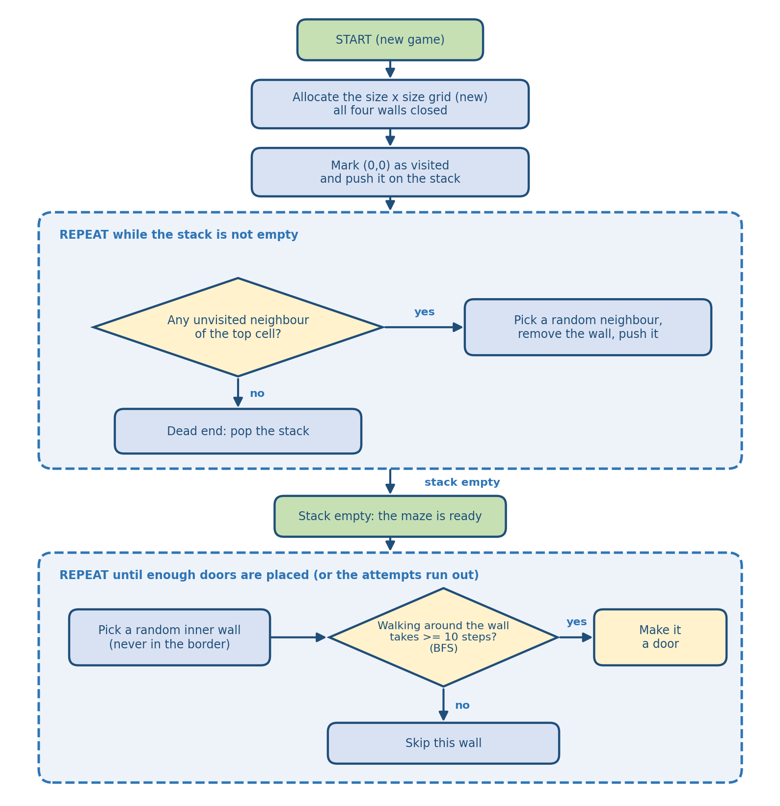
4.5 Special Doors
A door is a wall that the player is allowed to cross. After the maze is carved, the generator picks random inner walls and asks FindShortestPath how long the walk around each wall is. The wall becomes a door only if the detour is at least 10 steps, so every door is a real shortcut. When no good place is found, fewer doors are placed: the generator never fails.
4.6 Shortest Path (BFS)
Breadth-First Search is implemented once, in GameLogic::FindShortestPath, and is used in four places:
- the hint: the path from the current position of the player to the exit;
- the time limit: the length of the shortest path from the start, multiplied by 4 s (Medium) or 2 s (Hard);
- the score: the route part compares the moves of the player with the shortest path;
- the doors: the generator measures the detour around a wall.
The BFS only works with the grid: it does not draw anything and does not read the keyboard.
4.7 Dynamic Memory
- AllocateGrid creates the grid with new int*[size] and one new int[size] for every row; FreeGrid releases every row with delete[] and then the array of rows.
- The destructor of MazeGenerator calls FreeGrid, and AllocateGrid calls it first, so memory is never leaked when a new game starts.
- Copying of MazeGenerator is forbidden (= delete), so the same memory can never be freed twice.
- The memory is checked with AddressSanitizer and with a test that creates and destroys 200 mazes.
4.8 Camera and Smooth Movement
- The game logic moves the player cell by cell; the drawn position slides after it, so the movement looks smooth.
- The camera follows the player. A maze smaller than the window is centered.
- While M is held, while the hint is shown and when the game ends, the camera zooms out until the whole maze is visible.
- The pixel art is drawn with point filtering and DrawTexturePro, which scales the avatar to the cell size.
4.9 Table of Functions
Function | Return Type | File
IsValidSize | bool | GameLogic.cpp
CheckWallCollision | bool | GameLogic.cpp
CheckWinCondition | bool | GameLogic.cpp
FindShortestPath | std::vector<Point> | GameLogic.cpp
DoorCountFor | int | GameLogic.cpp
CalculateTimeLimit | int | GameLogic.cpp
CalculateScore | int | GameLogic.cpp
BuildTextMaze | std::vector<std::string> | GameLogic.cpp
AllocateGrid | void | MazeGenerator.cpp
FreeGrid | void | MazeGenerator.cpp
GenerateMaze | void | MazeGenerator.cpp
PlaceDoors | int | MazeGenerator.cpp
IsValidPath | bool | MazeGenerator.cpp
MovePlayer | void | PlayerAvatar.cpp
Reset | void | PlayerAvatar.cpp
LoadFromFile | void | ScoreBoard.cpp
SaveToFile | void | ScoreBoard.cpp
QualifiesForTable | bool | ScoreBoard.cpp
AddScore | void | ScoreBoard.cpp
IsValidName | bool | ScoreBoard.cpp
LoadAvatarTextures | void | AvatarRenderer.cpp
DrawPlayer | void | AvatarRenderer.cpp
DrawAvatar | void | AvatarRenderer.cpp
LoadUiFont | void | UiHelper.cpp
DrawLabel | void | UiHelper.cpp
DrawButton | bool | UiHelper.cpp
ShowMainMenu | ScreenState | Screens.cpp
ShowHelp | ScreenState | Screens.cpp
ShowSizeSelect | ScreenState | Screens.cpp
ShowDifficultySelect | ScreenState | Screens.cpp
ShowAvatarSelect | ScreenState | Screens.cpp
ShowScores | ScreenState | Screens.cpp
StartNewGame | void | GameplayScreen.cpp
HandleMovement | void | GameplayScreen.cpp
HandleHint | void | GameplayScreen.cpp
CheckEndOfGame | void | GameplayScreen.cpp
UpdateCamera | void | GameplayScreen.cpp
DrawMaze | void | GameplayScreen.cpp
DrawTextMaze | void | GameplayScreen.cpp
Render | ScreenState | GameplayScreen.cpp
InitializeEngine | void | GameManager.cpp
RunGameLoop | void | GameManager.cpp
UpdateScreen | void | GameManager.cpp
RenderScreen | void | GameManager.cpp
ShutdownEngine | void | GameManager.cpp
main | int | Main.cpp

5. Development Process
5.1 Workflow
- Planning: Scrum: the team discussed the idea, chose the roles and wrote the tasks as Issues on a GitHub Projects board.
- Implementation: every task was done in its own branch, from the simplest files to the most complex ones.
- Review: a team member checked every Pull Request before it was merged into main.
- Testing: the QA Engineer ran the automatic tests and the manual test plan.
- Documentation: technical documentation, presentation and the project website.
Team rules: commit messages are in English, short and clear; the main branch always compiles; the code has no compiler warnings.
5.2 Main Stages
Week | Dates | What we did
First week | 21.10 - 25.10 | Discussing the idea and the rules, choosing roles, GitHub board and repository, shared constants, assets (avatars and font), first README.
Second week | 26.10 - 01.11 | Backend: game logic, shortest path, maze generator, score board. Frontend: UI helper and avatar renderer. Data of the player.
Third week | 02.11 - 08.11 | Gameplay screen, menu screens, game manager, CMake build, QA test functions and QA documentation.
Fourth week | 09.11 - 15.11 | Testing on Windows, QA results, screenshots, technical documentation, presentation, project website and final fixes.

5.3 Milestones
# | Phase | Deliverables
1 | Planning | Idea, roles, GitHub board and repository
2 | Architecture | Game logic separated from graphics, shared constants and types
3 | Maze | Dynamic grid, Recursive Backtracker, shortcut doors
4 | Game Logic | Walls, win check, BFS, time limit, scoring, score board
5 | Interface | raylib menus, avatars, camera, smooth movement, text view
6 | Quality Assurance | 48 automatic checks, manual test plan, Excel test table, memory check
7 | Documentation | Documentation, presentation, project website
8 | Final Polish | Testing on Windows, GitHub cleanup, defense

5.4 Collaboration Tools
- GitHub: repository, Issues, Projects board, branches and Pull Requests
- Microsoft Teams: communication of the team
- Visual Studio 2022: writing, building and debugging the code
- Microsoft Word, PowerPoint and Excel: documentation, presentation and the QA table
6. Team
6.1 Team Members
Full Name | GitHub | Class | Role
Teodor Todorov | GitHub | 10A | Scrum Trainer
Borislav Andrikov | GitHub | 10B | Backend Developer
Alexander Kasabov | GitHub | 10G | Frontend Developer
Vasilen Gospodinov | GitHub | 10B | Quality Engineer

6.2 Roles and Responsibilities
- Teodor Todorov (Scrum Trainer): project coordination, GitHub board and deadlines, the README, this documentation and the presentation, the data of the player, the program entry point, the CMake build and the project website.
- Borislav Andrikov (Backend Developer): shared constants, the game logic (collisions, win check, shortest path, score, time limit), the maze generator with the dynamic grid and the shortcut doors, the score board with file saving.
- Alexander Kasabov (Frontend Developer): everything the player sees: the UI helper, the avatar renderer, the gameplay screen with camera and animation, the menu screens and the game manager.
- Vasilen Gospodinov (Quality Engineer): test functions, manual test plan, Excel table with 154 test steps, QA documentation and the screenshots of the finished game.
6.3 Who Wrote What
Member | Files
Teodor | .gitignore, README.md, PlayerAvatar.h / .cpp, Screens.h, Main.cpp, CMakeLists.txt, Media/, Docs/DesignDecisions.md, this documentation
Borislav | Constants.h, GameLogic.h / .cpp, MazeGenerator.h / .cpp, ScoreBoard.h / .cpp
Alexander | Assets/, UiHelper.h / .cpp, AvatarRenderer.h / .cpp, GameplayScreen.h / .cpp, Screens.cpp, GameManager.h / .cpp
Vasilen | Tests/Tests.cpp, Docs/QA.md, Docs/QA_ManualTestPlan.md, Docs/PointerBreak_QA_TestCases.xlsx, Media/Screenshots/

7. Quality Assurance
7.1 Strategy
Part | Classes | How it is tested
Game logic | GameLogic, MazeGenerator, PlayerAvatar, ScoreBoard | automatic test functions in Tests.cpp, no window needed
Graphics and controls | GameplayScreen, Screens, AvatarRenderer, UiHelper, GameManager | manual tests with a written plan

7.2 Automatic Tests
The program PointerBreakTests contains 12 test functions with 48 checks. Every check prints PASS or FAIL. The tests start with a fixed random seed, so they are repeatable.
Test function | Checks | What it proves
TestSizeValidation | 5 | sizes 9, 51 and −5 are rejected; 10 and 50 are accepted
TestEveryMazeIsSolvable | 2 | every size 10..50 has a path to the exit; the shortest path never crosses a wall
TestBorderAndSymmetry | 3 | the border is closed; walls and doors are the same from both cells; no doors in the border
TestDoors | 2 | doors are not more than requested and sit only on walls
TestWallCollision | 3 | a wall blocks, an open side does not, a door can be crossed
TestWinCondition | 3 | only the exit cell wins
TestPlayerAvatar | 4 | start position, movement, reset, invalid avatar is ignored
TestTimeLimitAndDoorCount | 5 | time limit and door count of every difficulty
TestScore | 4 | perfect run 1000, hint costs 20%, never above 1000
TestScoreBoard | 12 | top 5, sorting, name validation, broken and missing file
TestTextMaze | 4 | size 21×21, @ at the start, E at the exit
TestMemoryCreateAndDestroy | 1 | 200 mazes are created and destroyed without a crash

7.3 Manual Tests
106 manual steps in six groups (menus, setup screens, gameplay, game end, robustness and build) are written in the Excel table PointerBreak_QA_TestCases.xlsx, together with the 48 automatic checks:
154 steps in total. Every step has a status: PASSED, FAILED or NOT RUN.
7.4 Memory Check
The program is built with AddressSanitizer (-DENABLE_ASAN=ON), which finds memory leaks, double deletes and reads outside of an array. No problems were reported.
7.5 Results
Date | Environment | Result
04.11.2026 | Linux, g++ with AddressSanitizer | 48 of 48 automatic checks passed, no warnings, no memory errors
04.11.2026 | Linux, the real game on a virtual display | 84 of 106 manual steps tried, all as expected; 22 not run yet
04.11.2026 | Windows, Visual Studio 2022 | all as expected, no memory errors
A defect found during testing: on the size screen the big text “20 x 20” was so wide that it went under the + and − buttons. The font was made smaller and the problem was fixed.
8. Additional Work (project website)
In addition to the assignment we made a one-page presentation website for the game. It has animated pixel-art effects, a maze that solves itself, the rules and the controls, real screenshots, the six avatars, the difficulty levels, the architecture and the team. It is a single HTML file that can be published on GitHub Pages. Address: Pointer Break site
9. Conclusion
PointerBreak meets all requirements of the assignment: a maze game with dynamic memory and sizes from 10×10 to 50×50, a start and an exit in the opposite corners, a text view of the maze, control with the arrow keys, special doors, functions for the game logic that do not use cin and cout, a menu and input validation. The game also goes beyond the minimum: a smooth camera, a hint, three difficulties, six avatars, a high score table and a project website.
The project strengthened our understanding of dynamic memory in C++, of separating the game logic from the graphics, of graph algorithms (DFS and BFS) and of teamwork with Scrum and GitHub.
Possible future improvements: a Minotaur that chases the player, keys that open doors, sound effects and music, color themes, a “fog of war” mode and online high scores.
10. References
- raylib: raylib.com
- C++ Reference Documentation: cppreference.com
- Visual Studio Official Documentation: learn.microsoft.com
- GitHub Documentation: docs.github.com
- CMake Documentation: cmake.org
- Maze generation (Recursive Backtracker) and Breadth-first search: Wikipedia
- Press Start 2P font: fonts.google.com

