

TsaaP-Notes – Technical file
Contents
1 Attachment management 3
1.1 General aspect 3
1.2 Technical details 3
1.2.1 Use Jackrabbit classes 3
1.2.2 Spring configuration 3
1.2.3 Attachement, AttachementService, AttachementTagLib and AttachementDataStore 4
2 Learning TooIs Interoperability (LTI) integration 4
2.1 General aspect 4
2.2 Technical details 5
2.2.1 External libraries 5
2.2.2 Use SPV Software Products LTI package 5
2.2.3 Servlet mapping 6
2.2.4 Database relationships 6
2.2.5 Configure LTI link 7
2.2.5.1 On TsaaP-Notes 7
2.2.5.2 On Moodle 7
2.2.6 LTI operation 8
2.2.6.1 The Launch servlet 8
2.2.6.2 LmsUserService, LmsUserHelper 9
2.2.6.3 LmsContextService, LmsContextHelper 9
2.2.6.4 LmsGradeService 9

Attachment management

General aspect
Attachment management was implemented based on file storage management in Jackrabbit.
Each file corresponds to an attachment of a Note and is stored on the file system. The ID of the file is the SHA1 code file. Two attachments are therefore identical contents stored in one copy on the file system.

Technical details

Use Jackrabbit classes

We use Jackrabbit's binaries storage management also use in eliot-tdbase to save file data.
In TsaaP-Notes project, all this classes are in “src/java” record and “org.tsaap.uploadImage” package.
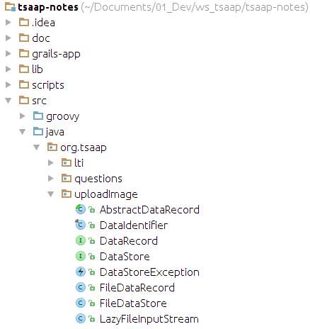

Spring configuration

The AttachementDataStore is injected within the AttachementService by Spring.
The Spring injection is described in “resources.groovy” file.

dataStore(AttachementDataStore) { bean ->
path = application.config.tsaap.datastore.path ?: null
bean.initMethod = 'initFileDataStore'
}
If AttachementDataStore fails with Spring configuration when application is launch, an exception is thrown and the application can't run.

Attachement, AttachementService, AttachementTagLib and AttachementDataStore

An attachment is represented by an Attachement domain class. This class contains one identifier for the corresponding file on the file system and have some others properties (file size, file name, mime type...).
The AttachementService is based on a DataStore object type whose implementation is provided by the AttachementDataStore class that extends the class FileDataStore provided by Jackrabbit. The AttachementDataStore class provides the method "initFileDataStore" who initialize dataStore root on file system. If initialization fails, the method throws an exception.

AttachementService details:
Some methods was created to attachment management.
- “addFileToNote”, create an attachment for a given file and attach it to a note.
- “addNoteToAttachement” and “detachAttachement” are use to respectively attach and detach an attachment to a note.
- “deleteAttachementAndFileInSystem” is use to find unused attachments and delete it from database and file system.
AttachementTagLib is use to correctly display attachments in notes detail view.
<g:if test="${attachment != null}">
<tsaap:viewAttachement width="650" height="380" attachement="${attachment}"/>
</g:if>

Learning TooIs Interoperability (LTI) integration

General aspect

The LTI protocol was designed by IMS Global in order to integrate learning application on platforms like Learning Management System (LMS)
In our case, TsaaP-Notes is our learning application and Moodle is our LMS.

Technical details

External libraries

To make this link between TsaaP-Notes and a LMS we need to import some external libraries.
To import these libraries, we need to add libraries' remote repository link in “BuildConfig.groovy” and especially in dependencies closure.
dependencies {
// specify dependencies here under either 'build', 'compile', 'runtime', 'test' or 'provided' scopes eg.
runtime 'mysql:mysql-connector-java:5.1.24'
compile 'org.gcontracts:gcontracts-grails:1.2.12'
compile 'org.liquibase:liquibase-core:3.2.2'
compile 'commons-beanutils:commons-beanutils:1.8.3'
compile 'jdom:jdom:1.0'
compile 'commons-httpclient:commons-httpclient:3.1'
compile 'commons-codec:commons-codec:1.8'
compile 'org.springframework.security:spring-security-crypto:3.2.3.RELEASE'
}
To use LTI protocol, we also need ApacheJMeter-oauth-v2 library. This library was include in TsaaP-Notes project because she don't have a Maven repository.
Some ApacheJMeter-oauth-v2 classes who are not contains in jar file are added in “src/java” record and “org.tsaap.lti.tp.net.oauth” package.

Use SPV Software Products LTI package

In order to make a link between TsaaP-Notes and a LMS, we use classes created by SPV Software Products.
These classes are contains in “src/java” record and “org.tsaap.lti” package.
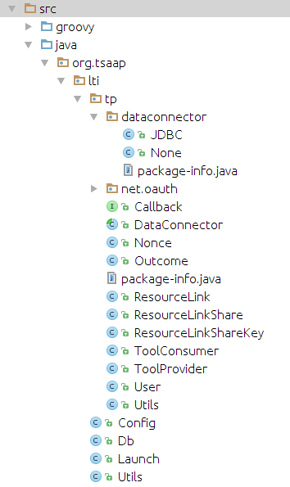

Only Launch class undergoes changes to be adapted to the TsaaP -Notes' context.

Servlet mapping

We need to define Launch servlet and configure the servlet mapping.
In doWithWebDescriptor closure of “TsaapNotesGrailsPlugin” we can define “servlet-name” and “servlet-mapping” tags.
def doWithWebDescriptor = { xml ->
def servlets = xml.'servlet'
servlets[servlets.size() - 1] + {
servlet {
'servlet-name'('Launch')
'servlet-class'('org.tsaap.lti.Launch')
}
}
def mappings = xml.'servlet-mapping'
mappings[mappings.size() - 1] + {
'servlet-mapping' {
'servlet-name'('Launch')
'url-pattern'('/launch')
}
}
}

Database relationships

In addition to Java classes SPV Software Products also uses its own database structure.
It is therefore imperative to link the already present data structure in TsaaP-Notes with the structure provided by SPV Software Products.
In addition LTI tables, we add two tables that are lms_user and lms_context to make this link that is show on the following diagram.

User
- id
- username
- password
...
Lms_user
Lti_user
- user_id
- #context_id
- #consumer_key
...
- #tsaap_user_id
- #lti_user_id
- #lti_consumer_key
1
1
1
1

Lms_context
Context
Lti_context
- id
- context_name
...
- #tsaap_context_id
- #lti_course_id
- #lti_activity_id
- #lti_consumer_key
- source
- consumer_key
- context_id
- lti_context_id
...
1
1
1
1

Configure LTI link

On TsaaP-Notes

To establish the link between TsaaP-Notes it's imperative to create a lti_consumer in the database.
The dedicated page to create lti_consumer is not implemented for the moment. Adding this lti_consumer must be done manually in the database.

The key, secret and enabled field are the most important field for the lti_consumer.
The key and the secret are the two elements secretly shared between TsaaP-Notes and the LMS.
If the two parts don't know the same key and secret, there is no connection enable between there.
Enabled field should be true to enable connection between TsaaP-Notes and the LMS.
Protected field should be true.

On Moodle

To configure LTI on Moodle, you must have administrators law, then you should go on “Site administration/Plugins/Activity Modules/LTI/Manage external tools types” page to add/update/delete some external tools.
On this page, you must configure external tools with the following parameters.
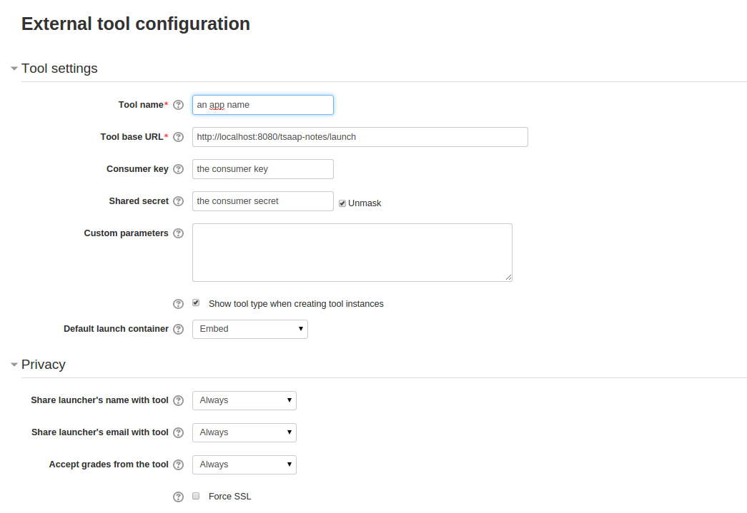

LTI operation

The Launch servlet

The Launch servlet receive a post request from the LMS with some parameters. Is job is to get a database connection and create a Tool Provider with the given parameters.
Then the Tool Provider goes to check all these parameters and particularly the consumer_key and secret parameters.
If there is some problems with parameters, the Tool Provider don't allow the connexion between TsaaP-Notes and the LMS.
If there isn't problem, the Tool Provider actualize LTI informations on database (lti_consumer, lti_context, lti_user).
Then the Tool Provider will make the hand to the Launch servlet that will call to services to determine the URL to redirect the LMS external tool.

LmsUserService, LmsUserHelper

The LmsUserService is a service use by the Launch servlet to know if the LTI user whose connect from the LMS have or not an enable TsaaP-Notes account.
If he have one, the service authenticate it on TsaaP-Notes. If he haven't, the service create for him a TsaaP-Notes user account an also authenticate it.
The LmsUserHelper class contains methods who get access to the database for the LmsUserService.

LmsContextService, LmsContextHelper

The LmsContextService is a service use by the Lauch servlet to know if the LTI context have a reference to a TsaaP-Notes context.
If it's the case, the service send context informations to the servlet who use these for redirect URL.
If it's not, the service create a context in reference to the LTI context.
The LmsContextHelper class contains methods who get access to database for the LmsContextService.

LmsGradeService

The LmsGradeService is use to send grades to a LMS for a given LTI user and a given LTI context.
This service have “getUserGradeForContext” method who get all questions grades in a context for users an compute grades to have an average for these users.
This service have also a “sendUserGradeToLms” method who send user's grade for a LTI context to a LMS.

