P#5 Activity Life Cycle Methods

Activity_main Java:

package com.example.actvitylifecycle;  
  
import androidx.appcompat.app.AppCompatActivity;  
  
import android.content.Intent;  
import android.os.Bundle;  
import android.view.View;  
  
import com.google.android.material.floatingactionbutton.FloatingActionButton;  
  
public class MainActivity extends AppCompatActivity {  
  
  
  
 @Override  
 protected void onCreate(Bundle savedInstanceState) {  
 super.onCreate(savedInstanceState);  
 setContentView(R.layout.*activity_main*);  
  
 FloatingActionButton floatingActionButton = (FloatingActionButton) findViewById(R.id.*floatingActionButton*);  
  
 floatingActionButton.setOnClickListener(new View.OnClickListener() {  
 @Override  
 public void onClick(View v) {  
 Intent intent = new Intent(MainActivity.this, LifeCycleActivity.class);  
 startActivity(intent);  
 }  
 });  
  
 }  
  
}

Activity_main XML:

<?xml version="1.0" encoding="utf-8"?>  
<androidx.coordinatorlayout.widget.CoordinatorLayout xmlns:android="http://schemas.android.com/apk/res/android"  
 xmlns:tools="http://schemas.android.com/tools"  
 xmlns:app="http://schemas.android.com/apk/res-auto"  
  
  
 android:layout_width="match_parent"  
 android:layout_height="match_parent"  
 android:background="@color/whiteshade1">  
  
 <com.google.android.material.appbar.AppBarLayout  
 android:id="@+id/appbar"  
 android:layout_height="64dp"  
 android:layout_width="match_parent"  
 android:background="@color/white">  
  
 <LinearLayout  
 android:layout_width="match_parent"  
 android:layout_height="wrap_content"  
 android:elevation="4sp"  
 android:orientation="horizontal"  
 android:weightSum="2">  
  
 <LinearLayout  
 android:layout_width="280dp"  
 android:layout_height="wrap_content"  
 android:layout_weight="1"  
 android:orientation="vertical">  
  
 <ImageView  
 android:id="@+id/cuLogo"  
 android:layout_width="187dp"  
 android:layout_height="64dp"  
 android:layout_marginRight="180dp"  
 android:layout_weight="1"  
 android:padding="4dp"  
 app:srcCompat="@drawable/androidlogo" />  
  
 </LinearLayout>  
 </LinearLayout>  
  
<!-- <com.google.android.material.appbar.CollapsingToolbarLayout-->  
<!-- android:layout_width="match_parent"-->  
<!-- android:layout_height="match_parent"-->  
<!-- app:toolbarId="@+id/toolbar"-->  
<!-- app:layout_scrollFlags="scroll|enterAlways|enterAlwaysCollapsed"-->  
  
<!-- app:contentScrim="?attr/colorPrimary">-->  
  
  
<!-- <androidx.appcompat.widget.Toolbar-->  
<!-- android:id="@+id/toolbar"-->  
<!-- android:layout_height="?attr/actionBarSize"-->  
<!-- android:layout_width="match_parent"></androidx.appcompat.widget.Toolbar>-->  
<!-- </com.google.android.material.appbar.CollapsingToolbarLayout>-->  
 </com.google.android.material.appbar.AppBarLayout>  
  
 <androidx.core.widget.NestedScrollView  
 android:layout_width="match_parent"  
 android:layout_height="match_parent"  
  
  
 app:layout_behavior="com.google.android.material.appbar.AppBarLayout$ScrollingViewBehavior">  
  
 <RelativeLayout  
 android:layout_width="match_parent"  
 android:layout_height="match_parent"  
 tools:context=".MainActivity">  
  
 <LinearLayout  
 android:layout_width="match_parent"  
 android:layout_height="match_parent"  
 android:gravity="center"  
 android:layout_margin="12dp"  
 android:orientation="vertical">  
  
 <androidx.cardview.widget.CardView  
 android:layout_width="wrap_content"  
 android:layout_height="wrap_content"  
 android:layout_margin="12dp"  
 app:cardCornerRadius="30dp"  
 app:cardElevation="4dp"  
 android:background="@drawable/custom_edittext">  
  
  
 <TextView  
 android:id="@+id/lifeCycleTV1"  
 android:layout_width="match_parent"  
 android:layout_height="wrap_content"  
 android:text="This App is developed by \n\nSAMSON ANDREW FERNANDEZ\n\nto show the Activity Life Cycle of this App\n\n So to check the Life Cycle\n\n click on the Button Below\n\nThe FLOATING ACTION BUTTON"  
 android:textSize="16sp"  
 android:textStyle="bold"  
 android:textAlignment="center"  
 android:layout_margin="8dp"/>  
  
  
 </androidx.cardview.widget.CardView>  
 </LinearLayout>  
  
  
  
  
  
  
 </RelativeLayout>  
  
 </androidx.core.widget.NestedScrollView>  
  
 <com.google.android.material.floatingactionbutton.FloatingActionButton  
 android:id="@+id/floatingActionButton"  
 android:layout_height="wrap_content"  
 android:layout_width="wrap_content"  
 android:src="@drawable/baseline_recycling_24"  
 android:layout_gravity="bottom|end"  
 android:layout_margin="16dp" />"  
  
</androidx.coordinatorlayout.widget.CoordinatorLayout>

Activity_main screenshot:

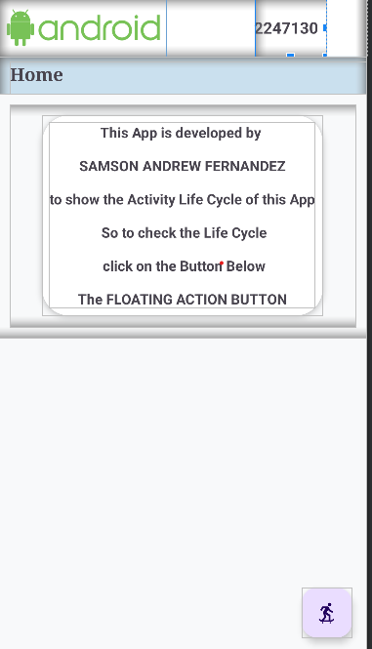

Activity_life_cycle XML:

<?xml version="1.0" encoding="utf-8"?>  
<androidx.coordinatorlayout.widget.CoordinatorLayout xmlns:android="http://schemas.android.com/apk/res/android"  
 xmlns:tools="http://schemas.android.com/tools"  
 xmlns:app="http://schemas.android.com/apk/res-auto"  
  
  
 android:layout_width="match_parent"  
 android:layout_height="match_parent"  
 android:background="@color/whiteshade1">  
  
 <com.google.android.material.appbar.AppBarLayout  
 android:id="@+id/appbar"  
 android:layout_height="64dp"  
 android:layout_width="match_parent"  
 android:background="@color/white">  
  
 <LinearLayout  
 android:layout_width="match_parent"  
 android:layout_height="wrap_content"  
 android:elevation="4sp"  
 android:orientation="horizontal"  
 android:weightSum="2">  
  
 <LinearLayout  
 android:layout_width="280dp"  
 android:layout_height="wrap_content"  
 android:layout_weight="1"  
 android:orientation="vertical">  
  
 <ImageView  
 android:id="@+id/cuLogo"  
 android:layout_width="187dp"  
 android:layout_height="64dp"  
 android:layout_marginRight="180dp"  
 android:layout_weight="1"  
 android:padding="4dp"  
 app:srcCompat="@drawable/androidlogo" />  
  
 </LinearLayout>  
 </LinearLayout>  
  
 <!-- <com.google.android.material.appbar.CollapsingToolbarLayout-->  
 <!-- android:layout_width="match_parent"-->  
 <!-- android:layout_height="match_parent"-->  
 <!-- app:toolbarId="@+id/toolbar"-->  
 <!-- app:layout_scrollFlags="scroll|enterAlways|enterAlwaysCollapsed"-->  
  
 <!-- app:contentScrim="?attr/colorPrimary">-->  
  
  
 <!-- <androidx.appcompat.widget.Toolbar-->  
 <!-- android:id="@+id/toolbar"-->  
 <!-- android:layout_height="?attr/actionBarSize"-->  
 <!-- android:layout_width="match_parent"></androidx.appcompat.widget.Toolbar>-->  
 <!-- </com.google.android.material.appbar.CollapsingToolbarLayout>-->  
 </com.google.android.material.appbar.AppBarLayout>  
  
 <androidx.core.widget.NestedScrollView  
 android:layout_width="match_parent"  
 android:layout_height="match_parent"  
  
  
 app:layout_behavior="com.google.android.material.appbar.AppBarLayout$ScrollingViewBehavior">  
  
 <RelativeLayout  
 android:layout_width="match_parent"  
 android:layout_height="match_parent"  
 tools:context=".MainActivity">  
  
 <LinearLayout  
 android:id="@+id/heading"  
 android:layout_width="match_parent"  
 android:layout_height="42dp"  
 android:background="@color/blueshade2"  
 android:orientation="horizontal">  
  
 <TextView  
 android:layout_width="match_parent"  
 android:layout_height="match_parent"  
 android:fontFamily="serif"  
 android:text="Activity Life Cycle"  
 android:textSize="20sp"  
 android:textStyle="bold"  
 android:layout_marginLeft="12dp"  
 android:layout_marginTop="6dp"  
 />  
  
 </LinearLayout>  
  
 <LinearLayout  
 android:layout_width="match_parent"  
 android:layout_height="match_parent"  
 android:gravity="center"  
 android:layout_margin="12dp"  
 android:orientation="vertical"  
 android:layout_below="@id/heading">  
  
 <androidx.cardview.widget.CardView  
 android:layout_width="wrap_content"  
 android:layout_height="wrap_content"  
 android:layout_margin="12dp"  
 app:cardCornerRadius="30dp"  
 app:cardElevation="4dp"  
 android:background="@drawable/custom_edittext">  
  
  
 <TextView  
 android:id="@+id/lifeCycleTV"  
 android:layout_width="match_parent"  
 android:layout_height="wrap_content"  
 android:textSize="16sp"  
 android:textStyle="bold"  
 android:textAlignment="center"  
 android:layout_margin="8dp"/>  
  
 </androidx.cardview.widget.CardView>  
  
 </LinearLayout>  
  
  
  
  
  
  
 </RelativeLayout>  
  
 </androidx.core.widget.NestedScrollView>  
</androidx.coordinatorlayout.widget.CoordinatorLayout>

Activity_life_cycle XML:

package com.example.actvitylifecycle;  
  
import androidx.appcompat.app.AppCompatActivity;  
  
import android.os.Bundle;  
import android.widget.TextView;  
  
public class LifeCycleActivity extends AppCompatActivity {  
  
 TextView lifeCycleTV;  
  
 @Override  
 protected void onCreate(Bundle savedInstanceState) {  
 super.onCreate(savedInstanceState);  
 setContentView(R.layout.*activity_life_cycle*);  
  
 lifeCycleTV =findViewById(R.id.*lifeCycleTV*);  
 appendLifecycleMessage("onCreate() : The Activity has 'Created'\n");  
 }  
 @Override  
 protected void onStart(){  
 super.onStart();  
 appendLifecycleMessage("onStart() : The Activity has 'started'\n");  
 }  
  
 @Override  
 protected void onResume() {  
 super.onResume();  
 appendLifecycleMessage("onResume() : The Activity has 'Resumed'\n");  
 }  
  
 @Override  
 protected void onPause() {  
 super.onPause();  
 appendLifecycleMessage("onPause() : The Activity has 'Paused'\n");  
 }  
  
 @Override  
 protected void onStop() {  
 super.onStop();  
 appendLifecycleMessage("onStop() : The Activity has 'Stopped'\n");  
 }  
  
 @Override  
 protected void onRestart() {  
 super.onRestart();  
 appendLifecycleMessage("onRestart() : The Activity has 'Restarted'\n");  
 }  
  
 @Override  
 protected void onDestroy() {  
 super.onDestroy();  
 appendLifecycleMessage("onDestroy() : The Activity has 'Destroyed'\n");  
 }  
  
 private void appendLifecycleMessage(String message) {  
 lifeCycleTV.append(message + "\n");  
 }  
}

Activity_life_cycle Screenshot:

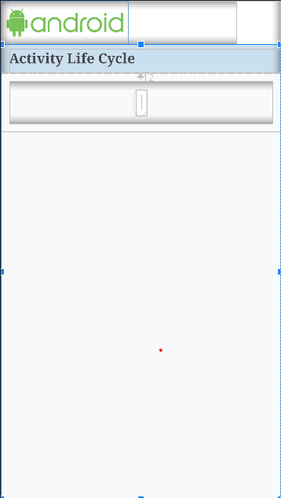

Activity Splashscreen xml:

<?xml version="1.0" encoding="utf-8"?>  
<androidx.constraintlayout.widget.ConstraintLayout xmlns:android="http://schemas.android.com/apk/res/android"  
 xmlns:app="http://schemas.android.com/apk/res-auto"  
 xmlns:tools="http://schemas.android.com/tools"  
 android:layout_width="match_parent"  
 android:layout_height="match_parent"  
 tools:context=".splashScreenActivity"  
 android:background="@color/whiteshade1">  
  
 <!-- activity_splash.xml -->  
 <LinearLayout  
 android:layout_width="match_parent"  
 android:layout_height="match_parent"  
 android:gravity="center"  
 android:orientation="vertical">  
  
 <!-- Add your desired splash screen content here -->  
 <ImageView  
 android:layout_width="325dp"  
 android:layout_height="wrap_content"  
 android:src="@drawable/androidlogo" />  
  
 <TextView  
 android:layout_width="wrap_content"  
 android:layout_height="wrap_content"  
 android:text="Activity Life Cycle"  
 android:textSize="24sp"  
 android:textColor="@color/greenAndroid"/>  
 </LinearLayout>  
  
  
  
</androidx.constraintlayout.widget.ConstraintLayout>

Activity splashscreen java:

package com.example.actvitylifecycle;  
  
import androidx.appcompat.app.AppCompatActivity;  
  
import android.content.Intent;  
import android.os.Bundle;  
import android.os.Handler;  
  
public class splashScreenActivity extends AppCompatActivity {  
  
 private static final long *SPLASH_DELAY* = 2000; //2sec  
  
 @Override  
 protected void onCreate(Bundle savedInstanceState) {  
 super.onCreate(savedInstanceState);  
 setContentView(R.layout.*activity_splash_screen*);  
  
 new Handler().postDelayed(new Runnable() {  
 @Override  
 public void run() {  
 Intent intent = new Intent(splashScreenActivity.this,MainActivity.class);  
 startActivity(intent);  
 finish();  
 }  
 },*SPLASH_DELAY*);  
 }  
}

Splashscreen screenshot:

