Golf

# Setting up the environment.

* When python is correctly installed, we first need to download Django itself with the following command in command prompt: *pip install Django*
* Additionally, since we will be using Bootstrap 4, we need to download compiled CSS and JS scripts from [official Bootstrap website](https://getbootstrap.com/docs/4.3/getting-started/download/)

# Initializing the project.

* After the Django has finished downloading, we can initialize new project by typing *django-admin startproject projectname.* Since our topic is Golf, we replaced “projectname” with “golf”.
* To make sure that everything is set up correctly, we first need to go to newly created project with *cd golf*  command, and type *python manage.py runserver* to start our local server.

# Coding

* Since our website will be very small and simple, consisting of several pages, we only need one app, which we create with *django startapp pages.* Now we have a new folder named pages inside our root folder.

Then we need to add this newly created app into our project settings. To do so, we head over to settings.py file and the following code to INSTALLED_APPS variable, which will add our app to a list of existing apps

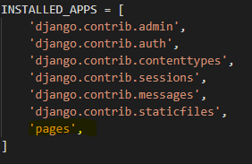

* 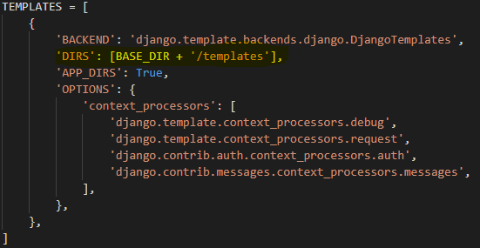Django has very useful feature of templates, meaning we can create a basic page template, which will be rendered on every page and only modify the dynamic parts. To do so, we create a folder called “templates” in the root folder, and as again need to link it to our project in settings.py file:
* Since we will be using static files (like CSS and Images), we need to link the path as well. 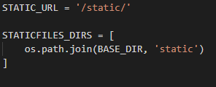
* Now we need to add routes to our future pages. In views.py in pages folder, we add the following code and repeat the same function to every page:

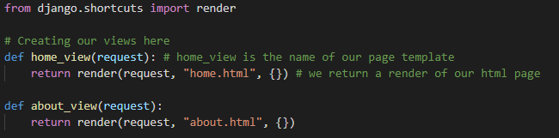

* Then in urls.py file in root folder, we first import those views, and add routes to urlpattern variable:

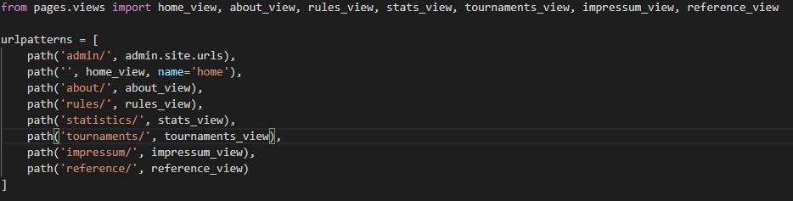

# Templates

* In order to use templates, first we need to create base template, and since our website will consist of 7 pages, we then create 7 different html files called home, about, rules, statistics, tournaments, impressum and reference.

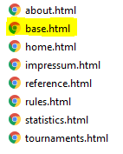

# Adding static files.

* Now we create the folder names **static** which will store all files like css, js, and images, and copy downloaded bootstrap files into css and js folder accordingly. Also we need to create **images** folder where we store our background image.

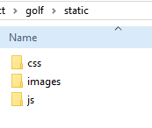

Basic setup is complete. Now it is time write HTML code and style it.

Base Template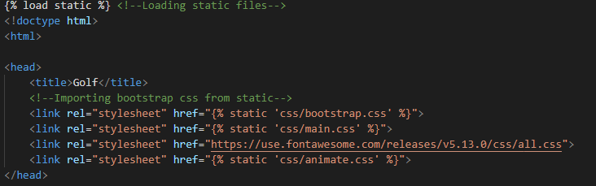

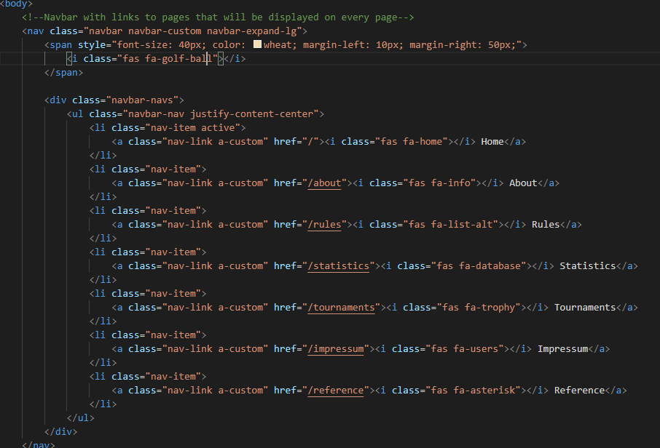

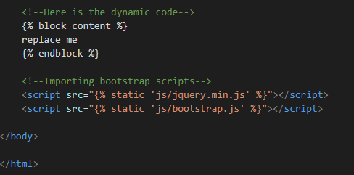

Home Page

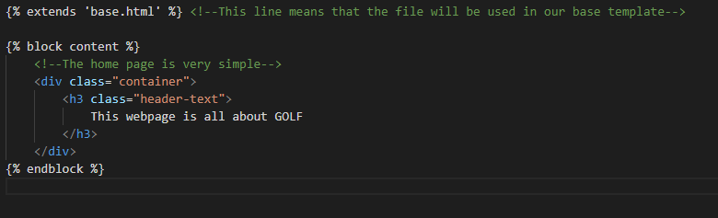

About Page

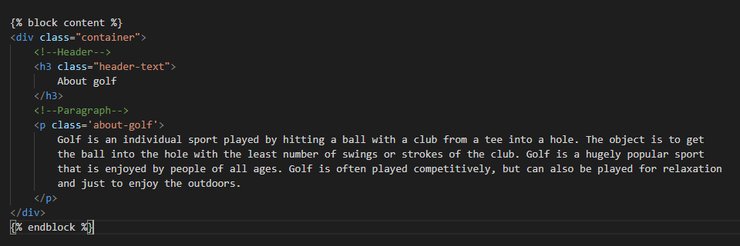

Rules

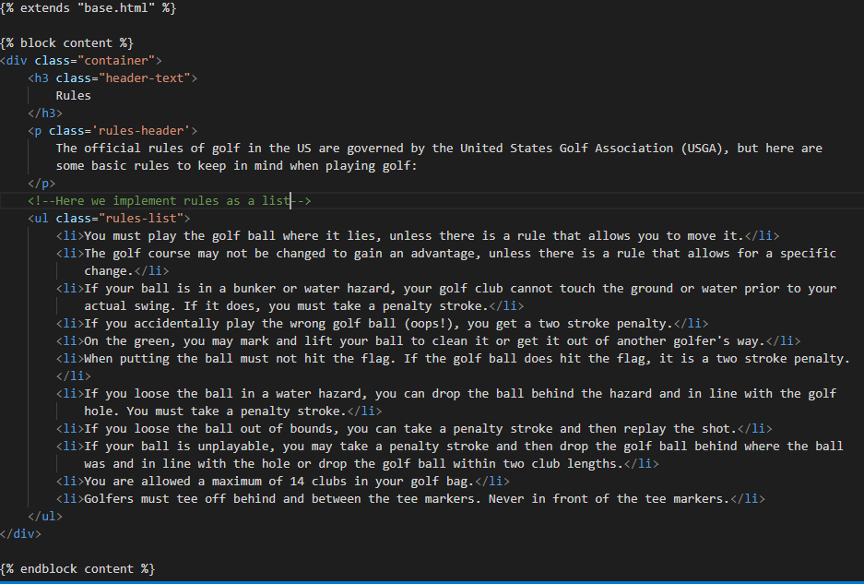

Statistics Page

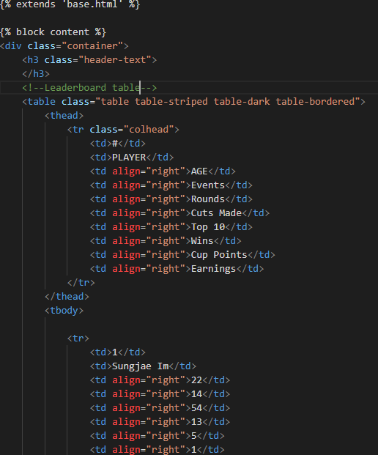

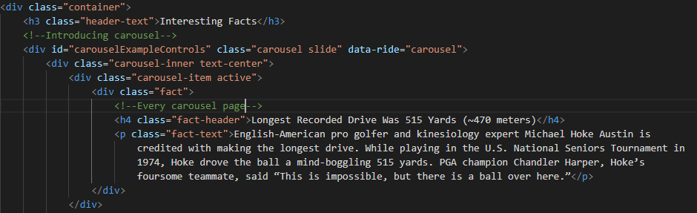

Tournaments

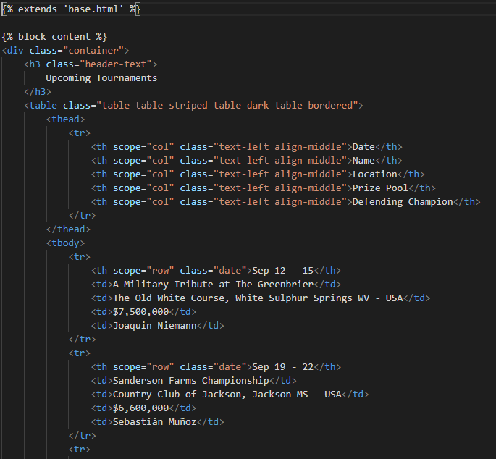

Impressum Page

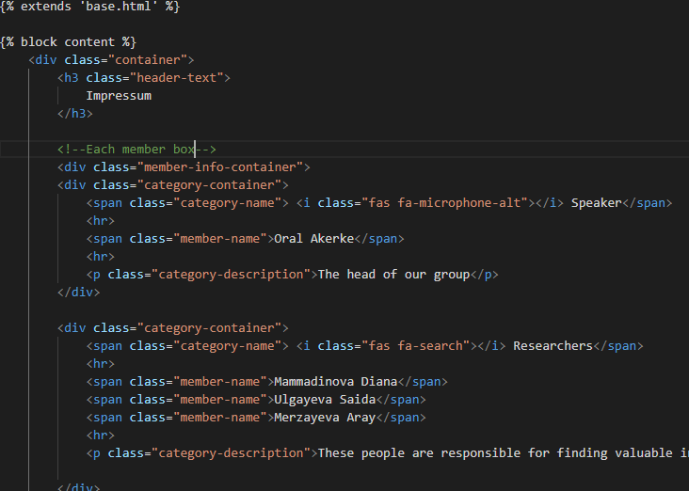

Reference Page

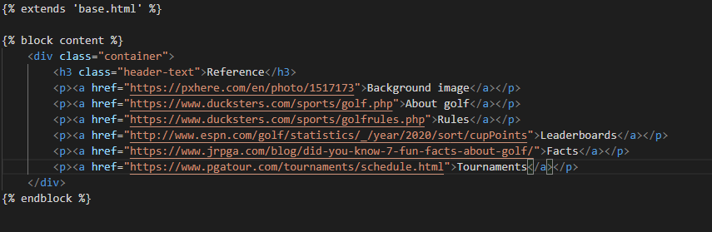

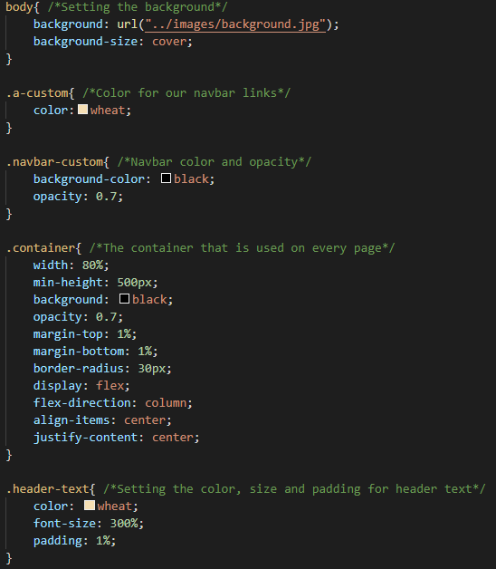CSS

