Hockey

1. **Introduction**
2. **Setting up**

Before we start coding, we need to set up our environment and download additional files like, in our case images, bootstrap and CSS libraries. Then we open *cmd* and type *django-admin startproject hockey*. After the initialization is complete, we need to create some folders for future uses.

Our website will be base on django libraries, and we decided to use one-page structure in our project because it looks very stylish and yet very interesting design wise. Also, we thought it would be easier to use django templates so we don’t have to copy part of the same codes into every page.

First of all, we need to link our media files (images) and css files together with the project, so we open **settings.py** file and add extra bit of code at the end of file. Then create new folder named **static** that will have 4 folders inside: *images, flags, css* and *js.* Images folder will contain our previously downloaded images, flags will contain images of the country flags and css and js folders will have bootstrap4 and animate css, as well as bootstrap JS files accordingly.

To use templates, we first need to create “templates” folder in our root folder as well as add a shortcut to the **settings.py** file in **hockey** folder. To do so, we simply add a directory path of our templates folder in “TEMPLATES” variable’s DIR key *'DIRS': [BASE_DIR+'/templates'],* where *BASE_DIR* is the default path to our project. After that we are ready to use templates.

Since our project will have only one page, we need to add one html file only, as well as base template html. We called them **base.html** and **page.html.** We will fill in the code later on.

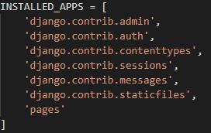

After the templates are configured, we need to create an app that will render our html files and visualize them as real html components to the user. For that we type *python manage.py startapp pages.* This will create new folder in our root folder. As with templates configuration, we need to add our newly created app into **settings.py** file in *INSTALLED_APPS* variable*.* This will let django know that we have our own app. Then navigating to our **pages** folder, we need to create view that will render our html code as a page content. In **view.py** file, we add a function called *page_view().*

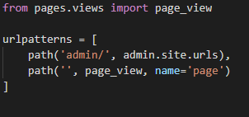This function takes the request that our browser makes when we load a page and returns the rendered page content from the file **page.html** that we created earlier in “templates” folder.

Lastly, we need to edit **urls.py** file in **hockey** folder and import page_view, then append additional empty url that simply leads to our one and only page.

1. **Coding.**

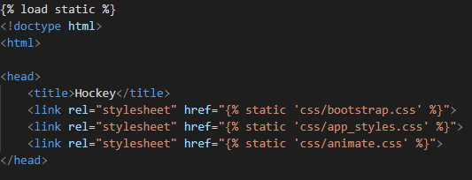After everything is settled down, we can start with the interesting part – coding. Since we are using templates, we make **base.html** file as our template, thus wrapping it as a html document, where we add links with paths to *bootstrap, app_styles* and *animate css* files. *{% load static %}* means it will import static folder for future uses. Then we add simple Navbar component from bootstrap with links to each section. After that we type the following code:

This means the code that will be included in other html files will be inserted here. Then we end our **base.html** file with including additional bootstrap scripts and div container with the source to website that we downloaded country flags from

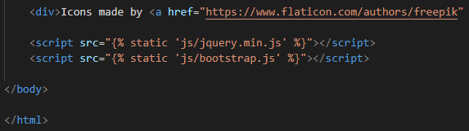

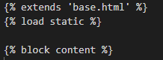Its time to code our main page – **page.html.** This file starts with the code that extends it to our **base.html** template, as well as loading static folder. And everything that comes after *{% block content %}* is the content of our page and will be inserted in the specific space in our template.

* Now we create our pages. First is the home container.

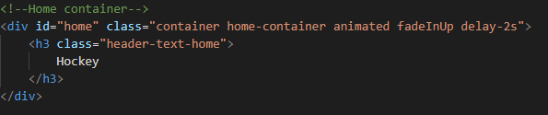

* 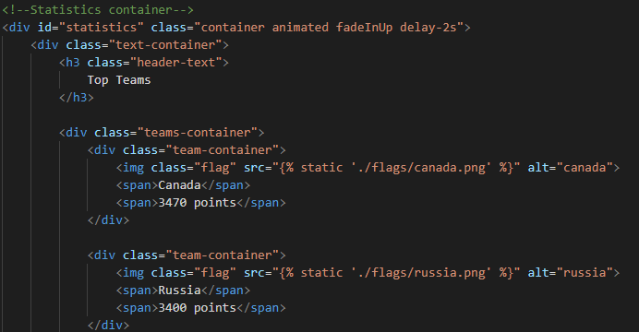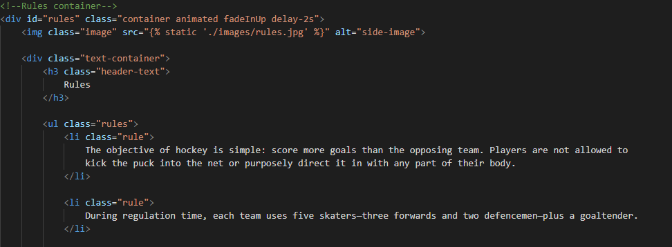Then *Rules* container that has some images and a list of rules.
* *Statistics* container is the one where we used flag images

Events, Impressum and Sources container are pretty much the same

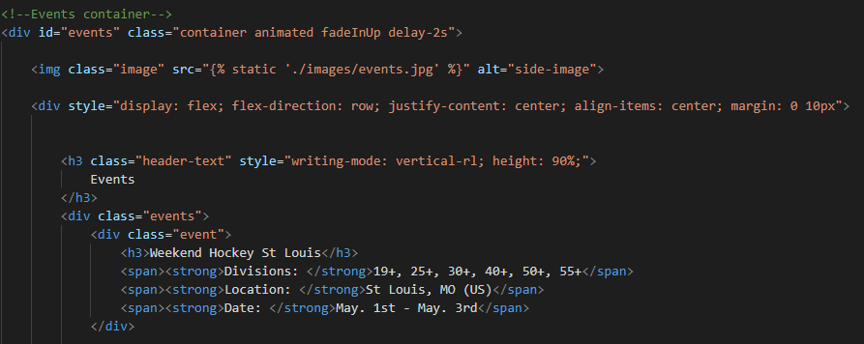

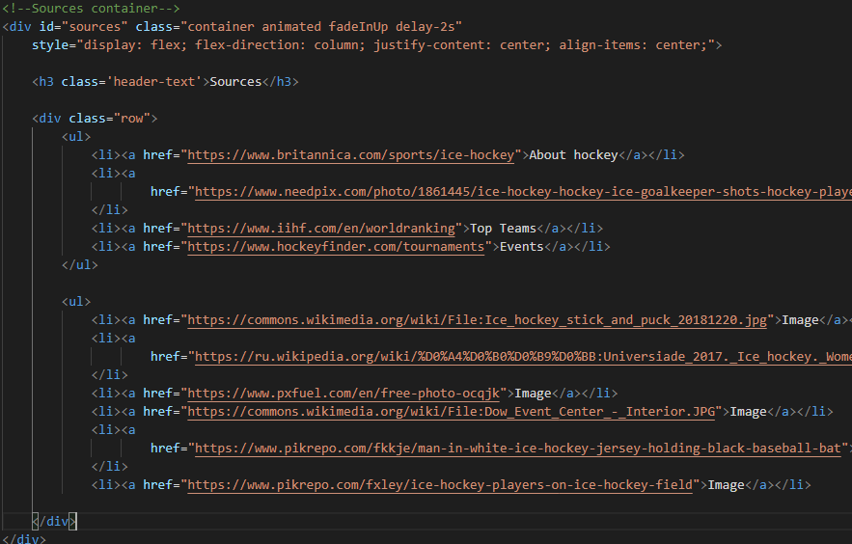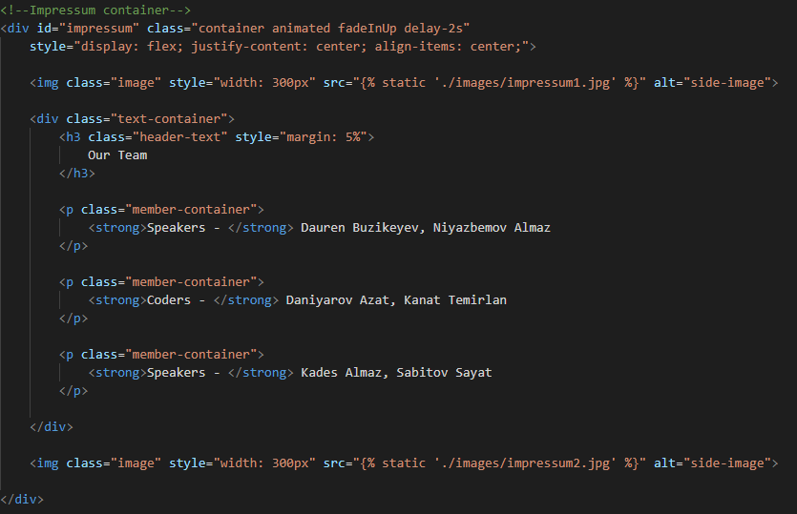

1. **Styling**

For styling our components we are going to create a file named **my_styles.css** in static/css folder. The inside of this file looks like this:

