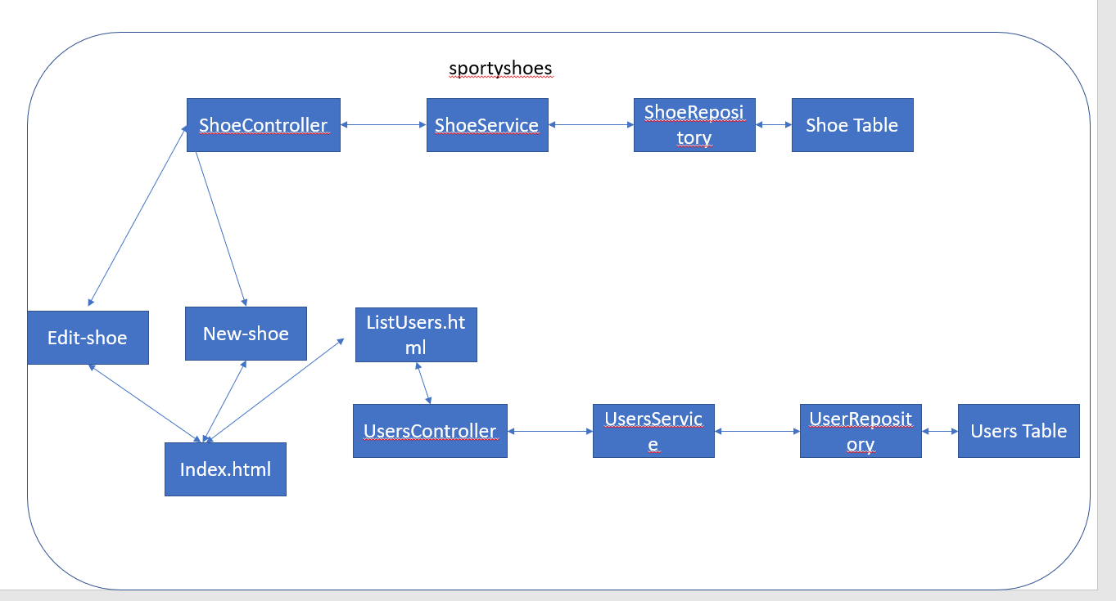

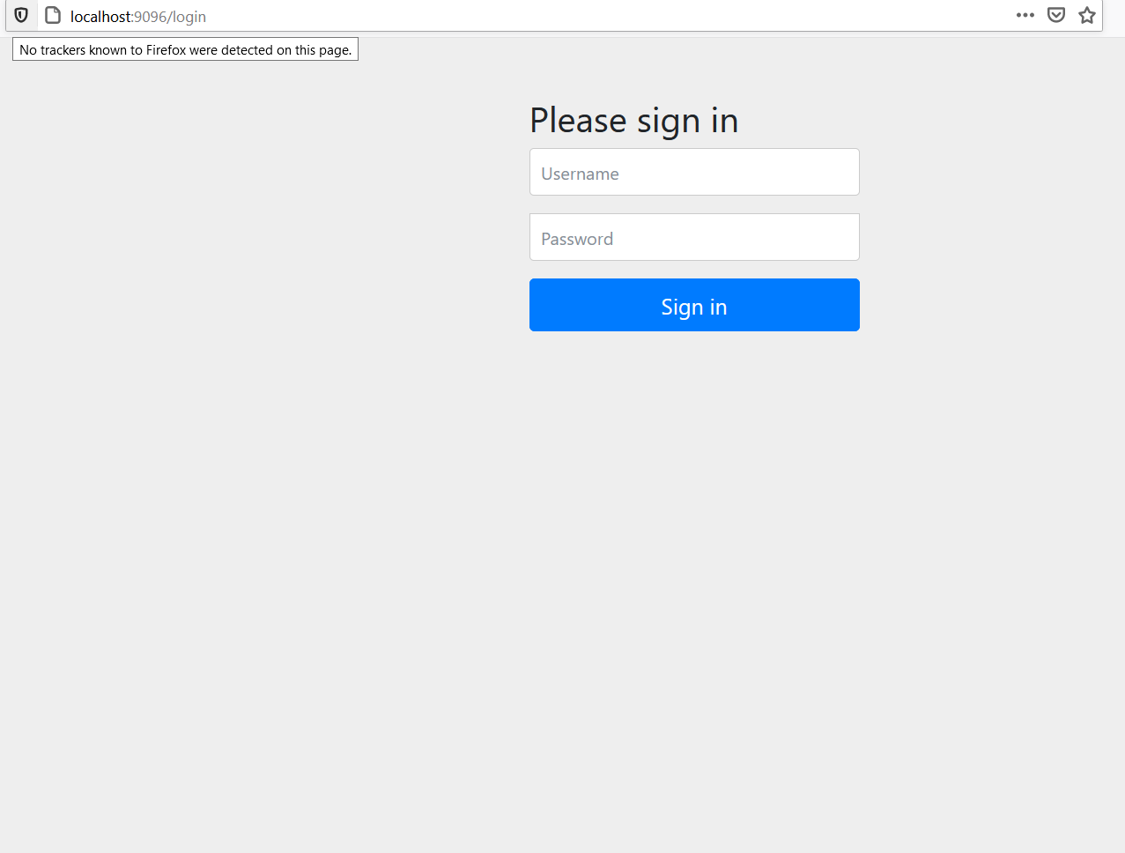

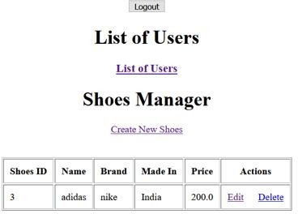

***After clicking create new shoe***

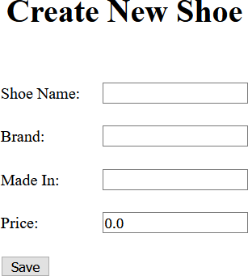

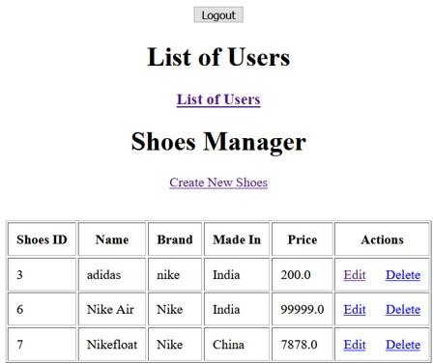

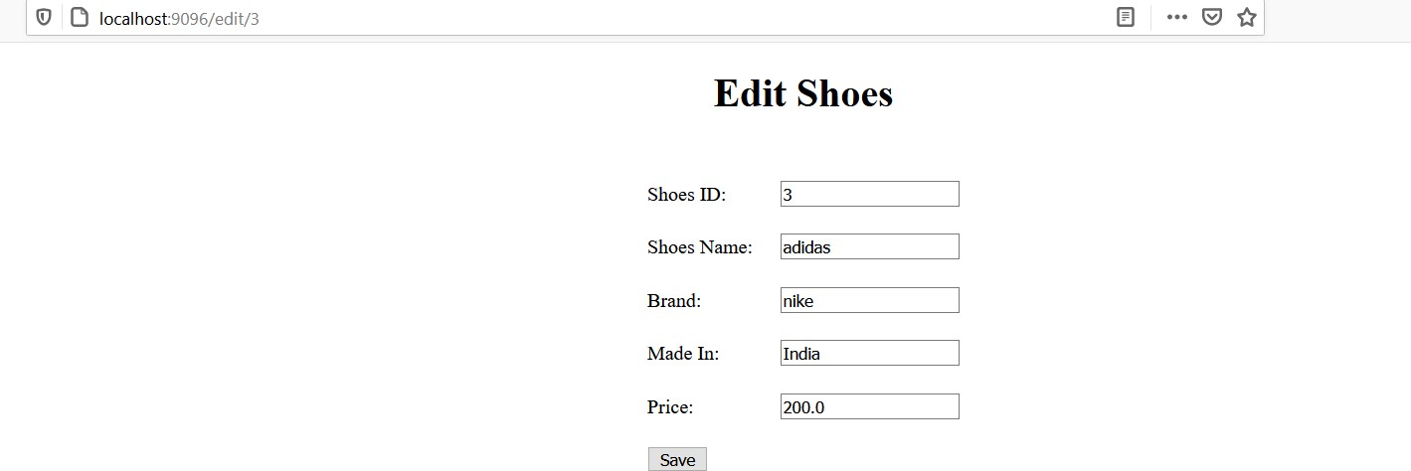

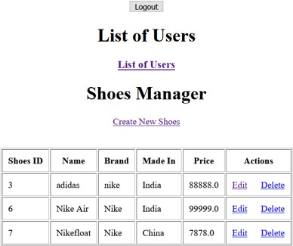

***After clicking delete***

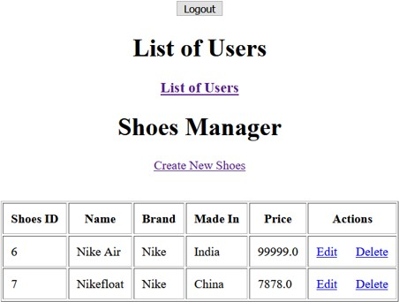

***After clicking list users***

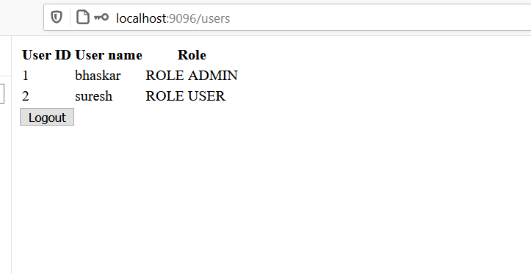

***After press logout***

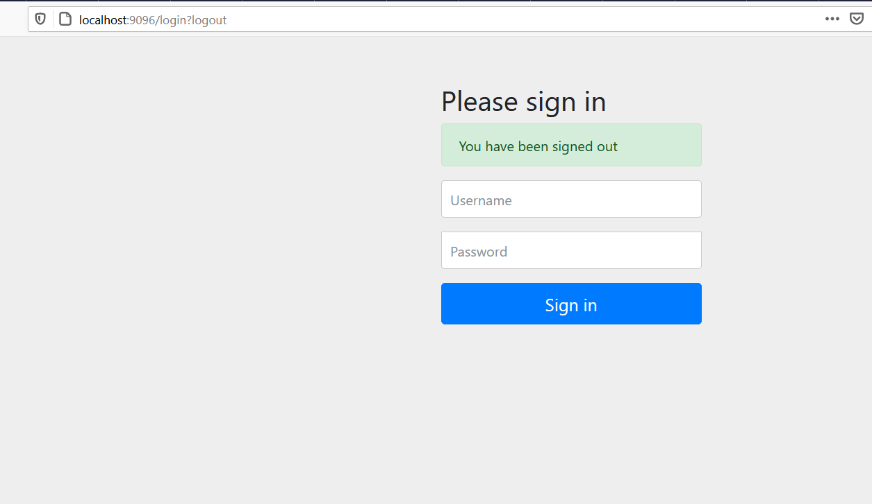

**Steps to push above project on Gitub**

1.Go to github account and create a new repository name as

Step3_Implement Frameworks the DevOps way

2.Open git bash in folder which is to push on github

3.Initialize this repository using **git init** command

4.Adding all files to staging area using **git add .** command

5.Commit the changes using the

**git commit -m “first commit step 3 ”**  command.

6.Update the changes made in local repository into remote repository using command

**git remote add origin** <https://github.com/TShivansh/Step3_Implement-Frameworks-the-DevOps-way.git>

**GitHub Repository link :**

**https://github.com/TShivansh/Step3_Implement-Frameworks-the-DevOps-way**