S1421057 TASK 1

2 largest eigenvalues: [ 14.55751626 11.52435032]

First 5 rows of E2:
[[ 0.00897703 0.12595201]
[ 0.10713756 0.05442521]
[-0.05553495 0.1155426 ]
[ 0.07305884 -0.1210169 ]
[ 0.01768294 0.11018595]]
First 5 rows of X_PCA:
[[ 5.69437513 3.60079859]
[ 5.52297389 1.43001254]
[ 0.90013833 -1.39092447]
[ 2.00892143 -1.23451795]
[ 4.33154391 1.68367736]]

Scatter plot:
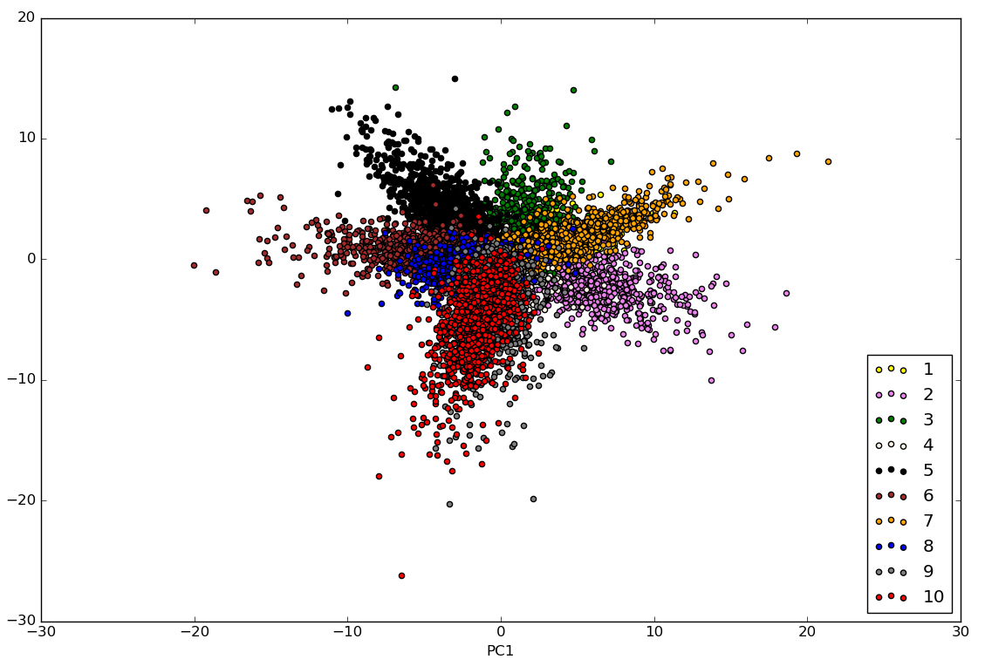

Cumulative variance plot:
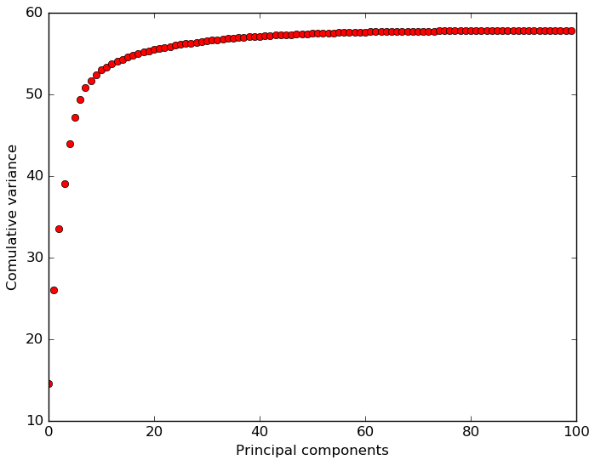
First 10 components are necessary to explain 90% of variance.

This shows that a small number of features heavily contributes to the identification problem. We could remove 50 least valuable features and that would have very little impact on the classification rate.

Even after projecting 100-dim vectors onto plane we can still see that different digits have different characteristics.

However, if we use different vectors the results are not so clear. The other combination of vectors that makes digit differences visible is 1 and 3. Here's the scatter plot:
