S1421057 TASK 3

KNN:
Precision: 0.341
Predicted class

1. 2. 3. 4. 5. 6. 7. 8. 9. 0.
[47 4 1 22 0 6 9 7 0 4]
[ 5 23 12 6 9 10 16 9 8 2]
[ 0 21 20 3 10 10 3 16 10 7]
Actual class

[23 9 6 32 6 5 6 8 0 5]
[ 1 10 4 1 52 13 1 13 3 2]
[ 9 8 15 10 16 11 2 11 12 6]
[ 5 21 6 4 1 4 50 8 1 0]
[ 3 18 14 10 12 11 7 18 3 4]
[ 1 9 8 2 6 12 1 2 34 25]
[ 0 3 1 7 1 7 1 4 22 54]

Full Gaussian:
Precision: 0.444
Predicted class

1. 2. 3. 4. 5. 6. 7. 8. 9. 0.
1.[55 4 2 32 0 0 7 0 0 0]
2.[ 0 33 38 10 6 0 11 0 1 1]
3.[ 0 16 61 7 7 0 2 0 7 0]
Actual class

4.[18 12 9 53 0 0 4 0 0 4]
5.[ 0 4 21 2 66 1 0 0 6 0]
6.[ 8 3 21 25 19 0 1 0 18 5]
7.[ 4 21 6 6 0 0 63 0 0 0]
8.[ 2 16 42 15 13 0 6 0 3 3]
9.[ 1 2 16 5 10 1 0 0 50 15]
0.[ 2 2 3 8 0 2 0 0 20 63]

LDA Gaussian:
Precision: 0.413
Predicted class

1. 2. 3. 4. 5 . 6. 7. 8. 9. 0.
1.[59 2 0 30 0 2 7 0 0 0]
2.[ 1 17 15 8 6 24 17 10 1 1]
3.[ 0 7 27 2 6 36 8 6 8 0]
Actual class

4.[24 4 0 43 0 18 2 4 1 4]
5.[ 0 2 8 1 66 19 0 1 3 0]
6.[ 7 3 9 20 18 19 2 1 18 3]
7.[ 6 11 3 3 0 3 70 4 0 0]
8.[ 4 9 21 10 13 23 8 6 4 2]
9.[ 1 1 2 2 11 19 0 0 43 21]
0.[ 3 1 0 5 0 10 0 0 18 63]

All classification methods performed much worse compared to Task2 but their positions didn't change.
Full Gaussian: dropped from 0.869 to 0.444
LDA Gaussian: from 0.857 to 0.413
KNN: from 0.853 to 0.341

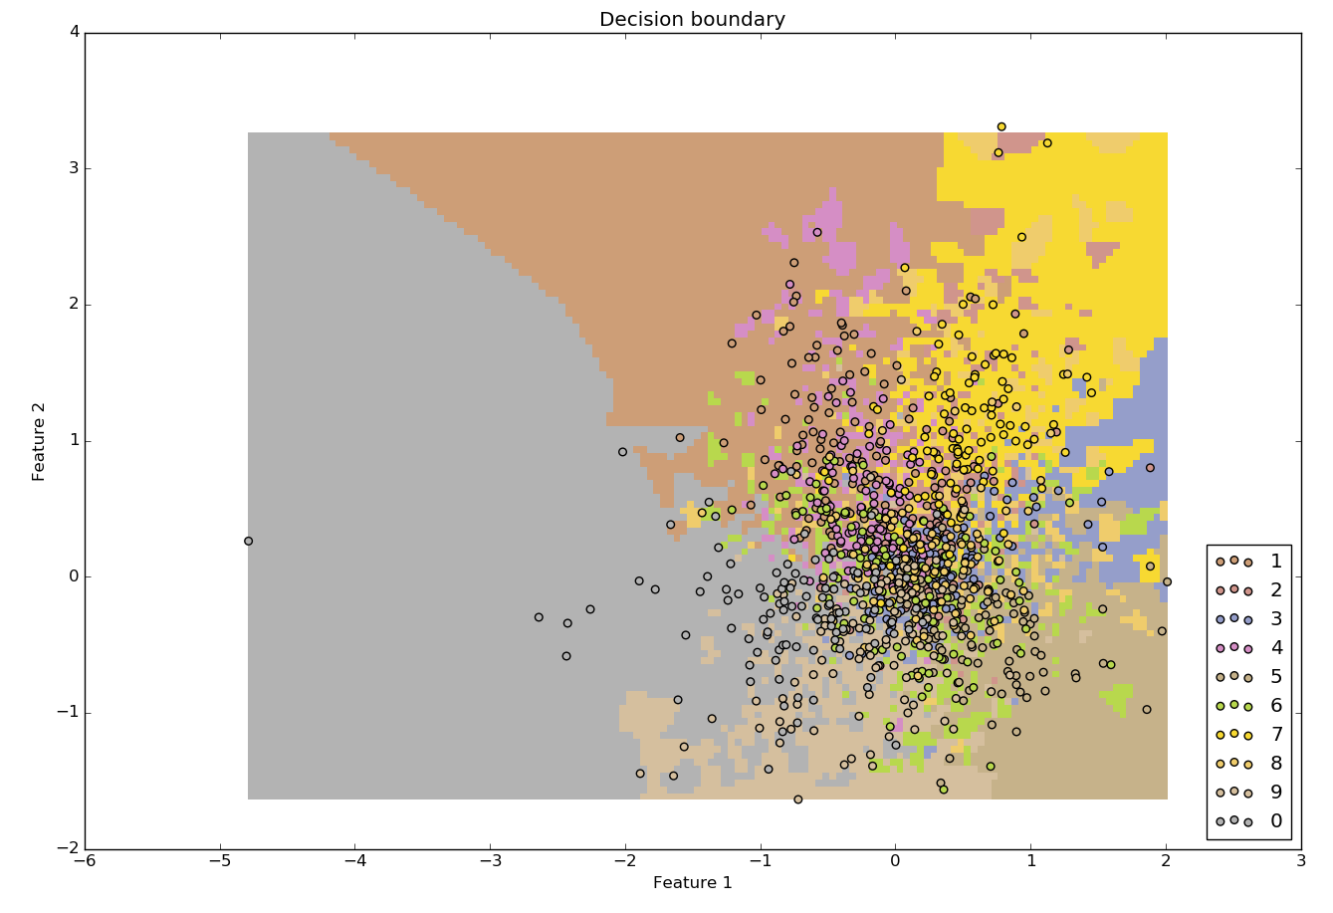
KNN:

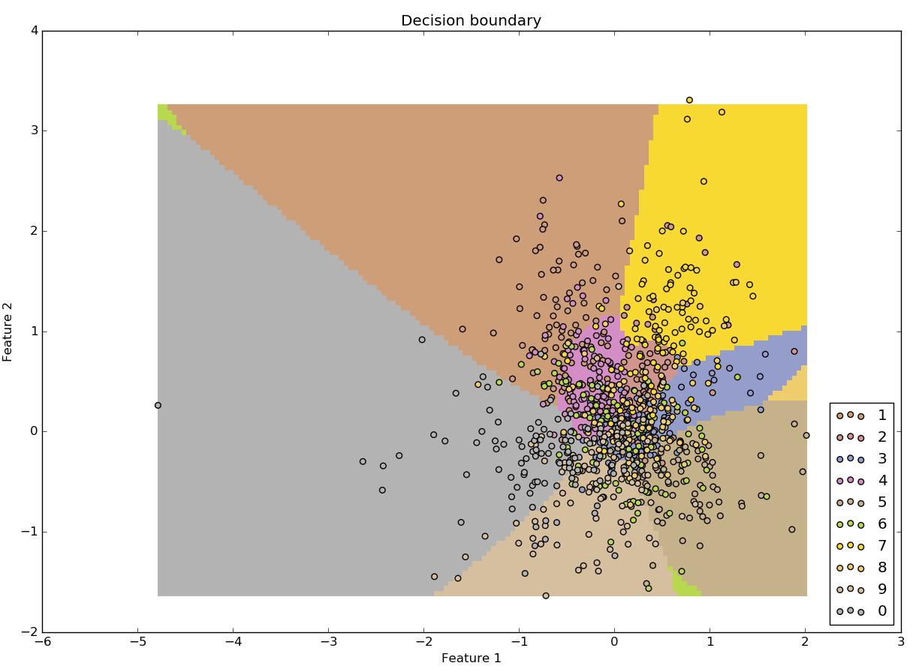
Full Gaussian:
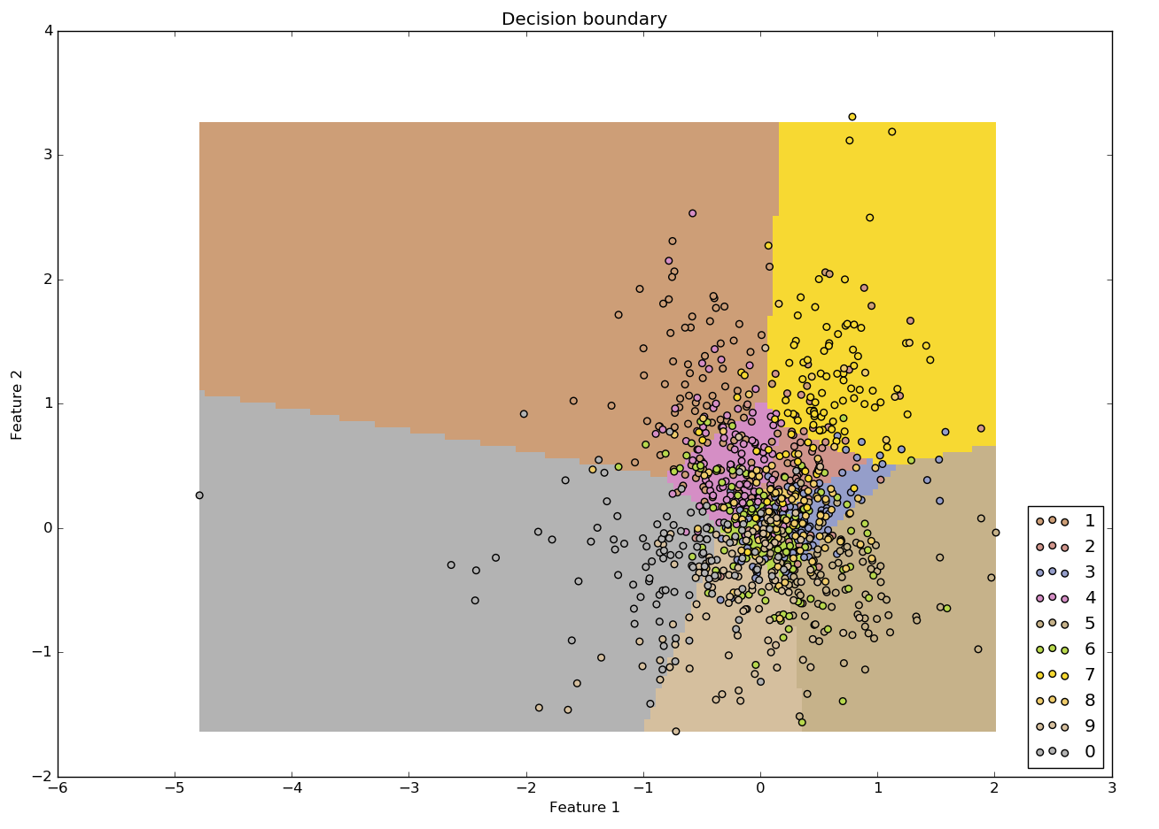
LDA Gaussian:

How do the shapes of the decision boundaries look for each method?
KNN decision boundaries are very inconsistent, patchy.
Gaussian_full and Gaussian_lda give relatively similar boundaries – straight and smooth.

Compare these methods based on the visualisation of these decision boundaries.
It looks like KNN tends to overfit data. Gaussian_full and Gaussian_lda – not so much.

Some classes are difficult to separete because some numbers look similar. For example 5 and 6.
Some classes are easy to distinguish. For example 0 and 7 takes different parts of the plane

